CS 455 – Artificial Intelligence

Module 1 Homework – Search Algorithms

Cameron Stark

1.1 Search path: 1 2 3 5 6 7 8 9 10 11 12 14 15 16 17 G

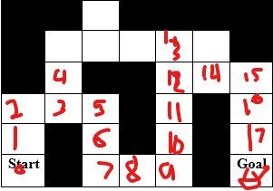

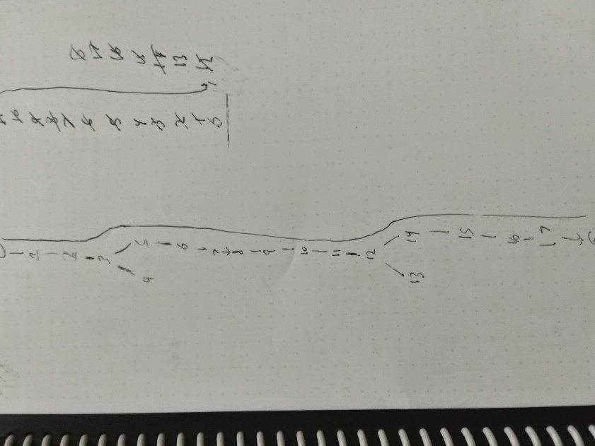

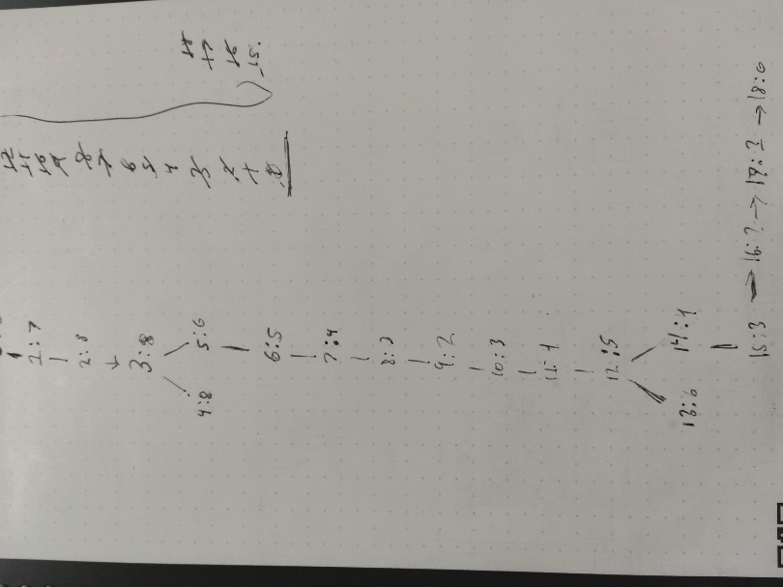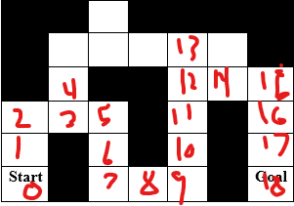

* 1. Search Path: 1 2 3 5 6 7 8 9 10 11 12 14 15 16 17 18

1.3

2

* A state within the algorithm would be represented by the current location, distance to goal, distance traveled, total cost and parent
* The successor function would be the movement to any adjacent city, that is not a current parent of the current city
* The admissible heuristic would be the distance to the goal and the remaining nodes
* Path cost would be the total moves to get to the end city
* Goal criteria would be shortest path with visiting each city at most once

3

* State is represented by current weight and current value, representing the bag
* The successor function is check if weight of next item is larger than max weight, if not compare the value to the next value combined with the previous and choose the larger
* The value/reward trying to optimize is getting the largest value for the least or maximum amount of weight supported
* It is a maximization problem because you are trying to maximize the values that can be stored, in the allotted amount of space by choosing the weights worth the most