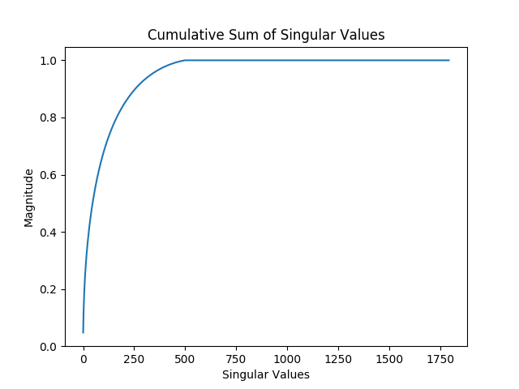

This graph represents the cumulative sum of the ordered singular values from the svd decomposition from the covariance matrix of a sample set of image features. Given a feature length of 1792 for each image, this means the feature vectors can be compressed to a length 256/1792=0.14 of their original length and still retain enough distinguishing information. The features can then be quantized into bytes and converted to a gray code for efficient hamming distance computation.

Tests

Compressed features are taken from images in a test set and compared to features from altered versions of the same image by a hamming distance computation. The images are altered in the following ways: blurring, compression, central cropping, decimation, added noise, black box occlusion on bottom margin of image, and one to three degree rotation. For comparison, the same is done for pairs of images that do not match.

Original/Blurred Original/Compressed
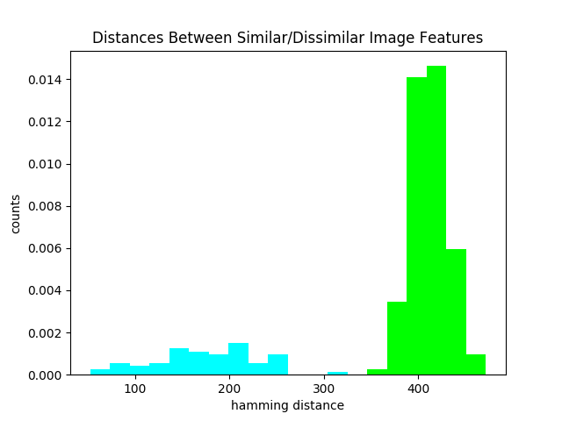
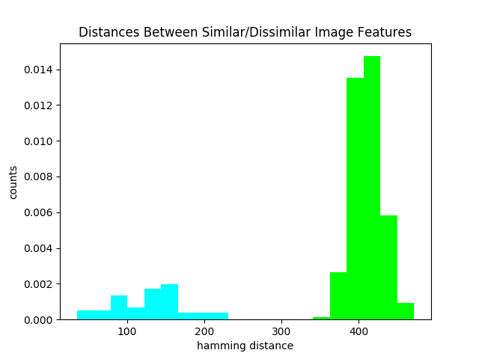

Original/Cropped Original/Decimated
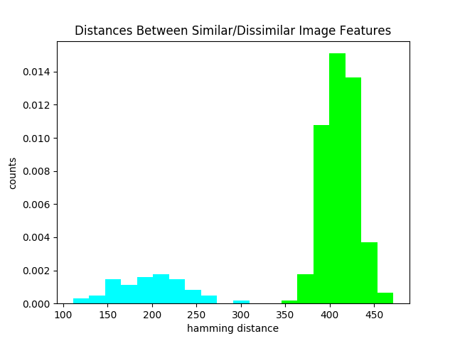
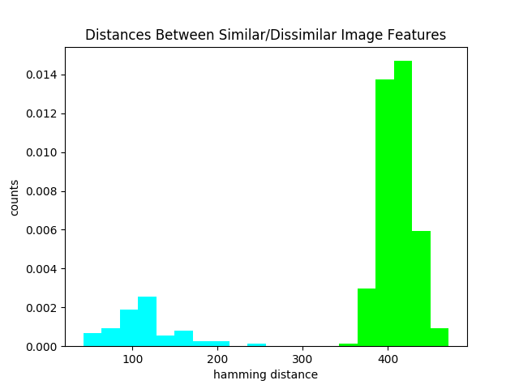

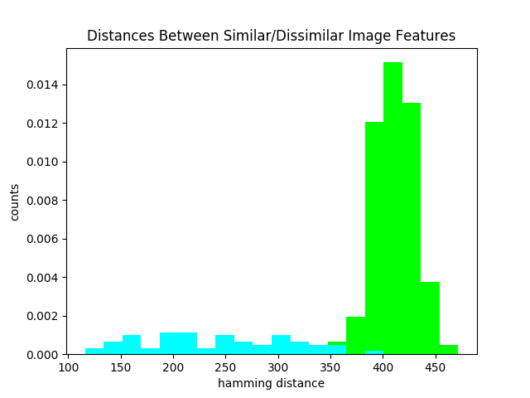
Original/Noise Original/Occluded
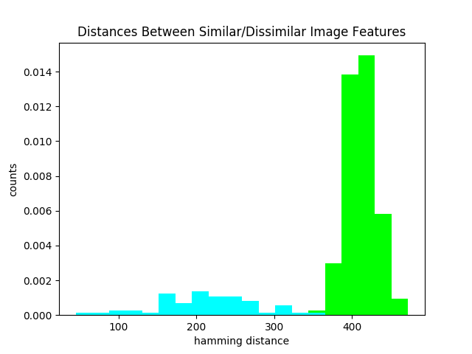

Original/Rotated
