INTRODUCTION

Voice Assistants are artificial intelligence (AI) systems that enable users to interact with devices and perform tasks using natural language voice commands. Voice assistants have become increasingly popular in recent years, with many people using them to control smart devices, access information, and perform a variety of tasks on their smartphones, smart speakers, and other devices.
Voice assistants use natural language processing algorithms and machine learning techniques to understand and respond to user requests. They can be activated using a specific trigger word or phrase, such as “Hey Siri” or “Ok Google”, and can perform a wide range of tasks, such as answering questions, setting reminders, playing music, or controlling smart home devices.
Voice assistants have the potential to make many everyday tasks more convenient and efficient, as they allow users to interact with devices and systems using their voice rather than requiring them to use a physical interface or input commands manually. However, voice assistant also raise privacy and security concerns due to the sensitive personal data that they may collect, store, and process.
Overall, voice assistants are an emerging and rapidly evolving technology that has the potential to transform how people interact with devices and systems, and they will likely continue to play an important role in the development of AI.

Aim and Purpose
Purpose of virtual assistant is to being capable of voice interaction, music playback, making to-do-lists, setting alarms, streaming podcasts, playing audiobooks, and providing weather information, traffic, sports and other real-time information, such as news. Virtual assistants enable users to speak natural language voice commands in order to operate the device and its apps.
There is an increased overall awareness and a higher level of comfort demonstrated specifically by millennial consumers. In this ever-evolving digital world where speed, efficiency, and convenience are constantly being optimized, it’s clear that we are moving towards less screen interaction.
Project Definition:
- Virtual Assistants are software programs that help us ease our day to day tasks, such as showing weather report, creating reminders, providing knowledge on any topic etc.
- They take’s commands via text (online chat bots) or by voice.
- Voice based intelligent assistants need an invoking word or wake word to activate the listener, followed by the command.
- For my project The wake word is JIA. We have so many virtual assistants, such as Apple’s Siri, Amazon’s Alexa and Microsoft’s Cortana.
- This system is designed to be used efficiently on desktops.
- Personal assistant software improves user productivity by managing routine tasks of the user and by providing information from online sources to the user.
- JIA is effortless to use. Call the wake word ‘JIA’ followed by the command. And within seconds, it gets executed.
- Voice searches have dominated over text search.
- Web searches conducted via mobile devices have only just overtaken those carried out using a computer and the analysts are already predicting that 50% of searches will be via voice by 2025.
- Virtual assistants are turning out to be smarter than ever.
- Allow our intelligent assistant to make email work for us.
- Detect intent, pick out important information, automate processes, and deliver personalized responses.
Project Profile
Project Title | AI Voice Assistant
Front-End | Python
Back-End | MySQL
Software Requirement | Visual Studio Code Editor, XAMPP
Hardware Requirement | Intel core i3, 8GB RAM, Speaker, Microphone etc.
Operating System | MS Windows 11
Documentation Tool | Microsoft Office 2016
Project Guide | Mr. Pradhyuman Parmar
Submitted By | Dipesh Patel
Submitted Through | Shree P.M. Patel College of Computer Science and Technology, Anand.
Submitted To | Sardar Patel University.

Study of Existing System
- Amazon Alexa is a cloud-based voice assistant, developed by Amazon, that performs a wide range of tasks via voice commands. It is embedded in smart devices like Amazon Echo, Fire TV and even third party devices.

- Front End: These are physical interface through which users interact with Alexa cloud service.

- Voice Processing: Voice recordings are processed in Amazon Web Services(AWS).

- Speech Recognition: Amazon’s Automatic Speech Recognition translates voice commands into text.

- Response Generation: Alexa sends the response back as voice output to user, often retrieving information from the cloud or triggering an action (e.g., playing musing, speaking news etc.).

- Core Components and Technologies:
  - Voice Recognition: Alexa uses ASR and NLU for interpreting spoken language. Machine learning models are continuously trained to improve understanding of accents, languages, and complex commands.
  - Voice User Interface: Alexa is controlled via VUI, which requires the system to handle various types of conversations, including one-shot queries and ongoing dialogues.

- Limitations:
  - Privacy and Data Security: Concerns regarding the storage and usage of voice recordings.
  - Accidental Activations: Alexa sometimes misinterprets words or activates without the wake word.

Need of Proposed System
Existing system:
- Performance: Voice assistants may have limitations in terms of their performance, such as the speed at which they can process and respond to user requests, or the complexity of tasks that they can handle.

- Privacy and security: Voice assistants may not always clearly communicate their data collection and sharing practices to users, which could raise concerns about transparency and consent.

- Customization: Voice assistants may not offer users a high degree of customization or control over their functionality, which could limit their usefulness and appeal to users.

- Accuracy: Voice assistants may not always accurately understand or respond to user requests and queries, which can lead to frustration and a poor user experience.

- Capabilities: Voice assistants may not support all tasks or functions that users may want to perform, and they may not be able to integrate with all devices or systems.

FEASIBILITY STUDY FOR PROPOSED SYSTEM

- The Feasibility study can help us determine whether or not one should proceed with project. It is essential to evaluate cost and benefit of the proposed system. Five types of feasibility study are taken into consideration.

- Technical feasibility: -
  - It includes finding out technologies for the project, both hardware and software.
  - For virtual assistant, user must have microphone to convey their message and a speaker to listen when system speaks
  - While using Jarvis, make sure We have a steady internet connection. It is also not an issue in this era where almost every home or office has Wi-Fi.
- Operational feasibility: -
  - It is the ease and simplicity of operation of proposed system.
  - System does not require any special skill set for users to operate it.
  - Kids who still don’t know to write can read out problems for system and get answers.
- Economic feasibility: -
  - Here, we find the total cost and benefit of the proposed system over current system.
  - For this project, the main cost is documentation cost.
  - User also would have to pay for microphone and speakers. Again, they are cheap and available.
  - As far as maintenance is concerned, JIA won’t cost too much.
- Organizational feasibility: -
  - This shows the management and organizational structure of the project.
  - This project is not built by a team. The management tasks are all to be carried out by a single person.
  - That won’t create any management issues and will increase the feasibility of the project.

- Overall feasibility study of the project reveals that the goals of the proposed system are achievable. Decision is taken to proceed with the project.

System Overview
- A virtual voice assistant is a software program that utilizes voice recognition technologies to understand and respond to spoken commands and queries.
- It allows users to interact with their devices, applications, and services using voice commands, and can perform a wide range of tasks such as making phone calls, scheduling appointments, setting reminders, and providing information.
- Some popular examples of virtual voice assistants include Amazon Alexa, Google Assistant, and Apple Siri. These AI Powered System can be integrated with other devices and services to create a more seamless and convenient user experience.
- One can use any IDE like Anaconda, Visual Studio etc. So the first step is to create a function for a voice which has arguments. Also, we are using Speech API to take voice as input.
- There are two default voices in our computer i.e. Male and Female. So one can use either any from these. Also, check the voice function by giving some text input and it will be converted into voice.
- One can create a new function for wishing the user. Use if-else condition statement for allocating the wished output. E.g. If its time between 12 to 18 then the system will say “Good Evening”.
- Along with this, one can get a welcome voice also. e.g. “Welcome, what can I do for you”.
- After that, one has to install the speech recognition model and then import it Define a new function for taking command from a user. Also mention class for speech recognition and input type like microphone etc.
- Set a query for voice recognition language. One can use Google engine to convert our voice input to the text. User have to install and import some other packages like pyttsx3, Wikipedia etc.
- Pyttsx3 helps to convert text input to speech conversion.
- If user ask for any information, then it will display the result in textual format. One can convert it very easily in the voice format as we have already defined a function in our code previously.

Requirement Analysis:
- In order to effectively design and develop a system, it is important to understand requirements of the system.

- The process of gathering and documenting the requirements of system is known as requirements analysis.

- It helps to identify the goals of the system, the stakeholders and the constraints within which the system will be developed.

- The requirements serve as a blueprint for the development of the system and provide a reference point for testing and validation.

- Functional Requirement:
These Specifies the core Functionality of AI Voice Assistant.
- Voice Recognition: The AI Should recognize and process voice commands.

- Text to Speech(TTS): Convert responses into natural-sounding speech.

- Task Execution: Perform web searches and fetch information.

- Non Functional Requirement:
These define the overall quality attributes of system.
- Usability: Easy to use interface, should work hands-free and be accessible to people with disabilities.

Scope of Proposed System
- Voice assistants will continue to offer more individualized experiences as they get better at differentiating between voices.
- However, it’s not just developers that need to address the complexity of developing for voice as brands also need to understand the capabilities of each device and integration and if it makes sense for their specific brand.
- They will also need to focus on maintaining a user experience that is consistent within the coming years as complexity becomes more of a concern.
- This is because the visual interface with voice assistants is missing. Users simply cannot see or touch a voice interface.

- Functionality of Proposed System:
  - Searching from Web (Google, YouTube, Wikipedia etc.)
  - Checking Temperature
  - Checking Time
  - Hot word Detection (Wake up JIA etc.)
  - Open/Close Apps with Just Your Voice
  - Set Alarm
  - Fully Automate YouTube Controls
  - News Speaking
  - Calculator in JIA
  - Shutdown System using JIA
  - Schedule Day Function
  - Open any App
  - Check Internet Speed
  - Rock Paper Scissor Game
  - Screenshot and Camera Accessibility
  - Google Translator

Features
- It can get some real time information such as news headlines, weather report, Internet speed, and system stats.
- It can also get entertaining contents such as jokes, latest movies or TV series, and playing songs and videos in YouTube.
- It can perform system operations such as opening/closing/switching tabs, copying/pasting/deleting/selecting the text, creating a new file, taking screen shot, minimizing/maximizing/switching/closing windows.
- It can also get brief information on any topic, perform arithmetic operations, and answer any general knowledge question.
- We can also open any installed app and some websites. It can play music for entertainment.

Merits of Proposed System
AI voice assistants offer a variety of advantages that enhance human life in several ways. Here are some of the key benefits:
1.Convenience and Efficiency: AI voice assistants allow users to perform tasks hands-free, such as setting reminders, making calls, or sending messages, which can save time and streamline daily activities.

2.Accessibility: They help individuals with disabilities or those who have difficulty using traditional interfaces by providing an alternative means of interaction. Voice commands can assist those with visual impairments or motor difficulties.

3. Multitasking: Voice assistants enable users to multitask more effectively. For instance, you can cook while getting recipe instructions or exercise while listening to music or a podcast.

4. 24/7 Availability: Unlike human assistants, AI voice assistants are available around the clock, providing support whenever needed without requiring breaks or downtime.

5. Information Retrieval: Voice assistants can quickly provide information on a wide range of topics, such as weather forecasts, news updates, or general knowledge, helping users stay informed without manual searching.

6. Entertainment: Voice assistants can play music, audiobooks, and podcasts, as well as provide interactive games and activities, offering a convenient source of entertainment.

System Configuration
Tools &Technology
Front-End: Python
Back-End: MySQL
Language: Python
Development Editor: VS Studio Code
Database: MySQL
Hardware Requirements:
- RAM - 8GB or more
- Input Devices – Microphone & keyboard
- Output Devices – Speaker & Monitor
- Internet Connection
Software Requirements:
- Python 3.12
- Python Packages (libraries)
  - Speech Recognition
  - Pyttsx3
  - Requests
  - Pyaudio
  - OS
  - MySQL Connector

Technology:
- PYTHON:
- Python is a high-level, interpreted programming language known for its simplicity and readability.
- It was created by Guido van Rossum in the late 1980s and has since gained widespread popularity. Python's elegance lies in its clean and concise syntax, making it accessible for both beginners and experienced developers.
- Python finds application in diverse fields, from web development and data analysis to machine learning and scientific computing.
- Its versatility is due to a vast standard library and a thriving ecosystem of third-party packages.
- Additionally, Python supports scripting, making it a go-to language for automating tasks and system administration.

Back-End Language:
- MYSQL:
- MySQL is an open-source relational database management system (RDBMS) that is widely used for managing and organizing structured data.
- It was first released in 1995 and has since become one of the most popular RDBMS choices. MySQL stores data in tables with rows and columns, making it efficient for structured data storage and retrieval.
- Users interact with MySQL using a structured query language (SQL) to perform tasks such as data insertion, retrieval, updating, and deletion.
- MySQL is known for its speed and reliability, making it suitable for applications ranging from small websites to large-scale enterprise systems.
- To summarise, MySQL is a powerful and widely adopted relational database system that efficiently manages structured data, making it a crucial component of many software applications and systems.

Python Modules:
- Speech Recognition: The Speech Recognition module in Python is a library used to convert spoken language into text. It provides an easy-to-use interface for integrating speech recognition capabilities into Python applications.
- KivyMD: KivyMD is an extension of the Kivy framework that provides Material Design components for building user interfaces in Python applications. It offers a collection of ready-to-use widgets that follow Google’s Material Design guidelines, making it easier to create visually appealing and consistent apps. KivyMD simplifies the development process by providing pre-designed elements like buttons, cards, dialogs, and navigation bars, allowing developers to focus on functionality and design without starting from scratch. It's ideal for those looking to create modern, responsive applications with Kivy.
- Pyttsx3: pyttsx3 is a Python library for text-to-speech (TTS) conversion, enabling the program to speak text aloud. It works offline and is cross-platform, supporting Windows, macOS, and Linux. The library allows users to customize voice characteristics like rate, volume, and accent, and it can handle multiple voices. Installation is simple via pip, making it easy to integrate into Python projects. Overall, `pyttsx3` is a user-friendly tool for adding speech capabilities to applications.
- PyAutoGUI: PyAutoGUI is a Python module used for automating mouse and keyboard actions, allowing users to control the GUI of applications programmatically. It enables developers to perform tasks like clicking, typing, dragging, and taking screenshots, making it ideal for automating repetitive tasks, testing user interfaces, and creating bots.
- Key Features:
- Mouse Control: Move the mouse, click, double-click, drag, and scroll.
- Keyboard Control: Type text, simulate key presses, and perform keyboard shortcuts.
- Screenshot Functionality: Capture screenshots and locate images on the screen.
- Cross-Platform Compatibility: Works on Windows, macOS, and Linux.
- MYSQL.CONNECTOR: MYSQL.CONNECTOR is a python library used to connect to and intersect with MySQL databases. MYSQL.CONNECTOR library using database connectivity, data retrieval, data manipulation provide more facility about MYSQL.CONNECTOR library.
- OS: Python has a built-in OS module with methods for interacting with the operating system, like creating files and directories, management of files and directories, input, output, environment variables, process management, etc.
- Requests: The requests module simplifies HTTP requests in Python, making it easy to interact with web services and APIs. Its user-friendly interface handles various HTTP methods, parameters, and headers, providing a powerful tool for web communication in Python.
Tools
- Microsoft Visio:
- Microsoft Visio Professional is a powerful diagramming tool known for its versatility.
- It offers an extensive library of templates and shapes, making it a go-to choice for professionals and businesses to create a wide variety of diagrams.
- From flowcharts to organizational charts, Visio Professional simplifies the diagram creation process, ensuring that your visualizations are clear and professional.

- VS CODE:
- VS Code, or Visual Studio Code, is a free and user-friendly code editor used by developers for writing and editing computer programs. It's like a digital notepad for writing code.
- VS Code offers various features such as code highlighting, auto-completion, and debugging tools, making it easier for programmers to write code with fewer errors.
- It supports many programming languages and extensions, allowing developers to customize it for their specific needs.
- VS Code has a simple and intuitive interface, making it suitable for both beginners and experienced programmers.
Speech Recognition:
Speech recognition, also known as automatic speech recognition (ASR) or voice recognition, is a technology that enables machines to understand and interpret spoken language. It converts spoken words into text or commands, allowing users to interact with devices using their voice. Here's a breakdown of how it works and its key components:

How Speech Recognition Works
- Audio Capture: The process begins with capturing the user's speech through a microphone or other audio input device. The audio signal is then digitized into a format that the computer can process.
- Pre-processing: The raw audio signal is cleaned and processed to remove background noise and normalize volume levels. This step ensures that the speech data is clear and consistent.
- Feature Extraction: The processed audio is analysed to extract features such as phonemes (distinct units of sound), pitch, and tone. This step helps in identifying the linguistic elements of the speech.
- Acoustic Modelling: Acoustic models use statistical methods to map the audio features to phonetic units. These models are trained on large datasets of spoken language and learn how different sounds correspond to phonemes and words.
- Language Modelling: Language models predict the likelihood of sequences of words based on grammar and context. They help in understanding the meaning and intent behind the spoken words, even when speech is ambiguous or includes errors.
- Decoding: The decoder combines information from acoustic and language models to generate the most likely text representation of the spoken input. This step involves matching the extracted features to known patterns and producing a text output.

LLMs: Large Language Models (LLMs) are advanced AI systems designed to understand and generate human language. Here's a structured breakdown of their characteristics, functionality, applications, limitations, and ethical considerations.
Architecture:
- Neural Networks: LLMs typically employ neural networks, often with multiple layers or "neurons" enabling them to process complex patterns in text.
- Training Data: They are trained on vast datasets, including books, articles, and websites, to recognize language structures and sword relationships.
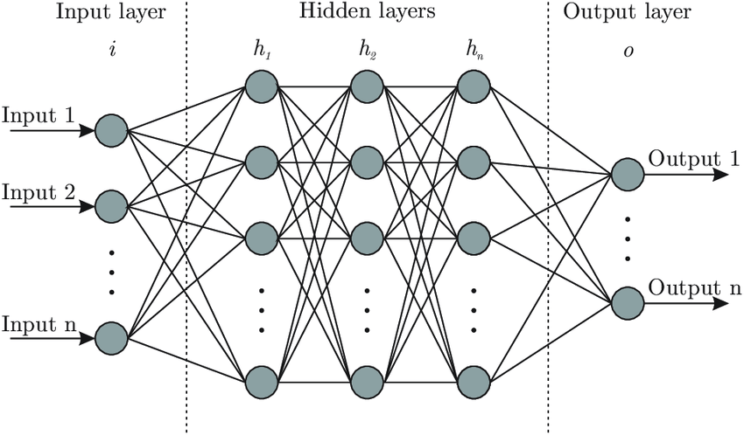
Functionality:
- Natural Language Processing (NLP): LLMs excel at tasks like translation, summarization, and question-answering by analysing text patterns.
- Creativity: Beyond analysis, they can generate new text creatively, such as writing essays or answering questions innovatively.
Applications:
- Essays and Reports: assisting in academic and professional writing.
- Conversational AI: driving Chabot’s and customer service applications.
- Translation and Summarization: translating languages and condensing information efficiently.
System Design
UML (Unified Modelling Language)
- Unified Modelling Language (UML) is a standard language for visually representing the design of software systems.
- It provides a set of graphical elements that can be used to model the structure, behaviour, and interactions of a system.
- UML is widely used in software development, and it is supported by a variety of tools and frameworks.

- UML Diagrams: -
- There are several different types of UML diagrams, each with its own specific purpose. Some of the most common UML diagrams include:

- Use Case diagrams: A use case diagram in UML is like a map that displays how a system interacts with users or external entities. In this project there is only one user.

- Class diagrams: A class diagram in UML is like a blueprint that shows different objects in a system and how they are connected.

- Activity diagrams: An activity diagram in UML is like a flowchart that illustrates the sequence of actions in a process.

- Sequence diagrams: A sequence diagram in UML is like a timeline that depicts interactions between different parts of a system over time.

- Symbol Description: The following table provides a description of the most common UML symbols:
- Class:
- A class represents the structure and functions of an object. A class can also be abstract, which means its functionalities are not defined.

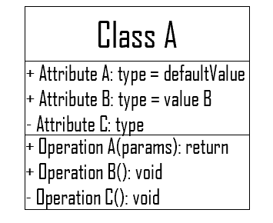
- Interface:
- An interface is a template that defines different functions without implementation details represented by a circle notation. A class that implements the interface also implements the functionality.
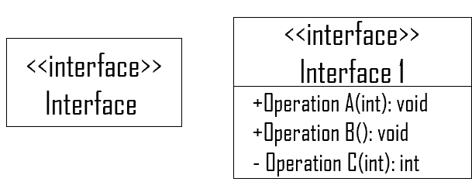
- Collaboration:
- A collaboration UML notation shows the relationship between two objects. It indicates that messages can pass between the objects. A dotted ellipse represents it.
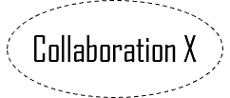
- Actor:
- An actor is any internal or external entity interacting with the system.
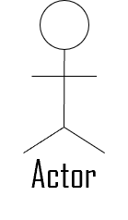
- Use Case:
- A use case represents a goal completed by the system on access by the user. In simple words, the use case is the function triggered by the actor, i.e., the user. An actor can also be another part of the system or an individual.

- Node:
- A node describes the physical part of the system. Examples are network, server, routers, etc.
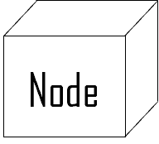
- Dependency:
- In the dependency relationship, one component depends on the target component, and the target changes affect the source. A dependency UML symbol is denoted by a dotted line with the arrow showing the direction of dependency.

- Generalization:
- Generalization notation shows the relationship between a general entity and a specific entity. In other words, it offers a parent-child relationship. The UML symbol for generalization notation is a straight line with a hollow arrowhead on one end.
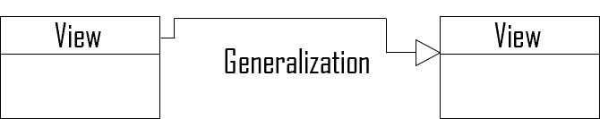

System Architecture: A virtual voice assistant is a software program that utilizes natural language processing and voice recognition technologies to understand and respond to spoken commands and queries.

Use Case Diagram: In this project there is only one user. The user queries command to the system. System then interprets it and fetches answer. The response is sent back to the user.
Virtual Assistant

Commands
Response

Query
Interpreted to

Receives
User

Class Diagram:
- The class user has 2 attributes command that it sends in audio/text and the response it receives which is also audio/text. It performs function to listen the user command. And after Interpretation reply or sends back response accordingly.
- Brain class receives command and check’s type of Command (Task or Question). Then pass it according to its type.
- Question class has the command in string form as it is interpreted by interpret class. It sends it to general or about or search function based on its identification. The task class also has interpreted command in string format. It has various functions like reminder, note, research, etc.
User
+Command Audio / Text
+Response Audio / Text
Listen (), Speak ()
Brain
+Command String
Brain () (Check’s type of command)
Task
+Command String
Reminder() , Research() , Open Websites()
Play_Music() etc.
If String is Query
If String is task
Command trends to AI Brain
Question
+Command String
General (), About (), Search () etc.
- Activity Diagram: Initially, the system is in idle mode. As it receives any wakeup call it begins execution. The received command is identified whether it is a questionnaire or a task to be performed. Specific action is taken accordingly. After the Question is being answered or the task is being performed, the system waits for another command. This loop continues unless it receives quit command. At that moment, it goes back to sleep.
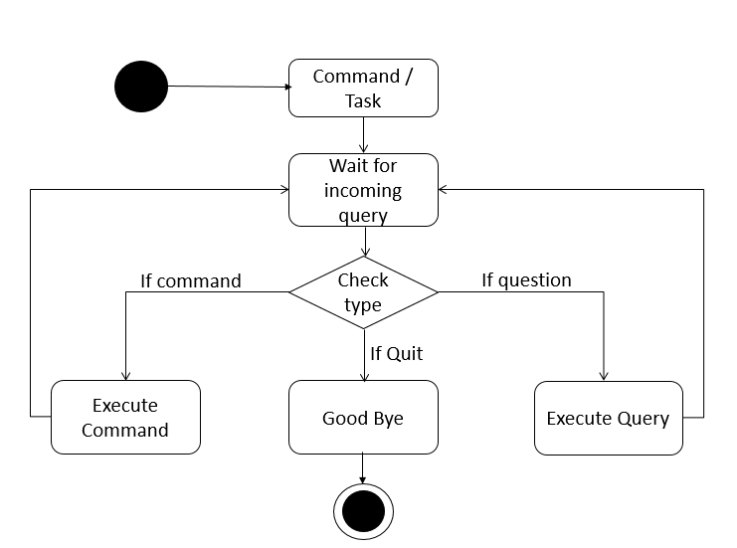

Sequence Diagram
Sequence Diagram for Query-Response:
The above sequence diagram shows how an answer asked by the user is being fetched from internet. The audio query is interpreted and sent to Web scraper. The web scraper searches and finds the answer. It is then sent back to speaker, where it speaks the answer to user.
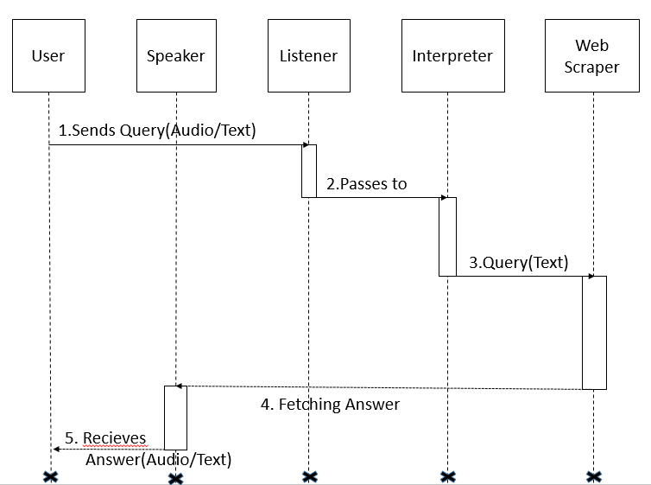

Sequence diagram for Task Execution: The user sends command to virtual assistant in audio form. The command is passed to the interpreter. It identifies what the user has asked and directs it to task executer. If the task is missing some info, the virtual assistant asks user back about it. The received information is sent back to task and it is accomplished. After execution feedback is sent back to user.
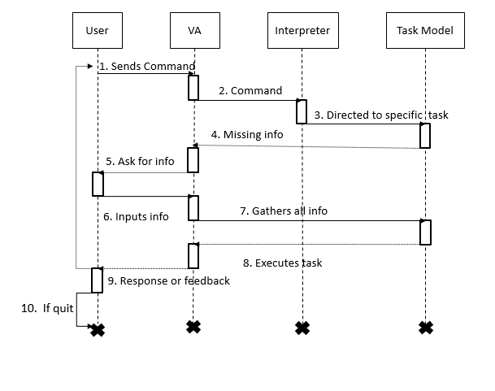
Time Line (Overall): A timeline chart is a visual tool used in project management to represent a project's schedule, tasks, and milestones over time. It provides a clear, sequential view of when each task or milestone is expected to start and finish.
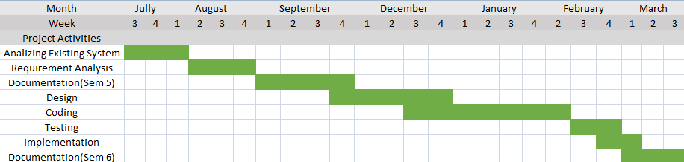

Data Dictionary
User Table: This table will be use to store user information to create username to personalize use of application.
Field Name | Data Type | Data Size | Constraint | Description
username | varchar | 15 | Primary Key | Name of user.
email id | varchar | 30 | Not Null | Email Id of user.
dob | date |  | Not Null | Date of birth of user.
password | varchar | 12 | Not Null | Password given by user.

SYSTEM LAYOUT
LOGIN FORM: This Form will be use to Login, if user is registered already.
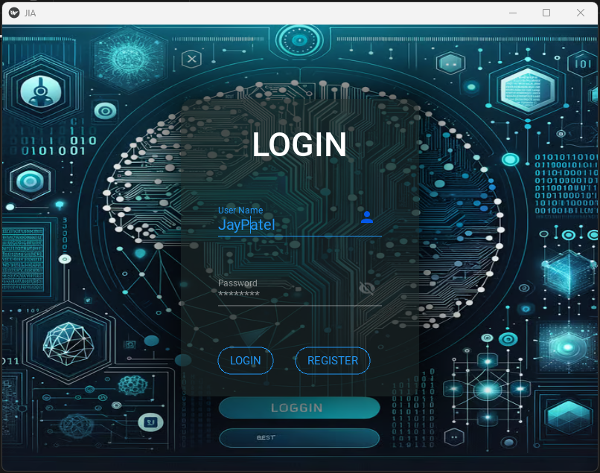

Login validation: Validating user if he is registered already in database.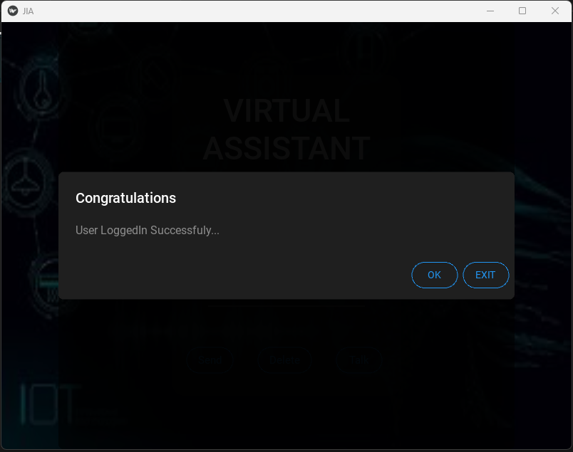

Login Validation: Error Occures if User is not registered in database for Application.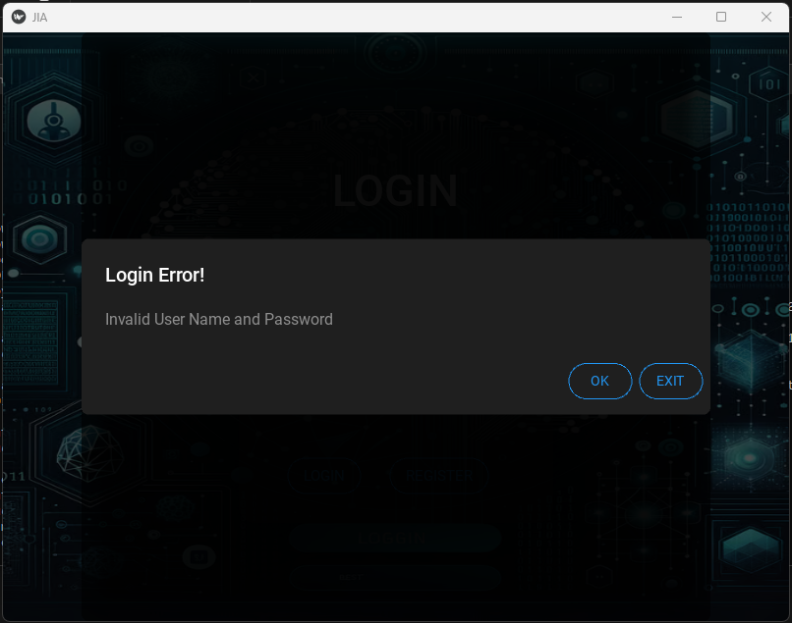
REGISTERATION FORM: This form will be use to register or create new user for Application.
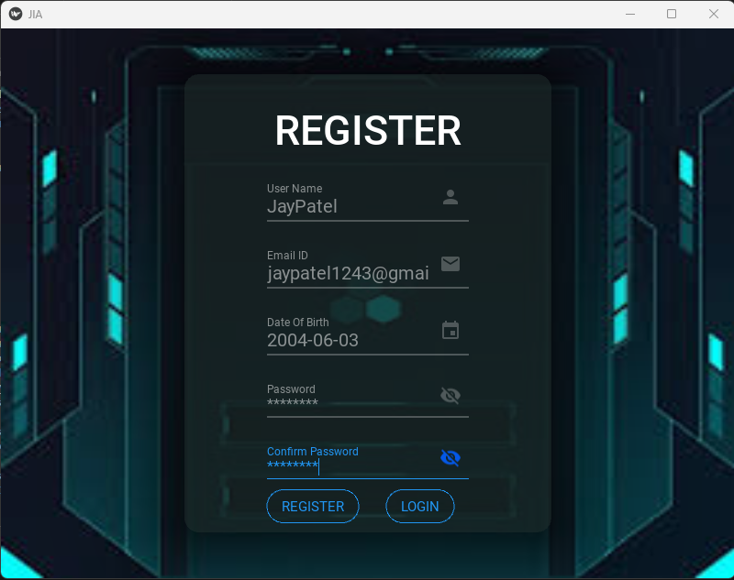
Registration Form Validation: Checking Validation of Registration form for everyfields requirements.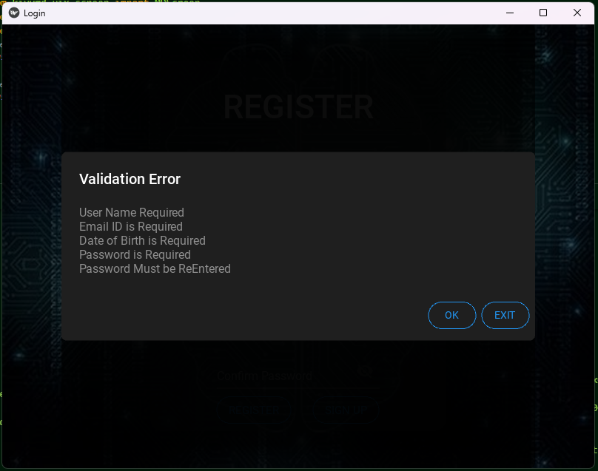
Registration Validation: Validating when user Register him/her self for Application.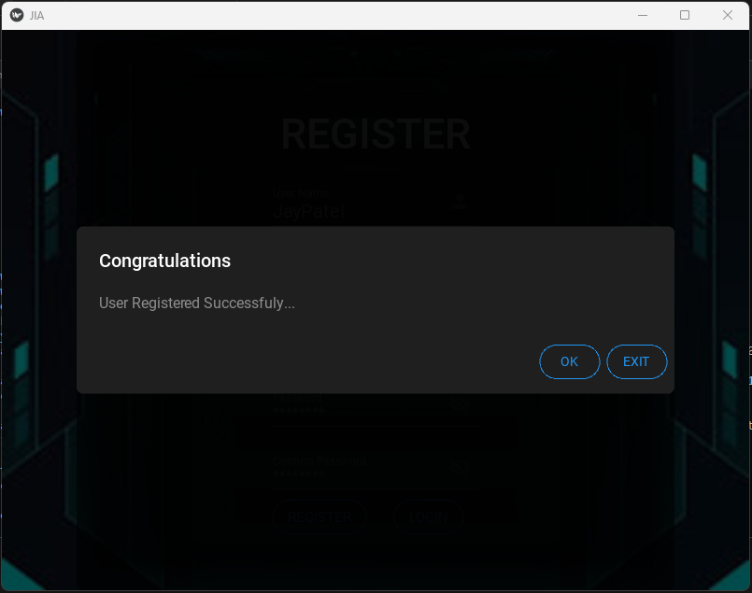
Chabot Page: In this Page user will be able to enter his or her query to JIA, and response will be generated through voice and written form.
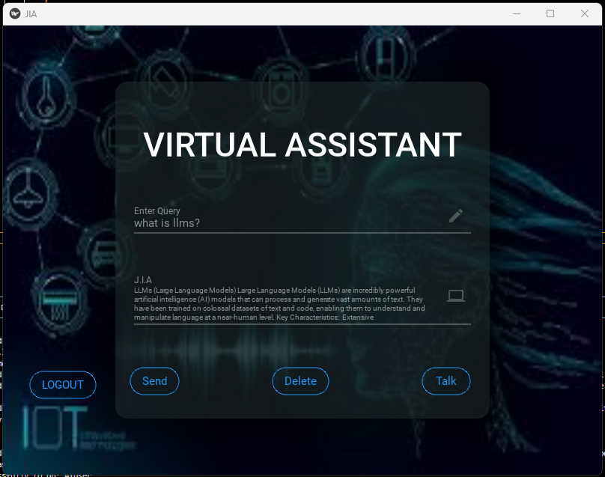
Talking Page: In this page user will establish conversation with Virtual Assistant directly by using microphone. Response will be generated through voice(Speaker).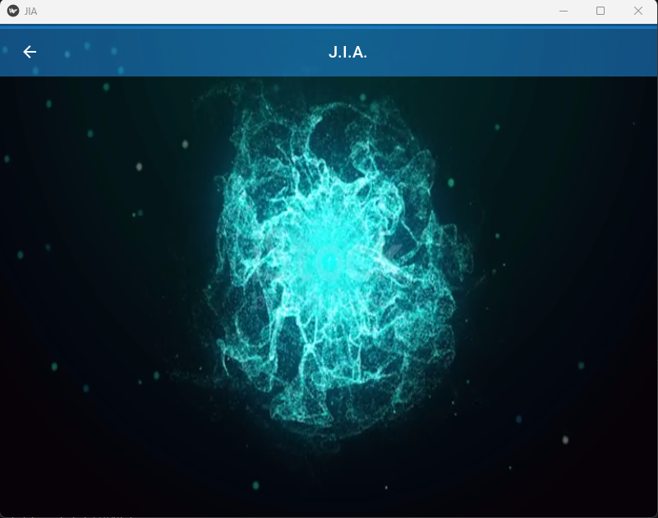
Future Enhancement
- Smart Home Integration: Smart home technologies will be connected to voice assistant and work on command of user.
- In future, it will be able to generate an image, PPT, pdf from given text and can also send email.
- In future, it will be able to predict next input of user.
- In future, user will be able to select voice of AI Voice Assistant according to them.
- User will be able to select language according to their convenience.
- AI Voice Assistant will be able to work offline.
- Implementing voice recognition for personalized responses and secure interaction.
- Allowing user to add new command and skills, making it adaptable to specific needs.
- Leverage AI to analyse user behaviour and usage patterns to provide more personalized and predictive suggestions over time.

CONCLUSION

Through this voice assistant, we have automated various services using a single line command. It eases most of the tasks of the user like searching the web, retrieving weather forecast details. We aim to make this project a complete server assistant and make it smart enough to act as a replacement for a general server administration.
The future plans include integrating JIA with mobile using React Native to provide a synchronised experience between the two connected devices. Further, in the long run, JIA is planned to feature auto deployment supporting elastic beanstalk, backup files, and all operations which a general Server Administrator does. The functionality would be seamless enough to replace the Server Administrator with JIA.

BIBLIOGRAPHY

- https://www.w3schools.com
- https://www.tutorialspoint.com
- https://www.python.org/doc
- Code with harry python playlist

