Quiz 5
(Assume the Modern/Boolean interpretation of categorial propositions throughout.)
I. Name the form of each proposition (A, E, I, or O) and list its quantity and quality.
1. No groundhogs are mechanics.
E proposition — universal, negative.
2. All caterpillars are future butterflies.
A proposition — universal, affirmative.
3. Some lies are permissible.
I proposition — particular, affirmative.
4. Some vampires don’t harm humans.
O proposition — particular, negative.
5. All politicians are liars.
A proposition — universal, affirmative.
II. Translate the following statements into standard categorical form.
6. Brighton Ski Resort is better than all other ski resorts in Utah.
All ski resorts in Utah other than Brighton Ski Resort are ski resorts worse than Brighton Ski Resort.
7. I only drink black coffee.
All things I drink are (instances of) black coffee.
8. There are aliens in the Mariana Trench.
Some things in the Mariana Trench are aliens.
9. The White Sox game will be cancelled if there is a thunderstorm.
All times there is a thunderstorm (during the game) are times the White Sox game is cancelled.
10. Professor Busch is a colleague of Professor Petrozzo.
All people identical to Professor Busch are colleagues of Professor Petrozzo.
III. Perform the operation listed next to each of the following propositions, write out the new proposition, and state whether it is logically equivalent to the original.
11. Some guilty defendants are not believable witnesses. (contraposition)
Contrapositive: Some non-believable-witnesses are not non-guilty-defendants. This IS logically equivalent to the original (contraposition is valid for O propositions).
12. Some orcas live in the Pacific Ocean. (conversion)
Converse: Some things that live in the Pacific Ocean are orcas. This IS logically equivalent to the original (conversion is valid for I propositions).
13. No true individuals are conformists. (obversion)
Obverse: All true individuals are non-conformists. This IS logically equivalent to the original (obversion is always valid).

IV. State whether or not the following pairs of categorical propositions are logically equivalent.
14. No person is perfect. :: It is false that all people are perfect.
NOT logically equivalent. “No person is perfect” is an E proposition; the negation of an A proposition is equivalent to an O proposition (“Some people are not perfect”). Under the Boolean interpretation, E and O are not equivalent.

15. It is false that no dogs are robots. :: Some dogs are robots.
Logically equivalent. The negation of an E proposition is equivalent to its contradictory, the I proposition — so “It is false that no dogs are robots” = “Some dogs are robots.”

16. All people are irrational. :: It is false that some people are not irrational.
Logically equivalent. The negation of an O proposition is equivalent to its contradictory, the A proposition — so “It is false that some people are not irrational” = “All people are irrational.”

V. Complete the following Venn diagrams so that they represent the categorical propositions listed next to them. Remember to use the Modern/Boolean method of constructing Venn diagrams. (If you have trouble entering your answers into the word document, you can print these problems out, complete them with pen or pencil, and upload a picture of them along with the other quiz questions.)

17. No Yankees fan would ever wear Red Sox merch.
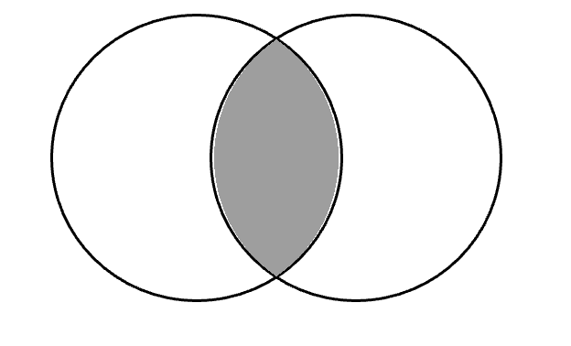
People who wear Red Sox merch
Yankees Fans

18. All cardinals are beautiful.
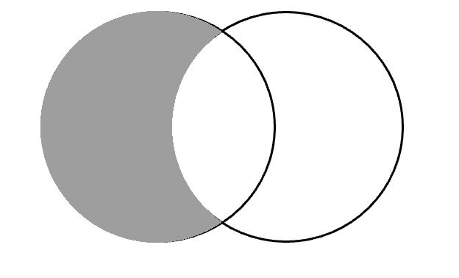
Things that are beautiful.
Cardinals

19. Some comedians are not good at sketch comedy.
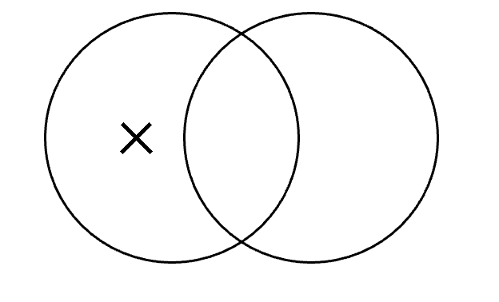
People who are good at sketch comedy.
Comedians
20. Some styles of sneakers are ugly.
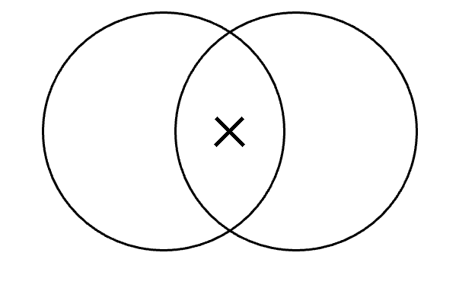
Sneaker styles
Things that are ugly.

