**Lab1 - Bitwise Not Circuit**

Jun ho Lim

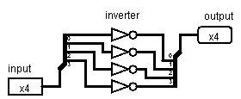

**Description**

A 4-bit Bitwise Not Circuit.