**Lab2 – Logic for Adder**

**Jun ho Lim**

**Part 1 - One Bit Half Adder**

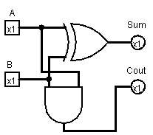

|  |  |  |  |
| --- | --- | --- | --- |
| **A** | **B** | **Sum** | **Cout** |
| 0 | 0 | 0 | 0 |
| 0 | 1 | 1 | 0 |
| 1 | 0 | 1 | 0 |
| 1 | 1 | 1 | 1 |

Sum = A V B

Cout = A ^ B

### Part 2 - One Bit Full Adder

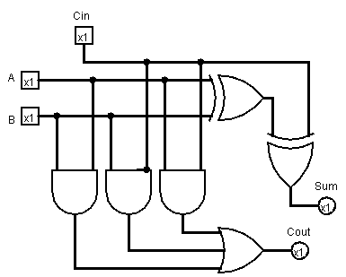

|  |  |  |  |  |
| --- | --- | --- | --- | --- |
| **A** | **B** | **Cin** | **Sum** | **Cout** |
| 0 | 0 | 0 | 0 | 0 |
| 0 | 0 | 1 | 1 | 0 |
| 0 | 1 | 0 | 1 | 0 |
| 0 | 1 | 1 | 0 | 1 |
| 1 | 0 | 0 | 1 | 0 |
| 1 | 0 | 1 | 0 | 1 |
| 1 | 1 | 0 | 0 | 1 |
| 1 | 1 | 1 | 1 | 1 |

Sum = (A^B^C) V (A^~B^~C) V (~A^B^~C) V (~A^~B^C)

Cout = (A^B) V (A^C) V (B^C) V (A^B^C)

### Part 3 - 4-bit Adder

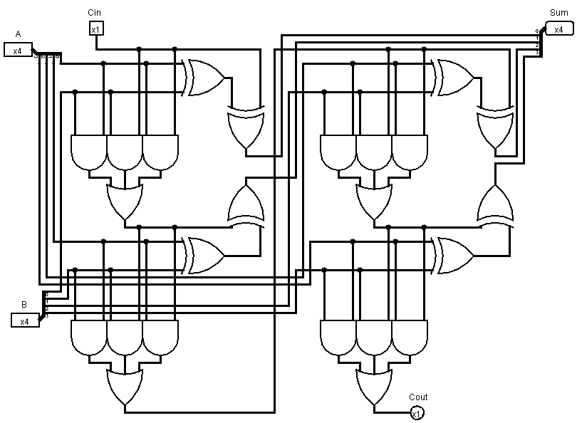

### Part 4 - Logisim 4-bit Adder

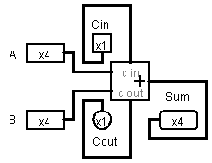

**Questions about a 4-bit Adder**

1. What is the range of unsigned numbers that you can represent in 4 bits?

-8 to +7

1. Fill out the following table of sums, carry, and borrow that your 4-bit adder circuit will give. Assume unsigned representation of numbers in 4 bits.

|  |  |  |  |  |  |  |
| --- | --- | --- | --- | --- | --- | --- |
| Binary A input | Binary B Input | Binary sum | Decimal A input | Decimal B input | Decimal sum | Carry |
| 0000 | 0111 | 0111 | 0 | 7 | 7 | 0 |
| 1100 | 0101 | 0001 | 12 | 5 | 17 | 1 |
| 0101 | 0101 | 1010 | 5 | 5 | 10 | 0 |
| 1111 | 1111 | 1110 | 15 | 15 | 30 | 1 |
| 0010 | 0110 | 1000 | 2 | 8 | 10 | 0 |

1. Assuming unsigned 4-bit representation of numbers, under what conditions does adding produce a result that is not meaningful with respect to normal addition and the constraint of only 4 bits to hold the sum?
2. What does the carry out pin signify?
3. Assuming unsigned 4-bit representation of numbers, what does your 4-bit adder actually produce if you try to add two numbers whose sum exceeds the 4-bit range of values? Give an arithmetic expression for the unsigned value of the sum bits in terms of x and y input values (use the modulus operation - mod; look for examples in your discrete math book).