**Jun ho Lim**

**Decoders**

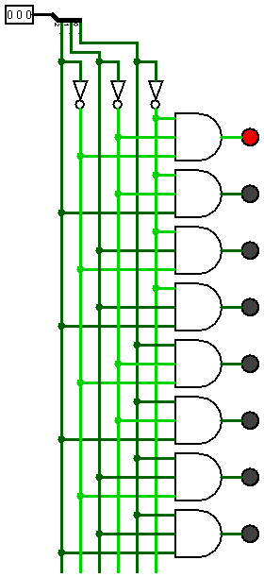 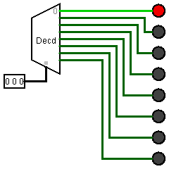

### Multiplexers

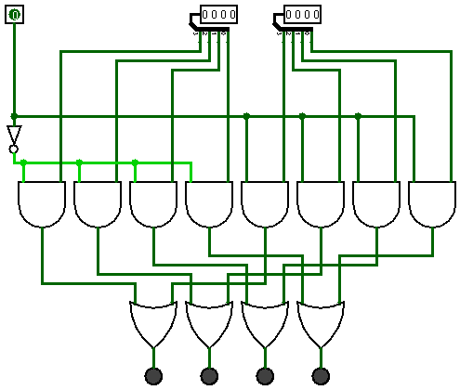

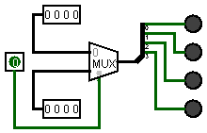

### Tiny Alu Circuit

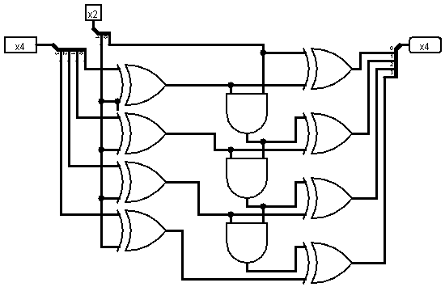

|  |  |  |  |  |  |  |
| --- | --- | --- | --- | --- | --- | --- |
| Input A | Input A | Input A | Input A | Control A | Control B | Output |
| 0 | 0 | 0 | 0 | 0 | 0 | 0000 |
| 0 | 0 | 0 | 0 | 0 | 1 | 0001 |
| 0 | 0 | 0 | 0 | 1 | 0 | 1111 |
| 0 | 0 | 0 | 0 | 1 | 1 | 0000 |
| 0 | 0 | 0 | 1 | 0 | 0 | 0001 |
| 0 | 0 | 0 | 1 | 0 | 1 | 0010 |
| 0 | 0 | 0 | 1 | 1 | 0 | 1110 |
| 0 | 0 | 0 | 1 | 1 | 1 | 1111 |
| 0 | 0 | 1 | 0 | 0 | 0 | 0010 |
| 0 | 0 | 1 | 0 | 0 | 1 | 0011 |
| 0 | 0 | 1 | 0 | 1 | 0 | 1101 |
| 0 | 0 | 1 | 0 | 1 | 1 | 1110 |
| 0 | 0 | 1 | 1 | 0 | 0 | 0011 |
| 0 | 0 | 1 | 1 | 0 | 1 | 0100 |
| 0 | 0 | 1 | 1 | 1 | 0 | 1100 |
| 0 | 0 | 1 | 1 | 1 | 1 | 1101 |
| 0 | 1 | 0 | 0 | 0 | 0 | 0100 |
| 0 | 1 | 0 | 0 | 0 | 1 | 0101 |
| 0 | 1 | 0 | 0 | 1 | 0 | 1011 |
| 0 | 1 | 0 | 0 | 1 | 1 | 1100 |
| 0 | 1 | 0 | 1 | 0 | 0 | 0101 |
| 0 | 1 | 0 | 1 | 0 | 1 | 0110 |
| 0 | 1 | 0 | 1 | 1 | 0 | 1010 |
| 0 | 1 | 0 | 1 | 1 | 1 | 1011 |
| 0 | 1 | 1 | 0 | 0 | 0 | 0110 |
| 0 | 1 | 1 | 0 | 0 | 1 | 0111 |
| 0 | 1 | 1 | 0 | 1 | 0 | 1001 |
| 0 | 1 | 1 | 0 | 1 | 1 | 1010 |
| 0 | 1 | 1 | 1 | 0 | 0 | 0111 |
| 0 | 1 | 1 | 1 | 0 | 1 | 1000 |
| 0 | 1 | 1 | 1 | 1 | 0 | 1000 |
| 0 | 1 | 1 | 1 | 1 | 1 | 1001 |
| 1 | 0 | 0 | 0 | 0 | 0 | 1000 |
| 1 | 0 | 0 | 0 | 0 | 1 | 1001 |
| 1 | 0 | 0 | 0 | 1 | 0 | 0111 |
| 1 | 0 | 0 | 0 | 1 | 1 | 1000 |
| 1 | 0 | 0 | 1 | 0 | 0 | 1001 |
| 1 | 0 | 0 | 1 | 0 | 1 | 1010 |
| 1 | 0 | 0 | 1 | 1 | 0 | 0110 |
| 1 | 0 | 0 | 1 | 1 | 1 | 0111 |
| 1 | 0 | 1 | 0 | 0 | 0 | 1010 |
| 1 | 0 | 1 | 0 | 0 | 1 | 1011 |
| 1 | 0 | 1 | 0 | 1 | 0 | 0101 |
| 1 | 0 | 1 | 0 | 1 | 1 | 0110 |
| 1 | 0 | 1 | 1 | 0 | 0 | 1011 |
| 1 | 0 | 1 | 1 | 0 | 1 | 1100 |
| 1 | 0 | 1 | 1 | 1 | 0 | 0100 |
| 1 | 0 | 1 | 1 | 1 | 1 | 0101 |
| 1 | 1 | 0 | 0 | 0 | 0 | 1100 |
| 1 | 1 | 0 | 0 | 0 | 1 | 1101 |
| 1 | 1 | 0 | 0 | 1 | 0 | 0011 |
| 1 | 1 | 0 | 0 | 1 | 1 | 0100 |
| 1 | 1 | 0 | 1 | 0 | 0 | 1101 |
| 1 | 1 | 0 | 1 | 0 | 1 | 1110 |
| 1 | 1 | 0 | 1 | 1 | 0 | 0010 |
| 1 | 1 | 0 | 1 | 1 | 1 | 0011 |
| 1 | 1 | 1 | 0 | 0 | 0 | 1110 |
| 1 | 1 | 1 | 0 | 0 | 1 | 1111 |
| 1 | 1 | 1 | 0 | 1 | 0 | 0001 |
| 1 | 1 | 1 | 0 | 1 | 1 | 0010 |
| 1 | 1 | 1 | 1 | 0 | 0 | 1111 |
| 1 | 1 | 1 | 1 | 0 | 1 | 0000 |
| 1 | 1 | 1 | 1 | 1 | 0 | 0000 |
| 1 | 1 | 1 | 1 | 1 | 1 | 0001 |