**Part 1 - Adder-Subtracter**

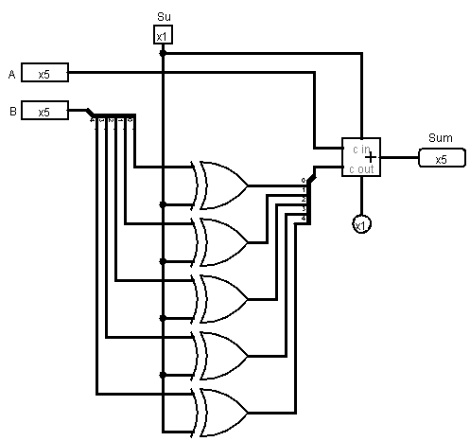

|  |  |  |  |
| --- | --- | --- | --- |
| x | y | Cin | Sum |
| x | y | Cin | If (x+y+Cin) > 2^4 -1 then x+y -2^5 |
| x | y | Cin | elseIf (x+y+Cin) < 2^4 -1 then x+y + 2^5 |
|  |  |  | else x+y |

### Part 2 - Two-Port Adder

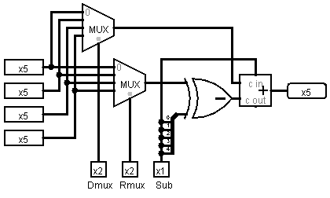

1. What is the purpose of the Xor gate?  
   - It effects on Rmux to either positive or negative. It does not effect on Dmux
2. What, specifically, is the wiring of the splitter near the Xor gate?  
   - Xor had value of 5bit and it brings the set of 5 bit to Xor gate .
3. The control code for the circuit is indicated by pins at the bottom of the circuit. How many control bits are there?  
   - 5 bits
4. How many operations can the circuit perform?  
   - 32
5. Describe in one or two sentences what operations can be performed on the inputs A,B,C,D by the circuit.  
   - Its adding and subtracting each other.
6. Imagine building a function table for the circuit (you don't have to actually build it). Your input columns would be labled by the four registers (A,B,C,D) and by each of the three elements of the control word (Dmux,Rmux,Sub). How many rows would you have in your function table if you assume that the values in the columns labeled by the registers would just be w,x,y,z for each row.  
   - 32 rows