Part 1 - A Datapath Circuit for Adder with Accumulator

1. Build the Datapath for Adder with Accumulator circuit shown as the last circuit in Section 5.7 of the text. Make sure you wire the clock signal to the proper clock input of the registers! You will not be using the clear (0) input to the registers so make sure you don't wire anything to that input. Also, make sure your multiplexers and decoders DO NOT have the output enable pin (set the attributes to "output enable no").

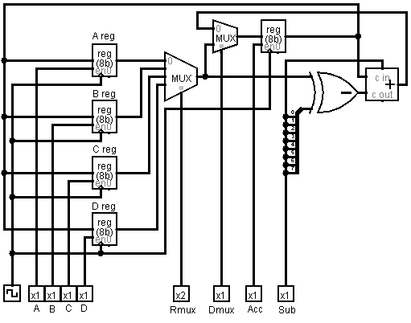

2. List the control word for the circuit (list the control word by the names of the control signals). How many bits are in the control word?

|  |  |  |  |  |  |  |  |
| --- | --- | --- | --- | --- | --- | --- | --- |
| A | B | C | D | Rmux | Dmux | Acc | Sub |
| 1 | 1 | 1 | 1 | 2 | 1 | 1 | 1 |

There are 8 Input with 9 control words.

Part 2 - Coding your Register Transfer Sequence

1. Use the Register Transfer Notation discussed in the text to specify the following sequence of data transfers for the datapath you built in the previous part of this lab. (See the right side of the table at the end of Section 5.7 as an example).

1) Transfer Register A to the Acc register

Give A reg value, Rmux = 00, Acc = 1, Clock

2) Add the B register to the Acc register and store the results in the Acc

Give A reg value, Rmux = 01, Acc = 1, Clock

3) Subtract the C register from the Acc register and store the results in the Acc.

Give C reg value, Rmux = 10, Acc = 1, Sub = 1, Clock

4) Add the D register to the Acc register and store the results in the Acc

Give D reg value, Rmux = 11, Acc = 1, Clock

2. Translate each of the above RT actions into the appropriate control code for each action. (See the left side of the table at the end of Section 5.7 as an example).

|  |  |  |  |  |  |  |  |  |
| --- | --- | --- | --- | --- | --- | --- | --- | --- |
| Control Code | | | | | | | | Action |
| A | B | C | D | Rmux | Dmux | Acc | Sub |  |
|  |  |  |  | 00 |  |  |  |  |
|  |  |  |  | 01 |  |  |  |  |
|  |  |  |  | 10 |  |  |  |  |
|  |  |  |  | 11 |  |  |  |  |

3. Initialize registers A,B,C,D to the values 0x13,0x5B,0x3A,0xF0 respectively. You'll initialize these registers only once at the beginning of the sequence of actions. Translate the initial value of each of the registers into decimal.

|  |  |  |  |
| --- | --- | --- | --- |
| A | B | C | D |
| 0x13 | 0x5B | 0x3A | 0xF0 |
| 00010011 | 01011011 | 00111010 | 11110000 |
| 19 | 91 | 58 | 240 |

4. Set the control codes in your circuit to the control code given in the time row 1 of the table, the control code for the first RT action. Single step your circuit through one complete clock cycle. That will be two clicks on the Clk button -- one click for the rising edge of the cycle and one click for the falling edge of the cycle. Record the register values in your Execution Trace table for the time row 1. You have just completed the first step of execution trace.