**Part 1 - Build the SAM Datapath**

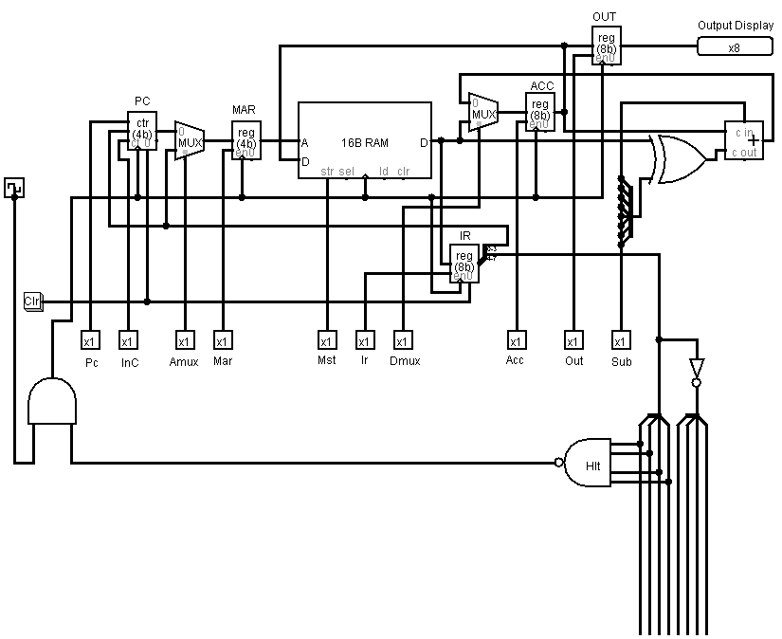

10 controls

### Part 2 - Coding and Testing the Instruction Fetch Sequence

|  |  |  |  |  |
| --- | --- | --- | --- | --- |
| Instruction fetch | | | | |
| Control Code | | | | Action |
| Inc | Mar | Mst | Ir | f(src) -> dst |
| 0 | 0 | 0 | 0 | PC -> MAR; inc(PC) |
| 0 | 0 | 1 | 0 | Mem(MAR) -> IR |

### Part 3 - Coding and Testing the Lda execution sequence.

|  |  |  |  |  |
| --- | --- | --- | --- | --- |
| Instruction execution transfer sequence | | | | |
| Control Code | | | | Action |
|  | Mar | Mst | Acc | f(src) -> dst |
| Read | 1 | 0 | 1 | Mem(MAR) -> ACC |

With the values given, it properly sent the Mem value to the ACC. As desired.

### Part 4 - Instruction exec sequences for all SAM instructions.

|  |  |  |  |  |
| --- | --- | --- | --- | --- |
| Instruction execution transfer sequence | | | | |
| Control Code | | | | Action |
|  | Mar | Mst | Acc | f(src) -> dst |
| Write | 1 | 1 | 0 | Acc -> Mem(MAR) |

