6. Convert the following 32-bit IEEE floating point numbers from hexadecimal into standard

decimal notation.

• 0x40200000

Binary = 0100 0000 0010 0000 0000 0000 0000 0000

IEEE = 0 (1000 0000) (0100 0000 0000 0000 0000 000)

Decimal = 1.25

• 0x41020000

Binary = 0100 0001 0000 0010 0000 0000 0000 0000

IEEE = 0 (1000 0010) (0000 0100 0000 0000 0000 000)

Decimal = 3.015225

• 0xC1060000

Binary = 1100 0001 0000 0110 0000 0000 0000 0000

IEEE = 1 (1000 0010) (0000 1100 0000 0000 0000 000)

Decimal = -3.?????

• 0xBD800000

Binary = 1011 1101 1000 0000 0000 0000 0000 0000

IEEE = 1 (0111 1011) (0000 0000 0000 0000 0000 000)

Decimal = -123.0

7. Convert the following decimal numbers into 32-bit IEEE floating point notation.

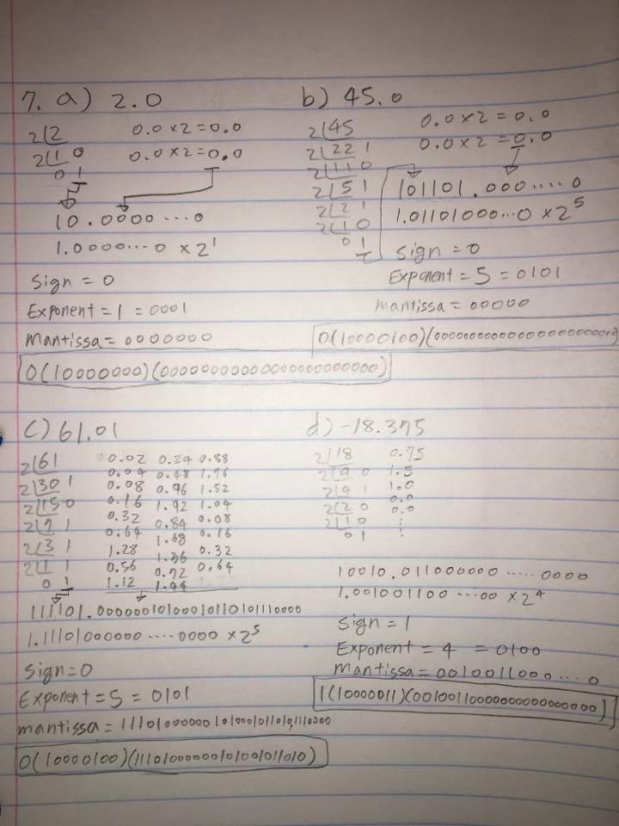

8. Are there any numbers that can be represented exactly as a 32-bit integer but not as a 32-bit

IEEE floating point number? Why or why not?

Yes. Example: 0xFFFF FFFF (1111 1111 1111 1111 1111 1111 1111 1111)

Because Mantissa value is not possible to get all 1. It will be 0 at some point if it is multiple by 2