1. Facebook developer config

-select iOS

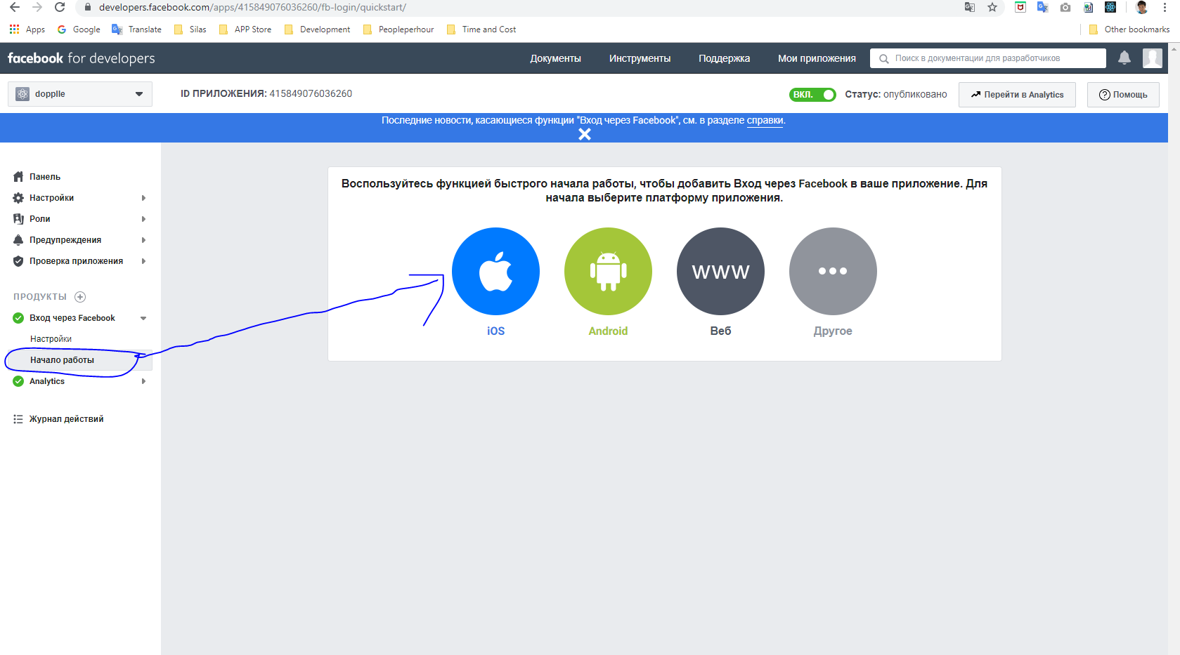

-select sdk

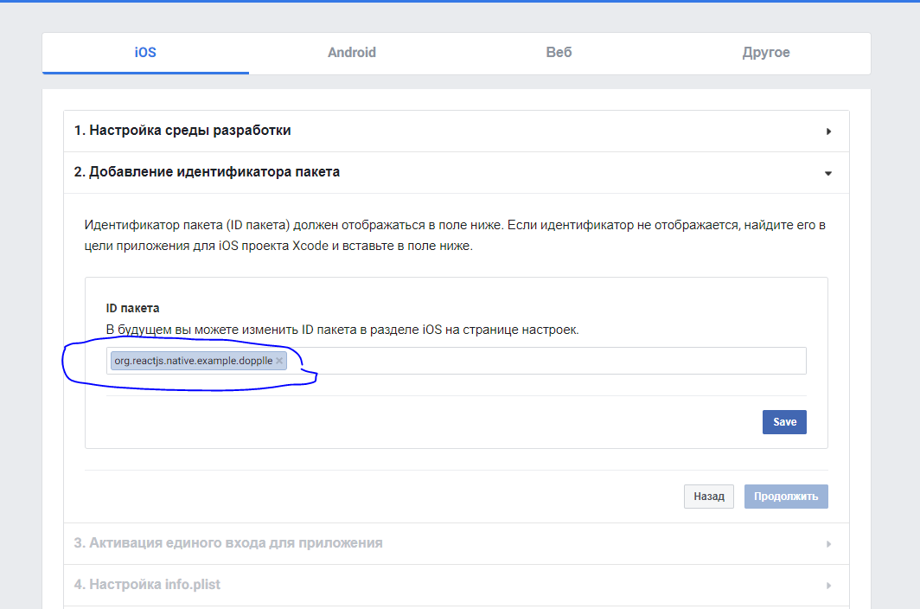

-enter your project bundle id

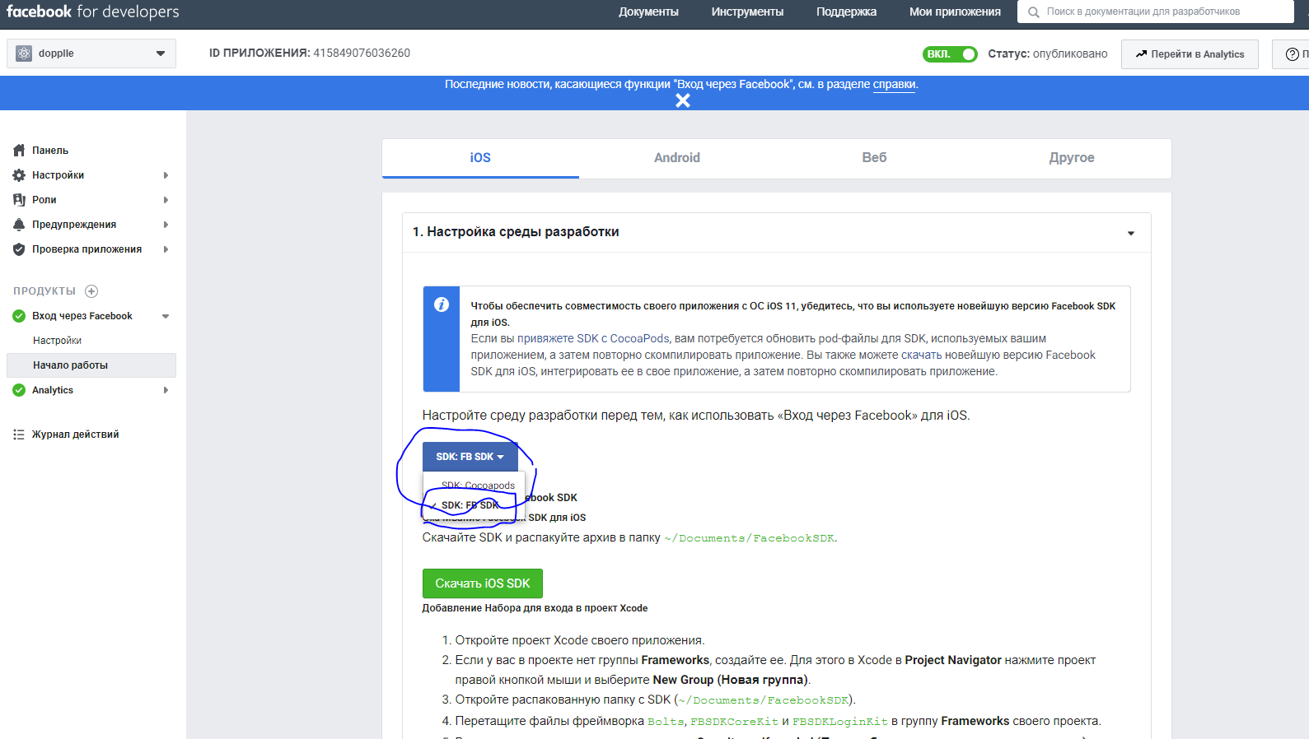

-set info.plist on your project xcode

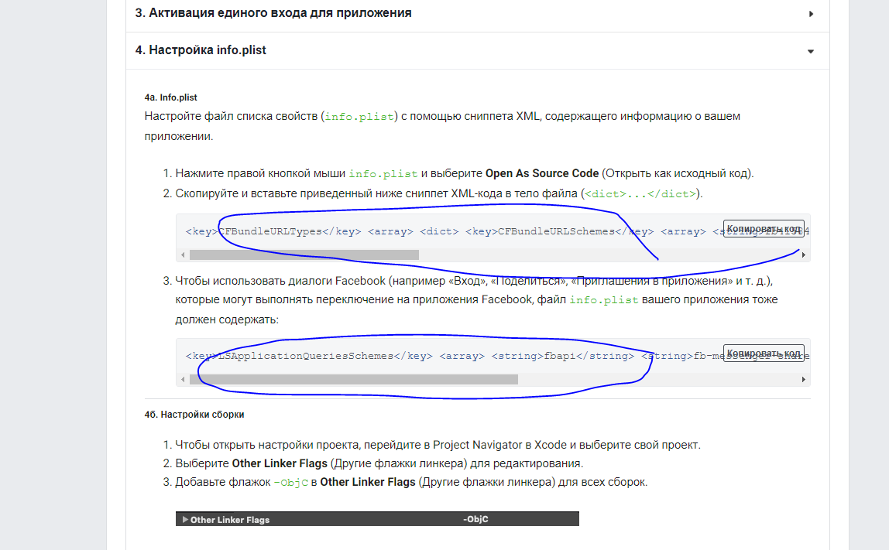

-insert code on appdelegate.m

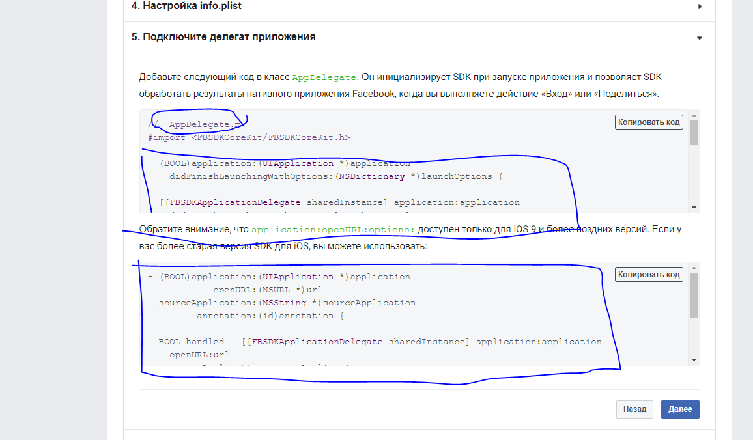

-6, 7, 8 skip

2. facebook config

-create firebase app

-Authentication/sign-in method tab/ facebook (Enabled)

-Insert app Id and secret key

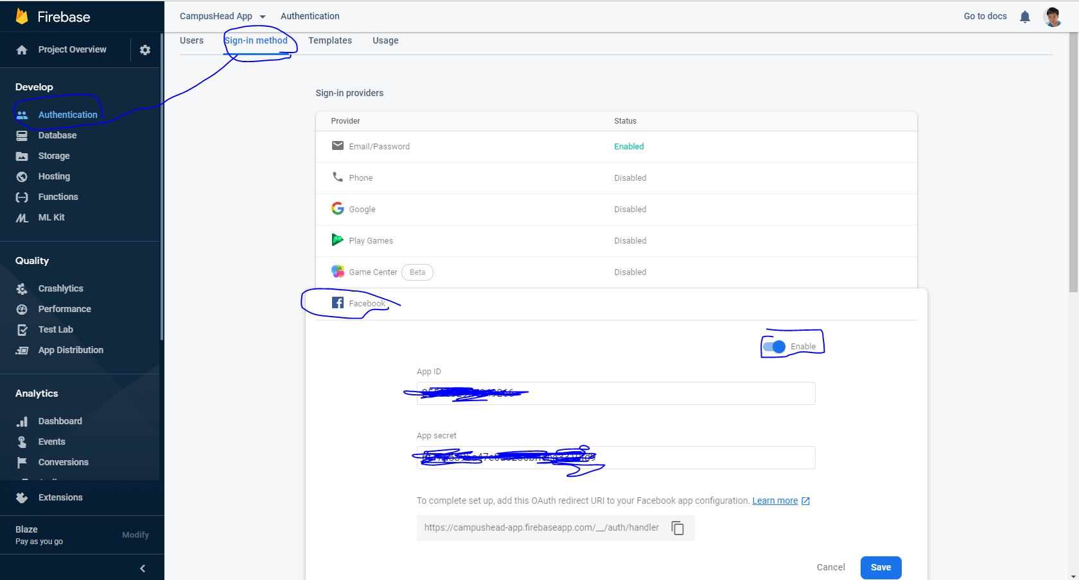

3. React-native node_module install

-cd project folder/ios

Npm install react-native-fbsdk

Mkdir Frameworks

Curl -#L [https://origincache.facebook.com/developers/resources/>id=facebook-ios-sdk-surrent.zip](https://origincache.facebook.com/developers/resources/%3eid=facebook-ios-sdk-surrent.zip) | bsdtar –xf- -C ./Frameworks; #download the FBSDK

-in drag and drop to xcode’s Frameworks

File: Bots.framework, FBSDKCoreKit.framework, FBSDKLoginKit.framework, FBSDKShareKit.framework

And react-native code input in project src

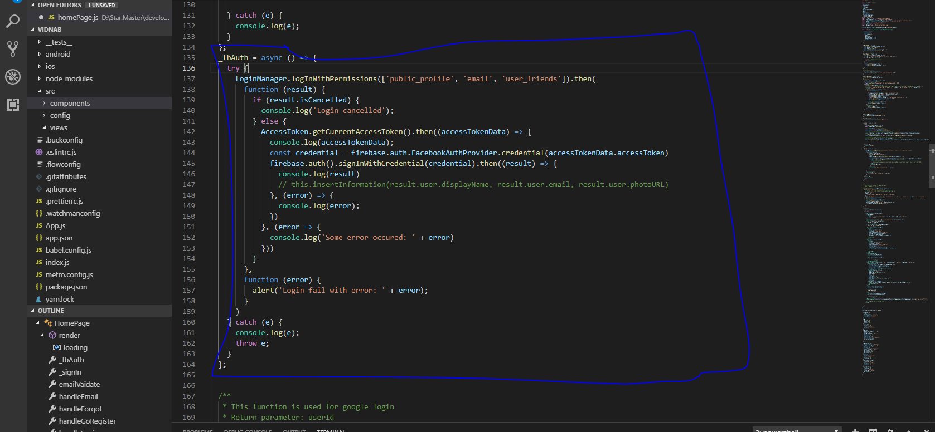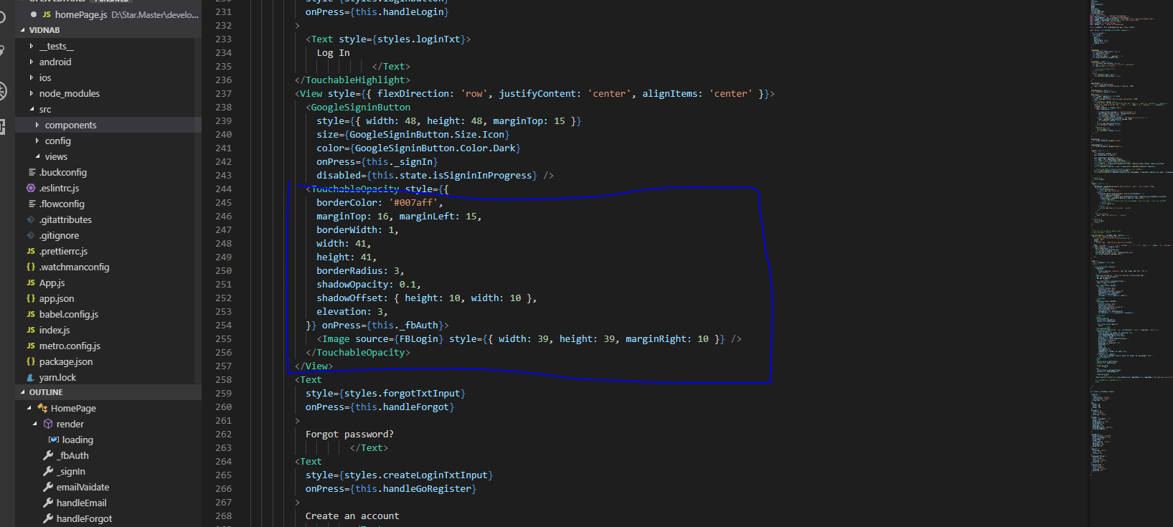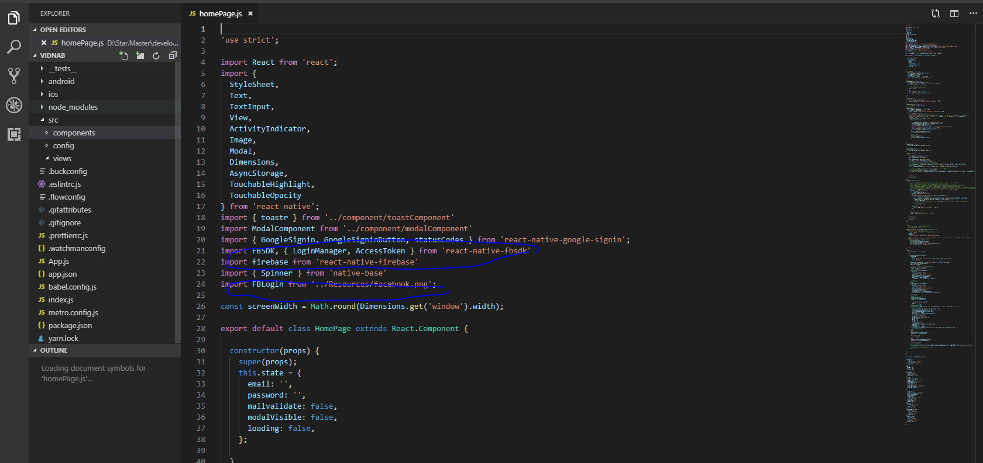

Reference: https://www.youtube.com/watch?reload=9&v=qi1S8k2jsFE

1. Firebase config