Professionalism
Student name: Boran Zhang (Bob)
1. GitHub Repository Link
GitHub Repository: https://github.com/starmatch9/3D-RPG-CuteStyleAdventureGame
Final Commit Hash: 1852cf7559fc4ae123f7abb5305f7ff72d9baf4c
Playable Build: https://github.com/starmatch9/3D-RPG-CuteStyleAdventureGame/releases/tag/v0.0.1
2. Development Log — Progress Over Time
Phase | Completed Content
Phase 1 | Created Unity project, set up Git; designed entity framework (EntityBase, Entity<T>); implemented state machine (EntityState<T>, EntityStateManager<T>)
Phase 2 | Implemented Player & PlayerInputManager; WASD movement, smooth turning, double jump, Coyote Time, variable jump height; created PlayerStats ScriptableObject
Phase 3 | Implemented PlayerCamera with Cinemachine; manual orbit, vertical dead zone follow, velocity-driven rotation
Phase 4 | Implemented GameManager singleton; collectibles (Coin), checkpoints (GameSavePoint), goal (GameFinish); UI & audio (EffectManager, BgmManager)
Phase 5 | Settings panel (resolution/fullscreen); pause system (StopGame); custom editor tool (ClassTypeNameDrawer); bug fixes & parameter tuning; vertical slice complete
3. Summary of Important Commits
Commit Hash | Phase | Description
fdd9925 | Phase 1 | State machine framework
c83bddb | Phase 2 | Cinemachine camera integration
d6d1ec8 | Phase 2 | Camera follow & animation system
d59962f | Phase 2 | Ground detection system
7ead31f | Phase 3 | GameManager & platform system
054ba54 | Phase 4 | Checkpoint & goal system
bd4cc65 | Phase 4 | UI & collectible system
34de41f | Phase 4 | Player animator optimization
9e01bcf | Phase 5 | Star rating, goal & scene layout
894920c | Phase 5 | Parameter tuning
1852cf7 | Phase 5 | Final version & demo video
4. Planning and Task Management
MoSCoW Prioritization:
Must-Have: Movement, jump, gravity, ground detection, camera, collectibles, checkpoints, reset, basic UI, pause. (All done)
Should-Have: Settings, victory & star rating, SFX, BGM. (All done)
Could-Have: Gliding, wall jump, climbing. (Planned)
Cut-First: Combat, dialogue, inventory, skill tree. (Cut)
5. Evidence of Response to Feedback
Self-testing found that acceleration was too high, causing abrupt startup. Reduced acceleration and introduced turningDrag for smooth startup.
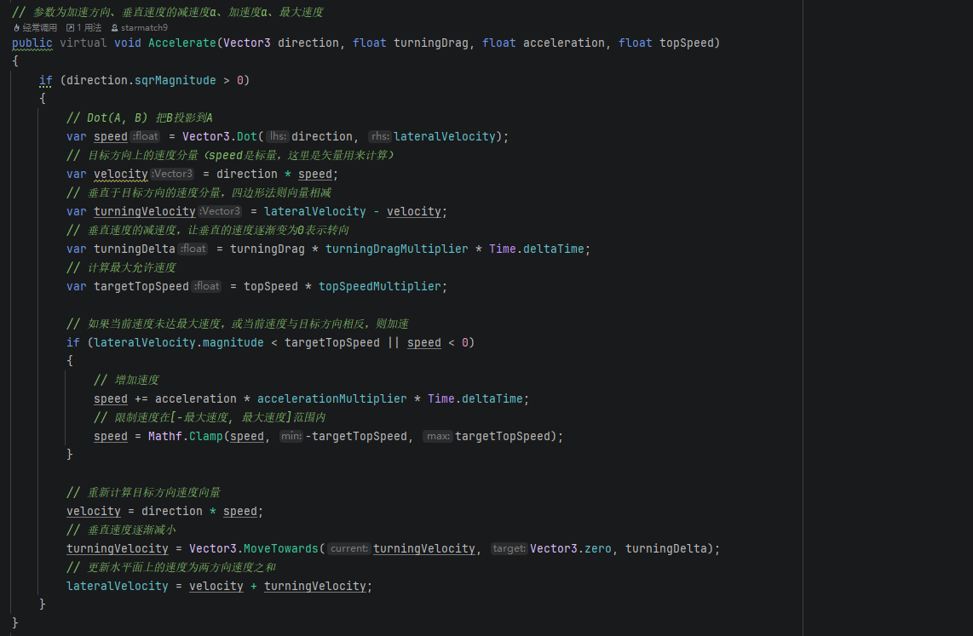
Self-testing found excessive camera shake during jumps. Introduced ground/air separated dead zone system, setting air dead zone to 4.0, significantly improving camera stability.
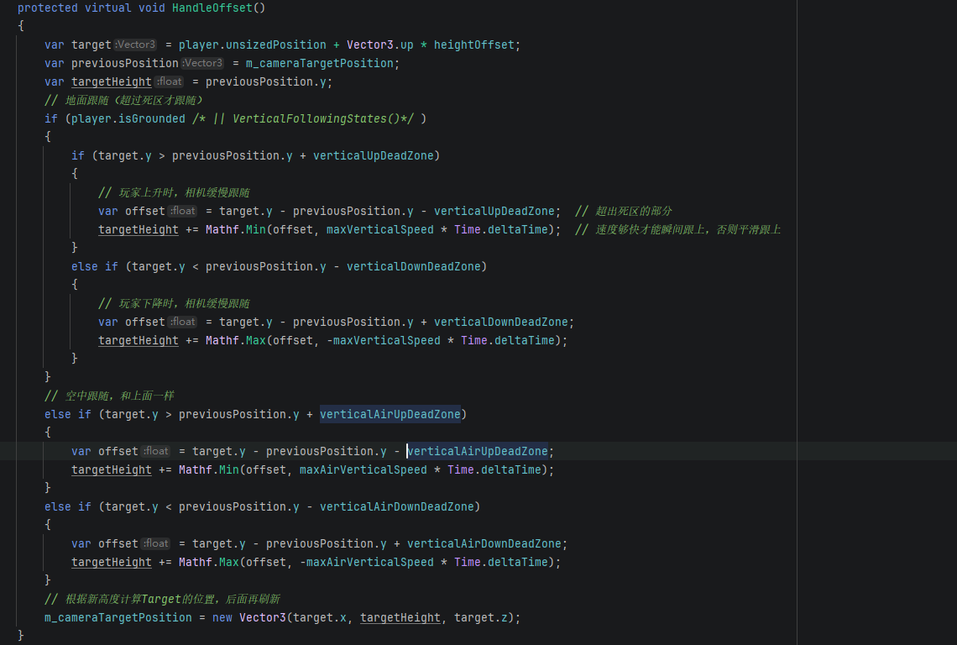
Self-testing found that state class configuration was not designer-friendly. Developed [ClassTypeName] custom editor dropdown selector, allowing designers to select states directly in the Inspector.
6. Project Change Summary
Phase 1: Technical verification prototype, testing 3C feasibility.
Phase 2: Feel-tuned version, evolving from "moving cube" to "character with feel."
Phase 3: Full 3C showcase, camera system refined, control experience close to commercial games.
Phase 4: Playable game, adding collection, checkpoints, victory conditions — forming a complete game loop.
Phase 5: Vertical slice, including complete level, UI, audio, settings, and pause system.
Key Turning Points:
- From "tech demo" to "playable game" — adding the game loop fundamentally changed the project's nature.
- From "programmer-only" to "designer-friendly" — editor tools enabled non-programmers to participate in configuration.
7. External Assets Declaration
Resource 1: KayKit Block Bits
- Name of resource: KayKit Block Bits
- Type: asset (3D model)
- Source: https://kaylousberg.itch.io/block-bits
- Licence or permission: CC0
- What it provided: Platform models and textures
- What I used unchanged: Model files, textures
- What I modified: Scene placement and combination
- What I created myself: Level design
- Where it appears in my game: All platforms in the game
- How it is credited: Non-commercial use only
Resource 2: Indienova Low Poly Survival Pack
- Name of resource: Indienova Low Poly Survival Pack
- Type: asset (3D model)
- Source: https://indienova.com/resource/r/ddbxscyxscb-2020low-poly-survival-pack
- Licence or permission: CC0
- What it provided: Water bottle model
- What I used unchanged: Model file
- What I modified: Import configuration
- What I created myself: Collection logic and interaction
- Where it appears in my game: As collectible items (Coin)
- How it is credited: Non-commercial use only
Resource 3: RPG Essentials Sound Effects
- Name of resource: RPG Essentials Sound Effects
- Type: asset (audio)
- Source: https://assetstore.unity.com/packages/audio/sound-fx/rpg-essentials-sound-effects-free-227708
- Licence or permission: Commercial license
- What it provided: Sound effect files
- What I used unchanged: Raw audio clips
- What I modified: Volume and playback logic
- What I created myself: SFX call system
- Where it appears in my game: UI/jump/pickup/victory sound effects
- How it is credited: Non-commercial use only
Resource 4: CGAlpha Character Model
- Name of resource: CGAlpha Character Model
- Type: asset (3D model)
- Source: https://www.cgalpha.com/archives/68688.html
- Licence or permission: Free for non-commercial use
- What it provided: Character model and animations
- What I used unchanged: Model files, animations
- What I modified: Import configuration and parameter adjustment
- What I created myself: Character controller and state machine
- Where it appears in my game: Player character
- How it is credited: Non-commercial use only
Resource 5: GitCode Skybox
- Name of resource: GitCode Skybox
- Type: asset (texture)
- Source: https://gitcode.com/open-source-toolkit/528bd/
- Licence or permission: Free for non-commercial use
- What it provided: Skybox textures
- What I used unchanged: Raw texture files
- What I modified: Import configuration
- What I created myself: Camera and scene setup
- Where it appears in my game: Scene background
- How it is credited: Non-commercial use only
Resource 6: Haimian Music BGM
- Name of resource: Haimian Music BGM
- Type: asset (audio)
- Source: https://www.haimian.com/create
- Licence or permission: Free for non-commercial use
- What it provided: AI-generated background music
- What I used unchanged: Raw audio files
- What I modified: Volume and loop logic
- What I created myself: BGM management system
- Where it appears in my game: Game background music
- How it is credited: Non-commercial use only
Resource 7: Itch.io Animal Models
- Name of resource: Everything Library - ANIMALS
- Type: asset (3D model)
- Source: https://davidoreilly.itch.io/everything-library-animals
- Licence or permission: Free for non-commercial use
- What it provided: Animal models
- What I used unchanged: Model files
- What I modified: Import configuration
- What I created myself: Scene placement
- Where it appears in my game: Scene decoration
- How it is credited: Non-commercial use only
8. AI Assistance Declaration
AI Assistance 1: Haimian Music
- Tool used: Haimian Music
- What I asked: Generate background music
- What output I used: AI-generated audio file
- What I changed: Imported to Unity and configured loop logic
- How I tested it: In-game playback test
- What I understand: How to use audio files
- What I still do not fully understand: None
- Where it appears in the project: BgmManager system
AI Assistance 2: Deepseek
- Tool used: Deepseek
- What I asked: Grammar check and translation
- What output I used: Proofreading and refinement suggestions in both Chinese and English
- What I changed: Adjusted document phrasing based on suggestions
- How I tested it: Verified against course requirements
- What I understand: Chinese-English grammar and document standards
- What I still do not fully understand: None
- Where it appears in the project: All documentation
9. Reflection on Organisation, Time Management, Independent Work, and Professionalism
Organisation: Maintained complete version history through GitHub, used MoSCoW method to prioritize features, established clear folder structure (Scripts/Entity/, Scripts/Player/, Scripts/Game/, etc.), maintaining code maintainability.
Time Management: Phased approach — Phase 1 for foundation, subsequent phases for system modules, final phase for polish and refinement. Set clear delivery goals for each phase and generally followed the plan. When encountering difficulties (e.g., CharacterController reset issue), adjusted priorities and completed other modules first.
Independent Work: Completed all project work independently, including concept design, coding, scene building, testing, and debugging. When facing technical challenges, solved problems through official documentation, tutorials, and self-experimentation rather than relying on others. Independently assessed priorities, deciding which features must be completed and which could be cut within the time constraint.
Professionalism: Code follows C# naming conventions with necessary comments; used version control to manage code with clear commit messages; honestly declared the scope of external resources and AI assistance used; maintained continuous documentation throughout development, able to fully trace the project's evolution.
Areas for Improvement: Could have conducted more systematic user testing rather than relying solely on self-testing; could have introduced tester feedback earlier, rather than adjusting feel in the later stages; time estimation could be more accurate, reserving more time for polish phase.
10. Known Limitations and How They Were Managed
Limited content: Accepted as vertical slice rather than full game; modular design leaves space for future expansion.
Insufficient user testing: Conducted self-testing and breakpoint debugging; documented untested parameters for future iteration.
Low UI polish: Kept UI functional but visually simple; did not invest excessive time in visual polish at this stage.
Lack of enemy system: Cut to "Could-Have" and documented; clear direction for future iteration.
Lack of multiple levels: Reserved extension interfaces in level system; focused on single-level completeness in current phase.

