Experiment Procedure Documentation

Introduction
This document captures the instructions to run the simulation.

Instructions
- To run the experiment, simply run the index.html file in Codes folder by clicking on it and the experiment will open in the browser.
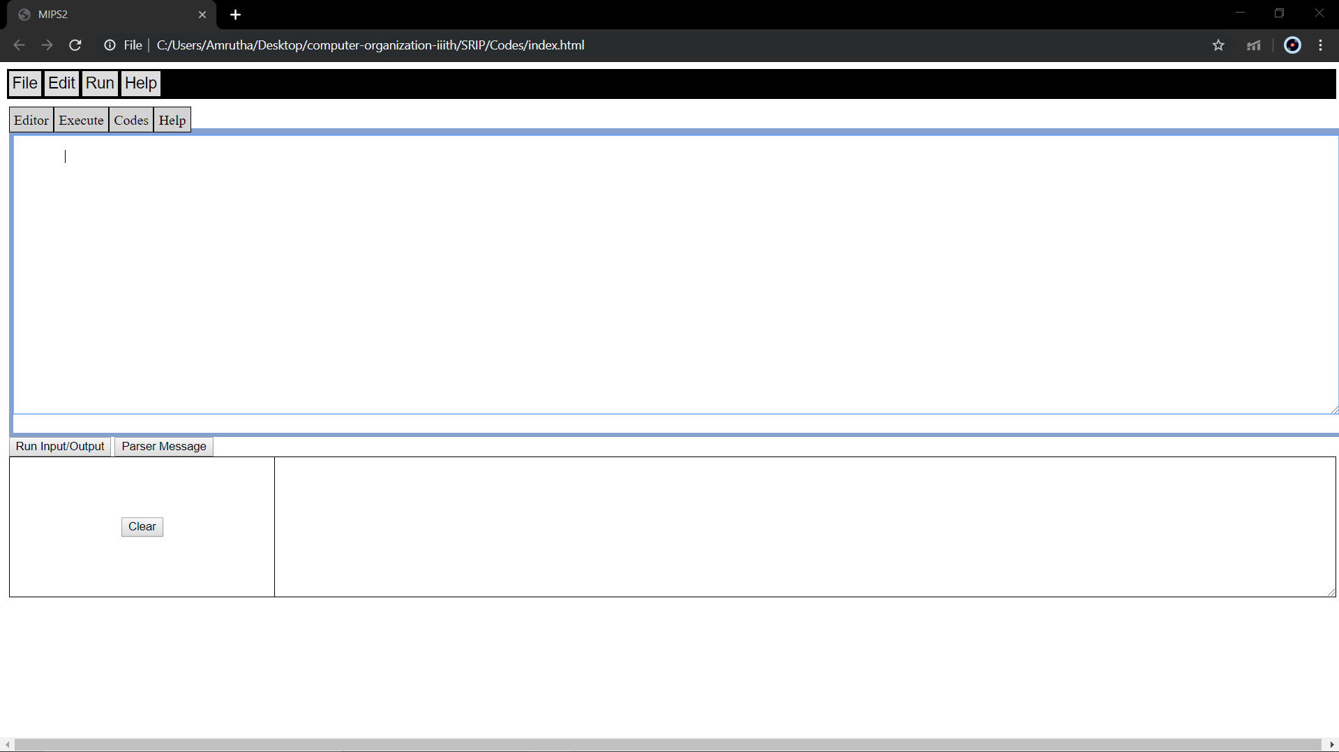

- To run the experiment, create ‘new file’ from FILE menu or open the existing one from your device using ‘open’ option in FILE menu. Add some MIPS code with the supported instructions.

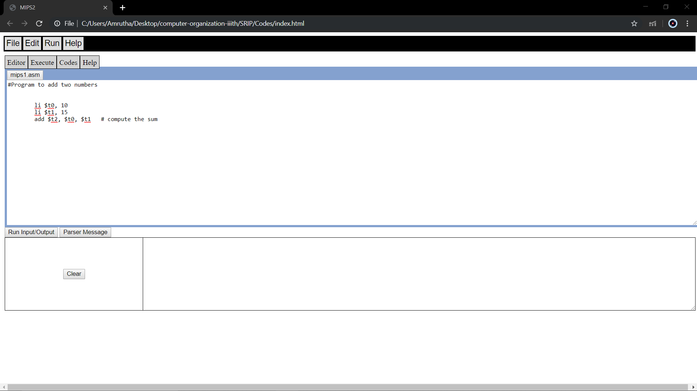
- Now move to Execute tab and Click on Assemble Option
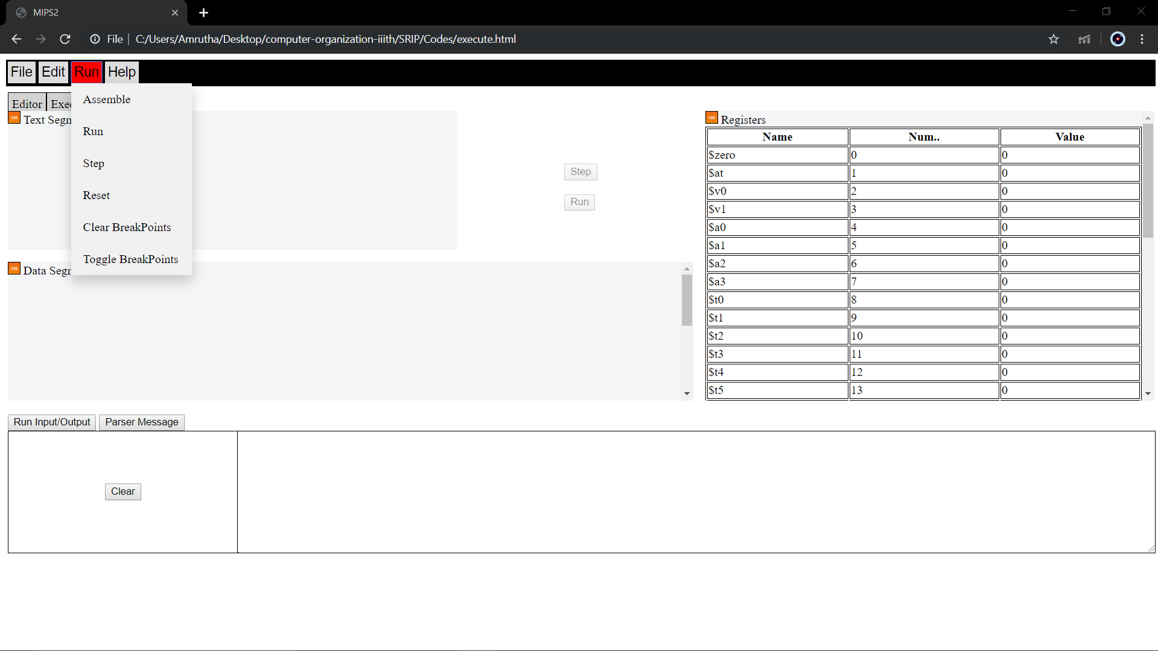
- After Assemble the page will look like this
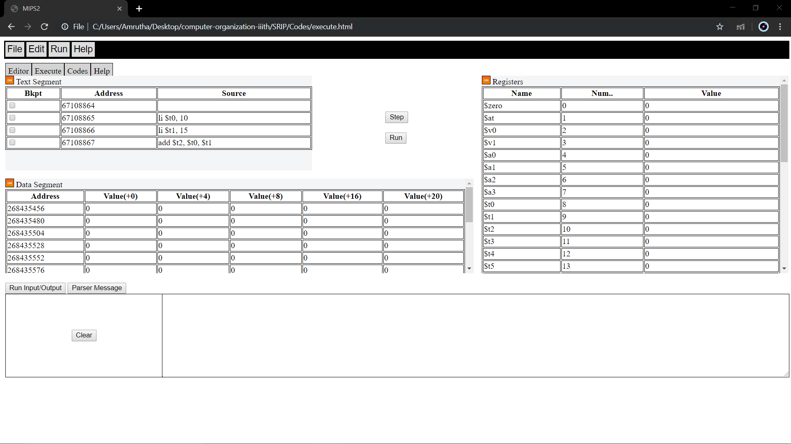

- Now either click Step for step wise execution or Run to complete the execution
