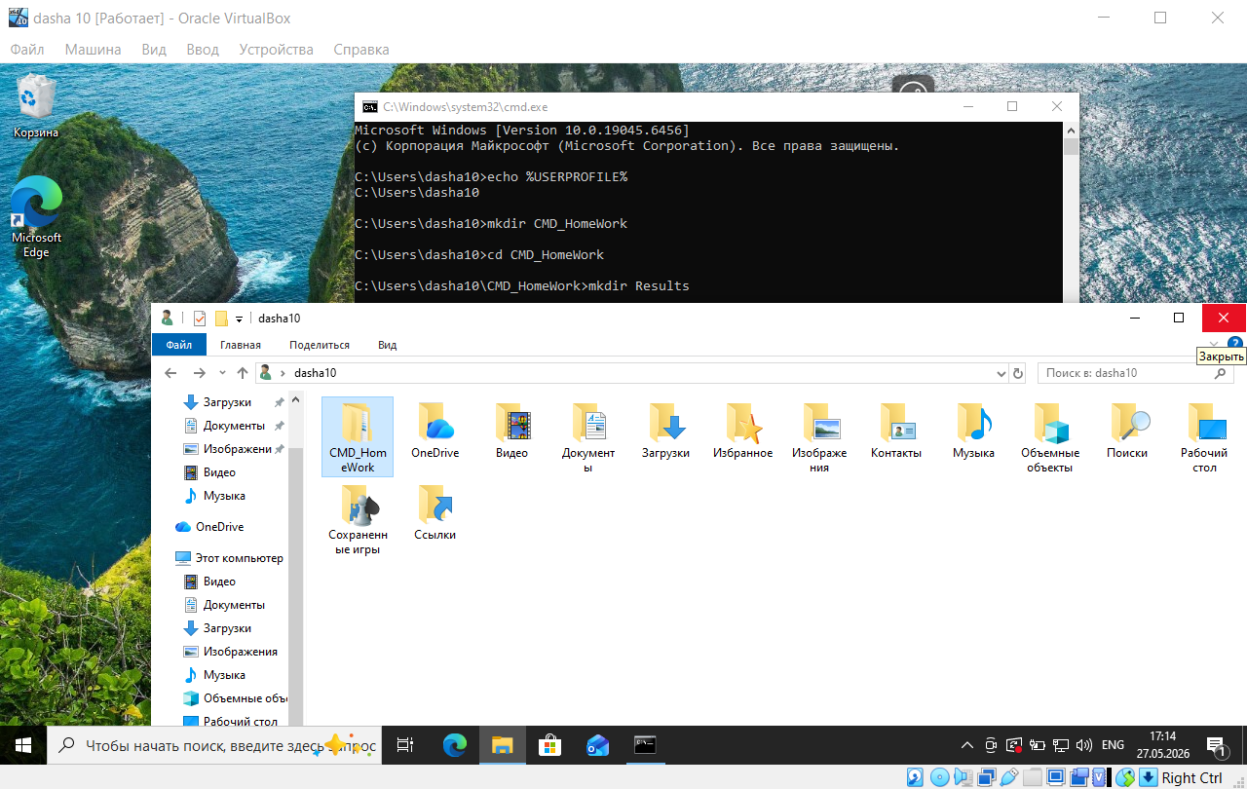
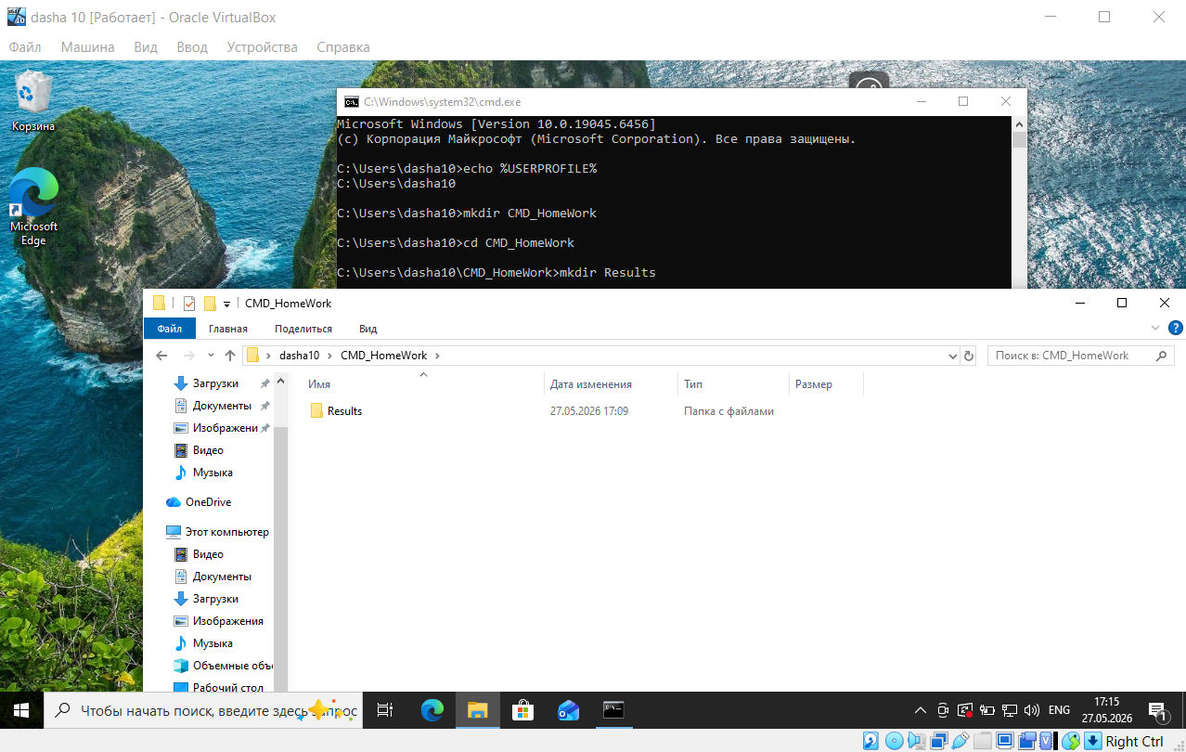
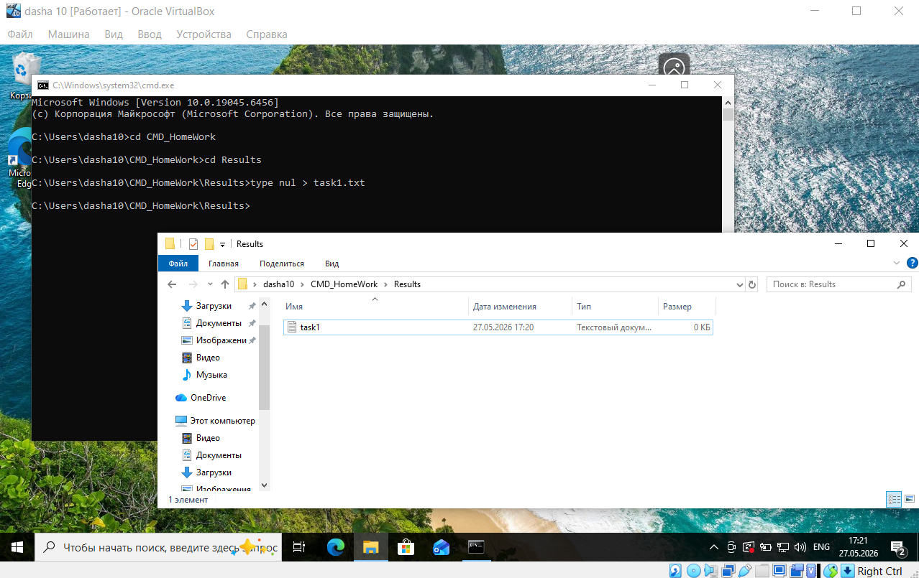
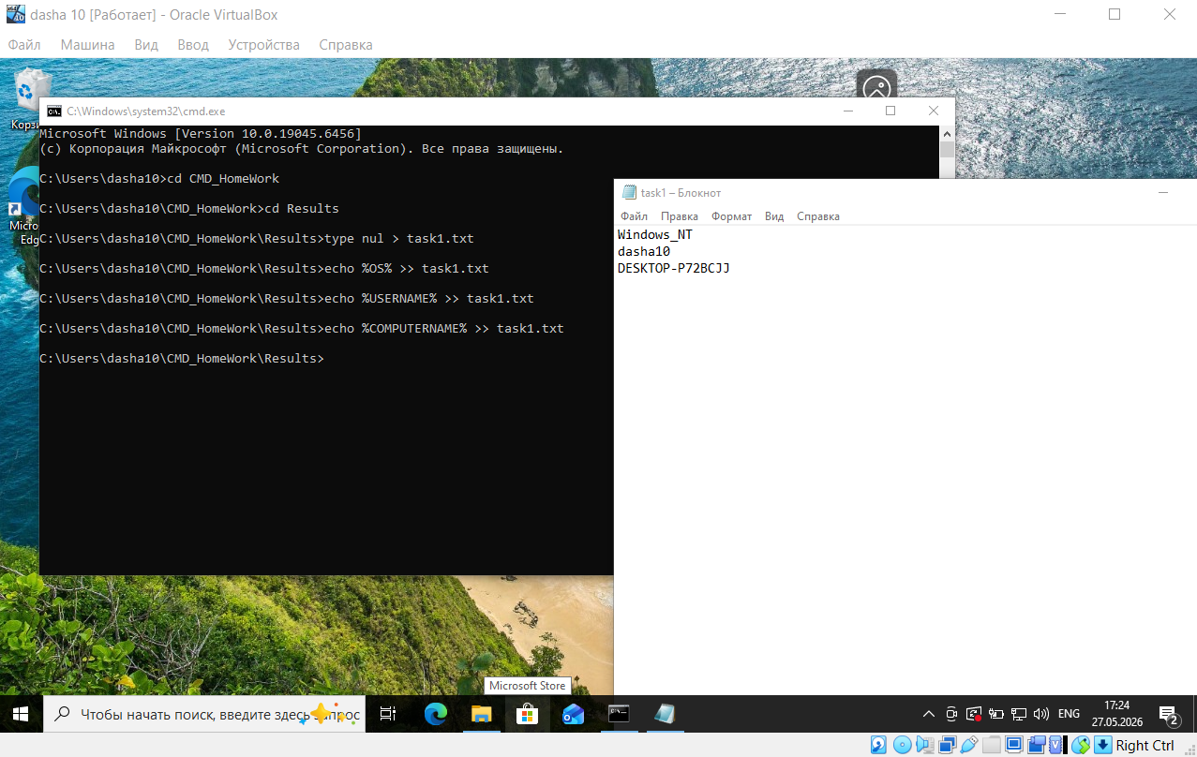
C: \Users\dasha10›echo %USERPROFILE%
C: \Users\dasha10
C: \Users\dasha10>mkdir CMD_HomeWork
C: \Users\dasha10>cd CMD_Homework
C: \Users\dasha10\CMD_HomeWork>mkdir Results
C: \Users\dasha10\CMD_HomeWork>cd Results
C: \Users\dasha10\CMD_Homework\Results>type nul > task1.txt
C: \Users\dasha10\CMD_HomeWork \Results>echo %0S% >> task1. txt
C: \Users\dasha10\CMD_HomeWork\Results>echo %USERNAME% >> task1.txt
C: \Users\dasha10\CMD_HomeWork \Results>echo %COMPUTERNAME% >> task1. txt

