Title Transfer Learning with Gradient-based Optimization Enhances Multifunctional Holography
Pu Peng and Zheyu Fang*

School of Physics, State Key Lab for Mesoscopic Physics, Academy for Advanced Interdisciplinary Studies, Collaborative Innovation Center of Quantum Matter, and Nano-optoelectronics Frontier Center of Ministry of Education, Peking University, Beijing 100871, China
Email: zhyfang@pku.edu.cn

Keywords: Multifunctional metasurfaces; Deep learning; Light control; Transfer learning

Abstract
Composed of massive nanostructures, metasurfaces are applied in metalens, deflector, and holography. Deep learning is introduced for on-demand design of metasurfaces, by designing each unit cell one by one. Deep learning explores underlying physical knowledge from a statistical perspective, rather than analyzing physical models. For multifunctional requirements, the limitations of optical resonance prevent deep learning from providing completely satisfactory unit cells. The strategy of designing unit cells one by one has reached the limit of improving the optical performance of metasurfaces. Here, a design platform, combing deep learning with gradient-based optimization, is proposed to learn QR-code-shaped nanostructures. Different from localized design for unit cells, gradient-based optimization adjusts the entire metasurface in each iteration. The optimization improves overall performance by carefully arranging partially satisfactory unit cells. With the help of transfer learning, a wavelength-polarization-multiplexing mimic metasurface was designed by this platform, achieving independent holographic imaging with 40 channels. This work redefines metasurface design by jointly optimizing unit cell structures and their arrangement, rather than aiming for perfect individual elements. Our platform can inspire the design of other optical systems, such as multimode fibers, photodetectors, and emitters.

Introduction
When light illuminates a nanostructure, some optical resonances are excited to emit light with certain intensity and optical phase. The geometric shape of the nanostructure plays a crucial part in this interaction. Arranging nanostructures on a two-dimensional plane makes an optical metasurface. The independent design of each unit cell helps to flexibly shape the output wavefront, thus achieving functions such as holographic imaging, optical focusing, generation and detection of structured light, and optical computation. Several independent functionalities can be integrated into one metasurface by multiplexing methods. The output light of a polarization-multiplexing metasurface varies with the polarization states of the incident light, and the wavelength-multiplexing metasurface can also integrate functionalities under different working wavelengths. The mimic metasurface achieves independent functionalities according to the environmental optical index, just like a chameleon changing its skin color with the environment. The essence of designing multifunctional metasurface is to build a relationship between the geometry and the high-dimensional optical responses.

Recently, deep learning has been introduced to design the unit cells of metasurfaces by deep neural networks. Two tandem networks map the relationship between geometric shape and optical responses. The former one, as known as inverse network, provides geometric shapes according to optical targets, while the latter one predicts the optical responses of the provided shapes. Before the tandem network is put into use, a dataset was used to train networks, enabling the design and prediction from a statistical manner. One optical target may have many satisfactory shapes, challenges the training of the retrieve network. But the subsequent predictive network guided its training and solved the challenge. According to optical target of unit cells, the tandem network provided specific shapes and reconstructed their optical responses. For multifunctional metasurfaces, the tandem network can only provide imperfect unit cells because of the limited optical resonances. Due to the limitations arising from physical principles, the improvement aimed at unit cells has reached the endpoint.

Here, combining deep learning and gradient-based optimization, a design platform is proposed to achieve multifunctional holographic metasurfaces. The tandem network in our platform designed QR-code-shaped nanostructures as unit cells without any physical models, avoiding underlying complex optical resonances. The complex shapes of unit cells provide possibilities for multifunctional optical responses. Based on the well-trained tandem network, an iterative gradient-based optimization was performed to the phase arrays of metasurfaces. The optimization improves overall performance by arranging imperfect units, so it works from a systematic perspective, different form the unit perspective of the tandem network. The optical responses both in air and oil were predicted by our platform with the help of transfer learning, enabling a polarization-wavelength-multiplexing mimic metasurface to achieve holographic imaging of up to 40 independent images. Besides significantly enhancing the capability of multifunctional holographic imaging, our platform inspires combinations between deep learning and other optimization algorithms. And the transferability of our platform provides a new possibility to other optical systems, such as multimode fibers, photodetectors, and emitters.

Results
The workflow of our iterative design platform is clearly described in Figure 1. Through Fourier transform, the reflection electric field distribution of the metasurface is obtained from the target imaging pattern. If the reflected optical phase meets the requirements, the target pattern will be holographic imaged in the far-field region. For multifunctional holography, each target imaging pattern corresponds to a phase array. The phase arrays impose a specific and clear phase target on each unit cell of the metasurface, and the phase target is input into the tandem network. The tandem network provides shapes of each unit cell, and the optical phases are reconstructed. The expected imaging results are reconstructed by fast Fourier transform (FFT). Due to the deviation of the reconstructed phase arrays, there is a discrepancy between the expected imaging results and the target pattern, described by the loss function. The phase arrays were updated to minimize the loss, and the update is made through a gradient-based optimization. The updated phase arrays are input into the tandem network, and start the next iteration.

The tandem network tries to provide perfect unit cells without any optical resonant models. The retrieve network and predictive network are both convolution neural networks, and they handle a unit cell at a time. They treat the unit cell as an independent object, which means the interaction between adjacent units is ignored. The tandem network was trained with the dataset, when the parameters in the networks were adjusted to acquire the design ability. The tandem network is not used for iterative gradient-based optimization until the training is completed, and the network parameters are frozen in optimization. The tandem network designed QR-code-shaped unit cells without analyzing any physical models, but this shape provides unit cells with inexhaustible possibilities for optical resonance. It is a data-driven design approach, distinct from the physical model driven approach. The tandem network tries to provide perfect units with the knowledge learned form dataset, but only imperfect units can be provided due to physical limitations. The reason is not inadequate mastery of optical principles, but all possible optical resonances cannot fulfill multifunctional demands on unit cells. For example, the Jones matrix of a single-layer nanostructure has only 3 independent components due to the optical reciprocity caused by the symmetry with respect to the plane, which prohibits the unit cell from having more than 3 polarization channels. The wavelength-multiplexing method requires strong dispersion in the reflected spectrum, imposing a challenge for finding unit cells with perfect optical resonance. If the perfect unit cells are prohibited by physical principles, it is impossible for tandem network to find them.

The gradient-based optimization improves the quality of multifunctional imaging with these imperfect unit cells. During the optimization process, the tandem network tries to provide perfect unit cells according to the target phase arrays in each iteration, while the phase arrays are optimized for better imaging quality. During the iterations, the best phase arrays are sought to compensate for the imperfect unit cells. The optimization strategically capitalizes on strengths and circumvent weaknesses of each unit cells from a systematic perspective. Although the improvement of each unit cell is limited by physical principle, the exquisite arrangement of the entire metasurface can further improve imaging quality. By integrating these unit cells into a metasurface, their individual limitations are offset through meticulous spatial arrangement and collective interaction. This work advances a paradigm shift in metasurface design by prioritizing the joint optimization of unit cell geometries and their spatial arrangement as a unified problem rather than pursuing individually perfect unit cells.
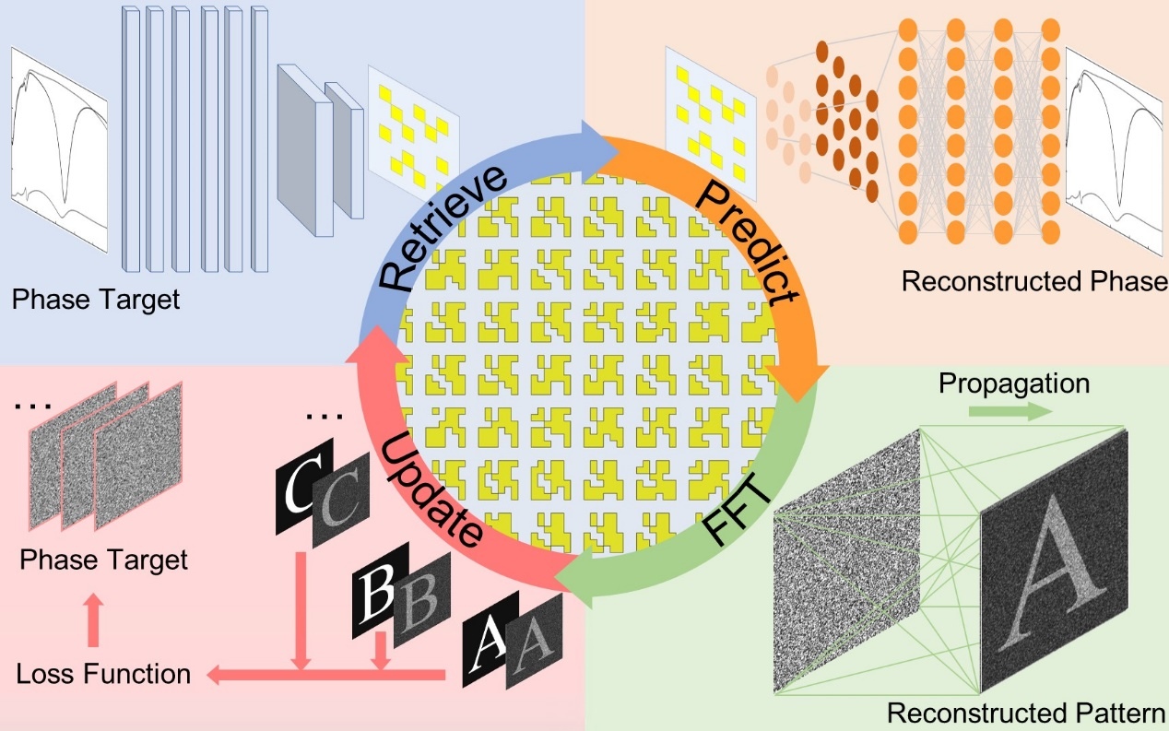
Figure 1. The workflow of inverse design platform.
Our dataset contains 4.4 × 10⁴ randomly generated QR-code-shaped nanostructures. The thickness of the golden nanostructure is 30 nm, with a substrate of 100 nm silicon dioxide, 100 nm gold, and silicon in sequence (Figure 2a). The Metal-Insulator-Metal structure is formed between the substrate and the nanostructure, enhancing the optical resonance and reflectivity of the nanostructure. The geometric shape is described by a 6 × 6 binary matrix, and each pixel is a 60 nm wide square. The distance L between structure and the boundary is also 60 nm, so the unit cell has a period length of 480 nm. Through FDTD simulation, the far-field reflection response, including reflectivity and phase shift, was obtained for the working wavelength from 530 nm to 1550 nm (Figure 2b). The far-field components of the reflected light with x and y polarization are obtained by FDTD when incident with x and y polarized light respectively.

When we represent x-polarized light and y-polarized light with unit intensities as $\left[\begin{matrix}0 \\ 1\end{matrix}\right]$and $\left[\begin{matrix}1 \\ 0\end{matrix}\right]$, respectively, the polarized light with a θ polarized angle and unit cell is $\left[\begin{matrix}cosθ \\ sinθ\end{matrix}\right]$. The reflection response is described by the Jones matrix J = $\left[\begin{matrix}r_{xx} & r_{xy} \\ r_{yx} & r_{yy}\end{matrix}\right]$. The $r_{xy}$ refers to the x-polarized component in the reflection under the y-polarized incidence with unit intensity, and the others refers to reflection with the same manner. Due to the optical reciprocity of the single-layer nanostructure, the $r_{xy}$ and the $r_{yx}$ is completely identical. When an α-angle linearly polarized light is incident, the β-angle linearly polarized component in the reflected light is
$${\left[\begin{matrix}cosβ \\ sinβ\end{matrix}\right]}^{†}\left[\begin{matrix}r_{xx} & r_{xy} \\ r_{yx} & r_{yy}\end{matrix}\right]\left[\begin{matrix}cosα \\ sinα\end{matrix}\right]$$
. Since the Jones Matrix is obtained with FDTD, the reflectivity and reflection phase of any polarization channel can be calculated. Considering the incidence and the output under the same angle linearly polarized light, 4 polarized channels are defined by 0, $±\frac{π}{4}$ and $\frac{π}{2}$ polarized angles. Then, the polarization channels at working wavelengths of 530, 670, and 800 nm can be calculated separately to define a 12-channel scenario. Define the optical phase in –$π$ to $π$, and consider a very small positive number δ, ($π$-δ)-(-$π$+δ)=2$π$-2δ, but their actual optical difference is 2δ. If the phase values are directly input to the neural network, the cyclicity will result in poor performance when the phase is around - π or π. To eliminate this negative impact, the sine and cosine values of the phases are used as response parameters to train the network. Thus, for a unit cell of the 12-channel device, the optical response is described by a 24-dimensional vector, and the geometric shape is described by a 6 × 6 binary matrix. 90% of the dataset are randomly extracted to train the network, and the remaining are used to test the network performance after training. The test set never participates in the update of network nodes, thus ensuring the reliability of the test results. The optical response is unique for a unit with a certain shape, so training a prediction network is easy. The geometric parameters are input to the network, the MSE between the network output and the response parameter is calculated as the loss function. The network is trained with Adam optimizer (learning rate 0.001), and the test loss decreased to 0.178 after 30 epochs. Different shapes may conform to a certain response parameter, challenging the training process of the retrieval network. Connect the pretrained prediction model after the retrieval network, and the MSE between the retrieval network input and the prediction network output is calculated as the loss function. The smaller the loss is, the more satisfying the unit cells provided by the retrieval network are. The network was also trained with Adam optimizer (learning rate 0.001), and the test loss decreased to 0.266 after 1870 epochs.

To demonstrate the network performance, we scanned the phase values of 4 channels at 530 nm as the target phase, and set the target phase of the other 8 channels to 0 (Figure 2c). Specifically, the phase of the x-polarized channel were scanned from - π to π, while keeping the other 3 polarized channels at different fixed values. The reconstructed phase for the x-polarized channel is generally consistent with the target phase, while the other 3 channels only partially match. For single-layer nanostructures, their Jones matrix can only have 3 independent matrix elements due to the optical reciprocity. This explains that the other 3 channels are not completely satisfactory. Sampling every $\frac{2}{3}π$ for all 12 channels, that is, a total of 3¹² = 5.31 × 10⁵ unique phase targets are selected (Figure 2d). The phase error between the target and the constructed is demonstrated separately. For each channel, more than half unit cells have phase error less than 0.5π. The phase error at 530 nm and 800 nm show satisfactory distributions, but there is still room for improvement in the other 4 channels at 670 nm.
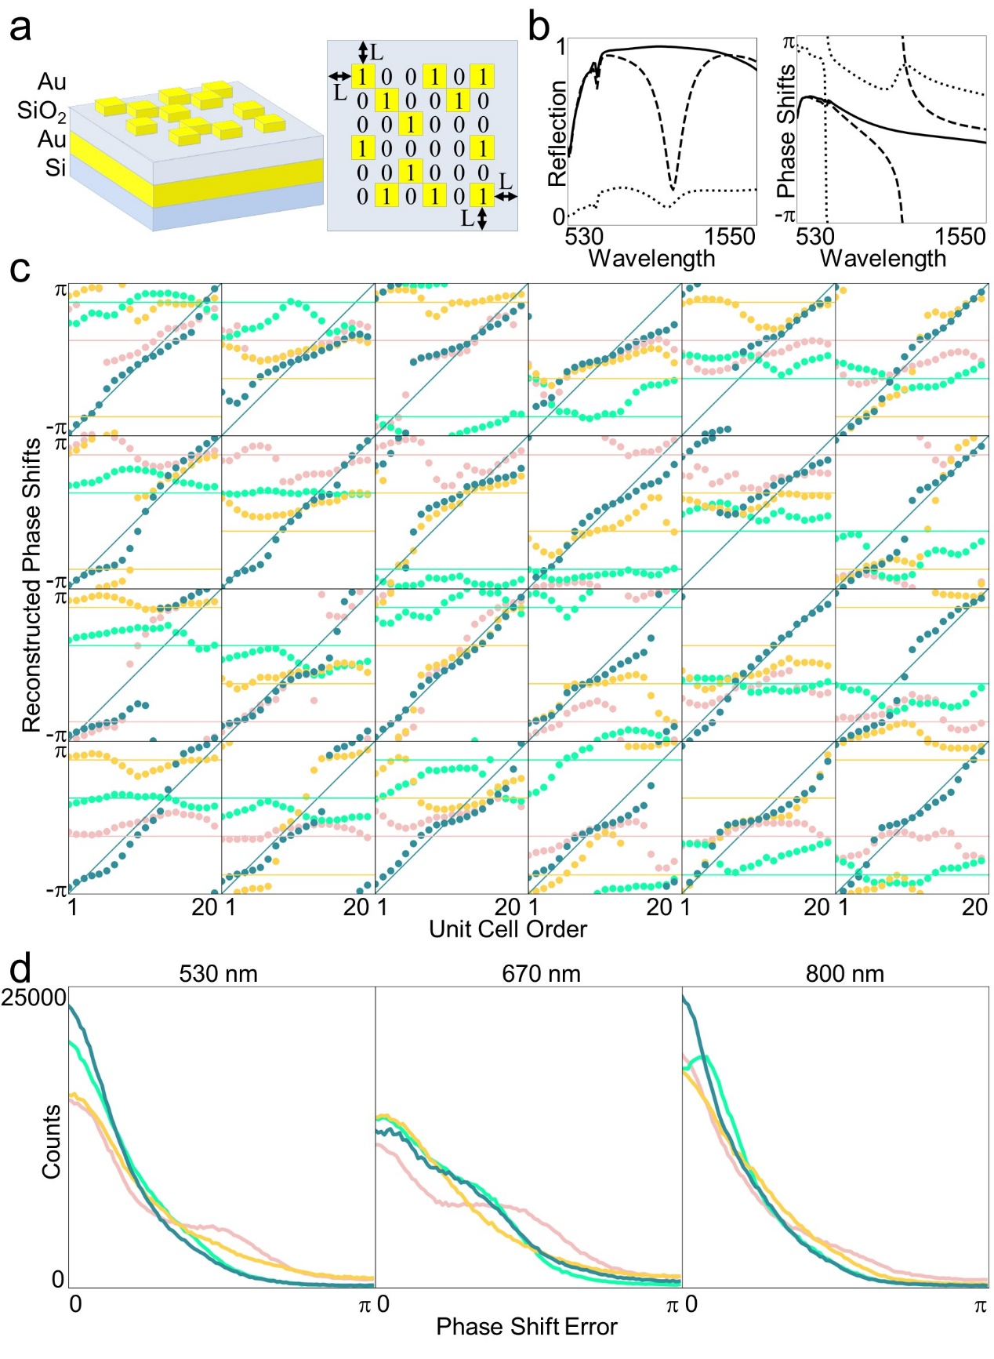
Figure 2. The validation of deep learning platform. (a) The substance and configuration of the metasurface (left). The geometry definition of unit cell of the metasurface (right). (b) The reflection and phase shifts of the unit cell in (a). The solid line, dashed line and dot line refer to xx, yy and xy polarized states respectively. (c) The reconstructed phase shifts of different phase shift target. The lines refer to target and the dots refer to reconstructed results. The blue, yellow, green and red refer to 0°, 45°, 90°, -45° polarized states respectively. (d) The error between reconstructed phases and target phases at different wavelength. The colors refer to the same polarized states in (c).

After training and testing the neural networks, we began optimizing the metasurface. Perform Fourier transform on the images of 12 zodiac symbols to obtain 12 phase arrays as targets. Each point in the phase array represents a unit cell. Input the phase array one by one into the retrieval model to obtain the geometric parameters of each unit cell. Then input the geometric parameters into the predictive model to obtain the reconstructed phase responses. Arrange the reconstructed phases into 12 arrays and perform Fourier transform to obtain 12 images. Calculate the MSE between these images and the corresponding target images as the loss function, and adjust the 12 phase matrices that are input to the retrieval model by the Adam optimizer (learning rate 0.1). Input the adjusted phase array into the retrieval model one by one again, and start a new epoch of optimization. After 1127 rounds of optimization, the loss reduced to 46641 (Figure 3a). This optimization method greatly improves the quality of imaging and achieves 12 channel holographic imaging. To characterize the crosstalk between the 12 channels, the correlation coefficient matrix of the device was calculated. For the final optimization result, the correlation coefficients between the 12 channels were calculated. Namely, $corr\left(A,B\right)=\frac{cov\left(A,B\right)}{\sqrt{D(A)∙D(B)}}$, where A and B respectively represent two images, cov(A, B) represents the covariance between them, and D represents the standard deviation. The lower the correlation coefficient between two images, the higher the independence between them. Calculate the correlation coefficients between any two of the 12 channels to obtain the correlation coefficient matrix (Figure 3b). The coefficient on the diagonal of the matrix is 1, while the other coefficients remain at a low level, indicating weak inter channel crosstalk in the device. The final imaging is shown in the figure 3c, where channels in the same row share a working wavelength, and channels in the same column share a polarized channel.

To demonstrate the power of our design platform, a 30-channel device was also designed, composed of 3 working wavelengths and 10 polarized channels. When the incident polarization is different from the output polarization, there are a total of 10 polarization combinations with the same 4 linear polarized states. The target images consist of 10 numbers and 20 uppercase letters in sequence. Extract phase values corresponding to 30 channels for each unit cell in the database. Change the output layer of the predictive network and retrain it. After 50 rounds of training, the test loss was reduced to 0.201. Change the input layer of the retrieval network and retrain the retrieval network under the guidance of the predictive network. After 510 rounds of training, the test loss of the retrieval network was reduced to 0.318. Replace these two neural networks into the design platform and start optimizing the entire metasurface. Same as the previous device, using Adam optimizer (learning rate 0.1), after 1656 rounds of optimization, the loss is reduced to 73479. The optimization results are shown in the figure 3d, where each row of channels shares a working wavelength and each column of channels shares a polarized channel. The channels of the same color in the figure share one output polarized state.
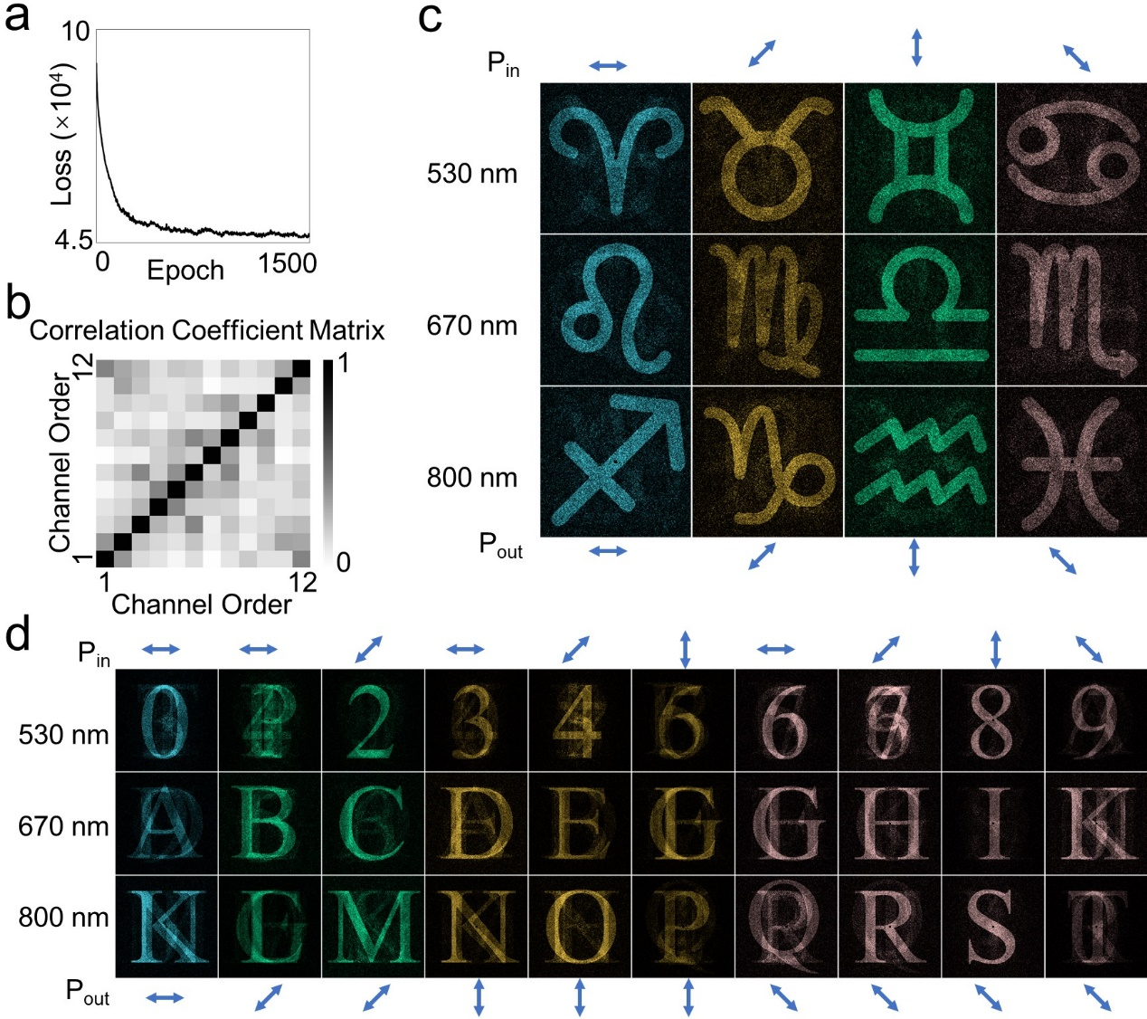
Figure 3. The designed multiplexing holography. (a) The loss, which is calculated between target images and designed results, varies with optimized epoch. (b) The correlation coefficient matrix of the 12 channels. (c) The calculated results of 12-channel metasurface (3 wavelengths and 4 polarization channels). (d) The calculated results of 30-channel metasurface (3 wavelengths and 10 polarization channels). (a-c) and the figure 2 (c-d) describe the same metasurface.

The mimic metasurface, like a chameleon, can change the output light with the environment. Under the same incident condition, the optical refractive index in the environment can alter the optical resonance of nanostructures. Our database contains 4.4 × 10⁴ nanostructures, each surrounded by air, with an environmental refractive index of 1. We randomly selected 5000 nanostructures and calculated their optical response in oil with a refractive index of 1.44 using FDTD. By transfer learning methods, the refractive index of the environment can be incorporated into the design of multifunctional metasurfaces (Figure 4a). For the original dataset, extract the phase responses of three linearly polarized channels at 1064 nm and 1550 nm, respectively. The polarized angles of incidence and output are the same, 0, $±\frac{π}{3}$ respectively. These data were used to train a 6-channel predictive network, consists of 3 convolutional layers and 4 fully connected layers. After completing the training, the last fully connected layers were retrained with the new dataset, while the other layers were kept unchanged. The minimum test loss varies with the number of retrained layers and the size of dataset used to retrain the network (Figure 4b). After the retrained dataset size exceeding 3000, the minimum test loss significantly increases, reducing the network performance. The retrieval model was trained with the best predictive network, that is, retrained the final 2 layers with 3000 data, together with the original predictive network. The 12-channel metasurface was designed following the aforementioned steps (Figure 4d). The crosstalk between different channels is relatively low due to the correlation coefficient matrix (Figure 4c). Using 10 polarized channels, a 40-channel holographic metasurface was designed following the aforementioned steps (Figure 4e).
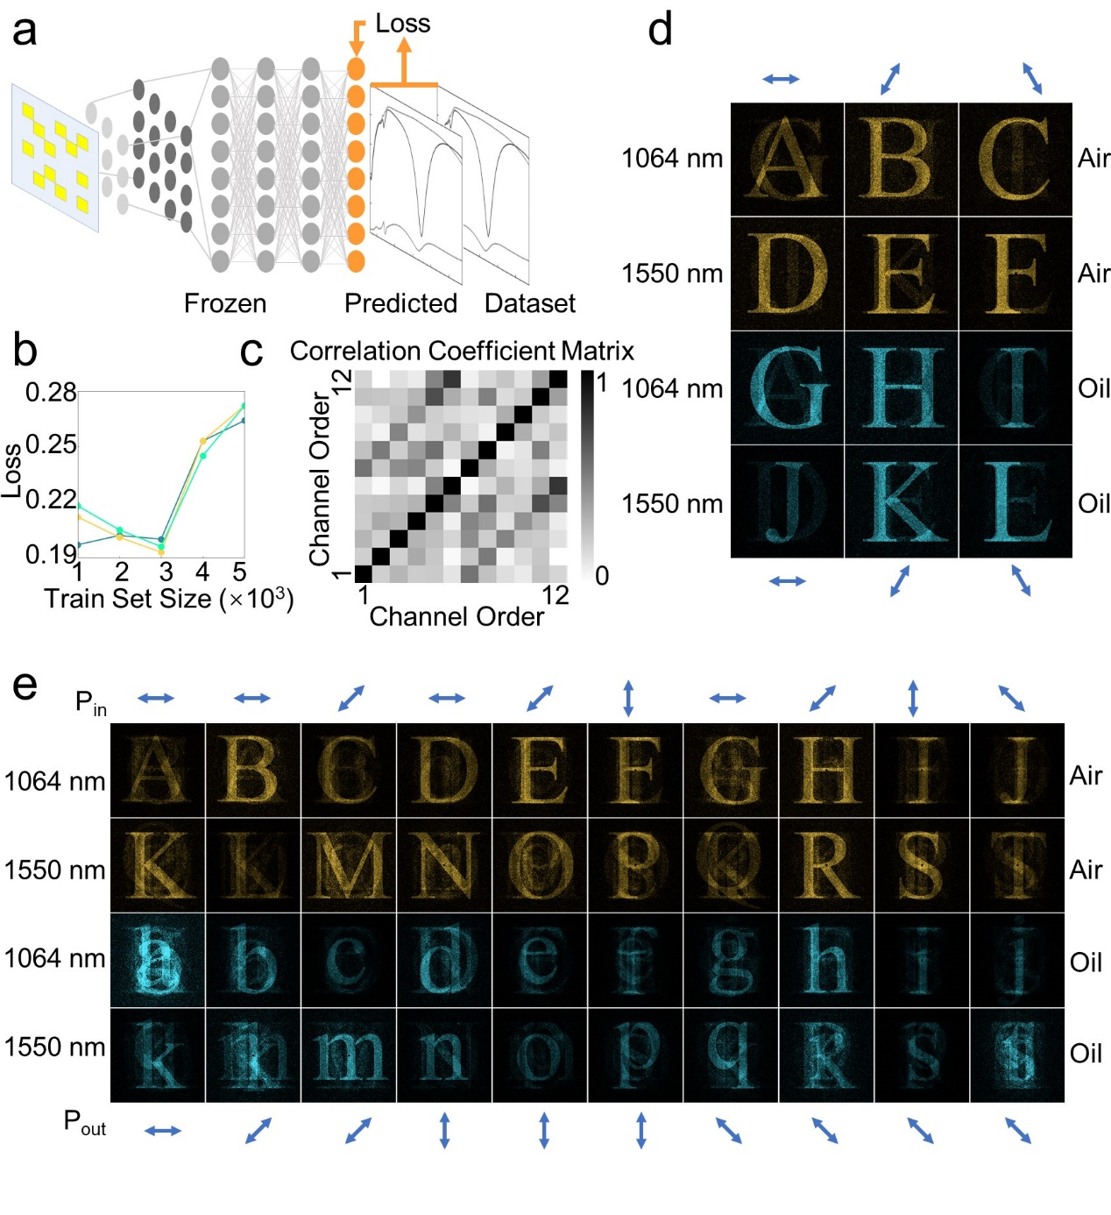
Figure 4. The mimic holography designed by transfer learning. (a) Illustration of transfer learning. (b) The test loss of the retrained prediction network varies with dataset size. The blue, yellow and green lines refer to 1, 2, and 3 frozen layers respectively. (c) The correlation coefficient matrix of the 12 channels. (d) The calculated results of 12-channel metasurface (2 wavelengths, 3 polarization channels and 2 environmental refractive indices). (e) The calculated results of 40-channel metasurface (2 wavelengths, 10 polarization channels and 2 environmental refractive indices). (b-d) describe the same metasurface.

Discussion
The QR-code-shaped nanostructures have complex resonance model, that is bypassed by the deep learning method. For each unit cell of the target phase arrays, deep learning tries to provide satisfactory nanostructures one by one. Although we cannot guarantee that each unit perfectly meets the phase requirements, we have incorporated a systematic optimization approach into the design platform, fully utilizing partially satisfactory nanostructures. By adjusting the phase arrays as the retrieval target for deep neural networks, the imaging quality of multifunctional metasurfaces is improved. Through this method, a 12-channel holographic metasurface with polarization-wavelength multiplexing has been achieved. We also incorporated mimic metasurfaces into multifunctional designs through transfer learning, achieving a 12-channel holographic metasurface. The crosstalk between channels of these two devices is low, enabling clear and independent imaging for each channel. On this basis, polarization channels were added, and devices with 30 and 40 channels were implemented separately, but the crosstalk between channels needs to be further reduced.

Conclusion
Our multifunctional metasurface inverse design platform combines deep learning and systematic optimization. Neural networks have fully learned the distribution of various shapes of nanostructures in high-dimensional phase space, and designed QR-code-shaped unit cells from a statistical perspective on demand, avoiding discussions about complex physical models. The systematic optimization method fully utilizes partially satisfactory unit cells, alleviating the problem of unit cells being unable to fully cover high-dimensional phase space. Our method combines local on-demand retrieval for unit cells with global optimization for the system, achieving multifunctional wavelength-polarization multiplexing. Our method is transferable and can easily achieve metasurfaces based on other multiplexing methods. We incorporate changes in environmental refractive index into the design of multifunctional devices through transfer learning methods. We have designed complex shaped nanostructures to achieve 40 channel holographic functional integration, providing a new possibility for the study of complex systems.

Acknowledgments
The authors were grateful to the support from the National Natural Science Foundation of China (grant Nos.12027807, 62225501), National Key Research and Development Program of China (2020YFA0211300), National Natural Science Foundation of China (grant Nos.62321004) and High-performance Computing Platform of Peking University.

Reference

