**>. Blog Article Template**

*This template should help you to write your blog article, the mentioned questions present just a guideline but are no fixed content.*

*The goal is to present your project from problem description to solution strategy to implementation in a concise way. To whom it should be addressed depends on who you want to present it to in the future. Overall, you can assume that your reader understands the technical basics and has some prior knowledge. Images help your readers to better understand your project. Especially when outsiders read the article this can be a huge advantage! However, images are not a must from our side.*

*Your blog article should be two (max. three) pages.*

*With sending this document to those responsible for TechLabs Dortmund e. V., you agree that TechLabs Dortmund e. V. can use the included information, images and personal data for publication on their e.g. websites, social media accounts and events, especially for the publication on techlabsdortmund.medium.com as well as in promoting events.*

*We took note of the disclaimer.*

*The following information appears on the certificate and on the blog!*

**Project titel:**

RUHRV7SION

**Project tagline:**

Please advertise your project in a short, meaningful sentence.

Creating a hyper-local jobplatform, to connect students to innovative and local companies in the Ruhr Valley.

*This project was carried out as part of the TechLabs “Digital Shaper Program” in Dortmund (winter term 2020).*

**In a nutshell:**

Please give a brief (4-5 sentences) summary of your project.

Our project aims to create a jobplatform exclusively for companies and students in the Ruhr Valley. It includes many useful features, to improve the user experience and is capitalizing on the hyper-local environment we created. The most important one is a matching system, that puts classical application on the trashpile of history, by bringing students and companies together easier and faster.

*The following information appears on the blog!*

**Introduction:**

What was the idea / background of the project?

Which was the specific problem to be solved?

What was your solution approach?

The project backround was somewhat special in our case. The product owners Nils and I (Luis) had the idea for this for quite a while, before even knowing of Techlabs. Techlabs was a great opportunity for us to realize it.

Our Idea was to create a jobplatform, that is fitting to the specific needs of students and local companies. These two groups often find themselves in a hard spot, trying to fulfil their needs on bigger platforms, as they aren’t a big enough customer group for them.

Concretely our aim was and is to develop a hyper-local environment, in which the two groups, local companies and students, could meet and connect to each other far more easily. This works because of entrance restrictions to the market, that is our jobplatform. Another goal of ours was and is to develop technical solutions to improve and ease up the user experience of our platform.

**Methodology:**

How did you proceed to develop a solution?

Which methods / tools from your learning tracks did you use to solve the problem?

To understand the nature of our project a little better you need to know, that the entire idea of ours already existed on paper in a quite concrete manner. So when our team was brought together for the first time, there weren’t to many problems left to solve. At least not on the logical frontier. So when we met as a team for the first time, we started by sharing the vision we had for the project and getting each others feedback. We also incorporated some minor changes and improvements.   
After that we had to find a way to organize ourselves and work together. For that it was great to have Mariusz on board who could help the team with his experience in setting up a working / scrum routine. Scrum is an agile framework in the field of software development (also projectmanagement), which can be flexibly applied to various projects. To organize ourselves even better we went ahead and created a clickUp room, so everybody could be assigned his/her tasks. clickUp is a management application (similar to jira) to monitor, distribute and coordinate the individual tasks in a larger project framework.   
The very first step we had to take was to conceptualize the technical scope of what we were going to achieve during this project phase. This included the systems, the interfaces, and the data sources. Thanks to the knowledge our team members gained from the WebDev and Data Sciences tracks, we could specify out the code languages we are using and the server architecture needed.

Based on that our UX/UI designers Beril, and Deborah (who joined the party a little later) could create not only the first wireframes for the WebDevs to start programming, but also concrete mockups. They did all of that working with Figma.

In the meantime Daniel was creating a logical framework for the funnels, which are a key to our matching system.   
In the programming phase that followed afterwards, Mariusz mainly took responsibility for the frontend. To create our website, he was using REACT (javascript) and as a css framework react bootstrap.   
To create a website, that is not just good looking, but also functional Nils set out to create the backend. Therefore he used Nodejs (javascript) to bring continuity into our code languages. To store the data of our platform, we used MongoDB, a nonSQL database.

To work together, our WebDevs Nils and Mariusz used GitHub and saved their code snippets there.

**Results:**

What is the final solution of your project?

What are the central results of your project?

What is the impact of your results?

What could be possible next steps in the development of your project?

What could be a long-term goal for this project?

For time reasons we couldn’t complete the project to the degree we would have wished to do. We realized that during the process and therefore adjusted our goals to the most core features, being a baseline website structure, a secure login system, a funnel (matching) system, a register for company information and a rudimentary jobplatform. Generally speaking our focus was set more on the company side than the student side of our project.

The final result of our work is a platform, that enables students to find new joboffers and inform themselves about the companies behind these offers. In a follow up, if an interesting offer is found, students can use our matching system to immediately apply for the job within minutes and without the troubles and fuzz of a normal application.   
For companies we have created a product, that allows them to broadcast their joboffers to a fitting audience of young and smart locals over multiple channels. One of them is the jobplatform part of our project, the other is the company register. To improve the application process for the companies as well, they can now take advantage of our matching system allowing them to quantify the criteria for a fitting applicant to make a better and more informed decision about who to hire.

Eventhough the work in our team was great fun and we put forward a tremendous effort, unfortunenatly weren’t able to complete all of the goals we initially set out to reach. Still we brought the project forward to a huge degree and even without our great team, Nils and I will continue to work on realizing our project.

We will still follow up on our aim to create a better solution for connecting students to local companies and thereby creating chances and opportunities for many people. We can’t give you an exact timeframe, but promise, that we will give our best to make the product we have worked on for a long while available for the public.

**GitHub repository (or similar):**

<https://github.com/starplayer632/ruhrv7sion-client-server>

**Team members:**

Track: First name, surname [email, LinkedIn, responsibility in the project, …]

Nils Pautzke (WebDevelopment + Backend, FullStack, co leader and Ruhrv7sion inventor),

Luis Follmer (No Track, leader and Ruhrv7sion inventor),

Mariusz Seget (WebDevelopment + Frontend, Frontend),

Daniel Manzhos (DataScience, Funnel/Matching system),

Beril Sargut (UX Design, Creating wireframes and mock-up pages),

Deborah Majekodunmi (UX Design, Creating wireframes and mock-up pages)

**Team mentors:**

First name, surname, responsible project part / track

Klicken oder tippen Sie hier, um Text einzugeben.

**Sources:**

For reasons of data protection it is necessary that if you are using somebody else's data, you need to cite your sources over here.

Klicken oder tippen Sie hier, um Text einzugeben.

*Please make sure that your text is long enough so this line appears at least on page 5, but not on page 7!*

**Figures / Images (optional):**



Figure 1:Ruhrv7sion full size logo

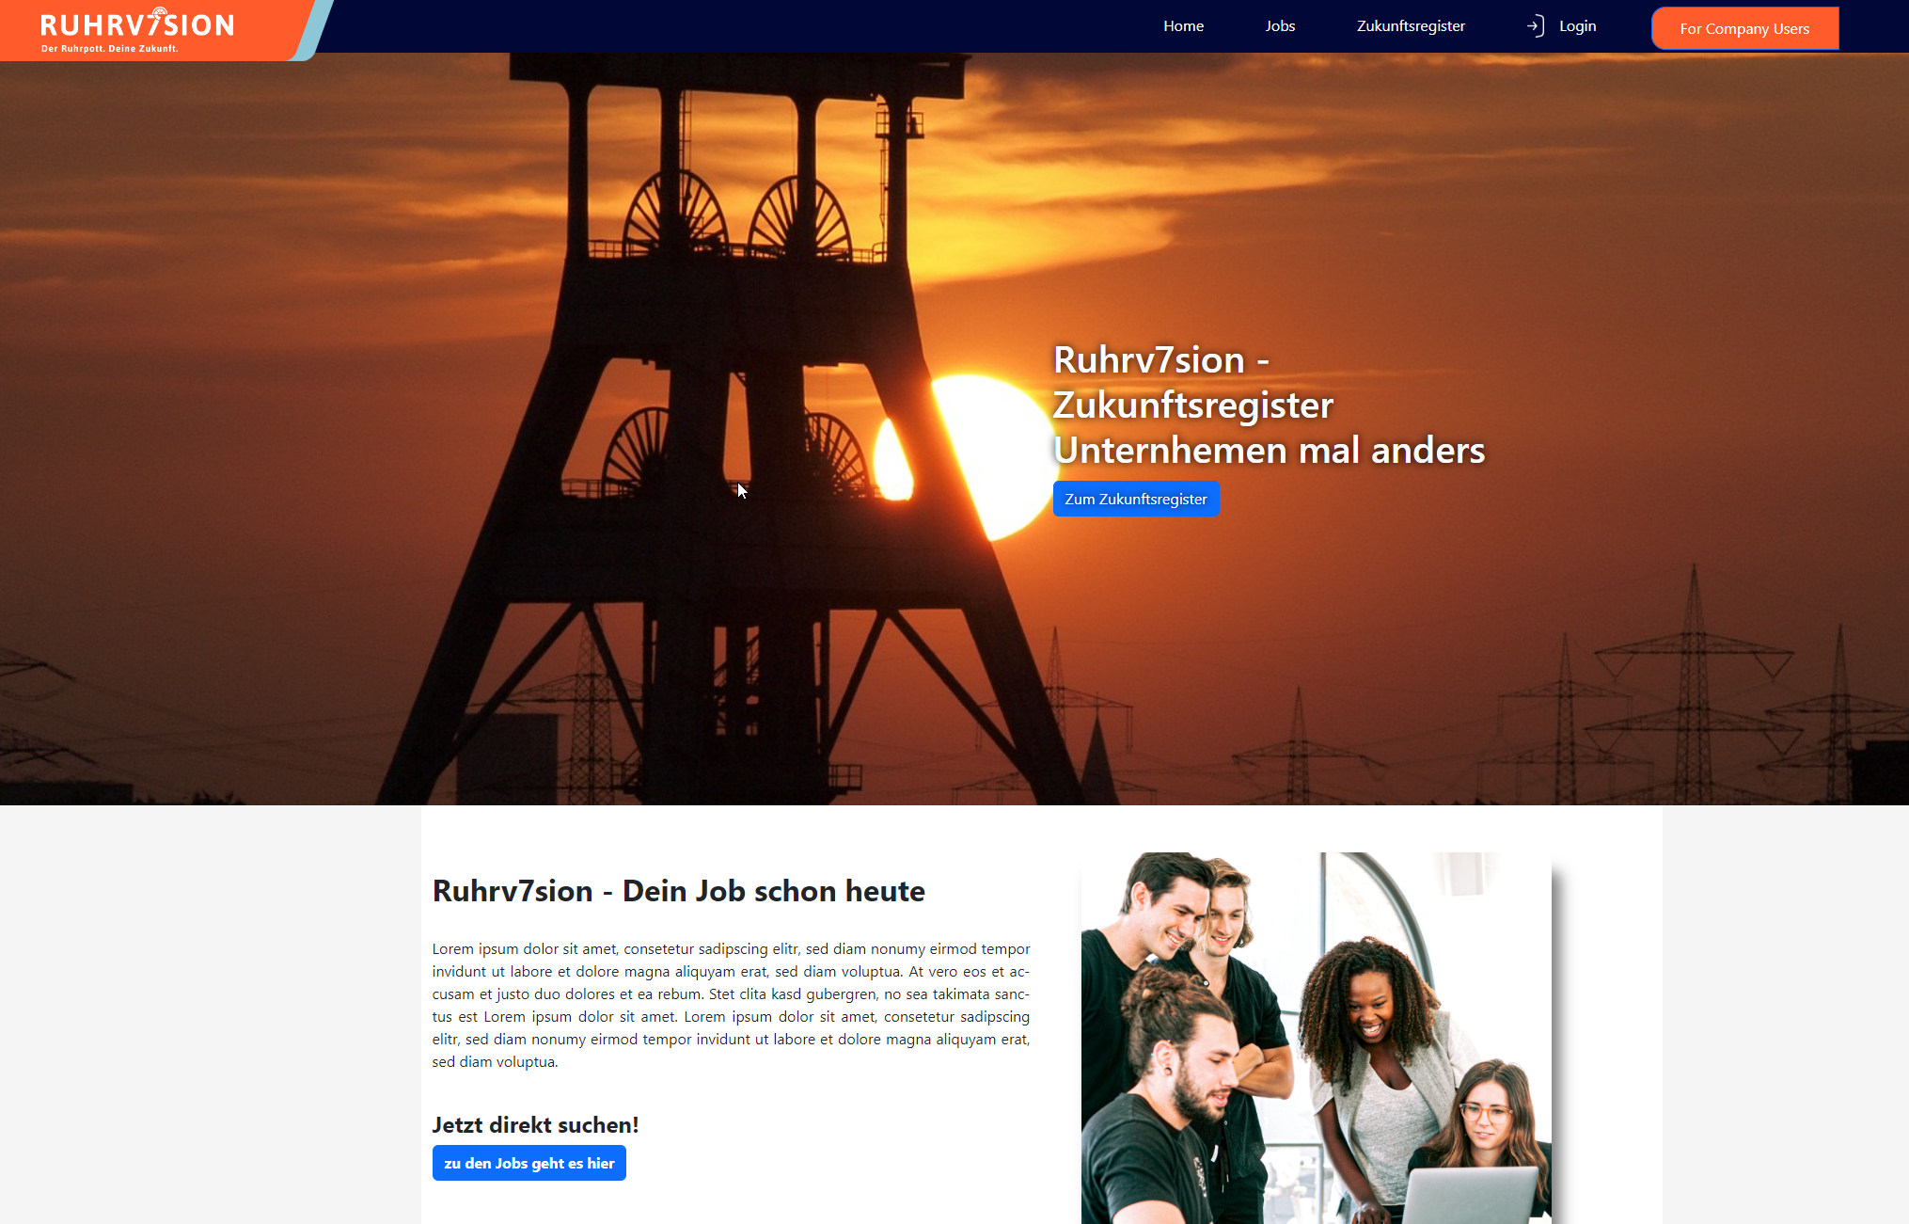

Figure 2:Frontpage

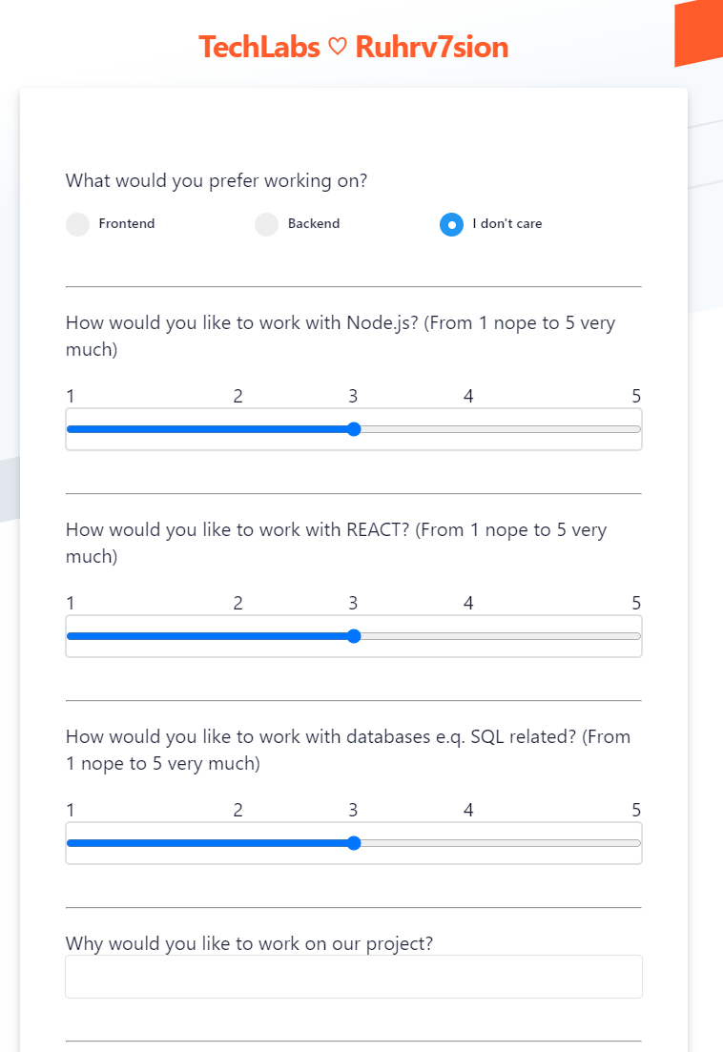

Figure 3: Funnel example

**Video (optional):**

Your video needs to be available as a (private) YouTube link!

Klicken oder tippen Sie hier, um Text einzugeben.