Exercise1：

Main Codes:

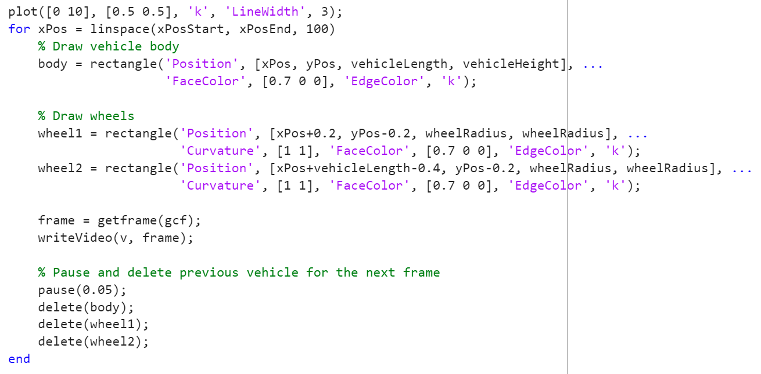

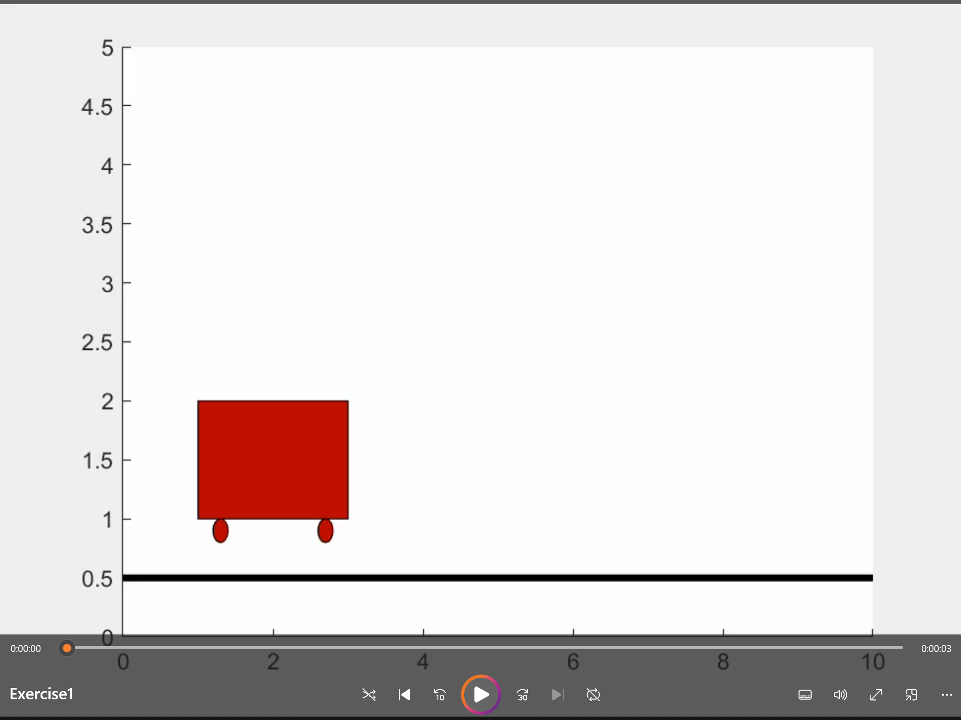 **->**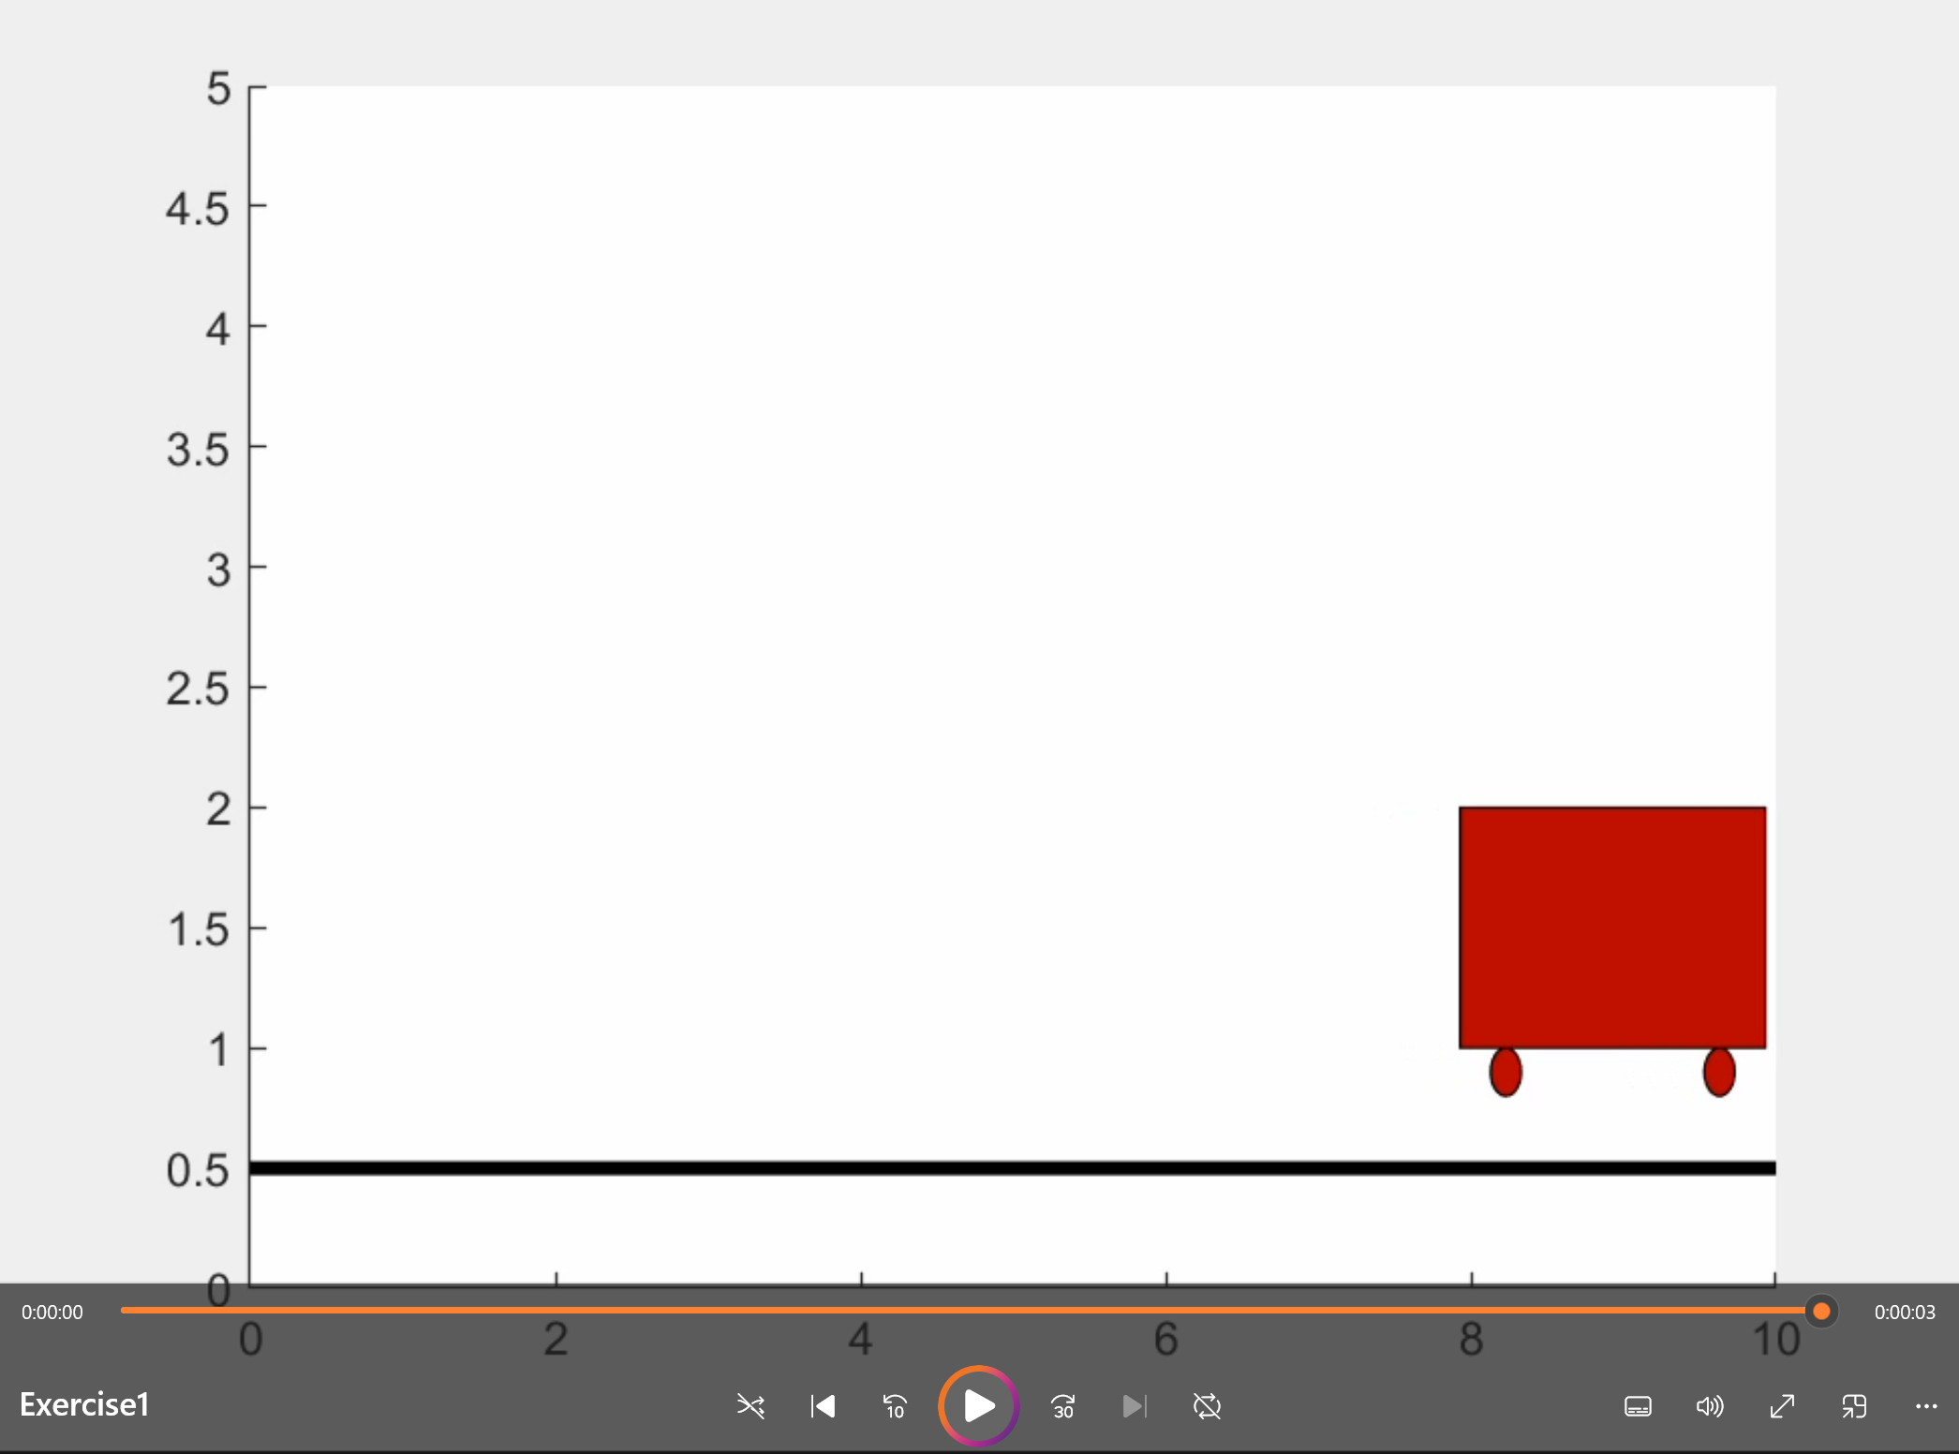

Execersice2:

Randomly swaps two cities in the route to explore new routes. Accepts the new route if it has a shorter length.

Main Codes:

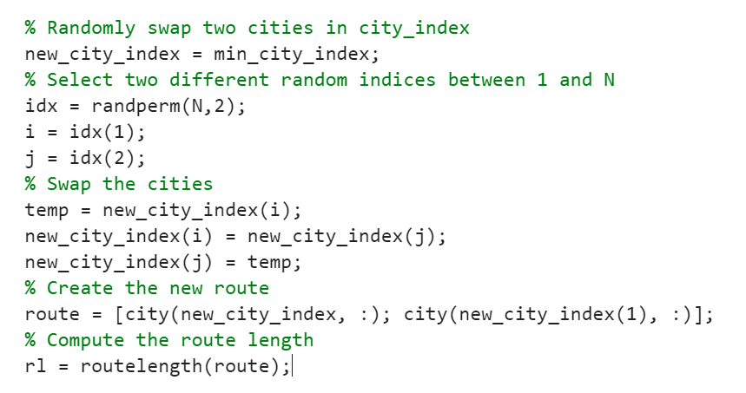

Result:

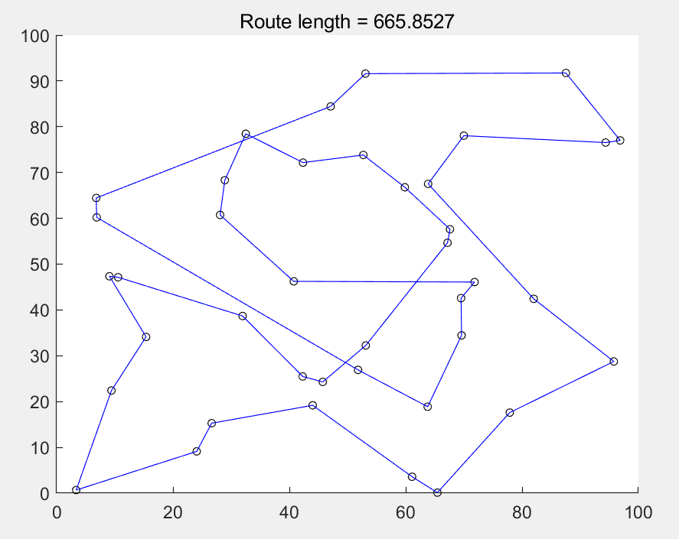

Exercise3:

The key to making sure that the rectangle doesn't float is that whenever you place a rectangle, you need to check that the bottom of the rectangle can be supported. To do this, we need to record and check the current highest point of each X position and make sure that the rectangle is placed at the very bottom of that position.

Main Codes:

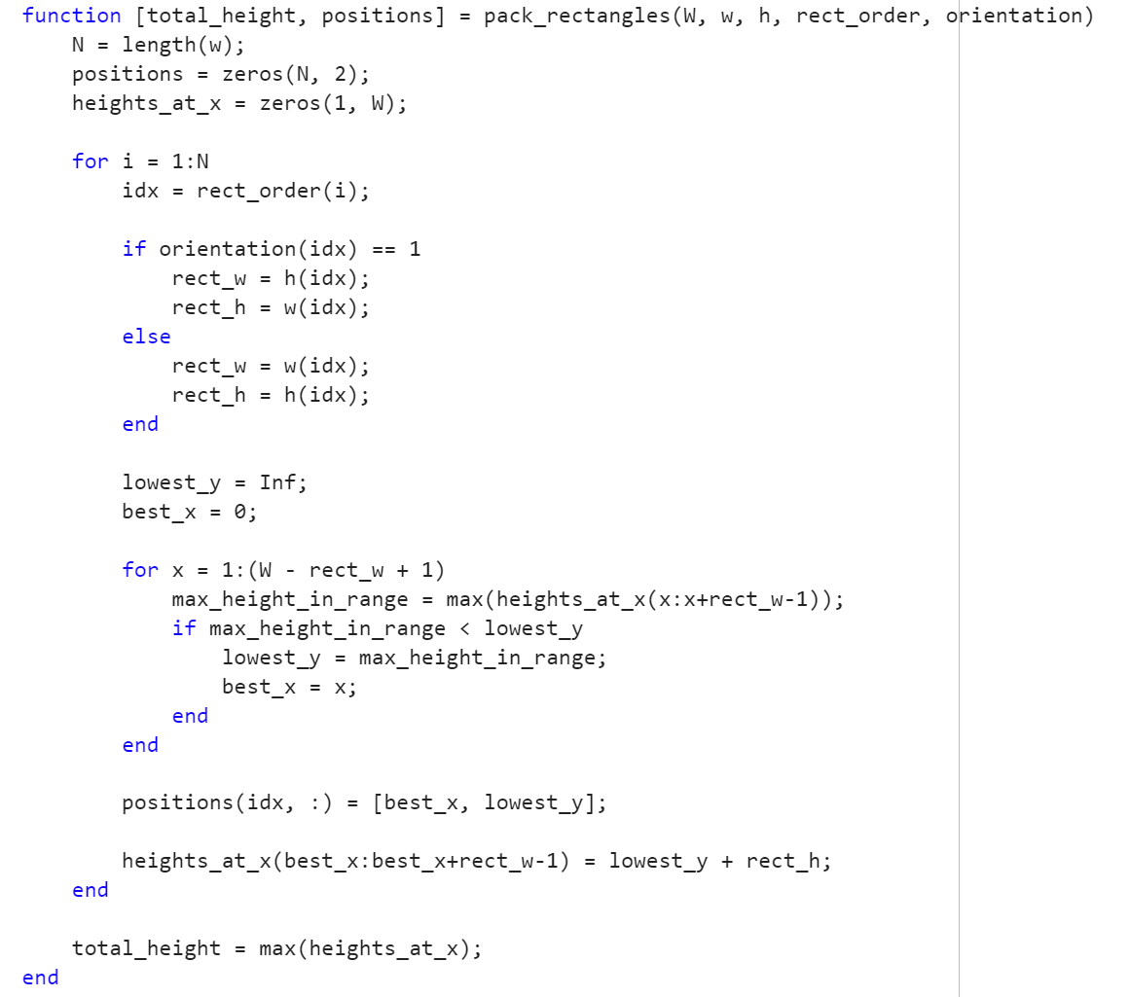

Result:

