**Exercise1：**

**Key code:**

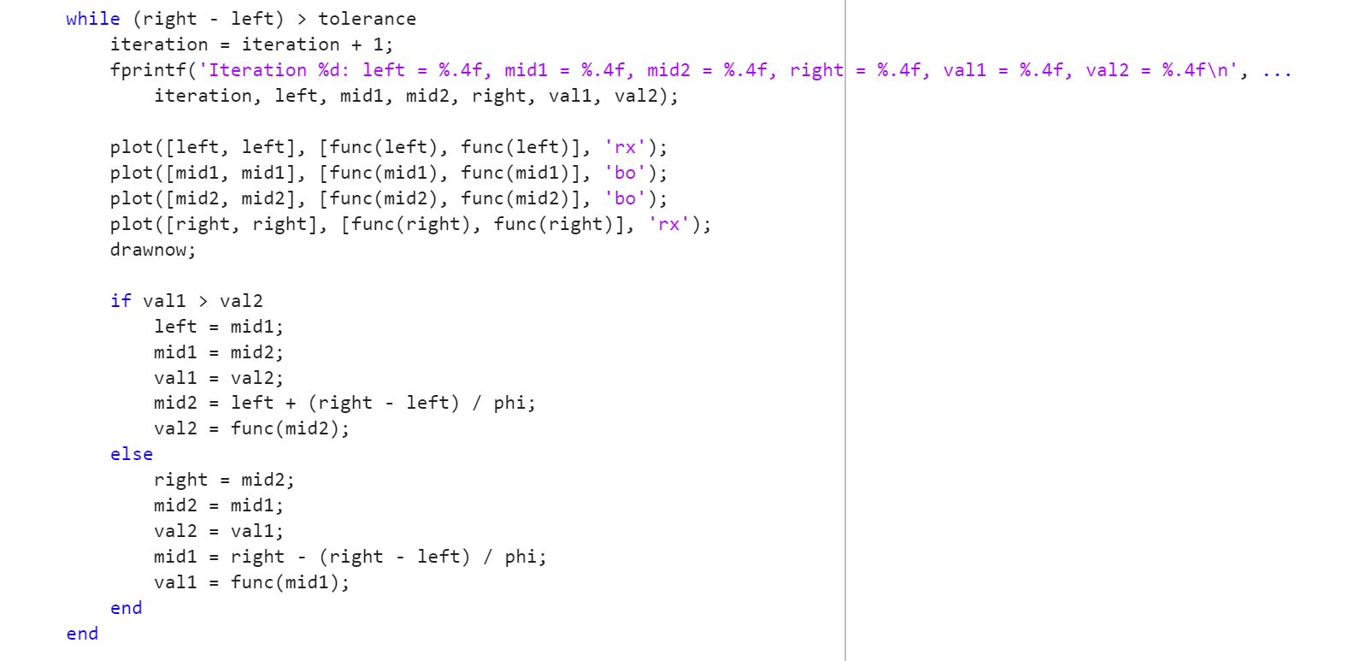

**Main idea:**

It evaluates two points within the interval based on the golden ratio, compares their function values, and reduces the interval accordingly. This process continues until the interval is small enough to approximate the minimum within a given tolerance.

**Case1:**

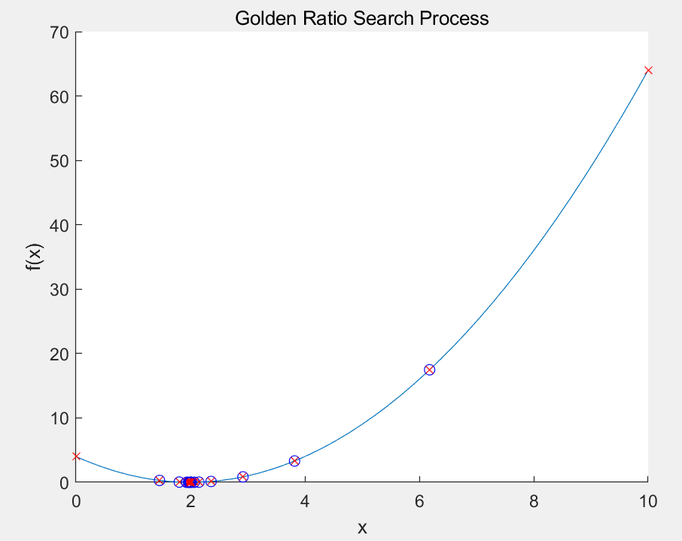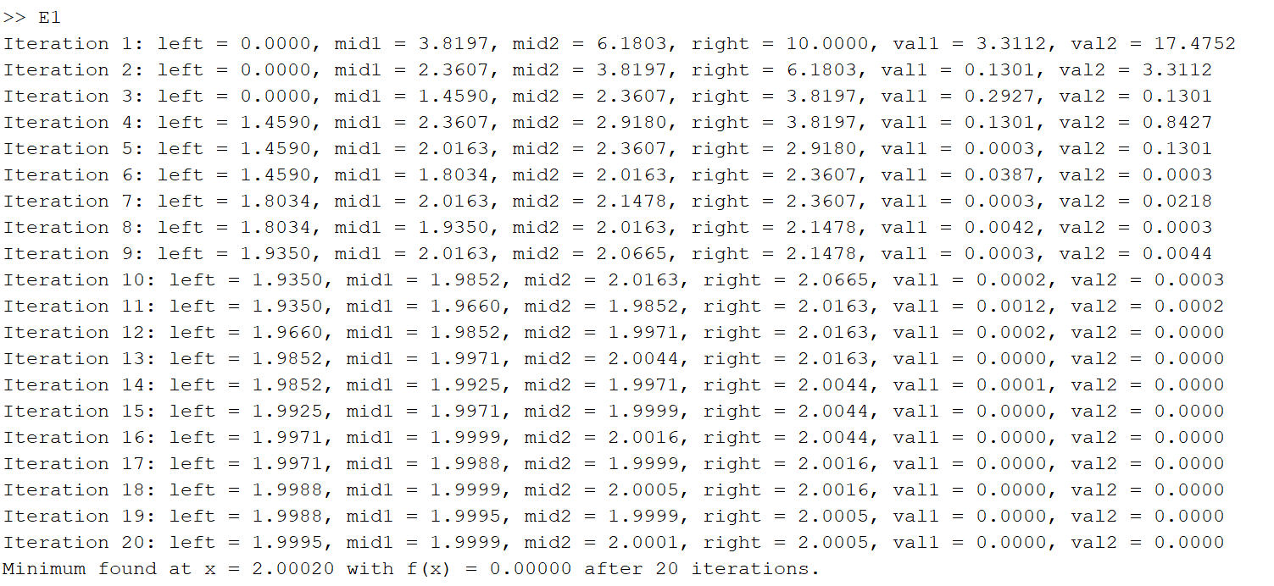

**Case2:**

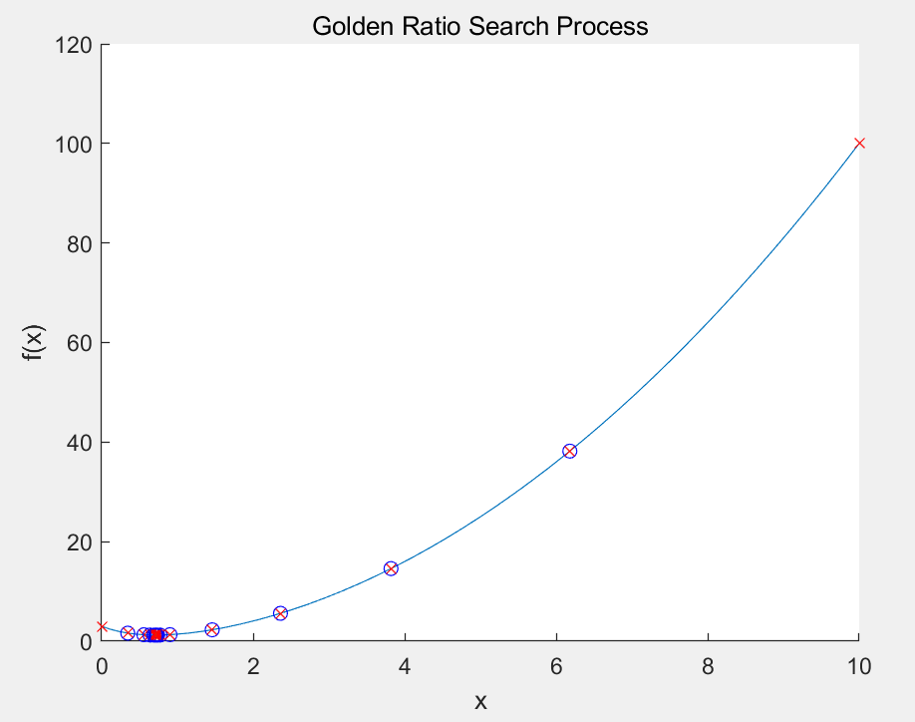

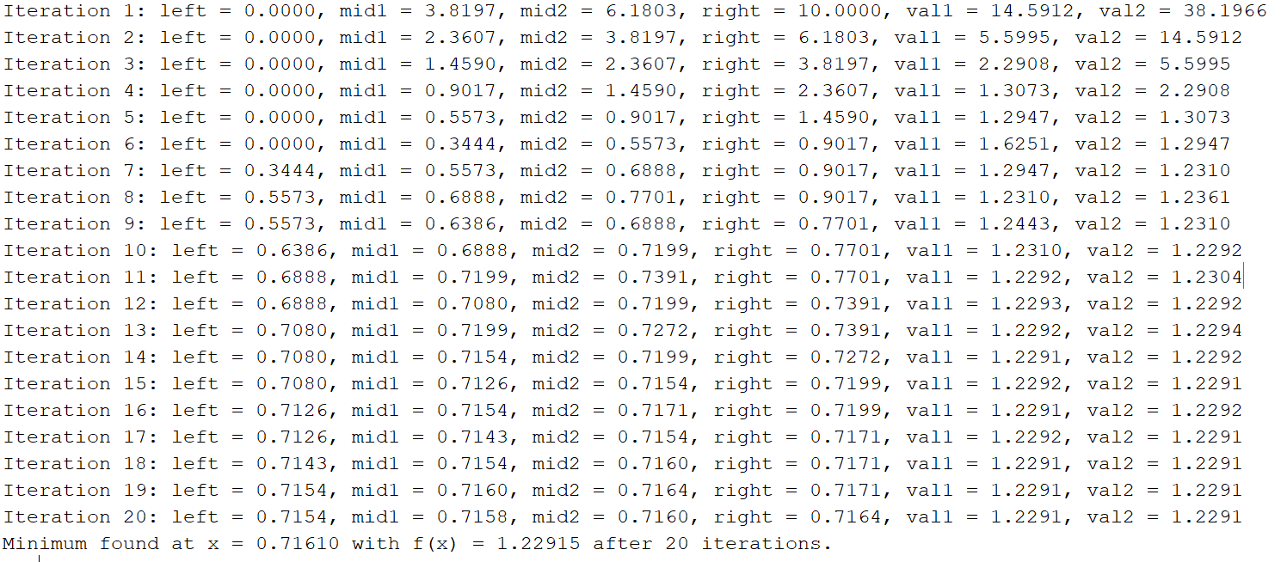

**Exercise2:**

**Key Code:**

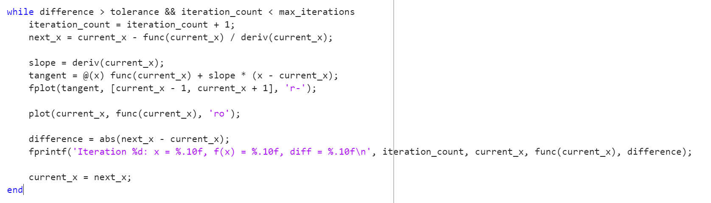

**Main idea:**

The Newton's Method implementation iteratively approximates the root of a function by using the tangent at the current point to find the next estimate. In each iteration, the method calculates the slope of the function's derivative, plots the tangent line as a solid red line, and updates the current estimate until the difference between successive estimates is below a given tolerance or a maximum number of iterations is reached.

**Case1:**

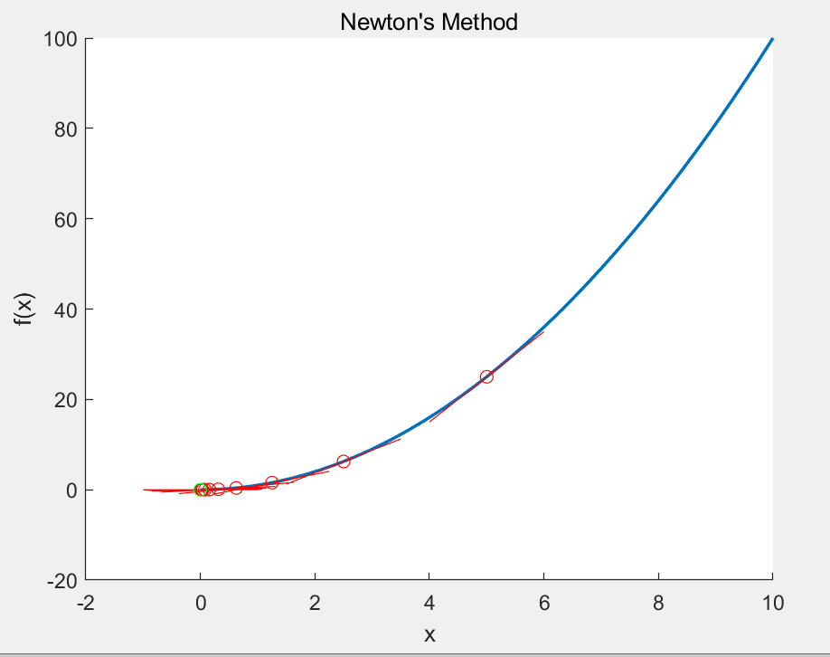

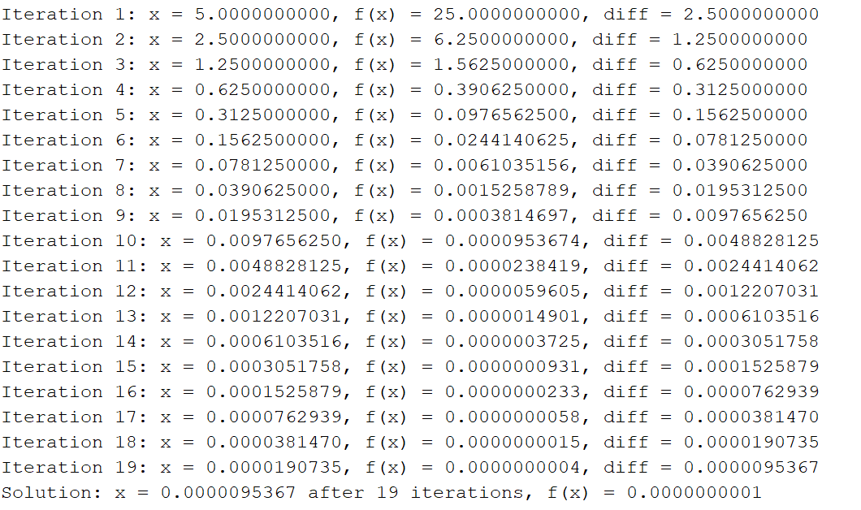

**Case2:**

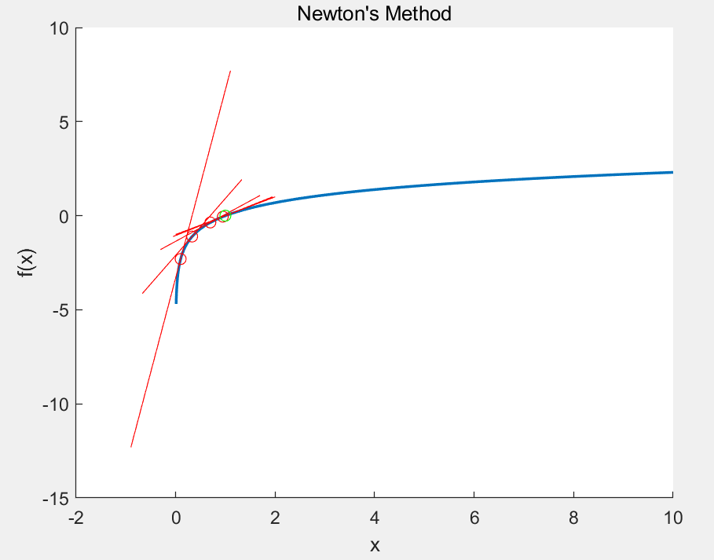

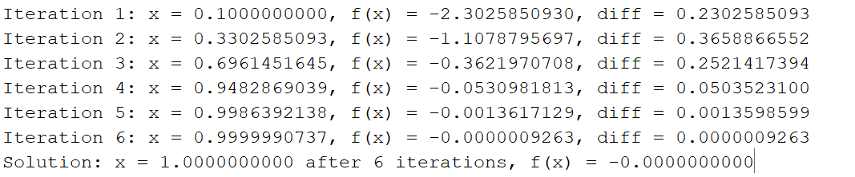

**Case3:**

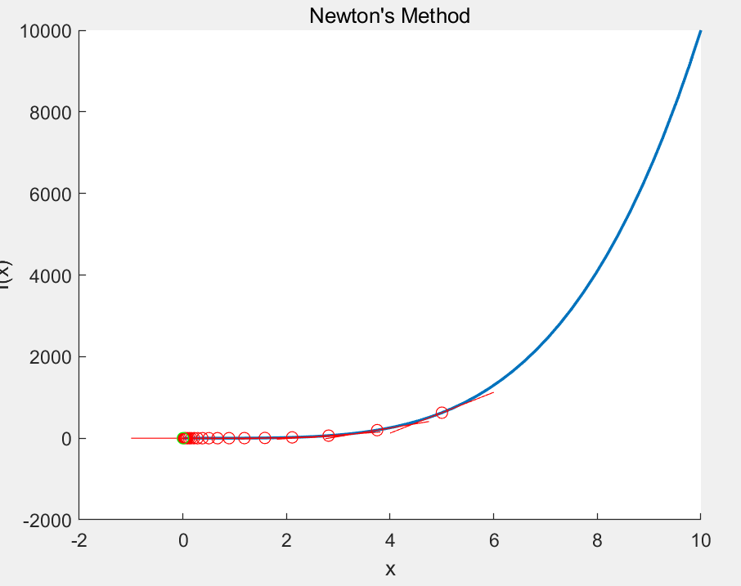

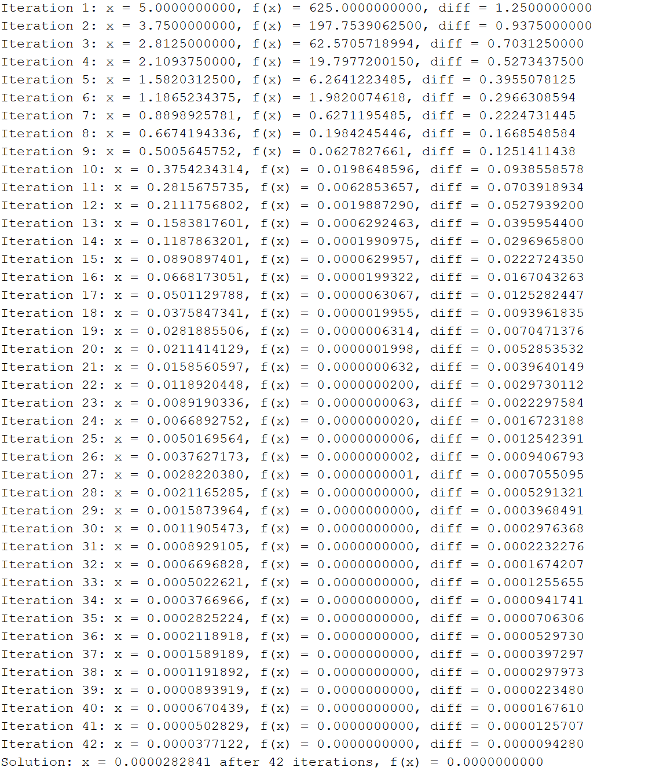

**Case4:**

