**Problem1:**

**Main idea:**

The code performs a multi-run gradient search on specified objective functions, starting from random initial points for each run. It iteratively updates each point by moving in the direction of the gradient until convergence or reaching the maximum iterations.

**Main code:**

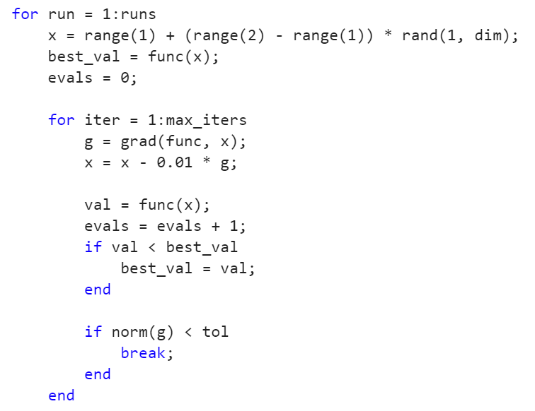

**Result:**

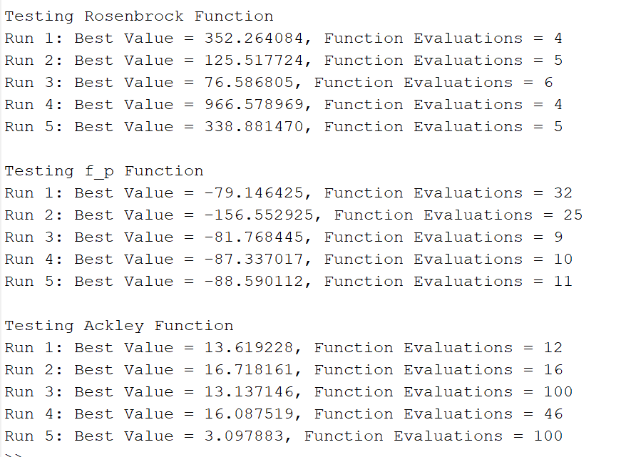

**Problem2:**

**Main idea:**

The code performs basic and smart random search to optimize functions, printing the best value and evaluations after each iteration. The smart search narrows its range over time.

**Main code:**

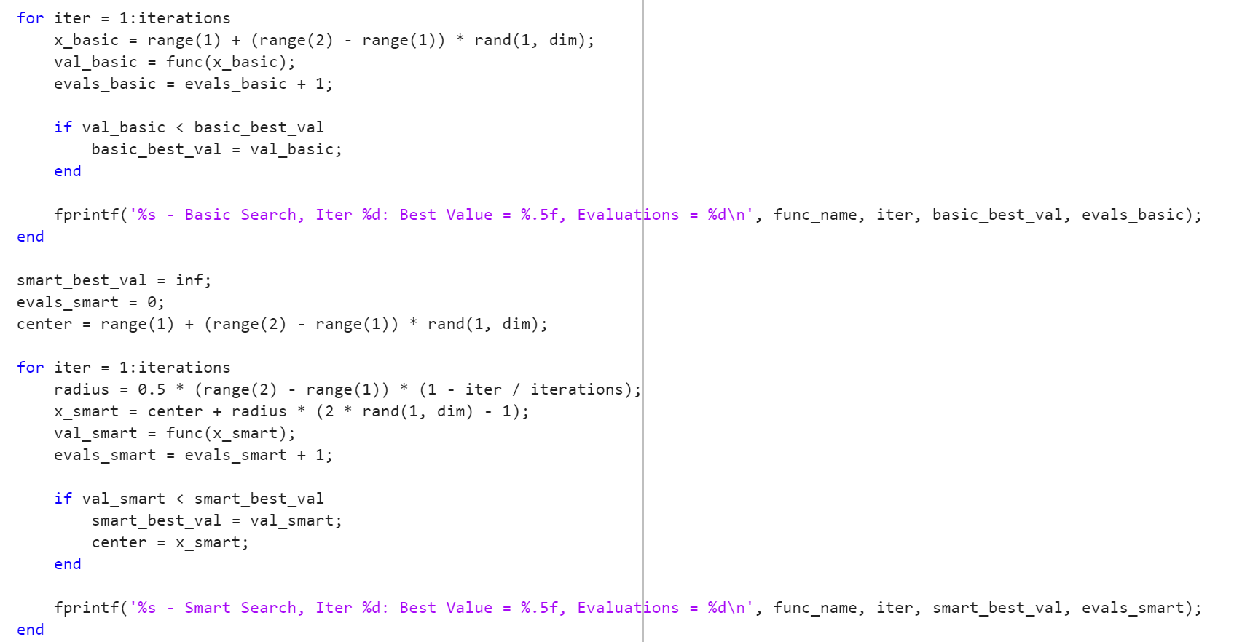

**Result:**

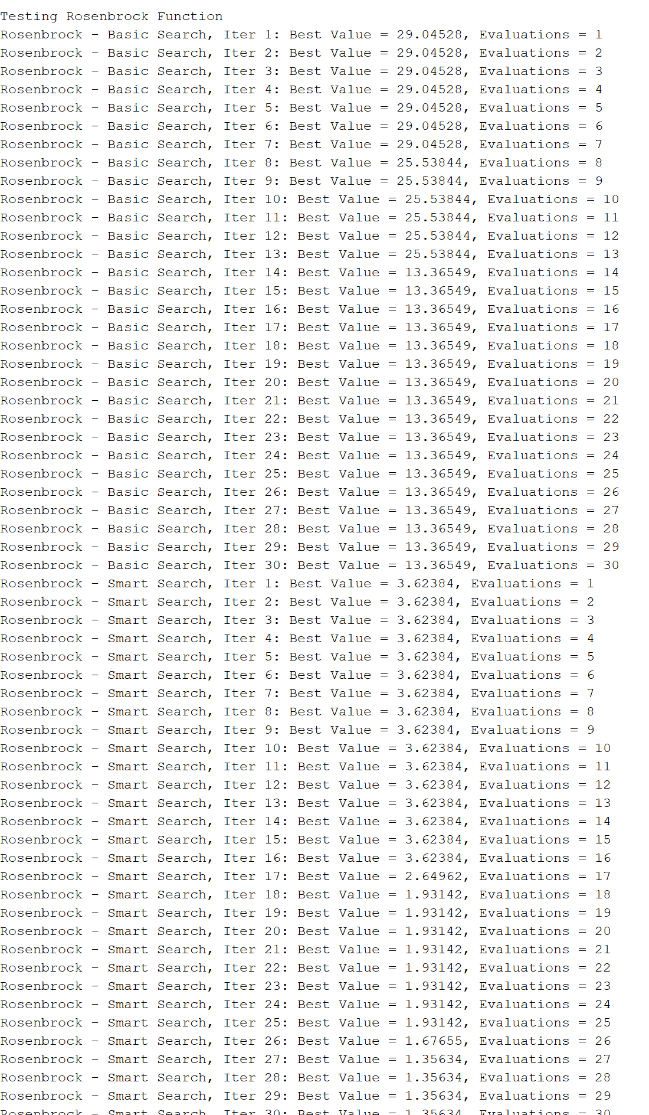

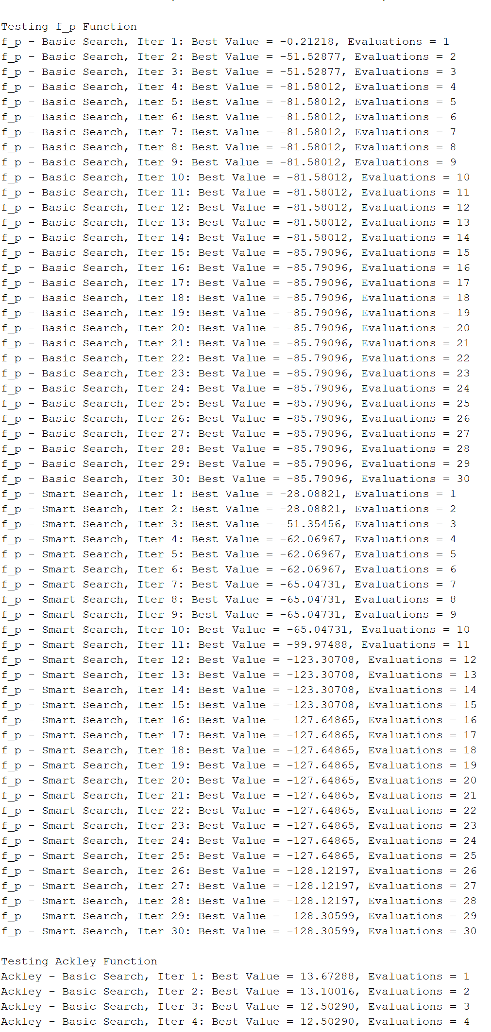

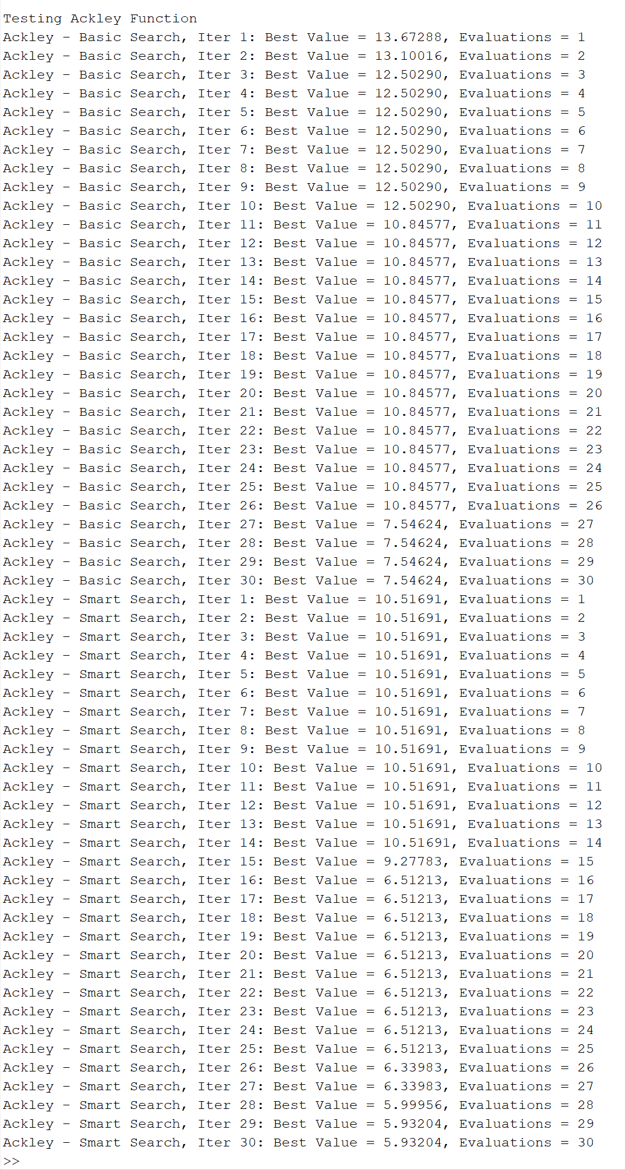

Basic random search is global random sampling, while smarter search uses the available information to optimize the search strategy to improve the convergence speed and solution quality.

Rosenbrock:13.3->1.3

F_p:-85->-128

Ackley:7.5->5.9

**Problem3:**

Since I am a DE researcher and have conceived and implemented more than a dozen variants of DE, I was delighted to see this question. 😇

**Main idea：**

The DE algorithm iteratively optimizes by generating new candidate solutions through mutation, crossover, and selection, balancing exploration and exploitation using the parameters and .

**Main code:**

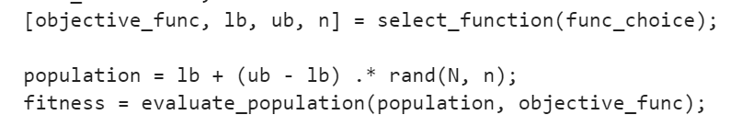

**Result:**

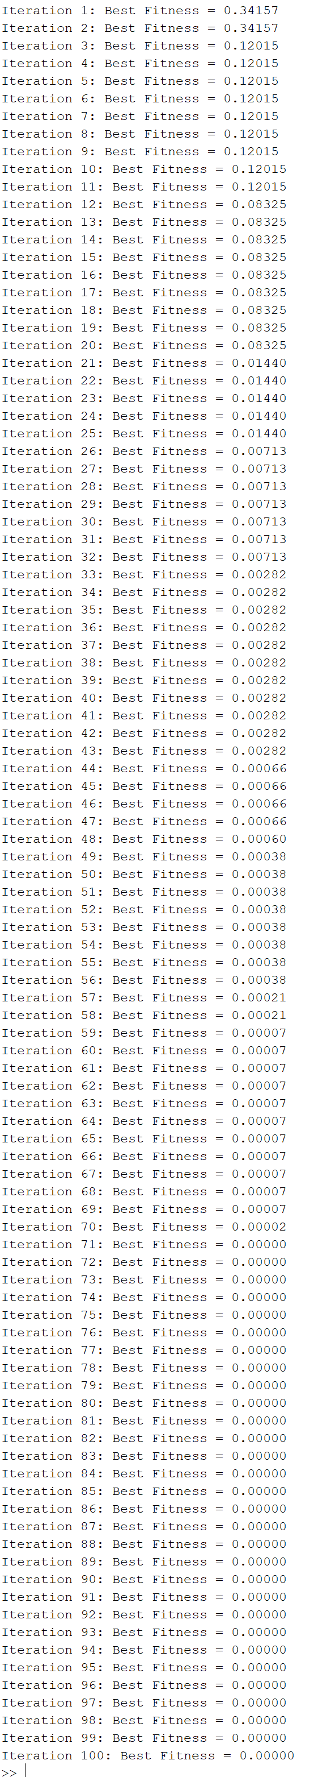

In Differential Evolution (DE) algorithm, and affect exploration and exploitation of the algorithm. The larger and are, the better DE exploration ability is, but the convergence rate is slow and unstable. The smaller the development ability is stronger, but it may fall into local optimum.

**Problem4:**

**Main idea:**

By iteratively updating the velocity and position of particles, PSO balances exploration and exploitation in the search space by using the information of the individual optimum and the global optimum, so as to find the optimal solution of the optimization problem.

**Main code:**

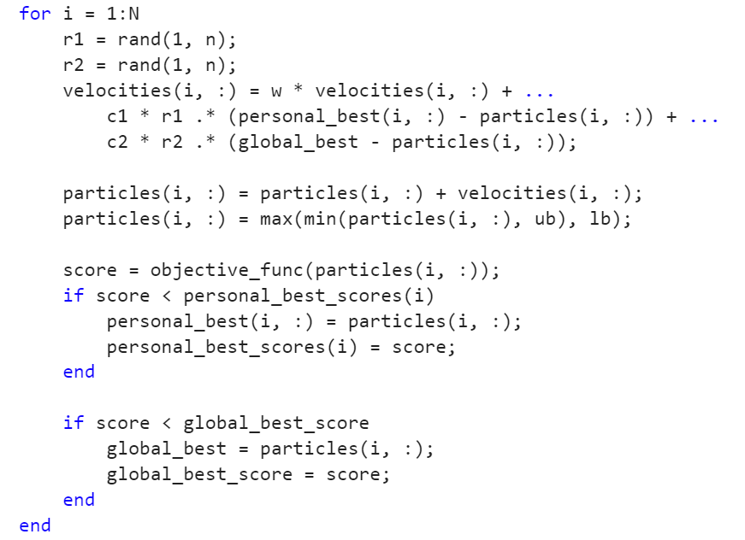

**Result:**

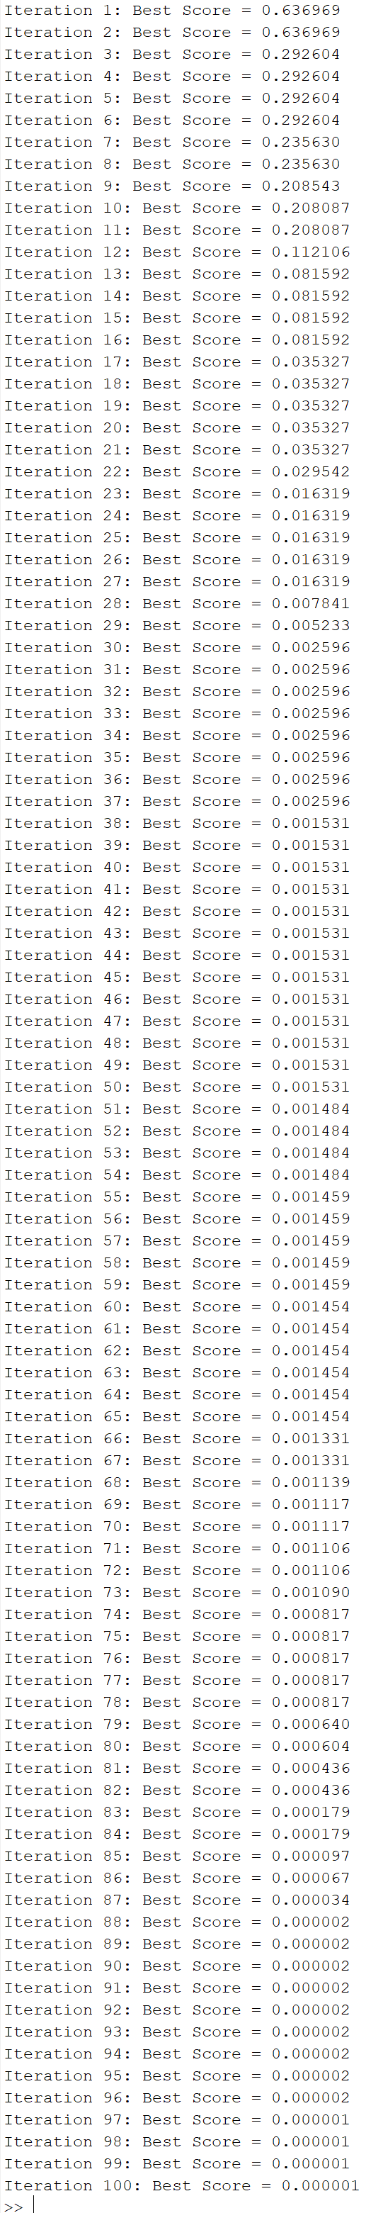

The larger number of particles (N) improves the comprehensiveness of the search, but increases the computational overhead. When the inertia weight (w) is large, it enhances the exploration ability, and when it is small, it promotes convergence. When cognitive factor (c1) increases, particles are more inclined to individual experience search, while when social factor (c2) increases, particles are more dependent on the group optimal solution, which affects the stability and accuracy of the algorithm.