**Problem1：**

**Main idea:**

The main idea is to use a genetic algorithm with floating-point representation and adaptive mutation rate to optimize three test functions in a complex search space through selection, crossover and mutation operations, and record the best solution and fitness value of each function to evaluate the performance of the algorithm.

**Main code:**

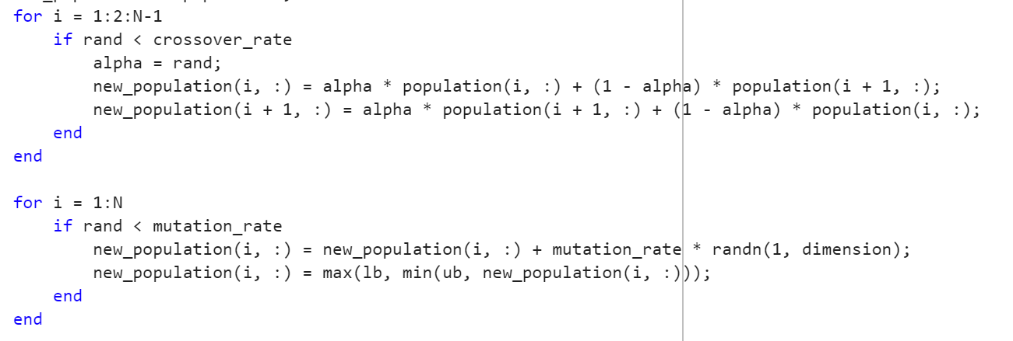

**Result:**

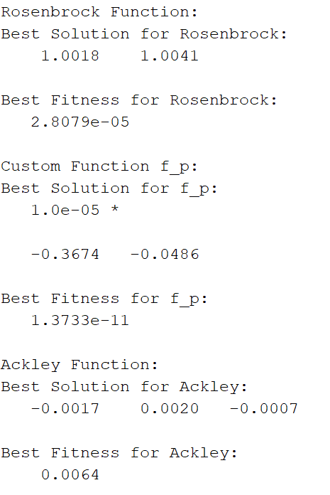

Control parameters balance exploration and exploitation in the search space; for example, larger population size and higher mutation rate increase diversity, reducing the risk of local optima. Higher crossover rates and selection favoring high-fitness individuals speed up convergence but can lower solution diversity.

**Problem2:**

**Main idea:**

By representing each possible path as a permutation of city numbers, random exchange is used for mutation operation to explore different paths, and crossover operation is used to ensure that the generated path is effective. At the same time, the mutation rate is adjusted according to the population diversity to increase the search efficiency.

**Main code:**

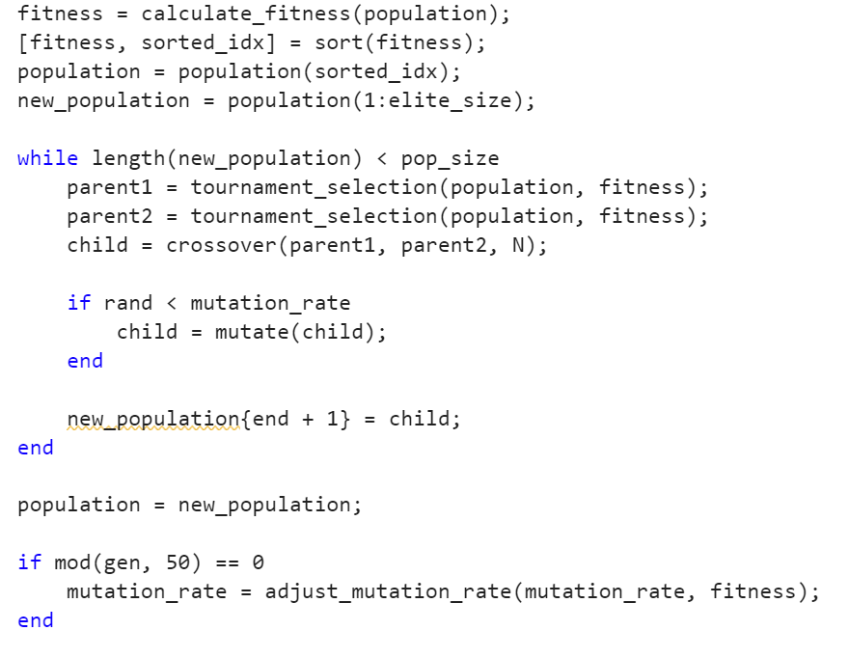

**Result:**

I tested the population size from 20 to 500. In general, the larger the population is, the slower the convergence speed is, but the convergence effect is improved. The overall result is better than random swapping. 500 populations in 20 generations can achieve the effect of 20 populations in 500 generations, because large populations can increase diversity and help the algorithm to better explore the solution space and escape from local optima, thus improving the quality of solutions. However, due to the slow computing speed and the shortage of computing resources, the large population algorithm is not outstanding in practical applications. Coincidentally, I was working on a GPU-accelerated large population algorithm. Compared with the traditional algorithm, the speed can be improved by more than 1000 times, and the maximum population can be opened to 500,000.

**Lab3 random swapping algorithm Pop=500:**

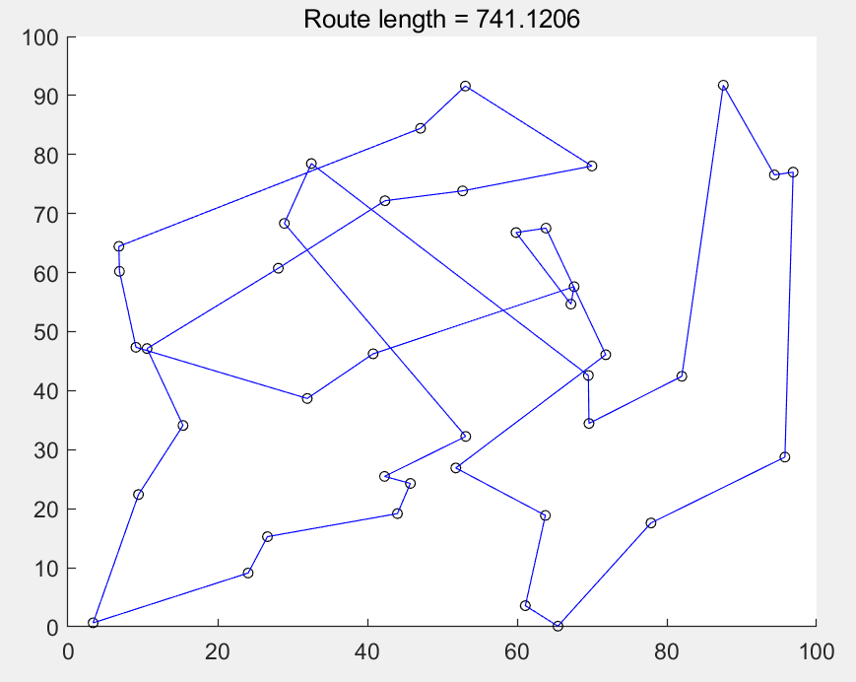

**EA Pop=20:**

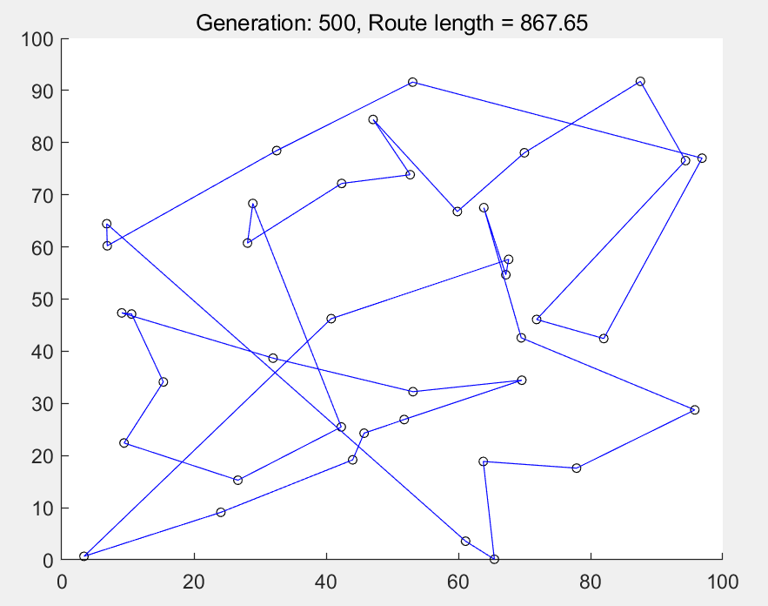

**EA Pop=500:**

