**Problem1:**

**Main idea:**

Using Solver-based Optimization gamultiobj.

**Main code:**

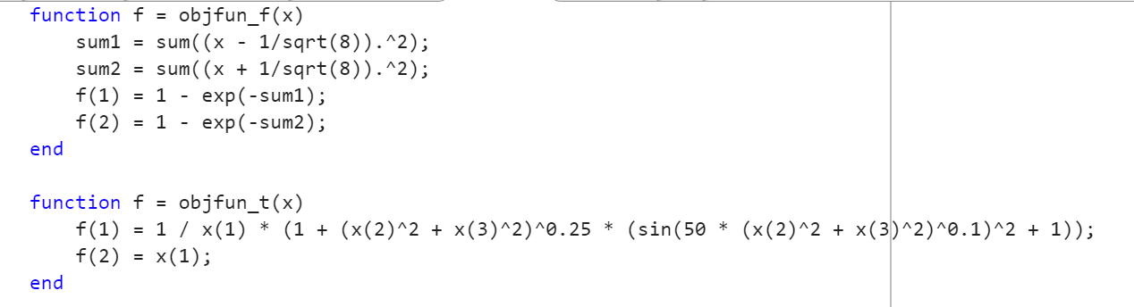

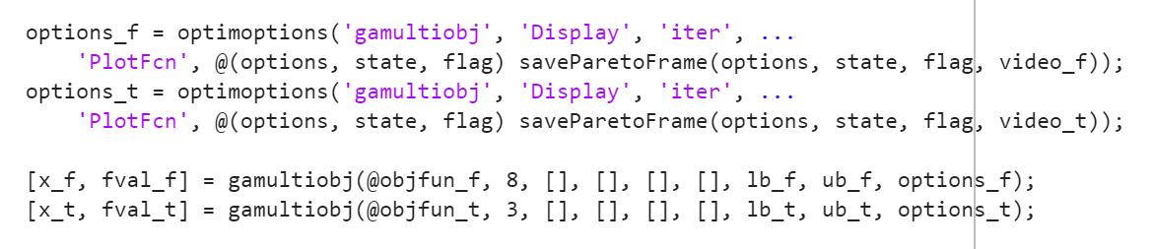

**Result:**

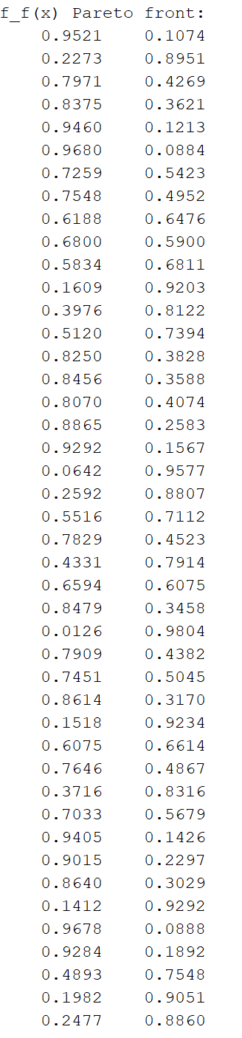

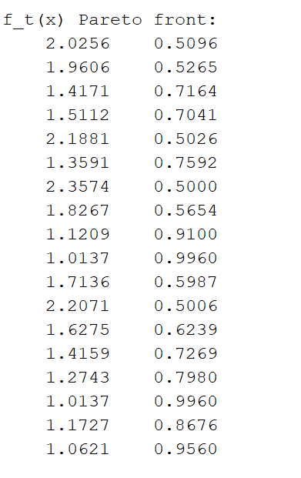

**Problem2:**

**Main code:**

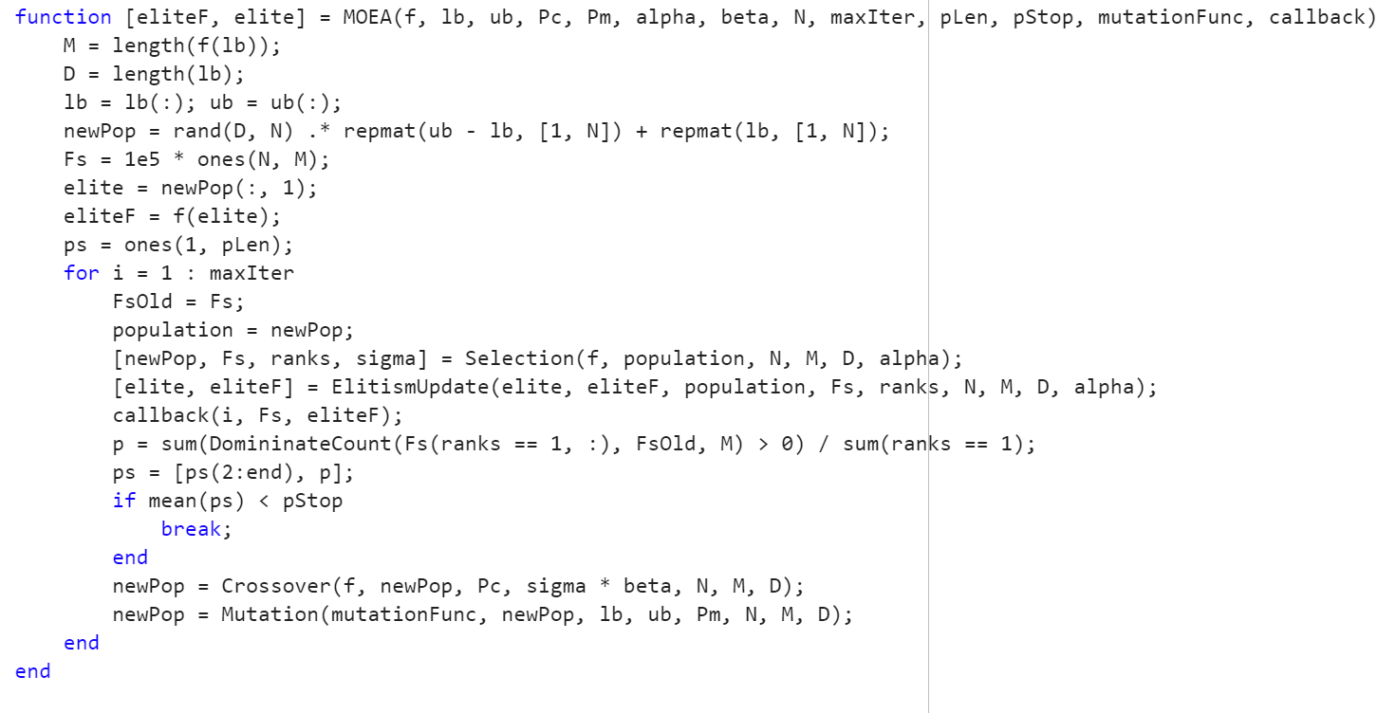

**High crossover and low variation（pc = 0.9, pm = 0.1）：**

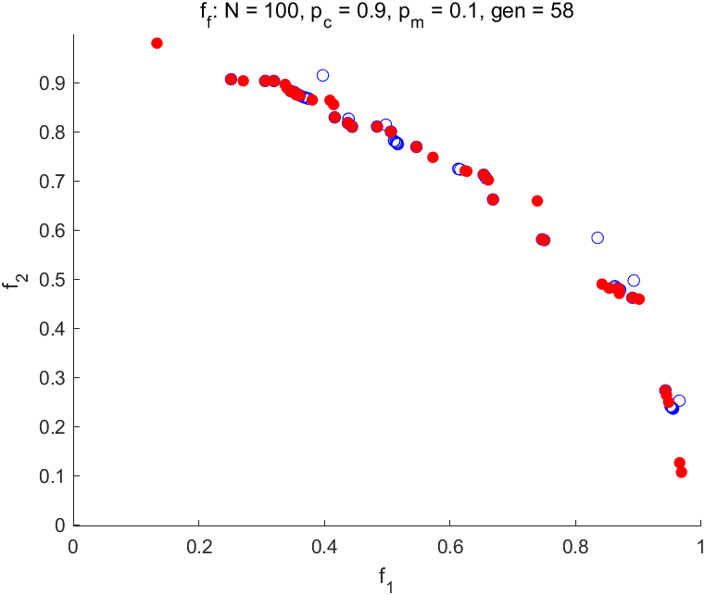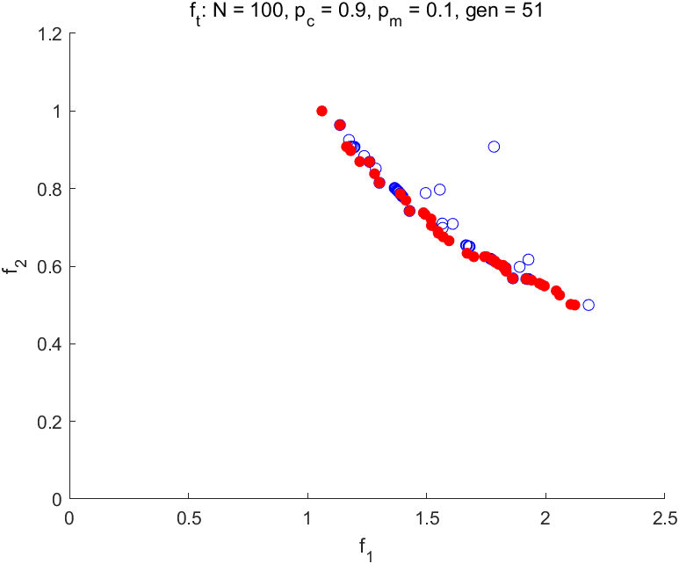

**Low crossover and high variation (pc = 0.3, pm = 0.3):**

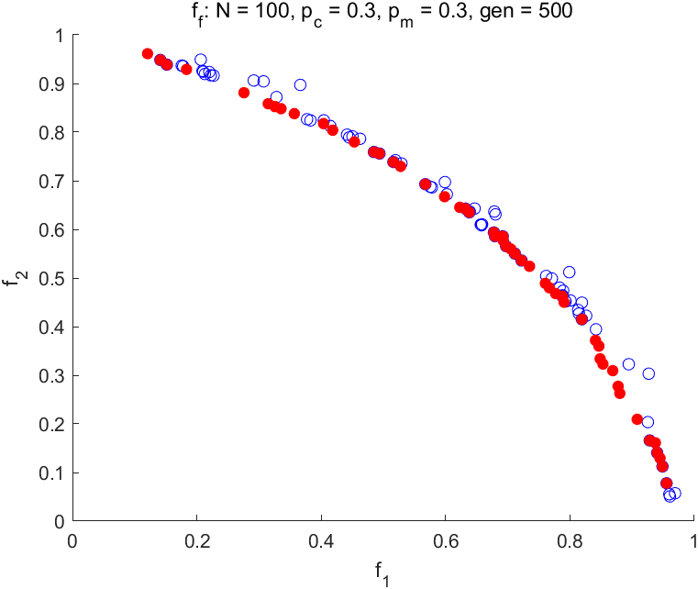 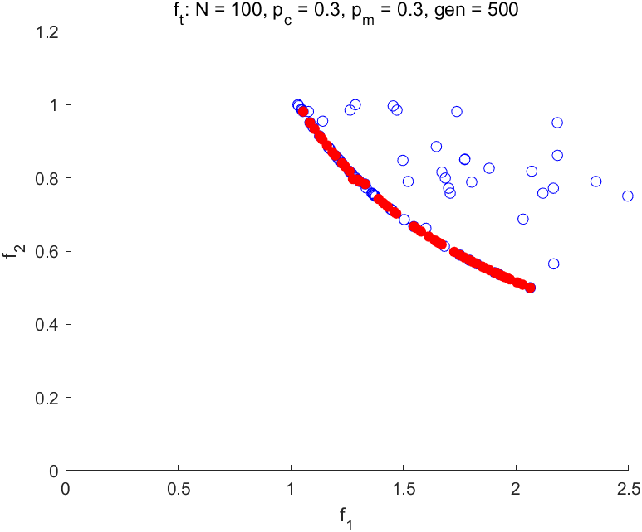

**Balanced crossover and high variation (pc = 0.7, pm = 0.2):**

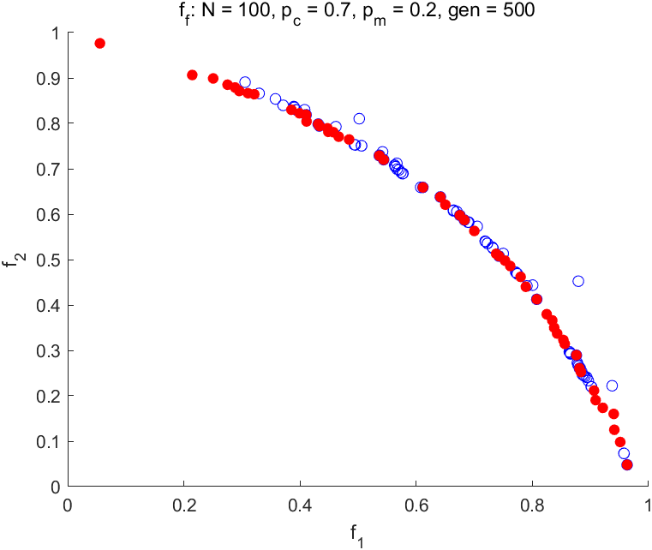 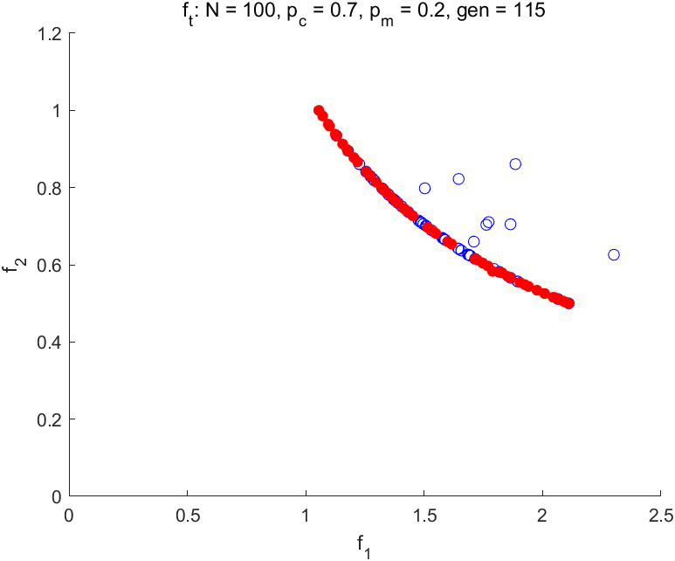

**Extreme (pc = 1.0, pm = 0.0):**

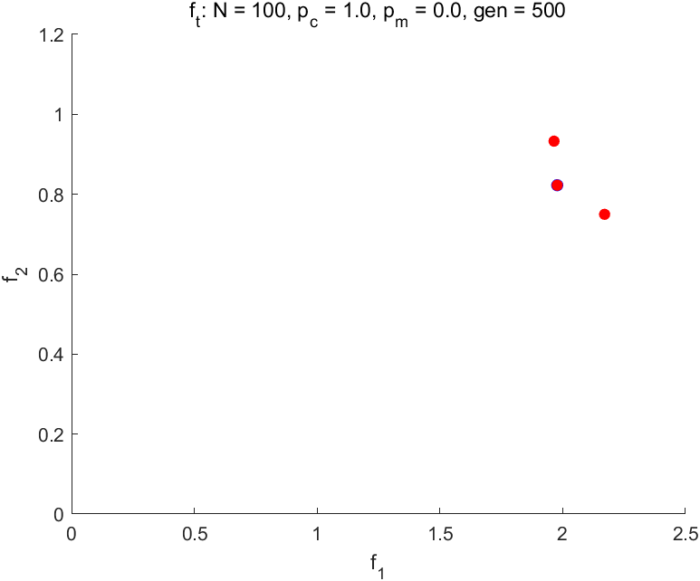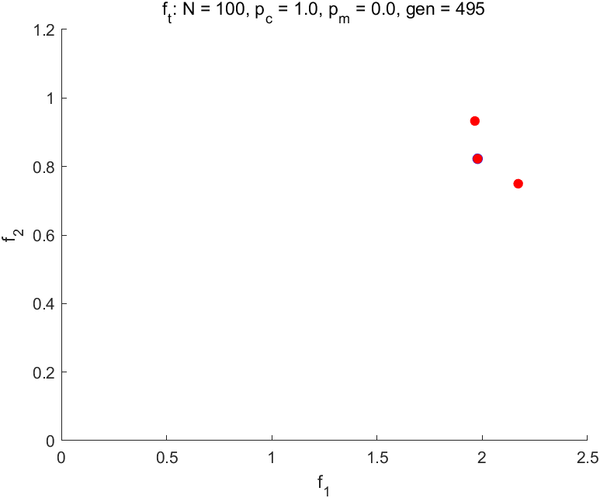

**Extreme (pc = 0.0, pm = 1.0):**

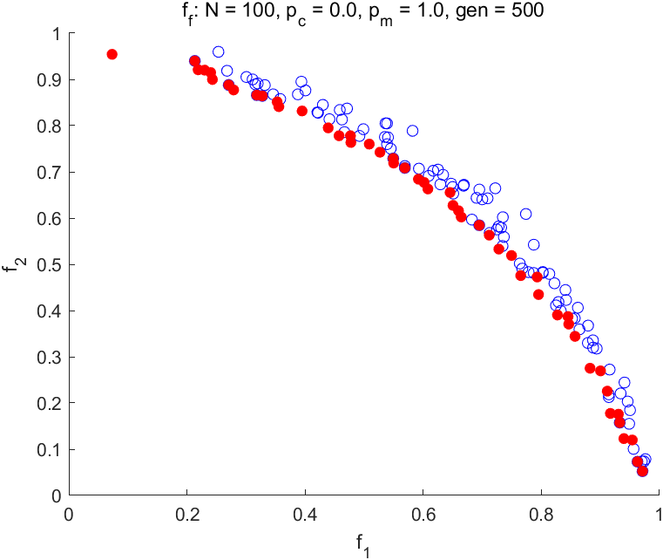 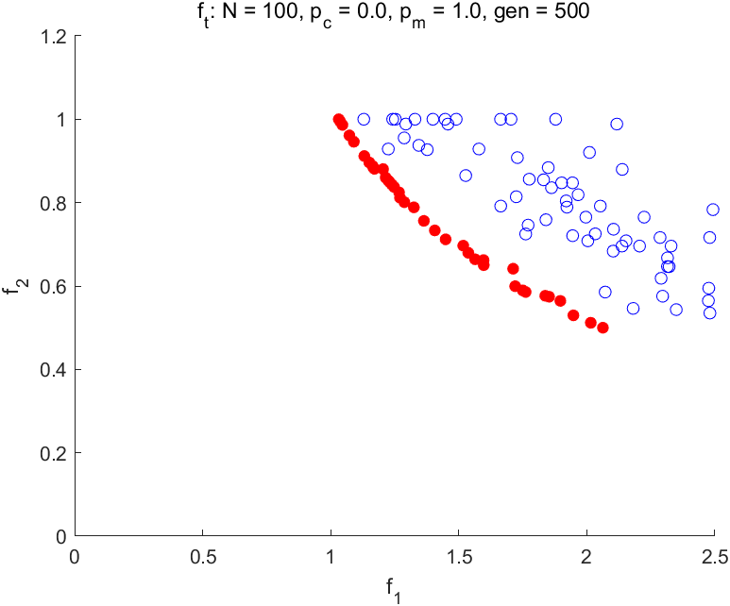

Using p_c = 0.7 and p_m = 0.2 provides a better balance between exploration and exploitation. The lower crossover rate helps maintain diversity, preventing the population from converging too quickly. Meanwhile, the higher mutation rate introduces enough randomness to explore new areas in the solution space.

**Mating=1:**

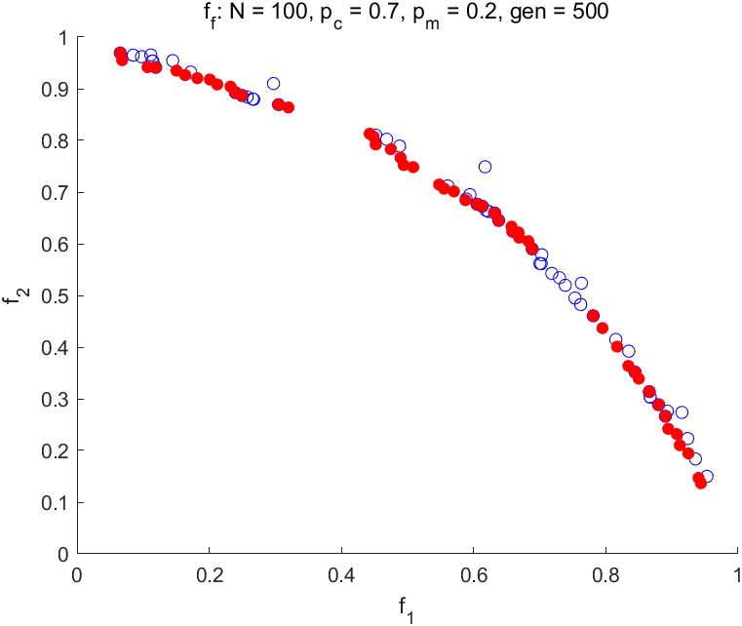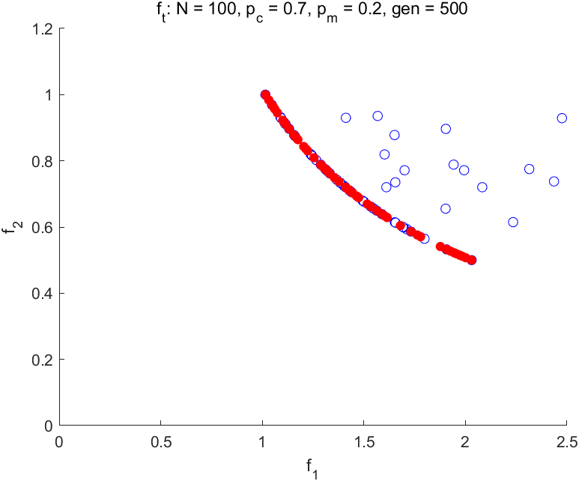

**Mating=3:**

 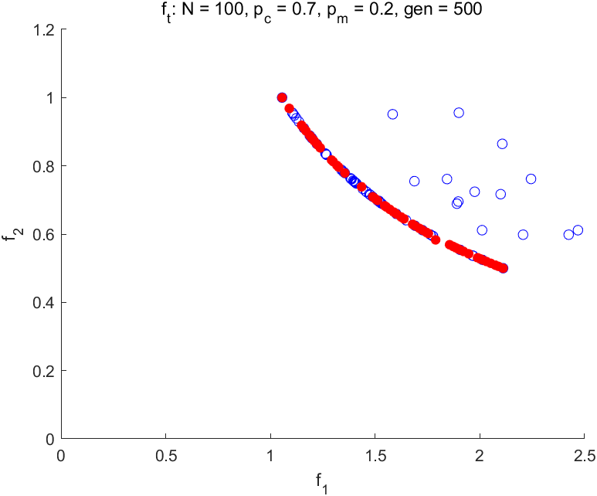

**Mating=5:**

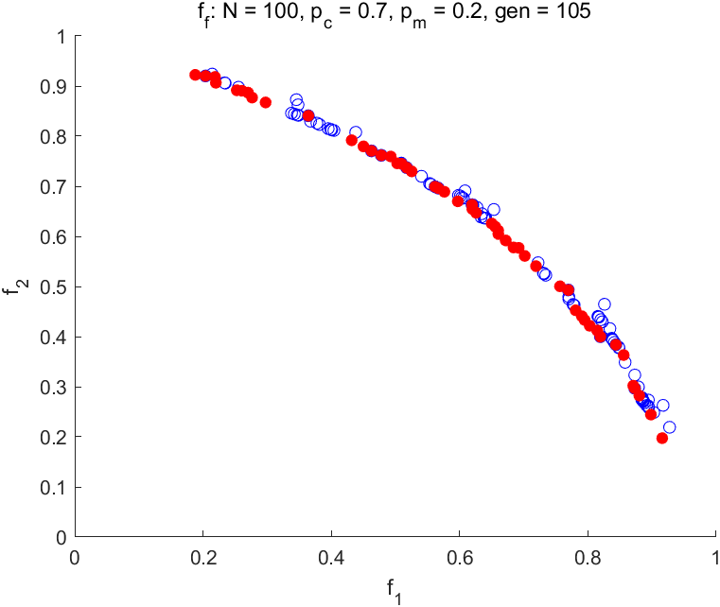 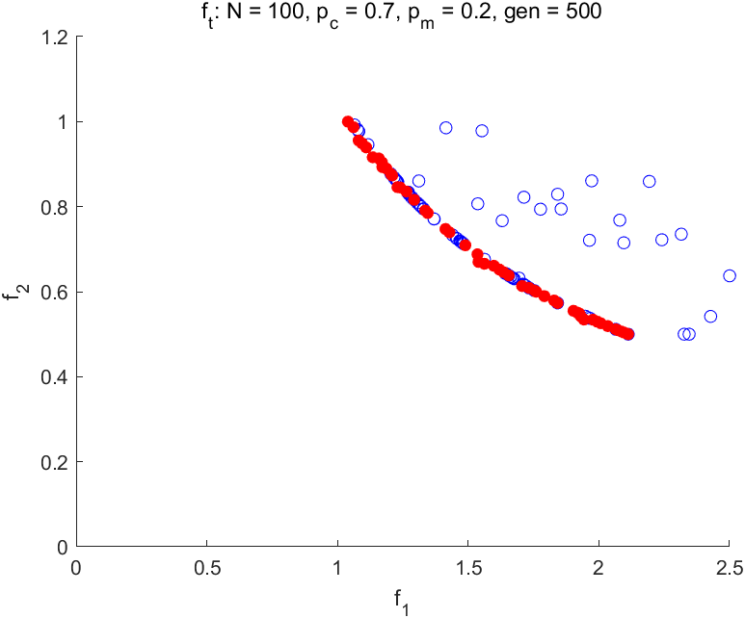

The experimental results show that the mating range parameter has little impact on algorithm performance. This suggests that sufficient diversity may already exist in the population. When mating is bigger, the resulting populations tends to converge to small regions. The influence of other parameters, like crossover and mutation rates, could be more significant in driving convergence.

**Sharing=1:**

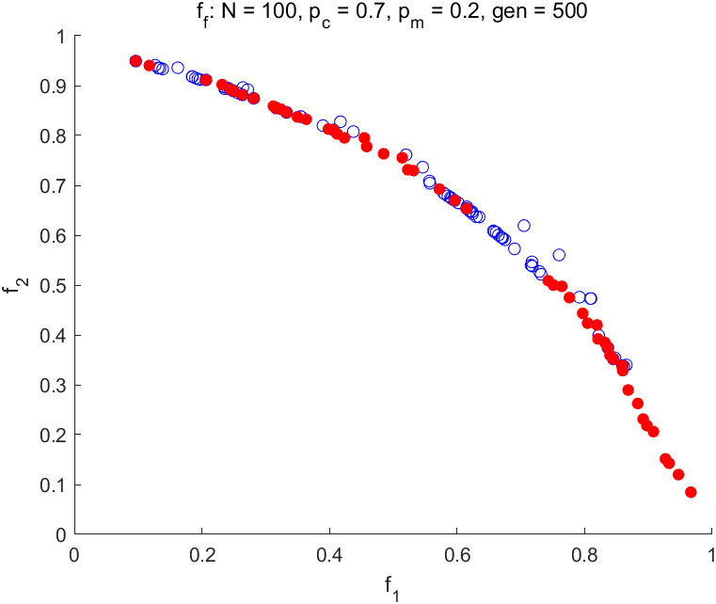 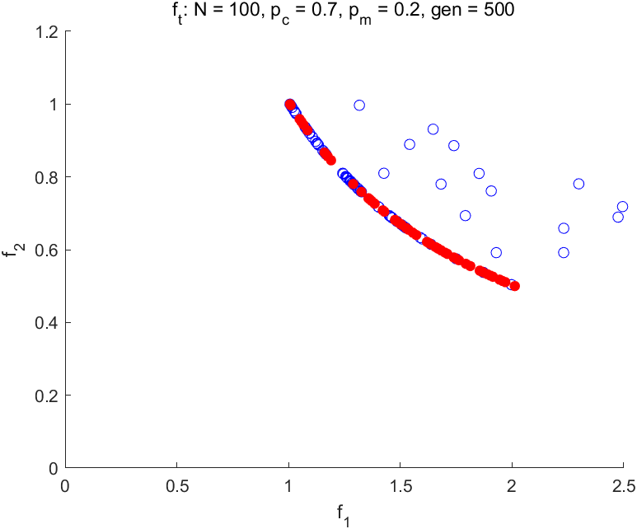

**Sharing=5:**

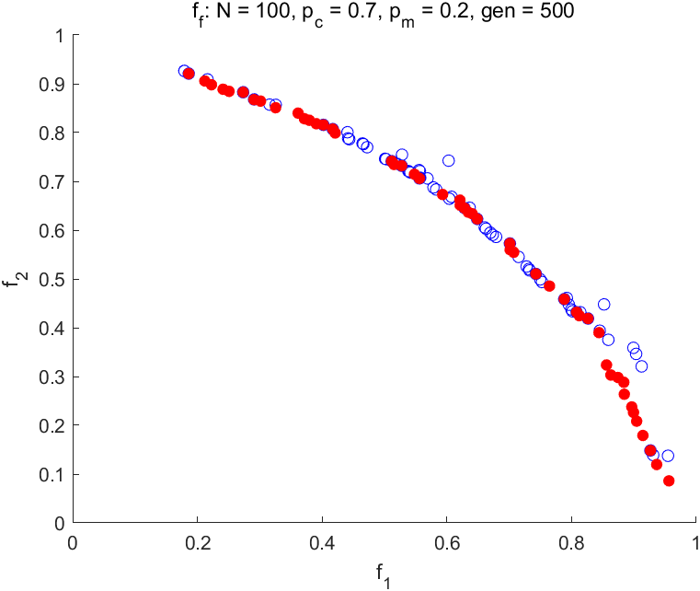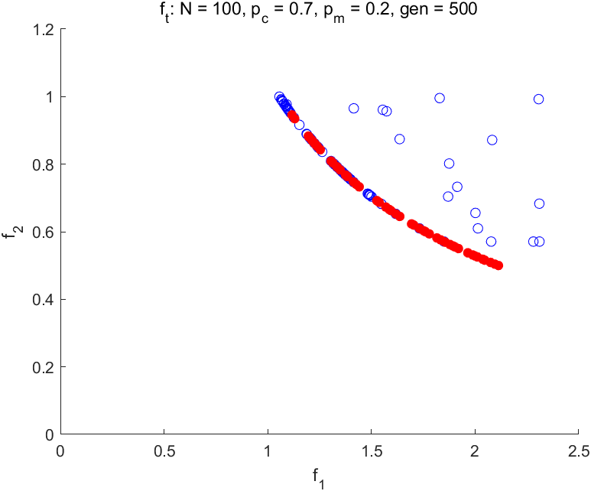

**Sharing=10:**

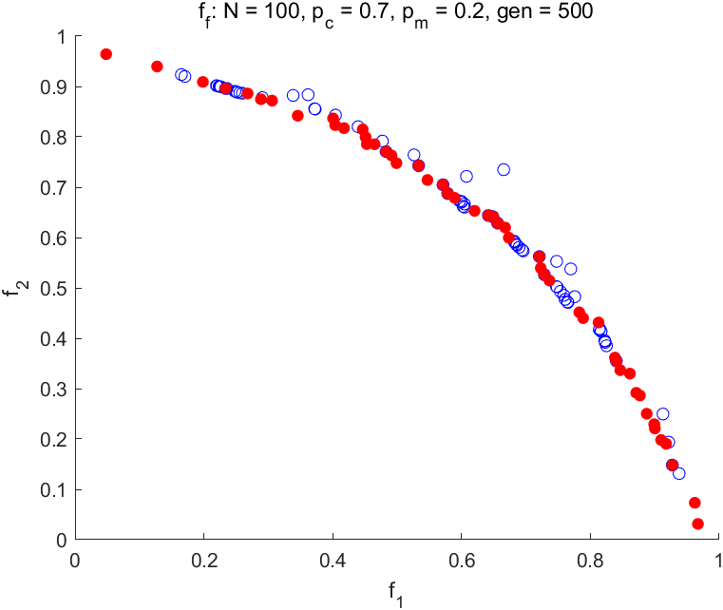 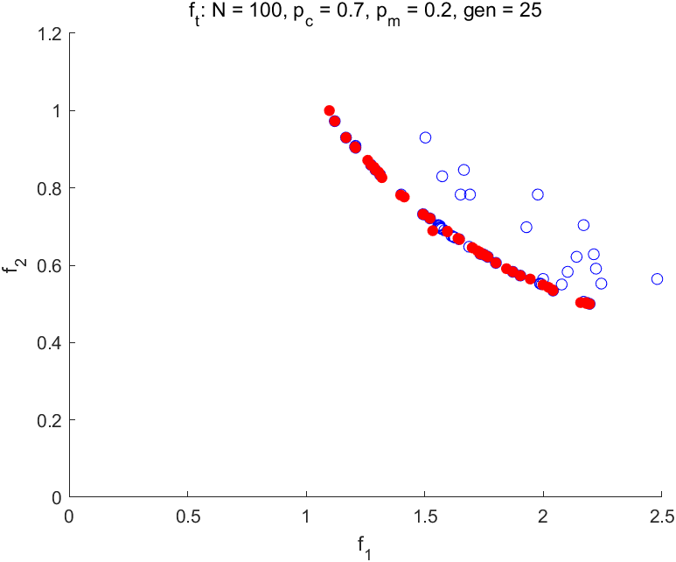

When the Sharing value is 1, the best result is obtained, but it is not obvious, which means that the sharing parameter has little effect on the algorithm.

**Mutation function(Uniform distribution in the interval [−0.15,0.15]):**

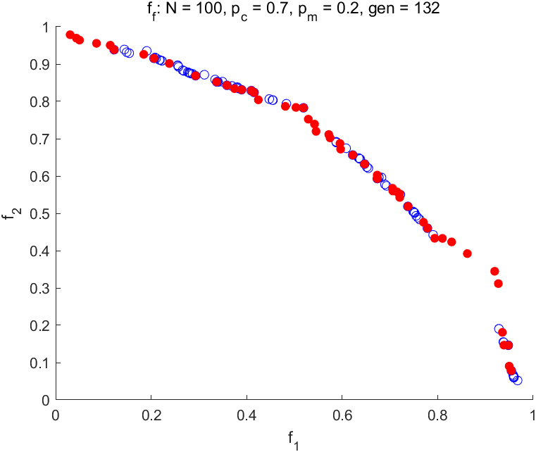 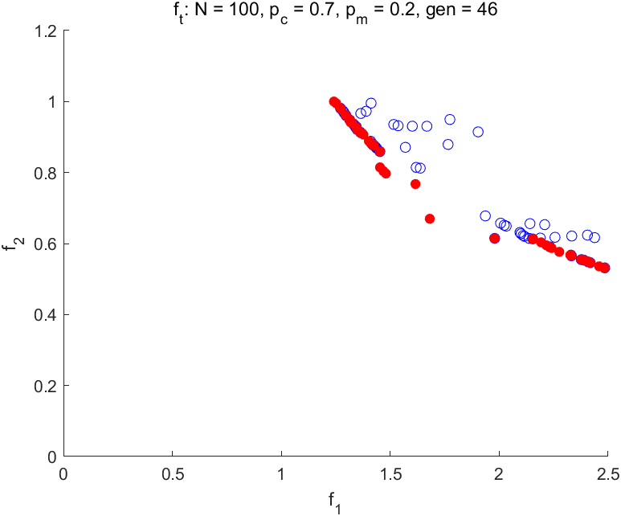

The algorithm's early termination with uniform distribution mutation is likely due to reduced population diversity; increasing the mutation range or using dynamic or Gaussian-based mutation can help maintain diversity, improve exploration, and avoid premature convergence.