TERNARY
FUND MANAGEMENT

Expense Claim Portal
User Guide — Employee & Admin

Covers: signing in, filling and submitting claims, auto-saving drafts,
the admin review dashboard, and claim-number settings.

Ternary Fund Management Pte Ltd · UEN 201902851Z
Prepared July 2026 · For internal use only

Table of Contents
1. Overview 3
2. Signing In 3
3. Employee Guide — Submitting a Claim 4
3.1 The claim form at a glance 4
3.2 Entering claim details 4
3.3 Adding and managing expense line items 4
3.4 Attaching receipts 5
3.5 Live Preview 5
3.6 Auto-saving drafts 5
3.7 Claim History (drafts and submitted claims) 6
3.8 Submitting the claim 6
3.9 Printing and exporting 7
4. Admin Guide — Reviewing Claims 8
4.1 Dashboard overview 8
4.2 Searching, filtering and sorting 8
4.3 Claim detail drawer 9
4.4 Approving or rejecting a claim 9
4.5 Editing, printing and exporting from Admin 9
4.6 Settings — claim numbering 10
5. Tips & Troubleshooting 11

1. Overview
The Ternary Expense Claim Portal is a web application that lets Ternary staff submit expense claims, attach supporting receipts, and generate an Excel claim sheet that matches the company's official template. Finance admins use a separate dashboard to review, filter, and approve or reject every claim that comes in and export physical copies of the claims and receipts for safekeeping purposes.
The app has two roles:
Role | What they can do
Employee (Claimant) | Fill in and submit their own expense claims, attach receipts, track claim/draft history, print or export their own claims.
Admin | Everything an employee can do, plus: view every employee's claim in one dashboard, search/filter/sort, approve or reject claims, edit any claim, and configure the next claim number.

Address: https://claim-app.tooboss.com/
Accounts: each person signs in with a username and password issued by the admins (Xingye, Peter and Mary). The table below lists the accounts seeded on first run — ask your admin if yours has since changed or to create a new account.

Username | Role
admin | Admin
edward | User
jason | User
peter | User
mary | User
hannah | User
thomas | User
chuiwhei | User
xingye | User
egan | User
yongchuan | User

Passwords are not shown here for security — get yours from whoever administers the app. Each employee only ever sees their own claims and drafts; only Admin accounts see everyone's.

2. Signing In
- Open a browser and go to the app's address (https://claim-app.tooboss.com/).
- Enter your username and password.
- Click Sign In.
If your account has the Admin role, you'll see an extra “Admin View” / “Admin Dashboard” link in the top bar after signing in — employees don't see this link.

3. Employee Guide — Submitting a Claim

3.1 The claim form at a glance
After signing in as an employee you land on the claim form. It's split into two panels:
- Left — an editable sheet styled to match the printed Ternary claim template exactly (same fonts, borders and layout as the Excel version).
- Right — a Live Preview that mirrors exactly what will be printed or exported, updating as you type.
The top bar has these actions, left to right: History, a small draft-status indicator, Print Form, Print Receipts, Download Excel, Save Draft, Submit Claim, and Sign out.

3.2 Entering claim details
- Employee's Name — type your name (an autocomplete list of past names helps).
- Claim Form No. — leave as it is; The system will automatically assign the a number when you submit.
- Claim Period (From / To) — pick the date range the claim covers using the date pickers.
- Currency — defaults to SGD; click it if you need to change the currency label.

3.3 Adding and managing expense line items
- Click + Add Row to add a new expense line.
- Fill in Date, Description (include a fund code if relevant, e.g. CYP001-POB), GST Amount, and Total.
- The Total Reimbursement at the bottom of the table recalculates automatically as you edit rows.
- Use the row's delete icon to remove a line item you no longer need.
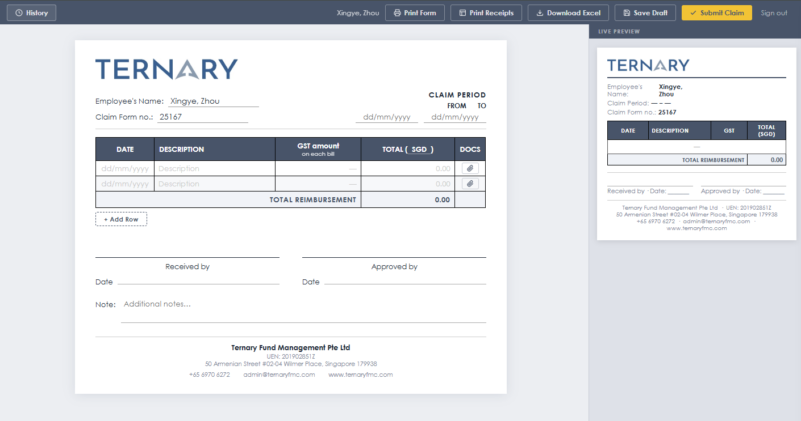

3.4 Attaching receipts
Each line item has its own upload button (the small paperclip/DOCS icon). Click it to open the upload modal, then either drag and drop files or click to browse.
- Supported formats: JPG, PNG, PDF, MSG, DOCX, GIF, WEBP, HEIC, DOC — up to 100 MB per file.
- You can attach multiple files to the same line item.
- Word documents (.docx/.doc) and Outlook items (.msg) are automatically converted to PDF in the background, so previews and printing work smoothly.
- Every attached file is listed on the Attachments sheet of the generated Excel file.
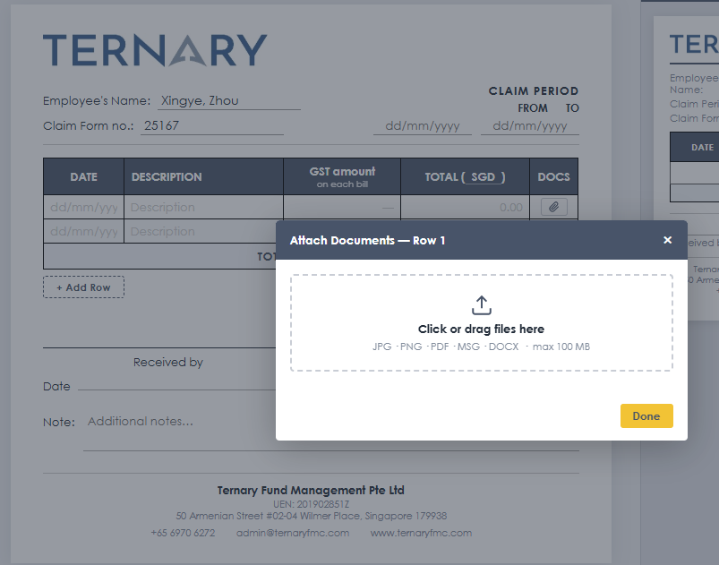

3.5 Live Preview
The panel on the right always shows exactly what your final document will look like — header, line items, signatures and footer — so you can sanity-check the layout before printing or submitting.

3.6 Auto-saving drafts
You never have to worry about losing work in progress (The progress is saved locally on your machine). The form saves a draft of your claim automatically:
- Any change — typing in a field, adding or removing a row, picking a date, uploading a file — schedules an auto-save about 0.8 seconds after you stop typing.
- A small status label near the History button shows “Saving…” and then “Draft saved”; the “Draft saved” message fades away after a few seconds.
- Drafts are private to you and stored on the server, so they survive closing the tab, restarting your computer, or switching devices — not just your browser's memory.
- The next time you open the claim form, your most recent draft is restored automatically, including any line items and attachments you'd already added.
- Use the Save Draft button any time you want to force an immediate save (for example, right before closing your laptop).
- When you click Submit Claim, the draft is deleted and replaced by the real submission — drafts never pile up as duplicate claims.
- You can keep more than one draft on the go — each is tracked separately and listed in your claim History (see 3.7).

3.7 Claim History (drafts and submitted claims)
Click History in the top bar to open a slide-in drawer listing:
- Drafts — unfinished claims, each showing its claim number (if any), employee name, and a Delete option. Click a draft card to reopen and continue editing it (this replaces whatever is currently on the form).
- Submitted — claims you've already sent to Finance, each tagged with its current status (Pending, Approved or Rejected).
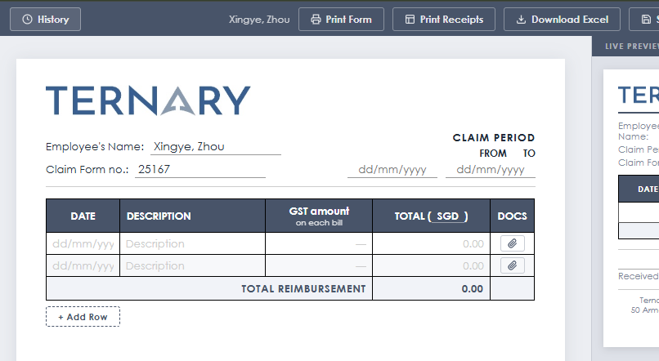

3.8 Submitting the claim
When the form is complete, click Submit Claim. The server assigns the claim its final reference and claim number, deletes the in-progress draft, and the claim immediately becomes visible to Finance admins on the Admin Dashboard with status Pending.

3.9 Printing and exporting
- Print Form — opens a print-ready version of the claim sheet itself.
- Print Receipts — renders every attached receipt into the browser's print preview so all documents print correctly on the first try, even scanned images or converted Word/Outlook files.
- Download Excel — generates a .xlsx file matching the official Ternary claim template, including an Attachments sheet listing every uploaded file.

4. Admin Guide — Reviewing Claims
Only accounts with the Admin role can open the Admin Dashboard (at /admin). From the claim form, admins see an “Admin View” link in the top bar; from the dashboard, a “+ New Claim” link goes back to the claim form and a “Settings” link opens claim-number settings.

4.1 Dashboard overview
The dashboard opens on a summary strip with five live counters:
Card | Meaning
Total Submitted | Every claim ever submitted, across all employees.
Pending Review | Claims awaiting a decision.
Approved | Claims marked Approved.
Rejected | Claims marked Rejected.
Total Approved (SGD) | Sum of the Approved claims' amounts.

Below the summary strip is the claims table, listing every submission with its submitted date, employee, claim number, period, amount, item count, document count, and status.
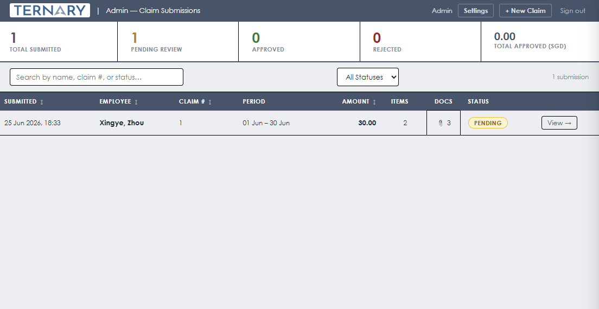

4.2 Searching, filtering and sorting
- Type in the search box to filter instantly by employee name, claim number, or status.
- Use the status dropdown to show only Pending, Approved or Rejected claims.
- Click any of the underlined column headers (Submitted, Employee, Claim #, Amount) to sort the table by that column; click again to reverse the order.


4.3 Claim detail drawer
Click any row to slide in a Claim Details drawer showing the full expense breakdown, notes, and every attached document for that claim.
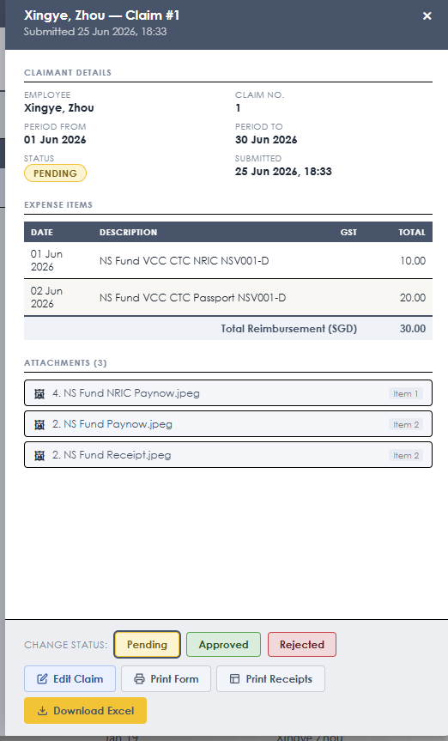

4.4 Approving or rejecting a claim
At the bottom of the detail drawer, click Pending, Approved, or Rejected to change a claim's status with a single click. The change is reflected immediately in the table and in the summary strip counters.


4.5 Editing, printing and exporting from Admin
- Edit Claim — opens the claim in the employee form, pre-filled, so an admin can correct entries on an employee's behalf (draft controls are hidden in this mode).
- Print Form / Print Receipts — same printing tools available to employees, usable here for any employee's claim.
- Download Excel — regenerates the .xlsx for that specific submission.

4.6 Settings — claim numbering
Open Settings from the Admin Dashboard top bar to control the sequential numbering Finance uses for new claims.
- Next claim number — sets the number the next newly submitted claim will receive; every claim after that increments automatically.
- A live preview line updates as you type, showing exactly what the next claim number will be.
- Click Save (or press Enter) to commit the change; a “✓ Saved” confirmation briefly appears.
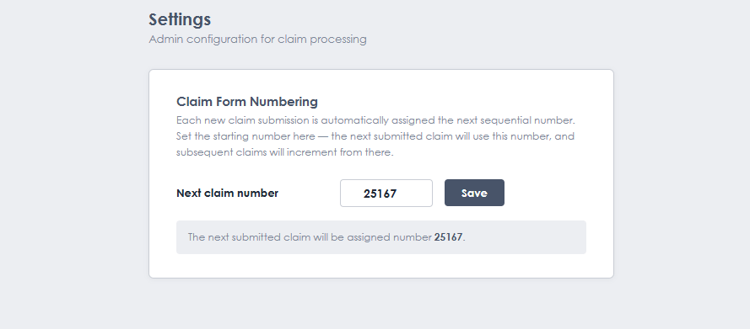

5. Tips & Troubleshooting
- Closed the tab by accident mid-claim? Just sign in again — your latest draft loads automatically (section 3.6).
- Working on more than one claim at once is fine — each Save Draft / auto-save updates its own draft; use History to jump between them and delete any you no longer need.
- Admins deploying this app for a shared team: make sure the SECRET_KEY environment variable is set to a unique value before going live, per the project's README.

Ternary Fund Management Pte Ltd · Confidential · 6 Temasek Boulevard, #09-03A/04, #4 Suntec Tower, Singapore 038986

