
2024年春季学期
计算学部《软件工程》课程

实验报告

Lab3 代码评审与单元测试

姓名 | 学号 | 联系方式
徐柯炎 | 2021110683 | 2259245769@qq.com/15189789979
高浚豪 | 2021111700 | 2152246548@qq.com/13359705210

目 录

1 实验要求 1
(1) 代码评审： 1
(2) 单元测试： 1
2 在IDE中配置代码审查与分析工具 1
2.1 Checkstyle 1
2.2 SpotBugs 3
2.3 EclEmma 4
2.4 Junit 4
3 Checkstyle所发现的代码问题清单及原因分析 5
4 SpotBugs所发现的代码问题清单及原因分析 6
5 针对Lab1的黑盒测试 7
5.1 所选的被测函数及其需求规约 7
5.2 等价类划分结果 7
5.3 测试用例设计 8
5.4 JUnit测试代码 8
5.5 JUnit单元测试结果 13
5.6 未通过测试的原因分析及代码修改 15
5.7 Git操作记录 16
6 针对Lab1的白盒测试 17
6.1 所选的被测函数 17
6.2 程序流程图 21
6.3 控制流图 21
6.4 圈复杂度计算与基本路径识别 22
6.5 测试用例设计 22
6.6 JUnit测试代码 26
6.7 JUnit单元测试结果 31
6.8 代码覆盖度分析 39
6.9 未通过测试的原因分析及代码修改 41
6.10 Git操作记录 42
7 计划与实际进度 43
8 小结 43

[文档全部完成之后，请更新上述区域]

实验要求

代码评审：
- 按照Lab1分组，两人共同完成实验；
- 针对Lab1所完成的代码，进行代码评审(走查) ，从代码规范性和正确性角度对代码进行评价；
- 使用以下两个工具完成实验：
  - Checkstyle
  - SpotBugs

单元测试：
- 按Lab1分组，两人共同完成实验。
- 设计黑盒测试用例和白盒测试用例。
- 在JUnit环境下撰写测试代码并执行测试。
- 使用EclEmma或IDE自带工具统计测试的覆盖度。

在IDE中配置代码审查与分析工具
简要描述在IDE中安装和配置Checkstyle、SpotBugs、EclEmma、JUnit等插件或IDE自带插件的过程。

Checkstyle
首先打开IDEA菜单栏Settings中的plugins，搜索CheckStyle-IDEA并安装；
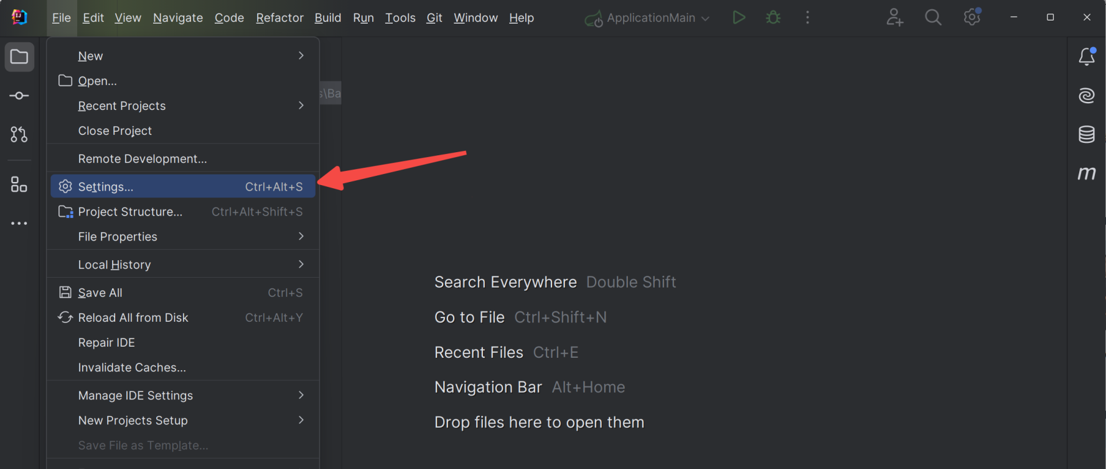
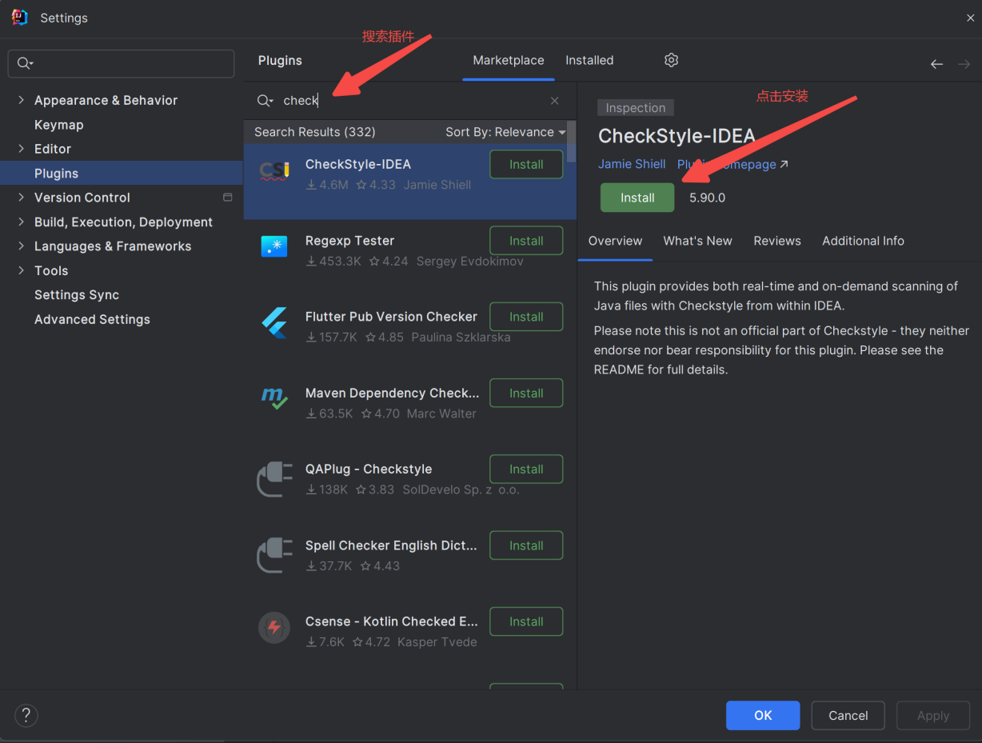
然后配置checkstyle。这里我们使用Google Checks。
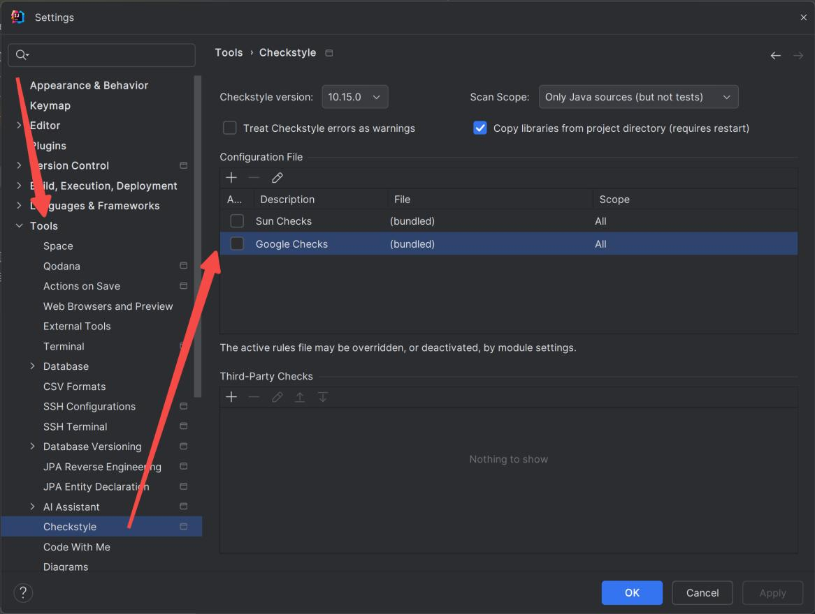

SpotBugs
首先在IDEA插件市场搜索SpotBugs，点击Install安装，安装后重启IDEA；
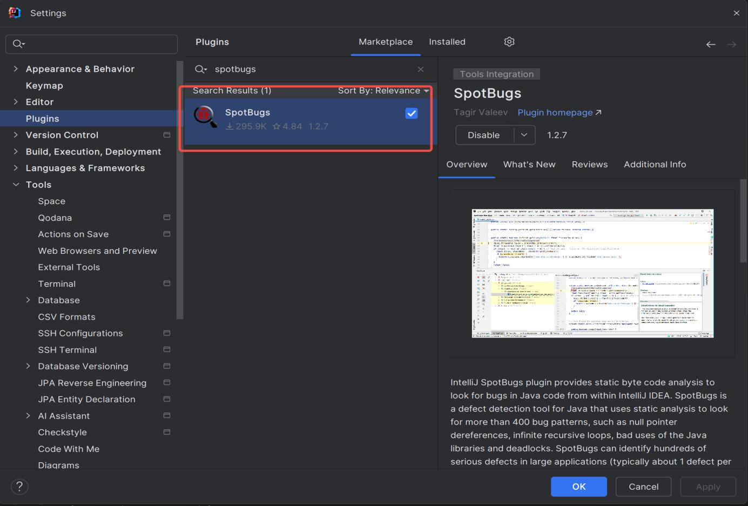
然后在设置的Tools下，点击SpotBugs，按下图所示点击加号，添加规则。
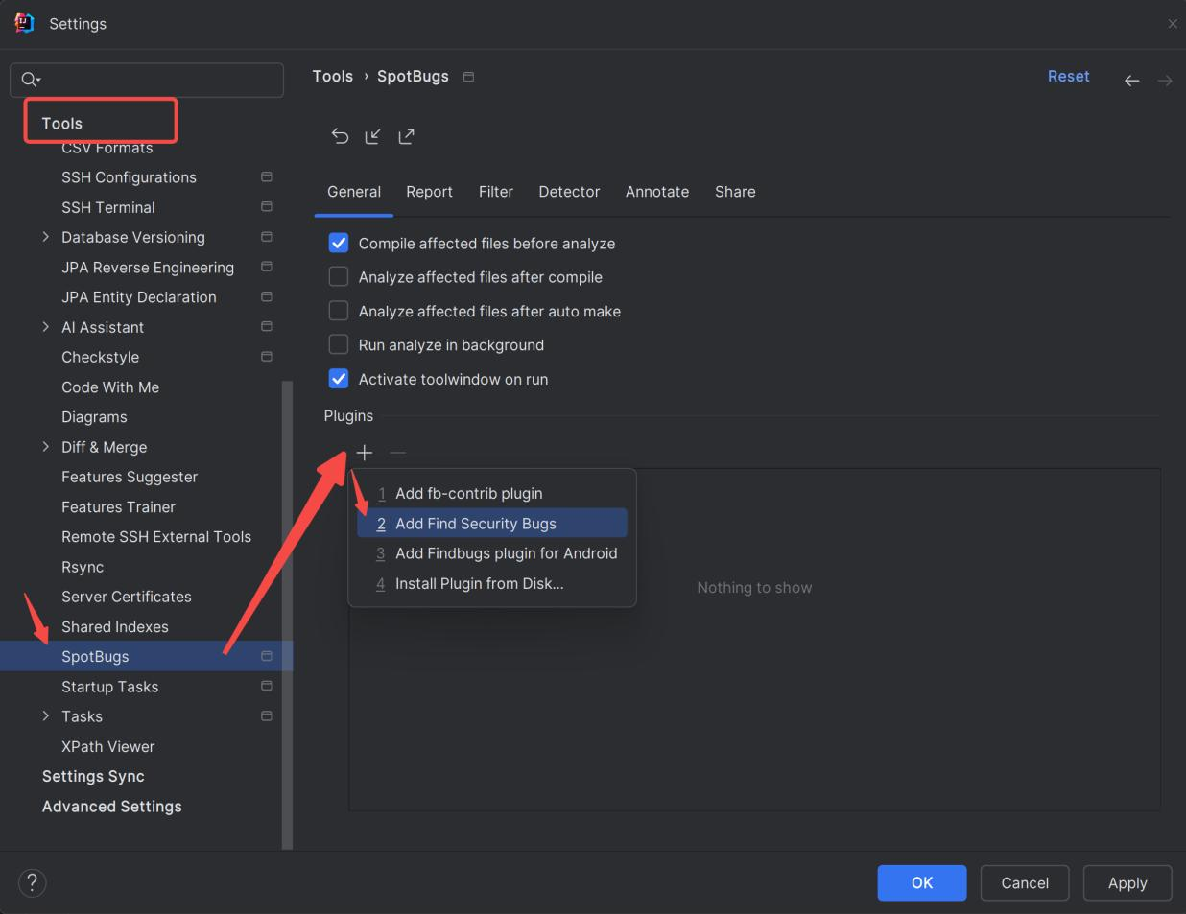

Junit
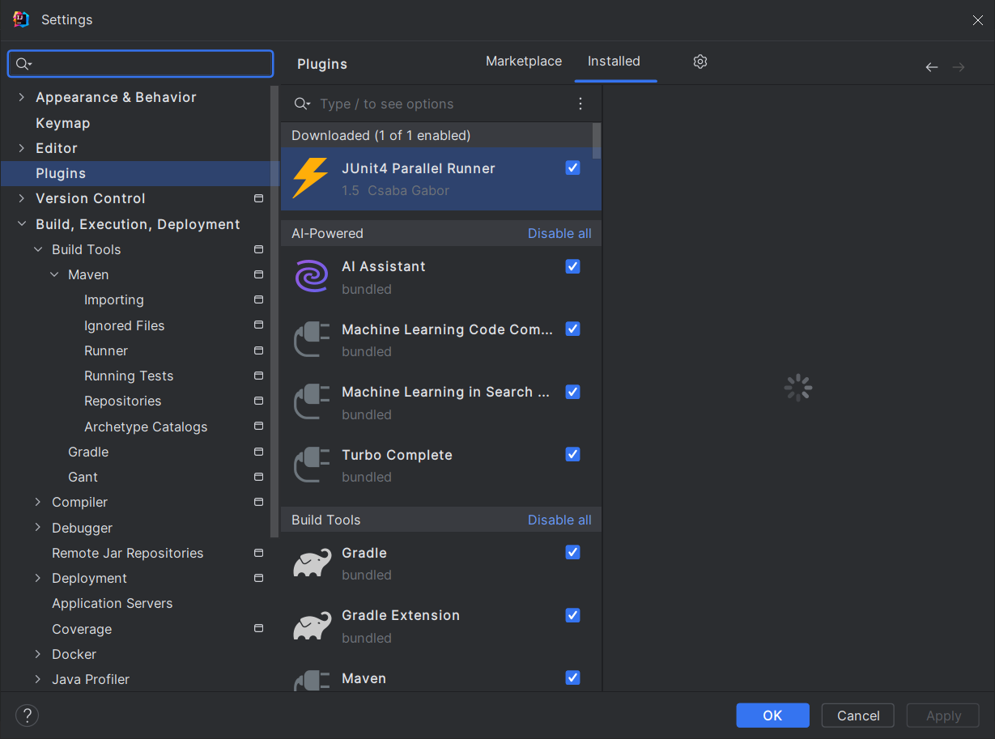
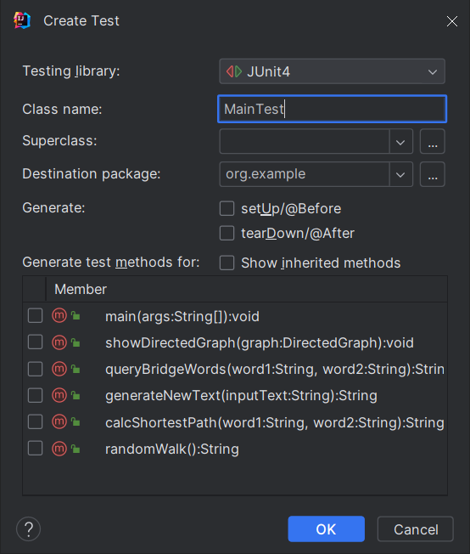

Checkstyle所发现的代码问题清单及原因分析
针对同种类型的问题，只需要列出一个典型代表即可。
编号 | 问题描述 | 类型 | 所在代码行号 | 修改策略
1 | xx元素缩进了x个缩进符，应为y个。 | Indentation | 几乎所有行 | 修改idea的缩进符策略，从四个修改为两个
2 | 注释应与第x行代码同样缩进y个缩进符，而不是0个。 | CommentsIndentation | 27、30、33、284、316、324、341、354 | 修改idea的注释风格，使得注释符号紧跟在注释前面
3 | 导入组之前的额外空行 'java.io.IOException'。 | CustomImportOrder | 9 | 删除空行
4 | 导入语句'java.io.IOException' 字典顺序错误。应在'org.jetbrains.annotations.NotNull'之前。 | CustomImportOrder | 10、11、12、13、14 | 手动调整顺序
5 | 不应使用 '.*' 形式的导入 - java.util.* 。 | AvoidStarImport | 4 | 更改导入形式，分别导入
6 | 缺少 Javadoc 。 | MissingJavadocType | 12 | 添加注释
7 | 缺少 Javadoc 。 | MissingJavadocMethod | 17 | 添加注释
8 | Parameter name 'G' must match pattern '^[a-z]([a-z0-9][a-zA-Z0-9]*)?$'. | ParameterName | 89 | 更改变量命名方式
9 | 本行字符数 109个，最多：100个。 | LineLength | 114 | 换行
10 | Method name 'ShortestPath' must match pattern '^[a-z][a-z0-9]\w*$' | MethodName | 174 | 更改方法命名方式

SpotBugs所发现的代码问题清单及原因分析
针对同种类型的问题，只需要列出一个典型代表即可。
优先级 | 问题描述 | 违反的规则集 | 所在代码行号 | 修改策略
3 | This random generator (java.lang.Math.random()) is predictable | Security | 171 | 修改随机方法，在这里我们采用SecureRandom()
2 | Random object created and used only once | Bad practice | 171 | 将SecureRandom()声明为一个静态的类成员，从而复用这个成员
1 | Found reliance on default encoding: new | Internationalization | 28、40、76 | 明确指定字符编码，这里采用UTF-8
1 | getNodes() may expose internal representation by returning DirectedGraph.nodes | Malicious code vulnerability | 173 | 返回一个不可变的视图来保护内部表示。在这里我们使用 Collections.unmodifiableList 来实现
3 | Unused field: Node.neighbors | Performance | 9 | 删除此变量即可
2 | Exceptional return value of java.io.File.delete() ignored | Bad practice | 45 | 记录delete的返回值，并增加删除失败时的操作

针对Lab1的黑盒测试

所选的被测函数及其需求规约
public static String queryBridgeWords(String word1, String word2)
函数功能：
queryBridgeWords 函数用于在一个有向图中查找从 word1 到 word2 的桥接词（bridge words）。桥接词是那些在两个指定词之间存在的词。
输入描述：
word1（类型：String）：查询桥接词的起始单词。
word2（类型：String）：查询桥接词的目标单词。
输出描述：
返回一个 String 类型的结果，该结果可能是以下几种情况：
如果 word1 和 word2 中的任何一个单词不在图中，返回描述缺失单词的错误信息。例如："No "word1" and "word2" in the graph!" 或 "No "word1" in the graph!"。
如果在 word1 和 word2 之间没有桥接词，返回："No bridge words from "word1" to "word2"!"。
如果存在桥接词，返回："The bridge words from "word1" to "word2" is: bridgeWord1 bridgeWord2 ...", 列出所有桥接词。

等价类划分结果
请根据自己的情况扩展该表格，给各个等价类唯一的编号
根据需要，增加下表的行数
约束条件说明 | 有效等价类及其编号 |  | 无效等价类及其编号
word1 和 word2 都在图中 | word1 和 word2 都在图中，且存在桥接词 | (1) | word1 和 word2 都不在图中 | (6)
 | word1 和 word2 都在图中，但没有桥接词存在 | (2) | word1 和 word2 都不在图中 | (6)
 | word1 和 word2 相同 | (3) | word1 和 word2 都不在图中 | (6)
 | word1 和 word2 直接相连且之间没有桥接词 | (4) | word1 和 word2 都不在图中 | (6)
word1 或 word2 在图中不存在 | word1 或 word2 不在图中 | (5) | word1 和 word2 都不在图中 | (6)
 |  |  | 输入 word1 或 word2 为 null 或空字符串 | (7)

测试用例设计
测试用例编号 | 输入 | 期望输出 | 所覆盖的等价类编号
 | "to", "strange" | "The bridge words from "to" to "strange" is: explore" | 有效等价类 1
 | "boldly", "before" | "No bridge words from "boldly" to "before"!" | 有效等价类 2
 | "out", "out" | No bridge words from "out" to "out"! | 有效等价类 3
 | "to", "boldly" | "No bridge words from "to" to "boldly"!" | 有效等价类 4
 | "to", "gjh" | No "gjh" in the graph! | 有效等价类5
 | "hello", "world" | "No "hello" and "world" in the graph!" | 无效等价类 6
 | "world", "" | "No "world" and "" in the graph!" | 无效等价类 7

JUnit测试代码
针对5.3中的每一个测试用例，把其测试代码粘贴如下，代码必须是完整的。

测试用例编号 | JUnit测试代码
package org.example;
import org.junit.Test;
import static org.junit.Assert.assertEquals;
import org.example.util.Func;
import java.util.List;
public class MainTest {
@Test
public void testValidBridgeWordsExist() {
Main main = new Main();
String str = Func.getStr("1.txt");
List<String> wordList = Func.getWords(str);
main.graph = Func.buildDirectedGraph(wordList);
String result = main.queryBridgeWords("to", "strange");
assertEquals("The bridge words from \"to\" to \"strange\" is: explore ", result);
}
}
package org.example;
import org.junit.Test;
import static org.junit.Assert.assertEquals;
import org.example.util.Func;
import java.util.List;
public class MainTest {
public void testNoBridgeWordsExist() {
Main main = new Main();
String str = Func.getStr("1.txt");
List<String> wordList = Func.getWords(str);
main.graph = Func.buildDirectedGraph(wordList);
String result = org.example.Main.queryBridgeWords("boldly", "before");
assertEquals("No bridge words from \"boldly\" to \"before\"!", result);
}

}
package org.example;
import org.junit.Test;
import static org.junit.Assert.assertEquals;
import org.example.util.Func;
import java.util.List;
public class MainTest {
@Test
public void testWordsEqual() {
Main main = new Main();
String str = Func.getStr("1.txt");
List<String> wordList = Func.getWords(str);
main.graph = Func.buildDirectedGraph(wordList);
String result = org.example.Main.queryBridgeWords("out", "out");
assertEquals("No bridge words from \"out\" to \"out\"!", result);
}

}
package org.example;
import org.junit.Test;
import static org.junit.Assert.assertEquals;
import org.example.util.Func;
import java.util.List;
public class MainTest {
@Test
public void testWordsConnect() {
Main main = new Main();
String str = Func.getStr("1.txt");
List<String> wordList = Func.getWords(str);
main.graph = Func.buildDirectedGraph(wordList);
String result = org.example.Main.queryBridgeWords("to", "boldly");
assertEquals("No bridge words from \"to\" to \"boldly\"!", result);
}

}
package org.example;
import org.junit.Test;
import static org.junit.Assert.assertEquals;
import org.example.util.Func;
import java.util.List;
public class MainTest {
@Test
public void testWord1DoesNotExist() {
Main main = new Main();
String str = Func.getStr("1.txt");
List<String> wordList = Func.getWords(str);
main.graph = Func.buildDirectedGraph(wordList);
String result = org.example.Main.queryBridgeWords("gjh", "to");
assertEquals("No \"gjh\" in the graph!", result);
}

}
package org.example;
import org.junit.Test;
import static org.junit.Assert.assertEquals;
import org.example.util.Func;
import java.util.List;
public class MainTest {
@Test
public void testWordsDoesNotExist() {
Main main = new Main();
String str = Func.getStr("1.txt");
List<String> wordList = Func.getWords(str);
main.graph = Func.buildDirectedGraph(wordList);
String result = org.example.Main.queryBridgeWords("hello", "world");
assertEquals("No \"hello\" and \"world\" in the graph!", result);
}

}
package org.example;
import org.junit.Test;
import static org.junit.Assert.assertEquals;
import org.example.util.Func;
import java.util.List;
public class MainTest {
@Test
public void testWordsNull() {
Main main = new Main();
String str = Func.getStr("1.txt");
List<String> wordList = Func.getWords(str);
main.graph = Func.buildDirectedGraph(wordList);
String result = org.example.Main.queryBridgeWords("world", " ");
assertEquals("No \"world\" and \" \" in the graph!", result);
}

}

JUnit单元测试结果
测试用例编号 | 期望输出 | 实际输出 | 是否通过测试，请给出屏幕截图
 | The bridge words from "to" to "strange" is: explore | The bridge words from "to" to "strange" is: explore | 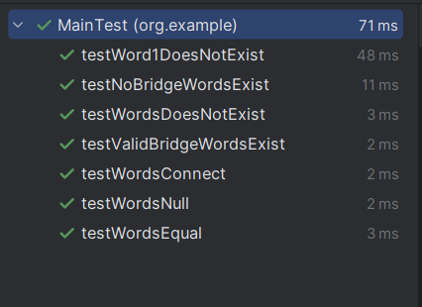
 | "No bridge words from "boldly" to "before"! | "No bridge words from "boldly" to "before"!
 | No bridge words from "out" to "out"! | No bridge words from "out" to "out"!
 | No bridge words from "to" to "boldly"! | No bridge words from "to" to "boldly"!
 | No "gjh" in the graph! | No "gjh" in the graph
 | No "hello" and "world" in the graph! | No "hello" and "world" in the graph!
 | "No "world" and " " in the graph! | "No "world" and " " in the graph!

未通过测试的原因分析及代码修改
测试全部通过
修改代码之后，请重新填写下表，尽可能保证所有测试用例都能通过测试。

测试用例编号 | 期望输出字符串 | 实际输出字符串 | 是否通过测试，请给出屏幕截图

Git操作记录
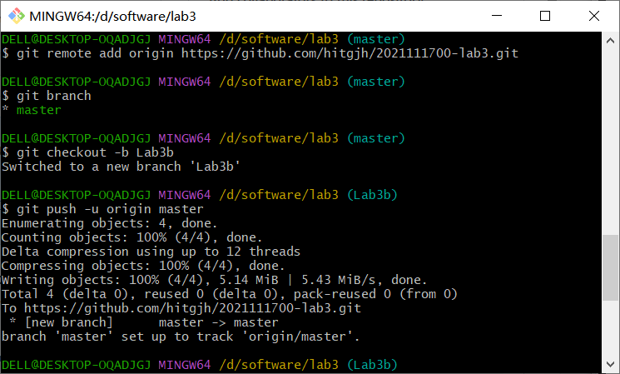
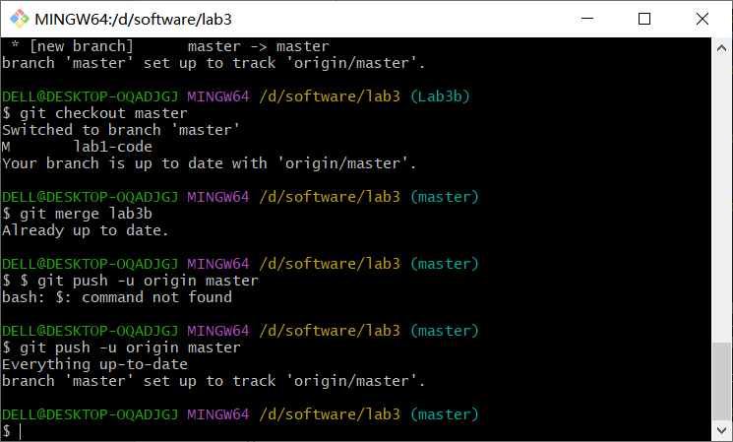

针对Lab1的白盒测试

所选的被测函数
注意：不能与5.1节所选函数重复。
被测函数的名称 | calcShortestPath
功能描述 | 输入两个节点，函数计算出两个节点间的最短路径，输出路径及其长度，如果只输入了一个节点，则输出该节点到所有节点的路径，如输入节点在图中不存在，则报告错误信息
被测函数的代码  （以IDE环境下的截图方式给出，确保能看清楚，并保留IDE为每行代码分配的行号，后续各部分均以此行号为准。如果一屏截取不下，可以分多屏截取，均插入右侧格中） | 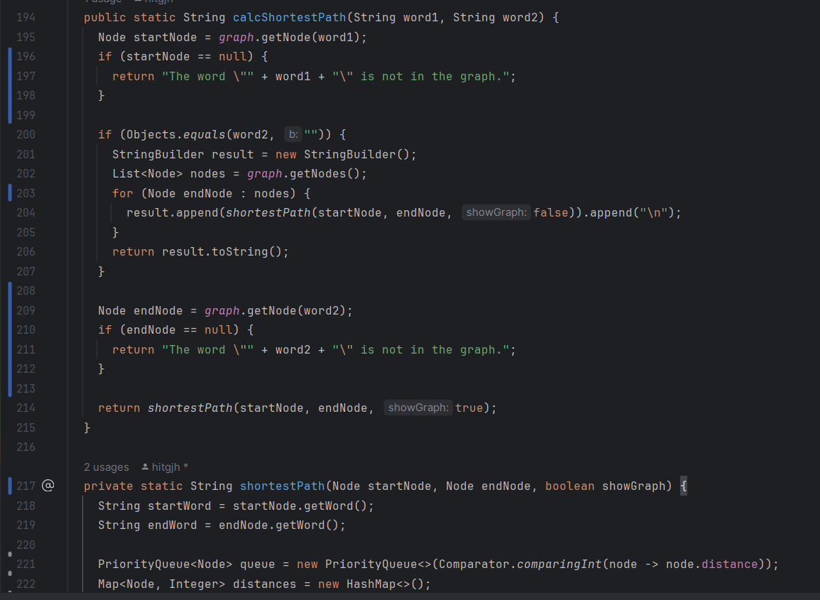  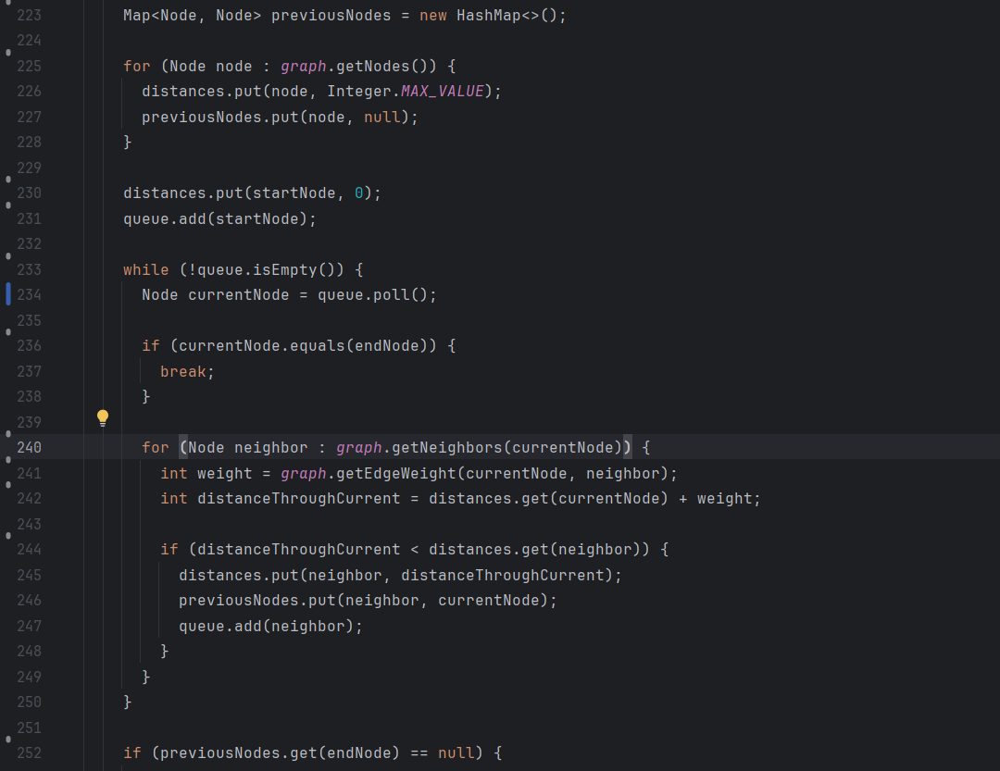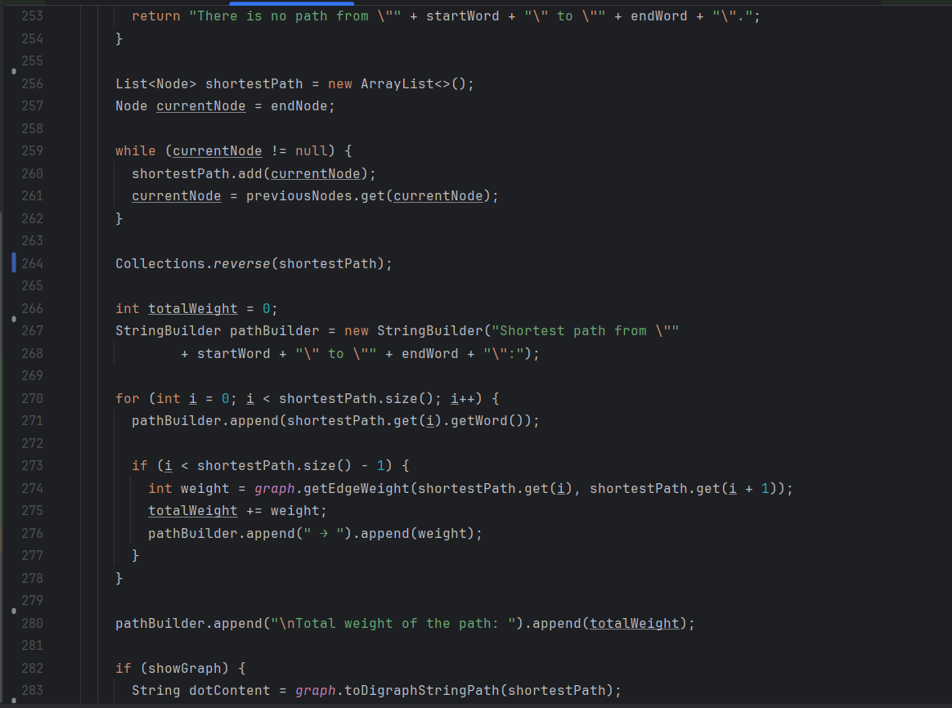  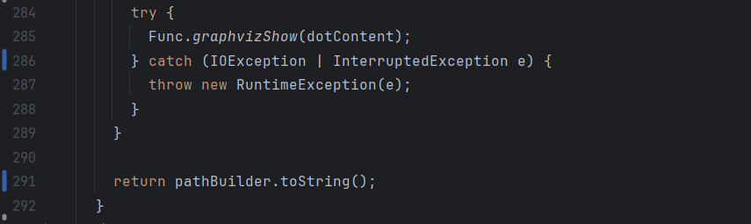
输入参数列表 | 参数名 | 含义 | 数据类型
输入参数列表 | word1 | 起始节点单词 | 字符串
输入参数列表 | word2 | 目标节点单词 | 字符串
输出参数 | 含义 |  | 数据类型
输出参数 | 最短路径描述字符串 |  | 字符串
代码总行数 | 99
包含的循环数 | 6
包含的判定数 | 8

程序流程图
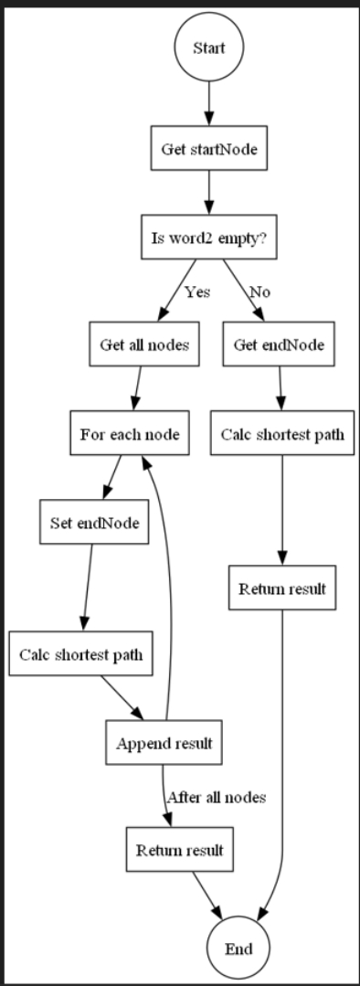

控制流图
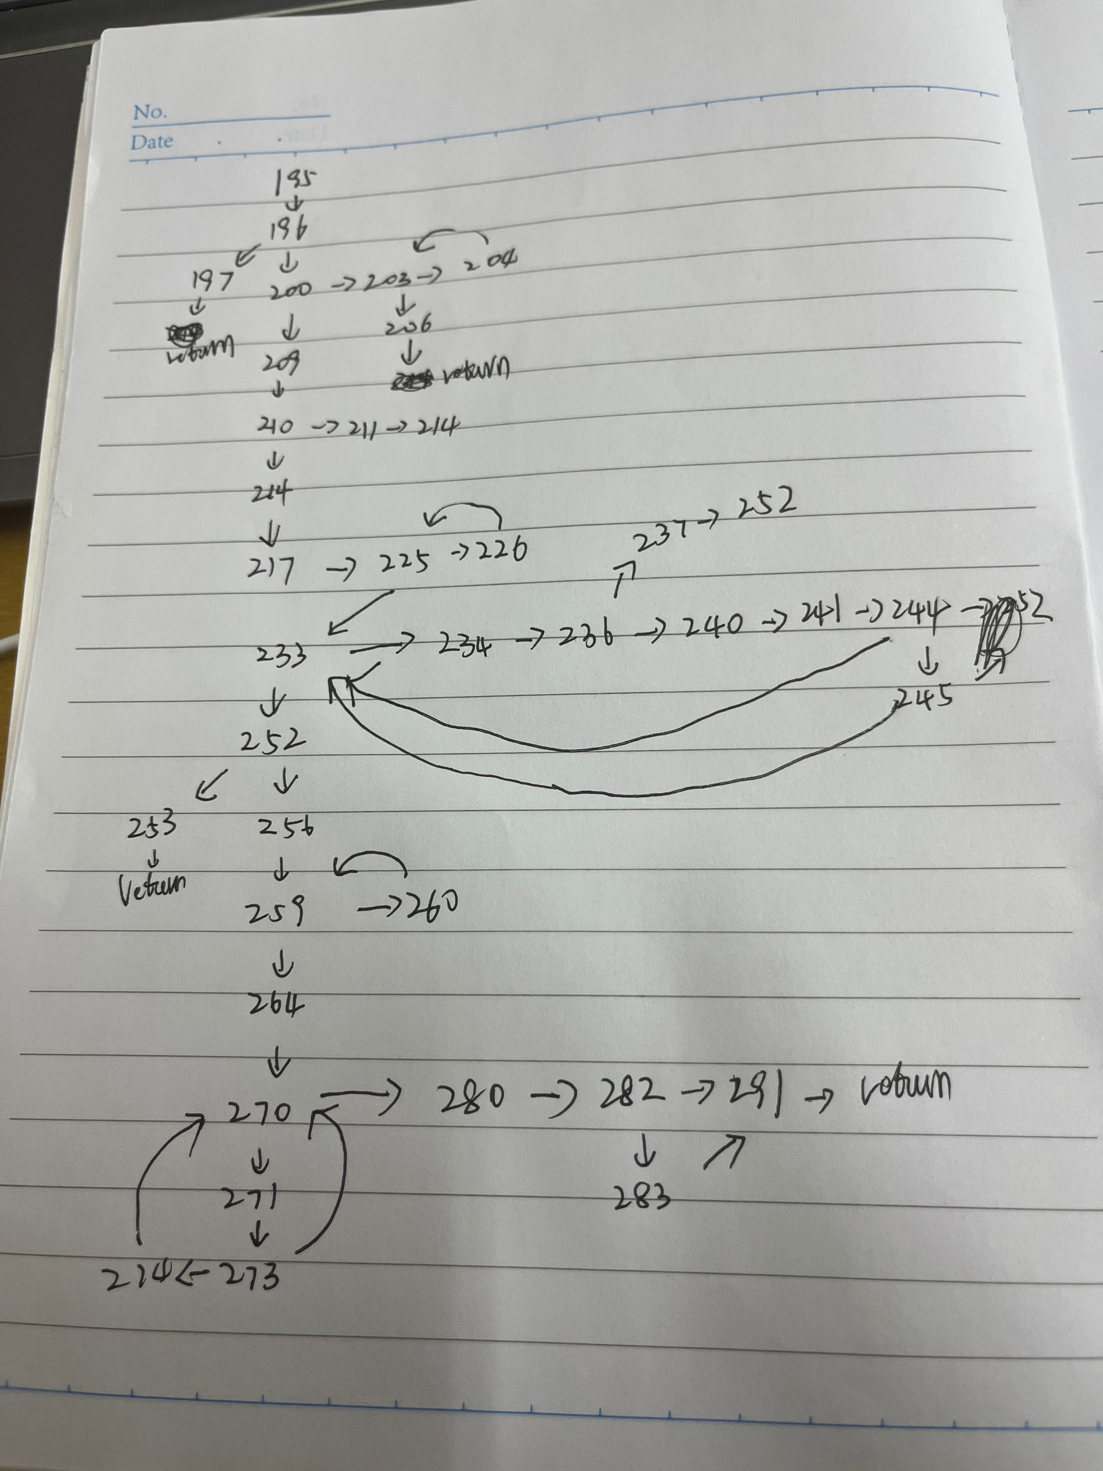

圈复杂度计算与基本路径识别
圈复杂度为：（请给出计算过程）
节点数量36
边数量47
圈复杂度13
基本路径1：195->196->197(起始节点不存在)
基本路径2：195->196->200->203->204->252->203->206(目标词为空）
基本路径3：195->196->200->210->211（目标词不存在）
基本路径4：(目标节点前驱节点为空）
195->196->200->214->217->225->226->225->230->233->234->236->240->241->244->245->233->234->236->237->252->253
基本路径5:(一般情况）
195->196->200->214->217->225->226->225->230->233->234->236->240->241->244->245->233->234->236->237->252->256->259->260->259->264->270->271->273->274->270->280->282->283->291
注意：各基本路径要使用6.1节表格里给出的行号。

测试用例设计
测试用例编号 | 输入数据 | 期望的输出 | 所覆盖的基本路径编号
 | gjh  Explore | "The word "gjh" is not in the graph. | 1
 | to | There is no path from "to" to "gjhgjh".  There is no path from "to" to "to".  Shortest path from "to" to "explore":to → 1explore  Total weight of the path: 1  Shortest path from "to" to "strange":to → 1explore → 1strange  Total weight of the path: 2  Shortest path from "to" to "new":to → 1explore → 1strange → 1new  Total weight of the path: 3  Shortest path from "to" to "worlds":to → 1explore → 1strange → 1new → 1worlds  Total weight of the path: 4  Shortest path from "to" to "seek":to → 1seek  Total weight of the path: 1  Shortest path from "to" to "out":to → 1seek → 1out  Total weight of the path: 2  Shortest path from "to" to "life":to → 1explore → 1strange → 1new → 1life  Total weight of the path: 4  Shortest path from "to" to "and":to → 1explore → 1strange → 1new → 1life → 1and  Total weight of the path: 5  Shortest path from "to" to "civilizations":to → 1explore → 1strange → 1new → 1civilizations  Total weight of the path: 4  Shortest path from "to" to "boldly":to → 2boldly  Total weight of the path: 2  Shortest path from "to" to "go":to → 2boldly → 2go  Total weight of the path: 4  Shortest path from "to" to "where":to → 2boldly → 2go → 2where  Total weight of the path: 6  Shortest path from "to" to "no":to → 2boldly → 2go → 2where → 2no  Total weight of the path: 8  Shortest path from "to" to "one":to → 2boldly → 2go → 2where → 2no → 2one  Total weight of the path: 10  Shortest path from "to" to "has":to → 2boldly → 2go → 2where → 2no → 2one → 2has  Total weight of the path: 12  Shortest path from "to" to "gone":to → 2boldly → 2go → 2where → 2no → 2one → 2has → 2gone  Total weight of the path: 14  Shortest path from "to" to "before":to → 2boldly → 2go → 2where → 2no → 2one → 2has → 2gone → 2before  Total weight of the path: 16  Shortest path from "to" to "dream":to → 1dream  Total weight of the path: 1  Shortest path from "to" to "big":to → 1dream → 1big  Total weight of the path: 2  Shortest path from "to" to "dreams":to → 1dream → 1big → 1dreams  Total weight of the path: 3  Shortest path from "to" to "chase":to → 1chase  Total weight of the path: 1  Shortest path from "to" to "after":to → 1chase → 1after  Total weight of the path: 2  Shortest path from "to" to "the":to → 1exercise → 1the  Total weight of the path: 2  Shortest path from "to" to "unknown":to → 1exercise → 1the → 2unknown  Total weight of the path: 4  Shortest path from "to" to "discover":to → 1discover  Total weight of the path: 1  Shortest path from "to" to "mysteries":to → 1exercise → 1the → 1mysteries  Total weight of the path: 3  Shortest path from "to" to "of":to → 1exercise → 1the → 1mysteries → 1of  Total weight of the path: 4  Shortest path from "to" to "universe":to → 1exercise → 1the → 1universe  Total weight of the path: 3  Shortest path from "to" to "exercise":to → 1exercise  Total weight of the path: 1  Shortest path from "to" to "imagination":to → 1exercise → 1the → 1imagination  Total weight of the path: 3  Shortest path from "to" to "expand":to → 1exercise → 1the → 1imagination → 1expand  Total weight of the path: 4  Shortest path from "to" to "consciousness":to → 1exercise → 1the → 1imagination → 1expand → 1consciousness  Total weight of the path: 5  Shortest path from "to" to "embrace":to → 1explore → 1strange → 1new → 1life → 1and → 1embrace  Total weight of the path: 6 | 2
 | to  gjh | The word "gjh" is not in the graph. | 3
 | to  gjhgjh | There is no path from "to" to "gjhgjh". | 4
 | to  strange | Shortest path from "to" to "strange":to → 1explore → 1strange  Total weight of the path: 2 | 5

JUnit测试代码
针对6.5中的每一个用例，把其测试代码粘贴如下，代码必须是完整的。

测试用例编号 | jUnit测试代码
package org.example;
import org.junit.Test;
import static org.junit.Assert.assertEquals;
import org.example.util.Func;
import java.util.List;
public class MainTest2 {
@Test
public void test1() {
Main main = new Main();
String str = Func.getStr("1.txt");
List<String> wordList = Func.getWords(str);
main.graph = Func.buildDirectedGraph(wordList);
String word1 = "gjh";
String word2 = "explore";
String expected = "The word \"gjh\" is not in the graph.";
String result = org.example.Main.calcShortestPath(word1, word2);
assertEquals(expected, result); }
}
package org.example;
import org.junit.Test;
import static org.junit.Assert.assertEquals;
import org.example.util.Func;
import java.util.List;
public class MainTest2 {
@Test
public void test2() {
Main main = new Main();
String str = Func.getStr("1.txt");
List<String> wordList = Func.getWords(str);
main.graph = Func.buildDirectedGraph(wordList);
String word1 = "to";
String word2 = "";
String expected = "There is no path from \"to\" to \"gjhgjh\".\n" +
"There is no path from \"to\" to \"to\".\n" +
"Shortest path from \"to\" to \"explore\":to → 1explore\n" +
"Total weight of the path: 1\n" +
"Shortest path from \"to\" to \"strange\":to → 1explore → 1strange\n" +
"Total weight of the path: 2\n" +
"Shortest path from \"to\" to \"new\":to → 1explore → 1strange → 1new\n" +
"Total weight of the path: 3\n" +
"Shortest path from \"to\" to \"worlds\":to → 1explore → 1strange → 1new → 1worlds\n" +
"Total weight of the path: 4\n" +
"Shortest path from \"to\" to \"seek\":to → 1seek\n" +
"Total weight of the path: 1\n" +
"Shortest path from \"to\" to \"out\":to → 1seek → 1out\n" +
"Total weight of the path: 2\n" +
"Shortest path from \"to\" to \"life\":to → 1explore → 1strange → 1new → 1life\n" +
"Total weight of the path: 4\n" +
"Shortest path from \"to\" to \"and\":to → 1explore → 1strange → 1new → 1life → 1and\n" +
"Total weight of the path: 5\n" +
"Shortest path from \"to\" to \"civilizations\":to → 1explore → 1strange → 1new → 1civilizations\n" +
"Total weight of the path: 4\n" +
"Shortest path from \"to\" to \"boldly\":to → 2boldly\n" +
"Total weight of the path: 2\n" +
"Shortest path from \"to\" to \"go\":to → 2boldly → 2go\n" +
"Total weight of the path: 4\n" +
"Shortest path from \"to\" to \"where\":to → 2boldly → 2go → 2where\n" +
"Total weight of the path: 6\n" +
"Shortest path from \"to\" to \"no\":to → 2boldly → 2go → 2where → 2no\n" +
"Total weight of the path: 8\n" +
"Shortest path from \"to\" to \"one\":to → 2boldly → 2go → 2where → 2no → 2one\n" +
"Total weight of the path: 10\n" +
"Shortest path from \"to\" to \"has\":to → 2boldly → 2go → 2where → 2no → 2one → 2has\n" +
"Total weight of the path: 12\n" +
"Shortest path from \"to\" to \"gone\":to → 2boldly → 2go → 2where → 2no → 2one → 2has → 2gone\n" +
"Total weight of the path: 14\n" +
"Shortest path from \"to\" to \"before\":to → 2boldly → 2go → 2where → 2no → 2one → 2has → 2gone → 2before\n" +
"Total weight of the path: 16\n" +
"Shortest path from \"to\" to \"dream\":to → 1dream\n" +
"Total weight of the path: 1\n" +
"Shortest path from \"to\" to \"big\":to → 1dream → 1big\n" +
"Total weight of the path: 2\n" +
"Shortest path from \"to\" to \"dreams\":to → 1dream → 1big → 1dreams\n" +
"Total weight of the path: 3\n" +
"Shortest path from \"to\" to \"chase\":to → 1chase\n" +
"Total weight of the path: 1\n" +
"Shortest path from \"to\" to \"after\":to → 1chase → 1after\n" +
"Total weight of the path: 2\n" +
"Shortest path from \"to\" to \"the\":to → 1exercise → 1the\n" +
"Total weight of the path: 2\n" +
"Shortest path from \"to\" to \"unknown\":to → 1exercise → 1the → 2unknown\n" +
"Total weight of the path: 4\n" +
"Shortest path from \"to\" to \"discover\":to → 1discover\n" +
"Total weight of the path: 1\n" +
"Shortest path from \"to\" to \"mysteries\":to → 1exercise → 1the → 1mysteries\n" +
"Total weight of the path: 3\n" +
"Shortest path from \"to\" to \"of\":to → 1exercise → 1the → 1mysteries → 1of\n" +
"Total weight of the path: 4\n" +
"Shortest path from \"to\" to \"universe\":to → 1exercise → 1the → 1universe\n" +
"Total weight of the path: 3\n" +
"Shortest path from \"to\" to \"exercise\":to → 1exercise\n" +
"Total weight of the path: 1\n" +
"Shortest path from \"to\" to \"imagination\":to → 1exercise → 1the → 1imagination\n" +
"Total weight of the path: 3\n" +
"Shortest path from \"to\" to \"expand\":to → 1exercise → 1the → 1imagination → 1expand\n" +
"Total weight of the path: 4\n" +
"Shortest path from \"to\" to \"consciousness\":to → 1exercise → 1the → 1imagination → 1expand → 1consciousness\n" +
"Total weight of the path: 5\n" +
"Shortest path from \"to\" to \"embrace\":to → 1explore → 1strange → 1new → 1life → 1and → 1embrace\n" +
"Total weight of the path: 6\n";
String result = org.example.Main.calcShortestPath(word1, word2);
assertEquals(expected, result); }

}
package org.example;
import org.junit.Test;
import static org.junit.Assert.assertEquals;
import org.example.util.Func;
import java.util.List;
public class MainTest2 {
@Test
public void test3() {
Main main = new Main();
String str = Func.getStr("1.txt");
List<String> wordList = Func.getWords(str);
main.graph = Func.buildDirectedGraph(wordList);
String word1 = "to";
String word2 = "gjh";
String expected = "The word \"gjh\" is not in the graph.";
String result = org.example.Main.calcShortestPath(word1, word2);
assertEquals(expected, result); }

}
package org.example;
import org.junit.Test;
import static org.junit.Assert.assertEquals;
import org.example.util.Func;
import java.util.List;
public class MainTest2 {
@Test
public void test4() {
Main main = new Main();
String str = Func.getStr("1.txt");
List<String> wordList = Func.getWords(str);
main.graph = Func.buildDirectedGraph(wordList);
String word1 = "to";
String word2 = "gjhgjh";
String expected = "There is no path from \"to\" to \"gjhgjh\".";
String result = org.example.Main.calcShortestPath(word1, word2);
assertEquals(expected, result);
}
}
package org.example;
import org.junit.Test;
import static org.junit.Assert.assertEquals;
import org.example.util.Func;
import java.util.List;
public class MainTest2 {
@Test
public void test5() {
Main main = new Main();
String str = Func.getStr("1.txt");
List<String> wordList = Func.getWords(str);
main.graph = Func.buildDirectedGraph(wordList);
String word1 = "to";
String word2 = "strange";
String expected = "Shortest path from \"to\" to \"strange\":to → 1explore → 1strange\nTotal weight of the path: 2";
String result = org.example.Main.calcShortestPath(word1, word2);
assertEquals(expected, result);
}
}

JUnit单元测试结果
测试用例编号 | 期望输出 | 实际输出 | 是否通过测试，请给出屏幕截图
 | "The word "gjh" is not in the graph. | "The word "gjh" is not in the graph. | 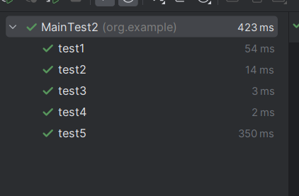
 | There is no path from "to" to "gjhgjh".  There is no path from "to" to "to".  Shortest path from "to" to "explore":to → 1explore  Total weight of the path: 1  Shortest path from "to" to "strange":to → 1explore → 1strange  Total weight of the path: 2  Shortest path from "to" to "new":to → 1explore → 1strange → 1new  Total weight of the path: 3  Shortest path from "to" to "worlds":to → 1explore → 1strange → 1new → 1worlds  Total weight of the path: 4  Shortest path from "to" to "seek":to → 1seek  Total weight of the path: 1  Shortest path from "to" to "out":to → 1seek → 1out  Total weight of the path: 2  Shortest path from "to" to "life":to → 1explore → 1strange → 1new → 1life  Total weight of the path: 4  Shortest path from "to" to "and":to → 1explore → 1strange → 1new → 1life → 1and  Total weight of the path: 5  Shortest path from "to" to "civilizations":to → 1explore → 1strange → 1new → 1civilizations  Total weight of the path: 4  Shortest path from "to" to "boldly":to → 2boldly  Total weight of the path: 2  Shortest path from "to" to "go":to → 2boldly → 2go  Total weight of the path: 4  Shortest path from "to" to "where":to → 2boldly → 2go → 2where  Total weight of the path: 6  Shortest path from "to" to "no":to → 2boldly → 2go → 2where → 2no  Total weight of the path: 8  Shortest path from "to" to "one":to → 2boldly → 2go → 2where → 2no → 2one  Total weight of the path: 10  Shortest path from "to" to "has":to → 2boldly → 2go → 2where → 2no → 2one → 2has  Total weight of the path: 12  Shortest path from "to" to "gone":to → 2boldly → 2go → 2where → 2no → 2one → 2has → 2gone  Total weight of the path: 14  Shortest path from "to" to "before":to → 2boldly → 2go → 2where → 2no → 2one → 2has → 2gone → 2before  Total weight of the path: 16  Shortest path from "to" to "dream":to → 1dream  Total weight of the path: 1  Shortest path from "to" to "big":to → 1dream → 1big  Total weight of the path: 2  Shortest path from "to" to "dreams":to → 1dream → 1big → 1dreams  Total weight of the path: 3  Shortest path from "to" to "chase":to → 1chase  Total weight of the path: 1  Shortest path from "to" to "after":to → 1chase → 1after  Total weight of the path: 2  Shortest path from "to" to "the":to → 1exercise → 1the  Total weight of the path: 2  Shortest path from "to" to "unknown":to → 1exercise → 1the → 2unknown  Total weight of the path: 4  Shortest path from "to" to "discover":to → 1discover  Total weight of the path: 1  Shortest path from "to" to "mysteries":to → 1exercise → 1the → 1mysteries  Total weight of the path: 3  Shortest path from "to" to "of":to → 1exercise → 1the → 1mysteries → 1of  Total weight of the path: 4  Shortest path from "to" to "universe":to → 1exercise → 1the → 1universe  Total weight of the path: 3  Shortest path from "to" to "exercise":to → 1exercise  Total weight of the path: 1  Shortest path from "to" to "imagination":to → 1exercise → 1the → 1imagination  Total weight of the path: 3  Shortest path from "to" to "expand":to → 1exercise → 1the → 1imagination → 1expand  Total weight of the path: 4  Shortest path from "to" to "consciousness":to → 1exercise → 1the → 1imagination → 1expand → 1consciousness  Total weight of the path: 5  Shortest path from "to" to "embrace":to → 1explore → 1strange → 1new → 1life → 1and → 1embrace  Total weight of the path: 6 | There is no path from "to" to "gjhgjh".  There is no path from "to" to "to".  Shortest path from "to" to "explore":to → 1explore  Total weight of the path: 1  Shortest path from "to" to "strange":to → 1explore → 1strange  Total weight of the path: 2  Shortest path from "to" to "new":to → 1explore → 1strange → 1new  Total weight of the path: 3  Shortest path from "to" to "worlds":to → 1explore → 1strange → 1new → 1worlds  Total weight of the path: 4  Shortest path from "to" to "seek":to → 1seek  Total weight of the path: 1  Shortest path from "to" to "out":to → 1seek → 1out  Total weight of the path: 2  Shortest path from "to" to "life":to → 1explore → 1strange → 1new → 1life  Total weight of the path: 4  Shortest path from "to" to "and":to → 1explore → 1strange → 1new → 1life → 1and  Total weight of the path: 5  Shortest path from "to" to "civilizations":to → 1explore → 1strange → 1new → 1civilizations  Total weight of the path: 4  Shortest path from "to" to "boldly":to → 2boldly  Total weight of the path: 2  Shortest path from "to" to "go":to → 2boldly → 2go  Total weight of the path: 4  Shortest path from "to" to "where":to → 2boldly → 2go → 2where  Total weight of the path: 6  Shortest path from "to" to "no":to → 2boldly → 2go → 2where → 2no  Total weight of the path: 8  Shortest path from "to" to "one":to → 2boldly → 2go → 2where → 2no → 2one  Total weight of the path: 10  Shortest path from "to" to "has":to → 2boldly → 2go → 2where → 2no → 2one → 2has  Total weight of the path: 12  Shortest path from "to" to "gone":to → 2boldly → 2go → 2where → 2no → 2one → 2has → 2gone  Total weight of the path: 14  Shortest path from "to" to "before":to → 2boldly → 2go → 2where → 2no → 2one → 2has → 2gone → 2before  Total weight of the path: 16  Shortest path from "to" to "dream":to → 1dream  Total weight of the path: 1  Shortest path from "to" to "big":to → 1dream → 1big  Total weight of the path: 2  Shortest path from "to" to "dreams":to → 1dream → 1big → 1dreams  Total weight of the path: 3  Shortest path from "to" to "chase":to → 1chase  Total weight of the path: 1  Shortest path from "to" to "after":to → 1chase → 1after  Total weight of the path: 2  Shortest path from "to" to "the":to → 1exercise → 1the  Total weight of the path: 2  Shortest path from "to" to "unknown":to → 1exercise → 1the → 2unknown  Total weight of the path: 4  Shortest path from "to" to "discover":to → 1discover  Total weight of the path: 1  Shortest path from "to" to "mysteries":to → 1exercise → 1the → 1mysteries  Total weight of the path: 3  Shortest path from "to" to "of":to → 1exercise → 1the → 1mysteries → 1of  Total weight of the path: 4  Shortest path from "to" to "universe":to → 1exercise → 1the → 1universe  Total weight of the path: 3  Shortest path from "to" to "exercise":to → 1exercise  Total weight of the path: 1  Shortest path from "to" to "imagination":to → 1exercise → 1the → 1imagination  Total weight of the path: 3  Shortest path from "to" to "expand":to → 1exercise → 1the → 1imagination → 1expand  Total weight of the path: 4  Shortest path from "to" to "consciousness":to → 1exercise → 1the → 1imagination → 1expand → 1consciousness  Total weight of the path: 5  Shortest path from "to" to "embrace":to → 1explore → 1strange → 1new → 1life → 1and → 1embrace  Total weight of the path: 6
 | The word "gjh" is not in the graph. | The word "gjh" is not in the graph.
 | There is no path from "to" to "gjhgjh". | There is no path from "to" to "gjhgjh".
 | Shortest path from "to" to "strange":to → 1explore → 1strange  Total weight of the path: 2 | Shortest path from "to" to "strange":to → 1explore → 1strange  Total weight of the path: 2

代码覆盖度分析
由于是对整个main类进行测试，但只测试了算最短路径函数，所以覆盖率比较低，但可以看到对函数的覆盖率很高
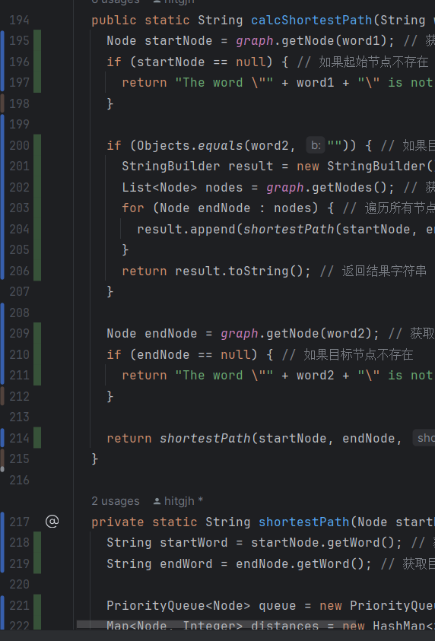
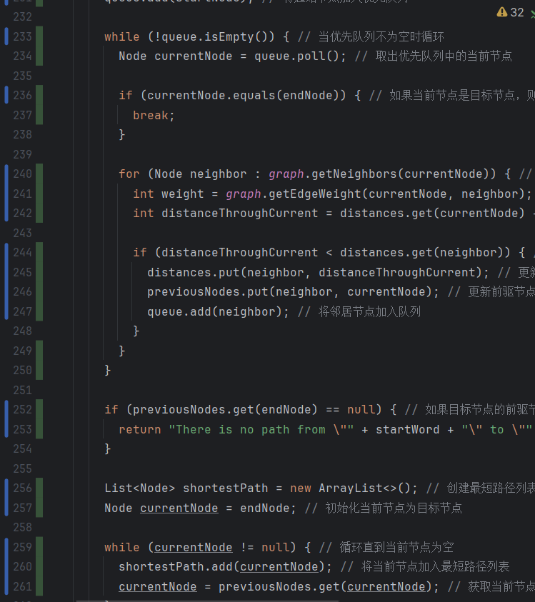
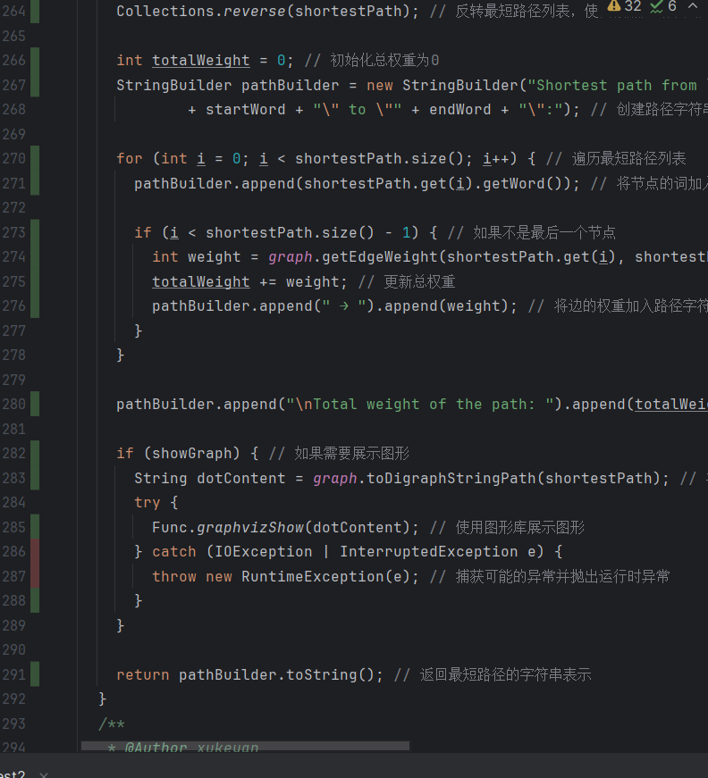
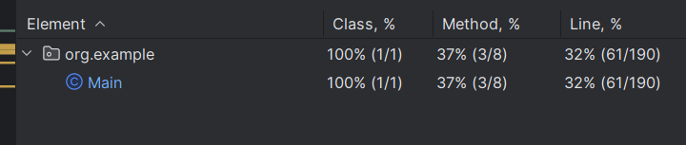

未通过测试的原因分析及代码修改
分析自己的Lab1代码为何未通过6.7节表格中某些测试用例的原因，并通过修改代码消除此类BUG。必要时给出修改后的代码。
若6.7节表格中没有未通过的测试用例，本节可空。
修改代码之后，请重新填写下表，保证所有测试用例都能通过测试。

测试用例编号 | 期望输出 | 实际输出 | 是否通过测试，请给出屏幕截图

Git操作记录
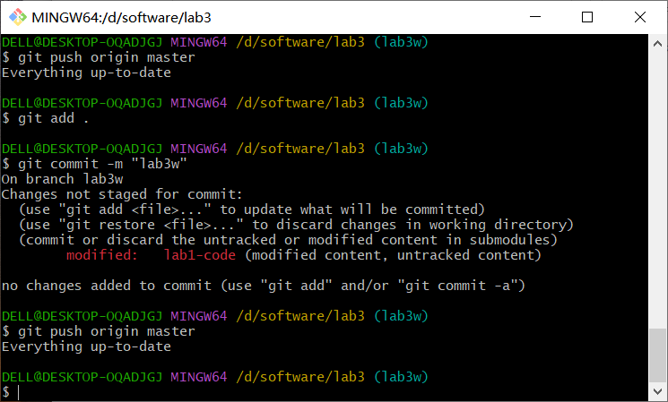
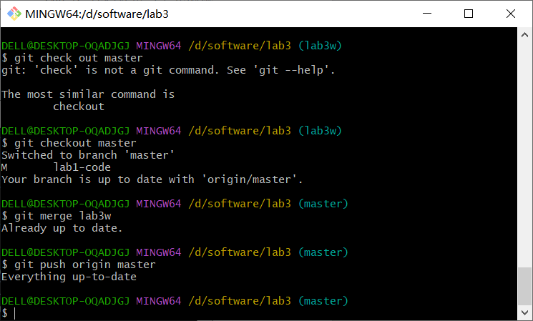

计划与实际进度
任务名称 | 计划时间长度（分钟） | 实际耗费时间（分钟） | 提前或延期的原因分析
进行代码评审 | 180 | 200 | 代码出现较多不规范，进行了修改
完成黑盒测试 | 150 | 150 | 按时完成
完成白盒测试 | 200 | 150 | 由于有黑盒测试的基础，编写测试代码耗时较少

小结

代码评审
在本次实验中，我们对Lab1所完成的代码进行了全面的代码评审（走查），重点从以下几个方面进行了评价：
代码规范性：总体上，代码命名规范，结构清晰，但部分注释较少，某些异常处理可以进一步完善。
代码正确性：算法逻辑基本正确，能够正确处理各种输入，但在极端边界条件和特殊输入的处理上存在改进空间。
通过这次评审，我们确定了代码的优点和需要改进的地方，并为后续优化提供了方向。

测试设计与执行
在测试设计与执行部分，我们完成了以下任务：
黑盒测试：设计了若干测试用例，涵盖了正常路径、无路径和边界条件等多种情况，确保了功能的正确性。
白盒测试：根据代码结构设计测试用例，保证了代码的高覆盖率，包括语句覆盖和分支覆盖。
具体步骤如下：
编写JUnit测试代码：在JUnit环境下撰写测试代码，验证各种输入情况下的输出是否符合预期。
执行测试：通过JUnit运行测试用例，验证代码功能是否正确。
统计覆盖率：使用IDE自带工具统计测试覆盖率，确保测试覆盖了代码的主要部分。
通过上述步骤，我们不仅验证了代码的功能正确性，还提高了代码的可靠性和稳定性。覆盖率统计结果表明，测试覆盖了绝大部分代码分支和语句，达到了预期的测试效果。

总结
本次实验不仅对现有代码进行了全面评审，找出了其中的优点和不足之处，还通过系统的测试设计与执行，提高了代码的可靠性和健壮性。通过这次实验，我们深刻理解了代码规范性的重要性，以及全面测试对保证代码质量的关键作用。

