Software Architecture and Design Specification
Project: Operation Theatre Management System (OTMS)
Version: 1.0
Authors: PES1UG24AM261, PES1UG24AM281, PES1UG24AM289, PES1UG24AM295
Date: 06-10-2026
Status: Vers 1
Revision History
Version | Date | Authors | Change Summary
1.0 | 06-10-2026 | PES1UG24AM261, PES1UG24AM281, PES1UG24AM289, PES1UG24AM295 | Initial SAD document

Approvals
Role | Name | Signature/Date
Course Coordinator | <Name> | <Signature/Date>
Project Guide | <Name> | <Signature/Date>

1. Introduction
1.1 Purpose
This document specifies the architecture and design of the Operation Theatre Management System (OTMS). It describes the major software components, their interactions, architectural decisions, security architecture, APIs, and system design.
1.2 Scope
The system manages operation theatre scheduling, surgeries, doctors, nurses, equipment, theatre availability, emergency cases, and resource allocation. It detects scheduling conflicts and provides information to improve operation theatre and resource utilization.
1.3 Audience
The intended audience includes developers, QA engineers, hospital administrators, doctors, operation theatre coordinators, security auditors, maintenance teams, and instructors.
1.4 Definitions
- OTMS – Operation Theatre Management System
- OT – Operation Theatre
- Surgery – A planned or emergency surgical procedure
- OR – Operation Room / Operation Theatre
- RBAC – Role-Based Access Control
- API – Application Programming Interface
- UI – User Interface
- DB – Database
- ADR – Architecture Decision Record
- TLS – Transport Layer Security

2. Document Overview
2.1 How to Use This Document
This document provides the architectural and design specifications of OTMS, including UML diagrams, component descriptions, architectural decisions, security architecture, API design, sequence diagrams, error handling, and monitoring mechanisms.
2.2 Related Documents
- Software Requirements Specification (SRS)
- Software Test Plan (STP)
- Requirements Traceability Matrix (RTM)

3. Architecture
3.1 Goals & Constraints
Goals
- Provide reliable and efficient operation theatre scheduling.
- Detect doctor, nurse, equipment, and theatre scheduling conflicts.
- Prioritize emergency surgeries appropriately.
- Improve operation theatre utilization.
- Provide secure access based on user roles.
- Maintain accurate surgery and resource information.
- Provide timely notifications regarding schedule changes and conflicts.
Constraints
- Patient and surgery information must be protected.
- The system must support multiple hospital users simultaneously.
- Scheduling must prevent double-booking of theatres and critical resources.
- Emergency cases must be accommodated without compromising existing schedules unnecessarily.
- The system depends on accurate availability information from hospital staff.
- Access to sensitive patient information must be restricted according to user roles.

3.2 Stakeholders & Concerns
Stakeholder | Main Concerns
Hospital Administrator | Overall operation theatre utilization, reports, system management
OT Coordinator | Scheduling, conflict detection, theatre availability
Doctors/Surgeons | Surgery schedules, availability, assigned theatres
Nurses | Assigned surgeries, schedules, required equipment
Anaesthesiologists | Surgery schedule, patient and procedure information
Technicians | Equipment availability and maintenance
Hospital Management | Resource utilization and performance reports
Developers | Maintainability, modularity, scalability
QA Engineers | Testability, reliability, correctness
Security/Admin Team | Authentication, authorization, data protection

3.3 Component (UML) Diagram
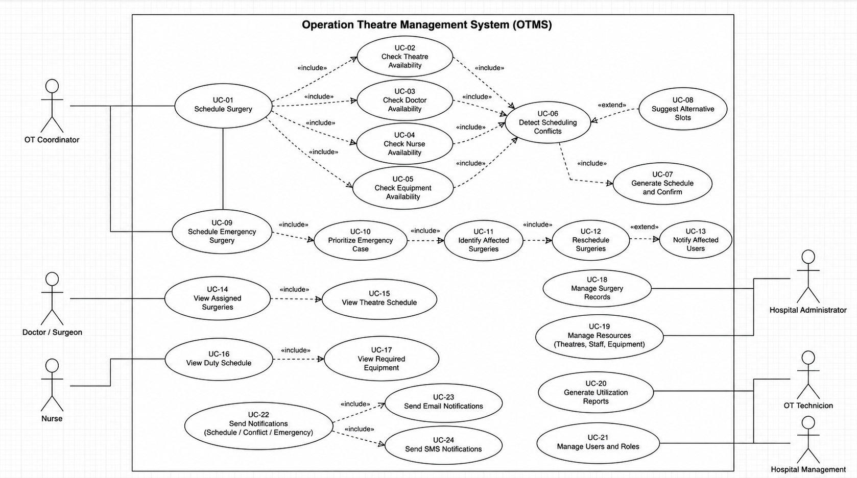

3.4 Component Descriptions
OTMS UI
Provides interfaces for hospital administrators, OT coordinators, doctors, nurses, and technicians. It allows users to view schedules, manage resources, and receive conflict notifications.
Authentication & RBAC Service
Authenticates users and controls access based on roles such as administrator, OT coordinator, doctor, nurse, and technician.
Surgery Management Service
Creates and manages surgery records, including surgery type, assigned doctor, required staff, estimated duration, priority, and status.
Scheduling & Conflict Detection Service
Assigns surgeries to available theatre slots and detects conflicts involving operation theatres, doctors, nurses, and equipment.
Resource Management Service
Maintains availability and allocation information for operation theatres, doctors, nurses, anaesthesia resources, and surgical equipment.
Emergency Prioritization Service
Identifies emergency surgeries and assigns them higher scheduling priority while checking the impact on already scheduled surgeries.
Notification Service
Sends notifications to relevant users when surgeries are scheduled, rescheduled, cancelled, or affected by conflicts or emergencies.
Database
Stores information about patients, surgeries, doctors, nurses, theatres, equipment, schedules, conflicts, and audit records.
Hospital Systems/API
Provides integration with other hospital systems where required, such as patient records or staff information systems.

3.5 Chosen Architecture Pattern and Rationale
A layered architecture is chosen for OTMS because it provides clear separation between the user interface, business logic, scheduling logic, and data storage.
The system can be divided into:
- Presentation Layer – OTMS web interface and dashboards.
- Application/Service Layer – Surgery, scheduling, resource, notification, and authentication services.
- Business Logic Layer – Conflict detection, emergency prioritization, scheduling rules, and resource allocation.
- Data Access Layer – Handles communication with the database.
- Database Layer – Stores persistent system data.
A fully distributed microservices architecture is not selected because it would introduce unnecessary deployment and communication complexity for the initial hospital system.

3.6 Technology Stack & Data Stores
Area | Technology
Frontend | HTML, CSS, JavaScript / React
Backend | Java with Spring Boot
API | REST APIs
Database | MySQL / PostgreSQL
Authentication | JWT / secure session-based authentication
Communication Security | TLS
Diagram Tools | PlantUML / draw.io
API Testing | Postman
Version Control | Git
Data Stores
The primary relational database stores:
- Patient information
- Surgery details
- Doctor information
- Nurse information
- Theatre information
- Equipment information
- Theatre schedules
- Resource allocations
- Scheduling conflicts
- Emergency cases
- Audit logs

3.7 Risks & Mitigations
Risk | Mitigation
Two surgeries being assigned to the same theatre slot | Automated conflict detection before confirmation
Doctor being assigned to overlapping surgeries | Validate doctor availability during scheduling
Required equipment being unavailable | Check equipment availability before scheduling
Emergency surgery disrupting existing schedule | Emergency prioritization and rescheduling mechanism
Incorrect resource availability data | Provide controlled resource update interfaces
Unauthorized access to patient/surgery information | Authentication and RBAC
Database/system failure | Regular backups and recovery mechanisms
Network failure | Retry mechanisms and graceful error handling

3.8 Traceability to Requirements
The architecture should directly map to requirements from the SRS.
SRS Requirement | Architectural Component
OTMS-F-001: User authentication | Authentication & RBAC Service
OTMS-F-002: Manage surgery records | Surgery Management Service
OTMS-F-003: Manage theatre slots | Scheduling Service
OTMS-F-004: Detect theatre conflicts | Conflict Detection Service
OTMS-F-005: Check doctor availability | Resource Management Service
OTMS-F-006: Check nurse availability | Resource Management Service
OTMS-F-007: Check equipment availability | Resource Management Service
OTMS-F-008: Prioritize emergency surgeries | Emergency Prioritization Service
OTMS-F-009: Reschedule affected surgeries | Scheduling Service
OTMS-F-010: Send schedule notifications | Notification Service
OTMS-F-011: Generate utilization reports | Reporting / Management Module

3.9 Security Architecture
The system uses role-based access control (RBAC) to ensure that users can access only the functionality and information appropriate to their roles.
Threat Modeling
A STRIDE-based approach is used:
Threat | Example | Mitigation
Spoofing | Unauthorized user pretending to be a doctor | Authentication + MFA where applicable
Tampering | Modification of surgery schedule | Authorization + audit logs
Repudiation | User denying a schedule change | Timestamped audit logs
Information Disclosure | Unauthorized access to patient data | Encryption + RBAC
Denial of Service | Excessive requests affecting scheduling | Rate limiting + monitoring
Elevation of Privilege | Nurse accessing administrator functions | Role-based authorization

4. Design
4.1 Design Overview
OTMS is designed using modular, layered components to separate user interaction, scheduling logic, resource management, security, and data storage.
The central design focus is the scheduling engine, which validates theatre, doctor, nurse, and equipment availability before confirming a surgery. Emergency cases are assigned higher priority and may trigger controlled rescheduling of lower-priority surgeries.

4.2 UML Sequence Diagrams

Sequence Diagram 1 — Schedule a Surgery
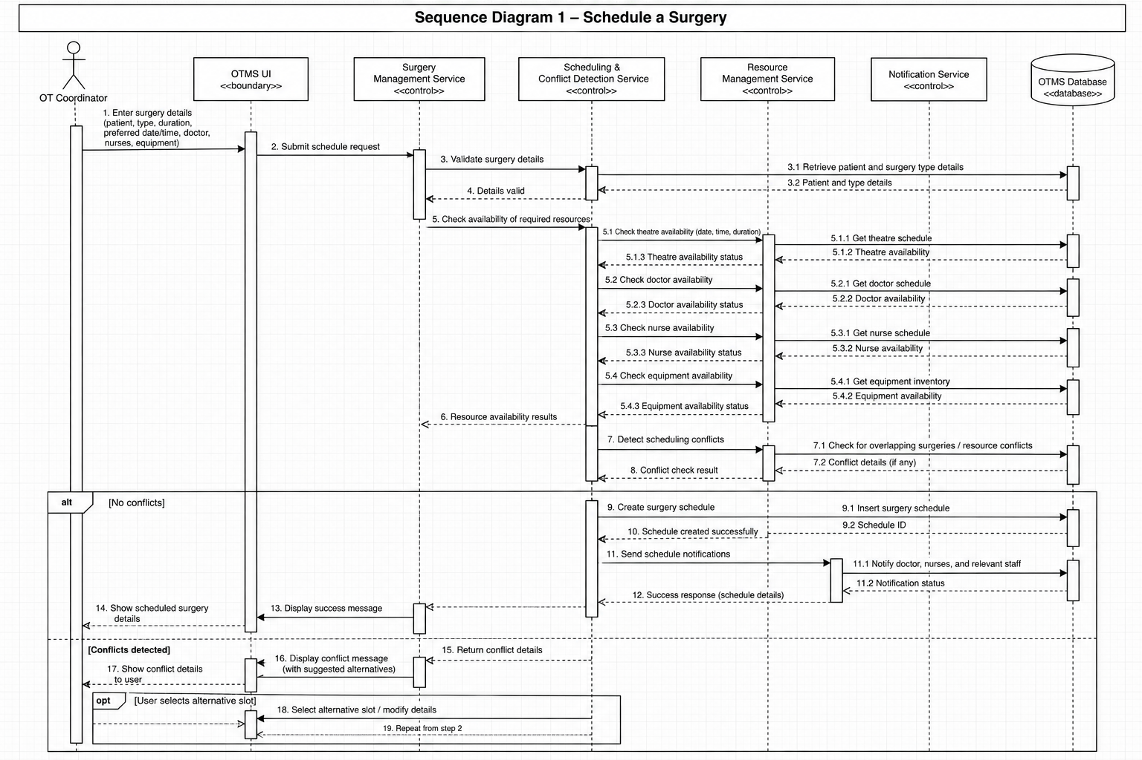

Sequence Diagram 2 — Emergency Surgery Scheduling
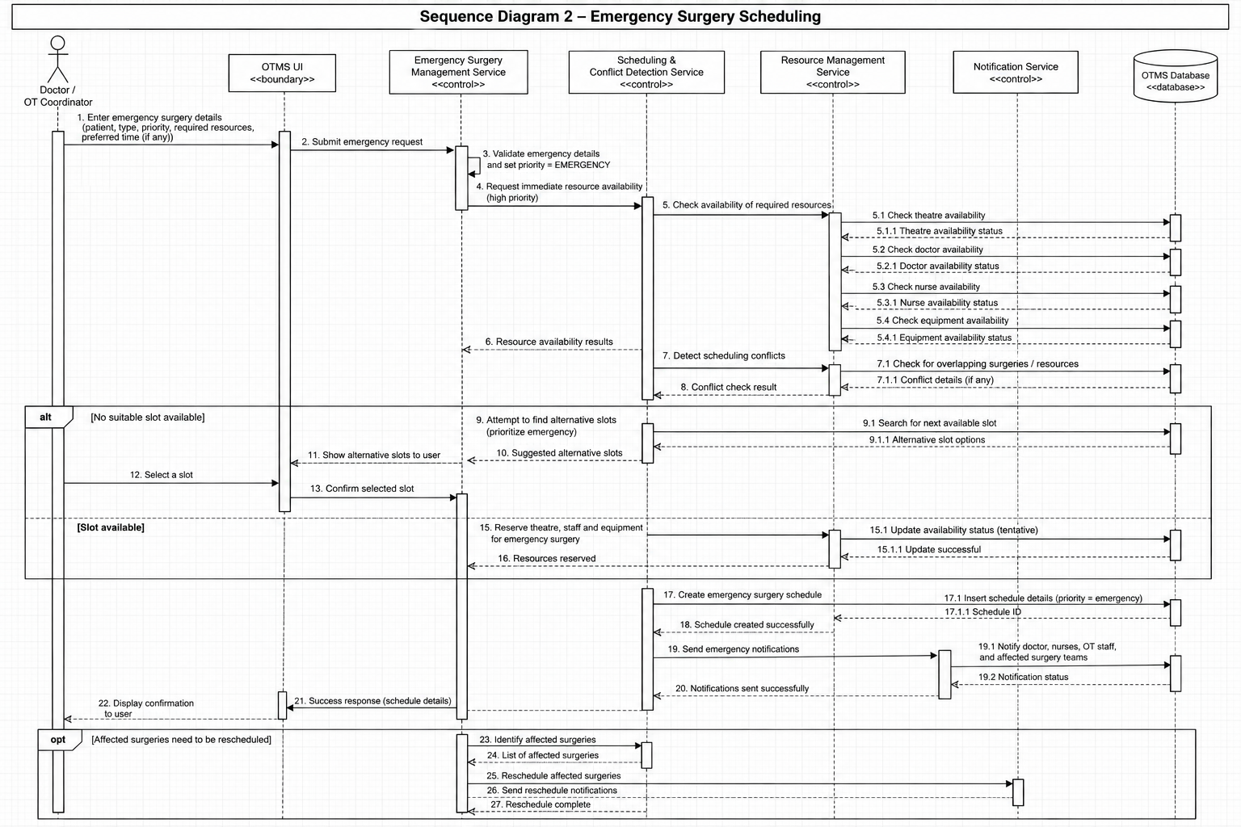

4.3 API Design
API 1 — Schedule Surgery
Endpoint: /api/surgeries/schedule
Method: POST
Request:
{
"surgeryId": "S1001",
"doctorId": "D101",
"nurseIds": ["N201", "N202"],
"theatreId": "OT03",
"equipmentIds": ["EQ12", "EQ18"],
"startTime": "10:00",
"endTime": "12:00"
}
Response:
{
"status": "SCHEDULED",
"surgeryId": "S1001",
"theatreId": "OT03"
}
Errors:
- 400 Invalid scheduling details
- 409 Scheduling conflict
- 404 Resource not found

API 2 — Check Resource Availability
Endpoint: /api/resources/availability
Method: GET
Request Parameters:
theatreId
startTime
endTime
Response:
{
"theatreAvailable": true,
"doctorAvailable": true,
"nurseAvailable": true,
"equipmentAvailable": false
}
Errors:
- 400 Invalid time range
- 404 Resource not found

API 3 — Emergency Surgery
Endpoint: /api/surgeries/emergency
Method: POST
Request:
{
"surgeryId": "S1005",
"priority": "EMERGENCY",
"requiredDuration": 120
}
Response:
{
"status": "PRIORITIZED",
"affectedSchedules": ["S1002", "S1003"]
}
Errors:
- 404 Surgery not found
- 409 No suitable theatre/resources available

4.4 Error Handling, Logging & Monitoring
Error Handling
The system uses standardized error responses for:
- Invalid user input
- Scheduling conflicts
- Unavailable theatres
- Unavailable doctors or nurses
- Equipment conflicts
- Database failures
- Unauthorized access
Sensitive patient information should not be included in error messages.
Logging
The system maintains logs for:
- User login and logout
- Surgery creation/modification
- Schedule changes
- Resource allocation
- Emergency prioritization
- Conflict detection
- System errors
Sensitive patient information and authentication credentials must not be stored unnecessarily in application logs.
Monitoring
The system monitors:
- Scheduling failure rate
- Number of active surgeries
- Theatre utilization
- Resource utilization
- Conflict frequency
- Emergency scheduling events
- System availability
- API response time

4.5 UX Design
The OTMS interface should provide a clear dashboard for each user role.
OT Coordinator
- View daily/weekly theatre schedule
- Schedule and reschedule surgeries
- View conflicts
- View theatre availability
- Prioritize emergency cases
Doctor
- View assigned surgeries
- View theatre and time allocation
- View required resources
- Receive schedule-change notifications
Nurse
- View assigned surgeries
- View duty schedule
- View required equipment/resources
Technician
- View equipment status
- Mark equipment as available/unavailable
- View maintenance requirements
Administrator
- Manage users and roles
- Manage theatres and equipment
- View utilization reports
- Monitor system activity
The UI should use clear status indicators, readable text, consistent navigation, and responsive layouts to reduce scheduling errors.

4.6 Open Issues & Next Steps
Potential future enhancements include:
- AI-assisted surgery scheduling and resource optimization
- Predictive theatre utilization analysis
- Mobile application for doctors and nurses
- Automated SMS/email notifications
- Integration with electronic health record systems
- Advanced analytics for theatre utilization
- Automatic prediction of surgery duration
- Integration with hospital inventory management
- Biometric authentication for privileged users

5. Appendices
5.1 Glossary
Term | Definition
OTMS | Operation Theatre Management System
OT | Operation Theatre
RBAC | Role-Based Access Control
API | Application Programming Interface
UI | User Interface
ADR | Architecture Decision Record
TLS | Transport Layer Security
STRIDE | Security threat-modeling methodology

5.2 References
- IEEE 42010 – Architecture Description
- OWASP Application Security Guidelines
- NIST Security and Privacy Guidelines
- Project Software Requirements Specification (SRS)
- Project Software Test Plan (STP)
5.3 Tools
- PlantUML – UML diagrams
- draw.io – Architecture and UML diagrams
- Postman – API testing
- Git/GitHub – Version control
- MySQL/PostgreSQL – Database

