Software Requirements Specification (SRS)

Document Details
Project | Operation Theatre Management System (OTMS)
Version | 1.0
Authors | PES1UG24AM261  PES1UG24AM281  PES1UG24AM289  PES1UG24AM295
Date | 06-10-2026
Status | Vers 1

Revision History
Version | Date | Authors | Change Summary
1.0 | 06-10-2026 | PES1UG24AM261, PES1UG24AM281, PES1UG24AM289, PES1UG24AM295 | Initial SAD document

Approvals
Role | Name | Signature / Email | Date
Course Coordinator | <Name> | <Signature / Email> | <Date>
Project Guide | <Name> | <Signature / Email> | <Date>

Table of Contents
1.Introduction
2.Overall Description
3.External Interface Requirements
4.System Features (Detailed)
5.Non-Functional Requirements (Detailed)
6.Quality Attributes & Acceptance Tests
7.UML Use-Case Diagrams
8.Requirements Traceability Matrix (RTM)

1. Introduction

1.1 Purpose
This document is a Software Requirements Specification (SRS) for the Operation Theatre Management System (OTMS). It defines the functional requirements, non-functional requirements, external interfaces, security requirements, and verification criteria for managing operation theatres, surgeries, medical staff, equipment, schedules, emergency cases, and resource utilization.
The document serves as a reference for developers, QA engineers, hospital personnel, instructors, and project evaluators.

1.2 Scope
The OTMS manages the scheduling and operational coordination of hospital operation theatres.
The system covers:
- Surgery creation and management
- Operation theatre scheduling
- Doctor and surgeon availability
- Nurse availability
- Surgical equipment availability
- Scheduling conflict detection
- Emergency surgery prioritization
- Rescheduling of affected surgeries
- Schedule and conflict notifications
- Resource allocation
- Theatre and resource utilization reporting
- User authentication and role-based access control
- Audit and monitoring
The system does not implement the internal clinical treatment process or perform medical diagnosis. Integration with external hospital information systems is limited to defined APIs and required data exchange.

1.3 Audience
The intended audience includes:
- Developers
- QA Engineers
- OT Coordinators
- Doctors / Surgeons
- Nurses
- OT Technicians
- Hospital Administrators
- Hospital Management
- System Integrators
- Security Auditors
- Assessment Evaluators

1.4 Definitions
Term | Definition
OTMS | Operation Theatre Management System
OT | Operation Theatre
UI | User Interface
API | Application Programming Interface
RBAC | Role-Based Access Control
CRUD | Create, Read, Update, Delete
ADR | Architecture Decision Record
TLS | Transport Layer Security
SRS | Software Requirements Specification
STP | Software Test Plan
RTM | Requirements Traceability Matrix

2. Overall Description

2.1 Product Perspective
The OTMS is a hospital management application that coordinates operation theatre activities and resources.
The system provides a centralized platform through which authorized hospital users can manage surgeries, operation theatres, medical staff, equipment, schedules, emergency cases, and operational reports.
The system consists of a web-based user interface, application services, scheduling and conflict-detection logic, resource management, notification services, and a relational database.
It may also communicate with external hospital information systems for patient and staff information.

2.2 Major Product Functions
The major functions of OTMS are:
- User authentication and role-based authorization
- Surgery record management
- Operation theatre management
- Surgery scheduling
- Theatre availability checking
- Doctor availability checking
- Nurse availability checking
- Equipment availability checking
- Scheduling conflict detection
- Emergency surgery prioritization
- Rescheduling affected surgeries
- Resource allocation
- Schedule and conflict notifications
- Equipment status and maintenance management
- Theatre and resource utilization reporting
- Audit logging and system monitoring

2.3 User Roles and Characteristics
Role | Responsibilities
OT Coordinator | Responsible for managing operation theatre schedules, assigning surgeries to theatre slots, identifying conflicts, and coordinating emergency cases.
Doctor / Surgeon | Views assigned surgeries, provides availability information, and receives schedule and conflict notifications.
Nurse | Views assigned surgeries and schedules and receives relevant schedule updates.
OT Technician | Manages equipment availability and maintenance status.
Hospital Administrator | Manages users, roles, theatres, equipment, and administrative information.
Hospital Management | Views theatre utilization, resource utilization, and operational reports.

2.4 Operating Environment
The OTMS shall operate in a hospital network environment.

Software Environment
- Web-based user interface
- Java / Spring Boot backend
- REST APIs
- MySQL or PostgreSQL relational database
- Modern web browsers
- Secure hospital network

Hardware Environment
The system may be accessed through:
- Hospital desktop computers
- Laptops
- Tablets were supported
- Hospital network infrastructure
- Database/server infrastructure

2.5 Constraints
The system is subject to the following constraints:
- Access to sensitive patient and surgery information shall be restricted to authorized users.
- Scheduling shall prevent double-booking of operation theatres.
- Scheduling shall account for doctor, nurse, and equipment availability.
- Emergency cases shall receive higher scheduling priority.
- User access shall be controlled through RBAC.
- Communication between system components shall use secure communication protocols.
- The system depends on accurate availability information entered by authorized hospital personnel.
- External hospital system integration shall use defined APIs.

3. External Interface Requirements

3.1 User Interfaces
The primary interface shall be a web-based OTMS dashboard.
The interface shall provide role-specific functionality.
Interface | Functionality
OT Coordinator Interface | Daily and weekly theatre schedules  Surgery scheduling form  Conflict warnings  Emergency surgery controls  Resource availability  Rescheduling options
Doctor Interface | Assigned surgery schedule  Surgery details  Availability management  Schedule notifications
Nurse Interface | Assigned surgery list  Duty schedule  Schedule-change notifications
Technician Interface | Equipment list  Equipment availability  Maintenance status
Administrator Interface | User management  Role management  Theatre management  Equipment management  Audit information
Management Interface | Theatre utilization reports  Resource utilization reports  Operational statistics

3.2 Hardware Interfaces
The OTMS does not directly control surgical equipment.
The system may interact indirectly with hospital infrastructure and equipment information systems through software interfaces.
Relevant hardware includes:
- Hospital computers and workstations
- Network infrastructure
- Server infrastructure
- Database servers
- Optional notification devices
Equipment availability is maintained through the OTMS interface or integrated hospital systems.

3.3 Software Interfaces

Hospital Information System API
Used for retrieving or exchanging:
- Patient information
- Staff information
- Hospital master data

OTMS REST API
Provides communication between the user interface and OTMS application services.
Example services include:
- Surgery Management API
- Scheduling API
- Resource Availability API
- Conflict Detection API
- Emergency Scheduling API
- Notification API
- Reporting API

Notification Gateway
The system may communicate with an external email/SMS service for notifications.

3.4 Communications
- Network communication shall use TLS 1.2 or higher.
- API communication shall use authenticated requests.
- The system shall validate incoming API requests.
- Failed network requests shall return standardized errors.
- Appropriate retry mechanisms may be used for temporary communication failures.
- Sensitive information shall not be transmitted through unsecured communication channels.

4. System Features (Detailed)
Each requirement includes an acceptance criterion and reference test case.
Requirement IDs follow the format OTMS-F-###.

4.1 Authentication and Authorization

Description
The system shall authenticate users and restrict system functionality according to their assigned roles.
Req ID | Requirement | Type | Priority | Source / Stakeholder | Acceptance Criteria / Test Case | Comments / Dependencies
OTMS-F-001 | The system shall authenticate users before providing access to protected OTMS functions. | Functional | High | Security / Administrator | Valid credentials result in successful login. Test: TC-Auth-01 | Authentication service required
OTMS-F-002 | The system shall enforce role-based access according to the user's assigned role. | Functional | High | Administrator / Security | Users can access only authorized functions. Test: TC-Auth-02 | RBAC required
OTMS-F-003 | The system shall record successful and failed authentication events in the audit log. | Functional | High | Security | Authentication events are recorded with timestamps. Test: TC-Auth-03 | Audit service required

4.2 Surgery Management

Description
The system shall allow authorized users to create, view, update, and manage surgery records.
Req ID | Requirement | Type | Priority | Source / Stakeholder | Acceptance Criteria / Test Case | Comments / Dependencies
OTMS-F-004 | The system shall allow authorized users to create a surgery record containing the required surgery details. | Functional | High | OT Coordinator | A valid surgery record is successfully created. Test: TC-SURG-01 | Database required
OTMS-F-005 | The system shall allow authorized users to update surgery details before the surgery is completed. | Functional | High | OT Coordinator / Doctor | Updated information is saved and displayed correctly. Test: TC-SURG-02 | Authorization required
OTMS-F-006 | The system shall allow authorized users to view surgery details and status. | Functional | High | Doctor / Nurse / Coordinator | Authorized users can retrieve permitted surgery information. Test: TC-SURG-03 | RBAC required

4.3 Theatre Scheduling

Description
The system shall allocate available operation theatre slots while considering surgery duration and resource availability.
Req ID | Requirement | Type | Priority | Source / Stakeholder | Acceptance Criteria / Test Case | Comments / Dependencies
OTMS-F-007 | The system shall allow authorized users to schedule a surgery in an available operation theatre slot. | Functional | High | OT Coordinator | Surgery is assigned to a valid available slot. Test: TC-SCH-01 | Scheduling service
OTMS-F-008 | The system shall check operation theatre availability before confirming a surgery schedule. | Functional | High | OT Coordinator | A theatre cannot be assigned when already occupied. Test: TC-SCH-02 | Theatre schedule required
OTMS-F-009 | The system shall prevent two surgeries from being scheduled in the same theatre at overlapping times. | Functional | High | Hospital Operations | Conflicting schedule is rejected. Test: TC-SCH-03 | Conflict detection required

4.4 Staff and Equipment Availability

Description
The system shall verify the availability of doctors, nurses, and required surgical equipment before confirming a surgery.
Req ID | Requirement | Type | Priority | Source / Stakeholder | Acceptance Criteria / Test Case | Comments / Dependencies
OTMS-F-010 | The system shall check the assigned doctor's availability before confirming a surgery. | Functional | High | Doctor / Coordinator | Surgery is rejected when the doctor has an overlapping assignment. Test: TC-RES-01 | Staff availability required
OTMS-F-011 | The system shall check nurse availability before confirming a surgery. | Functional | High | Nurse / Coordinator | Surgery is rejected when required nurses are unavailable. Test: TC-RES-02 | Staff availability required
OTMS-F-012 | The system shall check the availability of required surgical equipment before confirming a surgery. | Functional | High | OT Technician | Surgery is rejected when required equipment is unavailable. Test: TC-RES-03 | Equipment records required

4.5 Conflict Detection

Description
The system shall automatically identify scheduling conflicts involving theatres, doctors, nurses, and equipment.
Req ID | Requirement | Type | Priority | Source / Stakeholder | Acceptance Criteria / Test Case | Comments / Dependencies
OTMS-F-013 | The system shall detect conflicts between overlapping surgery schedules and allocated resources. | Functional | High | OT Coordinator | Conflicting resources are identified before schedule confirmation. Test: TC-CON-01 | Scheduling + resource services
OTMS-F-014 | The system shall display the details of detected scheduling conflicts to authorized users. | Functional | High | OT Coordinator | Conflict details identify the affected resource and time. Test: TC-CON-02 | UI required

4.6 Emergency Surgery Scheduling

Description
The system shall support emergency cases by prioritizing emergency surgeries and determining their impact on existing schedules.
Req ID | Requirement | Type | Priority | Source / Stakeholder | Acceptance Criteria / Test Case | Comments / Dependencies
OTMS-F-015 | The system shall allow authorized users to mark a surgery as an emergency case. | Functional | High | Doctor / OT Coordinator | Surgery priority is changed to emergency. Test: TC-EMG-01 | Emergency service
OTMS-F-016 | The system shall prioritize emergency surgeries when identifying suitable theatre slots and resources. | Functional | High | Hospital Operations | Emergency case receives priority over lower-priority cases. Test: TC-EMG-02 | Scheduling rules required
OTMS-F-017 | The system shall identify existing surgeries affected by emergency scheduling. | Functional | High | OT Coordinator | All affected schedules are identified. Test: TC-EMG-03 | Conflict detection required
OTMS-F-018 | The system shall allow affected non-emergency surgeries to be rescheduled to suitable alternative slots. | Functional | High | OT Coordinator | Affected surgery receives a valid alternative slot. Test: TC-EMG-04 | Scheduling service required

4.7 Notifications

Description
The system shall notify relevant users about schedule changes, conflicts, and emergency cases.
Req ID | Requirement | Type | Priority | Source / Stakeholder | Acceptance Criteria / Test Case | Comments / Dependencies
OTMS-F-019 | The system shall notify relevant users when a surgery schedule is created, changed, or cancelled. | Functional | Medium | Doctors / Nurses / Coordinator | Relevant users receive schedule notification. Test: TC-NOT-01 | Notification service
OTMS-F-020 | The system shall notify affected users when an emergency surgery causes a schedule change. | Functional | High | OT Coordinator / Staff | Affected users receive emergency-related schedule notification. Test: TC-NOT-02 | Notification gateway

4.8 Resource and Utilization Management

Description
The system shall maintain resource information and provide operational utilization information.
Req ID | Requirement | Type | Priority | Source / Stakeholder | Acceptance Criteria / Test Case | Comments / Dependencies
OTMS-F-021 | The system shall allow authorized users to update theatre and resource availability. | Functional | High | Administrator / Technician | Updated availability is reflected in scheduling. Test: TC-RES-04 | RBAC required
OTMS-F-022 | The system shall allow authorized users to update equipment maintenance or availability status. | Functional | Medium | OT Technician | Equipment status changes are reflected in resource checks. Test: TC-RES-05 | Equipment records
OTMS-F-023 | The system shall generate operation theatre utilization reports for authorized management users. | Functional | Medium | Hospital Management | Utilization report correctly reflects recorded schedules. Test: TC-REP-01 | Reporting service

Total Functional Requirements: 23

5. Non-Functional Requirements
The NFRs are measurable and linked to test plans.
IDs follow the format OTMS-NF-###.
Req ID | Requirement | Category | Priority | Acceptance Criteria / Measurement
OTMS-NF-001 | The system shall return normal scheduling and resource availability responses within 3 seconds for at least 90% of requests under normal load. | Performance | High | 90th percentile response time ≤ 3 seconds. Test: TC-Perf-01
OTMS-NF-002 | The system shall provide at least 99.9% monthly availability, excluding scheduled maintenance. | Reliability | High | Monthly uptime ≥ 99.9%. Test: TC-Rel-01
OTMS-NF-003 | The system shall protect sensitive patient and operational information from unauthorized access. | Security | High | Security and authorization tests pass. Test: TC-Sec-01
OTMS-NF-004 | The system shall maintain timestamped audit records for security-sensitive and scheduling activities. | Auditability | High | Audit records can be retrieved for tested events. Test: TC-Audit-01
OTMS-NF-005 | The system shall provide a clear and usable interface for hospital staff performing scheduling and resource management tasks. | Usability | Medium | Usability evaluation meets defined acceptance criteria. Test: TC-UX-01
OTMS-NF-006 | The system shall support concurrent access by multiple authorized hospital users without corrupting scheduling data. | Scalability / Reliability | High | Concurrent scheduling test produces consistent results. Test: TC-Conc-01

5.1 Security

5.1.1 Security Objectives

Security Objective 1 — Confidentiality
The system shall protect patient, surgery, staff, and operational information from unauthorized access or disclosure.

Security Objective 2 — Integrity
The system shall prevent unauthorized or invalid modification of surgery schedules, resource allocations, and other critical operational data.

Security Objective 3 — Accountability
The system shall maintain audit records of important authentication, scheduling, emergency, and administrative activities so that actions can be traced to authorized users.

5.1.2 Security Requirements
Req ID | Requirement | Type | Priority | Acceptance Criteria / Test Case
OTMS-SR-001 | The system shall use TLS 1.2 or higher for network communication involving sensitive OTMS information. | Security | High | Network security verification passes. Test: TC-SEC-01
OTMS-SR-002 | The system shall enforce role-based access control (RBAC) for all protected system functions. | Security | High | Unauthorized role-based access attempts are rejected. Test: TC-SEC-02
OTMS-SR-003 | The system shall maintain audit logs for authentication, schedule changes, emergency prioritization, and administrative actions. | Security | High | Required security events appear in audit logs. Test: TC-SEC-03
OTMS-SR-004 | The system shall prevent unauthorized users from viewing or modifying restricted patient and surgery information. | Security | High | Unauthorized access is denied. Test: TC-SEC-04
OTMS-SR-005 | The system shall validate and authorize API requests before allowing access to protected OTMS resources. | Security | High | Invalid or unauthorized API requests are rejected. Test: TC-SEC-05
OTMS-SR-006 | The system shall not store authentication credentials or other sensitive information in application logs in plaintext. | Security | High | Log review confirms sensitive credentials are absent. Test: TC-SEC-06

6. Quality Attributes & Acceptance Tests
The primary quality attributes of OTMS are:
Quality Attribute | Description
Security | The system shall protect patient and operational information using authentication, authorization, encryption, and auditing.
Reliability | The system shall remain available and maintain consistent scheduling information during normal operation.
Performance | Scheduling and resource availability requests should respond within the defined performance target.
Usability | The interface shall allow hospital staff to perform scheduling and resource management tasks clearly and efficiently.
Maintainability | The system shall use modular components so that scheduling, resource management, authentication, notifications, and reporting can be maintained independently.

Acceptance Criteria
The system shall be considered acceptable when:
- All high-priority functional requirements have been implemented and verified.
- No critical defects remain open.
- Required security requirements pass testing.
- NFR acceptance criteria are satisfied.
- Emergency scheduling works correctly.
- Scheduling conflicts are detected correctly.
- RTM coverage is complete for planned requirements and test cases.

Acceptance Test Suites
- Authentication testing
- Surgery management testing
- Theatre scheduling testing
- Resource availability testing
- Conflict detection testing
- Emergency scheduling testing
- Notification testing
- Performance testing
- Security testing
- Usability testing
- Reporting testing

7. System Models and Diagrams

7.1 UML Use-Case Diagrams
At least two UML use-case diagrams shall be created for the OTMS.

Use-Case Diagram 1 — Surgery Scheduling & Resource Management
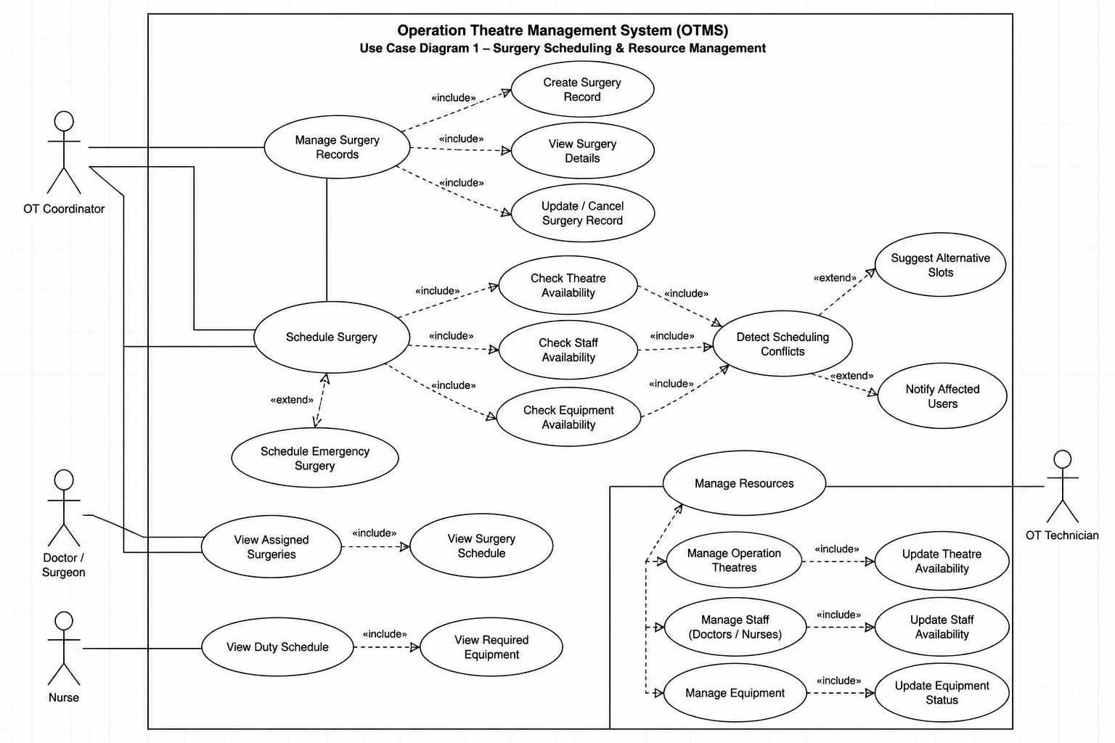

Use-Case Diagram 2 — Emergency Surgery Management
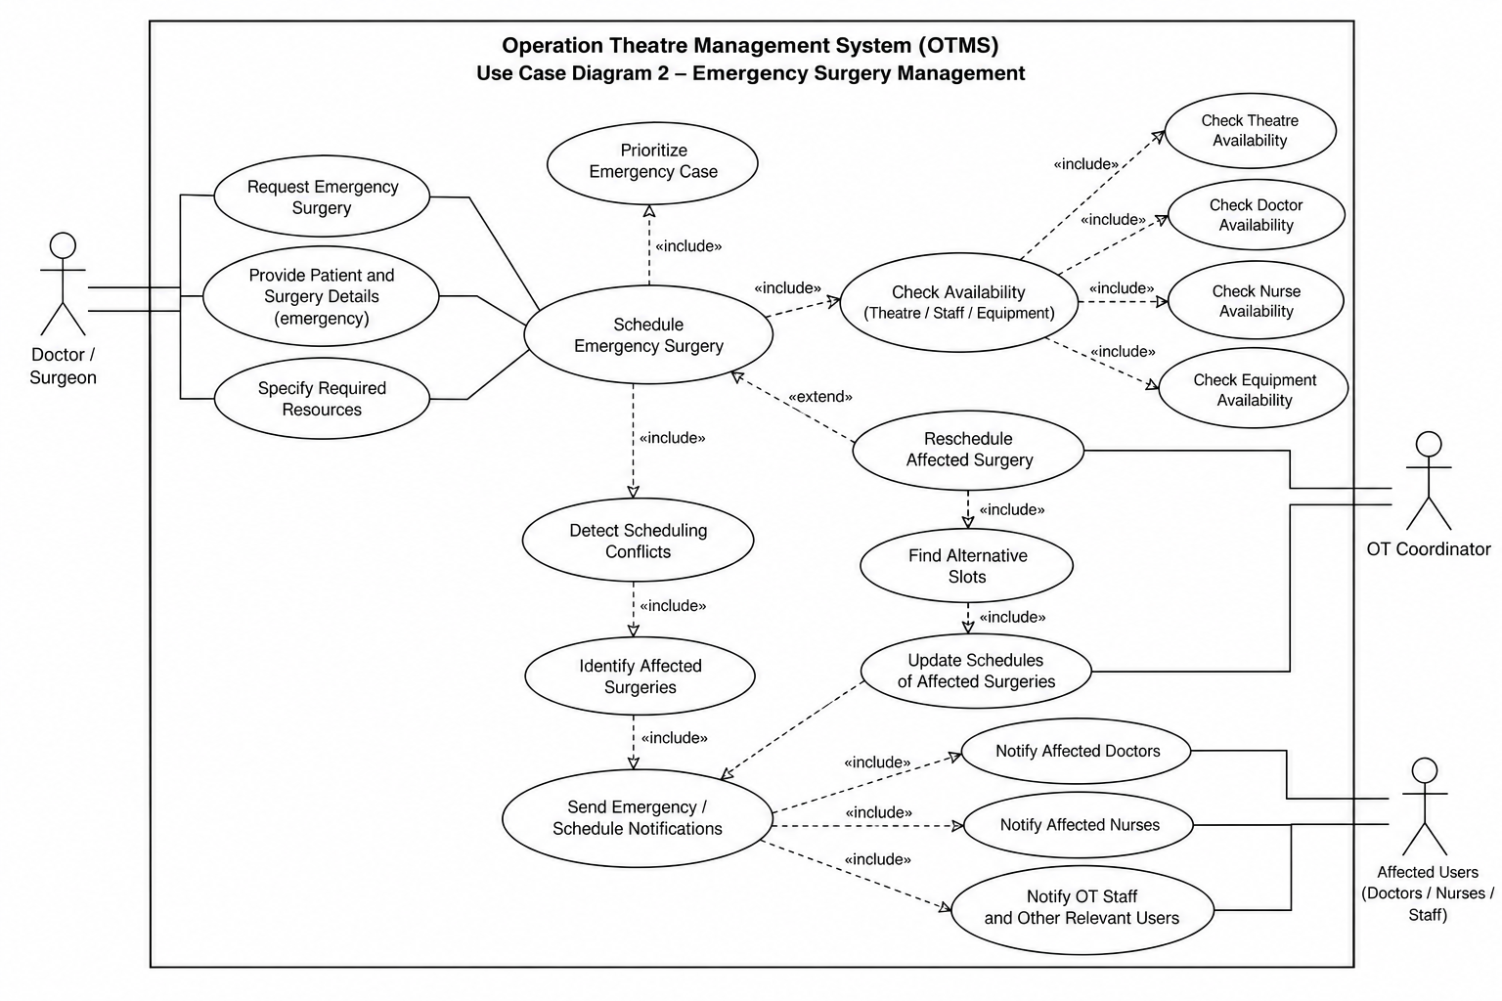

8. Requirements Traceability Matrix (RTM)
The RTM maps SRS requirements to their architectural components and test cases.
Req ID | Requirement Short | Section Ref / Design Spec | Module | Test Case(s) | Status | Comments
OTMS-F-001 | User authentication | 4.1 / DS-Auth-01 | Authentication & RBAC | TC-Auth-01 | N
OTMS-F-002 | Role-based access | 4.1 / DS-Auth-02 | Authentication & RBAC | TC-Auth-02 | N
OTMS-F-004 | Create surgery | 4.2 / DS-Surg-01 | Surgery Management | TC-SURG-01 | N
OTMS-F-007 | Schedule surgery | 4.3 / DS-Sched-01 | Scheduling Engine | TC-SCH-01 | N
OTMS-F-008 | Check theatre availability | 4.3 / DS-Sched-02 | Resource Management | TC-SCH-02 | N
OTMS-F-009 | Prevent theatre conflict | 4.3 / DS-Conflict-01 | Conflict Detection | TC-SCH-03 | N
OTMS-F-010 | Check doctor availability | 4.4 / DS-Resource-01 | Resource Management | TC-RES-01 | N
OTMS-F-011 | Check nurse availability | 4.4 / DS-Resource-02 | Resource Management | TC-RES-02 | N
OTMS-F-012 | Check equipment availability | 4.4 / DS-Resource-03 | Resource Management | TC-RES-03 | N
OTMS-F-013 | Detect scheduling conflicts | 4.5 / DS-Conflict-01 | Conflict Detection | TC-CON-01 | N
OTMS-F-015 | Mark emergency surgery | 4.6 / DS-Emergency-01 | Emergency Prioritization | TC-EMG-01 | N
OTMS-F-016 | Prioritize emergency surgery | 4.6 / DS-Emergency-02 | Emergency Prioritization | TC-EMG-02 | N
OTMS-F-017 | Identify affected surgeries | 4.6 / DS-Emergency-03 | Conflict Detection | TC-EMG-03 | N
OTMS-F-018 | Reschedule affected surgery | 4.6 / DS-Emergency-04 | Scheduling Engine | TC-EMG-04 | N
OTMS-F-019 | Schedule notifications | 4.7 / DS-Notify-01 | Notification Service | TC-NOT-01 | N
OTMS-F-023 | Utilization reports | 4.8 / DS-Report-01 | Utilization & Reporting | TC-REP-01 | N
OTMS-NF-001 | Response time | 5 / DS-Perf-01 | REST API / Core Services | TC-Perf-01 | N
OTMS-NF-002 | Availability | 5 / DS-Rel-01 | OTMS Application | TC-Rel-01 | N
OTMS-SR-001 | TLS 1.2+ | 5.1 / DS-Sec-01 | API Gateway | TC-SEC-01 | N
OTMS-SR-002 | RBAC | 5.1 / DS-Sec-02 | Authentication & RBAC | TC-SEC-02 | N
OTMS-SR-003 | Audit logging | 5.1 / DS-Sec-03 | Audit & Monitoring | TC-SEC-03 | N

Status:
- N = Not yet tested
- P = Passed
- A = Accepted

Final requirement count
Requirement Type | Count | Template Requirement
Functional Requirements | 23 | ≥ 15
Non-Functional Requirements | 6 | ≥ 5
Security Objectives | 3 | ≥ 2
Security Requirements | 6 | ≥ 5

