Pre-Meeting Calculation Requests : DAB-MOD

--------------------------------

**1) Provide Heavy-Flavor Transport Coefficients (mu_B=0)**

----------------------------------------------------

*(a) Current best estimtate of Ds(2\piT) as function of T over available T-range (both charm and bottom, if available).*

Because we use Moore and Teaney model the Ds(2\piT) does not depend on T :

* Ds(2\piT)/ћc=2.23 for charm.
* Ds(2\piT)/ћc =2.47 for bottom.

These are the optimized values used in arXiv:1907.03308.

*(b) Normalized momentum dependence of friction coefficient, A(p;T)/A(p=0;T), for current best estimate.*

The relativistic fluctuation-dissipation relation gives:  
 

As D_s is independent of p in Moore and Teaney model, we get:  
  
where m = 1.27 GeV for charms.

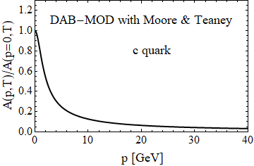

*(c) Table of current best estimates of charm friction and momentum-diffusion coefficients for p=0-40GeV (in steps of dp=0.2GeV) and T=0.16-0.6GeV (steps dT=0.02GeV) for mu_B=0. The idea is to run them through a Langevin simulation in a common hydrodynamic medium evolution.*

As writen above, the friction coefficient [in fm-1] is :  
, with ћc=0.1973 [GeV.fm].

You can estimate the values of the table with this relation.

The momentum-diffusion coefficient [in GeV2/fm] is :



You can estimate the values of the table with this relation.

**2) Assess Hadronization and Hadronic Phase (test case: 30-50% 5TeV PbPb collisions)**

-------------------------------------------------------------------------

*(a) Compute H_AA(pT;T_H) = R_AA^H_Q (pT;T_H) / R_AA^Q(pT;T_H) , the ratio of the R_AA of the heavy meson (H_Q) just after hadronization to the R_AA of the heavy quark (Q) just before hadronization, for H_Q=D,Lambda_c (as available) and Q=c.*

Only for direct D0 (data in : « H_RAA_D0overCharm_Centrality_30_50.dat ») :

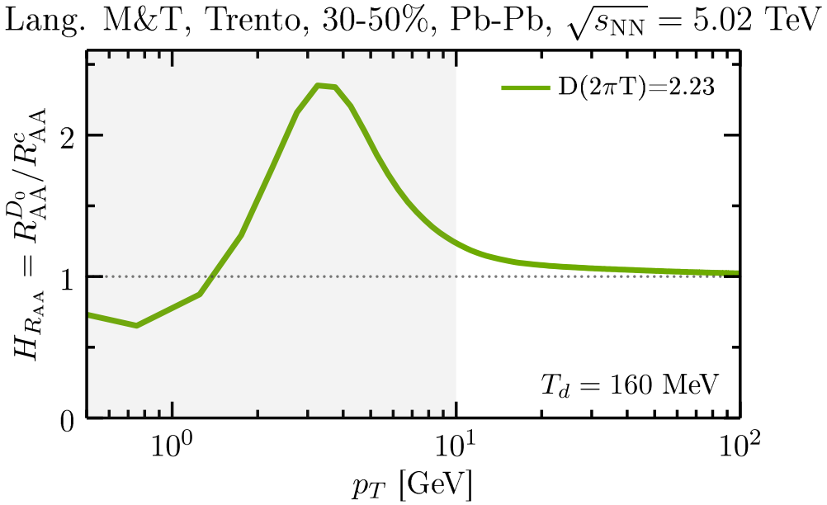

The corresponding RAA to better understand :

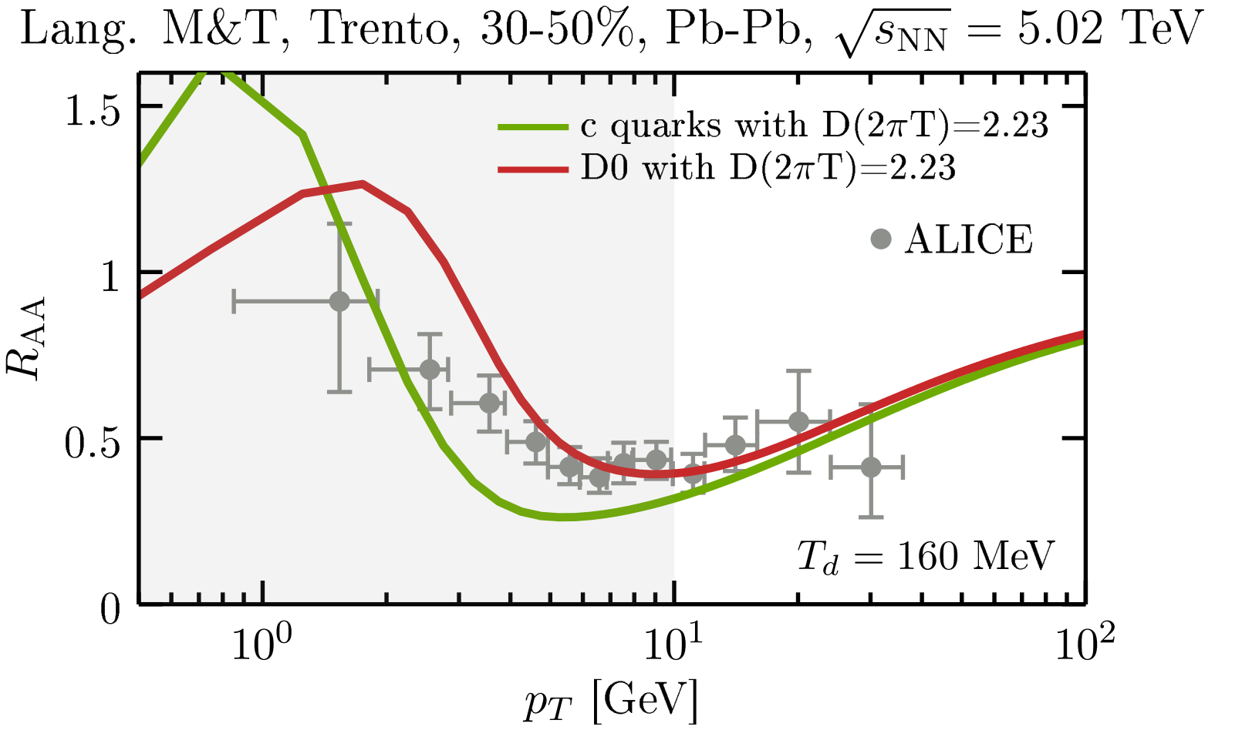

*(b) The same as (a) but for the elliptic flow, v2: H_v2(pT;T_H) = v2^H_Q (pT;T_H) / v2^Q(pT;T_H).*

Only for direct D0 (data in : « H_v2_D0overCharm_Centrality_30_50.dat ») :

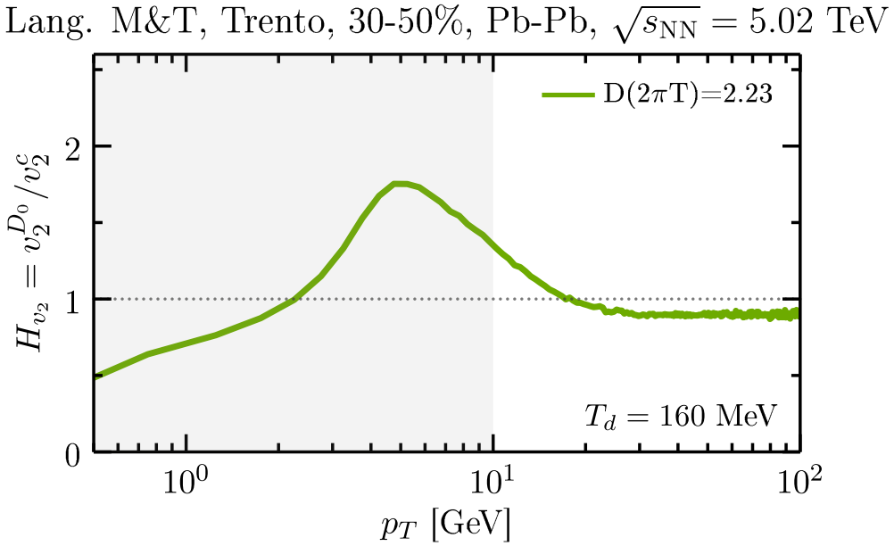

The corresponding v2 to better understand :

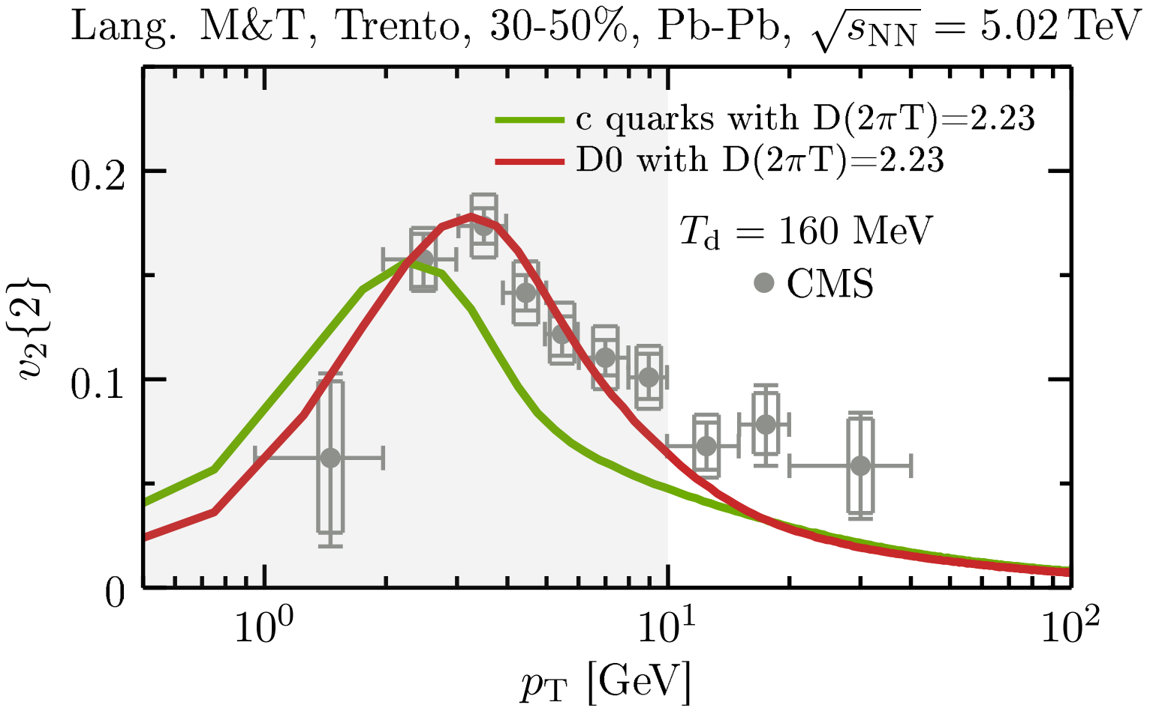

See arXiv:1906.10768 [nucl-th] (section V.) for more details about the fragmentation+coalescence model used in DAB-MOD.

*(c) Compute H_AA and H_v2 ratios for D-meson spectra at kinetic freezeout over those right after hadronization (if applicable).*

No hadronic rescattering in DAB-MOD.

**3) Transport Simulations with Imposed Coefficients**

------------------------------------------------

*(a) Renormalize the charm-quark transport coefficients with a temperature-dependent but momentum-independent K factor, K(T), as to obtain a temperature-independent value of D_s (2piT) == 4 (for Langevin approaches, D_s = T / [m_Q A(p=0)]); then compute R_AA and v2 of charm quarks right before hadronization for 30-50% 5TeV PbPb collisions within your model.*

Shown here for two different QGP backgrounds (initial conditions and equation of states) :  
- MCKLN (an implementation of a Color Glass Condensate kT-factorization model) + « S95n-v1 » outdated equation of state  
- Trento (tuned to IP-Glasma) + « EOS2+1 » (from lQCD) equation of state

(See arXiv:1906.10768 [nucl-th] for more details.)

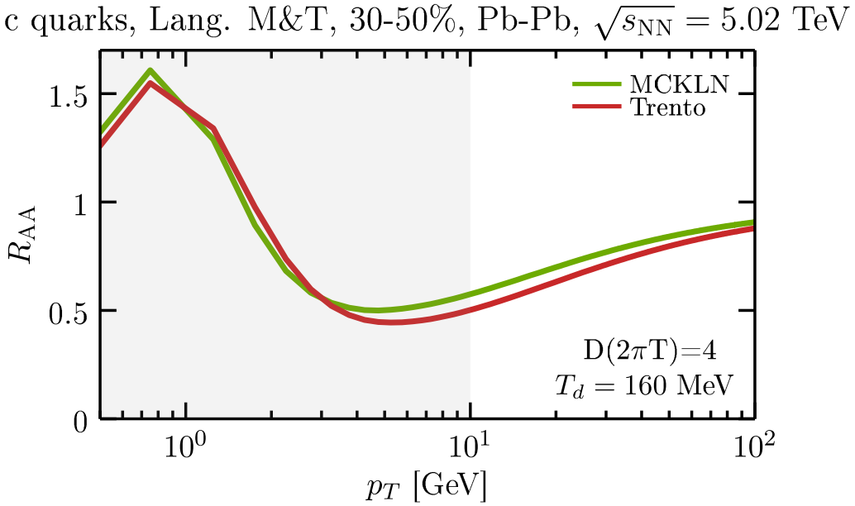

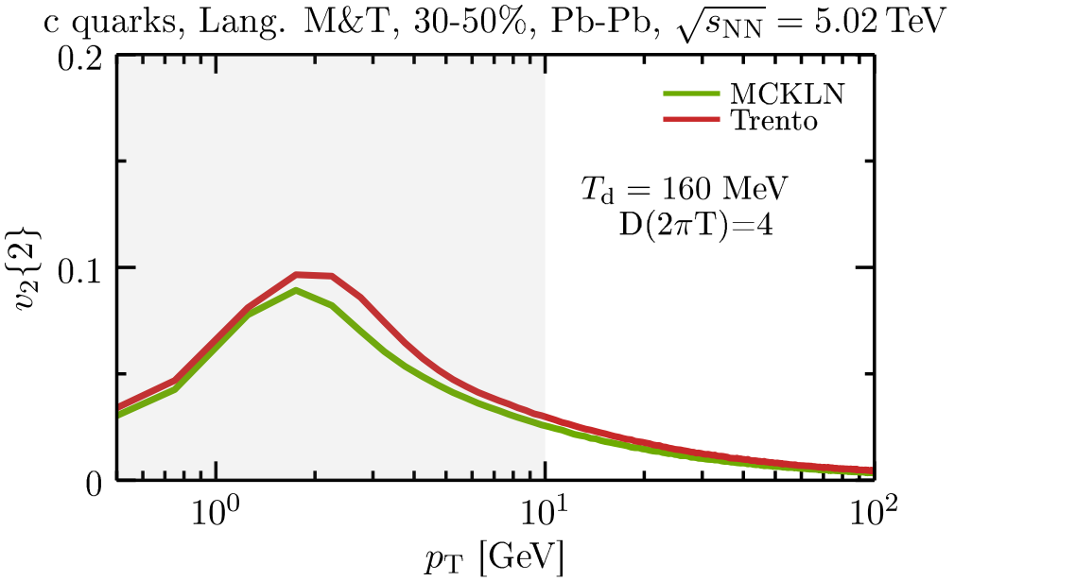

The related data files (« RAA_Charm_Trento_D2piT_4_Centrality_30_50.dat » and « v2_Charm_Trento_D2piT_4_Centrality_30_50.dat ») are given for Trento initial conditions.

*(b) As an optional assignment (time permitting), to compare transport coefficients from different models: Renormalize current charm-quark transport coefficient, A(p;T), qhat/T^3 for a common R_AA in a fixed brick problem (as in Fig. 7 in Phys. Rev. C99 (2019) 054907); then compute R_AA and v2 of charm quarks right before hadronization for 30-50% 5TeV PbPb collisions within your model.*

I didn’t have enough time to perform this analysis.