Recommended Practices for
Dimensions and Dimensional Tolerances

March 14, 2000

Contacts:

Mike Strub
EDS
750 Tower Drive, M/S 2234
P.O.Box 7019
Troy, MI 48007-7019
mike.strub@eds.com

Tom Hendrix
Boeing Commercial Airplane Group
P.O.Box 3707
Seattle, WA 98124 USA
thomas.e.hendrix@boeing.com

Table of Contents

1 Introduction 4
2 Scope 4
3 Fundamental concepts 4
3.1 Introduction 4
3.2 Location dimension relationships between shape_aspects 5
3.3 Linear Distance Dimension expressed as a Nominal Value with a Value Limit 9
3.4 Linear Distance Dimension expressed as a Nominal Value with a Plus Minus Bounds 12
3.5 Directed linear distance dimension, expressed as nominal value with different plus minus limits 15
3.6 Curved distance location dimension, expressed as nominal value with different plus minus bounds 18
3.7 General size dimension, expressed as nominal value with different plus minus bounds 21
3.8 General size dimension, expressed as nominal value with a limits and fits designation 23
3.9 Linear Distance Dimension expressed as a Value Range 25
3.10 Angular Size Dimension expressed as a Nominal Value with Significant Digits 28
3.11 Angular Location Dimension expressed as a Nominal Value 30
4 Instance diagrams 32
5 Part 21 file example 41
5.1 Conforming to AP203 42
5.2 Conforming to AP214 59
6 Known issues 76
6.1 Value_range instance #954 fails to pass value_range WR1 76
6.2 Geometrically_bounded_wireframe_shape_representation instance #719 76
7 Availability of implementation schemas 76
7.1 AP214 76
7.2 The application module 76
8 Change History 77
8.1 Changes from November 3, 1999 to March 14, 2000 77

List of Figures
Figure 1 – Instance diagram of common structure used to associate representation_items with location
dimensions 6
Figure 2 – Partial instance diagram for linear distance dimension expressed as nominal value with value
limit 9
Figure 3 – Partial instance diagram for linear distance dimension expressed as nominal value with plus (or)
minus bounds 13
Figure 4 – Partial instance diagram for linear distance dimension expressed as nominal value with
different plus minus bounds 16
Figure 5 – Partial instance diagram for a curved distance location dimension, expressed as a nominal value
with symmetric plus minus bounds 19
Figure 6 – Partial instance diagram for a general size dimension, expressed as a nominal value with
symmetric plus minus bounds 22
Figure 7 – Partial instance diagram for a general size dimension, expressed as a nominal value with limits
and fits designation 24
Figure 8 – Partial instance diagram for linear distance dimension expressed as a value range 26
Figure 9 – Partial instance diagram for angular_size_dimension expressed as a nominal_value with
significant digits 28
Figure 10 – Partial instance diagram for angular_location_dimension expressed as a nominal_value 30
Figure 11 – Complete diagram for linear distance dimension, expressed as nominal value with value limit 32
Figure 12 – Complete diagram for linear distance dimension, expressed as nominal value with plus minus
limit 33
Figure 13 – Complete instance diagram for directed linear distance dimension, expressed as nominal value
with different plus minus limits 34
Figure 14 – Complete instance diagram for curved distance location dimension, expressed as nominal
value with plus minus bounds 35
Figure 15 – Complete instance diagram for general size dimension, expressed as nominal value with plus
minus bounds 36
Figure 16 – Complete instance diagram for a general size dimension, expressed as a nominal value with
limits and fits designation 37
Figure 17 – Complete instance diagram for a linear distance dimension, expressed as a value range. 38
Figure 18 – Complete instance diagram for angular_size_dimension expressed as a nominal_value with
significant digits 39
Figure 19 – Complete instance diagram for angular_location_dimension expressed as a nominal_value 40
Figure 20 – Face of complete "geometric dimensions and dimensional tolerances" example 41
Figure 21 – Perspective view of "geometric dimensions and dimensional tolerances" example 41

Introduction
This document describes the recommended practices for implementing dimensions and dimensional tolerances. It illustrates a harmonised approach common to AP 214 and AP 202.
All instance diagrams presented within this document refer to instances defined within the Part 21 file examples included within section 5.
If questions arise during your review of this document, please contact any of the persons listed on the cover page of this document.

Scope
The information presented in this document covers how a STEP implementation would support:
- the representation of dimensions including:
- directional dimensions
- location dimensions such as angular, curved, or linear distances
- size dimensions such as angular, thickness, or other
- the association of dimensions with geometry
- the representation of dimensional tolerances including:
- plus-or-minus deviations
- maxima, minima, and nominal dimensions
- limits and fits
- significant digits
- the association of dimensional tolerances with dimensions.

Fundamental concepts
Particular concepts of interest within the scope of this recommendation are described within the following sections.

Introduction
Tolerance types
Tolerances treat the uncertainty with which the realized form or measurements of a real manufactured object compare to their design ideals. If all parts could be manufactured perfectly as designed, there would be no need for tolerancing practices. However, it is certain that this cannot be done for finite cost in any but the most trivial cases.
There are two main classes of tolerances, dimensional and geometric.
Geometric tolerances are the more complex of these two types. They address the acceptable deviation of the form of a manufactured object. Geometric tolerances usually are expessed as an area or a volume in which the realized form must lie in order to meet the design criteria. These tolerances are the subject of a separate application module and recommended practices guide.
Dimensional tolerances are the less complex of the two classes of tolerances. They address the acceptable deviation of individual dimensions on a manufactured object. An ideal, or nominal dimension is always expressible as a linear – one-dimensional – quantity. It may be an angle or a distance, and may refer to a size or a location. A tolerance on a dimension is therefore expressible as a range of values within which the manufactured dimension may fall in order to be acceptably close to the ideal value. Dimensional tolerances are the subject of this recommended practices guide, and of the "Geometric Dimensioning and Dimensional Tolerancing" application module whose application it describes.
Dimensional Tolerance types
A range of acceptable realized values for a dimension may be selected from a standard catalogue of acceptable ranges as a function of the value of the dimension and the purpose of the feature to which it is applied. Such dimensional tolerances are known as "limits and fits". Limits and fits tolerances have alphanumeric designations found and defined in the standard catalogue. The nominal value of a dimension may lie outside of the range of values provided by a limits and fits designation. Limits and fits normally apply to the diameters of holes and shafts which are intended to mate, with resulting designed effects ranging from loose fits to permanent force fits.
The range of acceptable values for a dimension may consist of a pair of upper and lower bounding values. These comprise plus-or-minus tolerances. Realized values which fall within these bounds are considered acceptable. Here, too, the nominal value to which the bounding values are applied may or may not fall between them.
The range may have only one bounding value when it is only necessary to constrain the upper or lower limit of the permissible realized value.
A dimension may have no apparent bounding values yet still be constrained by significant digits. The use of designating a number of significant digits has the effect of introducing upper and lower bounds implicitly – which are above and below the ideal value by one unit in the least significant digit position.
Finally, a nominal value may have no tolerance values associated with it, either explicit or implicit.

Location dimension relationships between shape_aspects
There are two basic instance diagram structures which will recur in the examples. The first is that there is a significant reference path traversal to be made in order to connect the specific geometrical elements to their dimensions. There are also correlations to be made to the product's shape, design, and contexts. This traversal is too large to be repeated for each example, so it is shown once here, and referred to indirectly later.
The second is simply the association of an instance to the unit_component attribute of a measure_representation_item. All measure_representation_items, whether in combination with qualified_representation_item or not, point either to the compound instance (#10 in this example) of length_unit, named_unit, and si_unit – a centimetre – or to the compound instance (#14 in this example) of conversion_based_unit, plane_angle_unit, and named_unit -–a degree.

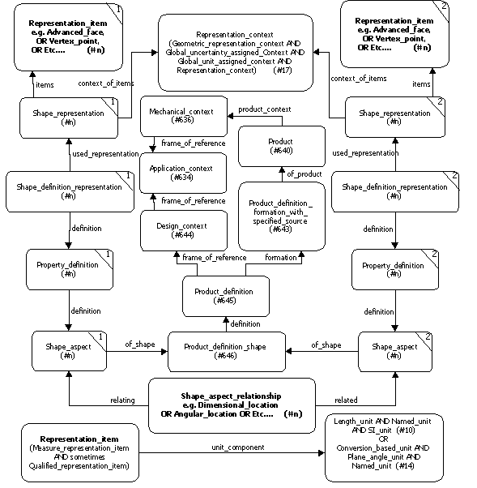

Figure 1 – Instance diagram of common structure used to associate geometric_representation_items and product with location dimensions

Entities and Attributes
Name | Explanation
Shape_aspect_-relationship | Specifies a spatial constraint between two shape_aspects. This may be a dimensional_location, a dimensional_location_with_path, and angular_location, and/or a directred_dimensional_location. The selection will be re-explained in the table for each example
name | A value is specified by the mapping table.
description | No requirement defined – instantiate this optional attribute with an empty string.
relating_shape_aspect | One of the two elements between which the location dimension is being represented.
related_shape_aspect | The other of the two elements between which the location dimension is being represented.
Shape_aspect | The representation of the shape property of an element of an object
name | No requirement defined – instantiate this with an empty string.
description | No requirement defined – instantiate this with an empty string.
of_shape | The overall product of which this shape_aspect is a property
product_definitional | If true, this instance of shape_aspect corresponds precisely with the physical boundary of the correlative product_definition_shape.
Property_definition | A property of a product.
name | No requirement defined – instantiate this with an empty string.
description | No requirement defined – instantiate this with an empty string.
definition | In this case, the shape_aspect whose property is being defined.
Shape_definition_-representation | Found in AP 203 and AP 214 but not in this module. An association between a property (shape) of a product and its representation
Shape_representation | An overall representation of shape of an object
name | No requirement defined – instantiate this with an empty string.
items | The representation_item(s)
context_of_items | Simply the common representation_context of all representations in this example

Representation_item | An element of product data that participates in one or more rep-resentations or contributes to the definition of another represen-tation_item. In this example it is either  - the element of geometry (which is a subtype of geomet-rical_representation_item or topological_representation_item) which is being associated with a shape_aspect for the purpose of tying a location dimension to it, or  - the value, unit, and sometimes qualifier(s) which quantify and qualify the value of a size or location dimension. The unit is a length_unit (centimetre in this example) or a plane_angle_unit (radian in this example) as appropriate. The unit in this example is always a named_unit and an SI_unit as well.
Product_definition_-shape | Shape of the overall product.
name | No requirement defined – instantiate this with an empty string.
description | No requirement defined – instantiate this with an empty string.
definition | The product_definition of which this represents the shape
Product_definition | Found in AP 203 and AP 214 but not in this module
Product_definition_-formation_with_-specified_source | Found in AP 203 and AP 214 but not in this module
Product | Found in AP 203 and AP 214 but not in this module
Design_context | Found in AP 203 and AP 214 but not in this module
Application_context | Found in AP 203 and AP 214 but not in this module
Mechanical_context | Found in AP 203 and AP 214 but not in this module

Linear Distance Dimension expressed as a Nominal Value with a Value Limit
Our first example combines the simplest dimension type, a linear (straight) distance between two geometrical entities of the example object, with a tolerance constraint that provides only one bound on the value of the dimension. This is the "9.5 cm" height dimension found at the left side of the drawing of the object (see section 5 for illustrations), indicating the distance from the top flat to the bottom flat of the part. The value of 9.5 cm is a nominal value. The bound is the word "MAX", indicating that the distance realized between these two faces, in any manufactured replica of the design, shall not exceed 9.5, but may be indeterminately less.
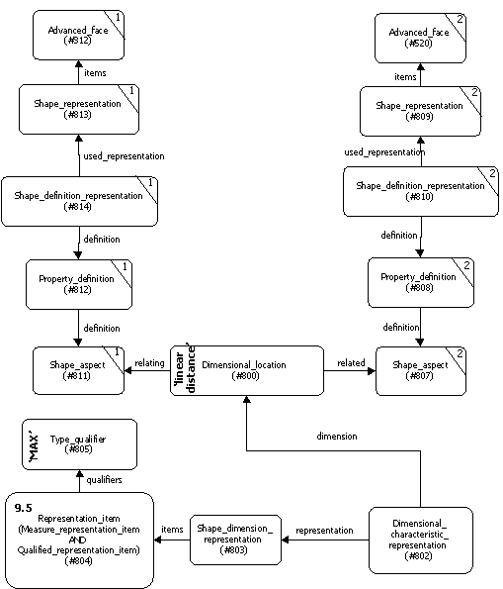
Figure 2 – Partial instance diagram for linear distance dimension expressed as nominal value with value limit

Entities and Attributes
Name | Explanation
Dimensional_location | Specifies a spatial constraint between two shape_aspects.
name | The value 'linear distance' is required by the mapping table.
description | No requirement defined – instantiate this optional attribute with an empty string.
relating_shape_aspect | One of the two elements between which a linear distance is being represented.
related_shape_aspect | The other of the two elements between which a linear distance is being represented.
Property_definition | Part of the path between one of the shape_aspects involved in the dimensional_location and the geometry that represents it. Merely an artifact of the integrated resource parts, having no independent significance.
name | No requirement defined – instantiate with an empty string.
description | No requirement defined – instantiate this optional attribute with an empty string.
definition | The object whose property is being defined. In this case, one of the shape_aspects which delimits the dimensional_location.
Dimensional_character-istic_representation | An association between a dimension and its representation
dimension | The dimension being associated.
representation | The representation being associated.
Shape_dimension_-representation | The collection of all representation_items in a model which are shape dimensions.
name | No requirement defined – instantiate this optional attribute with an empty string.
items | The set of representation_items in the representation.
context_of_items | The associated representation_context for this representation.
Representation_item | An element of product data that participates in one or more representations or contributes to the definition of another representation_item. In this example, a compound instance of value_representation_item and qualified_representation_item which quantifies the representation of the dimension value and limit.
Measure_representation_-item | The representation of a value with a unit. The unit is found in the representation_context for the representation which contains the representation_item of which this value_representation_item is a subtype.
name | No requirement defined – instantiate with an empty string.
unit_component | The unit being represented. In this case, a length_unit which is also a named_unit and an SI_unit with a .CENTI. prefix and a .METRE. suffix.
value_component | The value being represented. In this case, 9.5
Length_measure | A defined type which names a measure_value as a measure of length.
Positive_length_measure | A defined type which names a length_measure as having a positive quantification.
Qualified_representa-tion_item | The representation of a qualification of a value.
qualifier | The set of value qualifiers of the qualified_representation_item.
Length_unit | A type of named_unit used to express distance.
Named_unit | A unit quantity. Used to enable complex instantiation.
dimensions | The dimensions, in terms of the 7 base properties, of the unit. In this example, this attribute is calculated automatically by a function and does not need to be instantiated directly, so an asterisk * is inserted in its attribute section.
SI_unit | A systeme international (SI) unit name.
prefix | The SI prefix. In this example it is "centi-".
name | The SI name. In this example it is "metre".
Type_qualifier | A constraint which qualifies a representation. In this example it is a value constraint.
name | The label for the constraint. In this example it is "MAX".
Representation_context | The context in which a collection of representation_items, known as the representation, are related. In this example the subtype global_unit_assigned_context is used.
Global_unit_assigned_-context | A subtype of representation_context used for applying a single type of unit to all representation_items in a representation.
context_identifier | No requirement defined – instantiate with an empty string.
context_type | No requirement defined – instantiate with an empty string.
units | The common unit name(s) applied to all appropriate values in the representation. In this example it is the SI_unit "centimetre".
Advanced_face | An entity several entities down the subtype chain from representation_item, therefore one of very many geometrical and topological representation item entities which may be used as the origin and target entities between which a location dimension may be specified. In this example, a linear distance dimension is being specified between two representation_items which are topological_representation_items which are faces which are face_surfaces which are advanced_faces.

Linear Distance Dimension expressed as a Nominal Value with a Plus Minus Bounds
Our second example combines the simplest dimension type, a linear (straight) distance between two geometrical entities of the example object, with a tolerance constraint that provides both positive and negative bounds on the value of the dimension. This is the "6.1 cm" height dimension found at the left side of the drawing of the object (see section 5 for illustrations), indicating the distance from the top flat to the departure point for the bottom bevel of the part. The value of 6.1 cm is a nominal value. The upper bound is 6.15 cm and the lower bound is 6.05 cm, indicating that the distance realized between these two faces, in any manufactured replica of the design, shall not exceed 6.15 cm, and may not fall below 6.05 cm.
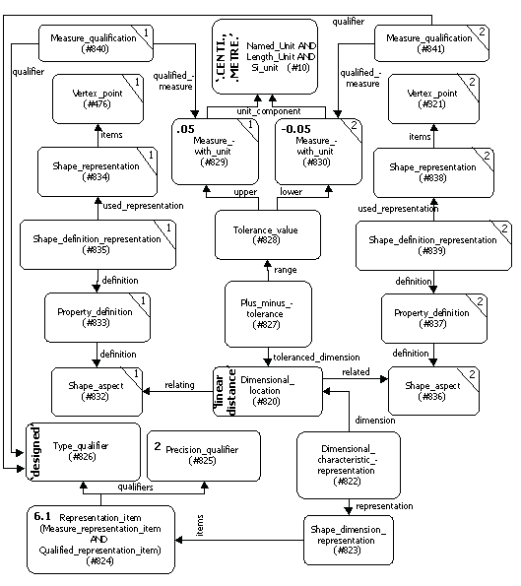
Figure 3 – Partial instance diagram for linear distance dimension expressed as nominal value with plus (or) minus bounds

Entities and Attributes in addition to, or which differ in their use, from those found in the table for the previous examples
Name | Explanation
Measure_representation_-item | The representation of a value with a unit. The unit is found in the representation_context for the representation which contains the representation_item of which this value_representation_item is a subtype.
name | No requirement defined – instantiate with an empty string.
unit_component | The unit being represented.
value_component | The (nominal) value being represented. In this case, 6.1
Qualified_representa-tion_item | The representation of a qualification of a value.
qualifier | The set of value qualifiers of the qualified_representation_item.
Precision_qualifier | Specifies the number of significant figures in a value.
precision_value | That number, which in this case, is 2
Type_qualifier | A constraint which qualifies a representation
name | The label for the constraint. In this example it is "designed".
Plus_minus_tolerance | The specification of the limits within which the value of a dimension may vary.
range | The means of specification of those limits. In this case, via a tolerance_value.
toleranced_dimension | The dimension to which the tolerance is applied. In this case, the dimensional_location
Tolerance_value | The values added to the dimension value to establish the range of a plus_minus_tolerance
lower_bound | The value added to the dimension value to establish the minimum value of the dimension
upper_bound | The value added to the dimension value to establish the maximum value of the dimension
Measure_with_unit | In this example, the means of expressing the upper and lower bounds of a tolerance_value, which combines both value and unit.
value_component | The value used.
unit_component | The unit used.

Measure_qualification | A means of associating value qualifier(s) with a measure_with_unit in an alternate way than the use of a qualified_representation_item. In this example, it allows association of the same type_qualifier ('designed') to each tolerance_value bound that was associated to the nominal value.
qualifier | The value_qualifier which provides a qualification of the value. In this example, it is a type_qualifier with the string value 'designed'.
qualified_measure | The measure_with_unit to which the qualifier applies. In this example, it is each of the values indicating permissible deviation from the nominal value.
Vertex_point | Another one of the very many geometrical and topological representation item entities which may be used as the origin and target entities between which a location dimension may be specified. In this example, a linear distance dimension is being specified between two representation_items which are geometric_representation_items which are vertex_points.

Directed linear distance dimension, expressed as nominal value with different plus minus limits
Our third example combines a directed linear (straight) distance between two geometrical entities of the example object, with a tolerance constraint that provides different positive and negative bounds on the value of the dimension. This is the "7.0 cm" horizontal dimension found at the top of the drawing of the object (see section 5 for illustrations), indicating the distance from the left to the right ends of the top flat. The value of 7.0 cm is a nominal value. The upper bound is 7.08 cm and the lower bound is 6.97 cm, indicating that the length of this face, in any manufactured replica of the design, shall not exceed 7.08 cm, and may not fall below 6.97 cm; and shall be measured from the left to the right, and not otherwise.

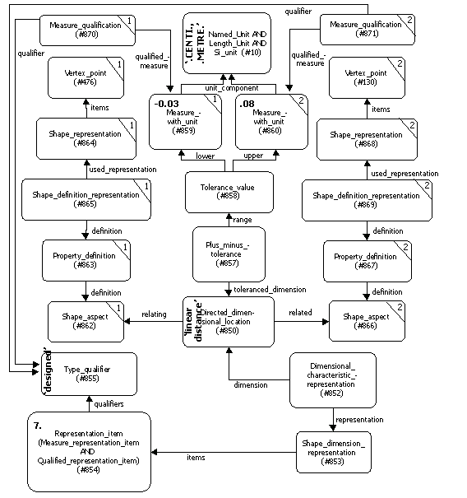
Figure 4 – Partial instance diagram for linear distance dimension expressed as nominal value with different plus minus bounds

Entities and Attributes in addition to, or which differ in their use, from those found in the tables for the previous examples
Name | Explanation
Directed_dimensional_-location | Specifies a spatial constraint between two shape_aspects. A type of dimension_location that specifies that the direction of the location dimension is of interest, i.e., the dimension is specified from the relating_shape_aspect to the related_shape_aspect.
name | The value 'linear distance' is (still) required by the mapping table.
description | No requirement defined – instantiate this optional attribute with an empty string.
relating_shape_aspect | One of the two elements between which a linear distance is being represented. In this case, the dimension is specified to begin with this element.
related_shape_aspect | The other of the two elements between which a linear distance is being represented. In this case, the dimension is specified to end with this element.
Measure_representation_-item | The representation of a value with a unit. The unit is found in the representation_context for the representation which contains the representation_item of which this value_representation_item is a subtype.
name | No requirement defined – instantiate with an empty string.
unit_component | The unit being represented.
value_component | The (nominal) value being represented. In this case, 7
Type_qualifier | A constraint which qualifies a representation.
name | The label for the constraint. In this example it is "designed".
Plus_minus_tolerance | The specification of the limits within which the value of a dimension may vary.
range | The means of specification of those limits. In this case, via a tolerance_value.
toleranced_dimension | The dimension to which the tolerance is applied. In this case, the directed_dimensional_location
Tolerance_value | The values added to the dimension value to establish the range of a plus_minus_tolerance
lower_bound | The value added to the dimension value to establish the minimum value of the dimension. In this case, -0.03 centimetres
upper_bound | The value added to the dimension value to establish the maximum value of the dimension. In this case, .08 centimetres

Measure_with_unit | The means of expressing the upper and lower bounds of a tolerance_value, which combines both value and unit.
value_component | The value used.
unit_component | The unit used.

Curved distance location dimension, expressed as nominal value with different plus minus bounds
Our fourth example combines a curved distance between two geometrical entities of the example object, with a symmetric pair of bounds on the value of the dimension. This is the "6.5 cm" curved dimension found at the top right-of-centre of the drawing of the object (see section 5 for illustrations), indicating the distance along the 10 cm radius arc of the part from the topmost point to the beginning of the 38.797º notch. The value of 6.5 cm is a nominal value. The upper bound is 6.6 cm and the lower bound is 6.4 cm.

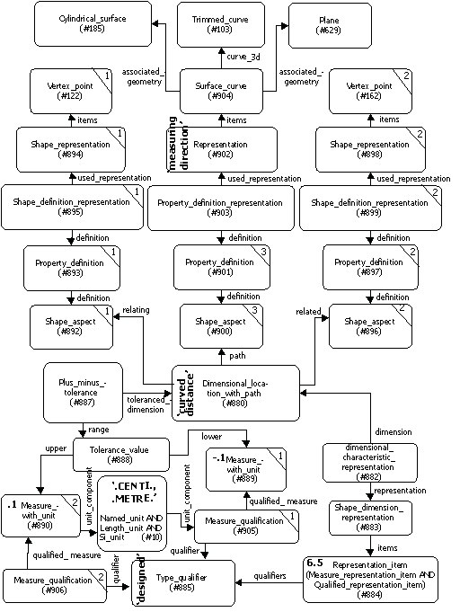
Figure 5 – Partial instance diagram for a curved distance location dimension, expressed as a nominal value with symmetric plus minus bounds

Entities and Attributes in addition to, or which differ in their use, from those found in the tables for the previous examples
Name | Explanation
Dimensional_location_-with_path | Specifies a spatial constraint between two shape_aspects that exists along an explicit path
path | The path, in the form of a shape_aspect, along which the dimensional_location is specified. In this example, a circuitous reference path eventually leads us to a trimmed_curve
name | The value 'curved distance' is required by the mapping table.
description | No requirement defined – instantiate this optional attribute with an empty string.
relating_shape_aspect | One of the two elements between which a linear distance is being represented. In this case, the vertex point uppermost on the diagram and in the back plane.
related_shape_aspect | The other of the two elements between which a linear distance is being represented. In this case, a vertex_point in the same back plane as the first vertex_point, but which is the topmost of the points for the notch on the arc side of the part.
Representation | A collection of one or more representation_items that are related in a representation_context. In this example, it collects the single instance of a representation_item that is a curve, the curve along which the dimensional_location_with_path is measured.
name | Constrained by the reference path to be 'measuring direction'
items | Pointer to the representation_items which constitute the representation. In this example, the set has one member, the curve.
context_of_items | The context of the representation. For this example, it is the same as that for all of the other geometry in the model.
Property_definition_-representation (instance #903 only) | The association between the property_definition that is defined by the shape_aspect, and the representation of the measurement_path.
definition | The property_definition that is the shape_aspect that is a reference to the curve along which the measurement path lies.
used_representation | The representation for the measurement path.
Surface_curve | An entity not found in this module, but which is found in implementations of AP 203 and 214. It represents a curve which lies on a surface. In this example, it is the path along which the dimensional_location_with_path is measured.
name | No requirement defined – instantiate with an empty string
curve_3d | The curve which is the 3 dimensional representation of the surface_curve

associated_geometry | Can mean various things, see Part 42 for a full explanation. In this example, points to two surface associations of the curve: a cylindrical_surface and a plane.
master_representation | Can mean various things, see Part 42 for a full explanation. Constrained by the present example to have the literal value of .CURVE_3D. , meaning in this case that the value of the curve_3D attribute of this entity is the preferred, or most accurate, means of comprehending the geometry of the surface_curve.
Trimmed_curve | An entity not found in this module, but which is found in implementations of AP 203 and 214. It represents a kind of bounded_curve, which is a kind of curve. In this example, it is the path along which the dimensional_location_with_path is to be applied.
Cylindrical_surface | An entity not found in this module, but which is found in implementations of AP 203 and 214. It represents a kind of elementary surface, which is a kind of surface. In this example, it is one of two elementary_surfaces on which the surface_curve lies: the uppermost outer curved surface of the example part.
Plane | An entity not found in this module, but which is found in implementations of AP 203 and 214. It represents a kind of elementary surface, which is a kind of surface. In this example, it is one of two elementary_surfaces on which the surface_curve lies: the "back" plane of the example part.

General size dimension, expressed as nominal value with different plus minus bounds
Our fifth example combines a general size dimension expressed as a nominal value with a symmetric pair of bounds on the value of the dimension. This is the "R10 ± 0.1" dimension (see section 5 for illustrations) representing the radius of curvature of the curved outer surface on the right and top right sides of the object. The manufactured radius is permitted to be as large as 10.1 cm and as small as 9.9 cm.

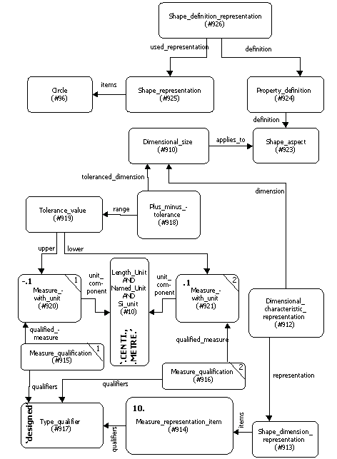
Figure 6 – Partial instance diagram for a general size dimension, expressed as a nominal value with symmetric plus minus bounds

Entities and Attributes in addition to, or which differ in their use, from those found in the tables for the previous examples
Name | Explanation
Dimensional_size | Specifies a spatial constraint between two shape_aspects that exists along an explicit path
name | The value 'curved distance' is required by the mapping table.
applies_to | No requirement defined – instantiate this optional attribute with an empty string.

General size dimension, expressed as nominal value with a limits and fits designation
Our sixth example combines a general size dimension expressed as limits and fits designation. This is the "(diameter symbol) 2 H9" dimension (see section 5 for illustrations) representing the diameter of the rightmost of the two holes in the object. The manufactured diameter is permitted to vary between two bounds which are near to, but may or may not bracket, the nominal value of 2. The exact values of these bounds are found by reference to the limits and fits standard which is applicable. In this case it is ANSI Y4.2, and it could easily be modified to refer instead to the ISO 286 standard. These exact values are not carried by the exchange structure when a limits and fits example is encountered, so they are not mentioned in this example.

The use of limits and fits is to enable engineers to design interfacing features – normally mating holes and shafts, but by natural extension, certain additional male and female (or positive and negative) interfacing shapes, such as ribs and slots, found on pairs of mating components. The purpose of the interface may be to permit relative movement with one of several possible levels of friction; or to prevent relative movement with one of several discrete levels of tightness. Rather than to compel designers to have to undertake the exceedingly complex re-calculations of requisite geometry for each time a design requirement for friction or tightness is encountered, the industry has adopted certain standard sets of tolerance values which enable the design requirement to be met more expediently. These standard tolerance values are tabulated in ANSI Y4.2 and ISO 286, and are customarily referred to only by their alphanumeric designations. The ANSI standard uses a capital letter or pair of letters, ranging from 'A' to 'ZC' for holes and 'a' to 'zc' for shafts, followed by a numeral, to designate the tabulated selection made. The ISO standard uses the alphanumeric designations "IT01 through IT18" for both hole and shaft. By consulting the relevant table, the actual values permitted for the diameter of the hole or shaft can be ascertained.

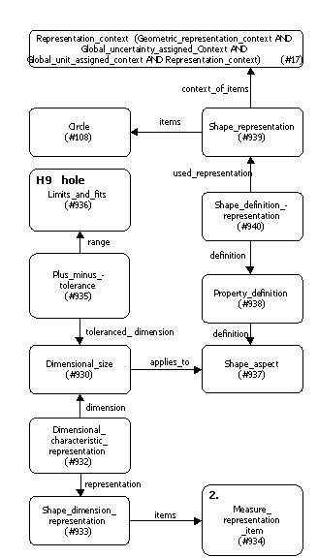

Figure 7 – Partial instance diagram for a general size dimension, expressed as a nominal value with limits and fits designation

Entities and Attributes in addition to, or which differ in their use, from those found in the tables for the previous examples
Name | Explanation
Limits_and_fits | A pre-defined fit system for specifying the tolerances associated with the assembly of mating product features. Used to specify tolerance values implicitly, by providing a code which can be looked up in a table defined by a limits and fits standard.
form_variance | The character(s) representing the fit. To determine how this specification translates into specific values, see the relevant standard. If this attribute is populated, the ANSI standard B4.2 is being used. In this example, the value is 'H9'.
zone_variance | The optional attribute indicating whether a hole or a shaft is applicable. In this example, it is a 'hole'.
grade | No requirement defined – instantiate with an empty string. The international standard tolerance grade based on ISO 289, which would read 'IT01' to 'IT18', normally goes here. In this example, we are not using one, but it would be easy to modify the example to populate this attribute instead of the form_variance attribute.
source | No requirement defined – instantiate with an empty string.

Linear Distance Dimension expressed as a Value Range
Our seventh example combines the simplest dimension type, a linear (straight) distance between two geometrical entities of the example object, with a value range. A value range is a range within which all values are equally acceptable – in essence, the "nominal value" here is the entire range between and including the two values provided. This is the "3.05 3.00 (cm)" dimension which horizontally locates the position of the rightmost circular hole on the example object (see section 5 for illustrations).
Linear distance dimensions require a pair of shape aspects between which to assert themselves. In this case, the model's geometry contained a point (lower right corner of object) to serve as the rightmost boundary, but no point laid directly to the left of it corresponding to the horizontal position of the circular hole centre. So an additional point was created with the same x-co-ordinate as the hole centre, but a y-co-ordinate the same as that of the rightmost boundary. This point was then associated with the point on which it was based – the circular hole's centre point – using the derived_shape_aspect entity.

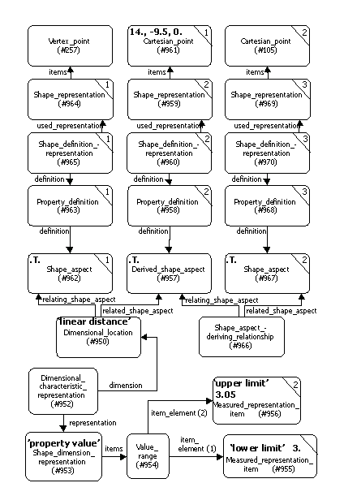
Figure 8 – Partial instance diagram for linear distance dimension expressed as a value range

Entities and Attributes in addition to, or which differ in their use, from those found in the table for the previous examples
Name | Explanation
Value_range | A type of compound_representation_item which specifies a range of values, given exactly two values via value_representation_-items (which define the range). This entity also introduces several where rules, which in this case assign values to the name attributes of the value_representation_item and to the representation whose .items attribute points to value_range
name | No requirement defined – instantiate with an empty string.
item_element | Points to the set of exactly two value_representation_items which define the range of the value.
Derived_shape_aspect | In this example, it is necessary to create a shape aspect to serve as one of the referenced bounds of a dimension. This shape aspect's position is derived from the x-co-ordinate of the centre of the circle whose horizontal position is to be dimensioned and toleranced; but it must lie in a direction directly horizontal to that of the other shape aspect. This entity therefore indicates that the purpose of the shape_aspect it refers to is to provide a measurement location rather than to actually 'be' the geometry of the object in question.
name | No requirement defined – instantiate with an empty string.
description | No requirement defined – instantiate with an empty string.
of_shape | The overall shape of which this shape aspect is a part.
product_definitional | Whether the shape aspect lies on the surface of the part, which it happens to do in this instance.
Measure_representation_-item | A type of representation_item used to represent a value with a unit. In this case, it is used to represent (in separate instances) the upper and lower limits of a value_range.
name | In this case, compelled by working rules in value_range to contain labels of 'upper limit' or 'lower limit'.
unit_component | The representation of the unit.
value_component | In this case, the value of the upper limit or the lower limit.
Representation | The collection of all representation_items in a model.
name | In this case, working rules in value_range compel a value of 'property value' in the instance of representation that points to value_range as one of its '.items'.
items | The set of representation_items in the representation.
context_of_items | The associated representation_context for this representation.
Shape_aspect_deriving_-relationship | A type of shape_aspect_relationship used to indicate that the relating shape aspect is a derived shape aspect, which is based on the related shape aspect
name | No requirement defined – instantiate with an empty string.
description | No requirement defined – instantiate with an empty string.
relating_shape_aspect | The shape_aspect which is a derived_shape_aspect, based on the other shape_aspect.
related_shape_aspect | The shape_aspect on which the relating shape aspect is based.

Angular Size Dimension expressed as a Nominal Value with Significant Digits
Our eighth example combines an angular size dimension with a specification of the number of significant digits for the nominal value. This angle is the 38.797 degree notch on the right curved face of the object. The specification of this angle is merely as a nominal value, with no tolerance in a conventional sense. But the requirement that 3 significant digits be maintained implies that the actual tolerance is plus or minus .0005 degrees. Admittedly, this is not a realistic manufacturing specification, but it does serve as an example of how to associate significant digits with an angular size in the part 21 file.
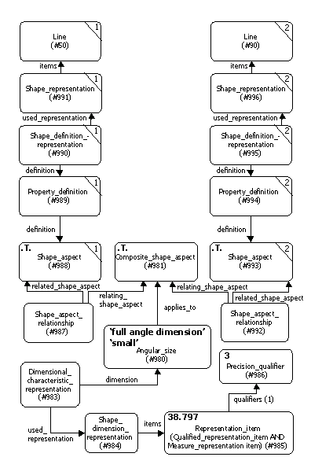
Figure 9 – Partial instance diagram for angular_size_dimension expressed as a nominal_value with significant digits

Entities and Attributes in addition to, or which differ in their use, from those found in the table for the previous examples
Name | Explanation
Composite_shape_aspect | In this example, it is necessary to create a composite shape aspect to serve as the single shape aspect referenced by a size dimension, since angle_dimensions and their supertype size_dimensions only refer to single shape_aspects, never pairs or groups of them.
name | No requirement defined – instantiate with an empty string.
description | No requirement defined – instantiate with an empty string.
of_shape | The overall shape of which this composite shape aspect is a part.
product_definiitonal | Whether the shape aspect lies on the surface of the part, which it happens to do in this instance.
Angular_size | A measure of the angle formed by two boundaries of a shape aspect and their common or projected intersection. This angle is represented by a single magnitude which is independent of the location of the shape aspect on or within the product.
name | The value 'full angle dimension' is required by the mapping table. It means that the angle is to be understood as being between the two component portions of the shape aspect, and not between one of the portions and a bisector.
applies_to | No requirement defined – instantiate this optional attribute with an empty string.
angle_selection | The value 'small' is required by the mapping table. (Since two lines in space, which cross each other, create two complementary angles, the angular_size entity has an attribute for explaining which of the possible angles – the smaller or the larger – is being specified.)

Angular Location Dimension expressed as a Nominal Value
Our ninth example is of a dimension without any tolerance, explicit or implicit. This angle is the 60 degree angle with which the bevelled edge at the lower left of the example object diverges from the downward extension of the lower of the two leftmost vertical edges of the object.
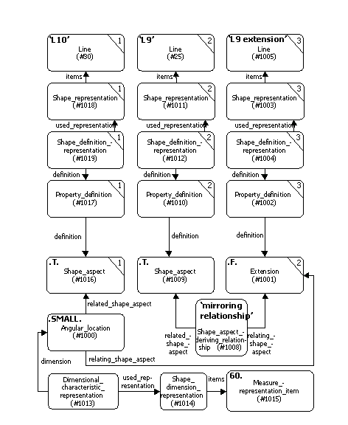
Figure 10 – Partial instance diagram for angular_location_dimension expressed as a nominal_value

Entities and Attributes in addition to, or which differ in their use, from those found in the table for the previous examples
Name | Explanation
Extension | In this example, it is necessary to create a shape aspect to serve as the origin of the angular location dimension, since only a projection line serves that purpose in the illustration of the example object, and because presentation entities are outside the scope of this module. Extension is a subtype of shape aspect which the mapping table compels us to use in this example to represent a line
name | No requirement defined – instantiate with an empty string.
description | No requirement defined – instantiate with an empty string.
of_shape | The overall shape with which this extension shape aspect is associated.
product_definiitonal | Whether the shape aspect lies on the surface of the part, which it happens not to do in this instance, so the value is .F.
Angular_location | A measure of the angle formed by two shape aspects at their common or projected intersection
name | No requirement defined – instantiate with an empty string.
description | No requirement defined – instantiate with an empty string.
relating_shape_aspect | The shape aspect that serves as the origin from which the angle of the angular location is to begin
related_shape_aspect | The shape aspect that serves as the target at which the angle of the angular location ends
angle_selection | Specifies which of the angles formed by an intersection of two straight lines is being referred to. If the lines were perpendicular, the value would be .EQUAL. But in this example they are not perpendicular, so either the 60 or the 120 degree angle they form could be meant. .SMALL. is used here to indicate the 60 degree angle.
Shape_aspect_deriving_-relationship | A type of shape_aspect_relationship used to indicate that the relating shape aspect is a derived shape aspect, which is based on the related shape aspect (see table 3.9.1 for complete details)
name | Required by the mapping table to have a value of 'mirroring relationship'.

Instance diagrams
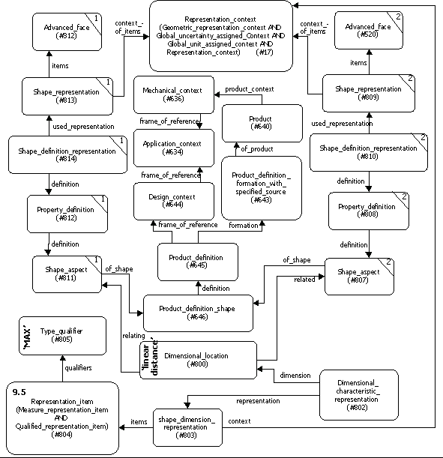
This section provides an overview of the structures used for the different capabilities defined in this document by combining the individual figures of the above descriptions.

Figure 11 – Complete diagram for linear distance dimension, expressed as nominal value with value limit
Figure 12 – Complete diagram for linear distance dimension, expressed as nominal value with plus minus limit
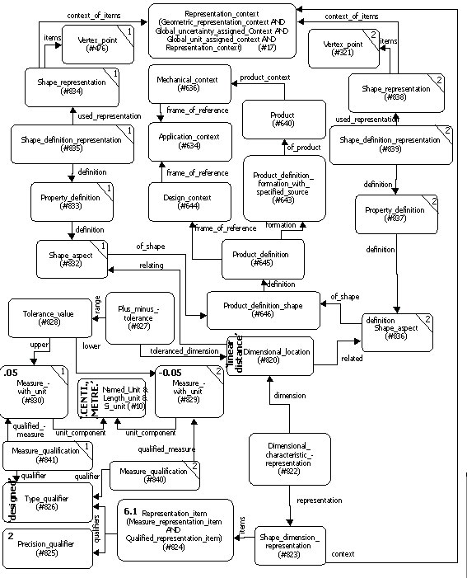
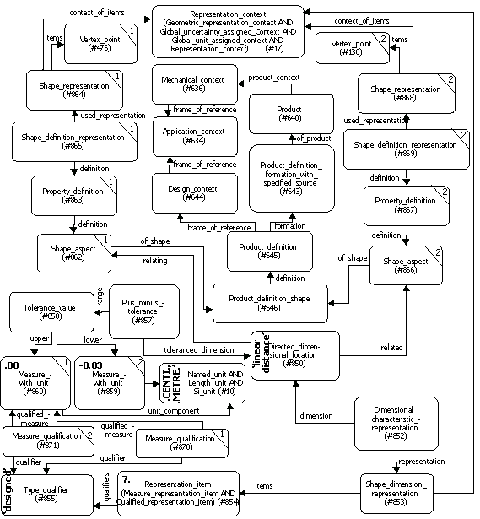
Figure 13 – Complete instance diagram for directed linear distance dimension, expressed as nominal value with different plus minus limits
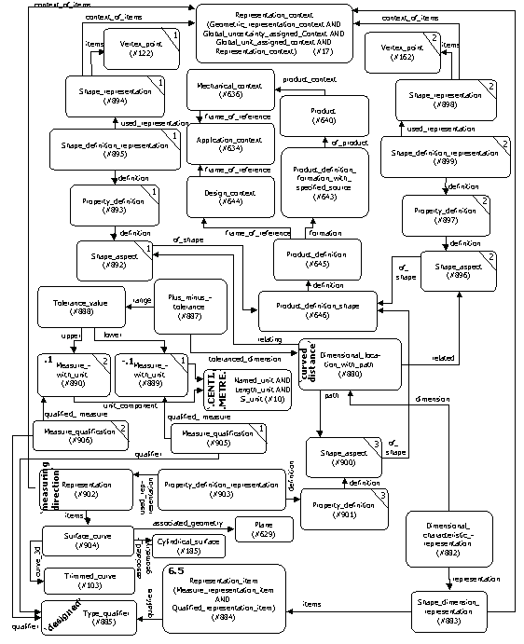
Figure 14 – Complete instance diagram for curved distance location dimension, expressed as nominal value with plus minus bounds

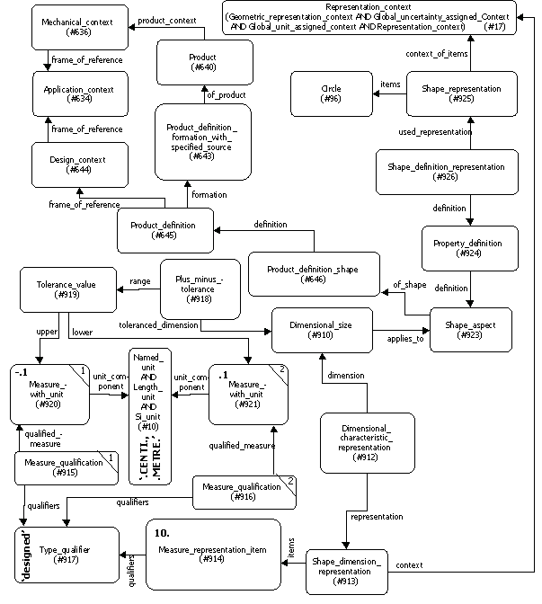
Figure 15 – Complete instance diagram for general size dimension, expressed as nominal value with plus minus bounds

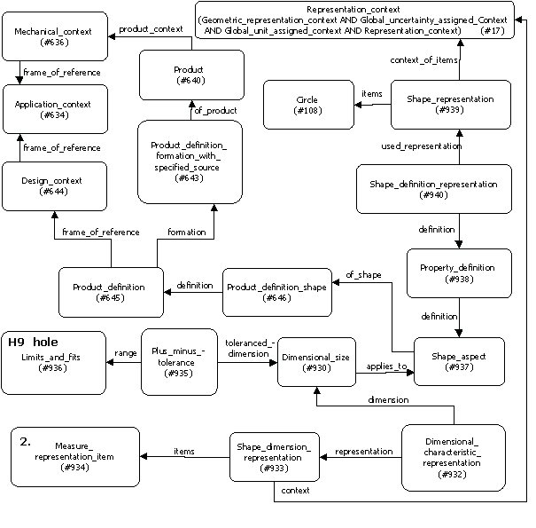
Figure 16 – Complete instance diagram for a general size dimension, expressed as a nominal value with limits and fits designation

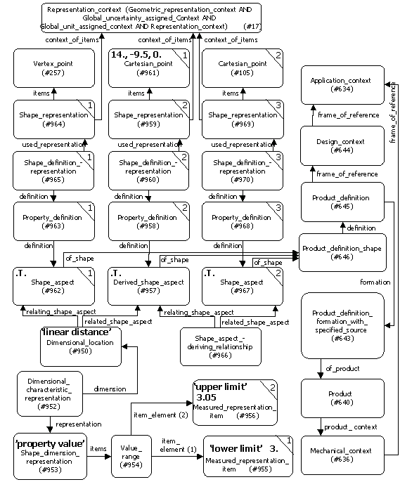
Figure 17 – Complete instance diagram for a linear distance dimension, expressed as a value range.

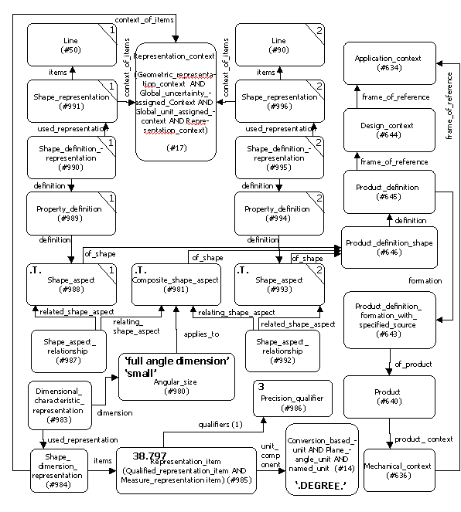

Figure 18 – Complete instance diagram for angular_size_dimension expressed as a nominal_value with significant digits

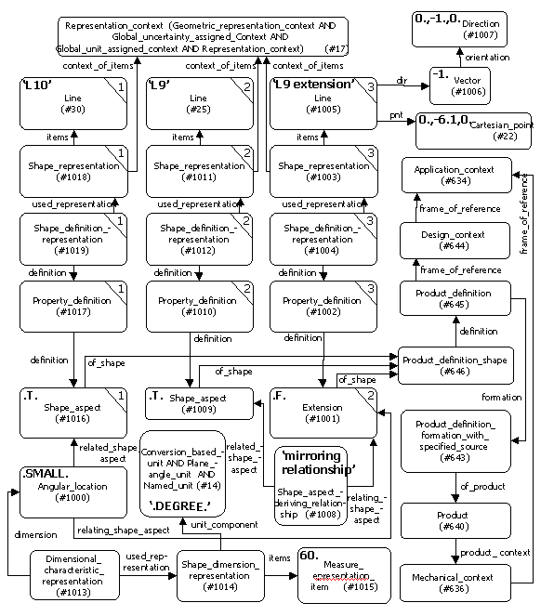
Figure 19 – Complete instance diagram for angular_location_dimension expressed as a nominal_value

Part 21 file example
This section presents part 21 file instantiation examples of the concepts discussed. Part 21 files conformant to AP 203 and to AP 214 follow.
A diagram depicting the geometric model used for this usage guide, along with the view that includes different types of dimensions, is shown in Figures 3 and 4 below.

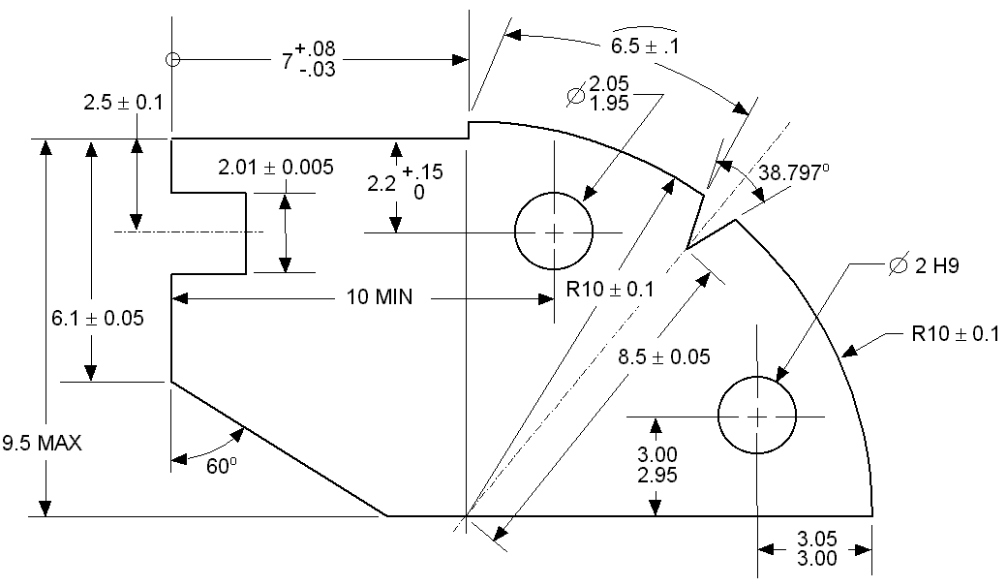
Figure 20 – Face of complete "geometric dimensions and dimensional tolerances" example
*
2.1 ± 0.05

Figure 21 – Perspective view of "geometric dimensions and dimensional tolerances" example

Conforming to AP203

ISO-10303-21;
HEADER;
/* Exchange file generated using ST-DEVELOPER 1.6 */
FILE_DESCRIPTION(
/* description */ (''),
/* implementation_level */ '2;1');
FILE_NAME(
/* name */ 'ddt2',
/* time_stamp */ '1999-05-27T14:37:21-04:00',
/* author */ (''),
/* organization */ (''),
/* preprocessor_version */ 'ST-DEVELOPER 1.6',
/* originating_system */ 'UNIGRAPHICS SOLUTIONS - UNIGRAPHICS 15.0',
/* authorisation */ '');
FILE_SCHEMA (('CONFIG_CONTROL_DESIGN'));
ENDSEC;
DATA;
#10=(LENGTH_UNIT()NAMED_UNIT(*)SI_UNIT(.CENTI.,.METRE.));
#11=(NAMED_UNIT(*)PLANE_ANGLE_UNIT()SI_UNIT($,.RADIAN.));
#12=PLANE_ANGLE_MEASURE_WITH_UNIT(PLANE_ANGLE_MEASURE(0.0174532925),#11);
#13=DIMENSIONAL_EXPONENTS(0.,0.,0.,0.,0.,0.,0.);
#14=(CONVERSION_BASED_UNIT('DEGREE',#12)NAMED_UNIT(#13)PLANE_ANGLE_UNIT());
#15=(NAMED_UNIT(*)SI_UNIT($,.STERADIAN.)SOLID_ANGLE_UNIT());
#16=UNCERTAINTY_MEASURE_WITH_UNIT(LENGTH_MEASURE(2.E-06),#10,
'DISTANCE_ACCURACY_VALUE','Maximum Tolerance applied to model');
#17=(GEOMETRIC_REPRESENTATION_CONTEXT(3)
GLOBAL_UNCERTAINTY_ASSIGNED_CONTEXT((#16))
GLOBAL_UNIT_ASSIGNED_CONTEXT((#10,#14,#15))
REPRESENTATION_CONTEXT('ddt2','TOP_LEVEL_ASSEMBLY_PART'));
#18=CARTESIAN_POINT('',(0.,0.,0.));
#19=DIRECTION('',(0.,0.,1.));
#20=DIRECTION('',(1.,0.,0.));
#21=AXIS2_PLACEMENT_3D('',#18,#19,#20);
#22=CARTESIAN_POINT('',(0.,-6.1,0.));
#23=DIRECTION('',(0.,1.,0.));
#24=VECTOR('',#23,2.6);
#25=LINE('L9',#22,#24);
#26=TRIMMED_CURVE('L9',#25,
(PARAMETER_VALUE(0.)),(PARAMETER_VALUE(1.)),.T.,.PARAMETER.);

#28=DIRECTION('',(0.866025403784438,-0.5,0.));
#29=VECTOR('',#28,6.8);
#30=LINE('L10',#22,#29);
#31=TRIMMED_CURVE('L10',#30,
(PARAMETER_VALUE(0.)),(PARAMETER_VALUE(1.)),.T.,.PARAMETER.);
#32=CARTESIAN_POINT('',(2.,-1.5,0.));
#33=DIRECTION('',(0.,-1.,0.));
#34=VECTOR('',#33,2.);
#35=LINE('L2',#32,#34);
#36=TRIMMED_CURVE('L2',#35,
(PARAMETER_VALUE(0.)),(PARAMETER_VALUE(1.)),.T.,.PARAMETER.);
#37=CARTESIAN_POINT('',(2.,-3.5,0.));
#38=DIRECTION('',(-1.,0.,0.));
#39=VECTOR('',#38,2.);
#40=LINE('L7',#37,#39);
#41=TRIMMED_CURVE('L7',#40,
(PARAMETER_VALUE(0.)),(PARAMETER_VALUE(1.)),.T.,.PARAMETER.);
#42=CARTESIAN_POINT('',(7.,-9.5,0.));
#43=DIRECTION('',(0.645956120434293,0.76337454141036,0.));
#44=VECTOR('',#43,8.5);
#45=LINE('L3',#42,#44);
#46=TRIMMED_CURVE('L3',#45,
(PARAMETER_VALUE(0.)),(PARAMETER_VALUE(1.)),.T.,.PARAMETER.);
#47=CARTESIAN_POINT('',(12.490627023691,-3.0113163980119,0.));
#48=DIRECTION('',(0.355743755790641,0.934583533032745,0.));
#49=VECTOR('',#48,1.5757471534870);
#50=LINE('L4',#47,#49);
#51=TRIMMED_CURVE('L4',#50,
(PARAMETER_VALUE(0.)),(PARAMETER_VALUE(1.)),.T.,.PARAMETER.);
#52=CARTESIAN_POINT('',(5.8889727457341,-9.5,0.));
#53=DIRECTION('',(1.,0.,0.));
#54=VECTOR('',#53,1.1110272542658);
#55=LINE('L13',#52,#54);
#56=TRIMMED_CURVE('L13',#55,
(PARAMETER_VALUE(0.)),(PARAMETER_VALUE(1.)),.T.,.PARAMETER.);

#58=DIRECTION('',(1.,0.,0.));
#59=VECTOR('',#58,10.);
#60=LINE('L14',#42,#59);
#61=TRIMMED_CURVE('L14',#60,
(PARAMETER_VALUE(0.)),(PARAMETER_VALUE(1.)),.T.,.PARAMETER.);

#63=DIRECTION('',(-1.,0.,0.));
#64=VECTOR('',#63,2.);
#65=LINE('L15',#32,#64);
#66=TRIMMED_CURVE('L15',#65,
(PARAMETER_VALUE(0.)),(PARAMETER_VALUE(1.)),.T.,.PARAMETER.);
#67=CARTESIAN_POINT('',(0.,-1.5,0.));
#68=DIRECTION('',(0.,1.,0.));
#69=VECTOR('',#68,1.5);
#70=LINE('L16',#67,#69);
#71=TRIMMED_CURVE('L16',#70,
(PARAMETER_VALUE(0.)),(PARAMETER_VALUE(1.)),.T.,.PARAMETER.);

#73=DIRECTION('',(1.,0.,0.));
#74=VECTOR('',#73,7.);
#75=LINE('L17',#18,#74);
#76=TRIMMED_CURVE('L17',#75,
(PARAMETER_VALUE(0.)),(PARAMETER_VALUE(1.)),.T.,.PARAMETER.);
#77=CARTESIAN_POINT('',(7.,0.,0.));
#78=DIRECTION('',(0.,1.,0.));
#79=VECTOR('',#78,.5);
#80=LINE('L18',#77,#79);
#81=TRIMMED_CURVE('L18',#80,
(PARAMETER_VALUE(0.)),(PARAMETER_VALUE(1.)),.T.,.PARAMETER.);

#83=DIRECTION('',(0.605118923424937,0.796135094386025,0.));
#84=VECT*OR('',#83,10.);
#85=LINE('L20',#42,#84);
#86=TRIMMED_CURVE('L20',#85,
(PARAMETER_VALUE(0.)),(PARAMETER_VALUE(1.)),.T.,.PARAMETER.);

#88=DIRECTION('',(0.862829381905455,0.505495259839943,0.));
#89=VECTOR('',#88,1.5757471534870);
#90=LINE('L22',#47,#89);
#91=TRIMMED_CURVE('L22',#90,
(PARAMETER_VALUE(0.)),(PARAMETER_VALUE(1.)),.T.,.PARAMETER.);
#92=AXIS2_PLACEMENT_3D('',#42,#94,#95);

#94=DIRECTION('',(0.,0.,1.));
#95=DIRECTION('',(1.,0.,0.));
#96=CIRCLE('A2',#92,10.);
#97=TRIMMED_CURVE('A2',#96,(PARAMETER_VALUE(0.)),
(PARAMETER_VALUE(46.7626)),.T.,.PARAMETER.);

#103=TRIMMED_CURVE('A3',#96,(PARAMETER_VALUE(52.7626)),
(PARAMETER_VALUE(90.)),.T.,.PARAMETER.);
#104=AXIS2_PLACEMENT_3D('',#105,#106,#107);
#105=CARTESIAN_POINT('',(14.,-6.5,0.));
#106=DIRECTION('',(0.,0.,1.));
#107=DIRECTION('',(1.,0.,0.));
#108=CIRCLE('A6',#104,1.);
#109=AXIS2_PLACEMENT_3D('',#110,#111,#112);
#110=CARTESIAN_POINT('',(10.,-2.2,0.));
#111=DIRECTION('',(0.,0.,1.));
#112=DIRECTION('',(1.,0.,0.));
#113=CIRCLE('A7',#109,1.);
#114=CARTESIAN_POINT('',(7.,.5,2.1));
#115=DIRECTION('',(0.,0.,-1.));
#116=VECTOR('',#115,1.);
#117=LINE('',#114,#116);
#118=EDGE_CURVE('',#120,#122,#117,.T.);

#120=VERTEX_POINT('',#114);
#121=CARTESIAN_POINT('',(7.,.5,0.));
#122=VERTEX_POINT('',#121);
#123=ORIENTED_EDGE('',*,*,#118,.T.);

#125=DIRECTION('',(0.,1.,0.));
#126=VECTOR('',#125,1.);
#127=LINE('',#77,#126);
#128=EDGE_CURVE('',#130,#122,#127,.T.);

#130=VERTEX_POINT('',#77);
#131=ORIENTED_EDGE('',*,*,#128,.F.);
#132=CARTESIAN_POINT('',(7.,0.,2.1));
#133=DIRECTION('',(0.,0.,-1.));
#134=VECTOR('',#133,1.);
#135=LINE('',#132,#134);
#136=EDGE_CURVE('',#138,#130,#135,.T.);

#138=VERTEX_POINT('',#132);
#139=ORIENTED_EDGE('',*,*,#136,.F.);

#141=DIRECTION('',(0.,1.,0.));
#142=VECTOR('',#141,1.);
#143=LINE('',#132,#142);
#144=EDGE_CURVE('',#138,#120,#143,.T.);
#145=ORIENTED_EDGE('',*,*,#144,.T.);
#146=EDGE_LOOP('',(#123,#131,#139,#145));
#147=FACE_BOUND('',#146,.T.);

#149=DIRECTION('',(-1.,0.,0.));
#150=DIRECTION('',(0.,0.,1.));
#151=AXIS2_PLACEMENT_3D('',#132,#149,#150);
#152=PLANE('',#151);
#153=ADVANCED_FACE('',(#147),#152,.T.);
#154=CARTESIAN_POINT('',(13.051189234249,-1.5386490561397,2.1));
#155=DIRECTION('',(0.,0.,-1.));
#156=VECTOR('',#155,1.);
#157=LINE('',#154,#156);
#158=EDGE_CURVE('',#160,#162,#157,.T.);

#160=VERTEX_POINT('',#154);
#161=CARTESIAN_POINT('',(13.051189234249,-1.5386490561397,0.));
#162=VERTEX_POINT('',#161);
#163=ORIENTED_EDGE('',*,*,#158,.T.);

#169=EDGE_CURVE('',#162,#122,#96,.T.);
#170=ORIENTED_EDGE('',*,*,#169,.T.);
#171=ORIENTED_EDGE('',*,*,#118,.F.);
#172=CARTESIAN_POINT('',(7.0,-9.5,2.1));
#173=DIRECTION('',(0.,0.,1.));
#174=DIRECTION('',(1.,0.,0.));
#175=AXIS2_PLACEMENT_3D('',#172,#173,#174);
#176=CIRCLE('',#175,10.);
#177=EDGE_CURVE('',#160,#120,#176,.T.);
#178=ORIENTED_EDGE('',*,*,#177,.F.);
#179=EDGE_LOOP('',(#163,#170,#171,#178));
#180=FACE_BOUND('',#179,.T.);

#182=DIRECTION('',(0.,0.,-1.));
#183=DIRECTION('',(-1.,0.,0.));
#184=AXIS2_PLACEMENT_3D('',#172,#182,#183);
#185=CYLINDRICAL_SURFACE('',#184,10.);
#186=ADVANCED_FACE('',(#180),#185,.T.);
#187=CARTESIAN_POINT('',(12.490627023691,-3.0113163980119,2.1));
#188=DIRECTION('',(0.,0.,-1.));
#189=VECTOR('',#188,1.);
#190=LINE('',#187,#189);
#191=EDGE_CURVE('',#193,#195,#190,.T.);

#193=VERTEX_POINT('',#187);

#195=VERTEX_POINT('',#47);
#196=ORIENTED_EDGE('',*,*,#191,.T.);

#198=DIRECTION('',(0.355743755790641,0.934583533032745,0.));
#199=VECTOR('',#198,1.);
#200=LINE('',#47,#199);
#201=EDGE_CURVE('',#195,#162,#200,.T.);
#202=ORIENTED_EDGE('',*,*,#201,.T.);
#203=ORIENTED_EDGE('',*,*,#158,.F.);

#205=DIRECTION('',(0.355743755790641,0.934583533032745,0.));
#206=VECTOR('',#205,1.);
#207=LINE('',#187,#206);
#208=EDGE_CURVE('',#193,#160,#207,.T.);
#209=ORIENTED_EDGE('',*,*,#208,.F.);
#210=EDGE_LOOP('',(#196,#202,#203,#209));
#211=FACE_BOUND('',#210,.T.);

#213=DIRECTION('',(-0.934583533032745,0.355743755790641,0.));
#214=DIRECTION('',(-0.355743755790641,-0.934583533032746,0.));
#215=AXIS2_PLACEMENT_3D('',#187,#213,#214);
#216=PLANE('',#215);
#217=ADVANCED_FACE('',(#211),#216,.F.);
#218=CARTESIAN_POINT('',(13.85022796617,-2.2147836812179,2.1));
#219=DIRECTION('',(0.,0.,-1.));
#220=VECTOR('',#219,1.);
#221=LINE('',#218,#220);
#222=EDGE_CURVE('',#224,#226,#221,.T.);

#224=VERTEX_POINT('',#218);
#225=CARTESIAN_POINT('',(13.850227966174,-2.21478368121797,0.));
#226=VERTEX_POINT('',#225);
#227=ORIENTED_EDGE('',*,*,#222,.T.);

#229=DIRECTION('',(0.862829381905455,0.505495259839943,0.));
#230=VECTOR('',#229,1.);
#231=LINE('',#47,#230);
#232=EDGE_CURVE('',#195,#226,#231,.T.);
#233=ORIENTED_EDGE('',*,*,#232,.F.);
#234=ORIENTED_EDGE('',*,*,#191,.F.);

#236=DIRECTION('',(0.862829381905455,0.505495259839943,0.));
#237=VECTOR('',#236,1.);
#238=LINE('',#187,#237);
#239=EDGE_CURVE('',#193,#224,#238,.T.);
#240=ORIENTED_EDGE('',*,*,#239,.T.);
#241=EDGE_LOOP('',(#227,#233,#234,#240));
#242=FACE_BOUND('',#241,.T.);

#244=DIRECTION('',(-0.505495259839943,0.862829381905455,0.));
#245=DIRECTION('',(-0.862829381905455,-0.505495259839943,0.));
#246=AXIS2_PLACEMENT_3D('',#187,#244,#245);
#247=PLANE('',#246);
#248=ADVANCED_FACE('',(#242),#247,.T.);
#249=CARTESIAN_POINT('',(17.,-9.5,2.1));
#250=DIRECTION('',(0.,0.,-1.));
#251=VECTOR('',#250,1.);
#252=LINE('',#249,#251);
#253=EDGE_CURVE('',#255,#257,#252,.T.);

#255=VERTEX_POINT('',#249);
#256=CARTESIAN_POINT('',(17.0,-9.5,0.));
#257=VERTEX_POINT('',#256);
#258=ORIENTED_EDGE('',*,*,#253,.T.);

#264=EDGE_CURVE('',#257,#226,#96,.T.);
#265=ORIENTED_EDGE('',*,*,#264,.T.);
#266=ORIENTED_EDGE('',*,*,#222,.F.);

#272=EDGE_CURVE('',#255,#224,#176,.T.);
#273=ORIENTED_EDGE('',*,*,#272,.F.);
#274=EDGE_LOOP('',(#258,#265,#266,#273));
#275=FACE_BOUND('',#274,.T.);

#280=CYLINDRICAL_SURFACE('',#184,10.);
#281=ADVANCED_FACE('',(#275),#280,.T.);
#282=CARTESIAN_POINT('',(5.88897274573418,-9.5,2.1));
#283=DIRECTION('',(0.,0.,-1.));
#284=VECTOR('',#283,1.);
#285=LINE('',#282,#284);
#286=EDGE_CURVE('',#288,#290,#285,.T.);

#288=VERTEX_POINT('',#282);

#290=VERTEX_POINT('',#52);
#291=ORIENTED_EDGE('',*,*,#286,.T.);

#293=DIRECTION('',(1.,0.,0.));
#294=VECTOR('',#293,1.);
#295=LINE('',#52,#294);
#296=EDGE_CURVE('',#290,#257,#295,.T.);
#297=ORIENTED_EDGE('',*,*,#296,.T.);
#298=ORIENTED_EDGE('',*,*,#253,.F.);

#300=DIRECTION('',(1.,0.,0.));
#301=VECTOR('',#300,1.);
#302=LINE('',#282,#301);
#303=EDGE_CURVE('',#288,#255,#302,.T.);
#304=ORIENTED_EDGE('',*,*,#303,.F.);
#305=EDGE_LOOP('',(#291,#297,#298,#304));
#306=FACE_BOUND('',#305,.T.);

#308=DIRECTION('',(0.,1.,0.));
#309=DIRECTION('',(0.,0.,1.));
#310=AXIS2_PLACEMENT_3D('',#282,#308,#309);
#311=PLANE('',#310);
#312=ADVANCED_FACE('',(#306),#311,.F.);
#313=CARTESIAN_POINT('',(0.,-6.1,2.1));
#314=DIRECTION('',(0.,0.,-1.));
#315=VECTOR('',#314,1.);
#316=LINE('',#313,#315);
#317=EDGE_CURVE('',#319,#321,#316,.T.);

#319=VERTEX_POINT('',#313);

#321=VERTEX_POINT('',#22);
#322=ORIENTED_EDGE('',*,*,#317,.T.);

#324=DIRECTION('',(0.866025403784438,-0.5,0.));
#325=VECTOR('',#324,1.);
#326=LINE('',#22,#325);
#327=EDGE_CURVE('',#321,#290,#326,.T.);
#328=ORIENTED_EDGE('',*,*,#327,.T.);
#329=ORIENTED_EDGE('',*,*,#286,.F.);

#331=DIRECTION('',(0.866025403784438,-0.5,0.));
#332=VECTOR('',#331,1.);
#333=LINE('',#313,#332);
#334=EDGE_CURVE('',#319,#288,#333,.T.);
#335=ORIENTED_EDGE('',*,*,#334,.F.);
#336=EDGE_LOOP('',(#322,#328,#329,#335));
#337=FACE_BOUND('',#336,.T.);

#339=DIRECTION('',(0.5,0.866025403784438,0.));
#340=DIRECTION('',(-0.866025403784438,0.5,0.));
#341=AXIS2_PLACEMENT_3D('',#313,#339,#340);
#342=PLANE('',#341);
#343=ADVANCED_FACE('',(#337),#342,.F.);
#344=CARTESIAN_POINT('',(0.,-3.5,2.1));
#345=DIRECTION('',(0.,0.,-1.));
#346=VECTOR('',#345,1.);
#347=LINE('',#344,#346);
#348=EDGE_CURVE('',#350,#352,#347,.T.);

#350=VERTEX_POINT('',#344);
#351=CARTESIAN_POINT('',(0.,-3.5,0.));
#352=VERTEX_POINT('',#351);
#353=ORIENTED_EDGE('',*,*,#348,.T.);

#355=DIRECTION('',(0.,1.,0.));
#356=VECTOR('',#355,1.);
#357=LINE('',#22,#356);
#358=EDGE_CURVE('',#321,#352,#357,.T.);
#359=ORIENTED_EDGE('',*,*,#358,.F.);
#360=ORIENTED_EDGE('',*,*,#317,.F.);

#362=DIRECTION('',(0.,1.,0.));
#363=VECTOR('',#362,1.);
#364=LINE('',#313,#363);
#365=EDGE_CURVE('',#319,#350,#364,.T.);
#366=ORIENTED_EDGE('',*,*,#365,.T.);
#367=EDGE_LOOP('',(#353,#359,#360,#366));
#368=FACE_BOUND('',#367,.T.);

#370=DIRECTION('',(-1.,0.,0.));
#371=DIRECTION('',(0.,0.,1.));
#372=AXIS2_PLACEMENT_3D('',#313,#370,#371);
#373=PLANE('',#372);
#374=ADVANCED_FACE('',(#368),#373,.T.);
#375=CARTESIAN_POINT('',(2.,-3.5,2.1));
#376=DIRECTION('',(0.,0.,-1.));
#377=VECTOR('',#376,1.);
#378=LINE('',#375,#377);
#379=EDGE_CURVE('',#381,#383,#378,.T.);

#381=VERTEX_POINT('',#375);

#383=VERTEX_POINT('',#37);
#384=ORIENTED_EDGE('',*,*,#379,.T.);

#386=DIRECTION('',(-1.,0.,0.));
#387=VECTOR('',#386,1.);
#388=LINE('',#37,#387);
#389=EDGE_CURVE('',#383,#352,#388,.T.);
#390=ORIENTED_EDGE('',*,*,#389,.T.);
#391=ORIENTED_EDGE('',*,*,#348,.F.);

#393=DIRECTION('',(-1.,0.,0.));
#394=VECTOR('',#393,1.);
#395=LINE('',#375,#394);
#396=EDGE_CURVE('',#381,#350,#395,.T.);
#397=ORIENTED_EDGE('',*,*,#396,.F.);
#398=EDGE_LOOP('',(#384,#390,#391,#397));
#399=FACE_BOUND('',#398,.T.);

#401=DIRECTION('',(0.,-1.,0.));
#402=DIRECTION('',(1.,0.,0.));
#403=AXIS2_PLACEMENT_3D('',#375,#401,#402);
#404=PLANE('',#403);
#405=ADVANCED_FACE('',(#399),#404,.F.);
#406=CARTESIAN_POINT('',(2.,-1.5,2.1));
#407=DIRECTION('',(0.,0.,-1.));
#408=VECTOR('',#407,1.);
#409=LINE('',#406,#408);
#410=EDGE_CURVE('',#412,#414,#409,.T.);

#412=VERTEX_POINT('',#406);

#414=VERTEX_POINT('',#32);
#415=ORIENTED_EDGE('',*,*,#410,.T.);

#417=DIRECTION('',(0.,-1.,0.));
#418=VECTOR('',#417,1.);
#419=LINE('',#32,#418);
#420=EDGE_CURVE('',#414,#383,#419,.T.);
#421=ORIENTED_EDGE('',*,*,#420,.T.);
#422=ORIENTED_EDGE('',*,*,#379,.F.);

#424=DIRECTION('',(0.,-1.,0.));
#425=VECTOR('',#424,1.);
#426=LINE('',#406,#425);
#427=EDGE_CURVE('',#412,#381,#426,.T.);
#428=ORIENTED_EDGE('',*,*,#427,.F.);
#429=EDGE_LOOP('',(#415,#421,#422,#428));
#430=FACE_BOUND('',#429,.T.);

#432=DIRECTION('',(1.,0.,0.));
#433=DIRECTION('',(0.,0.,-1.));
#434=AXIS2_PLACEMENT_3D('',#406,#432,#433);
#435=PLANE('',#434);
#436=ADVANCED_FACE('',(#430),#435,.F.);
#437=CARTESIAN_POINT('',(0.,-1.5,2.1));
#438=DIRECTION('',(0.,0.,-1.));
#439=VECTOR('',#438,1.);
#440=LINE('',#437,#439);
#441=EDGE_CURVE('',#443,#445,#440,.T.);

#443=VERTEX_POINT('',#437);

#445=VERTEX_POINT('',#67);
#446=ORIENTED_EDGE('',*,*,#441,.T.);

#448=DIRECTION('',(-1.,0.,0.));
#449=VECTOR('',#448,1.);
#450=LINE('',#32,#449);
#451=EDGE_CURVE('',#414,#445,#450,.T.);
#452=ORIENTED_EDGE('',*,*,#451,.F.);
#453=ORIENTED_EDGE('',*,*,#410,.F.);

#455=DIRECTION('',(-1.,0.,0.));
#456=VECTOR('',#455,1.);
#457=LINE('',#406,#456);
#458=EDGE_CURVE('',#412,#443,#457,.T.);
#459=ORIENTED_EDGE('',*,*,#458,.T.);
#460=EDGE_LOOP('',(#446,#452,#453,#459));
#461=FACE_BOUND('',#460,.T.);

#463=DIRECTION('',(0.,-1.,0.));
#464=DIRECTION('',(1.,0.,0.));
#465=AXIS2_PLACEMENT_3D('',#406,#463,#464);
#466=PLANE('',#465);
#467=ADVANCED_FACE('',(#461),#466,.T.);
#468=CARTESIAN_POINT('',(0.,0.,2.1));
#469=DIRECTION('',(0.,0.,-1.));
#470=VECTOR('',#469,1.);
#471=LINE('',#468,#470);
#472=EDGE_CURVE('',#474,#476,#471,.T.);

#474=VERTEX_POINT('',#468);

#476=VERTEX_POINT('',#18);
#477=ORIENTED_EDGE('',*,*,#472,.T.);

#479=DIRECTION('',(0.,1.,0.));
#480=VECTOR('',#479,1.);
#481=LINE('',#67,#480);
#482=EDGE_CURVE('',#445,#476,#481,.T.);
#483=ORIENTED_EDGE('',*,*,#482,.F.);
#484=ORIENTED_EDGE('',*,*,#441,.F.);

#486=DIRECTION('',(0.,1.,0.));
#487=VECTOR('',#486,1.);
#488=LINE('',#437,#487);
#489=EDGE_CURVE('',#443,#474,#488,.T.);
#490=ORIENTED_EDGE('',*,*,#489,.T.);
#491=EDGE_LOOP('',(#477,#483,#484,#490));
#492=FACE_BOUND('',#491,.T.);

#494=DIRECTION('',(-1.,0.,0.));
#495=DIRECTION('',(0.,0.,1.));
#496=AXIS2_PLACEMENT_3D('',#437,#494,#495);
#497=PLANE('',#496);
#498=ADVANCED_FACE('',(#492),#497,.T.);

#500=DIRECTION('',(1.,0.,0.));
#501=VECTOR('',#500,1.);
#502=LINE('',#468,#501);
#503=EDGE_CURVE('',#474,#138,#502,.T.);
#504=ORIENTED_EDGE('',*,*,#503,.T.);
#505=ORIENTED_EDGE('',*,*,#136,.T.);

#507=DIRECTION('',(1.,0.,0.));
#508=VECTOR('',#507,1.);
#509=LINE('',#18,#508);
#510=EDGE_CURVE('',#476,#130,#509,.T.);
#511=ORIENTED_EDGE('',*,*,#510,.F.);
#512=ORIENTED_EDGE('',*,*,#472,.F.);
#513=EDGE_LOOP('',(#504,#505,#511,#512));
#514=FACE_BOUND('',#513,.T.);

#516=DIRECTION('',(0.,1.,0.));
#517=DIRECTION('',(0.,0.,1.));
#518=AXIS2_PLACEMENT_3D('',#468,#516,#517);
#519=PLANE('',#518);
#520=ADVANCED_FACE('',(#514),#519,.T.);
#521=CARTESIAN_POINT('',(14.,-6.5,2.1));
#522=DIRECTION('',(0.,0.,1.));
#523=DIRECTION('',(1.,0.,0.));
#524=AXIS2_PLACEMENT_3D('',#521,#522,#523);
#525=CIRCLE('',#524,1.);
#526=EDGE_CURVE('',#528,#528,#525,.T.);
#527=CARTESIAN_POINT('',(15.,-6.5,2.1));
#528=VERTEX_POINT('',#527);
#529=ORIENTED_EDGE('',*,*,#526,.T.);
#530=EDGE_LOOP('',(#529));
#531=FACE_BOUND('',#530,.T.);

#537=EDGE_CURVE('',#539,#539,#108,.T.);
#538=CARTESIAN_POINT('',(15.,-6.5,0.));
#539=VERTEX_POINT('',#538);
#540=ORIENTED_EDGE('',*,*,#537,.F.);
#541=EDGE_LOOP('',(#540));
#542=FACE_BOUND('',#541,.T.);

#544=DIRECTION('',(0.,0.,-1.));
#545=DIRECTION('',(-1.,0.,0.));
#546=AXIS2_PLACEMENT_3D('',#521,#544,#545);
#547=CYLINDRICAL_SURFACE('',#546,10.);
#548=ADVANCED_FACE('',(#531,#542),#547,.F.);
#549=CARTESIAN_POINT('',(10.,-2.2,2.1));
#550=DIRECTION('',(0.,0.,1.));
#551=DIRECTION('',(1.,0.,0.));
#552=AXIS2_PLACEMENT_3D('',#549,#550,#551);
#553=CIRCLE('',#552,10.);
#554=EDGE_CURVE('',#556,#556,#553,.T.);
#555=CARTESIAN_POINT('',(11.,-2.2,2.1));
#556=VERTEX_POINT('',#555);
#557=ORIENTED_EDGE('',*,*,#554,.T.);
#558=EDGE_LOOP('',(#557));
#559=FACE_BOUND('',#558,.T.);

#565=EDGE_CURVE('',#567,#567,#113,.T.);
#566=CARTESIAN_POINT('',(11.,-2.2,0.));
#567=VERTEX_POINT('',#566);
#568=ORIENTED_EDGE('',*,*,#565,.F.);
#569=EDGE_LOOP('',(#568));
#570=FACE_BOUND('',#569,.T.);

#572=DIRECTION('',(0.,0.,-1.));
#573=DIRECTION('',(-1.,0.,0.));
#574=AXIS2_PLACEMENT_3D('',#549,#572,#573);
#575=CYLINDRICAL_SURFACE('',#574,10.);
#576=ADVANCED_FACE('',(#559,#570),#575,.F.);
#577=ORIENTED_EDGE('',*,*,#526,.F.);
#578=EDGE_LOOP('',(#577));
#579=FACE_BOUND('',#578,.T.);
#580=ORIENTED_EDGE('',*,*,#144,.F.);
#581=ORIENTED_EDGE('',*,*,#503,.F.);
#582=ORIENTED_EDGE('',*,*,#489,.F.);
#583=ORIENTED_EDGE('',*,*,#458,.F.);
#584=ORIENTED_EDGE('',*,*,#427,.T.);
#585=ORIENTED_EDGE('',*,*,#396,.T.);
#586=ORIENTED_EDGE('',*,*,#365,.F.);
#587=ORIENTED_EDGE('',*,*,#334,.T.);
#588=ORIENTED_EDGE('',*,*,#303,.T.);
#589=ORIENTED_EDGE('',*,*,#272,.T.);
#590=ORIENTED_EDGE('',*,*,#239,.F.);
#591=ORIENTED_EDGE('',*,*,#208,.T.);
#592=ORIENTED_EDGE('',*,*,#177,.T.);
#593=EDGE_LOOP('',
(#580,#581,#582,#583,#584,#585,#586,#587,#588,#589,#590,#591,#592));
#594=FACE_BOUND('',#593,.T.);
#595=ORIENTED_EDGE('',*,*,#554,.F.);
#596=EDGE_LOOP('',(#595));
#597=FACE_BOUND('',#596,.T.);

#602=PLANE('',#175);
#603=ADVANCED_FACE('',(#579,#594,#597),#602,.T.);
#604=ORIENTED_EDGE('',*,*,#537,.T.);
#605=EDGE_LOOP('',(#604));
#606=FACE_BOUND('',#605,.T.);
#607=ORIENTED_EDGE('',*,*,#128,.T.);
#608=ORIENTED_EDGE('',*,*,#169,.F.);
#609=ORIENTED_EDGE('',*,*,#201,.F.);
#610=ORIENTED_EDGE('',*,*,#232,.T.);
#611=ORIENTED_EDGE('',*,*,#264,.F.);
#612=ORIENTED_EDGE('',*,*,#296,.F.);
#613=ORIENTED_EDGE('',*,*,#327,.F.);
#614=ORIENTED_EDGE('',*,*,#358,.T.);
#615=ORIENTED_EDGE('',*,*,#389,.F.);
#616=ORIENTED_EDGE('',*,*,#420,.F.);
#617=ORIENTED_EDGE('',*,*,#451,.T.);
#618=ORIENTED_EDGE('',*,*,#482,.T.);
#619=ORIENTED_EDGE('',*,*,#510,.T.);
#620=EDGE_LOOP('',
(#607,#608,#609,#610,#611,#612,#613,#614,#615,#616,#617,#618,#619));
#621=FACE_BOUND('',#620,.T.);
#622=ORIENTED_EDGE('',*,*,#565,.T.);
#623=EDGE_LOOP('',(#622));
#624=FACE_BOUND('',#623,.T.);

#626=DIRECTION('',(0.,0.,1.));
#627=DIRECTION('',(1.,0.,0.));
#628=AXIS2_PLACEMENT_3D('',#42,#626,#627);
#629=PLANE('',#628);
#630=ADVANCED_FACE('',(#606,#621,#624),#629,.F.);
#631=CLOSED_SHELL('',(#153,#186,#217,#248,
#281,#312,#343,#374,#405,#436,#467,#498,#520,#548,#576,#603,#630));
#632=MANIFOLD_SOLID_BREP('',#631);
#633=SHAPE_REPRESENTATION('ddt2-none',(#21),#17);
#634=APPLICATION_CONTEXT('');
#635=APPLICATION_PROTOCOL_DEFINITION
('INTERNATIONAL STANDARD','config_control_design',1994,#634);
#636=MECHANICAL_CONTEXT('',#634,'mechanical');
#637=PRODUCT_CATEGORY('part','');
#638=PRODUCT_CATEGORY('','');
#639=PRODUCT_CATEGORY_RELATIONSHIP('','',#637,#638);
#640=PRODUCT('ddt2','','',(#636));
#641=PRODUCT_RELATED_PRODUCT_CATEGORY('detail','',(#640));
#642=PRODUCT_CATEGORY_RELATIONSHIP('','',#638,#641);
#643=PRODUCT_DEFINITION_FORMATION_WITH_SPECIFIED_SOURCE
('','',#640,.NOT_KNOWN.);
#644=DESIGN_CONTEXT('',#634,'design');
#645=PRODUCT_DEFINITION('','',#643,#644);
#646=PRODUCT_DEFINITION_SHAPE('','',#645);
#647=SHAPE_DEFINITION_REPRESENTATION(#646,#633);

/***************************************************************************
* PDM instances *
****************************************************************************/

#648=PERSON(' ',' ',' ',(' '),$,$);
#649=ORGANIZATION($,' ',' ');
#650=PERSON_AND_ORGANIZATION(#648,#649);
#651=PERSON_AND_ORGANIZATION_ROLE('creator');
#652=CC_DESIGN_PERSON_AND_ORGANIZATION_ASSIGNMENT(#650,#651,(#645,#643));
#653=ORGANIZATION($,' ',' ');
#654=PERSON_AND_ORGANIZATION(#648,#653);
#655=PERSON_AND_ORGANIZATION_ROLE('design_owner');
#656=CC_DESIGN_PERSON_AND_ORGANIZATION_ASSIGNMENT(#654,#655,(#640));
#657=ORGANIZATION($,' ',' ');
#658=PERSON_AND_ORGANIZATION(#648,#657);
#659=PERSON_AND_ORGANIZATION_ROLE('design_supplier');
#660=CC_DESIGN_PERSON_AND_ORGANIZATION_ASSIGNMENT(#658,#659,(#643));
#661=CALENDAR_DATE(0,1,1);
#662=COORDINATED_UNIVERSAL_TIME_OFFSET(0,0,.BEHIND.);
#663=LOCAL_TIME(0,0,0.,#662);
#664=DATE_AND_TIME(#661,#663);
#665=DATE_TIME_ROLE('creation_date');
#666=CC_DESIGN_DATE_AND_TIME_ASSIGNMENT(#664,#665,(#645));
#667=SECURITY_CLASSIFICATION_LEVEL('confidential');
#668=SECURITY_CLASSIFICATION(' ',' ',#667);
#669=CC_DESIGN_SECURITY_CLASSIFICATION(#668,(#643));
#670=ORGANIZATION($,' ',' ');
#671=PERSON_AND_ORGANIZATION(#648,#670);
#672=PERSON_AND_ORGANIZATION_ROLE('classification_officer');
#673=CC_DESIGN_PERSON_AND_ORGANIZATION_ASSIGNMENT(#671,#672,(#668));
#674=CALENDAR_DATE(0,1,1);
#675=COORDINATED_UNIVERSAL_TIME_OFFSET(0,0,.BEHIND.);
#676=LOCAL_TIME(0,0,0.,#675);
#677=DATE_AND_TIME(#674,#676);
#678=DATE_TIME_ROLE('classification_date');
#679=CC_DESIGN_DATE_AND_TIME_ASSIGNMENT(#677,#678,(#668));
#680=ORGANIZATION($,' ',' ');
#681=PERSON_AND_ORGANIZATION(#648,#680);
#682=APPROVAL_STATUS('not_yet_approved');
#683=APPROVAL(#682,' ');
#684=CALENDAR_DATE(0,1,1);
#685=COORDINATED_UNIVERSAL_TIME_OFFSET(0,0,.BEHIND.);
#686=LOCAL_TIME(0,0,0.,#685);
#687=DATE_AND_TIME(#684,#686);
#688=APPROVAL_DATE_TIME(#687,#683);
#689=APPROVAL_ROLE('APPROVER');
#690=APPROVAL_PERSON_ORGANIZATION(#681,#683,#689);
#691=CC_DESIGN_APPROVAL(#683,(#645));
#692=ORGANIZATION($,' ',' ');
#693=PERSON_AND_ORGANIZATION(#648,#692);
#694=APPROVAL_STATUS('not_yet_approved');
#695=APPROVAL(#694,' ');
#696=CALENDAR_DATE(0,1,1);
#697=COORDINATED_UNIVERSAL_TIME_OFFSET(0,0,.BEHIND.);
#698=LOCAL_TIME(0,0,0.,#697);
#699=DATE_AND_TIME(#696,#698);
#700=APPROVAL_DATE_TIME(#699,#695);
#701=APPROVAL_ROLE('APPROVER');
#702=APPROVAL_PERSON_ORGANIZATION(#693,#695,#701);
#703=CC_DESIGN_APPROVAL(#695,(#643));
#704=ORGANIZATION($,' ',' ');
#705=PERSON_AND_ORGANIZATION(#648,#704);
#706=APPROVAL_STATUS('not_yet_approved');
#707=APPROVAL(#706,' ');
#708=CALENDAR_DATE(0,1,1);
#709=COORDINATED_UNIVERSAL_TIME_OFFSET(0,0,.BEHIND.);
#710=LOCAL_TIME(0,0,0.,#709);
#711=DATE_AND_TIME(#708,#710);
#712=APPROVAL_DATE_TIME(#711,#707);
#713=APPROVAL_ROLE('APPROVER');
#714=APPROVAL_PERSON_ORGANIZATION(#705,#707,#713);
#715=CC_DESIGN_APPROVAL(#707,(#668));
#716=GEOMETRIC_CURVE_SET('',(#26,#31,
#36,#41,#46,#51,#56,#61,#66,#71,#76,#81,#86,#91,#97,#103,#108,#113));
#717=ADVANCED_BREP_SHAPE_REPRESENTATION('ddt2-none',(#632),#17);
#718=SHAPE_REPRESENTATION_RELATIONSHIP
('none','relationship between ddt2-none and ddt2-none',#633,#717);
#719=GEOMETRICALLY_BOUNDED_WIREFRAME_SHAPE_REPRESENTATION
('ddt2-none',(#716),#17);
#720=SHAPE_REPRESENTATION_RELATIONSHIP
('none','relationship between ddt2-none and ddt2-none',#633,#719);

/**************************************************************************** * Instances #800-#814 represent the linear distance dimension *
* "9.5 (cm) MAX" which is a nominal value with a value limit. *
* This is the example of section 3.3, and also utilizes the * * repeating structure of section 3.2. * *****************************************************************************/

#800=DIMENSIONAL_LOCATION('linear distance','',#807,#811);

#802=DIMENSIONAL_CHARACTERISTIC_REPRESENTATION(#800,#803);
#803=SHAPE_DIMENSION_REPRESENTATION('',(#804),#17);
#804=(MEASURE_REPRESENTATION_ITEM(#10,POSITIVE_LENGTH_MEASURE(9.5))
QUALIFIED_REPRESENTATION_ITEM((#805))
REPRESENTATION_ITEM(''));
#805=TYPE_QUALIFIER('MAX');
#807=SHAPE_ASPECT('','',#646,.U.);
#808=PROPERTY_DEFINITION('','',#807);
#809=SHAPE_REPRESENTATION('',(#520),#17);
#810=SHAPE_DEFINITION_REPRESENTATION(#808,#809);
#811=SHAPE_ASPECT('','',#646,.U.);
#812=PROPERTY_DEFINITION('','',#811);
#813=SHAPE_REPRESENTATION('',(#312),#17);
#814=SHAPE_DEFINITION_REPRESENTATION(#812,#813);

/**************************************************************************** * Instances #820-#841 represent the linear distance dimension *
* "6.1 ± 0.05(cm)" which is a nominal value with plus minus bounds. *
* This is the example of section 3.4, and also utilizes the * * repeating structure of section 3.2. * *****************************************************************************/

#820=DIMENSIONAL_LOCATION('linear distance','',#832,#836);

#822=DIMENSIONAL_CHARACTERISTIC_REPRESENTATION(#820,#823);
#823=SHAPE_DIMENSION_REPRESENTATION('',(#824),#17);
#824=(MEASURE_REPRESENTATION_ITEM(#10,POSITIVE_LENGTH_MEASURE(6.1))
QUALIFIED_REPRESENTATION_ITEM((#825, #826))
REPRESENTATION_ITEM(''));
#825=PRECISION_QUALIFIER(2);
#826=TYPE_QUALIFIER('designed');
#827=PLUS_MINUS_TOLERANCE(#828,#820);
#828=TOLERANCE_VALUE(#829,#830);
#829=MEASURE_WITH_UNIT(LENGTH_MEASURE(-0.05),#10);
#830=MEASURE_WITH_UNIT(LENGTH_MEASURE(.05),#10);

#832=SHAPE_ASPECT('','',#646,.U.);
#833=PROPERTY_DEFINITION('','',#832);
#834=SHAPE_REPRESENTATION('',(#476),#17);
#835=SHAPE_DEFINITION_REPRESENTATION(#833,#834);
#836=SHAPE_ASPECT('','',#646,.U.);
#837=PROPERTY_DEFINITION('','',#836);
#838=SHAPE_REPRESENTATION('',(#321),#17);
#839=SHAPE_DEFINITION_REPRESENTATION(#837,#838);
#840=MEASURE_QUALIFICATION('','',#829,(#826));
#841=MEASURE_QUALIFICATION('','',#830,(#826));

/**************************************************************************** * Instances #850-#871 represent the directed linear distance dimension * * "7(cm)", expressed as nominal value with different plus minus limits. *
* This is the example of section 3.5, and also utilizes the repeating * * structure of section 3.2. * *****************************************************************************/

#850=DIRECTED_DIMENSIONAL_LOCATION('linear distance','',#862,#866);

#852=DIMENSIONAL_CHARACTERISTIC_REPRESENTATION(#850,#853);
#853=SHAPE_DIMENSION_REPRESENTATION('',(#854),#17);
#854=(MEASURE_REPRESENTATION_ITEM(#10,POSITIVE_LENGTH_MEASURE(6.1))
QUALIFIED_REPRESENTATION_ITEM((#855))
REPRESENTATION_ITEM(''));
#855=TYPE_QUALIFIER('designed');
#857=PLUS_MINUS_TOLERANCE(#858,#850);
#858=TOLERANCE_VALUE(#859,#860);
#859=MEASURE_WITH_UNIT(LENGTH_MEASURE(-0.03),#10);
#860=MEASURE_WITH_UNIT(LENGTH_MEASURE(.08),#10);

#862=SHAPE_ASPECT('','',#646,.U.);
#863=PROPERTY_DEFINITION('','',#862);
#864=SHAPE_REPRESENTATION('',(#476),#17);
#865=SHAPE_DEFINITION_REPRESENTATION(#863,#864);
#866=SHAPE_ASPECT('','',#646,.U.);
#867=PROPERTY_DEFINITION('','',#866);
#868=SHAPE_REPRESENTATION('',(#130),#17);
#869=SHAPE_DEFINITION_REPRESENTATION(#867,#868);
#870=MEASURE_QUALIFICATION('','',#859,(#855));
#871=MEASURE_QUALIFICATION('','',#860,(#855));

/**************************************************************************** * Instances #880-#906 represent the curved distance location dimension * * "6.5(cm)", expressed as nominal value with different plus minus bounds. *
* This is the example of section 3.6, and also utilizes the repeating * * structure of section 3.2. * *****************************************************************************/

#880=DIMENSIONAL_LOCATION_WITH_PATH('curved distance','',#892,#896,#900);

#882=DIMENSIONAL_CHARACTERISTIC_REPRESENTATION(#880,#883);
#883=SHAPE_DIMENSION_REPRESENTATION('',(#884),#17);
#884=(MEASURE_REPRESENTATION_ITEM(#10,POSITIVE_LENGTH_MEASURE(6.5))
QUALIFIED_REPRESENTATION_ITEM((#885))
REPRESENTATION_ITEM(''));

#885=TYPE_QUALIFIER('designed');
#887=PLUS_MINUS_TOLERANCE(#888,#880);
#888=TOLERANCE_VALUE(#889,#890);
#889=MEASURE_WITH_UNIT(LENGTH_MEASURE(-0.1),#10);
#890=MEASURE_WITH_UNIT(LENGTH_MEASURE(.1),#10);

#892=SHAPE_ASPECT('','',#646,.U.);
#893=PROPERTY_DEFINITION('','',#892);
#894=SHAPE_REPRESENTATION('',(#122),#17);
#895=SHAPE_DEFINITION_REPRESENTATION(#893,#894); #896=SHAPE_ASPECT('','',#646,.U.);
#897=PROPERTY_DEFINITION('','',#896);
#898=SHAPE_REPRESENTATION('',(#162),#17);
#899=SHAPE_DEFINITION_REPRESENTATION(#897,#898); #900=SHAPE_ASPECT('','',#646,.U.);
#901=PROPERTY_DEFINITION('','',#900);
#902=REPRESENTATION('MEASURING DIRECTION',(#904),#17);
#903=PROPERTY_DEFINITION_REPRESENTATION(#901,#902);
#904=SURFACE_CURVE('',#96,(#185,#629),.CURVE_3D.);
#905=MEASURE_QUALIFICATION('','',#889,(#885));
#906=MEASURE_QUALIFICATION('','',#890,(#885));

/**************************************************************************** * Instances #910-#926 represent the general size dimension * * "R10 ± 0.1 (cm)", expressed as nominal value with plus minus bounds. *
* This is the example of section 3.7, and also utilizes the repeating * * structure of section 3.2. * *****************************************************************************/

#910=DIMENSIONAL_SIZE(#923,'');

#912=DIMENSIONAL_CHARACTERISTIC_REPRESENTATION(#910,#913);
#913=SHAPE_DIMENSION_REPRESENTATION('',(#914),#17);
#914=MEASURE_REPRESENTATION_ITEM('',#10,POSITIVE_LENGTH_MEASURE(10.));
#915=MEASURE_QUALIFICATION('','',#920,(#917));
#916=MEASURE_QUALIFICATION('','',#921,(#917));
#917=TYPE_QUALIFIER('designed');
#918=PLUS_MINUS_TOLERANCE(#919,#910);
#919=TOLERANCE_VALUE(#920,#921);
#920=MEASURE_WITH_UNIT(LENGTH_MEASURE(-0.1),#10);
#921=MEASURE_WITH_UNIT(LENGTH_MEASURE(.1),#10);

#923=SHAPE_ASPECT('','',#646,.T.);
#924=PROPERTY_DEFINITION('','',#923);
#925=SHAPE_REPRESENTATION('',(#96),#17);
#926=SHAPE_DEFINITION_REPRESENTATION(#924,#925);

/**************************************************************************** * Instances #930-#940 represent the general size dimension "(diameter) 2 * * H9" (cm), expressed as nominal value with a limits and fits designation. *
* This is the example of section 3.8, and also utilizes the repeating * * structure of section 3.2. * *****************************************************************************/

#930=DIMENSIONAL_SIZE(#937,'diametral size dimension');

#932=DIMENSIONAL_CHARACTERISTIC_REPRESENTATION(#930,#933);
#933=SHAPE_DIMENSION_REPRESENTATION('',(#934),#17);
#934=MEASURE_REPRESENTATION_ITEM('',#10,POSITIVE_LENGTH_MEASURE(2.));
#935=PLUS_MINUS_TOLERANCE(#936,#930);
#936=LIMITS_AND_FITS('H9','hole','','');
#937=SHAPE_ASPECT('','',#646,.T.);
#938=PROPERTY_DEFINITION('','',#937);
#939=SHAPE_REPRESENTATION('',(#108),#17);
#940=SHAPE_DEFINITION_REPRESENTATION(#938,#939);

/**************************************************************************** * Instances #950-#970 represent the linear distance (location) dimension * * that is expressed as a value range between 3.05 and 3.00 centimetres. *
* This is the example of section 3.9, and also utilizes the repeating * * structure of section 3.2. * *****************************************************************************/

#950=DIMENSIONAL_LOCATION('linear distance','',#957,#962);

#952=DIMENSIONAL_CHARACTERISTIC_REPRESENTATION(#950,#953);
#953=SHAPE_DIMENSION_REPRESENTATION('property value',(#954),#17);
#954=VALUE_RANGE('',(#955,#956));
#955=MEASURE_REPRESENTATION_ITEM('lower limit',#10,
POSITIVE_LENGTH_MEASURE(3.));
#956=MEASURE_REPRESENTATION_ITEM('upper limit',#10,
POSITIVE_LENGTH_MEASURE(3.05));
#957=DERIVED_SHAPE_ASPECT('','',#646,.T.);
#958=PROPERTY_DEFINITION('','',#957);
#959=SHAPE_REPRESENTATION('',(#961),#17);
#960=SHAPE_DEFINITION_REPRESENTATION(#958,#959);
#961=CARTESIAN_POINT('',(14.,-9.5,0.));
#962=SHAPE_ASPECT('','',#646,.T.);
#963=PROPERTY_DEFINITION('','',#962);
#964=SHAPE_REPRESENTATION('',(#257),#17);
#965=SHAPE_DEFINITION_REPRESENTATION(#963,#964); #966=SHAPE_ASPECT_DERIVING_RELATIONSHIP('','',#957,#967);
#967=SHAPE_ASPECT('','',#646,.T.);
#968=PROPERTY_DEFINITION('','',#967);
#969=SHAPE_REPRESENTATION('',(#105),#17);
#970=SHAPE_DEFINITION_REPRESENTATION(#968,#969);

/**************************************************************************** * Instances #980-#996 represent the angular size dimension 38.797º which * * represents the size of the notch on the right curved face of the object. *
* This value is represented as a nominal value with 3 significant digits. *
* This is the example of section 3.10, and also utilizes the repeating * * structure of section 3.2. * *****************************************************************************/

#980=ANGULAR_SIZE(#981,'full angle dimension',.SMALL.);
#981=COMPOSITE_SHAPE_ASPECT('','',#646,.T.);

#983=DIMENSIONAL_CHARACTERISTIC_REPRESENTATION(#980,#984);
#984=SHAPE_DIMENSION_REPRESENTATION('',(#985),#17);
#985=(MEASURE_REPRESENTATION_ITEM(#14,POSITIVE_PLANE_ANGLE_MEASURE(38.797))
QUALIFIED_REPRESENTATION_ITEM((#986))
REPRESENTATION_ITEM(''));
#986=PRECISION_QUALIFIER(3);
#987=SHAPE_ASPECT_RELATIONSHIP('','',#981,#988);

#988=SHAPE_ASPECT('','',#646,.T.);
#989=PROPERTY_DEFINITION('','',#988);
#990=SHAPE_DEFINITION_REPRESENTATION(#989,#991);
#991=SHAPE_REPRESENTATION('',(#50),#17);
#992=SHAPE_ASPECT_RELATIONSHIP('','',#981,#993);
#993=SHAPE_ASPECT('','',#646,.T.);
#994=PROPERTY_DEFINITION('','',#993);
#995=SHAPE_DEFINITION_REPRESENTATION(#994,#996);
#996=SHAPE_REPRESENTATION('',(#90),#17);

/**************************************************************************** * Instances #1000-#1019 represent the angular location dimension 60º which * * represents the angle of divergence of the lower left bevel face of the * * example object from the downward extension of the lowest left vertical * * edge of the object. *
* This value is represented as a nominal value without any tolerance data. *
* This is the example of section 3.11, and also utilizes the repeating * * structure of section 3.2. * *****************************************************************************/

#1000=ANGULAR_LOCATION('','',#1001,#1016,.SMALL.);
#1001=EXTENSION('','',#646,.F.);
#1002=PROPERTY_DEFINITION('','',#1001);
#1003=SHAPE_REPRESENTATION('',(#1005),#17);
#1004=SHAPE_DEFINITION_REPRESENTATION(#1002,#1003);
#1005=LINE('L9 extension',#22,#1006);
#1006=VECTOR('',#1007,1.);
#1007=DIRECTION('',(0.,-1.,0.));
#1008=SHAPE_ASPECT_DERIVING_RELATIONSHIP('mirroring relationship',
'',#1001,#1009);
#1009=SHAPE_ASPECT('','',#646,.T.);
#1010=PROPERTY_DEFINITION('','',#1009);
#1011=SHAPE_REPRESENTATION('',(#25),#17);
#1012=SHAPE_DEFINITION_REPRESENTATION(#1010,#1011);
#1013=DIMENSIONAL_CHARACTERISTIC_REPRESENTATION(#1000,#1014);
#1014=SHAPE_DIMENSION_REPRESENTATION('',(#1015),#17);
#1015=MEASURE_REPRESENTATION_ITEM('',#14,POSITIVE_PLANE_ANGLE_MEASURE(60.));
#1016=SHAPE_ASPECT('','',#646,.T.);
#1017=PROPERTY_DEFINITION('','',#1016);
#1018=SHAPE_REPRESENTATION('',(#30),#17);
#1019=SHAPE_DEFINITION_REPRESENTATION(#1017,#1018);
ENDSEC;
END-ISO-10303-21;

Conforming to AP214

ISO-10303-21;
HEADER;
FILE_DESCRIPTION(
/* description */ (''),
/* implementation_level */ '2;1');
FILE_NAME(
/* name */ 'ddt2',
/* time_stamp */ '1999-05-27T14:37:21-04:00',
/* author */ (''),
/* organization */ (''),
/* preprocessor_version */ '',
/* originating_system */ '',
/* authorisation */ '');
FILE_SCHEMA (('AUTOMOTIVE_DESIGN'));
ENDSEC;
DATA;
#10=(LENGTH_UNIT()NAMED_UNIT(*)SI_UNIT(.CENTI.,.METRE.));
#11=(NAMED_UNIT(*)PLANE_ANGLE_UNIT()SI_UNIT($,.RADIAN.));
#12=PLANE_ANGLE_MEASURE_WITH_UNIT(PLANE_ANGLE_MEASURE(0.0174532925),#11);
#13=DIMENSIONAL_EXPONENTS(0.,0.,0.,0.,0.,0.,0.);
#14=(CONVERSION_BASED_UNIT('DEGREE',#12)NAMED_UNIT(#13)PLANE_ANGLE_UNIT());
#15=(NAMED_UNIT(*)SI_UNIT($,.STERADIAN.)SOLID_ANGLE_UNIT());
#16=UNCERTAINTY_MEASURE_WITH_UNIT(LENGTH_MEASURE(2.E-06),#10,
'DISTANCE_ACCURACY_VALUE','Maximum Tolerance applied to model');
#17=(GEOMETRIC_REPRESENTATION_CONTEXT(3)
GLOBAL_UNCERTAINTY_ASSIGNED_CONTEXT((#16))
GLOBAL_UNIT_ASSIGNED_CONTEXT((#10,#14,#15))
REPRESENTATION_CONTEXT('ddt2','TOP_LEVEL_ASSEMBLY_PART'));
#18=CARTESIAN_POINT('',(0.,0.,0.));
#19=DIRECTION('',(0.,0.,1.));
#20=DIRECTION('',(1.,0.,0.));
#21=AXIS2_PLACEMENT_3D('',#18,#19,#20);
#22=CARTESIAN_POINT('',(0.,-6.1,0.));
#23=DIRECTION('',(0.,1.,0.));
#24=VECTOR('',#23,2.6);
#25=LINE('L9',#22,#24);
#26=TRIMMED_CURVE('L9',#25,
(PARAMETER_VALUE(0.)),(PARAMETER_VALUE(1.)),.T.,.PARAMETER.);

#28=DIRECTION('',(0.866025403784438,-0.5,0.));
#29=VECTOR('',#28,6.8);
#30=LINE('L10',#22,#29);
#31=TRIMMED_CURVE('L10',#30,
(PARAMETER_VALUE(0.)),(PARAMETER_VALUE(1.)),.T.,.PARAMETER.);
#32=CARTESIAN_POINT('',(2.,-1.5,0.));
#33=DIRECTION('',(0.,-1.,0.));
#34=VECTOR('',#33,2.);
#35=LINE('L2',#32,#34);
#36=TRIMMED_CURVE('L2',#35,
(PARAMETER_VALUE(0.)),(PARAMETER_VALUE(1.)),.T.,.PARAMETER.);
#37=CARTESIAN_POINT('',(2.,-3.5,0.));
#38=DIRECTION('',(-1.,0.,0.));
#39=VECTOR('',#38,2.);
#40=LINE('L7',#37,#39);
#41=TRIMMED_CURVE('L7',#40,
(PARAMETER_VALUE(0.)),(PARAMETER_VALUE(1.)),.T.,.PARAMETER.);
#42=CARTESIAN_POINT('',(7.,-9.5,0.));
#43=DIRECTION('',(0.645956120434293,0.76337454141036,0.));
#44=VECTOR('',#43,8.5);
#45=LINE('L3',#42,#44);
#46=TRIMMED_CURVE('L3',#45,
(PARAMETER_VALUE(0.)),(PARAMETER_VALUE(1.)),.T.,.PARAMETER.);
#47=CARTESIAN_POINT('',(12.490627023691,-3.0113163980119,0.));
#48=DIRECTION('',(0.355743755790641,0.934583533032745,0.));
#49=VECTOR('',#48,1.5757471534870);
#50=LINE('L4',#47,#49);
#51=TRIMMED_CURVE('L4',#50,
(PARAMETER_VALUE(0.)),(PARAMETER_VALUE(1.)),.T.,.PARAMETER.);
#52=CARTESIAN_POINT('',(5.8889727457341,-9.5,0.));
#53=DIRECTION('',(1.,0.,0.));
#54=VECTOR('',#53,1.1110272542658);
#55=LINE('L13',#52,#54);
#56=TRIMMED_CURVE('L13',#55,
(PARAMETER_VALUE(0.)),(PARAMETER_VALUE(1.)),.T.,.PARAMETER.);

#58=DIRECTION('',(1.,0.,0.));
#59=VECTOR('',#58,10.);
#60=LINE('L14',#42,#59);
#61=TRIMMED_CURVE('L14',#60,
(PARAMETER_VALUE(0.)),(PARAMETER_VALUE(1.)),.T.,.PARAMETER.);

#63=DIRECTION('',(-1.,0.,0.));
#64=VECTOR('',#63,2.);
#65=LINE('L15',#32,#64);
#66=TRIMMED_CURVE('L15',#65,
(PARAMETER_VALUE(0.)),(PARAMETER_VALUE(1.)),.T.,.PARAMETER.);
#67=CARTESIAN_POINT('',(0.,-1.5,0.));
#68=DIRECTION('',(0.,1.,0.));
#69=VECTOR('',#68,1.5);
#70=LINE('L16',#67,#69);
#71=TRIMMED_CURVE('L16',#70,
(PARAMETER_VALUE(0.)),(PARAMETER_VALUE(1.)),.T.,.PARAMETER.);

#73=DIRECTION('',(1.,0.,0.));
#74=VECTOR('',#73,7.);
#75=LINE('L17',#18,#74);
#76=TRIMMED_CURVE('L17',#75,
(PARAMETER_VALUE(0.)),(PARAMETER_VALUE(1.)),.T.,.PARAMETER.);
#77=CARTESIAN_POINT('',(7.,0.,0.));
#78=DIRECTION('',(0.,1.,0.));
#79=VECTOR('',#78,.5);
#80=LINE('L18',#77,#79);
#81=TRIMMED_CURVE('L18',#80,
(PARAMETER_VALUE(0.)),(PARAMETER_VALUE(1.)),.T.,.PARAMETER.);

#83=DIRECTION('',(0.605118923424937,0.796135094386025,0.));
#84=VECTOR('',#83,10.);
#85=LINE('L20',#42,#84);
#86=TRIMMED_CURVE('L20',#85,
(PARAMETER_VALUE(0.)),(PARAMETER_VALUE(1.)),.T.,.PARAMETER.);

#88=DIRECTION('',(0.862829381905455,0.505495259839943,0.));
#89=VECTOR('',#88,1.5757471534870);
#90=LINE('L22',#47,#89);
#91=TRIMMED_CURVE('L22',#90,
(PARAMETER_VALUE(0.)),(PARAMETER_VALUE(1.)),.T.,.PARAMETER.);
#92=AXIS2_PLACEMENT_3D('',#42,#94,#95);

#94=DIRECTION('',(0.,0.,1.));
#95=DIRECTION('',(1.,0.,0.));
#96=CIRCLE('A2',#92,10.);
#97=TRIMMED_CURVE('A2',#96,(PARAMETER_VALUE(0.)),
(PARAMETER_VALUE(46.7626)),.T.,.PARAMETER.);

#103=TRIMMED_CURVE('A3',#96,(PARAMETER_VALUE(52.7626)),
(PARAMETER_VALUE(90.)),.T.,.PARAMETER.);
#104=AXIS2_PLACEMENT_3D('',#105,#106,#107);
#105=CARTESIAN_POINT('',(14.,-6.5,0.));
#106=DIRECTION('',(0.,0.,1.));
#107=DIRECTION('',(1.,0.,0.));
#108=CIRCLE('A6',#104,1.);
#109=AXIS2_PLACEMENT_3D('',#110,#111,#112);
#110=CARTESIAN_POINT('',(10.,-2.2,0.));
#111=DIRECTION('',(0.,0.,1.));
#112=DIRECTION('',(1.,0.,0.));
#113=CIRCLE('A7',#109,1.);
#114=CARTESIAN_POINT('',(7.,.5,2.1));
#115=DIRECTION('',(0.,0.,-1.));
#116=VECTOR('',#115,1.);
#117=LINE('',#114,#116);
#118=EDGE_CURVE('',#120,#122,#117,.T.);

#120=VERTEX_POINT('',#114);
#121=CARTESIAN_POINT('',(7.,.5,0.));
#122=VERTEX_POINT('',#121);
#123=ORIENTED_EDGE('',*,*,#118,.T.);

#125=DIRECTION('',(0.,1.,0.));
#126=VECTOR('',#125,1.);
#127=LINE('',#77,#126);
#128=EDGE_CURVE('',#130,#122,#127,.T.);

#130=VERTEX_POINT('',#77);
#131=ORIENTED_EDGE('',*,*,#128,.F.);
#132=CARTESIAN_POINT('',(7.,0.,2.1));
#133=DIRECTION('',(0.,0.,-1.));
#134=VECTOR('',#133,1.);
#135=LINE('',#132,#134);
#136=EDGE_CURVE('',#138,#130,#135,.T.);

#138=VERTEX_POINT('',#132);
#139=ORIENTED_EDGE('',*,*,#136,.F.);

#141=DIRECTION('',(0.,1.,0.));
#142=VECTOR('',#141,1.);
#143=LINE('',#132,#142);
#144=EDGE_CURVE('',#138,#120,#143,.T.);
#145=ORIENTED_EDGE('',*,*,#144,.T.);
#146=EDGE_LOOP('',(#123,#131,#139,#145));
#147=FACE_BOUND('',#146,.T.);

#149=DIRECTION('',(-1.,0.,0.));
#150=DIRECTION('',(0.,0.,1.));
#151=AXIS2_PLACEMENT_3D('',#132,#149,#150);
#152=PLANE('',#151);
#153=ADVANCED_FACE('',(#147),#152,.T.);
#154=CARTESIAN_POINT('',(13.051189234249,-1.5386490561397,2.1));
#155=DIRECTION('',(0.,0.,-1.));
#156=VECTOR('',#155,1.);
#157=LINE('',#154,#156);
#158=EDGE_CURVE('',#160,#162,#157,.T.);

#160=VERTEX_POINT('',#154);
#161=CARTESIAN_POINT('',(13.051189234249,-1.5386490561397,0.));
#162=VERTEX_POINT('',#161);
#163=ORIENTED_EDGE('',*,*,#158,.T.);

#169=EDGE_CURVE('',#162,#122,#96,.T.);
#170=ORIENTED_EDGE('',*,*,#169,.T.);
#171=ORIENTED_EDGE('',*,*,#118,.F.);
#172=CARTESIAN_POINT('',(7.0,-9.5,2.1));
#173=DIRECTION('',(0.,0.,1.));
#174=DIRECTION('',(1.,0.,0.));
#175=AXIS2_PLACEMENT_3D('',#172,#173,#174);
#176=CIRCLE('',#175,10.);
#177=EDGE_CURVE('',#160,#120,#176,.T.);
#178=ORIENTED_EDGE('',*,*,#177,.F.);
#179=EDGE_LOOP('',(#163,#170,#171,#178));
#180=FACE_BOUND('',#179,.T.);

#182=DIRECTION('',(0.,0.,-1.));
#183=DIRECTION('',(-1.,0.,0.));
#184=AXIS2_PLACEMENT_3D('',#172,#182,#183);
#185=CYLINDRICAL_SURFACE('',#184,10.);
#186=ADVANCED_FACE('',(#180),#185,.T.);
#187=CARTESIAN_POINT('',(12.490627023691,-3.0113163980119,2.1));
#188=DIRECTION('',(0.,0.,-1.));
#189=VECTOR('',#188,1.);
#190=LINE('',#187,#189);
#191=EDGE_CURVE('',#193,#195,#190,.T.);

#193=VERTEX_POINT('',#187);

#195=VERTEX_POINT('',#47);
#196=ORIENTED_EDGE('',*,*,#191,.T.);

#198=DIRECTION('',(0.355743755790641,0.934583533032745,0.));
#199=VECTOR('',#198,1.);
#200=LINE('',#47,#199);
#201=EDGE_CURVE('',#195,#162,#200,.T.);
#202=ORIENTED_EDGE('',*,*,#201,.T.);
#203=ORIENTED_EDGE('',*,*,#158,.F.);

#205=DIRECTION('',(0.355743755790641,0.934583533032745,0.));
#206=VECTOR('',#205,1.);
#207=LINE('',#187,#206);
#208=EDGE_CURVE('',#193,#160,#207,.T.);
#209=ORIENTED_EDGE('',*,*,#208,.F.);
#210=EDGE_LOOP('',(#196,#202,#203,#209));
#211=FACE_BOUND('',#210,.T.);

#213=DIRECTION('',(-0.934583533032745,0.355743755790641,0.));
#214=DIRECTION('',(-0.355743755790641,-0.934583533032746,0.));
#215=AXIS2_PLACEMENT_3D('',#187,#213,#214);
#216=PLANE('',#215);
#217=ADVANCED_FACE('',(#211),#216,.F.);
#218=CARTESIAN_POINT('',(13.85022796617,-2.2147836812179,2.1));
#219=DIRECTION('',(0.,0.,-1.));
#220=VECTOR('',#219,1.);
#221=LINE('',#218,#220);
#222=EDGE_CURVE('',#224,#226,#221,.T.);

#224=VERTEX_POINT('',#218);
#225=CARTESIAN_POINT('',(13.850227966174,-2.21478368121797,0.));
#226=VERTEX_POINT('',#225);
#227=ORIENTED_EDGE('',*,*,#222,.T.);

#229=DIRECTION('',(0.862829381905455,0.505495259839943,0.));
#230=VECTOR('',#229,1.);
#231=LINE('',#47,#230);
#232=EDGE_CURVE('',#195,#226,#231,.T.);
#233=ORIENTED_EDGE('',*,*,#232,.F.);
#234=ORIENTED_EDGE('',*,*,#191,.F.);

#236=DIRECTION('',(0.862829381905455,0.505495259839943,0.));
#237=VECTOR('',#236,1.);
#238=LINE('',#187,#237);
#239=EDGE_CURVE('',#193,#224,#238,.T.);
#240=ORIENTED_EDGE('',*,*,#239,.T.);
#241=EDGE_LOOP('',(#227,#233,#234,#240));
#242=FACE_BOUND('',#241,.T.);

#244=DIRECTION('',(-0.505495259839943,0.862829381905455,0.));
#245=DIRECTION('',(-0.862829381905455,-0.505495259839943,0.));
#246=AXIS2_PLACEMENT_3D('',#187,#244,#245);
#247=PLANE('',#246);
#248=ADVANCED_FACE('',(#242),#247,.T.);
#249=CARTESIAN_POINT('',(17.,-9.5,2.1));
#250=DIRECTION('',(0.,0.,-1.));
#251=VECTOR('',#250,1.);
#252=LINE('',#249,#251);
#253=EDGE_CURVE('',#255,#257,#252,.T.);

#255=VERTEX_POINT('',#249);
#256=CARTESIAN_POINT('',(17.0,-9.5,0.));
#257=VERTEX_POINT('',#256);
#258=ORIENTED_EDGE('',*,*,#253,.T.);

#264=EDGE_CURVE('',#257,#226,#96,.T.);
#265=ORIENTED_EDGE('',*,*,#264,.T.);
#266=ORIENTED_EDGE('',*,*,#222,.F.);

#272=EDGE_CURVE('',#255,#224,#176,.T.);
#273=ORIENTED_EDGE('',*,*,#272,.F.);
#274=EDGE_LOOP('',(#258,#265,#266,#273));
#275=FACE_BOUND('',#274,.T.);

#280=CYLINDRICAL_SURFACE('',#184,10.);
#281=ADVANCED_FACE('',(#275),#280,.T.);
#282=CARTESIAN_POINT('',(5.88897274573418,-9.5,2.1));
#283=DIRECTION('',(0.,0.,-1.));
#284=VECTOR('',#283,1.);
#285=LINE('',#282,#284);
#286=EDGE_CURVE('',#288,#290,#285,.T.);

#288=VERTEX_POINT('',#282);

#290=VERTEX_POINT('',#52);
#291=ORIENTED_EDGE('',*,*,#286,.T.);

#293=DIRECTION('',(1.,0.,0.));
#294=VECTOR('',#293,1.);
#295=LINE('',#52,#294);
#296=EDGE_CURVE('',#290,#257,#295,.T.);
#297=ORIENTED_EDGE('',*,*,#296,.T.);
#298=ORIENTED_EDGE('',*,*,#253,.F.);

#300=DIRECTION('',(1.,0.,0.));
#301=VECTOR('',#300,1.);
#302=LINE('',#282,#301);
#303=EDGE_CURVE('',#288,#255,#302,.T.);
#304=ORIENTED_EDGE('',*,*,#303,.F.);
#305=EDGE_LOOP('',(#291,#297,#298,#304));
#306=FACE_BOUND('',#305,.T.);

#308=DIRECTION('',(0.,1.,0.));
#309=DIRECTION('',(0.,0.,1.));
#310=AXIS2_PLACEMENT_3D('',#282,#308,#309);
#311=PLANE('',#310);
#312=ADVANCED_FACE('',(#306),#311,.F.);
#313=CARTESIAN_POINT('',(0.,-6.1,2.1));
#314=DIRECTION('',(0.,0.,-1.));
#315=VECTOR('',#314,1.);
#316=LINE('',#313,#315);
#317=EDGE_CURVE('',#319,#321,#316,.T.);

#319=VERTEX_POINT('',#313);

#321=VERTEX_POINT('',#22);
#322=ORIENTED_EDGE('',*,*,#317,.T.);

#324=DIRECTION('',(0.866025403784438,-0.5,0.));
#325=VECTOR('',#324,1.);
#326=LINE('',#22,#325);
#327=EDGE_CURVE('',#321,#290,#326,.T.);
#328=ORIENTED_EDGE('',*,*,#327,.T.);
#329=ORIENTED_EDGE('',*,*,#286,.F.);

#331=DIRECTION('',(0.866025403784438,-0.5,0.));
#332=VECTOR('',#331,1.);
#333=LINE('',#313,#332);
#334=EDGE_CURVE('',#319,#288,#333,.T.);
#335=ORIENTED_EDGE('',*,*,#334,.F.);
#336=EDGE_LOOP('',(#322,#328,#329,#335));
#337=FACE_BOUND('',#336,.T.);

#339=DIRECTION('',(0.5,0.866025403784438,0.));
#340=DIRECTION('',(-0.866025403784438,0.5,0.));
#341=AXIS2_PLACEMENT_3D('',#313,#339,#340);
#342=PLANE('',#341);
#343=ADVANCED_FACE('',(#337),#342,.F.);
#344=CARTESIAN_POINT('',(0.,-3.5,2.1));
#345=DIRECTION('',(0.,0.,-1.));
#346=VECTOR('',#345,1.);
#347=LINE('',#344,#346);
#348=EDGE_CURVE('',#350,#352,#347,.T.);

#350=VERTEX_POINT('',#344);
#351=CARTESIAN_POINT('',(0.,-3.5,0.));
#352=VERTEX_POINT('',#351);
#353=ORIENTED_EDGE('',*,*,#348,.T.);

#355=DIRECTION('',(0.,1.,0.));
#356=VECTOR('',#355,1.);
#357=LINE('',#22,#356);
#358=EDGE_CURVE('',#321,#352,#357,.T.);
#359=ORIENTED_EDGE('',*,*,#358,.F.);
#360=ORIENTED_EDGE('',*,*,#317,.F.);

#362=DIRECTION('',(0.,1.,0.));
#363=VECTOR('',#362,1.);
#364=LINE('',#313,#363);
#365=EDGE_CURVE('',#319,#350,#364,.T.);
#366=ORIENTED_EDGE('',*,*,#365,.T.);
#367=EDGE_LOOP('',(#353,#359,#360,#366));
#368=FACE_BOUND('',#367,.T.);

#370=DIRECTION('',(-1.,0.,0.));
#371=DIRECTION('',(0.,0.,1.));
#372=AXIS2_PLACEMENT_3D('',#313,#370,#371);
#373=PLANE('',#372);
#374=ADVANCED_FACE('',(#368),#373,.T.);
#375=CARTESIAN_POINT('',(2.,-3.5,2.1));
#376=DIRECTION('',(0.,0.,-1.));
#377=VECTOR('',#376,1.);
#378=LINE('',#375,#377);
#379=EDGE_CURVE('',#381,#383,#378,.T.);

#381=VERTEX_POINT('',#375);

#383=VERTEX_POINT('',#37);
#384=ORIENTED_EDGE('',*,*,#379,.T.);

#386=DIRECTION('',(-1.,0.,0.));
#387=VECTOR('',#386,1.);
#388=LINE('',#37,#387);
#389=EDGE_CURVE('',#383,#352,#388,.T.);
#390=ORIENTED_EDGE('',*,*,#389,.T.);
#391=ORIENTED_EDGE('',*,*,#348,.F.);

#393=DIRECTION('',(-1.,0.,0.));
#394=VECTOR('',#393,1.);
#395=LINE('',#375,#394);
#396=EDGE_CURVE('',#381,#350,#395,.T.);
#397=ORIENTED_EDGE('',*,*,#396,.F.);
#398=EDGE_LOOP('',(#384,#390,#391,#397));
#399=FACE_BOUND('',#398,.T.);

#401=DIRECTION('',(0.,-1.,0.));
#402=DIRECTION('',(1.,0.,0.));
#403=AXIS2_PLACEMENT_3D('',#375,#401,#402);
#404=PLANE('',#403);
#405=ADVANCED_FACE('',(#399),#404,.F.);
#406=CARTESIAN_POINT('',(2.,-1.5,2.1));
#407=DIRECTION('',(0.,0.,-1.));
#408=VECTOR('',#407,1.);
#409=LINE('',#406,#408);
#410=EDGE_CURVE('',#412,#414,#409,.T.);

#412=VERTEX_POINT('',#406);

#414=VERTEX_POINT('',#32);
#415=ORIENTED_EDGE('',*,*,#410,.T.);

#417=DIRECTION('',(0.,-1.,0.));
#418=VECTOR('',#417,1.);
#419=LINE('',#32,#418);
#420=EDGE_CURVE('',#414,#383,#419,.T.);
#421=ORIENTED_EDGE('',*,*,#420,.T.);
#422=ORIENTED_EDGE('',*,*,#379,.F.);

#424=DIRECTION('',(0.,-1.,0.));
#425=VECTOR('',#424,1.);
#426=LINE('',#406,#425);
#427=EDGE_CURVE('',#412,#381,#426,.T.);
#428=ORIENTED_EDGE('',*,*,#427,.F.);
#429=EDGE_LOOP('',(#415,#421,#422,#428));
#430=FACE_BOUND('',#429,.T.);

#432=DIRECTION('',(1.,0.,0.));
#433=DIRECTION('',(0.,0.,-1.));
#434=AXIS2_PLACEMENT_3D('',#406,#432,#433);
#435=PLANE('',#434);
#436=ADVANCED_FACE('',(#430),#435,.F.);
#437=CARTESIAN_POINT('',(0.,-1.5,2.1));
#438=DIRECTION('',(0.,0.,-1.));
#439=VECTOR('',#438,1.);
#440=LINE('',#437,#439);
#441=EDGE_CURVE('',#443,#445,#440,.T.);

#443=VERTEX_POINT('',#437);

#445=VERTEX_POINT('',#67);
#446=ORIENTED_EDGE('',*,*,#441,.T.);

#448=DIRECTION('',(-1.,0.,0.));
#449=VECTOR('',#448,1.);
#450=LINE('',#32,#449);
#451=EDGE_CURVE('',#414,#445,#450,.T.);
#452=ORIENTED_EDGE('',*,*,#451,.F.);
#453=ORIENTED_EDGE('',*,*,#410,.F.);

#455=DIRECTION('',(-1.,0.,0.));
#456=VECTOR('',#455,1.);
#457=LINE('',#406,#456);
#458=EDGE_CURVE('',#412,#443,#457,.T.);
#459=ORIENTED_EDGE('',*,*,#458,.T.);
#460=EDGE_LOOP('',(#446,#452,#453,#459));
#461=FACE_BOUND('',#460,.T.);

#463=DIRECTION('',(0.,-1.,0.));
#464=DIRECTION('',(1.,0.,0.));
#465=AXIS2_PLACEMENT_3D('',#406,#463,#464);
#466=PLANE('',#465);
#467=ADVANCED_FACE('',(#461),#466,.T.);
#468=CARTESIAN_POINT('',(0.,0.,2.1));
#469=DIRECTION('',(0.,0.,-1.));
#470=VECTOR('',#469,1.);
#471=LINE('',#468,#470);
#472=EDGE_CURVE('',#474,#476,#471,.T.);

#474=VERTEX_POINT('',#468);

#476=VERTEX_POINT('',#18);
#477=ORIENTED_EDGE('',*,*,#472,.T.);

#479=DIRECTION('',(0.,1.,0.));
#480=VECTOR('',#479,1.);
#481=LINE('',#67,#480);
#482=EDGE_CURVE('',#445,#476,#481,.T.);
#483=ORIENTED_EDGE('',*,*,#482,.F.);
#484=ORIENTED_EDGE('',*,*,#441,.F.);

#486=DIRECTION('',(0.,1.,0.));
#487=VECTOR('',#486,1.);
#488=LINE('',#437,#487);
#489=EDGE_CURVE('',#443,#474,#488,.T.);
#490=ORIENTED_EDGE('',*,*,#489,.T.);
#491=EDGE_LOOP('',(#477,#483,#484,#490));
#492=FACE_BOUND('',#491,.T.);

#494=DIRECTION('',(-1.,0.,0.));
#495=DIRECTION('',(0.,0.,1.));
#496=AXIS2_PLACEMENT_3D('',#437,#494,#495);
#497=PLANE('',#496);
#498=ADVANCED_FACE('',(#492),#497,.T.);

#500=DIRECTION('',(1.,0.,0.));
#501=VECTOR('',#500,1.);
#502=LINE('',#468,#501);
#503=EDGE_CURVE('',#474,#138,#502,.T.);
#504=ORIENTED_EDGE('',*,*,#503,.T.);
#505=ORIENTED_EDGE('',*,*,#136,.T.);

#507=DIRECTION('',(1.,0.,0.));
#508=VECTOR('',#507,1.);
#509=LINE('',#18,#508);
#510=EDGE_CURVE('',#476,#130,#509,.T.);
#511=ORIENTED_EDGE('',*,*,#510,.F.);
#512=ORIENTED_EDGE('',*,*,#472,.F.);
#513=EDGE_LOOP('',(#504,#505,#511,#512));
#514=FACE_BOUND('',#513,.T.);

#516=DIRECTION('',(0.,1.,0.));
#517=DIRECTION('',(0.,0.,1.));
#518=AXIS2_PLACEMENT_3D('',#468,#516,#517);
#519=PLANE('',#518);
#520=ADVANCED_FACE('',(#514),#519,.T.);
#521=CARTESIAN_POINT('',(14.,-6.5,2.1));
#522=DIRECTION('',(0.,0.,1.));
#523=DIRECTION('',(1.,0.,0.));
#524=AXIS2_PLACEMENT_3D('',#521,#522,#523);
#525=CIRCLE('',#524,1.);
#526=EDGE_CURVE('',#528,#528,#525,.T.);
#527=CARTESIAN_POINT('',(15.,-6.5,2.1));
#528=VERTEX_POINT('',#527);
#529=ORIENTED_EDGE('',*,*,#526,.T.);
#530=EDGE_LOOP('',(#529));
#531=FACE_BOUND('',#530,.T.);

#537=EDGE_CURVE('',#539,#539,#108,.T.);
#538=CARTESIAN_POINT('',(15.,-6.5,0.));
#539=VERTEX_POINT('',#538);
#540=ORIENTED_EDGE('',*,*,#537,.F.);
#541=EDGE_LOOP('',(#540));
#542=FACE_BOUND('',#541,.T.);

#544=DIRECTION('',(0.,0.,-1.));
#545=DIRECTION('',(-1.,0.,0.));
#546=AXIS2_PLACEMENT_3D('',#521,#544,#545);
#547=CYLINDRICAL_SURFACE('',#546,10.);
#548=ADVANCED_FACE('',(#531,#542),#547,.F.);
#549=CARTESIAN_POINT('',(10.,-2.2,2.1));
#550=DIRECTION('',(0.,0.,1.));
#551=DIRECTION('',(1.,0.,0.));
#552=AXIS2_PLACEMENT_3D('',#549,#550,#551);
#553=CIRCLE('',#552,10.);
#554=EDGE_CURVE('',#556,#556,#553,.T.);
#555=CARTESIAN_POINT('',(11.,-2.2,2.1));
#556=VERTEX_POINT('',#555);
#557=ORIENTED_EDGE('',*,*,#554,.T.);
#558=EDGE_LOOP('',(#557));
#559=FACE_BOUND('',#558,.T.);

#565=EDGE_CURVE('',#567,#567,#113,.T.);
#566=CARTESIAN_POINT('',(11.,-2.2,0.));
#567=VERTEX_POINT('',#566);
#568=ORIENTED_EDGE('',*,*,#565,.F.);
#569=EDGE_LOOP('',(#568));
#570=FACE_BOUND('',#569,.T.);

#572=DIRECTION('',(0.,0.,-1.));
#573=DIRECTION('',(-1.,0.,0.));
#574=AXIS2_PLACEMENT_3D('',#549,#572,#573);
#575=CYLINDRICAL_SURFACE('',#574,10.);
#576=ADVANCED_FACE('',(#559,#570),#575,.F.);
#577=ORIENTED_EDGE('',*,*,#526,.F.);
#578=EDGE_LOOP('',(#577));
#579=FACE_BOUND('',#578,.T.);
#580=ORIENTED_EDGE('',*,*,#144,.F.);
#581=ORIENTED_EDGE('',*,*,#503,.F.);
#582=ORIENTED_EDGE('',*,*,#489,.F.);
#583=ORIENTED_EDGE('',*,*,#458,.F.);
#584=ORIENTED_EDGE('',*,*,#427,.T.);
#585=ORIENTED_EDGE('',*,*,#396,.T.);
#586=ORIENTED_EDGE('',*,*,#365,.F.);
#587=ORIENTED_EDGE('',*,*,#334,.T.);
#588=ORIENTED_EDGE('',*,*,#303,.T.);
#589=ORIENTED_EDGE('',*,*,#272,.T.);
#590=ORIENTED_EDGE('',*,*,#239,.F.);
#591=ORIENTED_EDGE('',*,*,#208,.T.);
#592=ORIENTED_EDGE('',*,*,#177,.T.);
#593=EDGE_LOOP('',
(#580,#581,#582,#583,#584,#585,#586,#587,#588,#589,#590,#591,#592));
#594=FACE_BOUND('',#593,.T.);
#595=ORIENTED_EDGE('',*,*,#554,.F.);
#596=EDGE_LOOP('',(#595));
#597=FACE_BOUND('',#596,.T.);

#602=PLANE('',#175);
#603=ADVANCED_FACE('',(#579,#594,#597),#602,.T.);
#604=ORIENTED_EDGE('',*,*,#537,.T.);
#605=EDGE_LOOP('',(#604));
#606=FACE_BOUND('',#605,.T.);
#607=ORIENTED_EDGE('',*,*,#128,.T.);
#608=ORIENTED_EDGE('',*,*,#169,.F.);
#609=ORIENTED_EDGE('',*,*,#201,.F.);
#610=ORIENTED_EDGE('',*,*,#232,.T.);
#611=ORIENTED_EDGE('',*,*,#264,.F.);
#612=ORIENTED_EDGE('',*,*,#296,.F.);
#613=ORIENTED_EDGE('',*,*,#327,.F.);
#614=ORIENTED_EDGE('',*,*,#358,.T.);
#615=ORIENTED_EDGE('',*,*,#389,.F.);
#616=ORIENTED_EDGE('',*,*,#420,.F.);
#617=ORIENTED_EDGE('',*,*,#451,.T.);
#618=ORIENTED_EDGE('',*,*,#482,.T.);
#619=ORIENTED_EDGE('',*,*,#510,.T.);
#620=EDGE_LOOP('',
(#607,#608,#609,#610,#611,#612,#613,#614,#615,#616,#617,#618,#619));
#621=FACE_BOUND('',#620,.T.);
#622=ORIENTED_EDGE('',*,*,#565,.T.);
#623=EDGE_LOOP('',(#622));
#624=FACE_BOUND('',#623,.T.);

#626=DIRECTION('',(0.,0.,1.));
#627=DIRECTION('',(1.,0.,0.));
#628=AXIS2_PLACEMENT_3D('',#42,#626,#627);
#629=PLANE('',#628);
#630=ADVANCED_FACE('',(#606,#621,#624),#629,.F.);
#631=CLOSED_SHELL('',(#153,#186,#217,#248,
#281,#312,#343,#374,#405,#436,#467,#498,#520,#548,#576,#603,#630));
#632=MANIFOLD_SOLID_BREP('',#631);
#633=SHAPE_REPRESENTATION('ddt2-none',(#21),#17);
#634=APPLICATION_CONTEXT('');
#635=APPLICATION_PROTOCOL_DEFINITION
('DRAFT INTERNATIONAL STANDARD','automotive_design',1999,#634);
#636=PRODUCT_CONTEXT('',#634,'mechanical');
#637=PRODUCT_CATEGORY('part','');
#638=PRODUCT_CATEGORY('','');
#639=PRODUCT_CATEGORY_RELATIONSHIP('','',#637,#638);
#640=PRODUCT('ddt2','','',(#636));
#641=PRODUCT_RELATED_PRODUCT_CATEGORY('part','',(#640));
#642=PRODUCT_CATEGORY_RELATIONSHIP('','',#638,#641);
#643=PRODUCT_DEFINITION_FORMATION_WITH_SPECIFIED_SOURCE
('','',#640,.NOT_KNOWN.);
#644=PRODUCT_DEFINITION_CONTEXT('',#634,'design');
#645=PRODUCT_DEFINITION('','',#643,#644);
#646=PRODUCT_DEFINITION_SHAPE('','',#645);
#647=SHAPE_DEFINITION_REPRESENTATION(#646,#633);

#716=GEOMETRIC_CURVE_SET('',(#26,#31,
#36,#41,#46,#51,#56,#61,#66,#71,#76,#81,#86,#91,#97,#103,#108,#113));
#717=ADVANCED_BREP_SHAPE_REPRESENTATION('ddt2-none',(#632),#17);
#718=SHAPE_REPRESENTATION_RELATIONSHIP
('none','relationship between ddt2-none and ddt2-none',#633,#717);
#719=GEOMETRICALLY_BOUNDED_WIREFRAME_SHAPE_REPRESENTATION
('ddt2-none',(#716),#17);
#720=SHAPE_REPRESENTATION_RELATIONSHIP
('none','relationship between ddt2-none and ddt2-none',#633,#719);

/****************************************************************************
* Instances #800-#814 represent the linear distance dimension *
* "9.5 (cm) MAX" which is a nominal value with a value limit. *
* This is the example of section 3.3, and also utilizes the *
* repeating structure of section 3.2. *
*****************************************************************************/

#800=DIMENSIONAL_LOCATION('linear distance','',#807,#811);

#802=DIMENSIONAL_CHARACTERISTIC_REPRESENTATION(#800,#803);
#803=SHAPE_DIMENSION_REPRESENTATION('',(#804),#17);
#804=(MEASURE_REPRESENTATION_ITEM() MEASURE_WITH_UNIT(POSITIVE_LENGTH_MEASURE(9.5),#10)
QUALIFIED_REPRESENTATION_ITEM((#805))
REPRESENTATION_ITEM(''));
#805=TYPE_QUALIFIER('MAX');
#807=SHAPE_ASPECT('','',#646,.U.);
#808=PROPERTY_DEFINITION('','',#807);
#809=SHAPE_REPRESENTATION('',(#520),#17);
#810=SHAPE_DEFINITION_REPRESENTATION(#808,#809);
#811=SHAPE_ASPECT('','',#646,.U.);
#812=PROPERTY_DEFINITION('','',#811);
#813=SHAPE_REPRESENTATION('',(#312),#17);
#814=SHAPE_DEFINITION_REPRESENTATION(#812,#813);

/****************************************************************************
* Instances #820-#841 represent the linear distance dimension *
* "6.1 ? 0.05(cm)" which is a nominal value with plus minus bounds. *
* This is the example of section 3.4, and also utilizes the *
* repeating structure of section 3.2. *
*****************************************************************************/

#820=DIMENSIONAL_LOCATION('linear distance','',#832,#836);

#822=DIMENSIONAL_CHARACTERISTIC_REPRESENTATION(#820,#823);
#823=SHAPE_DIMENSION_REPRESENTATION('',(#824),#17);
#824=(MEASURE_REPRESENTATION_ITEM() MEASURE_WITH_UNIT(POSITIVE_LENGTH_MEASURE(6.1),#10)
QUALIFIED_REPRESENTATION_ITEM((#825, #826))
REPRESENTATION_ITEM(''));
#825=PRECISION_QUALIFIER(2);
#826=TYPE_QUALIFIER('designed');
#827=PLUS_MINUS_TOLERANCE(#828,#820);
#828=TOLERANCE_VALUE(#829,#830);
#829=MEASURE_WITH_UNIT(LENGTH_MEASURE(-0.05),#10);
#830=MEASURE_WITH_UNIT(LENGTH_MEASURE(.05),#10);

#832=SHAPE_ASPECT('','',#646,.U.);
#833=PROPERTY_DEFINITION('','',#832);
#834=SHAPE_REPRESENTATION('',(#476),#17);
#835=SHAPE_DEFINITION_REPRESENTATION(#833,#834);
#836=SHAPE_ASPECT('','',#646,.U.);
#837=PROPERTY_DEFINITION('','',#836);
#838=SHAPE_REPRESENTATION('',(#321),#17);
#839=SHAPE_DEFINITION_REPRESENTATION(#837,#838);
#840=MEASURE_QUALIFICATION('','',#829,(#826));
#841=MEASURE_QUALIFICATION('','',#830,(#826));

/****************************************************************************
* Instances #850-#871 represent the directed linear distance dimension *
* "7(cm)", expressed as nominal value with different plus minus limits. *
* This is the example of section 3.5, and also utilizes the repeating *
* structure of section 3.2. *
*****************************************************************************/

#850=DIRECTED_DIMENSIONAL_LOCATION('linear distance','',#862,#866);

#852=DIMENSIONAL_CHARACTERISTIC_REPRESENTATION(#850,#853);
#853=SHAPE_DIMENSION_REPRESENTATION('',(#854),#17);
#854=(MEASURE_REPRESENTATION_ITEM() MEASURE_WITH_UNIT(POSITIVE_LENGTH_MEASURE(6.1),#10)
QUALIFIED_REPRESENTATION_ITEM((#855))
REPRESENTATION_ITEM(''));
#855=TYPE_QUALIFIER('designed');
#857=PLUS_MINUS_TOLERANCE(#858,#850);
#858=TOLERANCE_VALUE(#859,#860);
#859=MEASURE_WITH_UNIT(LENGTH_MEASURE(-0.03),#10);
#860=MEASURE_WITH_UNIT(LENGTH_MEASURE(.08),#10);

#862=SHAPE_ASPECT('','',#646,.U.);
#863=PROPERTY_DEFINITION('','',#862);
#864=SHAPE_REPRESENTATION('',(#476),#17);
#865=SHAPE_DEFINITION_REPRESENTATION(#863,#864);
#866=SHAPE_ASPECT('','',#646,.U.);
#867=PROPERTY_DEFINITION('','',#866);
#868=SHAPE_REPRESENTATION('',(#130),#17);
#869=SHAPE_DEFINITION_REPRESENTATION(#867,#868);
#870=MEASURE_QUALIFICATION('','',#859,(#855));
#871=MEASURE_QUALIFICATION('','',#860,(#855));

/****************************************************************************
* Instances #880-#906 represent the curved distance location dimension *
* "6.5(cm)", expressed as nominal value with different plus minus bounds. *
* This is the example of section 3.6, and also utilizes the repeating *
* structure of section 3.2. *
*****************************************************************************/

#880=DIMENSIONAL_LOCATION_WITH_PATH('curved distance','',#892,#896,#900);

#882=DIMENSIONAL_CHARACTERISTIC_REPRESENTATION(#880,#883);
#883=SHAPE_DIMENSION_REPRESENTATION('',(#884),#17);
#884=(MEASURE_REPRESENTATION_ITEM() MEASURE_WITH_UNIT(POSITIVE_LENGTH_MEASURE(6.5),#10)
QUALIFIED_REPRESENTATION_ITEM((#885))
REPRESENTATION_ITEM(''));

#885=TYPE_QUALIFIER('designed');
#887=PLUS_MINUS_TOLERANCE(#888,#880);
#888=TOLERANCE_VALUE(#889,#890);
#889=MEASURE_WITH_UNIT(LENGTH_MEASURE(-0.1),#10);
#890=MEASURE_WITH_UNIT(LENGTH_MEASURE(.1),#10);

#892=SHAPE_ASPECT('','',#646,.U.);
#893=PROPERTY_DEFINITION('','',#892);
#894=SHAPE_REPRESENTATION('',(#122),#17);
#895=SHAPE_DEFINITION_REPRESENTATION(#893,#894); #896=SHAPE_ASPECT('','',#646,.U.);
#897=PROPERTY_DEFINITION('','',#896);
#898=SHAPE_REPRESENTATION('',(#162),#17);
#899=SHAPE_DEFINITION_REPRESENTATION(#897,#898); #900=SHAPE_ASPECT('','',#646,.U.);
#901=PROPERTY_DEFINITION('','',#900);
#902=REPRESENTATION('MEASURING DIRECTION',(#904),#17);
#903=PROPERTY_DEFINITION_REPRESENTATION(#901,#902);
#904=SURFACE_CURVE('',#96,(#185,#629),.CURVE_3D.);
#905=MEASURE_QUALIFICATION('','',#889,(#885));
#906=MEASURE_QUALIFICATION('','',#890,(#885));

/****************************************************************************
* Instances #910-#926 represent the general size dimension *
* "R10 ? 0.1 (cm)", expressed as nominal value with plus minus bounds. *
* This is the example of section 3.7, and also utilizes the repeating *
* structure of section 3.2. *
*****************************************************************************/

#910=DIMENSIONAL_SIZE(#923,'');

#912=DIMENSIONAL_CHARACTERISTIC_REPRESENTATION(#910,#913);
#913=SHAPE_DIMENSION_REPRESENTATION('',(#914),#17);
#914=MEASURE_REPRESENTATION_ITEM('',POSITIVE_LENGTH_MEASURE(10.),#10);
#915=MEASURE_QUALIFICATION('','',#920,(#917));
#916=MEASURE_QUALIFICATION('','',#921,(#917));
#917=TYPE_QUALIFIER('designed');
#918=PLUS_MINUS_TOLERANCE(#919,#910);
#919=TOLERANCE_VALUE(#920,#921);
#920=MEASURE_WITH_UNIT(LENGTH_MEASURE(-0.1),#10);
#921=MEASURE_WITH_UNIT(LENGTH_MEASURE(.1),#10);

#923=SHAPE_ASPECT('','',#646,.T.);
#924=PROPERTY_DEFINITION('','',#923);
#925=SHAPE_REPRESENTATION('',(#96),#17);
#926=SHAPE_DEFINITION_REPRESENTATION(#924,#925);

/****************************************************************************
* Instances #930-#940 represent the general size dimension "(diameter) 2 *
* H9" (cm), expressed as nominal value with a limits and fits designation. *
* This is the example of section 3.8, and also utilizes the repeating *
* structure of section 3.2. *
*****************************************************************************/

#930=DIMENSIONAL_SIZE(#937,'diametral size dimension');

#932=DIMENSIONAL_CHARACTERISTIC_REPRESENTATION(#930,#933);
#933=SHAPE_DIMENSION_REPRESENTATION('',(#934),#17);
#934=MEASURE_REPRESENTATION_ITEM('',POSITIVE_LENGTH_MEASURE(2.),#10);
#935=PLUS_MINUS_TOLERANCE(#936,#930);
#936=LIMITS_AND_FITS('H9','hole','','');
#937=SHAPE_ASPECT('','',#646,.T.);
#938=PROPERTY_DEFINITION('','',#937);
#939=SHAPE_REPRESENTATION('',(#108),#17);
#940=SHAPE_DEFINITION_REPRESENTATION(#938,#939);

/****************************************************************************
* Instances #950-#970 represent the linear distance (location) dimension *
* that is expressed as a value range between 3.05 and 3.00 centimetres. *
* This is the example of section 3.9, and also utilizes the repeating *
* structure of section 3.2. *
*****************************************************************************/

#950=DIMENSIONAL_LOCATION('linear distance','',#957,#962);

#952=DIMENSIONAL_CHARACTERISTIC_REPRESENTATION(#950,#953);
#953=SHAPE_DIMENSION_REPRESENTATION('property value',(#954),#17);
#954=VALUE_RANGE('', SET_REPRESENTATION_ITEM((#955,#956)));
#955=MEASURE_REPRESENTATION_ITEM('lower limit',POSITIVE_LENGTH_MEASURE(3.),#10);
#956=MEASURE_REPRESENTATION_ITEM('upper limit',POSITIVE_LENGTH_MEASURE(3.05),#10);
#957=DERIVED_SHAPE_ASPECT('','',#646,.T.);
#958=PROPERTY_DEFINITION('','',#957);
#959=SHAPE_REPRESENTATION('',(#961),#17);
#960=SHAPE_DEFINITION_REPRESENTATION(#958,#959);
#961=CARTESIAN_POINT('',(14.,-9.5,0.));
#962=SHAPE_ASPECT('','',#646,.T.);
#963=PROPERTY_DEFINITION('','',#962);
#964=SHAPE_REPRESENTATION('',(#257),#17);
#965=SHAPE_DEFINITION_REPRESENTATION(#963,#964); #966=SHAPE_ASPECT_DERIVING_RELATIONSHIP('','',#957,#967);
#967=SHAPE_ASPECT('','',#646,.T.);
#968=PROPERTY_DEFINITION('','',#967);
#969=SHAPE_REPRESENTATION('',(#105),#17);
#970=SHAPE_DEFINITION_REPRESENTATION(#968,#969);

/****************************************************************************
* Instances #980-#996 represent the angular size dimension 38.797o which *
* represents the size of the notch on the right curved face of the object. *
* This value is represented as a nominal value with 3 significant digits. *
* This is the example of section 3.10, and also utilizes the repeating *
* structure of section 3.2. *
*****************************************************************************/

#980=ANGULAR_SIZE(#981,'full angle dimension',.SMALL.);

#982=PROPERTY_DEFINITION('','',#987);
#983=DIMENSIONAL_CHARACTERISTIC_REPRESENTATION(#980,#984);
#984=REPRESENTATION('',(#985),#17);
#985=(MEASURE_REPRESENTATION_ITEM() MEASURE_WITH_UNIT(POSITIVE_PLANE_ANGLE_MEASURE(38.797), #14)
QUALIFIED_REPRESENTATION_ITEM((#986))
REPRESENTATION_ITEM(''));
#986=PRECISION_QUALIFIER(3);
#987=SHAPE_ASPECT_RELATIONSHIP('','',#981,#988);

#988=SHAPE_ASPECT('','',#646,.T.);
#989=PROPERTY_DEFINITION('','',#988);
#990=SHAPE_DEFINITION_REPRESENTATION(#989,#991);
#991=SHAPE_REPRESENTATION('',(#50),#17);
#992=SHAPE_ASPECT_RELATIONSHIP('','',#981,#993);
#993=SHAPE_ASPECT('','',#646,.T.);
#994=PROPERTY_DEFINITION('','',#993);
#995=SHAPE_DEFINITION_REPRESENTATION(#994,#996);
#996=SHAPE_REPRESENTATION('',(#90),#17);

/****************************************************************************
* Instances #1000-#1019 represent the angular location dimension 60o which *
* represents the angle of divergence of the lower left bevel face of the *
* example object from the downward extension of the lowest left vertical *
* edge of the object. *
* This value is represented as a nominal value without any tolerance data. *
* This is the example of section 3.11, and also utilizes the repeating *
* structure of section 3.2. *
*****************************************************************************/

#1000=ANGULAR_LOCATION('','',#1001,#1016,.SMALL.);
#1001=EXTENSION('','',#646,.F.);
#1002=PROPERTY_DEFINITION('','',#1001);
#1003=SHAPE_REPRESENTATION('',(#1005),#17);
#1004=shape_DEFINITION_REPRESENTATION(#1002,#1003);
#1005=LINE('L9 extension',#22,#1006);
#1006=VECTOR('',#1007,1.);
#1007=DIRECTION('',(0.,-1.,0.));
#1008=SHAPE_ASPECT_DERIVING_RELATIONSHIP('mirroring relationship',
'',#1001,#1009);
#1009=SHAPE_ASPECT('','',#646,.T.);
#1010=PROPERTY_DEFINITION('','',#1009);
#1011=SHAPE_REPRESENTATION('',(#25),#17);
#1012=SHAPE_DEFINITION_REPRESENTATION(#1010,#1011);
#1013=DIMENSIONAL_CHARACTERISTIC_REPRESENTATION(#1000,#1014);
#1014=SHAPE_DIMENSION_REPRESENTATION('',(#1015),#17);
#1015=MEASURE_REPRESENTATION_ITEM('',POSITIVE_PLANE_ANGLE_MEASURE(60.),#14);
#1016=SHAPE_ASPECT('','',#646,.T.);
#1017=PROPERTY_DEFINITION('','',#1016);
#1018=SHAPE_REPRESENTATION('',(#30),#17);
#1019=SHAPE_DEFINITION_REPRESENTATION(#1017,#1018);
ENDSEC;
END-ISO-10303-21;

Known issues

Value_range instance #954 fails to pass value_range WR1
- The EXPRESS-O compiler complains that instance #954 should have a set_representation_item playing the role of item_element, and that it does not. However, correct EXPRESS does not make direct reference to the defined type set_representation_item, but instead encloses a parenthsized string (e.g. (#955,#956) ) which directly states the members of its set. In this case, the set_representation_item points to a set of two representation_items which are value_representation_items. This appears to be an error in EXPRESS-O which will be corrected soon.

Geometrically_bounded_wireframe_shape_representation instance #719
- Geometrically_bounded_wireframe_shape_representation instance #719 is asserted by EXPRESS-O to fail where rule #3 (WR3), which requires that the elements of a geometric_curve_set (here instance #716) all be bounded by explicit geometry. The function referred to in that where rule, valid_geometrically_bounded_wf_curve, allows for circles and parametrically bounded lines as valid; and all of the entities in #716 qualify by that criterion. Therefore the team has decided to ignore this problem, which probably lies with EXPRESS-O, or may possibly lie with a CAx-IF agreement unknown to us. At any rate, it is not in the scope of our test to debug geometry implementations.

Availability of implementation schemas

AP214
The AP214 DIS schema supports the implementation of the capabilities as described. The schema can be retrieved via anonymous ftp from:
ftp://ftp.prostep.de/pub/AP214/Schemas/DIS/automotive_design.exp

The application module
The application module for geometric dimensioning and dimensional tolerancing is located at:
http://www.cax-if.org

Change History

Changes from November 3, 1999 to March 14, 2000
The following changes were made to harmonize with AP202-based Model viewing, and with remapping of AP 214 geometric_tolerance that took place during FDIS.
- In all cases replaced the chain of three instances:
<- property_definition <- property_definition_representation -> representation
with two instances:
<- dimensional_characteristic_representation -> shape_dimension _representation
- For dimensional_size, we also rerouted the chain thus
Figure 7: shape_aspect <- property_definition
And figure 18: shape_aspect_relationship <- property_definition
Became: dimensional_size <- dimensional_characteristic_representation
- Part 21 changed in both AP 203 and AP 214 files to accomocate the above changes
From: #801=PROPERTY_DEFINITION('','',#800);
#802=PROPERTY_DEFINITION_REPRESENTATION(#801,#803);
#803=REPRESENTATION('',(#804),#17);
To: #802=DIMENSION_CHARACTERISTIC_REPRESENTATION(#801,#803);
#803=SHAPE_DIMENSION_REPRESENTATION('',(#804),#17);
Similar changes were made to both files for #821-#823, #851-#853, #881-#883, #911-#913,
#930-#933, #951-#953, #982-#984, and to #1013-#1014.
- Part 21, and figures 10 and 18, also changed in both files to reflect a change of entity name on
lines #1004, #1012, and #1019
From: PROPERTY_DEFINITION_REPRESENTATION
To: SHAPE_DEFINITION_REPRESENTATION
- Figure 1 caption clarified
- Figure 19 caption corrected.

