STEP AP 242 Electrical Harness
XML Tutorial

Version: 1.1
Date: 2016-07-05
Status: Update to version 1.0, primarily on clause 9.

Lothar Klein
LKSoftWare GmbH
Steinweg 1
36093 Künzell, Germany

This document contains SysML data models and XML Examples and is based on an XML schema (XSD file) provided by:

Sophie HERAIL
CIMPA S.A.S.
Subcontractor for AIRBUS Operations SAS - EZMBB
Centreda 1
4, Avenue Didier Daurat
31700 Blagnac
Links:
http://www.lotar-international.org/
http://www.ap242.org/
https://en.wikipedia.org/wiki/ISO_10303
http://www.iso.org






Table of Contents
1.Overview 3
1.1.Reference Example 3
2.Part, PartVersion, Part category 8
2.1.Generic Predefined Part Categories 9
2.2.Part Categories specific for Electrical Harness and other electrical applications 10
3.PartView and ViewContext 13
3.1.ViewContext: ApplicationDomain 14
3.2.Parts used in the reference example 15
4.Part Occurrence, and Multi-level Assembly Structure 16
5.Electrical Connectivity & AssemblyJoint 19
5.1.Adopted CFI Five-Box Model for Electrical Connectivity 19
5.2.Adopted CFI Five-Box Model for any Joints in an Assembly 20
5.3.Detailed ShapeElement and AssemblyJoint Model 21
5.4.Detailed PartTerminal Model 24
5.5.Detailed OccurrenceTerminal and PhysicalNode Model 27
5.6.Referencing Terminals in Hierarchical Assembly Structures 28
6.Cable and Wire Occurrences 31
7.Harness Topology 33
8.Cross Section of Cables or Harness Segments 37
9.Bringing all together 41
9.1.General Representation / Model and Transformation Capabilities 42
9.2.Defining the top part with a WiringHarnessAssemblyDesign view 43
9.3.Associating rigid and flexible components to the Topological Model 43
9.4.Mapping harness topology to a Geometry Model, 2D or 3D 47

Overview
The purpose of this document is to walk through the Electrical Harness Extension of the upcoming AP242 edition 2 standard, and to explain how to use it.
Readers are expected to be familiar with the Recommended Practices for AP242 Business Object Model XML Assembly Structure
This document is based on the following documents:
- Recommended Practices for AP242 Business Object Model XML Assembly Structure
Release 1.0.90; - Working Document –; October 26, 2015 (planned to be released as v1.2)
- STEP: ISO 10303 “Industrial automation systems and integration -- Product data representation and exchange”
  - AP242 ed1: ISO 10303-242:2014 Part 242: Application protocol: Managed model-based 3D engineering”
  - Change Request 11 for the SMRL, “STEP Module and Resource Library”, that is intended to be published in future version of the SMRL after v6 and basis for the upcoming CD document for the second edition of AP242.
  - Current draft SysML data model and derived XSD for AP242 CD second edition
The work is performed for the joint ASD-Stan / AIA / ProSTEP iViP / PDES Inc. consortium “LOTAR International”.

Reference Example
This tutorial comes together with a reference example that had been worked out by the electrical harness working group of the AP242 Edition 2 development team. The example is hand-crafted and is not a complete design. The intention of the example is to demonstrate how the different AP242 edition 2 extensions for electrical harness design play together.
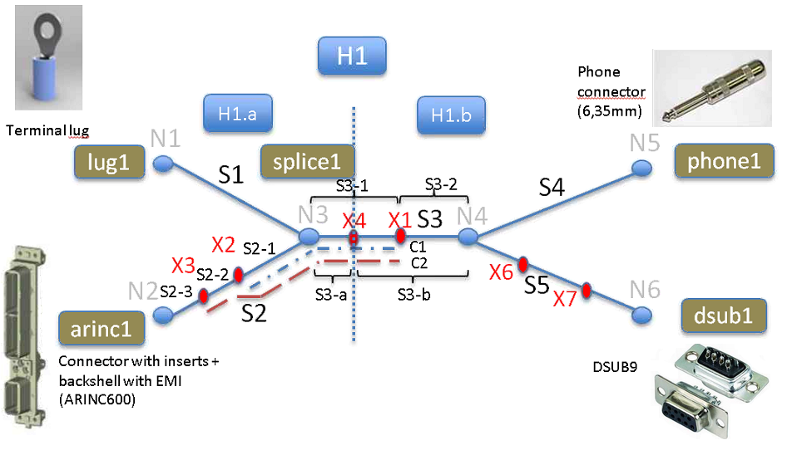Figure 1: Topological structure and connectors of the provided example Part_H1
The main harness topology in this example consists of five segments S1 to S5 that connects six nodes N1 to N6. On the end-nodes N1, N2, N5 and N6 different kinds of connectors and a terminal lug are placed.
- Most wires and cables are connected to the ARINC600 connector at node N2 and go through segment S2. These are two coax RG 58 cables (cable1, cable2), a speaker cable (cable3), and a single wire (wire2).
- On the internal node N3 a splice is placed that is realizing a T connection between 3 wires (wire1, wire2, wire3).
- The terminal lug at node N1 is connected by a single wire arriving from segment S1. As S1 contains only a single component no grouping is needed for this segment.
- The phone connector at node N5 is connected by a single speaker wire (cable3) arriving through segment S4. As S4 contains only a single component no grouping is needed for this segment.
- The DSUB connector at node N6 is connected by two coax cables (cable1, cable2) and a wire (wire3). These three wires and cables are grouped together with lacing in Segment S5.
- In segment S2 wire2 and cable3 are grouped by twisting around each other. The result is then grouped together with cable1 and cable2 and covered by a shielding braid that is connected to the GND of the backshell of the ARINC600 connector.
- Segment S3 contains the same arrangement of cables and wires as in segment S2, but because of the splice at node N3, it contains cable3 instead of cable2.
- A path through the segments S2, S3 and S4 has been defined for the speaker wire (cable 3)
- A path through the segments S2, S3 and S5 has been defined for the two coax cables (cable1, cable2) and the alternative of wire1 respectively wire3
Table 1: Wire / cable list for H1
A more detailed sub-topology on the main topology is available through the sub-nodes X1 to X7 that are placed on the main segments S2, S3 and S5. These sub-nodes divide the main segments. Segment S2 is divided by X2 and X3 into S2-1, S2-2 and S2-3. Segment S3 is divided in two alternative ways, S3-1 and S3-2 by X1 and S3-a and S3-B by X4. No sub-segments have been defined for the sub-nodes X6 and X7 on S5 because there had been no need for it. These detailed topology is used as follows:
- to define a path consisting of the segments S2-1 and S3-1 for a protective covering (wrap1)
- to define a path consisting of the segments S2-2, S2-1 and S3-1 for a heatshrink (heatshrink1)
- to split the overall harness H1 into two sub-harnesses H1.a and H1.b that different design groups are responsible for
- to define fixing locations at nodes X6 and X7
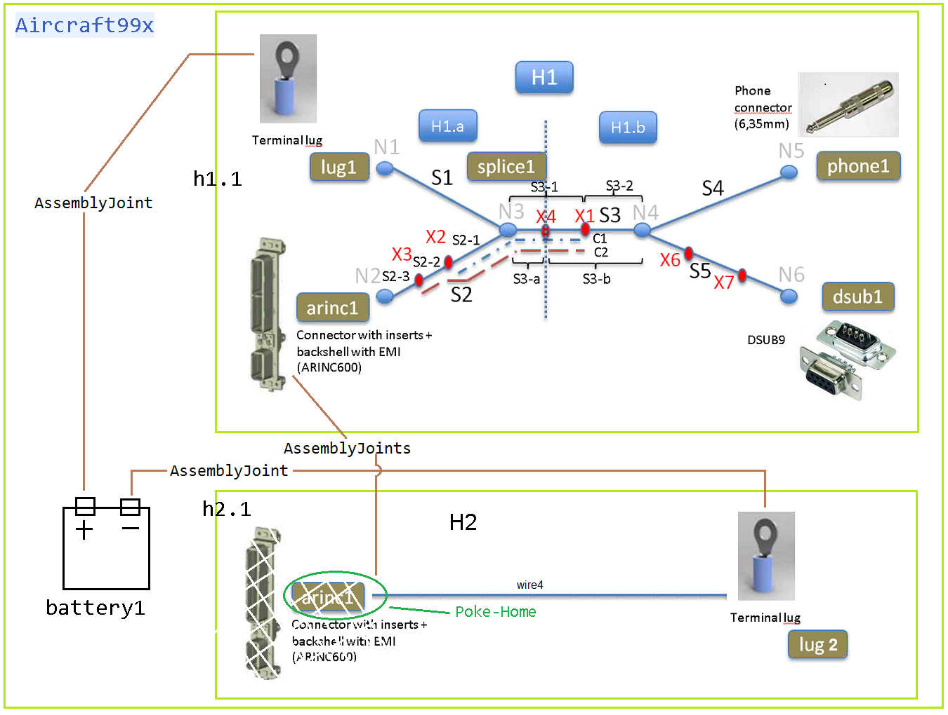Figure 2: Harnesses H1 and H2 combined in top assembly Aircraft99x
The example also contains a second mini harness example Part_H2 and a top assembly Aircraft99x (figure 2). The mini harness example Part_H2 consists only of a single wire (wire4) and a terminal lug (lug2) to which one end of the wire is connected to. The other end of the wire is intended to be connected to the arinc1 connector from the Part_H1 example above, but this connector is not part of the H2 assembly. This situation is in some industries called “poke-home”.
The top assembly Aircraft99x that contains 3 Occurrences:
- h1.1 that is of type Part_H1
- h2.1 that is of type Part_H2
- battery1 that is connected with the interface terminals of the two terminal lugs
The PLUS and MINUS terminals of the battery is connected to the interface terminals of the two terminal lugs (lug1 and lug2).
Also the “poke-home” connection from the H2 assembly can finally be connected in that top assembly because arinc1 from Part_H1 and wire4 from Part_H2 are available in this assembly.
In the following clauses this example is further detailed. The example file “HarnessExample1.xml“ is publicly available via downloaded from:
http://stepmod.cvs.sourceforge.net/viewvc/stepmod/stepmod/etc/ap242/EH_XML_Examples/HarnessExample1.xml?view=log

Table 2: AssemblyJoints

Part, PartVersion, Part category
Objects of type Part are used for the all the parts that are used to build an electrical harness. In addition an electrical harness is modelled as Part as well, so that it can be used in a next higher assembly; e.g. for a complete aircraft. For each Part at least one PartVersion shall be defined. A PartVersion may have one or several views (see next chapter).
Figure 3: Part, PartVersion and categories for Parts

Example: A wire part that is provided as bulk material. For the usage of the Part in an Occurrence it needs to be cut to a specific length.
<Part uid="_101000">
<Id id="04034-22-9"/>
<Name>
<CharacterString>WIRE,ELEC,COMP,SNGL CONDUCTOR,150 DEG C</CharacterString>
</Name>
<PartTypes>
<PartCategoryEnum>wire</PartCategoryEnum>
<PartCategoryEnum>raw material by length</PartCategoryEnum>
</PartTypes>
<Versions>
<PartVersion uid="_101001">
<Id id="Version 1"/>
<Views>
...
</Views>
</PartVersion>
</Versions>
</Part>

The example provided by this tutorial contains the following Parts:

The main attributes for a Part are its Id (used as master part number without version information) and Name. For the design exchange of electrical harness the specification of a part category is essential so that a receiving system can filter the data in a certain way. In this example the pre-defined category “wire” is used.

Generic Predefined Part Categories
AP242 defines the following generic categories (not specific for electrical harness):
- application control: this type of classification is used to indicate that a part shall be considered under certification aspects
EXAMPLE Prior to the release of a new car to the market, both function and quality of certain parts have to be certified by an authority, e.g., the department of transportation. For such item objects, certification requirements have to be considered during the design phase.
- assembly: this type of classification shall be used for any part that has an AssemblyDefinition provided for at least one of its versions, i.e., it is decomposed further;
- boxed: specifies the role of the boxed part;
EXAMPLE A can with one litre of a specific oil.
- collection: this type of classification shall be used for any part that has a CollectionDefinition provided for at least one of its versions;
- completely knocked down: this type of classification is used to indicate that a part is used in a production site that has assembling facilities only; EXAMPLE The 'completely knocked down' may indicate that the components are shipped to and assembled in a different country.
- continuous: this type of classification is used to indicate the part that can be measured by its volume or weight;
- detail: this type of classification shall be used for any part that has no AssemblyDefinition provided for any of its versions, i.e., it is not further decomposed;
- discrete: this type of classification is used to indicate that a part is one single piece.
- in process: this type of classification is used to indicate that the part identifies an intermediate object in a manufacturing process; NOTE Detailed information about the stage the part has within the manufacturing process may be obtained from the ProcessOperationOccurrence.
- inseparable assembly: the part plays the role of an inseparable assembly;
- prototype: this type of classification is used to indicate that the part identifies a prototype and is not intended for serial production;
- raw material: the part plays the role of raw material;
- raw material by area: the part plays the role of raw material, cut by area, e.g. chipboard;
- raw material by length: the part plays the role of raw material, cut by length, e.g. cable;
- raw material by volume: the part plays the role of raw material, cut by volume, e.g. a raw block of marble or oil;
- regulated: this type of classification is used to indicate that for a part certain regulations have to be considered;
- safety: this type of classification is used to indicate that a part is relevant for safety purposes;
- service: this type of classification is used to indicate that a part is relevant for service purposes;
- tool: the part plays the role of a tool.

Part Categories specific for Electrical Harness and other electrical applications
Here the pre-defined categories for electrical harness and other electrical applications. Most of these categories are standardized by IEC in the Electropedia: http://www.electropedia.org/
Preprocessors are required to provide these categories if they apply. This is needed so that a post-processor can rely on the incoming information and sort the parts suitable for the receiving system.
- wiring harness: assembly with a harness topology, consisting of cables or wires to enable electrical or optical connectivity, grouped together in one or more harness segments, each between two harness nodes in which the cables or wires either switch to other harness nodes or in which the cables and wires ends in connectors, contact members or terminal lugs
- wire [IEV ref 151-12-28]: flexible cylindrical conductor, with or without an insulating covering, the length of which is large with respect to its cross-sectional dimensions
Note – The cross-section of a wire may have any shape, but the term "wire" is not generally used for ribbons or tapes.
- cable [IEV ref 151-12-38]: assembly of one or more conductors and/or optical fibres, with a protective covering and possibly filling, insulating and protective material
- flat cable [IEV ref 461-06-05]: multi-core cable having cores or groups of cores arranged in parallel flat formation
- connector kit: collection of connector parts that are intended to be assembled together and that contain at least one connector housing and that may contain alternative parts that may or may not be used in the final assembly
- contact member [IEV ref 151-12-16]: conductive element intended to make an electric contact
- connector contact: contact member that is intended to be contained in a connector
- connector [IEV ref 151-12-19]: device providing connection and disconnection to a suitable mating component
Note – A connector has one or more contact members.
- plug [IEV ref 151-12-21]: connector attached to a cable
- socket [IEV ref 151-12-20]: connector attached to an apparatus, or to a constructional element or alike
Note – Contact members of a socket may be socket contacts, pin contacts or both.
- shielded connector [IEV ref 581-26-19]: connector designed to prevent the radiation of electromagnetic interference to and from the internal conductor(s)
- cavity plug: plug for a connector cavity for the purpose of sealing
- seal: mechanical object that helps join other mechanical objects together by preventing leakage, containing pressure, or excluding contamination
- connector housing [IEV ref 581-27-10]: part of a connector into which the connector insert and contacts are assembled
- emi connector housing: connector housing that shields against electromagnetic interference
- connector insert [IEV ref 581-27-11]: insulating element designed to support and position contacts in a connector housing
- backshell: connector accessory that is closing a connector from the back side and guide the wires and cables
- electrified backshell: backshell that is intended to be conductive
- cable support sleeve [IEV ref 581-27-23]: flexible accessory or a part of a component placed around the cable to minimize flexing of the cable at the point of entry into the component
- grommet [IEV ref 581-27-19]: part of a component or an accessory, used to support and protect the wires or cable at the point of entry; it may also prevent the ingress of moisture or contaminants
- strain relief accessory: connector accessory to guide and provide strain relief to wires and cables
- protective covering, sheat (North America jacket) [IEV ref 461-05-03]: uniform and continuous tubular covering of metallic or non-metallic material, generally extruded
Note – The term sheath is only used for metallic coverings in North America, whereas the term jacket is used for non-metallic coverings.
- overbraid: protective covering (sheath) that is also a braid
- conduit [IEV ref 442-02-03]: a part of a closed wiring system of generally circular cross section for insulated conductors and/or cables in electrical or communication installations, allowing them to be drawn in and/or replaced
- corrugated conduit [IEV ref 442-02-06]: a conduit in which the profile is corrugated in the longitudinal section
Note – Both annular and helical corrugated conduits are permissible and a combination of both corrugated and plain conduit is possible.
- shield (of a cable) [IEV ref 461-03-04]: surrounding earthed metallic layer which serves to confine the electric field within the cable and/or to protect the cable from external electrical influence
Note 1 – Metallic sheaths, foils, braids, armours and earthed concentric conductors may also serve as shields.
Note 2 – In French, the term "blindage" may be used when the main purpose of the screen is the protection from external electrical influence.
- terminal lug [IEV ref 461-17-01]: metallic device to connect a cable conductor to other electrical equipment
- terminal block [IEV ref 581-26-26]: part of a component or an accessory, used to support and protect the wires or cable at the point of entry; it may also prevent the ingress of moisture or contaminants
- joint ferrule, through connector (of cables) [IEV ref 461-17-04]: metallic device for connecting two consecutive lengths of conductor
- cable ferrule [IEV ref 581-27-18]: accessory in the form of a short tube to provide cable support or termination for a cable screen
- shield connector, screen connector [IEV ref 461-17-12]: device used to make a connection to the screen or shield of a cable for the purpose of continuity or earthing
- insulation piercing connector [IEV ref 461-11-08]: connector in which electrical contact with the conductor is made by metallic protrusions which pierce the insulation of the cable core
- splice [IEV ref 581-24-19]: connecting device with barrel(s) accommodating conductor(s) with or without additional provision to accommodate and secure the insulation
- fixing device [IEV ref 442-02-40]: system component specifically designed to secure other components to the wall, ceiling, floor or other structure
- cable fixing device: fixing device for a cable on a structure
- label: part that is intended to attach written information to other parts
- tape [IEV ref 212-15-03]: sheeting or plastic film of limited width and in long continuous lengths
Note – The width is typically less than some hundred millimetres.
- end cap [IEV ref 461-20-07]: device placed on the ends of a cable to prevent the ingress of moisture during storage, transportation and installation
- connector cavity: cavity in a connector, connector housing or insert intended to receive a connector contact or multi contact

PartView and ViewContext
The meaning and structure for Part, PartVersion, PartView with reference to ViewContext and also how to associate a geometric model is explained in great detail in the AP242 BO-Model XML Assembly Structure document and so we do not need to repeat this here.
Figure 4: Data model for PartView and ViewContext
Example: The Part “terminal lug” used in the reference example; incomplete
<ViewContext uid="_100102">
<ApplicationDomain>
<ProxyString>electrical design</ProxyString>
</ApplicationDomain>
<LifeCycleStage>
<ProxyString>design</ProxyString>
</LifeCycleStage>
</ViewContext>

<Part uid="_103000">
<Id id="MS5036-153"/>
<Name>
<LocalizedString lang="en-US">TERMINAL LUG CRIMP STYLE COPPER INSULATED RING TONGUE</LocalizedString>
<LocalizedString lang="fr-FR">COSSE</LocalizedString>
</Name>
<PartTypes>
<PartCategoryEnum>terminal lug</PartCategoryEnum>
</PartTypes>
<Versions>
<PartVersion uid="_103001">
<Id id="Version 1"/>
<Views>
<PartView uid="_103002">
<DefiningGeometry uidRef="_103090"/>
<InitialContext uidRef="_100102"/>
...
</PartView>
</Views>
</PartVersion>
</Versions>
</Part>

The specifics for electrical harness, compared to the Assembly Structure Recommended Practises, is explained in the following sub-clauses:

ViewContext: ApplicationDomain
A PartView shall have at least one ViewContext for the InitialContext and may have further ViewContexts as AdditionalContexts. For the design of an electrical harness all these ViewContexts shall have the value “design” for the LifeCycleStage attribute.
In the recommended practises for assembly design an example of ViewContext with the value “mechanical design” for the ApplicationDomain is provided. The expectation for PartViews that call out such a ViewContext as either initial or additional context is that these PartViews also provide either a 2D or a 3D geometric model that represents the part.
For the purpose of the design of an electrical harness the ApplicationDomain “electrical design” shall be used for all PartViews that define elements relevant for electrical connectivity such as electrical terminals and nodes. When this ApplicationDomain is used for a PartView it tells the receiver of the data that all relevant electrical connectivity information is provided. The ApplicationDomain “electrical design” may be used as either InitialContext or AdditionalContexts.
As detailed in the assembly recommended practises, an AssemblyDefinition is a specialization of a PartView that is to be used to define an assembly of parts. In the case that the assembly of an electrical harness is defined, the subtype of WiringHarnessAssemblyDesign shall be used . The following values for the ApplicationDomain of additional contexts for a WiringHarnessAssemblyDesign are defined:
- wire and part list with connectivity: the application domain comprises all wires and wire caps, cables, connectors and associated material, contact members, terminal lugs, terminal blocks, splices and electrically non conductive through termination, electrical shielding definition in the assembly, tape marking of a wiring harness assembly.
- wiring harness segment topology: the application domain comprises the complete harness topology of a wiring harness assembly.
- wiring harness assembly design stick line: the application domain comprises a stick line drawing of a wiring harness assembly.
- wiring harness formboard drawing: the application domain comprises a formboard drawing of a wiring harness assembly.
- wiring harness assembly 3d design: the application domain comprises a 3D geometry model of the harness topology of a wiring harness assembly.

Parts used in the reference example
Table 1 lists all the Part used in the reference example, together with the used PartVersion, PartView and part category.

Table 3: Parts used in the example

Part Occurrence, and Multi-level Assembly Structure
AP242 allows to build up single and multi level assembly structures. Each assembly, either a top assembly or an intermediate sub-assembly, is represented by an AssemblyDefinition that is a subtype of PartView. The “components” of an AssemblyDefinition are subtypes of Occurrence that are related into the assembly through AssemblyOccurrenceRelationships. Its supertype ViewOccurrenceRelationship allows in a generic way to relate an Occurrence to a PartView.
In cases that a set of Occurrences belong together but are not physically combined with each other a CollectionDefinition is to be used, that is also a subtype of PartView.
An AssemblyDefinition is the relating target of an AssemblyOccurrenceRelationship that is a subtype of ViewOccurrenceRelationship that in a generic way establishes a relation between an Occurrence and a PartView. An AssemblyOccurrenceRelationship is either a NextAssemblyOccurrenceUsage or a PromissoryAssemblyOccurrenceUsage. A NextAssemblyOccurrenceUsage makes an Occurrence a direct constituent of an AssemblyDefinition. A PromissoryAssemblyOccurrenceUsage only indicates that an Occurrence may become an constituent in some way, maybe in some indirect way.
An Occurrence may be defined in three different ways:
- In most cases an Occurrence is a particular usage of a PartView that inherits all its attributes including the geometric models from the PartView unless it is said otherwise.
- But an Occurrence may also be a usage of a ProductConfiguration that is a member of a ProductClass. This case is used especially for standard parts that are bought off the shelf with only limited design information.
- A third case is when an Occurrence is defined by a lower level Occurrence in the context of a higher level Occurrence. The specific subtype SpecifiedOccurrence is used in this case, see below and clause 5.6.
Occurrence itself is an abstract concept. One of the following subtype has to be used:
- A DefinitionBasedOccurrence is an Occurrence that is also abstract and that has as its definition either a PartView or a ProductConfiguration (but not another Occurrence).
- A SingleOccurrence is a DefinitionBasedOccurrence that is taken from its definition as a single piece.
- A QuantifiedOccurrence is a DefinitionBasedOccurrence that is taken from its definition in some quantity. The quantity can be defined in the number of pieces (e.g. 10 rivets), or by length (e.g. 2m wire), or by surface (e.g. 3 sqm. of glass) or by volume (2.5 litre of oil). It the quantity can not be specified exactly an alternative criterion can be specified (e.g. enough glue for the whole surface). At least either the quantity or the criterion must be specified.
- A SpecifiedOccurrence is an Occurrence that has as its definition another Occurrence. This definition is used by a NextAssemblyUsage in an AssemblyDefinition. In parallel the SpecifiedOccurrence calls out by the attribute UpperUsage one more other Occurrence, that has as its Definition (directly or indirectly) this AssemblyDefinition.
A single or multi level assembly structure shall form a directed acyclic graph. ProductConfigurations, PartViews, AssemblyDefinitions and Occurrences are the nodes, while AssemblyOccurrenceRelationships, and the attribute Occurrence.Definition are the links between the nodes in this graph. Other than that this graph shall be “directed” and “acyclic” the following constraints apply:
- An Occurrence can be related at most once into an AssemblyDefinition, but an Occurrence can be related several times into different AssemblyDefinitions; e.g. to represent variants.
- In the case that an Occurrence is defined by a PartView, this PartView must not be the AssemblyDefinition into which the Occurrence is related to nor any of its higher AssemblyDefinitions.
- PartViews or AssemblyDefinitions at different levels of an assembly structure shall not share the same PartVersion nor the same Part.
See the “Recommended Practices for AP242 Business Object Model XML Assembly Structure” for detailed information on how to implement assembly structures in general.
Clause 5.6 provides a detailed example of a hierarchical assembly structure with SpecifiedOccurrence.

Attention: Do not use the types AssemblyViewRelationship, NextAssemblyViewUsage and PromissoryAssemblyViewUsage for electrical harness. These types had been introduced in AP242 for the harmonization with AP239 (PLCS), but they do in no way support the functionality needed for electrical harness.
Figure 5: Detailed assembly structure model
The attribute Id of Occurrences shall be unique within all Occurrences used within an AssemblyDefinition. It is used as reference designator. In most cases a simple IdentifierString is sufficient. If there is a need to call out a specific reference designator system (e.g. IEC, IEEE or company specific) the Identifier Object with a Classification can be used.
See an overview of “IEC Reference Designations” at:
http://myelectrical.com/notes/entryid/24/iec-reference-designations
The attribute Id of ViewOccurrenceRelationship and all its subtypes is optional. Recommendation is to not use this attribute.

Electrical Connectivity & AssemblyJoint
The electrical connectivity in AP242 follows the so called “CFI five-box model of electrical connectivity”, defined originally by the CAD Framework Initiative (CFI), see
http://www10.edacafe.com/book/ASIC/CH09/CH09.5.php
The CFI model is used in AP242 for both, functional and physical connectivity. As this tutorial focuses on the physical design aspects of an electrical harness, only the physical connectivity aspects are presented here.

Adopted CFI Five-Box Model for Electrical Connectivity
Adopting the CFI five-box model to the modelling style and terminology used in AP242-XML and applying several simplifications the model would looks like this:

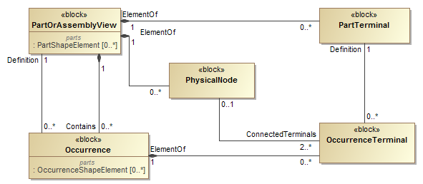Figure 6: Simplified adopted CFI five-box model for physical connectivity
- A PartView represents any kind of a physical design and all the underlying parts it is made of. So the design of an electrical harness is a part and also all the connectors, cables and other things it is made of are represented as PartViews.
- A PartTerminal represents some area of a PartView where it can be electrical or optical connected; e.g. one of the inside or outside terminals of a connector.
A PartTerminal belongs to exactly one PartView.
A PartView may have zero, one or many PartTerminals
- An Occurrence is a particular usage of a PartView and is therefore defined by one PartView.
A PartView may serve as the definition for many Occurrences.
A higher level PartView may “contain” Occurrences of lower level PartViews In STEP the subtype AssemblyView is to be used in this case. The structure is recursive and so also occurrences of higher level PartView can be constructed that may be contained in an even higher level PartView and so on. PartViews and Occurrences form a Direct Acyclic Graph, so a PartView can not contain Occurrences of itself.
Example: An electrical harness PartView that contains two Occurrences of a connector.
Note: This simplified model assumes that an Occurrence is ues in exactly one Part/AssemblyView. In STEP an Occurrence can be used in zero, one or many Part/AssemblyViews.
- An OccurrenceTerminal represents some area of an Occurrence where it can be connected.
An OccurrenceTerminal belongs to exactly one Occurrence.
An Occurrence can have zero, one or many OccurrenceTerminals
An OccurrenceTerminal is defined by one PartTerminal from which it inherits all characteristics.
A PartTerminal may serve as the definition for many OccurrenceTerminals.
- A PhysicalNode represents a node of one or several electrical connected elements. It is equivalent to the concept of a Kirchhoff node.
A PhysicalNode belongs to one PartView.
A PartView may have zero, one or many PhysicalNodes,
A PhysicalNode connects two or more OccurrenceTerminals. These terminals must belong to Occurrences that are contained on the PartView of the node. It is not allowed to connect OccurrenceTerminals of Occurrences that are not used in the PartView.
An OccurrenceTerminal can be used by at most one PhysicalNode for the same PartView.
The following clauses explain in detail how the simplified CFI model is realised in AP242.

Adopted CFI Five-Box Model for any Joints in an Assembly
AP242 also contains a variation of the CFI five-box model to represent any kind of mechanical connectivity in an assembly (figure 7). This is based on the entities PartShapeElement and OccurrenceShapeElement that are supertypes of PartTerminal respectively OccurrenceTerminal. An AssemblyJoint is itself a PartShapeElement and this belongs to one PartView that is an assembly. An AssemblyJoint connects in a binary way two OccurrenceShapeElements. So an AssemblyJoint plays a similar role as a PhysicalNode with the more generic supertypes PartShapeElement and OccurrenceShapeElement.
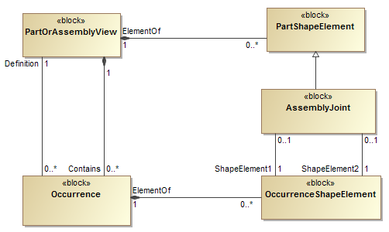Figure 7: Simplified adopted CFI five-box model for joints in an assembly

Figure 8 shows an example of the CFI 5 box model for an assembly of two occurrences of a part with 2 terminals.
- top: PartView A with two PartTerminals A1 and A2
- middle: Aa and Ab of PartView A. Each has two OccurrenceTerminals that are defined by the PartTerminals of PartView A.
Occurrence Aa has the OccurrenceTerminals Aa1 and Aa2.
Occurrence Ab has the OccurrenceTerminals Ab1 and Ab2.
- bottom: AssemblyView B with two AssemblyJoints.
AssemblyJoint Bx joints the OccurrenceTerminals Ab1 with Aa2.
AssemblyJoint By joints the OccurrenceTerminals Ab2 with Aa1.
OccurrenceTerminals are essential to exactly specific which terminals are connected or joined together. The same is true for the more generic supertype OccurrenceShapeElement.
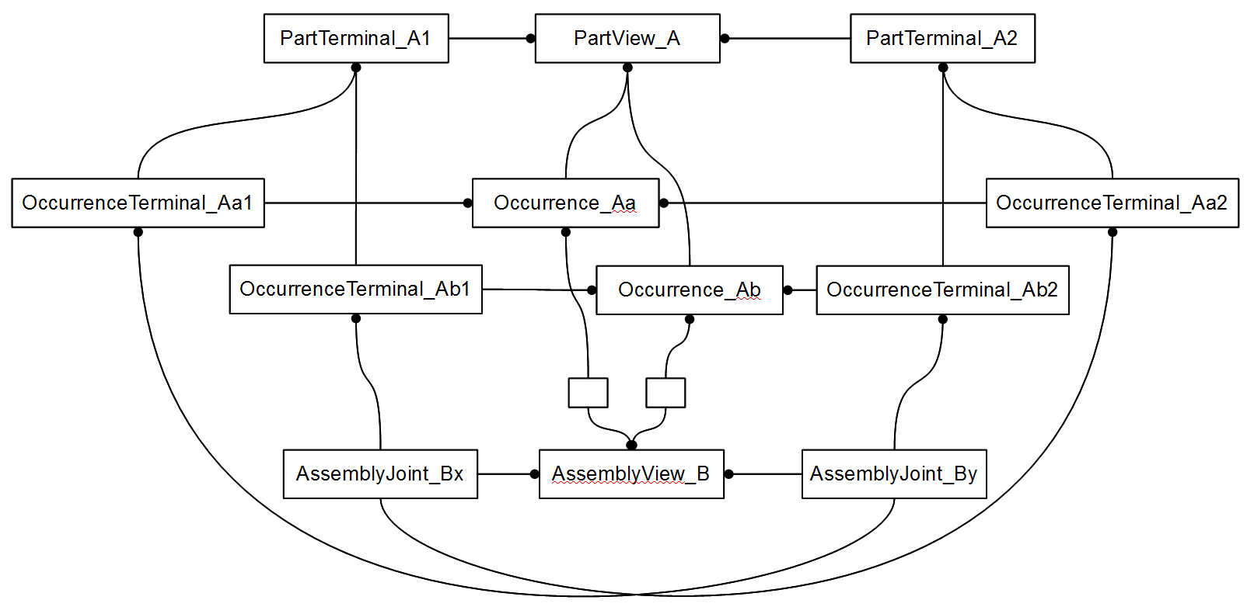Figure 8: Example of adopted CFI 5 box pattern for AssemblyJoint of terminals

Detailed ShapeElement and AssemblyJoint Model
This clause explains in detail how two OccurrenceTerminals within an assembly are joined together, e.g. an end of a wire with an “internal” terminal of a connector, or two “external” terminals of two connectors.
While in the previous clauses we showed pieces of the AP242 connectivity model in a rather simplified way to highlight the principles, we will now look to it in more detail.
As stated earlier OccurrenceShapeElement and PartShapeElement are both subtypes of ShapeElement. A PartShapeElement represents an element of the shape of a PartView, while an OccurrenceShapeElement represents an element of the shape of an Occurrence. To enforce this the ElementOf attribute of a PartShapeElement must call out a PartView, while the ElementOf attribute of an OccurrenceShapeElement must call out an Occurrence.
Note: ElementOf of a ShapeElement might also refer to an AssemblyViewRelationship, BreakdownElementView or IndividualPartView, but these cases are not addressed in this tutorial.
An OccurrenceShapeElement calls out as its Definition a PartOrOccurrenceShapeElementSelect that is either a PartShapeElement or an OccurrenceShapeElement. There is a constraint on the combination of the values for ElementOf and Definition. If and only if ElementOf has a value of type SpecifiedOccurrence the Definition attribute must have a value of type OccurrenceShapeElement.
An AssemblyJoint is a PartShapeElement that belongs to an AssemblyDefinition. In most cases an AssemblyJoint connects two OccurrenceShapeElements of two different Occurrences. These two Occurrences must be related into the same AssemblyDefinition as the one the AssemblyDefinition belongs to.
In some cases there is a need to joint three or more OccurrenceShapeElements, e.g. when two or more wires join in a single screw terminal. In this case a tree of two or more AssemblyJoints are used. The bottom AssemblyJoint(s) in that tree connect two OccurrenceShapeElement, while the higher ones in that three connect either two AssemblyJoints or an AssemblyJoint with an OccurrenceShapeElement.
Figure 9: Detailed AssemblyJoint model
For each AssemblyJoint the kind of joint can be specified. The following JointTypes are pre-defined:
- welded connection [IEV ref 581-23-06]: connection made by welding
- soldered connection [IEV ref 581-23-04]: connection made by soldering
- glued connection: connection made by glueing
- snap connection: connection made by snapping
- push connection: connection made by pushing
- screwed connection: connection made by screwing
- bolted connection [IEV ref 461-19-05]: connection in which the pressure to the conductor is applied by bolting
- wrapped connection [IEV ref 581-23-07]: solderless connection achieved by wrapping a solid conductor around a wrap post
- insulation displacement connection [IEV ref 581-23-35]: solderless connection made by inserting a single wire into a slot in an insulation displacement termination
- insulation piercing connection [IEV ref 461-19-06]: connection made by metallic protrusions which pierce the insulation of the cable core
- crimped connection [IEV ref 461-19-01] permanent connection made by the application of pressure inducing the deformation or reshaping of the barrel around the conductor of a cable
Note – In some cases, the deformation or reshaping of the barrel may affect the form of the conductor.
- circular compressed crimped connection [IEV ref 461-19-02]: crimp connection in which the barrel is compressed maintaining essentially its circular form
- hexagonal compressed crimped connection [IEV ref 461-19-03]: crimp connection in which the barrel is compressed and reshaped essentially to a hexagonal form
- deep indented crimped connection [IEV ref 461-19-04]: crimp connection in which the barrel and the cable conductor are deformed by deep indentations
- promissory connection: connection that is promised or expected to be established in some way, but that is by purpose not realised for this PartView
- promissory connection for higher assembly: promissory connection that will be realised in a higher assembly in which this assembly is an Occurrence
- promissory connection for installation constraints: the connection can not be realised on this assembly level because of installation constraints and this must be realised in a higher assembly
- promissory connection for missing contributors: the connection can not be realised on this assembly level because one or more needed OccurrenceShapeElements are not part of this assembly. So the final AssemblyJoint can only be realised in a higher assembly where the other OccurrenceShapeElements become accessible.
The attribute JointTypes is optional; it should only be provided if available in the sending system. Also the JointTypes does not need to be specified if one of the JointTypes of the affected PartTerminals that are called out as Definition of the OccurrenceTerminal is already specific enough. However if both AssemblyJoint JointTypes and one or two PartTerminals.JointTypes are provided, the JointTypes of the AssemblyJoint overrides the JointTypes of the PartTerminal(s). E.g. if the terminal type is a crimp terminal, and this terminal is used for an AssemblyJoint with type solder, then this means the joint is realised by soldering, not by crimping.
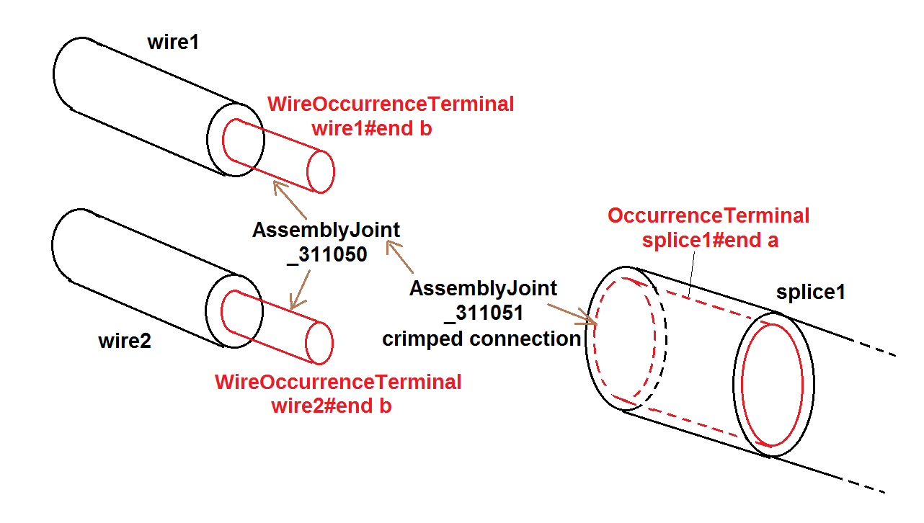Figure 10: Tree of AssemblyJoints
Example of a two AssemblyJoints for joining three OccurrenceTerminals (figure 10). First the ends of two wires (wire1 and wire2) are placed together to form a couple by AssemblyJoint _311050 that does not specify a particular JointType. The higher level AssemblyJoint _311051 is taking this couple and an OccurrenceTerminal from splice1 and only this is crimped.
<ShapeElement xsi:type="n0:AssemblyJoint" uid="_311050">
<ShapeElement1 uidRef="_201007"/> <!--wire1#end b-->
<ShapeElement2 uidRef="_201107"/> <!--wire2#end b-->
</ShapeElement>
<ShapeElement xsi:type="n0:AssemblyJoint" uid="_311051">
<JointType>crimped connection</JointType>
<ShapeElement1 uidRef="_311050"/> <!--AssemblyJoint(wire1 & wire2) -->
<ShapeElement2 uidRef="_218103"/> <!--splice1#end a-->
</ShapeElement>

Detailed PartTerminal Model
This clause explains in detail the concept of PartTerminal that identifies a feature of a part that can be connected with others either electrical or optical.

Figure 11: Detailed PartTerminal model
A PartTerminal carries three additional attributes in addition to those it inherits from PartShapeElement:
JointTypes characterises the intended way on how to contact the PartTerminal. Most of the allowed values listed below are taken from IEC definitions. To achieve a systematic naming convention the word “contact” has been replaced by the word “terminal” or the word “terminal” has been added at the end. The terms written in bold characters shall be used. Alternative IEC terms are separated by comma.
- socket terminal, socket contact, female contact [IEV ref 151-12-17]: contact member intended to make electric engagement on its inner surface for mating with the outer surface of another contact member
Note – In English, the term "socket contact" does not imply that socket contacts are always mounted in a socket nor that sockets have only socket contacts.
- pin terminal, pin contact, male contact [IEV ref 151-12-18]: contact member intended to make electric engagement on its outer surface for mating with the inner surface of another contact member
- crimp terminal, crimp contact [IEV ref 581-22-05]: contact having a conductor barrel designed to be crimped
- solder terminal [IEV ref 442-06-20]: a conductive part of a connecting device provided to enable a termination to be made by means of solder
- lug terminal [IEV ref 442-06-16]: a screw-type terminal designed for clamping a cable lug or bar directly or indirectly by means of a screw or nut
- screw terminal [IEV ref 442-06-08]: a terminal, in which the conductor is clamped under the head of one or more screws, and where the clamping pressure can be applied directly by the head of the screw or through an intermediate part, such as a washer, clamping plate or an anti-spread device
- mantle terminal [IEV ref 442-06-14]: a terminal, in which the conductor is clamped against the base of a slot in a threaded stud by means of a nut, by a suitably shaped washer under the nut, by a central peg if the nut is a cap nut, or by an equally effective means for transmitting the pressure from the nut to the conductor within the slot
- saddle terminal [IEV ref 442-06-09]: a terminal, in which the conductor is clamped against the base of a slot in a threaded stud by means of a nut, by a suitably shaped washer under the nut, by a central peg if the nut is a cap nut, or by an equally effective means for transmitting the pressure from the nut to the conductor within the slot
- pillar terminal [IEV ref 442-06-22]: a screw type terminal, in which the conductor(s) is (are) inserted into a hole or cavity, where it is clamped under the shank of the screw
Note – The clamping pressure can be applied directly by the shank of the screw or through an intermediate part, to which pressure is applied by the shank of the screw.
- stud terminal [IEV ref 442-06-23]: a screw-type terminal in which the conductor is clamped under a nut
Note – The clamping pressure can be applied directly by a suitably shaped nut or through an intermediate part, such as a washer, a clamping plate or an anti-spread device.
- resilient contact terminal [IEV ref 581-22-09]: contact having elastic properties to provide a force to its mating part
- snap on contact terminal [IEV ref 581-22-10]: push-on contact in which retention is achieved by means of a deformation of the contact area which provides positive axial location
- tuning fork contact terminal [IEV ref 581-22-12]: resilient contact having a shape similar to that of a tuning fork, the two arms of which apply contact force in opposite directions
- push on contact terminal [IEV ref 581-27-04]: contact with which a connection is achieved by axial force, separation being restricted by friction
- insulation displacement terminal, insulation displacement termination [IEV ref 581-23-39]: termination having slots with precisely controlled sides, which are intended to accept a wire and to displace its insulation, deform its conductor and to produce a gas-tight solderless connection
- non reusable insulation displacement termination [IEV ref 581-23-41]: insulation displacement termination that can be terminated only once
- fusion fibre splice, fusion splice [IEV ref 731-05-06]: a splice accomplished by the application of localised heat sufficient to fuse or melt the ends of two lengths of optical fibre, to produce a continuous single optical fibre
- mechanical fibre splice, mechanical splice [IEV ref 731-05-07]: a fibre splice accomplished by fixtures or materials, rather than by thermal fusion
- optical fibre splice [IEV ref 731-05-05]: a permanent joint whose purpose is to couple optical power between two optical fibres
Note – Associated terms : to splice, splicing.
DomainType: Either electrical or optical. In principle also the domain types thermal or magnetic are available, but these are not used in practise so far.
InterfaceOrJointTerminal: This indicates on whether a PartTerminal is intended to be connected on the next higher assembly level (e.g. the internal terminals of a connector) or whether the PartTerminals are intended to be used to “interface” on an even higher assembly level (e.g. the external terminals of a connector)

Detailed OccurrenceTerminal and PhysicalNode Model
This clause explains in detail how “components” of an electrical assembly are connected with each other, either by AssemblyJoints or by PhysicalNodes that represents nodes in the sense of the Kirchhoff's laws on electrical circuits.
For the exchange of electrical or optical connectivity information, PartTerminal, subtype of PartShapeElement, and OccurrenceTerminal, subtype of OccurrenceShapeElement, are to be used. The Definition attribute of OccurrenceTerminal is of type PartOrOccurrenceTerminalSelect which is either a PartTerminal or another OccurrenceTerminal. Similar to OccurrenceShapeElement, the Definition of OccurrenceTerminal shall only, and only if, be of type OccurrenceTerminal when ElementOf has a value of type SpecifiedOccurrence.
Figure 12: PhysicalNode & OccurrenceTerminal
Like AssemblyJoint, PhysicalNode, is also a subtype of PartShapeElement. It defines in a more generic way either electrical or optical connection between several terminals without providing all the details. This is done through the attribute ConnectedTerminals that is of type PartOrOccurrenceShapeElement. The following constraints apply:
- If a member of the ConnectedTerminals is of type PartTerminal, then this PartTerminal shall belong to the same PartView to which also PhysicalNode belongs to
- If a member of the ConnectedTerminals is of type OccurrenceTerminal, then the Occurrence this OccurrenceTerminal belongs to shall be related into an AssemblyDefinition via a AssemblyOccurrenceRelationship that is also the same AssemblyDefinition the PhysicalNode belongs to.
Two subtypes of PhysicalNode are defined:
- ConnectedPartTerminals defines connectivity between several PartTerminals only. This subtype shall be used when ElementOf points to a PartView that is not an AssemblyDefinition and so there are no OccurrenceTerminals among the ConnectedTerminals.
- ConnectedOccurrenceTerminals defines connectivity between several OccurrenceTerminals only. So this subtype can only be used when ElementOf refers to an AssemblyDefinition. This subtype shall be used to indicate that the node is internal to the part and not visible to the outside.
- The supertype PhysicalNode shall be used when ElementOf refers to an AssemblyDefinition and the ConnectedTerminals attribute contains at least one PartTerminal and contains (or may contain) at least one OccurrenceTerminals. So an inner node is accessible from the outside.
Example:
A PartView contains two PartTerminals whose internal connection is stated by a ConnectedPartTerminals.
<PartView uid="_103002">
<DefiningGeometry uidRef="_103090"/>
<InitialContext uidRef="_100102"/>
...
<ShapeElement xsi:type="n0:PartTerminal" uid="_103003">
<Id id="External"/>
<RepresentedGeometry uidRef="_103092"/>
<InterfaceOrJointTerminal>interface terminal</InterfaceOrJointTerminal>
<JointType>
<TerminalJointTypeEnum>screw terminal</TerminalJointTypeEnum>
</JointType>
</ShapeElement>
<ShapeElement xsi:type="n0:PartTerminal" uid="_103004">
<Id id="Internal"/>
<RepresentedGeometry uidRef="_103094"/>
<InterfaceOrJointTerminal>join terminal</InterfaceOrJointTerminal>
<JointType>
<TerminalJointTypeEnum>crimp terminal</TerminalJointTypeEnum>
</JointType>
</ShapeElement>
<ShapeElement xsi:type="n0:ConnectedPartTerminals" uid="_103007">
<ConnectedTerminals>
<PartTerminal uidRef="_103003"/>
<PartTerminal uidRef="_103004"/>
</ConnectedTerminals>
</ShapeElement>
</PartView>

Referencing Terminals in Hierarchical Assembly Structures
So far we explained only on how to use AssemblyJoints and PhysicalNodes within a single assembly level as these concepts can refer only to OccurrenceShapeElements respectively OccurrenceTerminals within the same assembly level. But what to do when the AssemblyJoints and PhysicalNodes need to span over a multi level assembly structure?
The answer is to use SpecifiedOccurrence to make OccurrenceShapeElements/OccurrenceTerminals from a lower assembly level visible on a higher assembly level.
A SpecifiedOccurrence has as its Definition another Occurrence (or subtype SpecifiedOccurrence) and calls out with its attribute UpperUsage a higher level Occurrence, and thus making the lower level Occurrence visible in the higher level Occurrence. In a similar way the OccurrenceShapeElements and OccurrenceTerminals from the lower level Occurrence can be reflected for the higher level Occurrence by creating copies of OccurrenceShapeElements and OccurrenceTerminals that refer with their Definition attributes to the lower level OccurrenceShapeElements and OccurrenceTerminals.
Here an example on how this mechanism works through an assembly hierarchy with four levels:
- The top assembly “Aircraft99x” contains an occurrence “h1.1” that is a “Part_H1”
- The assembly “Part_H1” contains an occurrence “arinc1” that is a “ARINC 600 set”
- The assembly “ARINC 600 set” contains an occurrence “C-Assy” for the insert at position C that is a “5W2 assy”
- The assembly “5W2 assy” contains an occurrence “power3” that is a “#16 Rack plug power contact”
A series of SpecifiedOccurrences flatten this hierarchical assembly structure:
- “h1.1/arinc1” represents the “arinc1” occurrence for the higher occurrence “h1.1”
- “arinc1/C-Assy” represents the “A-Assy” occurrence for the higher occurrence “arinc1”
- “h1.1/arinc1/C-Assy” represents the “arinc1/A-Assy” occurrence for the higher occurrence “arinc1/C-Assy”
- “C-Assy/power3” represents the “power3” occurrence for the higher occurrence “C-Assy”
- “arinc1/C-Assy/power3” represents the “C-Assy/power3” occurrence for the higher occurrence “arinc1”
- “h1.1/arinc1/C-Assy/power3” represents the “arinc1/C-Assy/power3” occurrence for the higher occurrence “h1.1”
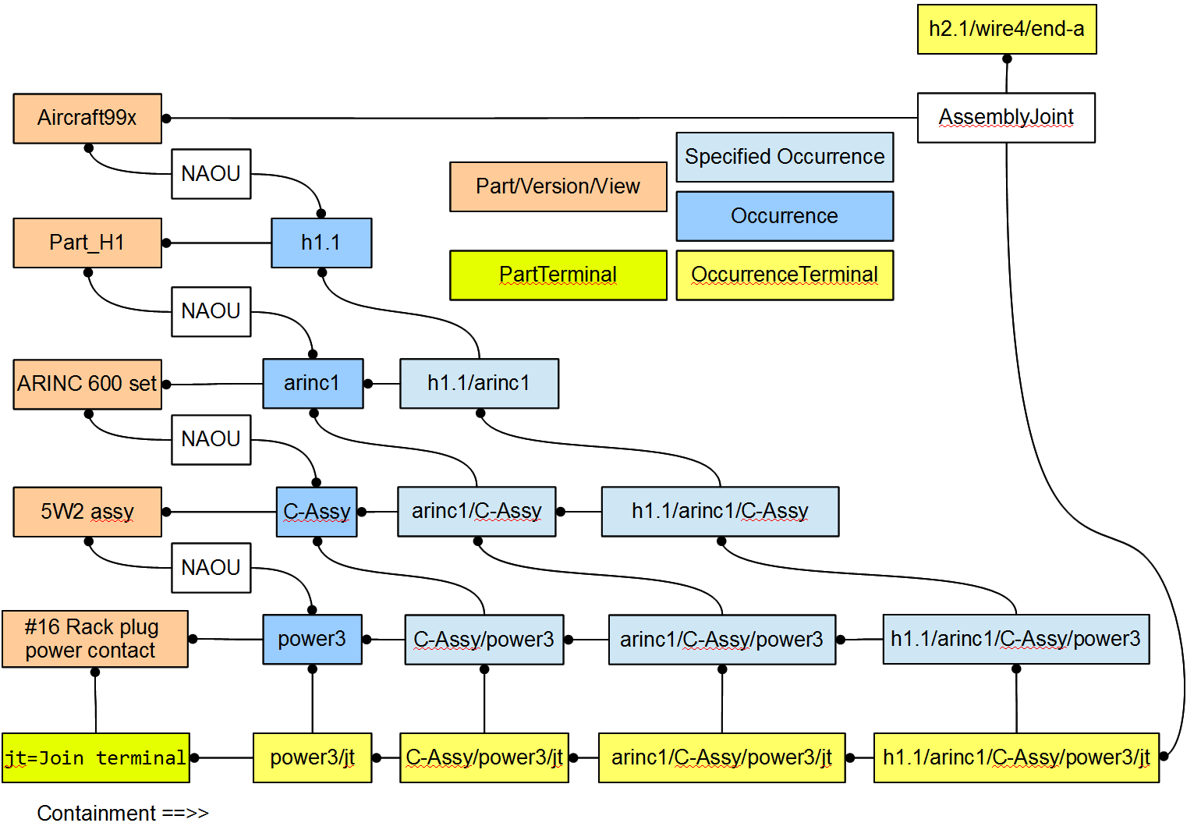Figure 13: SpecifiedOccurrence Tree with OccurrenceTerminals
Now the terminal “jt” is made visible on the top assembly level and it can there be connected by an AssemblyJoint to another terminal “h2.1/wire1/end-a” for which a similar structure will be build up.
Please note that the flattening of the hierarchical structure into a flat structure is essential because:
- the “5W2 assy” might contain another occurrence “power4” of an “#16 Rack plug power contact” (which is the case in our example)
- the “ARINC 600 set” might contain another occurrence “D-Assy” of an “5W2 assy”
- the “Part_H1” might contain another occurrence “arinc2” of an “ARINC 600 set”
- the “ Aircraft99x” might contain another example “h1.2” of an “Part_H1”
If all this would be the case, an AssemblyJoint on the top assembly level would need to be specific as to which one of the following “jt” OccurrenceTerminals a connection is made:
- “h1.1/arinc1/C-Assy/power3”
- “h1.1/arinc1/C-Assy/power4”
- “h1.1/arinc1/D-Assy/power3”
- “h1.1/arinc1/D-Assy/power4”
- “h1.1/arinc2/C-Assy/power3”
- “h1.1/arinc2/C-Assy/power4”
- “h1.1/arinc2/D-Assy/power3”
- “h1.1/arinc2/D-Assy/power4”
- “h1.2/arinc1/C-Assy/power3”
- “h1.2/arinc1/C-Assy/power4”
- “h1.2/arinc1/D-Assy/power3”
- “h1.2/arinc1/D-Assy/power4”
- “h1.2/arinc2/C-Assy/power3”
- “h1.2/arinc2/C-Assy/power4”
- “h1.2/arinc2/D-Assy/power3”
- “h1.2/arinc2/D-Assy/power4”

Cable and Wire Occurrences
Let's start with the IEC definitions of what a wire and cable is:
- wire [IEV ref 151-12-28]: flexible cylindrical conductor, with or without an insulating covering, the length of which is large with respect to its cross-sectional dimensions
Note – The cross-section of a wire may have any shape, but the term "wire" is not generally used for ribbons or tapes.
- cable [IEV ref 151-12-38]: assembly of one or more conductors and/or optical fibres, with a protective covering and possibly filling, insulating and protective material
For the purpose of AP242 the definitions may be used in a slightly different way. Important is that a wire has exactly one conductor, but it might be rigid (not flexible). And it is recommended to use cable only if there are two or more conductors.
Figure 14: Cable- and WireOccurrence and their Terminals

Cables and Wires as raw materials are treated as Parts with the PartTypes attribute set to the PartCategoryEnum values “cable” respectively “wire”. Cables and wires are typically produced and sold in big lengths that are coiled. The length is often much bigger that the length needed for a particular usage and so a piece of wire or cable has to be cut from the coil in a certain length. Because of this the Part for the raw material get for PartType the additional PartCategoryEnum values “raw material by length”.
If the exact cut length is know it can directly be specified as a quantity with unit, e.g. 1.5 m. Otherwise a criterion can be specified e.g. “not determined in engineering; to be defined by manufacturer”.
CableOccurrence and WireOccurrence are Occurrences of Parts with a PartTypes that has the PartCategoryEnum values “cable” respectively “wire”. Because each CableOccurrence and WireOccurrence has a particular length they are subtypes of QuantifiedOccurrence.
So far we looked only to OccurrenceTerminals that are defined by PartTerminals. There is another class of terminals on Occurrences that are derived from the more generic PartShapeElement which are called DerivedOccurrenceTerminals.
Because the raw cable and wire material are typically rolled up and protected by some isolation, it is not possible to identify any particular PartTerminal on that raw material. So instead of identifying PartTerminals we only identify conductors (one or several) using WireIdentification. Both PartTerminal and WireIdentification are subtypes of PartShapeElement. A WireIdentification has a pre-defined property named Code for the “wire colour-based identification code”.
Cable and wire parts are raw material; they do no have specific PartTerminals. CableOccurrences and WireOccurrences on the other hand have terminals. These terminals are derived from the WireIdentifications of the raw materials.
In the same way we could have e.g. a GND-bar and define any number of terminals on it.

Harness Topology
The topological structure of a wire harness, is primarily build up from the root topological elements Vertex and Edge, that are combined in a ConnectedEdgeWithLengthSetRepresentation that is referenced by a WiringHarnessAssemblyDesign with the Topology attribute. Unlike a 2D or 3D geometrical model, the topological model does not define any geometry other than the fact that Edges have a particular length. In most cases the wires, cables and tubular covers an electrical harness is made of are flexible and thus can be arranged in many possible 2D and 3D geometries. By associating these wires, cables and tubular covers to the Edges and Paths (see below) of the ConnectedEdgeWithLengthSetRepresentation a receiving system will know:
- at which Vertex a wire, cable or tubular cover will start and where it will end
- which wires, cables and tubular covers are associated to each single edge
Figure 15: ConnectedEdgeWithLengthSetRepresentation
The main topological structure consists of the following subtypes of RepresentationItems:
- Vertex
- Edge
- EdgeWithLength
- ConnectedEdgeSet
- Path
These items are grouped together in a ConnectedEdgeWithLengthSetRepresentation.

An Edge is starting in one Vertex and is ending in another Vertex. Because of this an Edge has a direction. An EdgeWithLength is an Edge for which the length is defined. Edges that are connected with each other through common vertices can be grouped together in a ConnectedEdgeSet. A ConnectedEdgeSet defines a directed graph that may be cyclic (in other words, it may contain loops). Within this graph Paths can be specified that consists of an ordered list of connected Edges and a corresponding ordered list of boolean values for the orientation of the Edges. The Edges in a Path are constrained, so that the start Vertex of a following Edge must start at the end Vertex of a previous Edge. As needed the direction of an Edge can be inverted in its usage by the corresponding boolean attribute in the OrientationList.
Sub-topological structures can be defined on the main topological structure or a higher sub-topological structure with the following RepresentationItems:
- SubEdge
- VertexOnEdge
- ConnectedEdgeSubSet
A SubEdge is an Edge that represents a portion of a ParentEdge. A SubEdge might have the same start or same end Vertex or none of the Vertices of the parent Edge. In all other cases the start and end Vertex of a SubEdge must be VertexOnEdge.
A VertexOnEdge is a Vertex on a parent Edge that is an EdgeWithLength in a defined distance from either the start or the end Vertex. A VertexOnEdge must only be referenced by SubEdges with the same parent Edge.
A ConnectedEdgeSubSet is a ConnectedEdgeSet that defines a sub-set of connected Edges of a ParentEdgeSet.
A ConnectedEdgeWithLengthSetRepresentation is a Representation that consists of exactly one ConnectedEdgeSet (with all the underlying edges and vertices) and any number of Paths on that ConnectedEdgeSet and any number of additional SubEdges and VertexOfEdges defined on the Edges of the ConnectedEdgeSet.
As with all kinds of Representations, the RepresentationItems are defined under the Items section of a RepresentationContext and referenced in the Items section of a ConnectedEdgeWithLengthSetRepresentation. Several ConnectedEdgeWithLengthSetRepresentation can be defined under the same RepresentationContext, and thus allowing to share the same RepresentationItems.
Example: The RepresentationContext _321000 contains items for which the length unit meter applies. Within this context three ConnectedEdgeWithLengthSetRepresentations are defined. The first one (_321010) defines the complete harness topology for the H1 example, while the other two defines sub-sets of the main one (_323010 for “H1-a” and _323010 for “H1-b”); see figure 1.
<RepresentationContext uid="_321000">
<Id id="H1.x Harness topology context"/>
<Items>
... Definitions of RepresentationItem
</Items>
<Representations>
<Representation xsi:type="n0:ConnectedEdgeWithLengthSetRepresentation" uid="_321010">
<Id id="Topological representation of H1 harness"/>
<Items>
... References to RepresentationItems
</Items>
</Representation>
<Representation xsi:type="n0:ConnectedEdgeWithLengthSetRepresentation" uid="_322010">
<Id id="SubRep H1.a"/>
<Items>
... References to RepresentationItems
</Items>
</Representation>
<Representation xsi:type="n0:ConnectedEdgeWithLengthSetRepresentation" uid="_323010">
<Id id="SubRep H1.b"/>
<Items>
... References to RepresentationItems
</Items>
</Representation>
</Representations>
<Units> <Unit uidRef="_100301"/> </Units>
</RepresentationContext>
...
<Unit uid="_100301">
<Name><ClassString>metre</ClassString></Name>
<Quantity><ClassString>length</ClassString></Quantity>
</Unit>

Example: The ConnectedEdgeWithLengthSetRepresentation _321010 is referred by the PartView “Part_H1 “ as its topological model:
<Part uid="_311000">
<Id id="Part_H1"/>
...
<Versions>
<PartVersion uid="_311001">
<Id></Id>
<Views>
<PartView xsi:type="n0:WiringHarnessAssemblyDesign" uid="_311002">
...
<Topology uidRef="_321010" />
</PartView>
</Views>
</PartVersion>
</Versions>
</Part>

Example for the main topological representation items in the RepresentationContext:
The ConnectedEdgeSet _321020 consists of the Edges _321022 and _321023 (and others). These Edges have the names S2 and S3, are defined as EdgeWithLength with the lengths 1.7m and 2.0m, and use the 3 Vertices _ 321042, _ 321043 and _ 321043 that have the names N2, N3 and N4. The Vertex _321043 (N3) is shared by both Edges as EdgeEnd. The Path _321065 with the name S2-S3 is defined along the edges S2 in original direction and S3 in inverse direction, so that the Path starts at Vertex N2, then follows to N3 and ends at N4.
<RepresentationItem xsi:type="n0:ConnectedEdgeSet" uid="_321020">
<ConnectedEdges> ...
<Edge uidRef="_321022"/> <!-- S2 -->
<Edge uidRef="_321023"/> <!-- S3 -->
</ConnectedEdges>
</RepresentationItem>
<RepresentationItem xsi:type="n0:EdgeWithLength" uid="_321022">
<Name> <CharacterString>S2</CharacterString> </Name>
<EdgeEnd uidRef="_321043"/> <!-- N3 -->
<EdgeStart uidRef="_321042"/> <!-- N2 -->
<EdgeLength>1.7</EdgeLength>
</RepresentationItem>
<RepresentationItem xsi:type="n0:EdgeWithLength" uid="_321023">
<Name> <CharacterString>S3</CharacterString> </Name>
<EdgeEnd uidRef="_321043"/> <!-- N3 -->
<EdgeStart uidRef="_321044"/> <!-- N4 -->
<EdgeLength>2.0</EdgeLength>
</RepresentationItem>
<RepresentationItem xsi:type="n0:Vertex" uid="_321042">
<Name> <CharacterString>N2</CharacterString> </Name>
</RepresentationItem>
<RepresentationItem xsi:type="n0:Vertex" uid="_321043">
<Name> <CharacterString>N3</CharacterString> </Name>
</RepresentationItem>
<RepresentationItem xsi:type="n0:Vertex" uid="_321044">
<Name> <CharacterString>N4</CharacterString> </Name>
</RepresentationItem>
<RepresentationItem xsi:type="n0:Path" uid="_321065">
<Name> <CharacterString>S2-S3</CharacterString> </Name>
<EdgeList>
<Edge uidRef="_321022"/> <!-- S2 -->
<Edge uidRef="_321023"/> <!-- S3 -->
</EdgeList>
<OrientationList>
<Boolean>true</Boolean>
<Boolean>false</Boolean>
</OrientationList>
</RepresentationItem>

Example of sub-topological elements for the main topological elements defined above:
The VertexOnEdge _321051 with the name X1 is defined on the Edge _321023 (S3) at a distance of 0.8 m from Vertex _321044 (N4). The SubEdge _321035 (S3-2) is defined on _321023 (S3) between the start vertex _321051 (X1) and the end vertex _321044 (N4). Another SubEdge _321034 (S3-1) is defined on the same parent edge between the start vertex _321051 (X1) and the end vertex _321043 (N3). Because the main edge S3 is 2.0 m long, a receiving system can deduce that the length of the S3-1 SubEdge is 1.2 m. The ConnectedEdgeSubSet defines a sub-set of Edges from the parent _321020 and contains the main edge _321022 (S2), the sub-edge _321034 (S-1) and others.
<RepresentationItem xsi:type="n0:ConnectedEdgeSubSet" uid="_322020">
<ConnectedEdges> ...
<Edge uidRef="_321022"/> <!-- S2 -->
<Edge uidRef="_321034"/> <!-- S3-1 -->
</ConnectedEdges>
<ParentEdgeSet uidRef="_321020"/>
</RepresentationItem>
<RepresentationItem xsi:type="n0:SubEdge" uid="_321034">
<Name> <CharacterString>S3-1</CharacterString> </Name>
<EdgeEnd uidRef="_321043"/> <!-- N3 -->
<EdgeStart uidRef="_321051"/> <!-- X1 -->
<ParentEdge uidRef="_321023"/> <!-- S3 -->
</RepresentationItem><RepresentationItem xsi:type="n0:SubEdge" uid="_321035">
<Name> <CharacterString>S3-2</CharacterString> </Name>
<EdgeEnd uidRef="_321044"/> <!-- N4 -->
<EdgeStart uidRef="_321051"/> <!-- X1 -->
<ParentEdge uidRef="_321023"/> <!-- S3 -->
</RepresentationItem>
<RepresentationItem xsi:type="n0:VertexOnEdge" uid="_321051">
<Name> <CharacterString>X1</CharacterString> </Name>
<DistanceFromStartOrEnd>0.8</DistanceFromStartOrEnd>
<MeasureFromStartOrEnd>true</MeasureFromStartOrEnd>
<ParentEdge uidRef="_321023"/> <!-- S3 -->
</RepresentationItem>

Cross Section of Cables or Harness Segments
When cutting through a harness segment perpendicular to its centre line we will see cables, wires, and other auxiliary materials such as isolations, shields, protections and more. The following data model is provided to describe such a structure.
The data model defines a directed acyclic graph, with CrossSectionalOccurrenceShapeElements as the leave elements that are defined by CrossSectionalPartShapeElements. The higher level nodes and root nodes in this graph are:
- CrossSectionalAlternativePartShapeElement
- TwistedCrossSectionalGroupShapeElement
- CrossSectionalGroupShapeElement
- TwistedCrossSectionalGroupShapeElement
- CrossSectionalGroupShapeElementWithTubularCover
- CrossSectionalGroupShapeElementWithLacing
The cross-section of a HarnessSegment can be defined by any ones of these nodes. However the definition of any of these nodes and leaves is not restricted to a single HarnessSegment. These nodes may span several segments and are therefore defined and reusable for the whole harness.
Figure 16: Cross-sections of extruded structures

A CrossSectionalPartShapeElement, subtype of PartShapeElement represents an extruded shape along some centre-line of a part. The minimum bend radius for this shape (to the centre-line) as well as the minimal and maximal cross sectional diameter of the shape is provided. The exact geometry of the cross sectional ShapeElement (e.g. circular or rounded rectangle) is not specified as this may vary along the centre line. The boolean attribute Outer specifies if TRUE the outer shape along the centre line. If FALSE an inner shape is provided. A PartView can have at most one CrossSectionalPartShapeElement with value TRUE for Outer, but it may have zero, one or more CrossSectionalPartShapeElements with the value FALSE.
A CrossSectionalOccurrenceShapeElement is an OccurrenceShapeElement defined by a CrossSectionalPartShapeElement for an Occurrence of a Part. CrossSectionalOccurrenceShapeElements are the leave elements from which the cross section of a harness segment is build up.
A CrossSectionalConstituentElementSelect defines a select of either a CrossSectionalPartShapeElement or a CrossSectionalOccurrenceShapeElement.
A CrossSectionalAlternativePartShapeElement is a CrossSectionalPartShapeElement that defines that one of two or more CrossSectionalConstituentElementSelects is to be used as alternatives in a cross section.
A CrossSectionalGroupShapeElement is a CrossSectionalPartShapeElement that groups one or more items defined by CrossSectionalConstituentElementSelect. How the grouping is realised is not defined.
A TwistedCrossSectionalGroupShapeElement is a CrossSectionalGroupShapeElement where the items are grouped by twisting. The twist direction and period can be specified.
A CrossSectionalGroupShapeElementWithTubularCover is a CrossSectionalGroupShapeElement where the items are grouped by covering them all around with a specified side of material from a specific side of this material.
CrossSectionalGroupShapeElementWithLacing is a CrossSectionalGroupShapeElement where the items are laced together by some material. The details of lacing such as the period length are not specified.

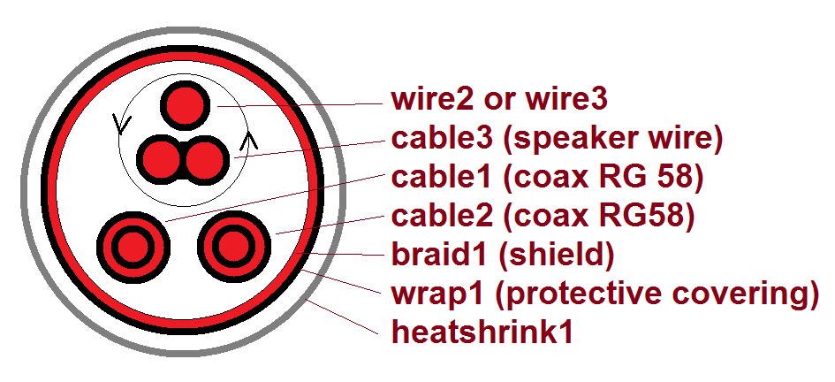Figure 17: Example cross-section for harness segments S2-1 and S3-1
Explanation of the cross sectional structure in the provided example:
- for the wire, coax cable RG 48, and the Speaker Cable no detailed information is provided about the inner structure, insulation etc. So only the outer CrossSectionalPartShapeElement is provided for these parts, together with corresponding CrossSectionalOccurrenceShapeElements for the Occurrences. See the upper part of table 1
- for the Braid, Wrap and HeatShrink the inner CrossSectionalPartShapeElement and corresponding CrossSectionalOccurrenceShapeElement is needed as they need to go over something else. See the lower part of table 1.
- wire2 in segment S2 is equivalent to wire3 in segment S3; so these are taken as alternatives for a AlternativeLongitudinalExtendPart (_313001)
- the alternative of wire2 and wire3 are twisted with cable3, covered by TwistedCrossSectionalGroupShapeElement (_313002). The twist-direction is clockwise and the length of the period is 5 cm.
- the result of the upper twist is together with cable1 and cable2 grouped together and covered by braid1 for shielding purpose by CrossSectionalGroupShapeElementWithTubularCover (_313004).
- the group covered by braid1 is protected by wrap1 through CrossSectionalGroupShapeElementWithTubularCover (_313005).
- the group protected by wrap1 is further protected by heatshrink1 through CrossSectionalGroupShapeElementWithTubularCover _313006
- in some places (S2-2) the heatshrink1 is directly on braid1, CrossSectionalGroupShapeElementWithLacing (_313008).
In table4 and table5 the details of the cross sectional structure used in H1 are provided.
Table 4: Cross-sectional ShapeElements of "bought" parts

Table 5: Cross-sectional structure definitions in H1

Bringing all together
A WiringHarnessAssemblyDesign is an AssemblyDefinition in which all the physical elements and the physical connectivity of an electrical harness is defined. Unless the harness has a very primitive structure, it refers to a ConnectedEdgeWithLengthSetRepresentation that defines the topological structure.
A HarnessSegment is a kind of PartShapeElement for a WiringHarnessAssemblyDesign that links an Edge from the topological representation of the harness to a CrossSectionalGroupShapeElement. For manufacturing purpose the length of a referenced Edge can be overridden by the ForcedLength attribute.
Figure 18: WiringHarnessAssemblyDesign with HarnessSegement and -Node
A HarnessNode is another kind of PartShapeElement for a WiringHarnessAssemblyDesign that links a Vertex from the topological representation to an OccurrenceShapeElement that represents an aspect of an Occurrence. With the attribute NodeType it is possible to characterise the kind of node:
- branch node: A node that is used by more than one Edge or HarnessSegment. The nodes N3 and N4 of the example are of this kind.
- extremity node: A node that is used by a single Edge or HarnessSegment. The nodes N1, N2, N5 and N6 of the example are of this kind.
- external node: A node in a partial harness design that is used by a single Edge or HarnessSegment and that is indicating that the harness continues beyond that node in another design. The node X4 in the example is of this kind for the sub-harnesses H1.a and H1.b.
- intermediate node: Additional nodes defined on Edges. The nodes X1, X2, X3, X4 (for H1), X5 and X6 of the example are of this type.

General Representation / Model and Transformation Capabilities
Figure 19 shows the data model for Representation, GeometricRepresentation and -Model and transformations between them. In this tutorial we only explain the concepts needed for electrical harness. For a more thorough understanding of the concepts see ISO 10303-42 “Representation structures”.
STEP defines many specializations of RepresentationItem (e.g. AxisPlacement, Curve, CartesianPoint, Edge, Vertex, Path ...). Each RepresentationItem is defined within a RepresentationContext. A Representation groups a set of RepresentationItems for a specific purpose. A RepresentationItem is included in a Representation either directly (via the Items attribute or indirectly because it it referenced by another RepresentationItem. E.g. when a Representation contains an Edge, it also contains the two Vertices called out by EdgeStart and EdgeEnd.
Representations can be related to each other by RepresentationRelationship. If the Definitional attribute is set to TRUE, the Related Representation becomes a definitional part of the Relating Representation. Note that the Relating attribute is covered as containment in XML.
Figure 19: GeometricRepresentation, Relationship and Transformation
For the purpose of geometry GeometricRepresentation (a specialization of Representation) and GeometricCoordinateSystem (a specialization of RepresentationContext) is used. The attribute DimensionCount of GeometricCoordinateSystem defined on whether it is a 2D or a 3D coordinate system.
Transformations between Representations are defined by specializations of RepresentationRelationship. Most widely used in STEP is GeometricRepresentationRelationshipWithPlacementTransformation where the transformation is indirectly defined by placing an AxisPlacement from the related Representation (attribute Origin) onto an AxisPlacement (attribute Target) of the relating Representation.
Especially for the purpose of electrical harness the transformations GeometricRepresentationRelationshipWithMultiItemTransformation and RepresentationRelationshipWithPlacementToTopologicalTransformation are defined that are further explained below.

Defining the top part with a WiringHarnessAssemblyDesign view
The top object of an electrical wiring harness is a Part with the PartCategoryEnum “wiring harness”.
The specific associations needed to represent the design of an electrical wiring harness are supported by WiringHarnessAssemblyDesign that is a specialization of PartView (and AssemblyDefinition).
As with any other PartView one or several 2D or 3D geometric models can be associated with the DefiningGeometry attribute.
For a full design documentation a WiringHarnessAssemblyDesign shall have an associated topological model in the form of a ConnectedEdgeWithLengthSetRepresentation topology. The attribute Topology might not be set if the ConnectedEdgeWithLengthSetRepresentation is not available or if the topology is so simple (e.g. a single segment with two nodes) that it is not needed.

Example:
<Part uid="_311000"> <!-- Part_H1 -->
<Id id="Part_H1"/>
<Name>
<CharacterString>Electrical Harness example 1</CharacterString>
</Name>
<PartTypes>
<PartCategoryEnum>wiring harness</PartCategoryEnum>
</PartTypes>
<Versions>
<PartVersion uid="_311001">
<Id></Id>
<Views>
<PartView xsi:type="n0:WiringHarnessAssemblyDesign" uid="_311002">
<AdditionalContexts>
<ViewContext uidRef="_100104"/>
<ViewContext uidRef="_100105"/>
</AdditionalContexts>
<DefiningGeometry uidRef="_314090"/>
<InitialContext uidRef="_100102"/>
...
<Topology uidRef="_321010" />
</PartView>
</Views>
</PartVersion>
</Versions>
</Part>

Associating rigid and flexible components to the Topological Model
This clause describes how occurrences (components) of rigid and flexible parts are associated to items of a ConnectedEdgeWithLengthSetRepresentation (CEWLSR) of a WiringHarnessAssemblyDesign (WHAD), see figure 20.
As with all other assemblies, Single- or QuantifiedOccurrences are brought into a WiringHarnessAssemblyDesign through NextAssemblyOccurrenceUsages (NAOU).
To be able to link with items of the ConnectedEdgeWithLengthSetRepresentation, the Occurrences or their underlying PartViews must have an associated GeometryModel. This might be an externally defined model or a placeholder model with just a single AxisPlacement.
A RepresentationRelationshipWithPlacementToTopologyTransformation (RRWPTTT) is used to link the geometric model of an underlying PartView or Occurrence with a ConnectedEdgeWithLengthSetRepresentation. To be able to distinguish several occurrences of the same PartView, the attribute Transformation of NextAssemblyOccurrenceUsages must refer to the corresponding RepresentationRelationshipWithPlacementToTopologyTransformation. Note that the transformation is defined as a set so it can support additional transformations, e.g. for an additional 2D stick-line representation and a 3D representation.
In addition we need to specify the details of the geometrical to topological mapping. This is done by the Origin and Target attribute of the RepresentationRelationshipWithPlacementToTopologyTransformation. The Origin attribute calls out an AxisPlacement of the geometric model of the Occurrence or underlying PartView and maps it to either an Edge, Vertex or Path of the ConnectedEdgeWithLengthSetRepresentation.
This mapping is the key point to support the flexible nature of a wire harness. Typically for rigid parts the AxisPlacements of the geometric model of the PartView is mapped onto a Vertex or specialization VertexOnEdge, while flexible parts such as wires and cables are mapped onto an Edge with its specializations EdgeWithLength and SubEdge or to a Path that consists of several Edges.

Figure 20: Transformation of Flexible and rigid parts onto the topological model
Example:
The mapping of flexible objects such as wires, cables and tubular covers to the topological model is done as follows.
1) A generic geometric model (example _104890) is representing the centreline of a linear extruded - possibly flexible - objects by a single RepresentationItem of type Vector. This model might be used by several independent PartViews.
<!--Generic AxisPlacement representation for all wire, cable, covering -->
<RepresentationContext xsi:type="n0:GeometricCoordinateSpace" uid="_104891">
<Id id="/NULL"/>
<Items>
<RepresentationItem xsi:type="n0:AxisPlacement" uid="_104896">
<Position>0.0 0.0 0.0</Position>
</RepresentationItem>
</Items>
<Representations>
<Representation xsi:type="n0:GeometricModel" uid="_104890">
<Id id=""/>
<Items>
<RepresentationItem uidRef="_104896"/>
</Items>
</Representation>
</Representations>
<DimensionCount>3</DimensionCount>
</RepresentationContext>

2) A PartView refers to the generic centreline representation as its DefiningGeometry. In addition the Occurrences of the PartView are defined (in the example these are wire2/_201104 and wire3/_201204).
<Part uid="_101000"> <!-- WIRE,ELEC,COMP,SNGL CONDUCTOR,150 DEG C -->
...
<Versions>
<PartVersion uid="_101001">
<Id id="Version 1"/>
<Views>
<PartView uid="_101002">
<DefiningGeometry uidRef="_104890"/>
...
<Occurrence xsi:type="n0:WireOccurrence" uid="_201104">
<Id id="wire2"/> ...
</Occurrence>
<Occurrence xsi:type="n0:WireOccurrence" uid="_201204">
<Id id="wire3"/> ...
</Occurrence>
</PartView>
</Views>
</PartVersion>
</Versions>
</Part>

3) The WiringHarnessAssemblyDesign (Part_H1/_311002) contains NextAssemblyOccurrenceUsages (wire2/_315012, wire3/_315041, ...) with Placement attribute to RepresentationRelationshipWithPlacementToTopologyTransformation (subtypes _321080, _321082) and a NextAssemblyOccurrenceUsages (lug1/_315041) with Placement attribute to GeometricRepresentationRelationship specialization GeometricRepresentationRelationshipWithPlacementTransformation.
<PartView xsi:type="n0:WiringHarnessAssemblyDesign" uid="_311002">
...
<DefiningGeometry uidRef="_314090"/>
...
<ViewOccurrenceRelationship uid="_315012" xsi:type="n0:NextAssemblyOccurrenceUsage">
<Related uidRef="_201104"/> <!--WireOccurrence wire2-->
<RelationType>
<ClassString>next assembly occurrence</ClassString>
</RelationType>
<Placement>
<RepresentationRelationshipWithPlacementToTopologyTransformation uidRef="_321080"/>
</Placement>
</ViewOccurrenceRelationship>
<ViewOccurrenceRelationship uid="_315013" xsi:type="n0:NextAssemblyOccurrenceUsage">
<Related uidRef="_201204"/> <!--WireOccurrence wire3-->
<RelationType>
<ClassString>next assembly occurrence</ClassString>
</RelationType>
<Placement>
<RepresentationRelationshipWithPlacementToTopologyTransformation uidRef="_321082"/>
</Placement>
</ViewOccurrenceRelationship>
...
<ViewOccurrenceRelationship uid="_315041" xsi:type="n0:NextAssemblyOccurrenceUsage">
<Related uidRef="_203005"/> <!--SingleOccurrence lug1 -->
<RelationType>
<ClassString>next assembly occurrence</ClassString>
</RelationType>
<Placement>
<GeometricRepresentationRelationship uidRef="_314210"/>
</Placement>
</ViewOccurrenceRelationship>
...
<Topology uidRef="_321010" />
</PartView>

4) A ConnectedEdgeWithLengthSetRepresentation is representing the topology of a wiring harness. It contains (Geometric)RepresentationRelationships that are referenced by the NextAssemblyOccurrenceUsages of the wire harness. The specific subtype RepresentationRelationshipWithPlacementToTopologyTransformation is used to indicate how the flexible centreline of the extruded parts is mapped to either a single Edge or a Path that is a sequence of Edges.
<RepresentationContext uid="_321000">
<Id id="H1.x Harness topology context"/>
<Representations>
<Representation xsi:type="n0:ConnectedEdgeWithLengthSetRepresentation" uid="_321010">
<Id id="Topological representation of H1 harness"/> <!--This should be the name but Id is mandatory-->
<Items> ... </Items> ...
<!--Transformation of wire2-->
<RepresentationRelationship xsi:type="n0:RepresentationRelationshipWithPlacementToTopologyTransformation" uid="_321081">
<Definitional>false</Definitional>
<Related uidRef="_104890"/>
<Origin uidRef="_104896"/>
<Target uidRef="_321022"/> <!--Edge S2-->
</RepresentationRelationship>
<!--Transformation of wire3-->
<RepresentationRelationship xsi:type="n0:RepresentationRelationshipWithPlacementToTopologyTransformation" uid="_321082">
<Definitional>false</Definitional>
<Related uidRef="_104890"/>
<Origin uidRef="_104896"/>
<Target uidRef="_321066"/> <!--Path S3-S5-->
</RepresentationRelationship>
...
</Representation>
</Representations>
<Units>
<Unit uidRef="_100301"/>
</Units>
</RepresentationContext>

Mapping harness topology to a Geometry Model, 2D or 3D
On the right side of figure 21 we see the transformation of rigid parts into the assembly. The structure is identical to what is detailed in the Recommended Practices for AP242 Business Object Model XML Assembly Structure. E.g. the PartView of a connector calls out an ExternalAdvancedBrepShapeRepresentation as its DefiningGeometry. This representation is defined within a GeometricCoordinateSpace (Geo.Coor.Space) and contains an AxisPlacement (usually at the position 0/0/0 with no rotation) for placement purposes.
Figure 21: Flexible and rigid part transformation into a 3D (2D) model
A SingleOccurrence of the PartView of the connector is brought into the WiringHarnessAssemblyDesign by a NextAssemblyOccurrenceUsage. The DefiningGeometry of a WiringHarnessAssemblyDesign is represented by another GeometricCoordinateSpace that also contains several AxisPlacements that are on the positions and orientations on where to place the occurrences. A GeometricRepresentationRelationshipWithPlacementTransformation (GRRWPT) brings the ABREP of the connector into the ABREP of the WiringHarnessAssemblyDesign. The transformation is defined by aligning two AxisPlacements onto each other. The Placement attribute of the NextAssemblyOccurrenceUsage refers to this GRRWPT. This is needed to be able to distinguish the geometry of several occurrences of the same type.
On the left side of figure 21 we see the transformation of flexible parts such as cables and wires into the wiring harness assembly that is different, but similar to the one of a rigid part. As a first step the occurrence of a cable is transformed onto a Path or Edge of the ConnectedEdgeWithLengthSetRepresentation that defines the Topology of the WiringHarnessAssemblyDesign by a RepresentationRelationshipWithPlacementToTopologyTransformation (RRWPTTT). Here the position of the AxisPlacement represents the start of the cable that is mapped onto the start Vertex of the Path. The z-direction (Axis[3]) of the AxisPlacement represents the direction of the centreline of the cable. As the target Path and underlying Edges have no particular geometry defined yet, we only know that this direction refers to the direction of the first Edge of the Path at the start Vertex.
At a next step the topological elements of the ConnectedEdgeWithLengthSetRepresentation are transformed onto items of the ExternalAdvancedBrepShapeRepresentation that defines one of possible many representations of the wire harness. For this a GeometricRepresentationRelationshipWithMultiItemTransformation is used that allows a pair-wise transformation of the items of the ConnectedEdgeWithLengthSetRepresentation onto the items of a GeometricModel. Usually Edges are transformed onto Curves and Vertices onto AxisPlacements. The figure shows a single Edge that is mapped onto an external Curve within the ExternalAdvancedBrepShapeRepresentation.
Note: In the provided example a GeometricRepresentationRelationshipWithMultiItemTransformation is only used to map Edges and Paths onto Curves. It could also be used to map Vertices to AxisPlacement. This possible alternative had not been chosen because traditional 3D STEP implementations are used to directly map the 3D model of the piece-parts to the 3D model of the assembly.

