Evaluation of AP-233 FBB draft 8
Erik Herzog

Summary
This document contains identified issues with the AP-233 FBB draft 8 as well as general observations on the module development process. Comments are also made regarding to issues captured and resolved in the FBB draft 8 issue log. The comments are made in the following order.
- Comments against the FBB draft 8 under the assumption that the purpose is to support EFFBD only.
- Comments on the general approach selected by the module development team.
- Observations on resolution proposals in the issue log.

Data exchange
If we assume that maintenance of the semantics in a specification is a high priority for a data exchange information model then the following can stated for all methods identified as being relevant (supported by the data exchange information model).
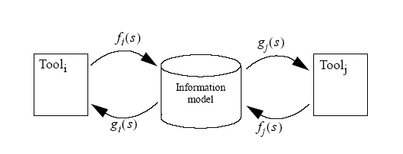
Figure 1, Mapping function illustration

- Mapping from a Tool_{i} to the information via mapping functions f_{i}(s) and back via mapping functions g_{i}(s) shall result in a specification which is semantically equivalent (and preferably have the same syntax, or it will be difficult to interpret).
- Mapping from a Tool_{i} to the information via mapping function f_{i}(s) to Tool_{j} via mapping functions g_{j}(s) shall result in a situation where it is possible to identify any modification to specification semantics due to tool capabilities (Fine grain information model semantics required).
Not considering these statements implies that maintenance of specification semantics is not considered to be a priority within the AP-233 project. In this case we could as well state that specification consistency is not a priority in systems engineering. Which in turn implies that the systems engineering community does not feel they are not providing anything useful in the engineering process.

Draft 8 FBB comments
FBB draft 8 is designed to support EFFBD semantics. In this section a number issues are presented based on the assumption that the scope of the module is to support EFFD only – disregarding our position that more methods should be supported by AP-233.
Issues are presented on a module basis.
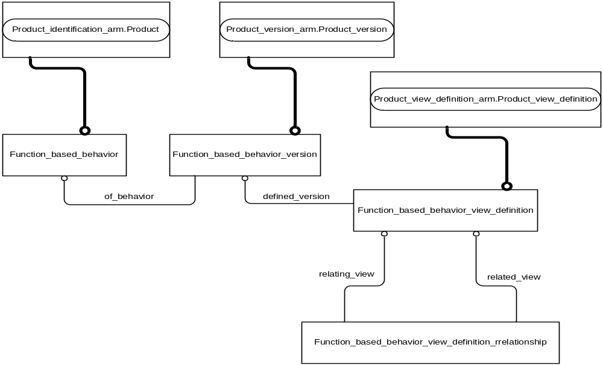
Figure 2 Module function_based_behaviour_arm

Module Function_based_behaviour_arm
The module presented in Figure 2 is a standard ARM module with the following exception
- Entity function_based_behaviour_view_definition_relationship which should be a subtype of entity view_definition_relationship (direct or indirect).
In the module repository similar functionality is provided by module 1216, alternatively the module 1614 could be considered.
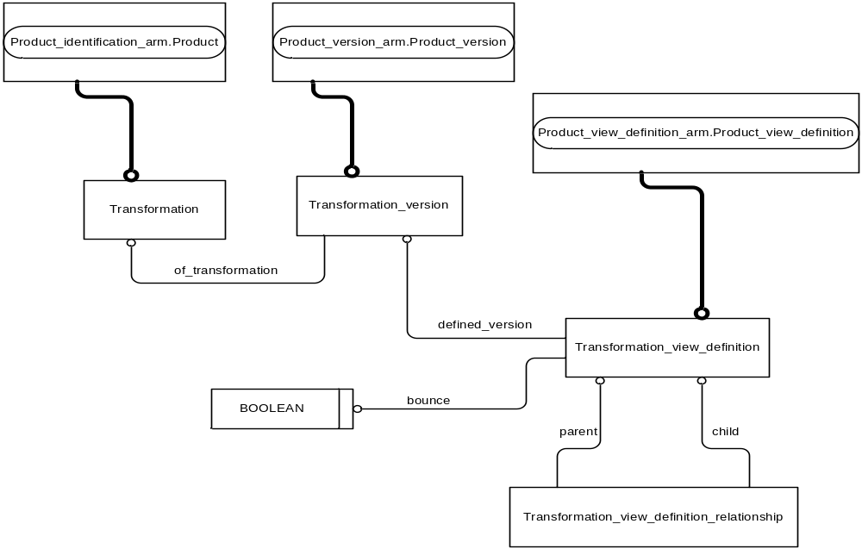
Figure 3 ARM of module transformation_arm

Module Transformation_arm
The module presented in Figure 3 is a standard ARM module with the following exception
- Entity transformation_view_definition_relationship which should be a subtype of entity view_definition_relationship (direct or indirect).
- The naming convention to state that functions are transformations is odd and need justification.
- The bounce attribute is a property of a particular simulation environment setting and not a property of the transformation_view_definition.
In the module repository similar functionality is provided by module 1216.
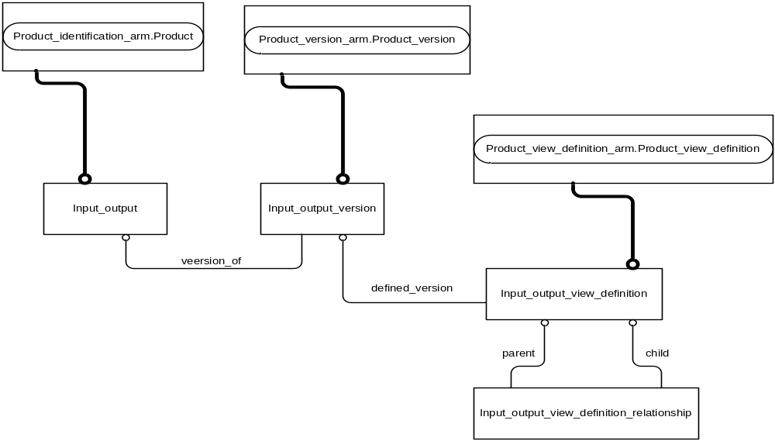
Figure 4 ARM of module input_output_ARM

Module input_output_arm
The module presented in Figure 4 is a standard ARM module with the following exceptions:
- Entity input_output_view_definition_relationship which should be a subtype of entity view_definition_relationship (direct or indirect).
- There is no provision for capturing typing data (value range) for simulation.
It is no surprise that the module is underdeveloped as the target environment (ViTech Core – EFFBD notation) does not support reading the value of the items (ios) exchanged/communicated across functions.
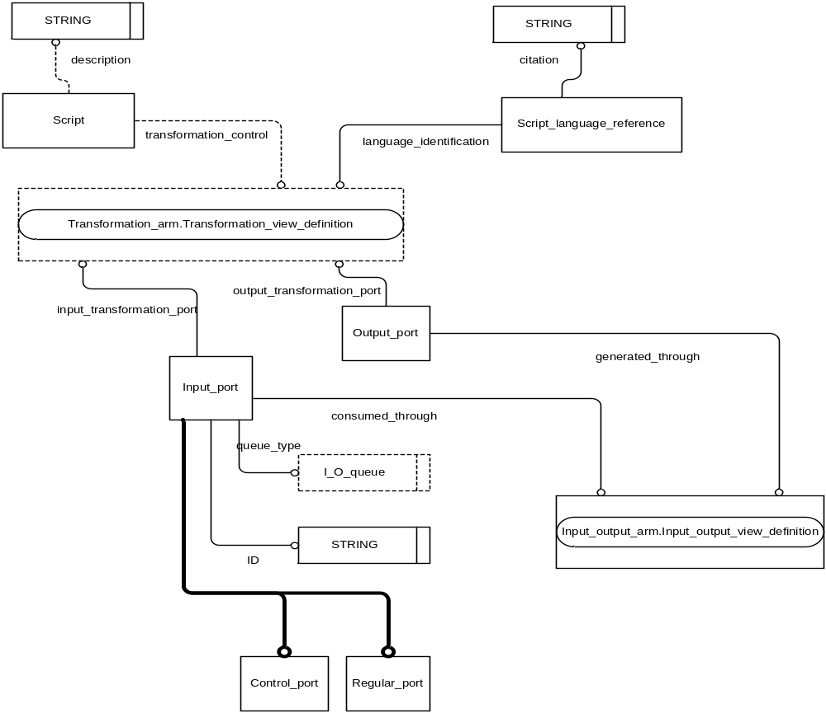
Figure 5 ARM of module transformation_input_output

Module transformation_input_output
The module presented in Figure 5 defines the interfaces for functional interaction. The following issues are identified.
- Use of two entities to capture script and language is unfortunate. Allow the creation of instances that
  - Has script, but no language
  - Has language, but no script
  - Has multiple languages but only one script
  - Has script in multiple languages
  - What is the semantics of a transformation_view_definition with multiple scripts (which one is going to execute?).
  - Recommendation: Add language attribute to entity script and delete entity script_language_reference.
- There is no support for input ports that trigger a function based on the value of an input_output_definition.
- Why does an input port have an ID when an output_port has not?
- How will the module support the capture of the visual routing of input_output objects from an output_port to an input_port?
- Some methods use the presence of information on all inputs as sufficient condition for function activation, e.g., IDEF0. How is this supported?
- How can discrete and continuous interaction be captured? Transitions from continuous to discrete and discrete to continuous functions?

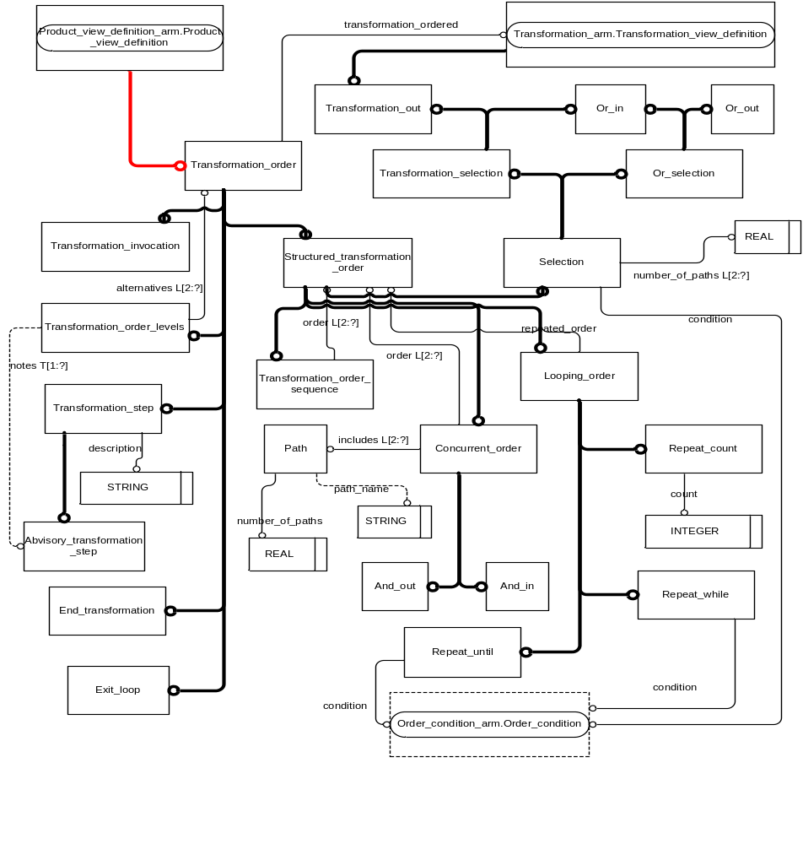
Figure 6 Tranformation_order_arm

Module transformation_order_arm
The transformation_order_arm module is presented in Figure 6. The module contains multiple severe errors and does not support EFFBD.
- Each transformation_order object relates to exactly one transformation_view_definition object via the transformation_ordered attribute. The semantics of this attribute is unclear. In previous versions of the module the attribute was used to indicate causality, with a corresponding attribute at the entity transformation_view_definition. Since this attribute has now been removed from the module it is possible that the attribute is intended to indicate that
  - Control is through transformation_order objects only
  - Function activation is implied by the transformation_ordered attribute.
No matter what the presented model can not represent the control structure of an EFFBD. The following examples can be considered:
  - In EFFBD it is common that control elements follow control elements, i.e., there is no function element being activated being executed between two control elements, see Figure 7. This is not supported due to the transformation_ordered attribute of entity transformation_order.
  - If the attribute relating a transformation_view_definition to a transformation_order has been dropped accidentally then the same deficiency occur. Multiple control elements is not supported. Also note that if the said attribute has been dropped accidentally then the control flow is hard coded into the function based behaviour modules. This excludes support for methods such as IDEF0, DFD, traditional block diagrams etc.
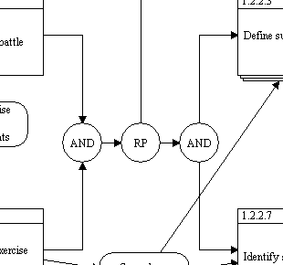
Figure 7 Snippet of an EFFBD containing multiple control elements following each other
  - Control elements such a looping_order have a list attribute order containing at least two elements. The semantics of this attribute is unclear.
  - There are no rules for combining control elements. No support for creating valid sequences of control structures. If all other deficiencies are fixed, how can the model enforce that all concurrent control elements (and_out) have a corresponding and_in object?
  - The entity concurrent_order has a path attribute containing a list of at least 2 path objects. Each of these has an attribute number_of_paths. What is the semantics of a list of two path objects with the first having number_of_paths set to 10 and the second the same attribute set to 5? Hint, the number of paths of a control structure for concurrency or selection is given by the number of outgoing paths. There is no need for capturing the number explicitly.
  - Can’t find support for the kill semantics for concurrent threads.
- Recommendation: Reconsider module based on a review of EFFBD and other relevant methods. Creating instantiation patterns using paper and pen is an excellent method for validating the correctness of a model.
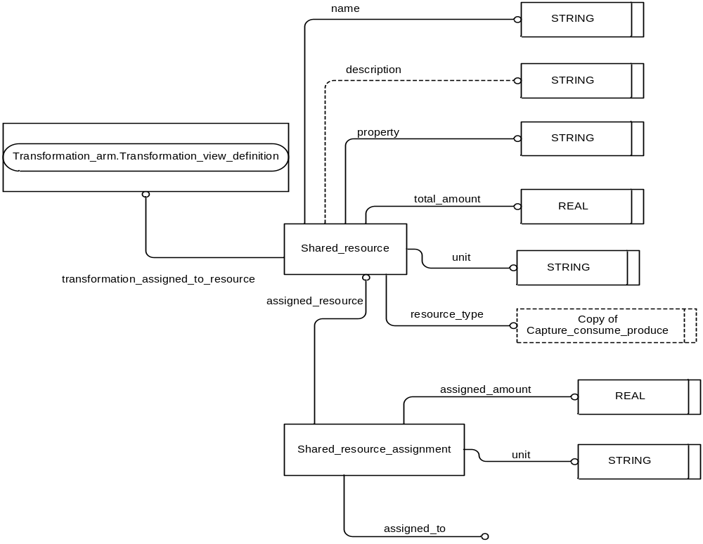Figure 8 Shared resource ARM

Module shared_resource_arm
The module is defined to capture the ViTech Core resource concept. This can also be represented as a shared pool of elements, a persistent storage which from which functions withdraw and deposit elements. Consequently, the resource concept is very similar to the data store concept found in some modelling methods. Suggest that the shared_resource and data store concept is merged within the information mode.

Comments on the general approach to module development selected.
It is obvious that the module development is a straightforward mapping from the concept model developed within the AP-233 project. This approach may appear logical to the module developers since the concept model has been used to create consensus among the participating organisations. Clearly, the concept model defines the scope of AP-233 at a high level of abstraction.

It is however not suitable as a blueprint for data exchange information modelling. While the work practise at a high level of abstraction appears similar there are a lot of differences when specification methods are considered in detail. An activity diagram in SysML is at a high level of abstraction similar to an EFFBD, but on the detailed level there are many important differences. These differences must be considered up front in the module development process, and can not be satisfactory accommodated on-top of a high level common structure.

Conclusion: Module development shall be driven by detailed method knowledge and not by a high level general notion. After all, the objective must be to support current practise, rather than develop a new method which is clearly inadequate for all. Or, does the module development team feel they are in a position to redefine the current practise in systems engineering modelling?

Suggestion: Identify the modelling methods in scope for AP-233 and develop modules based on detailed understanding of methods to be supported as opposed to the current approach of creating modules supporting no existing method. This last statement may appear controversial, but as shown in previous section: The FBB modules do not provide adequate support for the single method it is targeted at – EFFBD.

Resolution proposals in the issue log
I am pleased to see the model related issues has been properly documented in the issue log as it promotes visibility in the project. It would of course be beneficial if issues raised against requirements documents where handled in similar ways. After all, for the requirements it is important that all stakeholders have a common understanding of what is implied by the requirements. The fact that the document author knows what’s implied by the requirements is not sufficient and will only lead to problems later in the project.

The remaining comments in this section relates to issues from the issue log with each issue addressed is identified through its id number.

Id | Comment
2 | While the modules now acknowledge the intention to handle functionality as products, it does not build on existing modules for capturing functionality. Suggest alignment with existing STEP modules.
3 | The approach suggested in the resolution implies that there is a difference between functions captured in N2 charts as compared to functions captured in FFBD.  Suggestion: The function concept is similar in all functional methods, what is different is the support for capturing  - Control flow  - Functional interaction  - Function activation  An approach based on the creation of subclasses for each modelling language variant will be clumsy and never quite satisfactory. Instead it is more fruitful to create multiple approaches to capturing control flow, function interaction and activation conditions and combine these to support specific methods.
4 | Queue concept is now adequately supported. The i/o model is however not as indicated above.
6 | Reopen and solve along lines described above.
7 | Model is broken in this aspect. Rework required.
8 | Suggest SEDRES approach.
10 | Commented upon above.
12 | Agree with resolution
15 | While the root cause is now resolved it is not clear if the semantics of the IO_port is sufficicent.
16 | Agree that AP239 structure reused in not applicable.
17 | The issue brought up is whether the module team thinks EFFBD support is sufficient to meet the data exchange requirements of the systems engineering community?  See also comments regarding the use of concept model as starting point for module development.
19 | How is the initial and final function in the FFBD graph captured? An instance model showing this would be most appreciated. My interpretation is that the initial and final function can not be captured. Justification for closing the issue is requested.
20 | Causal and state based methods are two different methods for capturing control flow, the pure functional view is common. What about support for models that do not have explicit control flow?  Suggestion: Re-open and reconsider selected architecture.
21 | Suggestion. Create an instance model from example in Figure 7 to evaluate the appropriateness of the current model.
22 | Suggestion. Create an instance model from example in Figure 7 to evaluate the appropriateness of the current model.
23 | Refer to discussion earlier in this document.
24 | Refer to discussion earlier in this document.
25 | Refer to discussion earlier in this document.

Conclusions
In this document a number of problems have been identified with the FBB draft 8 modules. The problems are serious; both in their architecture, the scope selected and the way requirements are handled. Specific suggestions:

- Identify modelling methods to be support and base modules on method specific features. Approximations at a high level of abstraction are of no value to anybody.
- Improve clarity in requirements document to allow all stakeholder to have a common view on the requirements.
- Create model instantiations to identify validity of proposed modules.

