System physical architecture modelling alternatives within AP-233
Erik Herzog, Syntell AB

References
- Ap-233, Structure module set draft 4, 2005-04-13
- AP-233, Concept model draft 12, 2004-03-25
- Sheard, Sarah, “Twelve Systems Engineering Roles”. In Proceedings of the INCOSE. INCOSE, 1996

Comments: Tom Thurman & Erik
Tom:

I reviewed your proposal and am requesting more information:
How does a conceptual_part differ from a system?

Erik:
Good question Tom,

Do I need both a system entity and a conceptual product entity?

I do ask the same question at regular intervals, have intense debates with myself and tend to come up with justifications each time.

I will put together a justification document, but it may take a few days as all contributions to this forum are outside the set of tasks my boss likes to see me accomplish - and he insists in having priority!

Tom:
As you are putting together the justification document, the central thing
(from my perspective) is to capture what explicit mechanisms are used for
identification.

Rationale
A module set has been published within AP-233 for support of system physical architecture [1]. These modules extend existing STEP modules based on the STEP Part concept (STEP module 1022). This design decision suggests that the AP-233 development team suggest that the physical architecture structures handled in the systems engineering process equates the product structure of the realised physical product. This impression is further underlined by statements in the concept model used for AP-233 development [2].

Note, the selection of the STEP Part concept is significant to the author as a Part is representing “a discrete object that may come into existence as a consequence of a manufacturing process”. The implication is that the part holds information for manufacturing purposes.

This document outlines an alternate approach for realising the system physical architecture modules and compares it with the one taken.

Interpretation of structure module draft
Representing structure using the part structure suggests that AP-233 development team has the following approach in mind.
Figure 1 Simple AP-233 instantiation

Figure 1 shows a single requirement object being allocated to a single part object within a system. The allocation is assumed to be made within the systems engineering process.
Figure 2 Simple instantiation with domain engineering view added
Figure 2 is an extension of Figure 1 showing an additional part_view_definition object added to capture a specific realisation/manufacturing view. I.e., systems engineering and component/domain engineering share a common part/part list view on the system under development.

This is of course only an interpretation of what the development team has in mind, but it is further underlined by the statements below taken from the concept model [2].
“Part
The Part is simply a part or component list. The name used follows the STEP manufacturing point of view of looking at a part or component and talking about it as an assembly because their job is to assemble it. This is a place where it may be advisable for clarity to use the words component or part as an alias for Part.”

Views on the systems engineering process
Multiple notations are in use for capturing the systems engineering process. The V process model is in common use, Figure 3
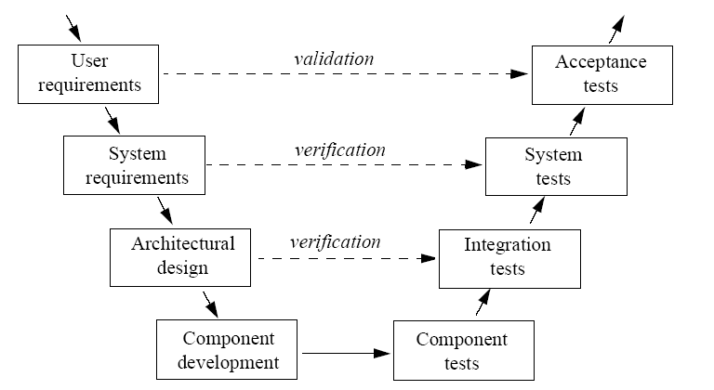
Figure 3, The V-model

If a component in a system is complex in itself, then the process need to be applied from the top left for the component as well. I.e., the “system requirements” identified for a complex component becomes the “stakeholder requirements” for the development of the component. This part of the process may also be illustrated as in Figure 4.

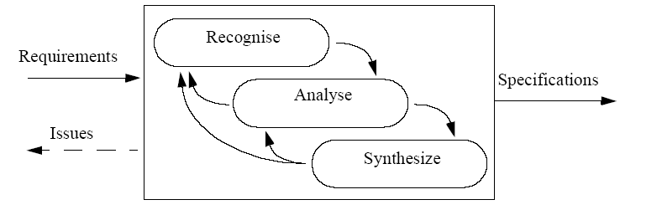
Figure 4, System design

The illustration in Figure 4 is significant as it illustrates that the output specification from an activity can be seen as the input requirements for the next activity in the process (Figure 5).

Figure 5 Relationship between system and component development

In traditional document based systems engineering specifications are typically captured in a set of three documents:
- SSS for identified system requirements and definition of functional architectures
- SSDD for capturing identified system components and allocation. I.e., the system physical structure
- A verification document identifying the criteria the realised system shall fulfil under specified conditions for acceptance.

The significance of this, and it also applies to Model Based Systems Engineering, is that the structures defined by systems engineers need not coincide with the product structures defined by the engineers closer to the realisation of the components.
The trivial example below illustrates the point:

In a recent project the task was to “realise a mobile facility for evaluation of army tactical training“. After reviewing the requirements and surveying the market a solution, a 3 in 1 container was selected and described at a high level of abstraction. Of course detailed requirements driving the equipment installation in the container was also identified.

The important point here is of course not the solution, but that in our specifications and structures we only saw the conceptual 3-in 1 container and conceptual equipment to be installed. It did not have any measures, no unique identification, no geometry etc. The manufacturing design of the container and its components, based on the specifications did of course have all this, but it was not an issue on system level. Also important, the manufacturing view selected was only one of many potential designs for meeting the requirements.

Verification of the delivered container was performed against the criteria identified at the abstract system level

Likewise, the verification of container and the installed equipment was performed at the level of detail specified in our abstract requirements.

Moreover, we could have had multiple manufacturing design alternatives based on conceptual design of the container.

Alternate structure module outline
The discussion and example in the previous section suggest that there exist a difference between the system structure as defined in from a conceptual perspective and the structure as specified from a manufacturing/realisation perspective.

duplicates the information model from Figure 1 with the exception that a SE unique Part is used to represent the conceptual components identified in systems engineering.
Figure 6 SE structure with SE part entities

The distinction between the approaches is more apparent when realisation/manufacturing views as introduced as in Figure 7. Using this approach the realisation/manufacturing views are part of their own structure as opposed to being part of a common structure as in Figure 2.
Figure 7 SE structure with link to manufacturing/realisation information

Comparison between the two approaches
The two approaches can be compared from multiple perspectives. Here three perspectives are considered:
- Support for multiple realisation alternatives. The systems engineering view is a requirements view for realisation and hence there may be multiple design solutions meeting the requirements.
- Configuration management process compliance. In the CM process multiple baselines are maintained over the life of a system. Maintenance of these baselines should be supported in the AP-233 information model.
- Direct support for integration with manufacturing design. AP-233 should support the transition from conceptual design elements to realisation/manufacturing elements.

Perspective | AP-233 draft approach | Alternate approach
Multiple realisation alternatives | Integrated conceptual and realisation/manufacturing view. In cases where multiple realisation alternatives are being investigated then each alternatives must be handled using its own <part> object leading to redundant information. | Separation of conceptual and realisation/manufacturing view allow for one conceptual design to act as input requirements for multiple alternate realisation/manufacturing designs (Part type objects).
CM process compliance | Difficult to maintain CM baselines as the ealisation/manufacturing design evolves. Each conceptual design part_view_definition object is tightly bound to a single part_version object. Consequently the conceptual design part_view_definition objects must be duplicated for each version of a part in order to maintain baselines.  This leads to redundant information being stored, complicates CM (Are the different part_view_definition objects capturing conceptual design in different part_versions really identical?) | Baselines for conceptual design are easy to capture and maintain.
Support for detailed design | Good support for allocating functions and requirements to realisation/manufacturing views. | The approach does not preclude the introduction of relationships for allocation of requirements and functionality to the realisation/manufacturing view.

Conclusions
It appears that the solutions proposed in draft 4 of the system structure modules are missing modelling concepts for capturing system conceptual design. The missing functionality has several implications to the execution the development process.

It is proposed that the AP-233 structure modelling team introduces an intermediate conceptual design view separated from the standard STEP Part view. This is not to say that the Part view is inappropriate for systems engineers, just that a complimentary view is required to support system design.

