Abstract
This report provides a specification for the configuration management of STEPmod.

Additional Document Information
Project Reference | 010809
Author(s) | Rob Bodington
Document Owner | Eurostep Limited
Availability | Eurostep

Eurostep Limited  Cwttir Lane, St Asaph, DENBIGHSHIRE, LL17 0LQ UNITED KINGDOM  Phone: +44 1745 582008 Fax: +44 1745 585556  E-mail: info.uk@eurostep.com | 

Revision history :

Version: 0.6; date: 2007-12-10; Modified by: T. Thurman (Rockwell Collins); Revision Contents: Updated Appendix A dtd to agree with cm_record.xml contents on stepmod. Updated Appendix C to agree with cm_record.xml on stepmod. NOTE: Appendix B was not modified as it is currently unused.

Table of contents
Table of contents 2
Abbreviations, Terms and Definitions 4
1 Introduction 5
2 The configuration problem 5
3 The approach 6
3.1 Configuration management database 6
3.2 CVS and baselines 6
3.3 Releasing a part 7
4 Architecture 8
5 STEP Part releases 9
5.1 Part release identification and meta data 10
5.1.1 Release meta data 10
5.1.2 Release identification 10
5.2 Release source files 11
5.3 Release dependent parts 12
5.3.1 Module dependent parts 12
5.3.2 Application Protocol dependent parts 13
5.3.3 Resource document dependent parts 13
5.3.4 Conflict in dependent parts 13
5.3.5 STEPmod library files 13
5.3.6 STEPMOD XSL release 13
5.4 STEPmod Configuration Management records for STEP parts 13
6 Baselining STEPmod 14
7 Part development process 14
8 Configuration management of XSL 14
9 Software functionality 15
9.1 Core CM functionality 15
9.1.1 Initialisation 15
9.1.2 Browsing the repository 15
9.1.3 Downloading a given edition / release 16
9.1.4 Download all published editions 16
9.1.5 Creating a release 16
9.1.6 Deleting a release 17
9.1.7 Generate a module publication package 17
9.1.8 Generate a common resource publication package 17
9.1.9 Generate an Application Protocol publication package 17
9.1.10 Identifying the STEPmod App release 17
9.1.11 Online help 17
9.1.12 Creating an XSL release 18
9.1.13 Retrieving an XSL release 18
9.2 STEPmod functionality 18
9.2.1 Create a module 18
9.2.2 Add an issue to a module 18
9.2.3 Produce an ISO issue log for a module 18
9.2.4 Check a module 18
9.2.5 Create a common resource document. 18
9.2.6 Create an Application protocol 19
10 Document List 19
Appendix A DTD for cm_record.xml 20
Appendix B XML Schema for cm_record.xml 21
Appendix C Module configuration management record -cm_record.xml 23
Appendix D DTD for stepmod_cm_record.xml 27
Appendix E XML Schema for stepmod_cm_record.xml 28
Appendix F STEPmod configuration management record -stepmod_cm_record.xml 29

Abbreviations, Terms and Definitions

ANT A software tool for automating software build processes. See: http://ant.apache.org/.
AP Application Protocol – the implementable component of ISO 10303 STEP which specifies an information model to support a specific business domain.
Baseline A set of files at a given revision that have been identified for configuration management purposes, such as identifying the constituents of a release.
CM Configuration management
CVS Configuration management software.
Edition A published/released module identification known by customers at the ISO level
File revision A committed change in the history of a file or set of files.
Part A numbered part of the ISO 10303 standard. STEPmod supports the development of the following parts: a module, a common resource, an application protocol.
Release A set of files that have been baselined and released for review, ballot or publication.
SC4 The subcommittee within ISO responsible for the development of ISO 10303.
SCM Software configuration management
SourceForge An open source hosting service being used to host STEPmod.
STEPmod STEPmod is the XML environment that can be used to develop SC4 parts.
STEP ISO 10303 – The Standard for the Exchange of Product Model Data. A family of standards for product data exchange.
Tag A CVS term referring to the identification of a configuration baseline - a set of files at a given revision.
Version An identification of the state of a module/file that is used by developers and that is probably not known by customers. Versions are the subject of a development workflow.

Introduction
This report describes work under taken for ATI as part of the contract: “STEPmod Configuration Management” and comprises the following deliverable:
“Tool design document describing proposed architecture and data structures, and including process diagrams, use cases and CVS capability assessment documentation.”
Intended readership
This report provides a specification for the work required to implement a tool to support the configuration management of ISO 10303 parts developed using the STEPmod framework. Hence, some familiarity with the process of developing modules, application protocols and resources parts within the STEPmod framework is assumed. The report also assumes some familiarity with software configuration management (SCM). SCM terms used in the report, such as Edition, Release, Baseline which are defined in the section “Abbreviations, Terms and Definitions”

Structure of the report
The report has the following structure:
- Section 2 “The configuration problem”
- Section 3 “The approach”;
- Section 4 “Architecture”;
- Section 5 “STEP Part releases”;
- Section 6 “Baselining STEPmod”;
- Section 7 “Part development process”;
- Section 8 “Configuration management of XSL”;
- Section 9 “Software functionality”;

The configuration problem
STEPmod has been successfully used to develop and publish a number of ISO parts.
The parts are developed by constructing a set of XML, graphics and EXPRESS files for the part and then using a set of XSL programs to transform the XML into HTML which is then packaged and published as the ISO part.
Once a part is published, a publication record is created that details the revisions of the XML and EXPRESS files that were used to generate the published HTML. Whilst this maintains a record of what source files were used to construct the HTML, no support is provided for using the publication record to retrieve a previous edition of a published part.
The primary requirements are therefore to:
- Uniquely identify and release a version of a part
      - Force proper identification with minimal user effort.
      - Lock published/released editions from modification.
      - Register the information identifying supporting scripts, XML, XSL, XSLT, EXPRESS (ARM and MIM short and long forms), EXPRESS-G source files, and tools used to create the part.
- Enable a developer to retrieve a given release of the part.
- Be able to retrieve the supporting scripts, XML, XSL, XSLT, EXPRESS source files, and tools used to create a given release of a part.
- Be able to assure that the constituents of the module package or AP put forward for publication are valid Editions. I.e. that the file revisions used to build the package have been used to produce a release.
- Be easy to use by non-IT experts yet leverage exiting SCM capabilities such as CVS.

The approach

Configuration management database
The approach is to use a Software Configuration management (SCM) tool such as CVS to:
- track revisions of files that are used to generate a part,
- then to use a baseline, that can be retrieved from the SCM tool, to identify the file revisions that make up a given release of the part.
A configuration management database will then be used to record:
- that a baseline has been created in the SCM tool;
- that the part built from the baselined files has been released;
- the purpose of the release, e.g. released for convener review, or released for ballot;
- which file revisions correspond to that release so that it can be retrieved;
- the releases of any dependent parts. For example, a module may use other modules. Hence the releases of the used modules should be recorded as well.
In addition, the XSL files that are used to generate the HTML will also be under configuration change management and the files baselined and formally released. A record of the XSL release used to build a part release will also be included in the configuration management database.

CVS and baselines
Currently STEPmod is using CVS as SCM tool. In CVS, the baseline is created by “tagging” the files that make up the baseline. Once the files have been tagged, CVS can be used to retrieve the revisions of the files in the baseline. When CVS is used to retrieve a “tagged” file, it is set “sticky”, in other words, any subsequent CVS updates leave the file at the tagged revisions, even if other developers have modified the file and created later revisions.
The use of CVS Tags to create a baseline is shown in Figure 1which shows two releases of the module “Activity_method”, “mod-activity-method-e2-IS-r1-20060102” and “mod-activity-method-e1-IS-r3-20051106” and the associated file revisions files (as shown in blue in the diagram) that make up the release. The diagram also shows which release of the XSL that the individual part releases are dependent on.
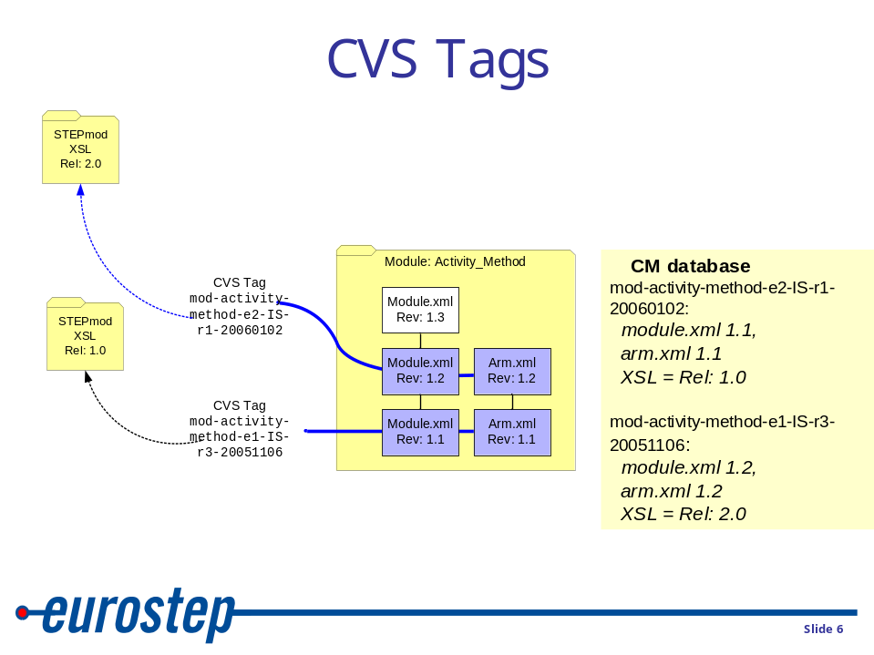

Figure 1 Baselining using CVS tags

Releasing a part
The proposed approach to recording a release of a part is:
- Identify a release and the revisions of the files that make up the release.
Note – these will just be the files used to generate a given part. For example the XML file for a given module.
- Store the identifier in CM database and relate it the file revisions
- Use the identifier as the name of CVS Tag
- Tag the constituent files in CVS.
Having tagged the released part, the files that make up the release can be retrieved by doing a CVS update on the tagged files.
So for each release of a STEP part, a corresponding configuration management (CM) record will be maintained in the CM database recording the information above.
In order to make it easier to identify, create and retrieve a released part, a Java based tool will be implemented that reads the CM database and uses ANT to drive CVS – this will be referred to as the “STEPmod App”
A conceptual architecture is shown in Figure 2.
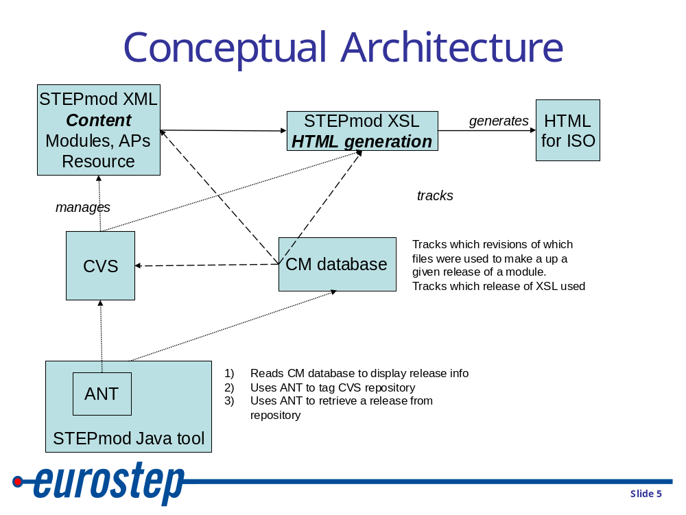
Figure 2 Conceptual architecture

Architecture
A detailed architecture of the tools and repositories used to provide configuration management in STEPmod is given in Figure 3.
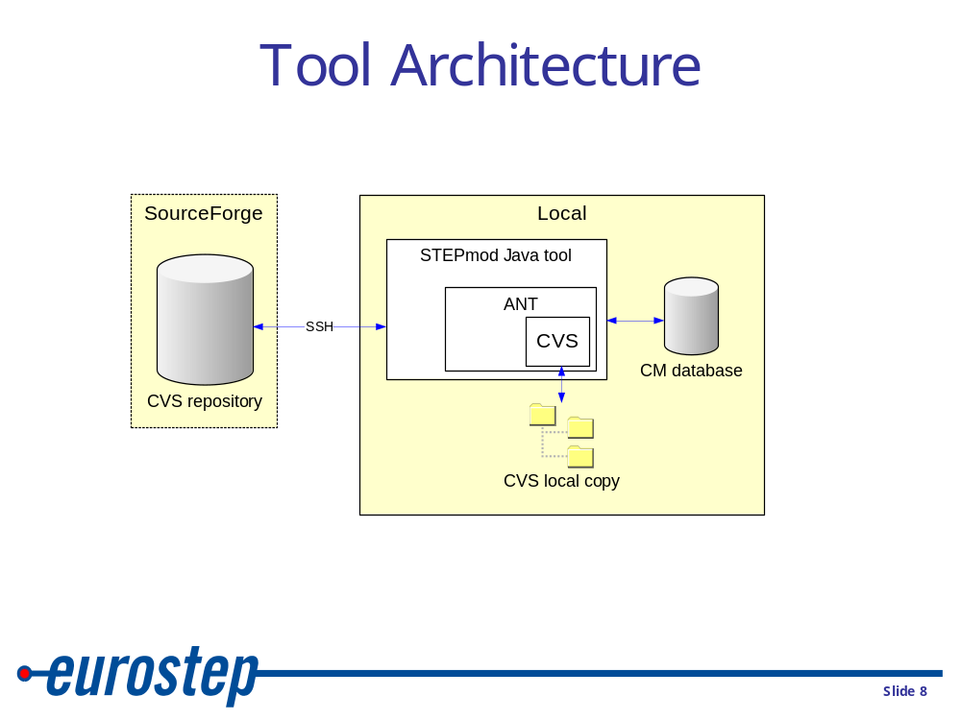

Figure 3 Tool architecture
The CVS repository is maintained on SourceForge and accessed by a secure communication layer (SSH).
Once the repository is checked out using CVS a local copy is maintained, edited and changes checked back into the CVS repository on SourceForge.
The STEPmod App will use ANT and CVS to check out a given tagged releases of STEP parts. Once a tagged release is checked out, the tagged files in the local copy are set “sticky”. In other words, doing a CVS update will not overwrite the “sticky” files, even if there is a later revision that supersedes the one checked out.
The STEPmod App will use ANT and CVS to tag a release of a STEP part. In addition to tagging the files in the CVS repository, a CM record will be updated. This maintains a record of the release and the file revisions of the files in that release. Details of the CM record for a given part are provided in section 5.
Note, the STEPmod App is not intended to replace any CVS client that a user may be using. Its primary initial use is to retrieve identified releases from the CVS repository. Having retrieved a release, the user is free to use the CVS client of choice.

STEP Part releases
This section discusses the information that is to be stored in the CM records.
When a STEP part is released, it is necessary for the CM record to identify:
- the part release and meta data, such as who created the release;
- the source files that generated the HTML for that release;
- any dependent parts. E.g. modules, common resource schemas;
- any dependent STEPmod library files. E.g. normrefs.xml;
- the release of the XSL that was used to generate the released HTML;
These are described in the following sections.

Part release identification and meta data
The CM record shall record the following meta data about the release of the part.

Release meta data
The following meta data about a release is common to all parts.
- Release
The release identifier
- STEPmod release
The release of STEPmod used to create HTML for the release
- Release_sequence
an iterative count of the releases
- Edition
the edition of the part that has been released
- Who
The person who created the release.
- When
The date when the release was created.
- Description
A description of the release.
- Status
A record of the status of the release. The status of the release will only change if it passes a review with no changes. If there are any changes required during the review, then a new release will be created. The following statuses are allowed:
- Team review – the release has been made available for Team review
- Convener review – the release has been made available for Convener review
- Secretariat review – the release has been made available for Secretariat review
- ISO review – the release has been made available for Team review
- Ballot – the release has been made submitted for ballot
- ISO publication – the release has been published by ISO

Release identification
The following convention will be used to identify a release in the CM record. This will also be the name of tag used to record the release in CVS.
The convention is:
{part-type}-{part_name}-{edition}- {stage}-{release}-{date}
Where {part type} is the type of the part. Either:
- mod – for modules
- ap – for application protocols
- resdoc – for resource documents
Where {part name} is the name of the directory in STEPmod used to store the part.
Where {edition} is the edition of the module. e.g.
- ed1
- ed2
- ed3
Where {stage} is the lifecycle stage of the module. Either:
- CD
- CD-TS
- DIS
- FDIS
- IS
- TS
No distinction is made as to whether the release is being submitted for team, convener, secretariat or ISO review as the release may initially be sent for team review, then convener, then the secretariat, then ISO without any changes being made. The progress of the release is recorded separately in the progress meta data.
Where {release} indicates the current iteration of the releases at a given life cycle stage. E.g.
- r1
- r2
Where {date} is the date at which the release was created using the following format: yyyymmdd.
An example of a release is the 3rd release of edition 1 of the IS version of the module activity.
mod-activity-e1-TS-r3-20051106

Release source files
The CM record shall record the names and revisions of the source files that make up a release, namely all the EXPRESS, XML and image files in the directory for the Part.
So for a module, it will be all EXPRESS, XML and image files in stepmod/data/module/{module} where module is the name of the MODULE. So for the module Activity, the following files would be tagged:
stepmod/data/modules/activity:  arm.exp  arm.xml  arm_descriptions.xml  armexpg1.gif  armexpg1.xml  armexpg2.gif  armexpg2.xml  index.xml  mim.exp  mim.xml  mim_descriptions.xml  mimexpg1.gif  mimexpg1.xml  mimexpg2.gif  mimexpg2.xml  module.xml  stepmod/data/modules/activity/dvlp:  issues.xml  projmg.xml | stepmod/data/modules/activity/sys:  1_scope.xml  2_refs.xml  3_defs.xml  4_info_reqs.xml  5_main.xml  5_mapping.xml  5_mim.xml  a_short_names.xml  abstract.xml  b_obj_reg.xml  biblio.xml  c_arm_expg.xml  contents.xml  cover.xml  d_mim_expg.xml  e_exp.xml  e_exp_arm.xml  e_exp_arm_lf.xml  e_exp_mim.xml  e_exp_mim_lf.xml  f_guide.xml  foreword.xml  introduction.xml  isocover.xml  main.xml  modindex.xml

For an application protocol the source files will be all the file stored in stepmod/data/application_protocols/{ap}/ where {ap} is the name of the application protocol.
For a resource document the source files will be all the file stored in stepmod/data/resource_docs/{res}/ where {res} is the name of the resource document.

Release dependent parts
Most STEP parts are dependent on other STEP parts. A module imports another module, and the EXPRESS schemas use from other EXPRESS schemas. An Application protocol is built up from a set of modules. When creating a release of a part it is therefore necessary to identify the releases of the dependent parts as well in order to be able to recreate the release.
The CM record shall therefore record the part names and releases of any dependent parts.

Module dependent parts
A module is dependent on:
- Other modules;
- Common resources schemas.
The CM record therefore must record the part names and releases of the dependent modules. These will be the modules imported into the ARM and MIM, and also all modules on which those modules are dependent, i.e. a recursive trace through the dependent modules.
The CM record must also record the releases of the dependent common resource schemas. These are stored in stepmod/data/resources. Like a module, a schema will be dependent on other schemas. Hence the CM record should list the releases of the schemas used in the MIM of the module and all schemas on which those are dependent.

Application Protocol dependent parts
An application protocol is dependent on a set of modules. When the AP is packaged, it will include all the dependent modules and common resource schemas. The CM record should list the releases of all of these.

Resource document dependent parts
A resource document may be dependent on a set of common resource schemas, i.e., the schemas that the resource document uses. The CM record therefore list the releases of the schemas used in the resource schemas and all schemas on which those are dependent.

Conflict in dependent parts
The interdependency of the STEP parts represents a graph. It is possible that situations will arise were one part may be checked out locally at a given release and another part requires a different release. An example is illustrated in Figure 4.

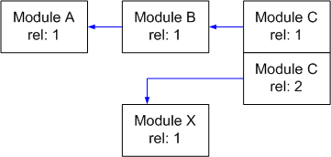
Figure 4 Module dependencies
The assumption is made that all part editions are backwardly compatible. Hence the STEPmod CM tool will flag a warning, but allow a module or application protocol to be pubished.

STEPmod library files
In order to avoid STEPmod developers having to repeatedly enter normative references into parts, a number of library facilities have been created in STEPmod. These are XML files that contain information that can be imported by the XSL into a given part. For example, the documents called out as normative references are defined in stepmod/data/basic/normrefs.xml. All such files are stored in stepmod/data/basic.
In order to provide an accurate configuration record of a release, the revisions of these files should be included in the configuration management record.

STEPMOD XSL release
The STEPmod XSL used to build the released HTML must be identified. The process and configuration management record for the XSL release is described in section 7.

STEPmod Configuration Management records for STEP parts
Each STEP part will have a configuration management record that records the release information described in the previous sections. A record will be a single XML file, called cm_record.xml, stored in the appropriate part directory. Namely:
- stepmod/data/module/<module> for modules;
- stepmod/data/application_protocols/<ap>/ for the application protocols,
- stepmod/data/resource_docs/<res>/ for resource documents.
The DTD for cm_record.xml is provided in 10 and the XML Schema in Appendix B. An
example of configuration management records for a STEP module is provided in Appendix C
.

HTML meta data
In addition to maintaining a configuration management record. It would be usefult to add a meta tag to the published HTML referring back to the release that created it. This will require the XSL to be modified. The meta tag should be: STEPMOD.release. E.g.
<META name="STEPMOD.release" content=" mod-activity_as_realized-e1-TS-r1-20050817">

Baselining STEPmod
A number of the STEP parts developed using STEPmod have been published. It is therefore necessary to create publication records for these parts and add a release to the record corresponding to the published part.
Furthermore all parts in development will need to have configuration management records created and added to CVS.

Part development process
The process for developing a part using STEPmod is defined as a UML activity model in [2]. See: stepmod_process\stepmod_cm_7.html

Configuration management of XSL
The XSL used to build the HTML and the DTDs for the STEP parts need to be placed under a configuration change management regime.
The relevant files should be baselined and released for use. CVS should be used to do this by tagging the release. All files in the directories:
stepmod/xsl
stepmod/dtd
will be tagged.
A configuration management record will need to be maintained to track the releases. The record will be a single XML file stepmod/xsl/cm_record.xml.
The CM record will identify:
- Release
The release identifier
- Release_sequence
an iterative count of the releases
- Who
The person who created the release.
- When
The date when the release was created.
- Description
A description of the release.
- Issues
A list of references to the issues recorded in stepmod/doc/issues that the release has addressed.
The DTD for stepmod/xsl/cm_record.xml is provided in Appendix D and the XML Schema in Appendix E. An example of the configuration management record for STEPmod XSL is provided in Appendix F.
The XSL used for the navigation of STEPmod does not affect the publication of the ISO parts, and is therefore maintained under a separate CM stream. Hence all files in the directories:
stepmod/nav
will be baselined and tagged. And additional configuration management record will need to be maintained to track the releases of the navigational functionality. The record will be a single XML file stepmod/nav/xsl/cm_record.xml. It will record the same information as the XSL record above.

Software functionality
The intention is to develop the STEPmod Java tool “STEPmod App” as a tool or “dashboard” that can be used to support the configuration management of STEPmod, and also as general purpose tool that can perform a number of the tasks in STEPmod that are currently done by individual Jscripts, such as creating a module.
The following sections define the functionality that shall be provided by tool “STEPmod App”. Only the specification and development of the CM component of the tool will be addressed at this stage. The other STEPmod functionality will be included at a later date. The tool will however be architected so that the non CM functionality can be accommodated.

Core CM functionality
The following sections detail the initial functionality that shall be provided to support the CM functions of STEPmod.

Initialisation
An SSH client shall be initialised to communicate with SourceForge. A normal CVS client will then be used to download the latest version of the STEPmod repository.

Browsing the repository
Once the repository has been downloaded, STEPmod App can be used to browse the parts identified in the STEPmod repository_index.xml file.
The CM record for each part will be read and displayed to the user via the GUI showing:
- The name and part number.
Note: STEPmod App will read this from repository_index.xml and either module.xml, application_protocol.xml or resource.xml.
- The latest edition / release regardless as to whether it is checked out.
Note: STEPmod App will read this from the parts CM record.
- A list of available releases and editions;
Note: STEPmod App will read this from the parts CM record.
- The user can either check out a given edition / release or the latest development edition. The GUI will indicate which has been checked out. If a given edition /release has been checked out, the user will be informed through the GUI, If any of the part files has been modified and hence does not conform to the edition checked out the GUI will flag the user.
Note: STEPmod App will deduce this from the parts CM record and the CVS information held in the CVS directory.
- The list of dependent parts and editions for the edition checked out. If any dependent part is currently checked out at a different edition to that used to build the current edition, the user will be flagged.
Note: STEPmod App will read this from the parts CM record.
- The XSL release used to build the release of the part currently checked out.
Note: STEPmod App will read this from the parts CM record

Downloading a given edition / release
The user can download a specified edition/ release from CVS.
The user will identify the edition / release through the STEPmod App GUI, and then STEPmod App will use CVS to checkout the revisions of the files that make up the given release.
This will result in the files being set “sticky” by CVS so that any subsequent CVS updates at a repository level will not update the sticky files, even if the later revisions are available.

Download all published editions
A number of modules have already been published. The user can use STEPmod App to download all the published editions. STEPmod App will identify the latest published editions of the parts and then will follow the process defined in 9.1.3 for each part to download the latest edition.

Creating a release
The user can create a new release for a part.
The STEPmod App will first check that the module is suitable for release, by checking:
- That the module is a development module, not a checked out release;
- That all the files that make up the development part are committed to CVS;
- That all the files that make up the dependent parts are committed to CVS;
Note: It is assumed that the user has checked out the latest published editions or development versions. The user will be advised of the status of the dependent parts.
- Perform the checks in 9.2.4. Note – this will not be implemented at this stage.
The STEPmod App will then create an identifier for the release according to the criteria described in 5.1.2, and then present a GUI to the user requiring the completion of the meta information detailed in 5.1.1.
A CM record will then be created for the part.
The HTML that makes up the release will be generated. This will include generating the HTML for the dependent parts.
STEPmod App will then use CVS to check in the CM record.
The release identifier will then be used by STEPmod App to tag the files that make up the part, including the CM record.
Note: It is possible to use the “avail” facility in the SourceForge CVS repository to restrict the users that can check in the CM records for a given part. The proposal is that each project identifies a CM manager who has responsibility for creating the releases. The project CM managers and the STEPmod system administrators are then the only people to have the rights to create releases.

Deleting a release
A given release can be deleted by using STEPmod App to identify the release to be deleted, and then marking it for deletion.
STEPmod App will remove the release from the CM record and delete the CVS tag from the CVS repository on SourceForge.

Generate a module publication package
A publication package is used to package the HTML for a review, ballot or for publication by ISO. ISO only want the module for publication, whereas for ballot and review it is useful to include the dependent modules and resource schemas.
In order to create a module publication package, STEPmod App is first used to create a release, (see 9.1.5) then package the HTML that makes the release. The user is given the option as to whether to include the dependent modules or not in the package.
The resulting package is a zip file of the HTML, including an HTML index explaining how to access the modules.

Generate a common resource publication package
In order to create a common resource publication package, STEPmod App is first used to create a release, (see 9.1.5) then package the HTML that makes the release.
The resulting package is a zip file of the HTML, including an HTML index explaining how to access the common resource.

Generate an Application Protocol publication package
In order to create an AP publication package, STEPmod App is first used to create a release, (see 9.1.5) then package the HTML that makes the release.
The resulting package is a zip file of the HTML for the AP document and all dependent modules, and an HTML index explaining how to access the AP.

Identifying the STEPmod App release
The user can access an “about” menu entry in STEPmod App to display the revision of STEPmod App being run.

Online help
The user can access online help through the STEPmod App

Creating an XSL release
Development should proceed in CVS branches. When a release of the XSL is planned, the branch should be merged and tagged. Note that this only involves the directories stepmod/xsl and stepmod/dtd. The CM record stepmod/xsl/cm_record.xml should be updated accordingly.
This will be a manual process and not be performed by STEPmod App.

Retrieving an XSL release
A given release of the XSL can be retrieved by using the CVS tag mechanism.

STEPmod functionality
The following sections detail general purpose STEPmod functionality that is currently implemented by scripts.
Note: This section just lists the most common functionality and is expected to be expanded.

Create a module
Enable STEPmod App to create a new module by incorporating the functionality currently provided by stepmod/utils/mkmodule.wsf

Add an issue to a module
Add an issue to issue.xml
Note: If bugzilla is now being used, then this is redundant.

Produce an ISO issue log for a module
Read issue.xml and produce a issue log in the form required by ISO.
Note: If bugzilla is now being used, then this is redundant and should be provided the implementation of bugzilla.

Check a module
Enable STEPmod App to check a module by incorporating the functionality currently provided by stepmod/utils/ checkModuleMain.js. The following checks will be made on a module:
- All the files that make up the module are valid XML.
- All the files that make up the module have been checked into CVS.
- Check that the relevant mete data tags are included in module.xml. E.g. name, wg.number
- Check that the ARM and MIM EXPRESS has correct header and that the WG number agree with those stated in the module.xml. E.g.
(*
$Id: arm.exp,v 1.7 2004/11/19 21:37:33 robbod Exp $
ISO TC184/SC4/WG3 N1553 - ISO/TS 10303-439 AP239 product life cycle support - EXPRESS ARM
Supersedes ISO TC184/SC4/WG3 N1399
*)

Create a common resource document.
Enable STEPmod App to create a new resource document by incorporating the functionality currently provided by stepmod/utils/resource/mkresource.wsf.wsf

Create an Application protocol
Enable STEPmod App to create a new application protocol document by incorporating the functionality currently provided by stepmod/utils/ap_docs/mkapdoc.wsf

Document List
Reference | Document id | Title
1 | Eurostep.ESUKPC08.000104 | Information Management Procedure
2 | stepmod_cm_7.html | STEPmod part development process
3 | cm_record_module.xsd.html | XML Schema for part CM record
4 | stepmod_cm_record.xsd.html | XML Schema for STEPmod XSL CM record

- DTD for cm_record.xml
This appendix provides the DTD for the XML used to store a CM record.
<!ELEMENT directory (#PCDATA | file)*>
<!ATTLIST directory name CDATA #IMPLIED>
<!ELEMENT dependencies (#PCDATA | sources | library_files | modules | resource_schemas)*>
<!ELEMENT cm_release (#PCDATA | dependencies)*>
<!ATTLIST cm_release release CDATA #IMPLIED>
<!ATTLIST cm_release who CDATA #IMPLIED>
<!ATTLIST cm_release when CDATA #IMPLIED>
<!ATTLIST cm_release stepmod_common_release CDATA #IMPLIED>
<!ATTLIST cm_release stepmod_framework_release CDATA #IMPLIED>
<!ATTLIST cm_release iso_status CDATA #IMPLIED>
<!ATTLIST cm_release release_status CDATA #IMPLIED>
<!ATTLIST cm_release release_sequence CDATA #IMPLIED>
<!ATTLIST cm_release edition CDATA #IMPLIED>
<!ATTLIST cm_release description CDATA #IMPLIED>
<!ELEMENT sources (#PCDATA | directory)*>
<!ELEMENT cm_record (#PCDATA | cm_releases)*>
<!ATTLIST cm_record part_name CDATA #IMPLIED>
<!ATTLIST cm_record part_type CDATA #IMPLIED>
<!ATTLIST cm_record part_number CDATA #IMPLIED>
<!ATTLIST cm_record cvs_revision CDATA #IMPLIED>
<!ATTLIST cm_record cvs_date CDATA #IMPLIED>
<!ELEMENT resource_schemas (#PCDATA | resource)*>
<!ELEMENT resource (#PCDATA)>
<!ATTLIST resource name CDATA #IMPLIED>
<!ATTLIST resource part CDATA #IMPLIED>
<!ATTLIST resource release CDATA #IMPLIED>
<!ATTLIST resource cvs_revision CDATA #IMPLIED>
<!ATTLIST resource cvs_date CDATA #IMPLIED>
<!ELEMENT library_files (#PCDATA | directory)*>
<!ELEMENT schema (#PCDATA)>
<!ATTLIST schema name CDATA #IMPLIED>
<!ATTLIST schema part CDATA #IMPLIED>
<!ATTLIST schema cvs_date CDATA #IMPLIED>
<!ATTLIST schema cvs_revision CDATA #IMPLIED>
<!ELEMENT modules (#PCDATA | module)*>
<!ELEMENT module (#PCDATA)>
<!ATTLIST module name CDATA #IMPLIED>
<!ATTLIST module part CDATA #IMPLIED>
<!ATTLIST module release CDATA #IMPLIED>
<!ELEMENT cm_releases (#PCDATA | cm_release)*>
- XML Schema for cm_record.xml
This appendix provides the XML Schema for the XML used to store a CM record. Note an HTML version is provided in [3].
NOTE: This appendix is not up to date: Appendix A is the reference dtd.
For details see version 0.6.
See: cm_record_module.xsd.htm\cm_record_module.xsd.html
<?xml version="1.0" encoding="UTF-8"?>
<xs:schema xmlns:xs="http://www.w3.org/2001/XMLSchema" elementFormDefault="qualified">
<xs:element name="cm_record">
<xs:complexType>
<xs:sequence>
<xs:element ref="cm_releases"/>
</xs:sequence>
<xs:attribute name="cvs_date" use="required"/>
<xs:attribute name="cvs_revision" use="required"/>
<xs:attribute name="part_name" use="required" type="xs:NCName"/>
<xs:attribute name="part_number" use="required" type="xs:integer"/>
<xs:attribute name="part_type" use="required" type="xs:NCName"/>
</xs:complexType>
</xs:element>
<xs:element name="cm_releases">
<xs:complexType>
<xs:sequence>
<xs:element maxOccurs="unbounded" ref="cm_release"/>
</xs:sequence>
</xs:complexType>
</xs:element>
<xs:element name="cm_release">
<xs:complexType>
<xs:sequence>
<xs:element ref="dependencies"/>
</xs:sequence>
<xs:attribute name="description" use="required"/>
<xs:attribute name="edition" use="required" type="xs:NCName"/>
<xs:attribute name="release" use="required"/>
<xs:attribute name="release_sequence" use="required" type="xs:NCName"/>
<xs:attribute name="status" use="required"/>
<xs:attribute name="stepmod_release" use="required" type="xs:NCName"/>
<xs:attribute name="when" use="required" type="xs:integer"/>
<xs:attribute name="who" use="required"/>
</xs:complexType>
</xs:element>
<xs:element name="dependencies">
<xs:complexType>
<xs:sequence>
<xs:element ref="sources"/>
<xs:element ref="library_files"/>
<xs:element ref="modules"/>
<xs:element ref="resource_schemas"/>
</xs:sequence>
</xs:complexType>
</xs:element>
<xs:element name="sources">
<xs:complexType>
<xs:sequence>
<xs:element maxOccurs="unbounded" ref="directory"/>
</xs:sequence>
</xs:complexType>
</xs:element>
<xs:element name="library_files">
<xs:complexType>
<xs:sequence>
<xs:element maxOccurs="unbounded" ref="directory"/>
</xs:sequence>
</xs:complexType>
</xs:element>
<xs:element name="modules">
<xs:complexType>
<xs:sequence>
<xs:element maxOccurs="unbounded" ref="module"/>
</xs:sequence>
</xs:complexType>
</xs:element>
<xs:element name="module">
<xs:complexType>
<xs:attribute name="name" use="required" type="xs:NCName"/>
<xs:attribute name="part" use="required" type="xs:integer"/>
<xs:attribute name="release" use="required"/>
</xs:complexType>
</xs:element>
<xs:element name="resource_schemas">
<xs:complexType>
<xs:sequence>
<xs:element maxOccurs="unbounded" ref="schema"/>
</xs:sequence>
</xs:complexType>
</xs:element>
<xs:element name="schema">
<xs:complexType>
<xs:attribute name="cvs_date" use="required"/>
<xs:attribute name="cvs_revision" use="required" type="xs:decimal"/>
<xs:attribute name="name" use="required" type="xs:NCName"/>
<xs:attribute name="part" use="required"/>
</xs:complexType>
</xs:element>
<xs:element name="directory">
<xs:complexType>
<xs:sequence>
<xs:element maxOccurs="unbounded" ref="file"/>
</xs:sequence>
<xs:attribute name="name" use="required" type="xs:NMTOKEN"/>
</xs:complexType>
</xs:element>
<xs:element name="file">
<xs:complexType>
<xs:attribute name="cvs_date" use="required"/>
<xs:attribute name="cvs_revision" use="required" type="xs:decimal"/>
<xs:attribute name="name" use="required" type="xs:NMTOKEN"/>
</xs:complexType>
</xs:element>
</xs:schema>
- Module configuration management record -cm_record.xml
This appendix provides an example of the information that will be stored in the CM record XML file for a module.
Note – the CM records for common resources and application protocols will be very similar.

<?xml version="1.0" encoding="UTF-8"?>
<!-- $Id: cm_record.xml,v 1.40 2004/11/09 17:36:47 robbod Exp $ -->

<!-- A configuration management record
part_name
The name of the STEP part
part_type
The type of the STEP part. Either module, application_protocol or resource_doc
part_number
The ISO part number
cvs_revision
The file revision of the cm record. (RCS keyword Revision)
cvs_date
The date of the file revision. (RCS keyword Date)
-->
<cm_record
part_name="activity_as_realized"
part_type="module"
part_number="1259"
cvs_revision="$Revision: 1.7 $"
cvs_date="$Date: Thu Jun 20 11:01:14 2002 $">

<!-- A set of all the releases of this part -->
<cm_releases>
<!-- A release of the part
release
the release identifier
stepmod_release
the release of STEPmod used to create HTML for the release
who
the person who created the release
when
the date when the release was created
status
A record of the status of the release. The status of the release
will only change if it passes a review with no changes. If there
are any changes required during the review, then a new release will be
created. The following statuses are allowed:
- Team review - the release distributed for Team review
- Convener review - the release distributed for Convener review
- Secretariat review - the release distributed for Secretariat review
- ISO review - the release distributed for Team review
- Ballot - the release distributed for ballot
- ISO publication - the release has been published by ISO

release_sequence
an iterative count of the releases
edition
the edition of the part that has been released
description
free text description of the release
-->
<cm_release
release="mod-activity_as_realized-e1-TS-r1-20050817"
who="Rob Bodington"
when="20050817"
stepmod_common_release="r1"
stepmod_framework_release=""
iso_status=””
release_status="ISO publication"
release_sequence="r1"
edition="e1"
description="Edition 1 as published">
<!-- A set of all components on which this part is dependent -->
<dependencies>
<!-- The revisions of the source files that this part is dependent on.
They are organized according to the directories of the part.
-->
<sources>
<directory name=".">
<file name="armexpg1.gif"
cvs_revision="1.7"
cvs_date="Thu Jun 20 11:01:14 2002"/>
<file name="index.xml"
cvs_revision="1.1"
cvs_date="Fri Mar 21 10:20:37 2003"/>
<file name="arm.xml"
cvs_revision="1.14"
cvs_date="Sat Jul 26 05:53:36 2003"/>
<file name="armexpg1.xml"
cvs_revision="1.11"
cvs_date="Sat Jul 26 05:53:37 2003"/>
<file name="armexpg2.gif"
cvs_revision="1.6"
cvs_date="Sat Jul 26 05:53:39 2003"/>
<file name="armexpg2.xml"
cvs_revision="1.8"
cvs_date="Sat Jul 26 05:53:40 2003"/>
<file name="mim_descriptions.xml"
cvs_revision="1.12"
cvs_date="Sun Sep 7 17:02:49 2003"/>
<file name="mim.xml"
cvs_revision="1.14"
cvs_date="Thu Aug 26 09:19:37 2004"/>
<file name="mimexpg1.gif"
cvs_revision="1.10"
cvs_date="Thu Aug 26 09:19:38 2004"/>
<file name="mimexpg1.xml"
cvs_revision="1.13"
cvs_date="Thu Aug 26 09:19:38 2004"/>
<file name="mimexpg2.gif"
cvs_revision="1.11"
cvs_date="Thu Aug 26 09:19:38 2004"/>
<file name="mimexpg2.xml"
cvs_revision="1.13"
cvs_date="Thu Aug 26 09:19:38 2004"/>
<file name="mim.exp"
cvs_revision="1.16"
cvs_date="Fri Oct 22 16:22:28 2004"/>
<file name="arm.exp"
cvs_revision="1.17"
cvs_date="Mon Nov 8 08:59:41 2004"/>
<file name="arm_descriptions.xml"
cvs_revision="1.20"
cvs_date="Mon Nov 8 08:59:41 2004"/>
<file name="module.xml"
cvs_revision="1.40"
cvs_date="Wed Nov 17 16:19:37 2004"/>
</directory>
<directory name="dvlp">
<file name="projmg.xml"
cvs_revision="1.2"
cvs_date="Wed Jun 11 15:30:59 2003"/>
<file name="issues.xml"
cvs_revision="1.11"
cvs_date="Mon Nov 8 08:59:42 2004"/>
</directory>
<directory name="sys">
<file name="1_scope.xml"
cvs_revision="1.1"
cvs_date="Mon Mar 18 10:29:41 2002"/>
<file name="2_refs.xml"
cvs_revision="1.1"
cvs_date="Mon Mar 18 10:29:41 2002"/>
<file name="3_defs.xml"
cvs_revision="1.1"
cvs_date="Mon Mar 18 10:29:41 2002"/>
<file name="4_info_reqs.xml"
cvs_revision="1.1"
cvs_date="Mon Mar 18 10:29:41 2002"/>
<file name="5_main.xml"
cvs_revision="1.1"
cvs_date="Mon Jun 17 15:58:31 2002"/>
<file name="5_mapping.xml"
cvs_revision="1.1"
cvs_date="Mon Mar 18 10:29:41 2002"/>
<file name="5_mim.xml"
cvs_revision="1.1"
cvs_date="Mon Mar 18 10:29:41 2002"/>
<file name="a_short_names.xml"
cvs_revision="1.1"
cvs_date="Mon Mar 18 10:29:41 2002"/>
<file name="abstract.xml"
cvs_revision="1.1"
cvs_date="Mon Mar 10 00:58:53 2003"/>
<file name="b_obj_reg.xml"
cvs_revision="1.1"
cvs_date="Mon Mar 18 10:29:41 2002"/>
<file name="biblio.xml"
cvs_revision="1.1"
cvs_date="Mon Mar 18 10:29:41 2002"/>
<file name="c_arm_expg.xml"
cvs_revision="1.1"
cvs_date="Mon Mar 18 10:29:41 2002"/>
<file name="contents.xml"
cvs_revision="1.1"
cvs_date="Mon Jun 17 15:42:58 2002"/>
<file name="cover.xml"
cvs_revision="1.1"
cvs_date="Mon Mar 18 10:29:41 2002"/>
<file name="d_mim_expg.xml"
cvs_revision="1.1"
cvs_date="Mon Mar 18 10:29:41 2002"/>
<file name="e_exp.xml"
cvs_revision="1.1"
cvs_date="Mon Mar 18 10:29:41 2002"/>
<file name="e_exp_arm.xml"
cvs_revision="1.1"
cvs_date="Mon Mar 18 10:29:41 2002"/>
<file name="e_exp_arm_lf.xml"
cvs_revision="1.1"
cvs_date="Mon Mar 18 10:29:41 2002"/>
<file name="e_exp_mim.xml"
cvs_revision="1.1"
cvs_date="Mon Mar 18 10:29:41 2002"/>
<file name="e_exp_mim_lf.xml"
cvs_revision="1.1"
cvs_date="Mon Mar 18 10:29:41 2002"/>
<file name="f_guide.xml"
cvs_revision="1.1"
cvs_date="Mon Mar 18 10:29:41 2002"/>
<file name="foreword.xml"
cvs_revision="1.1"
cvs_date="Mon Mar 18 10:29:41 2002"/>
<file name="introduction.xml"
cvs_revision="1.1"
cvs_date="Mon Mar 18 10:29:41 2002"/>
<file name="main.xml"
cvs_revision="1.1"
cvs_date="Mon Mar 18 10:29:41 2002"/>
<file name="modindex.xml"
cvs_revision="1.1"
cvs_date="Wed Jul 23 11:02:40 2003"/>
<file name="isocover.xml"
cvs_revision="1.2"
cvs_date="Wed Oct 20 09:27:51 2004"/>
</directory>
</sources>

<!-- The revisions of all the library files that may be accessed by
the XSL. E.g. normrefs.xml
All files are stored in stepmod/data/basic or stepmod/data/basic/ap_doc
-->
<library_files>
<directory name=".">
<file name="abbreviations.xml"
cvs_revision="1.1"
cvs_date="Mon Mar 18 10:29:41 2002"/>
<file name="bibliography.xml"
cvs_revision="1.1"
cvs_date="Mon Mar 18 10:29:41 2002"/>
</directory>
<directory name="ap_doc">
<file name="abbreviations_default.xml"
cvs_revision="1.1"
cvs_date="Mon Mar 18 10:29:41 2002"/>
</directory>
</library_files>

<!-- The releases of the modules that this part is dependent on.
This lists the modules that are directly imported into this
part and any modules that they may import.
-->
<modules>
<module name="activity" part="1047"
release="mod-activity_method-e1-TS-r3-20041109"/>
<module name="activity_method" part="1049"
release="mod-activity_method-e1-TS-r3-20041109"/>
</modules>
<!-- The revisions of the common resource schemas that this part is
dependent on
-->
<resource_schemas>
<resource name="action_schema" part="ISO 10303-41" release=””
cvs_date="2004/12/01 16:38:13"
cvs_revision="1.14"/>
<resource name="basic_attribute_schema" part="ISO 10303-41" release=””
cvs_date="2004/12/01 16:38:13"
cvs_revision="1.14"/>
<resource name="management_resources_schema" part="ISO
10303-41" release=””
cvs_date="2004/12/01 16:38:13"
cvs_revision="1.14"/>
</resource_schemas>
</dependencies>
</cm_release>
</cm_releases>
</cm_record>

- DTD for stepmod_cm_record.xml
This appendix provides the DTD for the XML used to store a CM record.
<?xml encoding="UTF-8"?>

<!ELEMENT stepmod_cm_record (stepmod_cm_releases)>
<!ATTLIST stepmod_cm_record
xmlns CDATA #FIXED ''
cvs_date CDATA #REQUIRED
cvs_revision CDATA #REQUIRED>

<!ELEMENT stepmod_cm_releases (stepmod_cm_release)+>
<!ATTLIST stepmod_cm_releases
xmlns CDATA #FIXED ''>

<!ELEMENT stepmod_cm_release (issues)>
<!ATTLIST stepmod_cm_release
xmlns CDATA #FIXED ''
description NMTOKEN #REQUIRED
release NMTOKEN #REQUIRED
tag NMTOKEN #REQUIRED
when CDATA #REQUIRED
who CDATA #REQUIRED>

<!ELEMENT issues (issue)+>
<!ATTLIST issues
xmlns CDATA #FIXED ''>

<!ELEMENT issue EMPTY>
<!ATTLIST issue
xmlns CDATA #FIXED ''
file NMTOKEN #REQUIRED
id NMTOKEN #REQUIRED>
- XML Schema for stepmod_cm_record.xml
This appendix provides the XML Schema for the XML used to store a CM record. Note an HTML version is provided in [3]. See: cm_record_stepmod.xsd.htm\cm_record_stepmod.xsd.html
<?xml version="1.0" encoding="UTF-8"?>
<xs:schema xmlns:xs="http://www.w3.org/2001/XMLSchema" elementFormDefault="qualified">
<xs:element name="stepmod_cm_record">
<xs:complexType>
<xs:sequence>
<xs:element ref="stepmod_cm_releases"/>
</xs:sequence>
<xs:attribute name="cvs_date" use="required"/>
<xs:attribute name="cvs_revision" use="required"/>
</xs:complexType>
</xs:element>
<xs:element name="stepmod_cm_releases">
<xs:complexType>
<xs:sequence>
<xs:element maxOccurs="unbounded" ref="stepmod_cm_release"/>
</xs:sequence>
</xs:complexType>
</xs:element>
<xs:element name="stepmod_cm_release">
<xs:complexType>
<xs:sequence>
<xs:element ref="issues"/>
</xs:sequence>
<xs:attribute name="description" use="required" type="xs:NCName"/>
<xs:attribute name="release" use="required" type="xs:NCName"/>
<xs:attribute name="tag" use="required" type="xs:NCName"/>
<xs:attribute name="when" use="required" type="xs:integer"/>
<xs:attribute name="who" use="required"/>
</xs:complexType>
</xs:element>
<xs:element name="issues">
<xs:complexType>
<xs:sequence>
<xs:element maxOccurs="unbounded" ref="issue"/>
</xs:sequence>
</xs:complexType>
</xs:element>
<xs:element name="issue">
<xs:complexType>
<xs:attribute name="file" use="required" type="xs:NCName"/>
<xs:attribute name="id" use="required" type="xs:NCName"/>
</xs:complexType>
</xs:element>
</xs:schema>
- STEPmod configuration management record -stepmod_cm_record.xml
This appendix provides an example of the information that will be stored in the CM record XML file for the STEPmod XSL releases.

<?xml version="1.0" encoding="UTF-8"?>
<!-- $Id: cm_record.xml,v 1.40 2004/11/09 17:36:47 robbod Exp $ -->

<!--
The configuration management record for the STEPmod XSL and associated files
cvs_revision
The file revision of the cm record. (RCS keyword Revision)
cvs_date
The date of the file revision. (RCS keyword Date)
-->
<stepmod_cm_record
cvs_revision="$Revision: 1.7 $"
cvs_date="$Date: Thu Jun 20 11:01:14 2002 $">

<!-- A set of all the releases of STEPmod -->
<stepmod_cm_releases>
<!-- A relase of the STEPmod framework
release
the release identifier
who
the person who created the release
when
the date when the release was created
description
free text description of the release
-->
<stepmod_cm_release
release="r1"
tag="stepmod-r1"
who="Rob Bodington"
when="20050817"
description="First">
<!-- A list of all the issues that have been addressed by this
release
-->
<issues>
<issue file="module_issues.xml" id="THX-10"/>
<issue file="apdoc_issues.xml" id="RBN-51"/>
</issues>
</stepmod_cm_release>
</stepmod_cm_releases>
</cm_record>

This is purely for human convenience.

