Late AP239/PLSC Modules Ballot Comments

David Price

These issues were identified during the mapping of an OMG in-process standard called SysML which covers some of the same scope as modules used in AP239. It is based on the following example diagram:

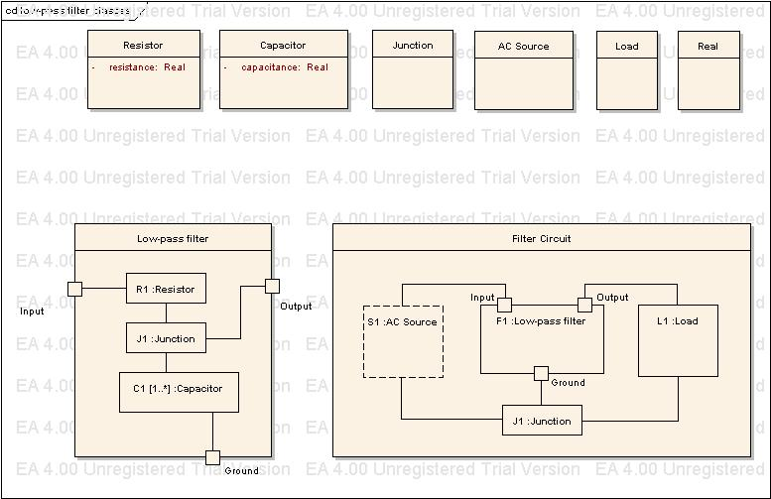

ISSUE: Interface Connectors

In SysML you don’t have to name every connector but in the Interface modules you do. So, I end up creating dummy Interface_connector, Interface_connector_version and Interface_connector_definition instances for each connector with names like “Anonymous Connector 1 on R1 in Low-pass filter” for the Interface connector and appending “Version 1” and then “Version 1 Definition 1” for the version and definition. While this is tedious I can accept that STEP wants to make explicit what is implicit in the SysML diagram. Then you add instances of Connector_on to relate the Interface_connector_definition to the item it’s attached to which is either a Product_view_definition or a View_definition_relationship and while tedious, this also works.

However, when the connector has a name in SysML, like “Input on Low-pass filter” there’s a problem. You create the Interface_connector, Interface_connector_version and Interface_connector_definition and say is is on the Product_view_definintion named “Low-pass filter Version 1 Definition 1”. The problem arises when “Low-pass filter Version 1 Definition 1” is used as a component “F1” in a higher level assembly like Filter Circuit. It turns out that you cannot reuse the definition “Input on Low-pass filter” wrt “F1” when you are making a Interface_connection instance… you can only do that between Interface_connector_definitions. The only workaround seems to be to have to create “duplicate” instances of Interface_connector, Interface_connector_version and Interface_connector_definition for each use of a named Interface_connector. This is a problem because “Input on Low-pass filter Version 1 Definition 1” and “Input on F1 Low-pass filter in Filter Circuit Version 1 Definition 1” are really the same connector definition.

On the above diagram it boils down to the fact that when connecting “S1” and “Input” on “F1” in “Filter Circuit”, I am forced to treat “Input” on “F1” in “Filter Circuit” as completely unrelated to the definition of “Input” on “Low-pass filter” when they are clearly the same definition (i.e. they would have the same properties, etc.).

PROPOSED SOLUTION:

The only solution I can come up with is to allow Interface_connection to refer to Connector_on as well as Interface_connector_definition given the current structure but that doesn’t make sense as Interface_connection is a kind of View_definition_relationship. So, a rethink might be more in order. Perhaps Interface_connection is not a kind of View_definition_relationship?

ISSUE: System breakdown

In STEP, Breakdowns seems to be thought of as quite different from Assemblies and that’s why the Product_breakdown module and System_breakdown module do not use the entity type Next_assembly_usage but instead created a separate entity type called Breakdown_element_usage.

The use of Breakdown_element_usage is one reason why System_breakdown cannot be used for the SysML to STEP mapping – because there is quantity attribute.

A second reason seems to stem from the text found in the Product_breakdown introduction which says “These views are complementary to the assembly structure and bill of materials views that are the primary focus for manufacturing (realization) of a product (see Part definition relationship ). Breakdowns may be of designs or realized individual products. For any product, more than one breakdown may exist to support various different engineering activities.” where I added the bold. If Systems engineers create “assembly structure” then this seems to say they should not use Product_breakdown.

Is the intent for the current Breakdown modules to be harmonized/reusable between AP239 and AP233? If so, they seem not to satisfy AP233 requirements in this area.

PROPOSED SOLUTION:

Here are a few options… there may be more:

1) Change System_breakdown (and perhaps all Breakdowns to use the same structures as STEP Assembly uses)

2) Create modules for System_definition or something like that which works for AP233 but not AP239.

3) Use Product, Product_view_definition,etc. and categorize/classify them as a “System” and “System engineering view” etc

4) Create a patch module that allows Next_assembly_usage or similar to apply to System_breakdown_element saying not to use Breakdown_element_usage in AP233

ISSUE: Connector_on is not Next_assembly_usage

In SysML a Port (i.e. Interface_connector in STEP) is a kind of Part (i.e. Product in STEP). Therefore, Ports appear as normal Parts in the assembly structure. In AP239, it seems that the idea of an Interface_connector being part of an assembly requires two sets of relationships, first the Next_assembly_usage is needed to make the it part of the assembly and then Connector_on is needed to link the definition of the connector to the definition of the assembly. The modules do not provide clear guidance as to whether this duplication is expected or whether there is an error in the way Connector_on works.

PROPOSED SOLUTION:

Determine if Connector_on makes something part of an “assembly” and update the documentation or the model or both as appropriate.

ISSUE: Anonymous Ports

In SysML, not all Ports (i.e STEP connectors) are required to be defined. In the example diagram, Resistor has two “anonymous” Ports. However, in STEP these Ports are required to be created as Interface_connector_defintion (and Interface_connector_version and Interface_connector). As there is no name in the SysML diagram they are “anonymous”. For the mapping we did, we generated names such as “Anonymous connector 1 on Version 1 of Definition 1 … “. This creation of explicit instances is caused by the fact that STEP only allows Interface_connection between two Interface_connector_definition instances.

PROPOSED SOLUTION:

Do not require explicit instantiation of unmodeled ports. It seems like something such as allowing Interface_connection between Interface_connector_definition and Next_assembly_usage might work.

