User instructions for mkcmrecord
Gerry Radack
2007-04-20

Purpose
mkcmrecord is a program for creating configuration management (CM) records. It is a temporary work-around until the CM Tool is fixed.

Limitations
Because it is a temporary workaround, it does not do much error checking. It is the responsibility of the user to review the generated CM record file and ensure that it is correct.

Preparation
Ensure that Saxon-B 8 is installed on your computer. Saxon is available for download from

Set environment variable SAXON_HOME to point to the root directory of Saxon-B 8.

Right-click My Computer and select Properties.
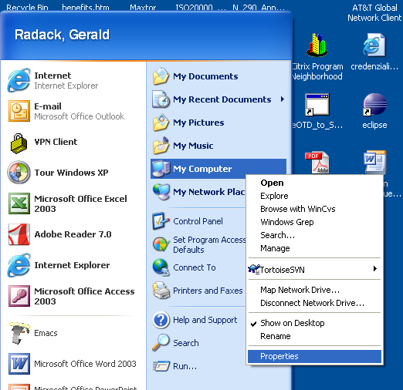

Select the Advanced tab and click Environment Variables.
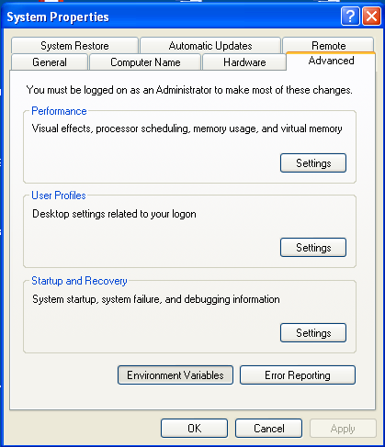

Click New to add the environment variable.

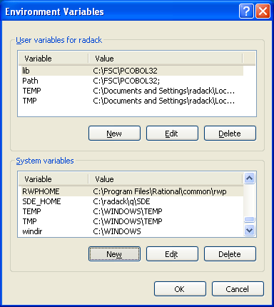

In the variable value field, enter the root of the directory tree containing Saxon-B 8.

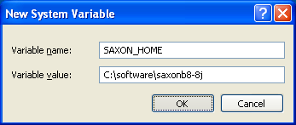

Click OK.
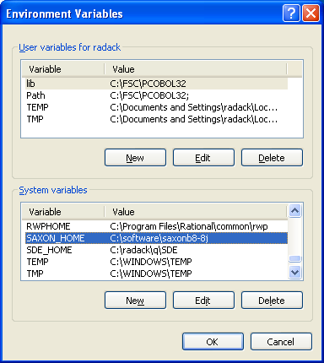

Click OK.

Use
Prepare the module directory
- Remove temporary files and other unneeded files.
- Make sure that each text file has either a $Id tag or a $Date and a $Revision tag.
- Make sure that each file is checked in. If the files are not checked in, an incorrect CM record will be generated.
- If there is an existing cm_record.xml file, generated for a previous release of the module, ensure that it is checked in.

NOTE mkcmrecord will overwrite cm_record.xml. It is designed to copy the existing cm_release elements from the existing cm_record.xml, but if there are errors in the existing cm_record.xml file, the elements may not be copied. Therefore, it is highly recommended that you make a backup copy of cm_record.xml before running the program, and examine cm_record.xml after running the program to make sure that any previous cm_release elements were correctly copied.

Run program mkcmrecord.wsf in directory stepmod\utils.

Enter module name when prompted and click "OK".
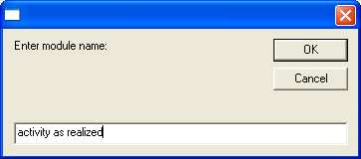

Complete the fields of the form.
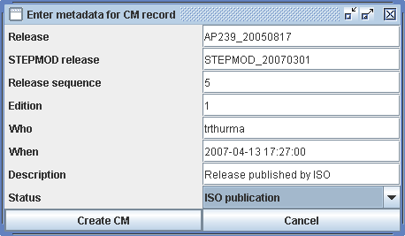

Click "Create CM".

Edit the file cm_record.xml in the module directory using an XML editor.

NOTE Each time you run the program and click "Create CM", the program adds a cm_release element to cm_record.xml. If you later decide not to keep a generated cm_release element (e.g., if you ran the program for testing purposes), you must remove the element manually from the cm_record.xml.
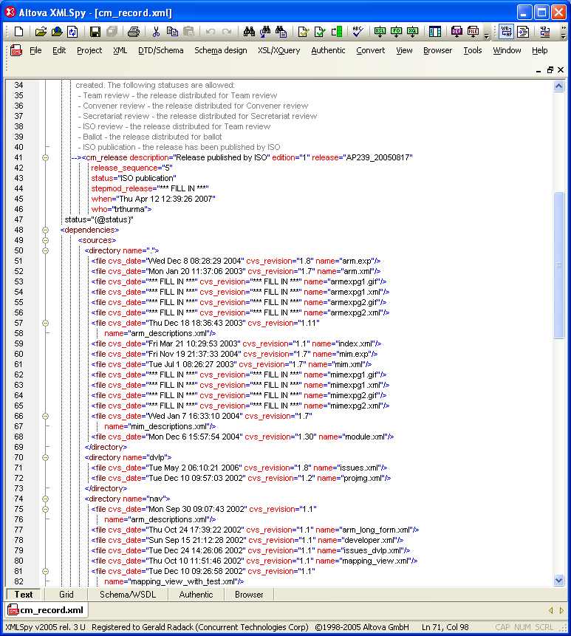

Remove any <file> entries for files that do not make up the configuration.
Replace all occurrences of "*** FILL IN ***" with the correct values.

NOTE mkcmrecord does not get cvs_date and cvs_revision information for binary files. You will have to fill those values in yourself.

Ensure that the file is valid (well-formed and conforms to the XML schema for CM records).

Pretty-print the file.

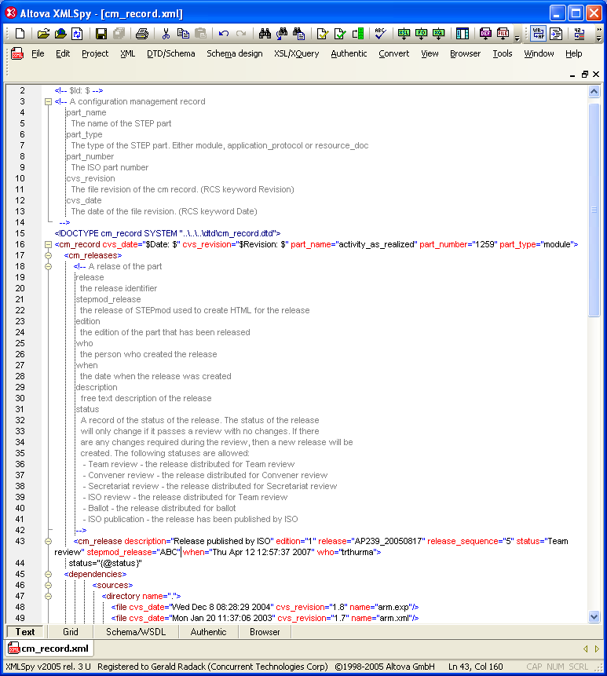

If this is an update to an existing CM record, verify that the cm_release elements from the previous version of the record have been copied to the updated record.

Verify that the newly generated cm_release element is complete and correct.

Save the file.

Check the file into CVS.

