Tutorial

Parts (library concepts) : _101xxx (for the 1st Part), _102xxx (for the 2nd Part)

Define extended Part template with specific PartCategory and PartFeature/PartTerminals

* Wire
* Cable
* Backshell
* Connector
* Connector set
* …

ExternalGeometricModels :

* 3D
* 2D stick Line
* 2D Formboard

Template for ConnectedEdgeWithLengthSetRepresentation

Part (WiringHarnessAssemblyDesign) *31xxxx (*311xxx for the Part)

Define extended Assembly template with references to:

* ConnectedEdgeWithLengthSetRepresentation, ( _312xxx)
* Connectivity
* AssemblyJoint
* CrossSection (_313xxx)
* HarnessSegment & HarnessNode (_314xxx)

Further templates based on existing SingleOccurrence template: (_201xxx for 1st Occurrence of Part _101xxx, _2011xx for the 1st Occurrence, _2012xx for the 2nd occurrence)

* Extended SingleOccurence with Feature/TerminalOccurrences defined by PartOccurence
* QuantifiedOccurrences for Cables and Wires with a specific length
* Wire and Cable occurrence terminals and grouping
* AssemblyGroupOccurrences for connectors

Template for CrossSection

Template for the HarnessSegment & HarnessNode and how they link to the topological model and to the corresponding occurrence features

Template for AssemblyJoint

Template for connectivity

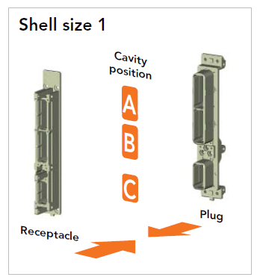

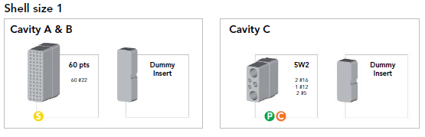

Parts used in the example:

_101000 wire (WIRE,ELEC,COMP,SNGL CONDUCTOR,150 DEG C) )

_104000 cable (speaker wires)

_102000 cable (COAX)

_202006

_202106

_103000 terminal lug (TERMINAL LUG CRIMP STYLE COPPER INSULATED RING TONGUE)

_110000 connector kit (ARINC 600 set)

_210100

_111000 connector insert (ARINC 600 shell 1 A and B dummy)

_112000 connector insert (ARINC 600 shell 1 C 5W2 insert)

_212005

_113000 connector contact (#5 Coax contact)

_213100

_213200

_114000 connector contact (#16 Power contact)

_214100

_214200

_115000 connector insert assembly (2 COAX & 3 single contacts)

_215100

_116000 connector contact (#12 signal)

_216100

_120000 braid

_121000 protective covering C1(wrap)

_121000 protective covering C2 (HeatShrink)

_311000 wiring harness (Electrical Harness team reference example)

* ConnectedEdgeWithLengthSetRepresentation, ( _312xxx)
* Connectivity
* AssemblyJoint (_31101X)
* CrossSection (_313xxx)
* HarnessSegment & HarnessNode

Example: big example (at the end) with some extract for each template

Note: Validation properties for EH to be defined in further version. Examples: number of terminals, number of connectors…