StarShield Affiliate Portal
Detailed Specification & Architecture
Date: 2025-10-25
Roles: Affiliate (User), Admin
1. Executive Summary
This document describes the complete design for the StarShield Affiliate Portal with two portals: the Affiliate portal (mobile-first PWA) and the Admin portal (desktop-focused). It specifies features, architecture, data model, APIs, tracking/attribution, commission calculation, payouts, analytics, security, and a phased build plan. Finance, Support, and SuperAdmin roles are not included—only Affiliate and Admin.

2. Feature Overview

2.1 Affiliate Portal (User)
- Mobile-first PWA; onboarding with KYC/tax; payout method; T&Cs e-signature
- Dashboard (clicks, conversions, revenue, commission, top products)
- Product Catalog (details, creatives, affiliate link generator, QR codes, UTM templates)
- Link & Coupon Manager (deep links, short links, expiries, coupon mapping)
- Reports (time-series, itemized orders & commissions, CSV/Excel export)
- Payouts (balances, pending/approved/paid, payout history, receipts)
- Notifications (sales, payouts, policy updates); Help (FAQs, contact)
- Quality-of-life: dark mode, saved filters, copy buttons, accessibility

2.2 Admin Portal
- Overview KPIs + anomalies + leaderboards
- Affiliates (approve/suspend, KYC state)
- Commission Rules (percent/flat, product/category scope, time windows; simulation)
- Orders & Refunds (idempotent ingestion, reversals)
- Payouts (batching, provider submission, receipts)
- Reports (scheduled & on-demand)
- Attribution policy (last-click vs coupon priority, window)
- Fraud checks (bot/velocity/self-purchase/ASN)
- Audit logs (sensitive mutations), Settings (integrations, consent text, email templates)

4. Data Model (ERD)
Core entities and relationships. See ERD overview:
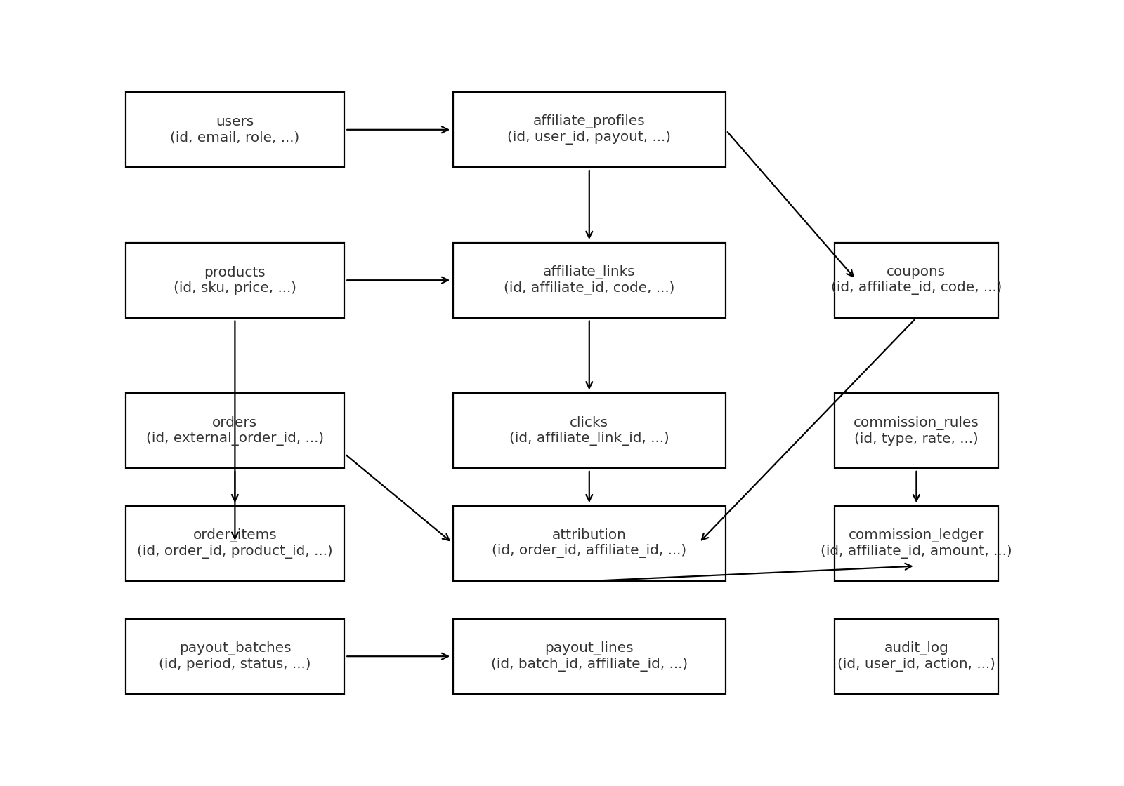

5. Core Flow: Click → Order → Commission
The following flow shows attribution and commission lifecycle after a tracked click.

6. Tracking & Attribution
- First-party cookie at redirect (default 30-day window, configurable)
- Bot filtering (user-agent denylist, velocity caps, ASN checks)
- Attribution policies: last-click wins or coupon priority; first-click/multi-touch as future options
- Manual override per order by Admin with audit trail

7. Commission Engine
- Rule types: percent-of-net, flat-per-item/order
- Scopes: global, category, product, affiliate, time windows
- Exclusions: tax, shipping, gift cards; self-purchase prevention
- Lifecycle: pending → approved (after grace) → paid; reversed on refund
- Multi-currency handling and rounding rules

8. Payouts
Payouts can be done via Stripe Connect (preferred) or PayPal/Wise; batch processing with receipts and status sync.

9. Analytics & Charts (Samples)
Illustrative charts below for the report sections:
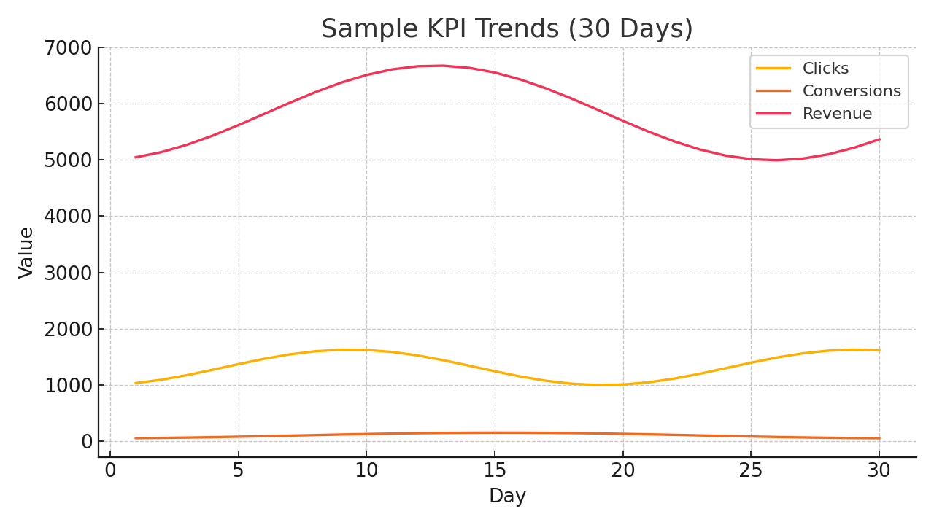
Figure: Sample KPI trends over 30 days (Clicks, Conversions, Revenue).
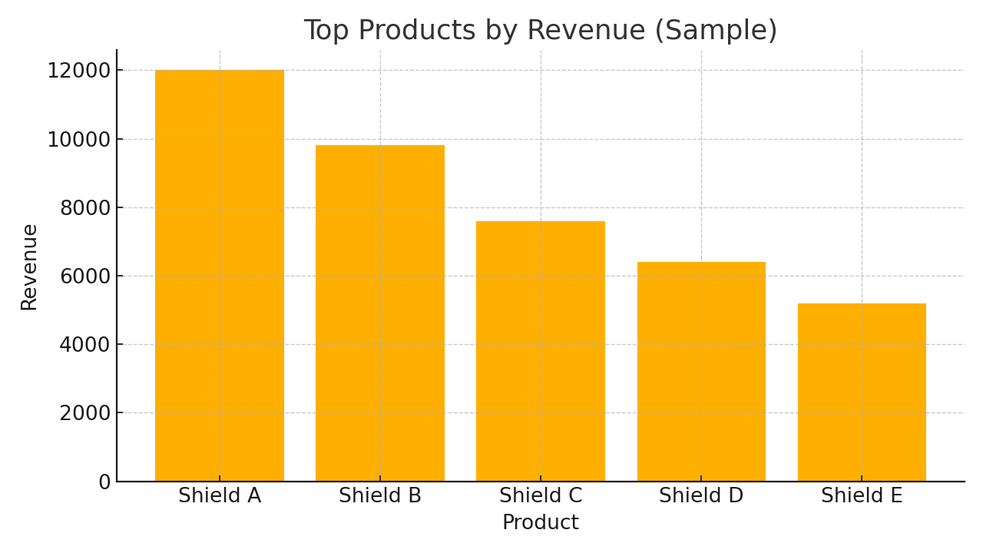
Figure: Sample top products by revenue.

10. API Overview (Selected Endpoints)
Method & Path | Purpose | Role
POST /auth/login | Authenticate and receive tokens | Affiliate/Admin
GET /me | Fetch current user & affiliate profile | Affiliate/Admin
GET /products | List catalog items | Affiliate
GET/POST /me/links | List/Create affiliate links | Affiliate
GET /me/coupons | List coupons owned by affiliate | Affiliate
GET /r/{code} | Redirect + log click | Public
POST /webhooks/orders | Order ingestion | Platform
POST /webhooks/refunds | Refund ingestion | Platform
GET/PATCH /admin/affiliates/{id} | Approve/Suspend affiliates | Admin
GET/POST /admin/commission-rules | Manage commission rules | Admin
POST /admin/payouts/batches | Create payout batch | Admin
POST /admin/payouts/batches/{id}/submit | Submit batch to provider | Admin

11. Security & Privacy
- HTTPS/HSTS, CSP, rate limiting, WAF
- JWT rotation + refresh; optional 2FA
- PII encryption at rest; key rotation
- Consent banner & logs; configurable cookie window
- Audit logs for all admin overrides and configuration changes

12. DevOps & Deployment
- AWS (ALB, ECS/EKS, RDS Postgres, ElastiCache Redis, S3, CloudFront, Secrets Manager, SQS)
- CI/CD via GitHub Actions (lint, typecheck, tests, build, canary deploy)
- Observability (OpenTelemetry traces, logs, metrics) and SLO alerts

13. Roadmap
- Phase 1 (MVP): tracking, catalog sync, orders + attribution, basic rules, dashboards, CSV export
- Phase 2: payouts, refunds/reversals, coupon attribution, fraud checks, audit logs, scheduled reports
- Phase 3: multi-touch attribution, rule simulations, advanced analytics, PWA offline mode

Appendix A – Full Software Requirements Specification (SRS)

Appendix B – API Spec (OpenAPI excerpt)

Appendix C – Database Schema (PostgreSQL DDL)

Appendix D – Commission Rule Examples (JSON)

