category_name

Dress 72158

Tee 36887

Blouse 24557

Shorts 19666

Tank 15429

Skirt 14773

Cardigan 13311

Sweater 13123

Jacket 10467

Top 10078

Blazer 7495

~~Romper 7408~~

Jeans 7076

**~~Jumpsuit 6153~~ (상하의가 붙은 바지)**

Leggings 5013

Joggers 4416

Hoodie 4048

Sweatpants 3048

**~~Kimono 2294~~**

Coat 2120

~~Cutoffs 1669~~

Sweatshorts 1106

Poncho 791

Jersey 748

Henley 716

Parka 676

Jeggings 594

Chinos 527

**Culottes 486 (치마바지)**

Trunks 386

Button-Down 330

Flannel 324

Bomber 309

Anorak 160

Robe 150

Turtleneck 146

Kaftan 126

Peacoat 97

Capris 77

~~Onesie 70 (파자마)~~

Caftan 54

~~Gauchos 49 (유목민들이 입는 옷 – 스커트, 바지 섞임)~~

Jodhpurs 45

~~Sarong 32~~

Coverup 17

Halter 17

**shirt**

Tee 36887

Blouse 24557

Tank 15429

Cardigan 13311

Sweater 13123

Top 10078

Hoodie 4048

Poncho 791

Jersey 748

Henley 716

Button-Down 330

Flannel 324 (털이 보풀보풀 모직물)

Turtleneck 146

Halter 17

Kimono 일부

**jumper**

Bomber 309

Anorak 160

**jacket**

Jacket 10467

Blazer 7495

**vest**

**winter jacket**

Parka 676

**coat**

Coat 2120

Peacoat 97

**dress**

Dress 72158

Robe 150

Kaftan 126 (카프탄 드레스)

~~Kimono (일부만)~~

Caftan 54

Coverup 17

**pants**

Shorts 19666

Jeans 7076

Leggings 5013

Joggers 4416 (조깅할 때 입는 옷..)

Sweatpants 3048 (추리링)

Sweatshorts 1106

Jeggings 594 (스키니..?)

Chinos 527

Cutoff 일부

**Culottes 486 (통 넒은 바지) 일부**

Trunks 386 (남자 수영복 바지)

Capris 77

Jodhpurs 45

Gauchos (일부)

**Skirt**

Skirt 14773

**Culottes 486 (통 넒은 바지)일부**

Gauchos (일부)

**우선 삭제할 것**

* **mini 들어간 것 (mini_skirt, mini_dress) – 3014개**

**mini_dress: 639**

  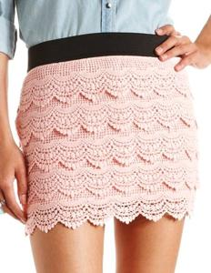

 

Zippered_Faux_Leather_Mini_Skirt, Tropical_Print_Mini_Skirt, Tiered_Crochet_Mini_Skirt, Textured_Damask_Mini_Skirt…

* **Crop_top, crop_tank, crop_tee, crop_sweater, crop_hoodie – 3780개**

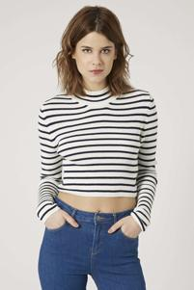 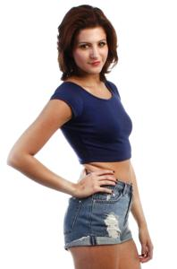 , crop_

V-Neck_Crop_Tee, Striped_Crop_Sweater, Ribbed_Crop_Tee…

* **Cutoffs – 1669개**

  

Sunny_Days_Dip-Dyed_Cutoffs, Solid_Denim_Cutoffs, Ripped_Denim_Cutoffs, Ripped_&_Frayed_Denim_Cutoffs…

* **Skater 들어간 것(skater_dress, skater_skirt) – 4264개**

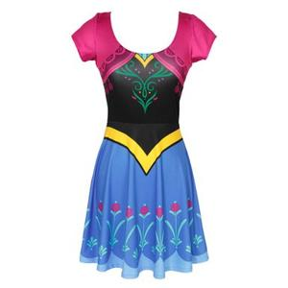 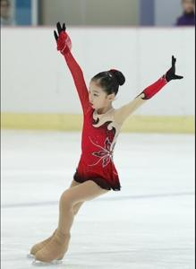 

Windowpane_Print_Skater_Skirt, Wild_Rose_Skater_Dress, Watercolor_Rose_Skater_Skirt…

Skater_dress: 2643

* **Sarong - 32개**

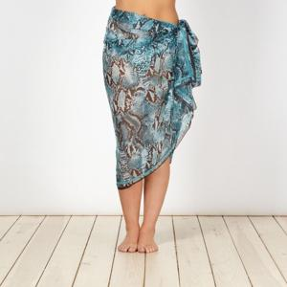  

Water_Print_Sarong

* **Onesie – 70개**

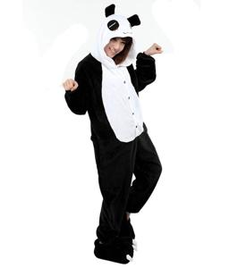 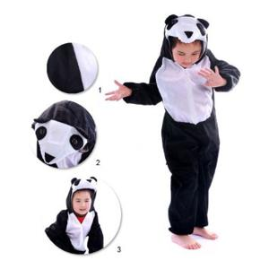 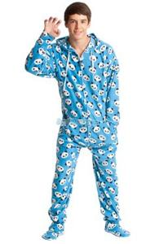

Panda-Hood_Pajama_Onesie

* **Shorts 중 짧은 바지 – 16358**

  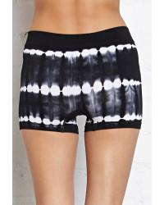 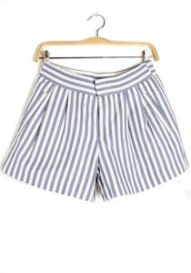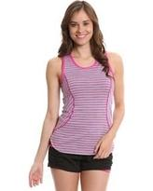

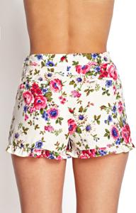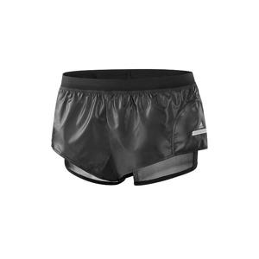

Zippered_Faux_Leather_Shorts, Zipper-Front_Shorts, Zippered_Denim_Shorts,

Woven_Running_Shorts, Woven_Pleated_Shorts, Woven_Dolphin_Shorts,

Wildflower_Denim_Shorts…..

* **Romper – 7408개**

 

ㄴㅇ

* **Jumpsuit - 6153개**

**Dress..? pants..?**

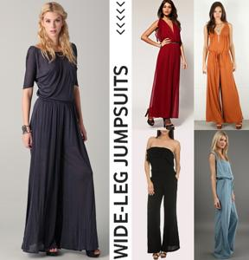 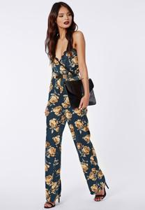

* **Kimono – 2536개**

**Dress..? shirts..?coat…?**

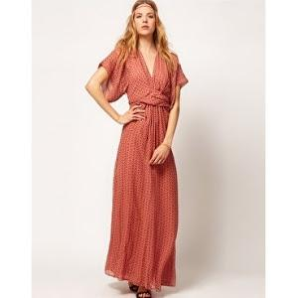 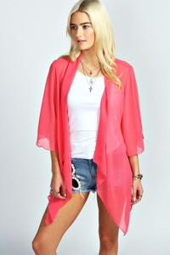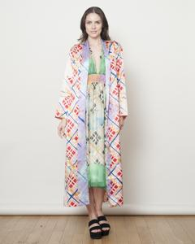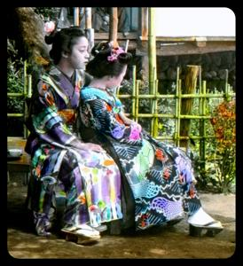

* **Cardigan**

**Jacket? Shirts?**

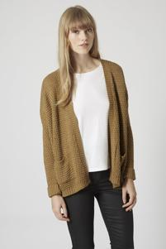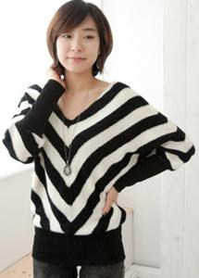

Dress:

* Mini_dress: 639
* Skater_dress : 2643

Skirt:

* Mini_skirt: 2465
* Skater_skirt: 1621

Top:

* Crop_top: 1867

Tank:

* Crop_tank: 417

Tee:

* Crop_tee: 542

Sweater:

* Crop_sweater: 640

Hoodie:

* Crop_hoodie: 150

Shorts:

* 짧은바지: 16358

Turtleneck:

* Crop_turtleneck: 53

Cutoffs: 1633

Romper: 7408

Jumpsuit: 6153

Kimono: 2536

Sarong: 32

Onesie: 70

289220-244654

**44566**