**Python In Finance Lab1**

**Software Installation**

**System requirement**

==================

**Hardware requirements**

32- or 64-bit computer.

Minimum 3 GB disk space to download and install.

**Software & system requirements**

Client environment may be Windows, macOS.

User Admin rights is required on the operating system.

1. Download the Anaconda software based on your Operating System from : <https://www.anaconda.com/products/individual>

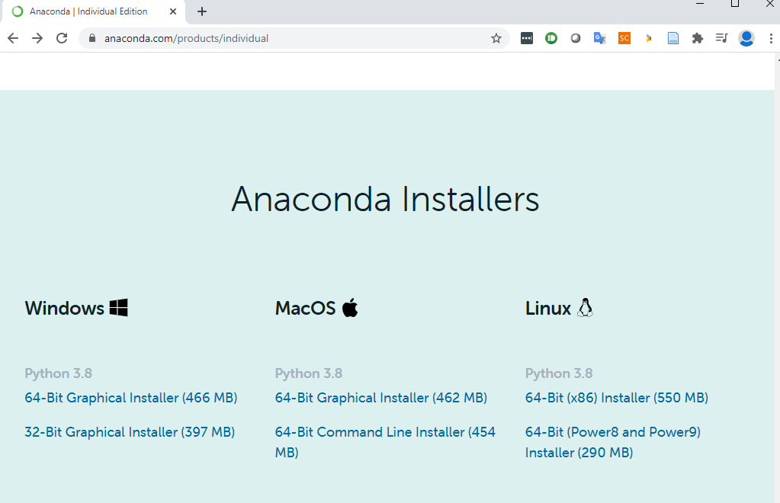

1. Install the Anaconda

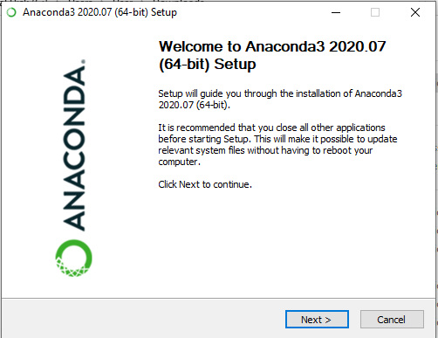

Select Next

1. Install Location

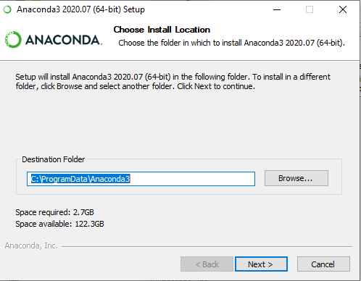

Keep the default installation location and select “Next”

1. Start Install

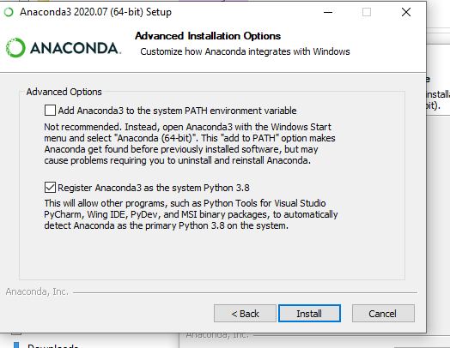

Select “Install” to start the installation

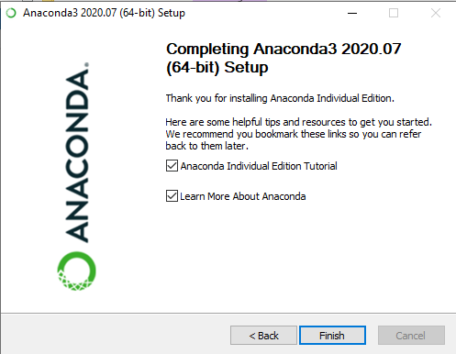

When install completed, select the “Finish” .

GIT

1. Download the GIT Git-2.29.2.2-64-bit version from: <https://git-scm.com/downloads>
2. Install the GIT

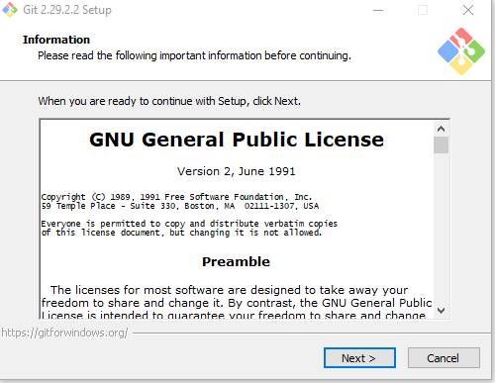

Select “Next”

1. Install location

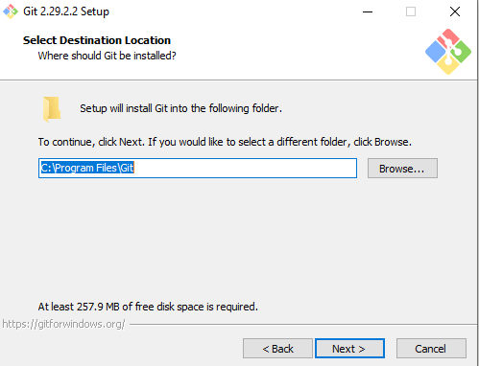

Keep the default installation location and select “Next”

1. Install component

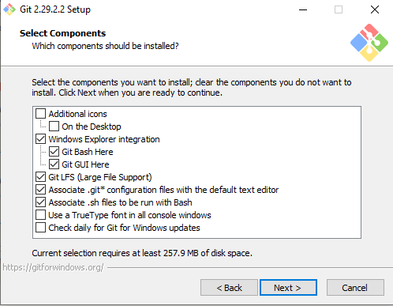

Keep the default option and select “Next”

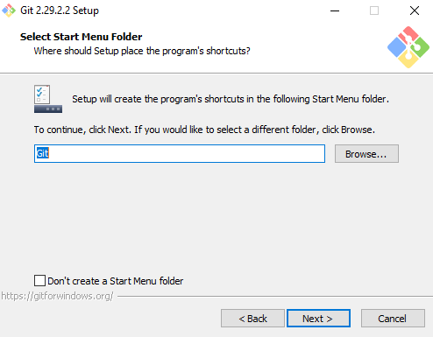

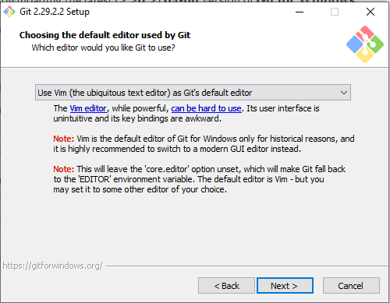

Keep the default setting and select “Next”

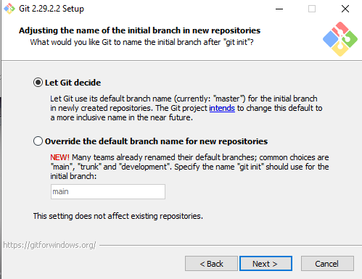

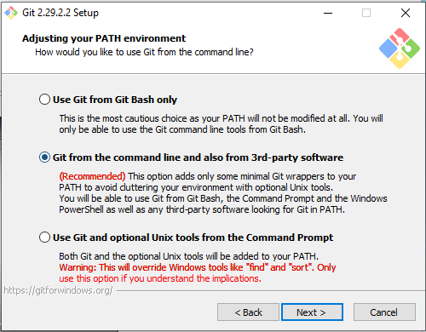

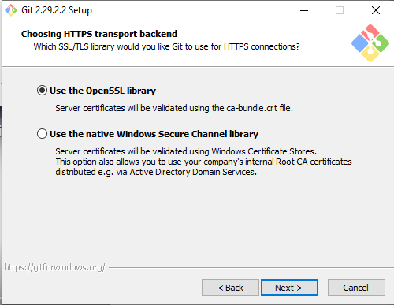

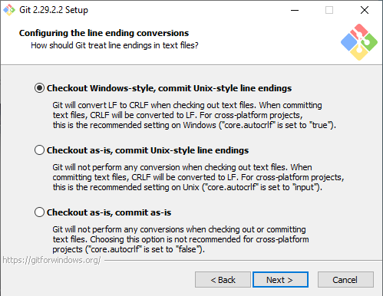

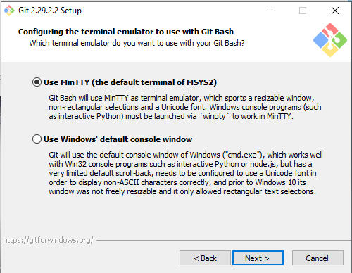

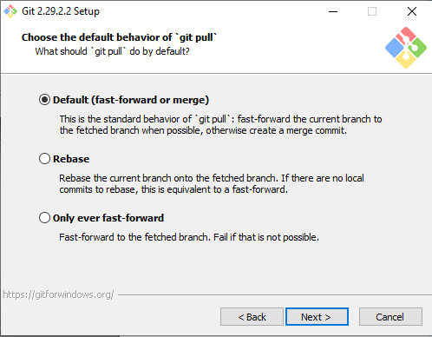

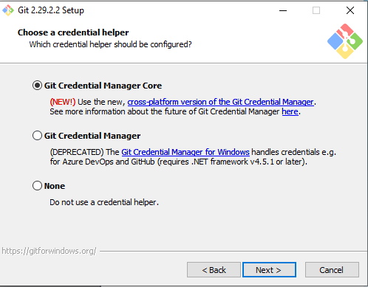

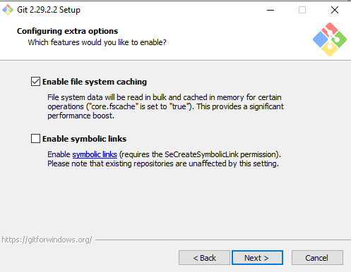

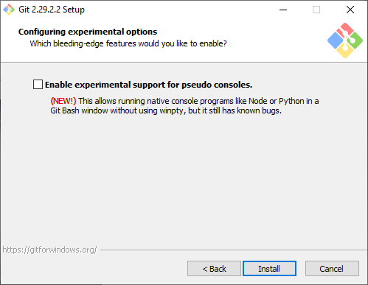

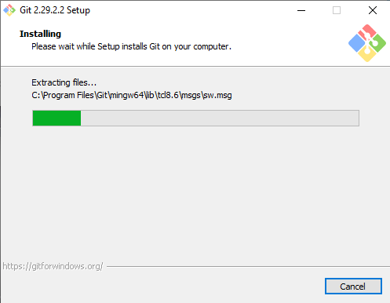

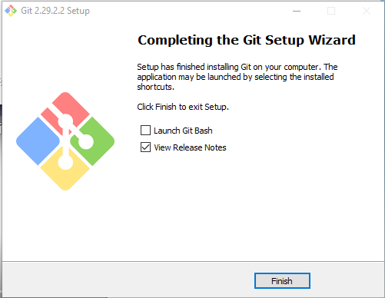

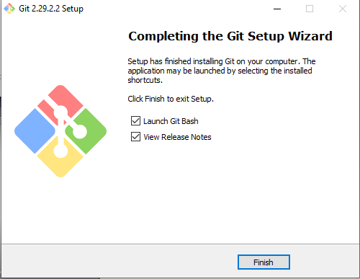

Register a new account in GITHUB

Open browser and go to <https://github.com/>

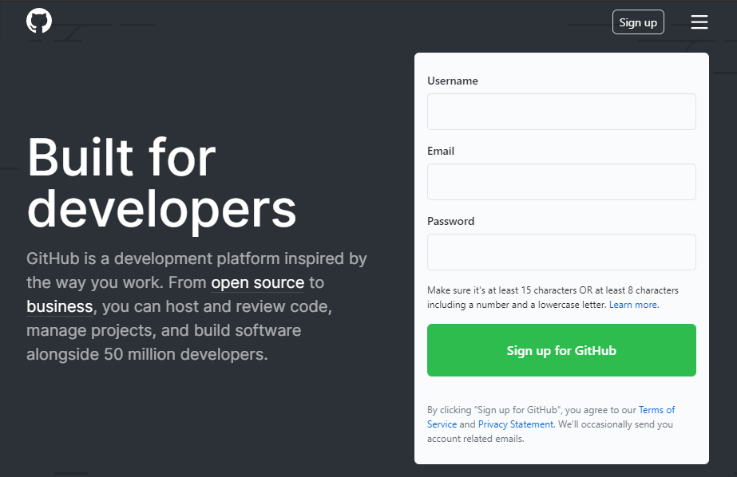

Enter a Username, Email and Password, then select “Sign up for GitHub”

Once the registration completed, please share your account name or email with the course lecturer.

**My SQL**

**SQL Bench**

**Zoom**

Got URL: <https://zoom.us/signup>

Create a new user account

Go to URL: <https://zoom.us/download> select “Download”

Double click the downloaded “ZooInstaller.exe” the Zoom will be installed automatically

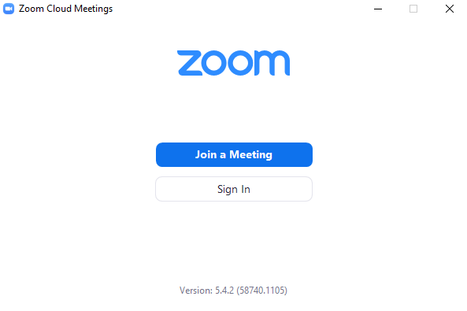

Select “Sign In”

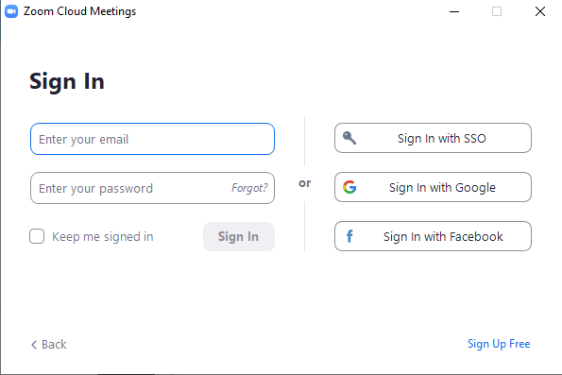

Enter your email and password to sign in your account

Reference to read:

How to Join a Zoom Meeting

<https://www.youtube.com/watch?v=wo1l6Ijz_wg>

Learn Git In 15 Minutes

<https://www.youtube.com/watch?v=USjZcfj8yxE>