**Python In Finance Lab2**

1. **Download/Setup repository**

**1.1 Direct download project**

1) Log into [www.github.com](http://www.github.com) with your credential

2) Browser into URL: <https://github.com/starswish2100/pythoninfinance>

3) Make sure you have the access to this repository

4) Click the green “Code” button then choose “Download ZIP”

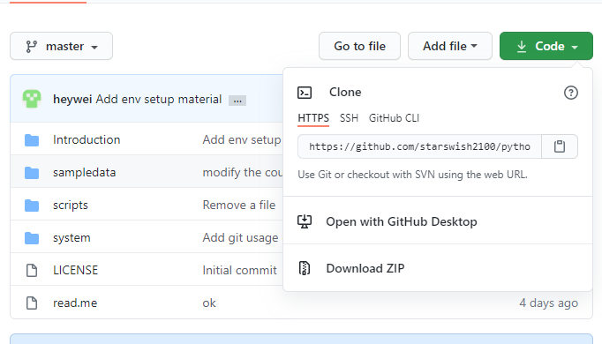

5) Save the Zip file under your chosen folder and unzip the content.

**1.2 Sync the project using GIT**

1. Open Git Bash from Start menu
2. Run command “pwd” and keep a record of your current directory

User@DESKTOP-4Q5SFJV MINGW64 ~

$ pwd

/c/Users/User

1. Go to the desired directory where the project is to be save. E.g “Desktop”

User@DESKTOP-4Q5SFJV MINGW64 ~

$ cd Desktop/

1. Checkout the Project directory

User@DESKTOP-4Q5SFJV MINGW64 ~/Desktop

$ git clone <https://github.com/starswish2100/pythoninfinance.git>

Note: you can copy the URL by clicking the code, and then the copy sign highlighted below



1. Cloning into 'pythoninfinance'...

~~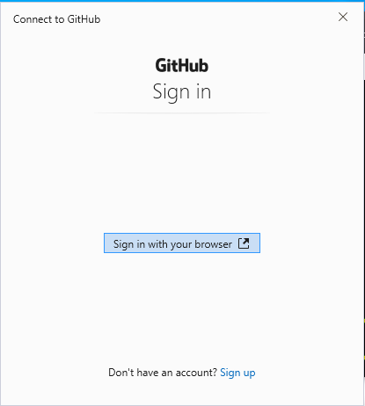~~

1. Select “ Authorize GitCredentialManager” 
2. Type in the password and select “Confirm password” 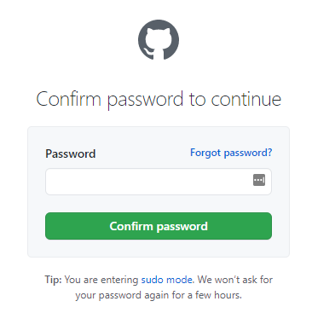
3. Browser will redirect and the GIT Bash will display below code checkout

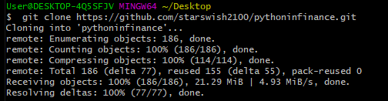

1. **Anaconda and Jupiter Notebook**

**2.1 Start Anaconda and Jupyter Notebook**

1) Open the “Anaconda Prompt (Anaconda)” form the Start menu

2) Type “Python -version” to check the python version

3) Type “conda info” to check conda version

4) Enter the Desktop\pythoninfinance folder

cd Desktop\pythoninfinance

5) Type “jupyter notebook”

(base) C:\Users\User\Desktop\pythoninfinance >jupyter notebook

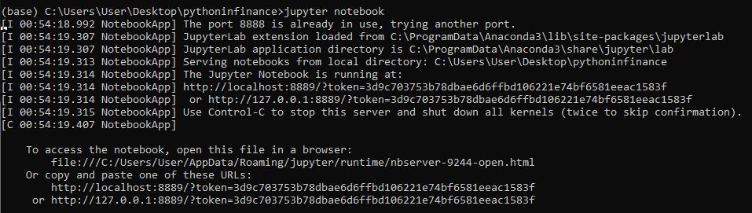

6) Keep the Anaconda prompt running. The default browser is redirected and start up on the screen

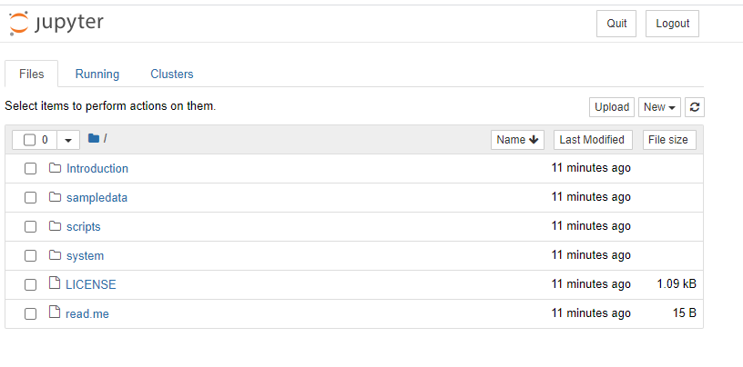

**2.2 Jupyter Exercise**

Here is a quick Jupyter notebook exercise to help your get familiar with the Jupyter notebook

**- Create a new notebook**

Select "New" -> "Python 3"

**- Execute a Python command**

type below in the box

**print("Hello World")**

press "Shift"+"Enter" to execute

**- Add a new cell before the current cell**

press"Esc" + "a"

**-Add a new cell after the current cell**

press"Esc" + "b"

**-Save the notebook**

select "File"-> " Save as", provide a file name to save. File name is usually save with *.ipynb suffix.

**-Create markdown cells**

Markdown is very useful for the annotation

Create a new cell, then select “Cell”->”Cell Type”->”Markdown”

Type “##Loading Data”, press “Shift” + “ Enter” to see the effect. (this creates a secondary heading)