New Facs Graphs

4/14/2014

control

Great!

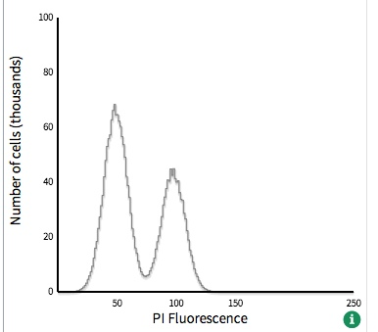

               function g0g1(x) {

                return normal_dist(x, 0.78, 0.08, 4, false)*2;

            }

            function g2m(x) {

                return normal_dist(x, 0.39, 0.08, 1, false)*3 ;

            }

g0g1(x + bias) + g2m(x + bias);

#5

The tail on the right side of the graph is better. Is there anyway that you can create more of a "bump" on the left side of the graph while keeping the point where it starts on the x-axis?

normal_dist(x, 0.2, 0.27, -25, true)* 0.7;

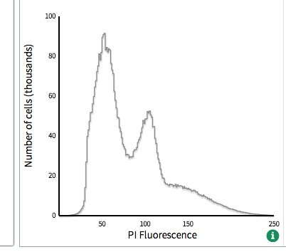

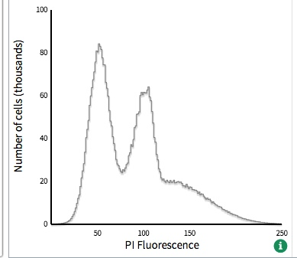

g1(x + bias) + g2(x + bias) + g3(x + bias) ;

            function g3(x) {

                    return normal_dist(x, 1, 0.32, 1, false)*0.77;

            }

            function g2(x) {

                return normal_dist(x, 0.85, 0.14, 3, true)*0.5;

            }

            function g1(x) {

                    return normal_dist(x, 0.38, 0.09, 1, false)*0.85;

            }

#2

This is great!

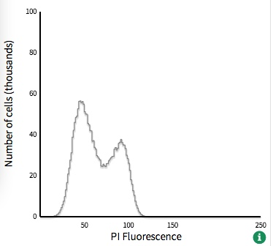

            function g2(x) {

                return normal_dist(x, 0.83, 0.165, 3, true)*4.1;

            }

            function g1(x) {

                    return normal_dist(x, 0.31, 0.14, -2, true)*6;

            }

g1(x + bias) +  g2(x + bias);