StarCellBio_dev_page_review

4/16/2014

**Note - the StarCellBio icon in the upper left corner takes me back to the starcellbio.mit.edu homepage, and off of the dev page. I may have then written some things down by mistake - I think I caught everything, but let me know if you think you fixed something that is still on the list.**

**Bugs**

When I click on the StarCellBio icon in the upper left corner (and am signed in), the homepage flashes and then it takes me to the assignment page.

Is there a reason why I can't see the homepage and stay signed in? Yes, this was done intentionally. The homepage includes links to creating new accounts and trying experiments, links which would not make sense or work properly within a student account. The default view for a signed in account is the Assignments Page. If you would like this to change, then we should probably talk about handling the links on the homepage that are not useful to a signed in user. So this means that if you are logged in, your "homepage" is the assignment page? Correct, because bringing you back to the main page is not useful, because most of the links (like Try Experiment, create Student Account, create Instructor Account) are not needed and cannot be used once you are logged in.

BUG: I can't select another sample to view under the microscope in the Samples window I don't see this problem… It seems to be working for me now.

Bug: In the microscopy prep page of the microscopy analysis, if there is only one Condition, then it should be automatically labeled. (For example, p53fl/fl;Rb fl/fl; AdCre; 3 months, IHC)

Bug: in the experiment setup table of the microscopy test assignment, if I copy a sample and then try to edit the collection time point, I cannot change the time point. It always defaults to the originally-selected time. I didn't get this error. Can you show this to me later? I just did :) Done

**Overall Formatting**

The StarCellBio window is currently right of center in the web browser window

Remove the blue outlines that appear around all the buttons when selected Check the particular icons that had this blue border. I removed the border on all icons, but just check to be sure. They are still appearing around the buttons in popup and error messages. Some of these windows only have one button (for example OK) and so we don't need the blue highlight. In other cases where there are two buttons, the blue outline provides a recommendation to the user on which button we think they should click. Maybe there's another way to indicate the suggested button? The blue highlights also appear around the Create student account, Try an Experiment, etc links on the homepage.  I've removed the blue highlights on the homepage links, but other than changing the color of the outline, there really isn't another way to indicate the recommended button on the error/popup windows. The blue outline is a universal sign of which button is in focus (i.e. the button that will respond to keyboard clicks, like clicking Enter on an OK button). The problem with removing the blue outline is that even though the user can click Enter on the keyboard and even though a particular button is in focus, there is no visual representation of this focus.

 I can remove the blue outline, but there really isn't another seamless way to indicate the recommended button, other than changing the outline color. **I think that we can differentiate with a different background color on the button instead of the blue outline. I'll ask Jamie if she has a recommendation for a different background on these types of buttons. For example, this one that Ivan put in the new StarGenetics:  Ok, just let me know what to do.**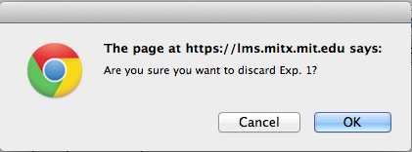

Reduce the width of the "Library" link in the top header bar. The spacing on the left looks great, but reduce the space on the right to match.

Move the "Contact" icon and text down to align with the Library and User Guide text.

**Sign In**

If you sign in after "trying an experiment" a dialog window should appear saying, "If you sign in to your account, you will lose your current work as a guest. Would you like to continue?" The options should be yes/no. This message should appear before the sign in window appears. Then once the user signs in (or creates an account and signs in), no message should appear.

**Assignments Page**

The hover states appear on the left and right arrows (next to the pages at the top and the arrows at the bottom of each assignment page) even if you can't click left/right anymore . I don't see the hover states for the arrow sin the top bar that contains all of the names of each page, but I do still see the hover states for the left arrow at the bottom of each page when the assignment first loads. But once you click through the pages, the hover states all show up correctly. I corrected this, but the hover states are not suppose to show up when the button is disabled. On the first load, because the window starts at the leftmost section, the left arrow at both the top and bottom are disabled initially, the right arrows still have the hover state. It's working now!

**Experiment Setup**

Once "Create new set-up" is selected, the text moves down slightly. (I notice that this happens with several radio buttons throughout the program - for example gel type in western blotting)

The headings are mis-aligned in the setup table for many assignments. The heading should be left aligned with the text in the column. The headings are still misaligned once you click "Create new setup" but before you click the Add samples button. The headings are in the same position before and after the setup. What is misaligned? Oops - my mistake. Strains seemed more inset than it needs to be.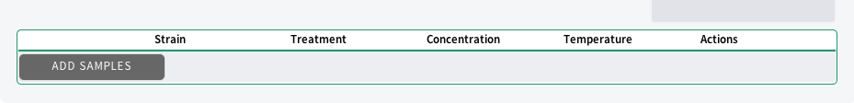

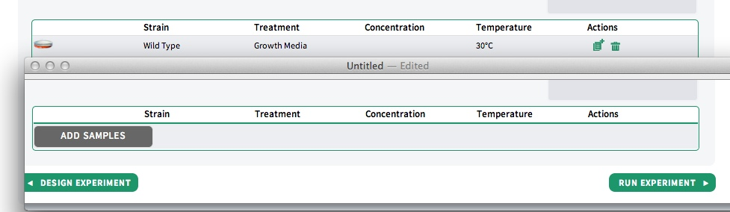

Headings are appearing that shouldn't appear in some assignments -  for example, StarCellBio usability assignment Which heading in the usability assignment shouldn't be there? I included the concentration as blank from the beginning. Any headings that are in the assignments are there intentionally; let me know which ones to remove, and I can remove them. Concentration should not appear in the usability assignment as there are no values in that column. This change has been made, but you cannot see it until I clear the database. Ok

**Navigation Bar**

Have the top and bottom of the white arrow lines between the elements in the navigation bar meet the top and bottom of the navigation bar

Move the arrows slightly to the left so that the arrowhead is not so close to the number.

**User Guide**

In the first pop up window that appears, can you force a scroll bar to appear so that users know they can scroll down?

**Progress Bars**

The diagonal gray lines are extending past the labeled steps on the progress bar

**Western Blotting**

The checkmarks take some time to show up once checking the box in the sample prep table. **The delay still seems pronounced when checking individual checkboxes if there are a lot of samples in the list. I was using the first assignment from 7.06 this spring with all of the possible samples from the experiment setup. There doesn't seem to be a significant delay, at least when I tried it with this problem set. Could you show me the example?**

Gel type/Samples window - the left margin is greater than the right margin. Can you move the items to the left slightly? (I also think this change will be needed for users who always have a scroll bar visible and for cases where we have a lot of samples and a scroll bar is needed.) I've changed the margin outside the window, but did you mean the margin inside the window also? I was referring to the margins inside the window, not the outside. I reverted the outer margin and fixed the inner margin.

Format the hover states of the re-ordering arrows to be like the hover states on the assignment page. The arrow should always be white, but the background color changes to different shades of gray. Can you also format them like the arrows that appear at the bottom of each assignment page (slightly rounded corners, with a thin black outline, and have them abutting one another)

Divide the "Load gel" button from the samples window with a horizontal line (like "Run" in flow cytometry and "load" in microscopy)

We need to discuss this: Protein measurement tool and sizes of bands on the gels.

Marker bands after Run Gel & Transfer - missing the 20 kDa band in the 10% gel

Move the label "kDa" up so that it doesn't run into the marker labels on the 15% gel

Protein measurement tool is showing the incorrect sizes based on the ladder labels on the right side for the 15% gel

**Flow Cytometry**

The checkmarks take some time to show up once checking the box in the sample prep table I don't see this problem. What is the case in which it occurs? Are there multiple tabs open? How many samples are in the list when this occurs. I think I was referring to when you click Select all with a lot of samples but this may refer more to the microscopy technique. Done

In the Sample Prep table, the radio button should not appear selected until the sample is selected. Then the dot can appear inside. I think in other techniques, the unselected radio buttons appear as just an outline. Is that right?

The bottom of the "Run Samples" button is cutoff

I clicked "Run Samples" and it automatically selected the bottom sample in the list instead of the first sample in the list.  I don't see this problem. What is the case in which it occurs? I couldn't recreate this, but I'll let you know if I can.

**Microscopy**

The checkmarks take some time to show up once checking the box in the microscopy prep table I don't see this problem. What is the case in which it occurs? Are there multiple tabs open? How many samples are in the list when this occurs. This happens when I click Select all with a lot of samples (for example the first 7.06 assignment from this spring). Done **There is still a delay in the microscopy technique when there are a lot of samples and I click on an individual checkbox. I was using the 7.06 assignment #1 from this spring and I had all of the samples in the window. The delay with the "Select All" button seems better. There doesn't seem to be a significant delay, at least when I tried it with this problem set. Could you show me the example?**

If the focus feature is inactivated, then the horizontal lines between should also appear gray I mentioned this to Lourdes a while back; I will need icons from Jamie for the two sets of three lines, since the lines aren't drawn individually, but altogether in single images. **Ok we'll talk to Jamie.**

When opening the "?" icons in the microscopy analyze page, the image in the microscope viewfinder flickers

Brightness icon - show the user where he/she is on the brightness scale by only having green vertical lines up to the brightness level point. Then have gray vertical lines on the other side. It seems like there are more brightness levels than indicated by vertical bars. Is this true? It seems true - especially near the "white" end of the brightness spectrum. I would click it two times before I saw another green line appear. - There are actually 30 degrees of brightness. 9 below normal and 20 above normal. The reason that there are more above normal is because reducing the 20 degrees to 10 would create a significant jump in brightness for each line. The issue I have is that there are 18 lines on the scale, so I can either pick a set of 9 degrees above normal and make each line correspond to one of those, or I can use the current scale and just make each line worth ~2 above normal. I realize that my current method causes this problem, so let me know what you would like me to do. -I think the brightness scale going from the "normal" state to dark works really well. Let's try the same thing for the light side of the scale too - which means going to 9 states above the normal stage. Then I think that each stage will correspond to a line? Done

I don't see the laser filter selected when looking at light microscopy images. I thought that we were going to have a selected filter, but the selected filter is just irrelevant. (I was looking at the microscopy test assignment when making this comment) Actually, now they show up - but they didn't show up UNTIL I looked at an IF image. Even though I did try to turn the light off and turn the laser on while looking at light microscopy images. **This is working for me, but Lourdes is detecting a bug for this. Refer to email**

Navigation arrows - if you click and hold a navigation arrow, can you continue to move the image and move the image more quickly?

When selecting microscopy analyses at the bottom of the setup table, it takes me back up the top of the setup table.

Don't close the message that appears after you click Load, until the user clicks the "x" box. It closes for me automatically if I go click on the "?" icon.

Add in a hover state for the "X" in the upper right corner of the message that appears once you click Load.

When I view an IF image after viewing a bright field image and I turn the laser on, the brightness automatically turns all the way to the dark setting (without me adjusting it). The left arrow is gray, but the green lines still appear. In the case of the microscopy assignment where students are switching between many images of different types, I don't think the brightness should automatically adjust. This means that the IF image won't be apparent until the image is almost very dark (brightness turned almost all the way down) or until the light is turned off.

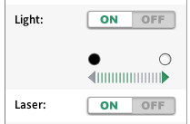

**Future To-Do**

Create "hover states" for all buttons. Will need to ask Jamie what colors to use for this.

Lab Notebook - can you format the window that appears saying that the Lab Notebook is under construction in the same manner as our other error messages?

Minor overall formatting: I notice that elements on the page move when switching back and forth between experimental techniques. It is particularly noticeable for the navigation bar - between western blotting and microscopy for example Fixed the navigation bar drifting

Be able to move the microscopy image around the viewfinder by clicking and dragging.