

**BF2 Statistics 2.0.0 README**

Written By: Wilson212

Table of Contents

**1. Intro2**

1.1 Introduction2

1.2 Requirements2

1.3 References2

**2. Installation Part 1: Web Files3**

2.1 Installing WAMP (Windows Only)3

2.2 Setting up the ASP7

2.3 Bf2sClone10

**3. Installation Part 2: Client and Server Files11**

3.1 Client Files (Windows Only)11

3.2 Server Files13

A. Windows13

B. Linux14

**4. Upgrading An Existing BF2Statistics Install15**

**5. Configuring BF2Statistics16**

5.1 Basic Settings16

5.2 Backend / Central ASP Settings17

5.3 Clan Manager18

**6. Playing BF2Statistics20**

1. Intro

### Introduction

"BF2Statistics is designed to enable a server admin to run their own Private Statistics system for EA's Battlefield 2 game. It aims to emulate the functionality of the official statistics system included in the game. However, as it is controlled by the server admin, it can easily be customized to suit a particular need/purpose (ie, LAN Sessions, Private Clans, etc...)."

Bf2statistics was a project started back in 2006 by MrNiceGuy, Chump, and **Twhyman. Since then the project has had a few more devs including, but not limited to** nylOn, Wolverine, TheShadow, and myself. Today I bring the last Major update for bf2statistics that I will release, as I myself am starting to take a turn in my life, and move on to bigger and greater things :) . I hope this README provides you with all the information to get your own BF2statistics enabled server all setup and ready to go!

### Requirements

Here is a list of requirements to get your bf2statistics system up and running

* Battlefield 2 Dedicated server, Patch 1.2 or newer
* An Apache server
* PHP version 5.3.2 or newer
* MySQL version 5+

This installation package comes with a WAMP server, which meets all these requirements. If you plan to use the included BF2Statistics client launcher, and server control panel, you will also need to install the .NET framework 4.0, which comes recommended by Microsoft, therefore it might already be installed.

### References

BF2 Statistics Website: <http://bf2statistics.com>

BF2 Technical Information: <http://bf2tech.org>

2. Installation Part 1: Web Files

### Installing WAMP

Included with this package, in the "Tools" folder is a copy of WAMP 2.2e. In my opinion, WAMP is a much better choice than Xampp, but you may choose to use whichever program you wish. You may use the included WAMP installer, or you may download a new / older version from the Official WAMP website: <http://www.wampserver.com/>. If you have your XAMPP or your own Apache / Mysql server installed, you may go ahead and Skip this section, and use that instead.

This first step, is to open up, and install the WAMP server. You will be presented with the screen below:

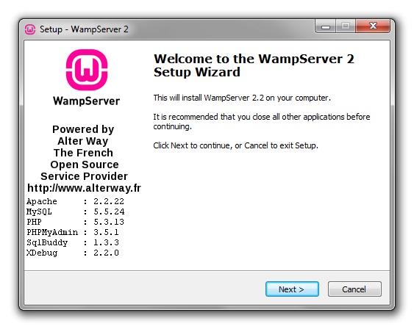

Click "Next >" to begin the installation. Go ahead and go through all of the screens to finish the installation.

Once you have finished installing WAMP, go ahead and start it up. You will notice a new Icon in your task menu that looks like so:

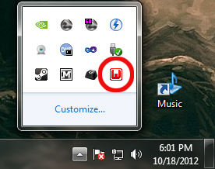

The red W will turn from Red ( Services Offline ), to Orange ( Not all Services are running ), and Finally to Green ( All Services are running ). If the icon fails to turn green, and is stuck on orange, it means that you probably have another program using one of the ports. If you have Skype or Team viewer running in the background, this could be preventing the Apache server from starting, or if you have an Apache or MySQL server currently running, the they are probably preventing WAMP from running as well. If Skype is the issue, you can Google ways to have skype use a different port instead. Once the Icon is green and running, left clicking on the icon will bring up the context menu tray:

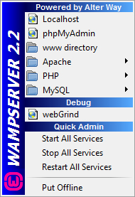

The WAMP menu has all the tools you need to run your WAMP server. The first thing you should do, is Set the MySQL password, as currently... Well, there isnt one. To setup the MySQL password, We need to open up the MySQL console from the WAMP menu as shown below:

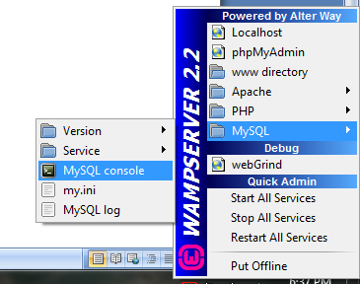

A black screen will popup that says "password: ". Since there is no password, simply just hit the enter key to continue. Some new information will display on the console screen, and flickering underscore to show that the console is waiting for your command. The command to set your password is:

**SET PASSWORD FOR root@localhost=PASSWORD('<your password>');**

You will need to replace the <your password> with your password. You should see something print out like this:

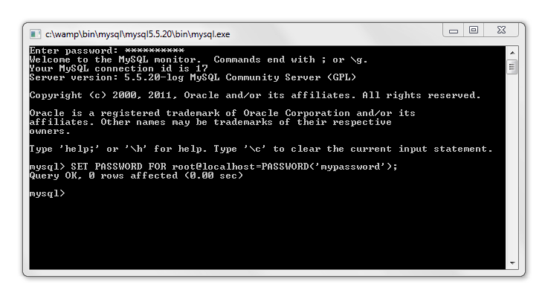

As long as you see this line in the console window "Query OK", Your WAMP server is all setup, and ready to roll :) .

### Setting up the ASP

Now that you have your WAMP server installed and running, It's time to actually start installing Battlefield 2 statistics on your server. First, navigate to your www (or htdocs) folder. If you are using the WAMP server, this can easily be done by opening your WAMP context menu tray, and selecting the option "www directory". You will need to copy over the ASP folder located in this package under the "Web files" folder, into your www/htdocs folder. **NOTE: The ASP must be located in the ROOT of your www folder!** You may optionally also copy over the bf2sclone folder, which is a clone of the [bf2s.com](http://bf2s.com) website, and can be used to view your stats online.

Ensure the following files/directories have read/write access by PHP (CHMOD 777):

* /ASP/system/config
* /ASP/system/config/config.php
* /ASP/system/database
* /ASP/system/logs
* /ASP/system/logs/admin_event.log
* /ASP/system/logs/merge_players.log
* /ASP/system/logs/php_errors.log
* /ASP/system/logs/stats_debug.log
* /ASP/system/logs/validate_awards.log
* /ASP/system/logs/validate_ranks.log
* /ASP/system/snapshots/processed
* /ASP/system/snapshots/temp

If you are using WAMP / XAMPP under windows (XP, Vista, 7, 8), these file will automatically have Read/Write access to them, so you will not need to worry there. You will also need to configure your web server to process ".aspx" files. For Apache based systems (including WAMP and XAMPP), this should be automatic (via the .htaccess file). For IIS (and others?) you will have extra work to do. For IIS6 users (IIS5.x systems should be similar...):

1. Start "Internet Information Services" Manager
2. Navigate to your web site (ie, "Default Web Site"), right-click t and choose properties
3. Select the "Home Directory" tab, and Click "Configuration..."
4. In the "Applications Extensions" list edit ".aspx" (if it doesn't exist, simply add it)
5. Change the "Executable" to be the same as what your ".php" files use (ie, C:\PHP\php.exe, C:\PHP\php4isapi.dll, or C:\PHP\php5isapi.dll)
6. Set "Verbs, Limit to:" to GET,POST,HEAD
7. OK all windows. Done!

Before you begin the ASP installation process, you will first need to create your bf2stats database. To do this, you can either use the MySQL console, or you may use PhpMyAdmin if you have it (WAMP users do have PhpMyAdmin). To open PhpMyAdmin, Open your WAMP context menu (tray icon), and select the option "PhpMyAdmin". Your browser will be directed to the PhpMyAdmin login screen... You will need to login with the same password that you created earlier in this readme. Once logged into PhpMyAdmin, you will see a navigation bar at the top... Select the "Databases" menu option. Fill out the information to create the new bf2stats database. You may type whatever database name you wish, just remember it later ;)

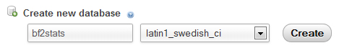

Now that you have your bf2stats database created, and you have copied the ASP over to your www directory, Open up your web browser and enter this URL <http://localhost/ASP>. If all is well, you will be fronted by the ASP login page. Note: If you are browsing from a remote machine, please change the value of "$admin_hosts" in" /ASP/system/config/config.php" to include your IP address. The default login information for the ASP is "admin", and the password is "admin" as well. Just take note that the login information is case sensitive, so make sure you have CAPSLOCK turned off. After you have successfully logged in, you should see a notification message above like so:

5---ASP-Notification.jpg

Click the link to begin the installation process. There are tooltips that will popup when you click on an input field that explain what information you are required to input. Once you have finished filling out the install form, click "Next" to begin the installation. The next step is to edit the configuration options for the ASP. Look for the navigation item entitled "Edit Configuration" under the "System" navigation pane. Once you are finished with that, it's time to see if you ASP is ready to start receiving stats. Click the "Test System" link under the "System" navigation menu. After this, click the "Run System Tests" button to begin. A popup will display letting you know that the server is working, and to wait patiently. Once finished, you will see a list of what was successful, and what failed during the test. If all options are green (or at least yellow), your system is good to Go! If you have any errors, there will be a good explanation there on how to fix the problem, and get your ASP in full working condition. Ideally, you want your screen to look like this:

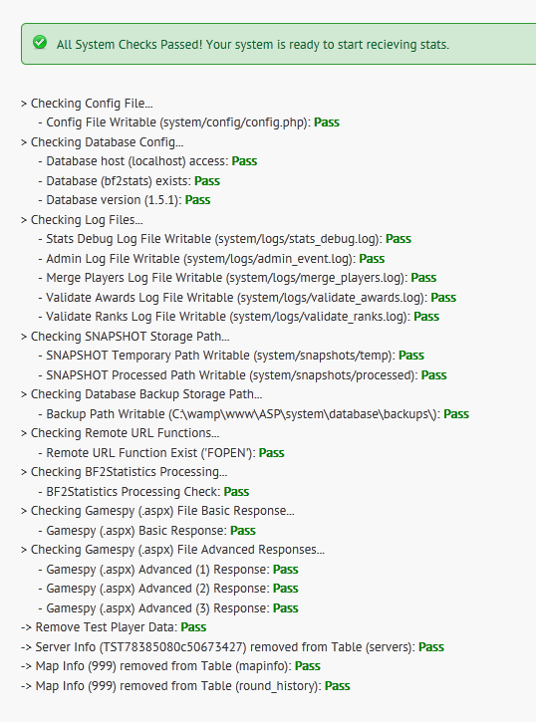

### Installing bf2sclone

Included with this release is a copy of bf2sclone. Bf2sclone is a clone of the official bf2s stats website, that allows you to view you bf2statistics in your web browser. If you wish to use bf2sclone, just copy the bf2sclone folder over to your www/htdocs folder, and enter the URL in your browser to the bf2sclone location (example: <http://localhost/bf2sclone>). You may wish to change the bf2sclone folder name, and that is completely fine, take note however that it will also change the URL you need to enter to get to it. You will automatically be redirected to the install page. Just enter your database information, and your good to go. Just make sure to delete the **install.php** file after installing, so nobody can mess with your website ;)

3. Installation Part 2: Client and Server Files

### Client Launcher (Windows Only)

Because of BF2Statistics, In Patch 1.3, EA implemented a system that would prevent people from emulating the stats system. What exactly did they do you ask? Well quite simply, all they did was add a HOSTS file check. The windows HOSTS file is used to map hostnames to IP addresses, which is primarily how bf2statistics operates. I get into more detail about this later in the guide, but back to the point... Luckily for us, It isn't too difficult to implement a work around for this HOSTS file check.

The Battlefield2 Statistics client launcher has a feature that can lock the HOSTS file, and prevent the BF2 client from being able to read it. The BF2 Statistics client launcher is located in the "Client Files" folder, and to install it, just place it inside the root of your BF2 installation folder (same location as the BF2.exe). You will also need to copy over the "**SetACL.exe**" file over, as this is the file that Locks and Unlocks the HOSTS file. Whenever you want to play BF2 with your BF2 statistics enabled server, just launch the game from this GUI ( you might want to make a shortcut on your desktop ;) ). In order for your BF2HQ and Stats to work properly, The HOSTS file redirection must be on AT ALL TIMES while the bf2 game is running.

Let's talk about the BF2Statistics client launcher GUI. Examine the image below:

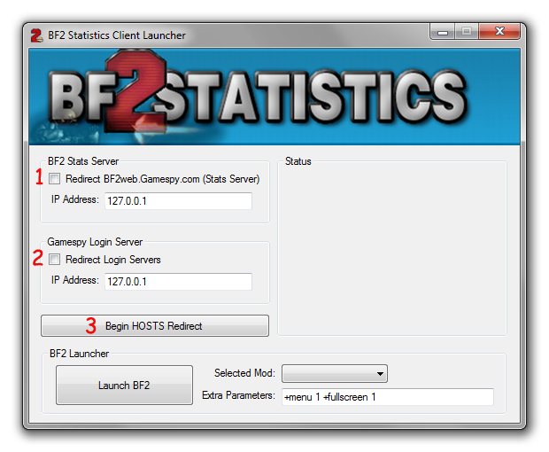

The red #1 and #2 indicate which redirects you want to write to the HOSTS file. When using a bf2statistics enabled server, you must ALWAYS have #1 checked. bf2web.gamespy.com is the backend address in which the BF2 client connects up to when retrieving you're in game stats, as well as update your score and earned medals after every round. The red #2 is only to be checked when using the Gamespy login emulator. I won't get into detail here, but IF you are using a login emulator, you would also check this box, and redirect the BF2 clients query on the account servers. Once you have checked which redirects you are going to use, you will then click on the #3 button. When this button is clicked, the GUI will write the new data to your HOSTS file, and remove all read permissions for the USER group. It's important to note that you DO NOT want the BF2 client running as an administrator! Once the redirect is in place (as shown in the status window), you are free to launch BF2 and play :)

If you encounter an error when writing to the HOSTS file, it is most likely that it is under the Windows system protection. There are 2 things you can try, (1) Run the BF2Statistics Client Launcher as an admin and try again, and if that doesn't work, I've included a HOSTS file in the "Tools" folder of this release package that has all the heavy protection removed from it. All you will need to do, is rename your current HOSTS file ( %DRIVE% /windows/System32/drivers/etc ), and copy the one in the release package over. If you continue to have problems, feel free to search around the forums at http://bf2statistics.com. There are tons of posts about different issues that have been addressed, and you will probably find an answer to whatever problem you are having. You may also message me directly here: <http://www.bf2statistics.com/user.php?id.5224>

### Server Files and the BF2Statistics Server Control Panel

#### Windows:

To install the BF2Statistics system to your bf2 dedicated server, all you need do is copy the files and folders from the "Server Files" folder included in this release package (Don't worry, nothing will be overwritten). One that is finished, fire up the "**BF2StatisticsServerLauncher.exe**". You will notice there is 2 tabs, the first tab is the server launcher, and the second tab, is for BF2 Statistics. Click on the second tab. Your screen should like the one below:

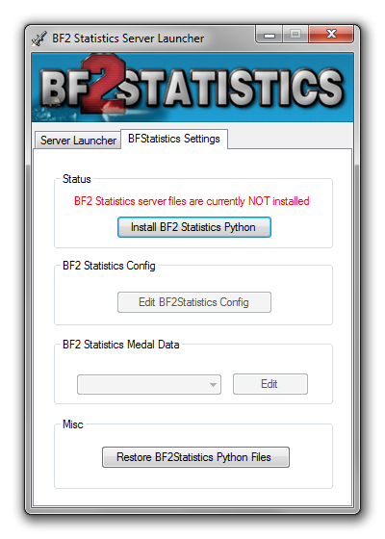

All you need to do is click the button "Install BF2 Statistics Python", and the system will do the rest. Your original python files will be backed up, and can be replaced by pressing the Uninstall button that replaces the Install button. The same goes for your BF2statistics python files... any changes you make to those will also be backed up until next time you re-install, so you never lose your changes. If

you need to reset your bf2statistics python files back to the original, un-modified version, All you need to do is click the "Restore BF2Statistics Python Files" button, and any modifications you have your BF2stats python files will be undone.

#### Linux:

For Linux users, the installation process has to be done manually:

1. Backup your original bf2 python folder (%bf2 server root%/python/bf2)
2. Copy the files located in the installation archive directory "**Server FIles/bf2statistics/python/bf2statisitcs**" over to your servers "**python/bf2**" folder.
3. Configure BF2 Statistics by editing "**python/bf2/BF2StatisticsConfig.py**".

On Linux, you are unable to use the Server Launcher GUI, however, in chapter 5, I do go into detail about each config option that still may be of use to Linux users.

4. Upgrading An Existing BF2Statistics Install

If you already have an older version of BF2Statistics installed, All you will need to do is follow these couple of steps:

#### Windows:

1. Copy over the **BF2StatisticsServerLauncher.exe** and **bf2statistics** folder from the "Server Files" folder of this installation archive, over to your Dedicated Server's root folder (same folder as the bf2_w32ded.exe).
2. Copy over the **BF2StatisticsClientLauncher.exe**, and the **SetACL.exe** from the "Client Files" folder of this installation archive, over to your BF2 root folder (same folder as the BF2.exe).
3. Replace your old ASP folder with the one located in the "Web Files" folder of this installation archive.
4. Upgrade your ASP database ( "System -> Upgrade Database" ) to the current version.

There you have it, your bf2statistics is upgraded to the new version. Unless otherwise specified in the release notes of any update, you should be safe to keep your current python files installed.

** IF a future update requires a Python update, Here is what you do:

1. Run the BF2Statistics Server Launcher, and select the **BF2Statistics Settings** tab.
2. Uninstall the BF2Statistics python folder (by clicking the Uninstall button)
3. Click the button at the bottom of the window titled "Restore BF2statistics Python Files".
4. Re-install the BF2Statistics python files (by clicking the Install button)
5. Re-Configure the BF2 Statistics Config.

#### Linux:

1. Replace your old ASP folder with the one located in the "Web FIles" folder of this installation archive
2. Upgrade your ASP database ("System -> Upgrade Database") to the current version.

There are no Python files updates from 1.5.1 to 2.0.0.

5. Configuring Battlefield 2 Statistics

Once you have copied over the server files from the previous chapter, it's time to configure bf2statistics. In the past (or if using Linux), you needed to modify a python file, but with the new Server Control Panel, there is a nice GUI that will allow you to make the changes you want. Go ahead and click the button "Edit BF2Statistics Config" button in the server control panel. Below i will explain each sections config options.

### Basic Settings

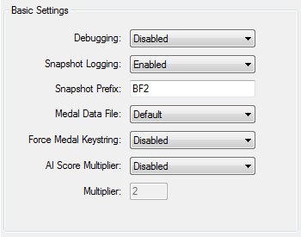

1. Debugging: If enabled, detailed logs will be generated on server startup and shutdown, to help aid in debugging.
2. Snapshot Logging: There are 3 modes to snapshot logging:
   1. Disabled: Snapshots will not be recorded
   2. Enabled: All snapshots will be recorded and stored in the following location "python/bf2/logs/snapshots".
   3. Only On Error: Snapshots will only be recorded and saved when the sending of the snapshot to the ASP fails.
3. Snapshot Prefix: The snapshot prefix is used by the ASP to determine your server ID (along with the name). Also, all snapshot files will be prefixed with this prefix.
4. Medal Data File: This is the suffix of the medal data file that will be loaded when the server starts up. The medal data file holds all of the requirements for all awards and ranks to be earned. To use a custom medal data, you must copy the default one, and use that as a template. Here is an example: "medal_data_custom.py". The name of this medal data file is "custom", as you can see from the suffix. To make one for the special forces expansion pack, add a new suffix like so "medal_data_custom_xpack.py". The server will know that the name of this medal data is "custom", and is to only be loaded when running the "xpack" (special forces) expansion pack.
5. Force Global Keystring: If you remove requirements from awards, it is most likely that they could stop working in game. If you do remove any requirements from any award, its best you enable this to prevent errors.
6. AI Score Multiplier: If enabled, the AI score will be multiplied by the input amount at the end of the round. This is for people who want it to be more challenging to be the top player at the end of the round in Coop Mode.

### Backend / Central ASP Settings

The ASP is responsible for sending stats to the BF2 server & client, as well as process end game snapshots, so the stats can be stored in a database. When you first enter the BF2HQ, the BF2 game client sends a request to bf2web.gamespy.com, and the returned data is the player stats (score, rank, kills, deaths etc). The server does the opposite, at the end of the round, each and every players score, kills, deaths and other information are send to the ASP to be processed.

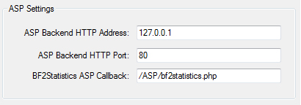

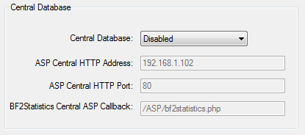

1. ASP HTTP Address: This is the web address for the ASP. This is just the hostname or IP address, do not include any sub directories. The backend ASP is the main asp your stats will be sent to, and the Central ASP is for a centralized stats system. The central ASP is optional, and will only be used for those who are running a LAN or tournament (With local stats), but wish to have this data credited to their normal STATS as well.
2. ASP HTTP Port: This is the port number your stats will be sent to. This will most likely never change because the default (and most common) port for all non-secure web transactions use port 80. Another common port is 8080.
3. BF2Statistics ASP Callback: This is the script (relative from the HTTP address) that the server will post the end game stats to. This will most likely **never** change.
4. Central Database: There are 3 modes for the centralized database:
   1. Disabled: Stats will not be sent to a centralized ASP
   2. Sync: This simply copies the SNAPSHOT as-is to the central DB
   3. Minimal: Record everything, except Rank & Award data (typically use for LANs or Tournaments where local db starts blank).

### Clan Manager

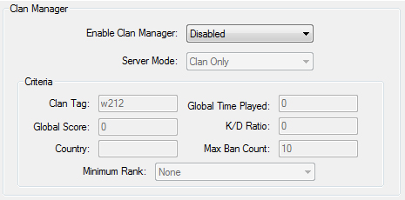

1. Enable Clan Manager: Pretty self explanatory.
2. Server Mode: There are 5 different server Modes:
   1. Clan ONLY (Must be on Clan List to Join Server)
   2. Priority Proving Grounds (Clan Members AND those players that meet the minimum requirements. Clan Members get priority)
   3. Proving Grounds (Clan Members AND those players that meet the minimum requirements)
   4. Experts ONLY (Only players that meet the minimum requirements)
   5. Public (Free-for-All. No Restrictions!)
3. Criteria: In this section, you can define the minimum requirements for players to be able to join the server. Below i describe each field:
   1. ClanTag: Player must have this clantag to be able to join to the server.
   2. Global Score: Player must have this global score, or higher to join the server.
   3. Country: Registered Country of Origin Code (Separate multiple by comma ',') to join the server.
   4. Global Time Played: This is the global time played (in seconds) the player must have to join the server.
   5. K/D Ratio: The Kill / Death ratio the player must have (or better) to join the server.
   6. Max Ban Count: Maximum banned count! PermBan is ALWAY Blacklisted.
   7. Minimum Rank: Minimum global rank to join the server.

6. Playing BF2Statistics

### Playing on your new private ranked server

Below is an outline of how to start playing on your BF2Statistics, private ranked server (Windows):

1. Make sure your Webserver (Wamp, Xampp, or Apache + MySQL) is up and running.
2. Launch the BF2Statistics Server Launcher in your dedicated servers root path.
3. Select your mod from the drop down list.
4. Edit the maplist, the server settings, and/ or the score settings if you wish
5. Launch the server.
6. *OPTIONAL* Launch your BF2 Gamespy Login Emulator if you are using one.
7. Launch the BF2Statistics Client Launcher in your BF2 installation folder.
8. Check which redirects you want, and hit the "Begin HOSTS redirect". If the Client Launcher detects the redirect already, you can skip this step.
9. Select your BF2 mod from the drop down list, add any parameters, and Click the "Launch" button.

That should be it, you are good to start playing you BF2Statistics enabled server :)