




USER MANUAL FOR ONLINE CLASS 4 CONTRACTOR REGISTRATION IN ROAD CONSTRUCTION DEPARTMENT BIHAR
- How to Register Online in Road Construction Department Govt. of Bihar
- Start the Web Page
- Go to the URL and click the address bar
- Type the address of URL 'http://serorg.cloudapp.net/ContractorCLASS4/HomePage.aspx ' (as shown in fig.1)

Fig. 1

- After opening the page screen will appear like as shown in fig.2
- Before start of registration read all the requirements as given in 'Guidelines for Registration'
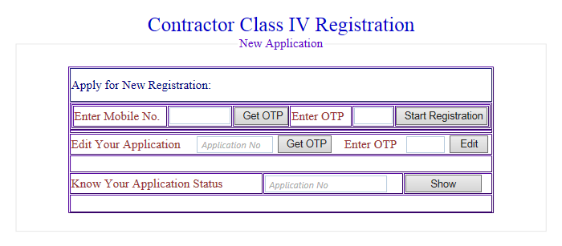
Fig. 2
- This page contains following fields of Entry
      - 'Enter Mobile No.' . It is mandatory for Registration.
      - After entry of Mobile No. Click on 'Get OTP' (One Time Password). OTP will generated and will sent to the entered mobile no. Enter OTP and click on 'Start Registration'

- After clicking on start registration the screen will appear like as shown in fig. 3

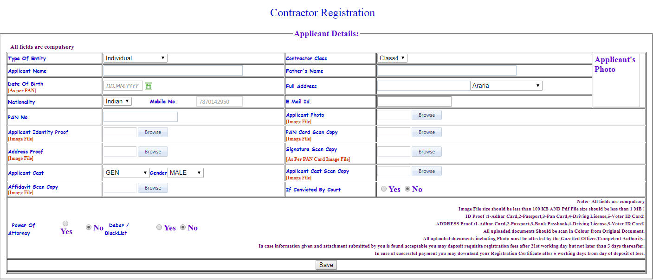
Fig.3
      - This page contains 'Applicant Details' inwhich all fields are compulsory
          - Select 'Type of Entity'


- For 'Individual Entity'
- Type 'Applicant's Name', 'Father's Name'
- 'Date of Birth' [As per PAN in case Firm or Company date of incorporation]
- Full Address, Nationality, Email ID, PAN No., Cast, Gender.
- Upload 'Applicant's Photo'(Image file size should be less than 100 Kb)
- Upload ' Identity Proof (with Photograph)such as:1-Adhar Card,2-Passport,3-Pan Card,4-Driving License, 5-Voter ID Card (Image File size should be less than 100 Kb)
- Upload 'PAN Card Scan Copy' (Image file size should be less than 100 Kb)
- Upload 'Address proof scan copy' such as; 1-Adhar Card,2-Passport,3-Bank Passbook,4-Driving License,5-Voter ID Card
- Upload 'Signature scan copy' as in PAN Card (Image file size should be less than 100 Kb)
- Upload ‘Cast Certificate' (Image file size should be less than 100 Kb)
- Upload ‘Affidavit' (Image file size should be less than 100 Kb)
- Select whether applicant having 'Power of Attorney' - Yes/No
- Select whether applicant is 'Debar/Blacklist'- Yes/No

- For 'Sole Proprietorship'
- Type 'Applicant's Name', 'Father's Name'
- 'Date of Birth' [As per PAN in case Firm or Company date of incorporation]
- Full Address, Nationality, Email ID, PAN No.
- Upload 'Applicant's Photo' (Image file size should be less than 100 Kb)
- Upload ' Identity Proof (with Photograph) such as: 1-Adhar Card,2-Passport,3-Pan Card,4-Driving License, 5-Voter ID Card (Image File size should be less than 100 Kb)
- Upload 'PAN Card Scan Copy' (Image file size should be less than 100 Kb)
- Upload 'Address proof scan copy' such as; 1-Adhar Card,2-Passport,3-Bank Passbook,4-Driving License,5-Voter ID Card
- Upload 'Signature scan copy' as in PAN Card (Image file size should be less than 100 Kb)
- Upload ‘Affidavit' (Image file size should be less than 100 Kb)
- Select whether applicant having 'Power of Attorney' - Yes/No
- Select whether applicant is 'Debar/Blacklist'- Yes/No

      - In Case of 'Partnership'
      - Enter 'Firm's Name', 'Partner's Name'
      - Upload 'Applicant's Photo' (Image file size should be less than 100 Kb)
      - Upload ' Identity Proof (with Photograph) such as: 1-Adhar Card,2-Passport,3-Pan Card,4-Driving License, 5-Voter ID Card (Image File size should be less than 100 Kb)
      - Upload 'PAN Card Scan Copy' (Image file size should be less than 100 Kb)
      - Upload 'Address proof scan copy' such as; 1-Adhar Card,2-Passport,3-Bank Passbook,4-Driving License,5-Voter ID Card
      - Upload 'Signature scan copy' as in PAN Card (Image file size should be less than 100 Kb)
      - Upload ‘Affidavit' (Image file size should be less than 100 Kb)
      - Enter 'Firm Partnership Amendment date' as per PAN in case of Firm
      - Upload Registrar of Firms Scan Copy (Image file size should be less than 100 Kb)
      - Upload 'Partnership Deed' (pdf file size should be less than 1 Mb)
      - Select whether applicant having 'Power of Attorney' - Yes/No
      - Select whether applicant is 'Debar/Blacklist'- Yes/No

- After filling of all entries click on 'Save' and screen will appear as in fig. 4

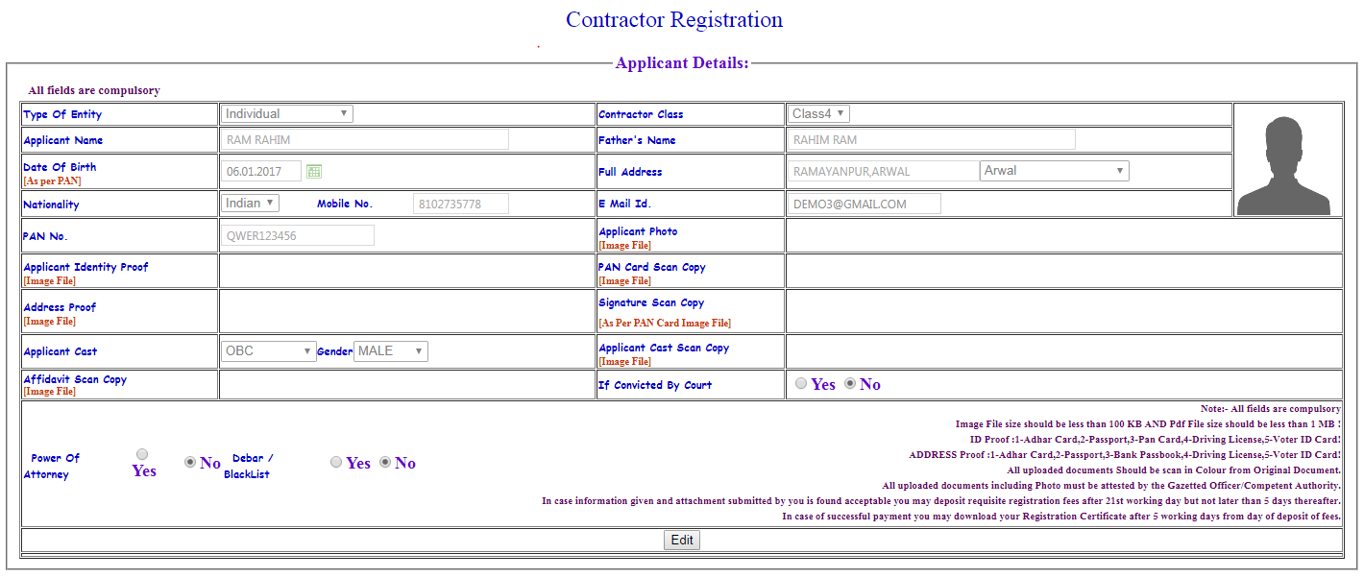
Application ID-170614IN02400001

Fig. 4

- This page contains entrystatus filled by the applicant and 'Application ID'
- After clicking on 'Next' the screen will appear as shown in fig. 5
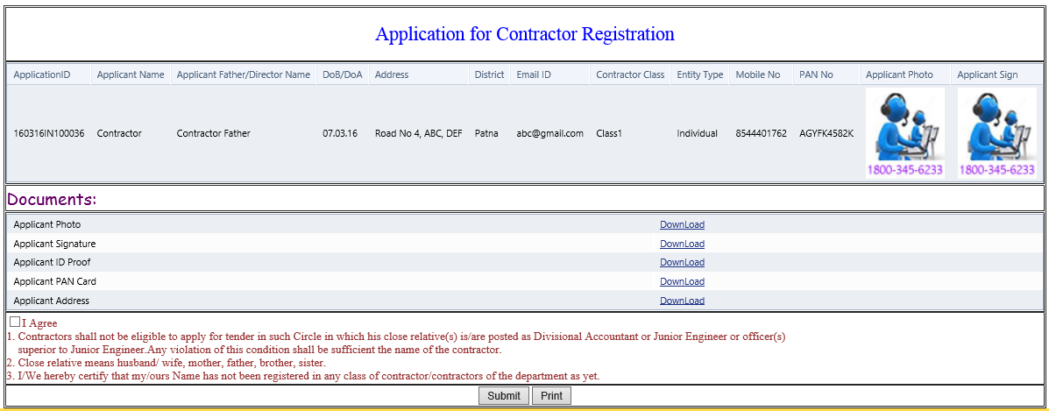
Fig. 5
    - This page contains all the information provided by the Applicant.
    - On Checking the declaration box as shown in fig. 6 click on 'Submit'

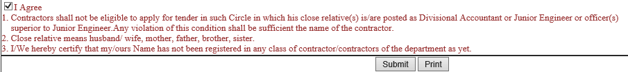
Fig.6

- On Submission Application ID will be sent to entered Mobile no. and print can be taken on clicking 'Print'
- To know the 'Application Status' go to home page, enter Application ID, click on 'Show' the opening page will show the status of Application and appear like as in fig. 7
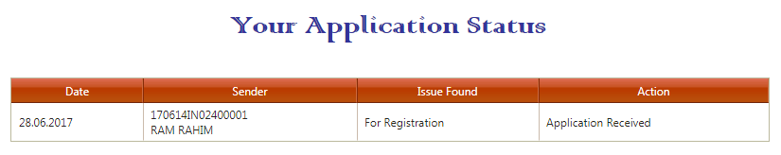Fig. 7

- To make any change in Application go to home page, Select 'Edit Your Application', enter Application ID, click on 'Show' the opening page will show the entries filled by the applicant. Click 'Edit', modify the details and Click 'Next' and 'Submit'
- For Assistant
- Go to the URL ‘http://serorg.cloudapp.net/ContractorClass4/HomePage.aspx' and Click on Official Login. the opening screen will appear as shown in fig. 10
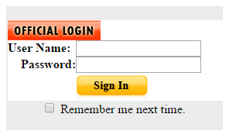
fig. 10

- Enter the 'User Name' & 'Password' and 'Sign In' the screen will show as in fig. 11
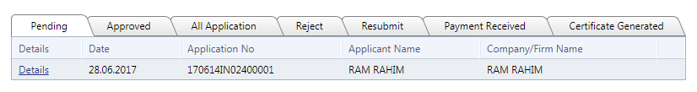
fig. 11
- This page contains Pending, All, Approved, Rejected and Resubmitted applications.
- Now Section Officer has to click on any particular pending application,click on 'Details' download the information provided by the Applicant.
- On successfully verification of the applicant's details and forms, Section Officer will verify by checking the concern boxes as shown in fig. 12
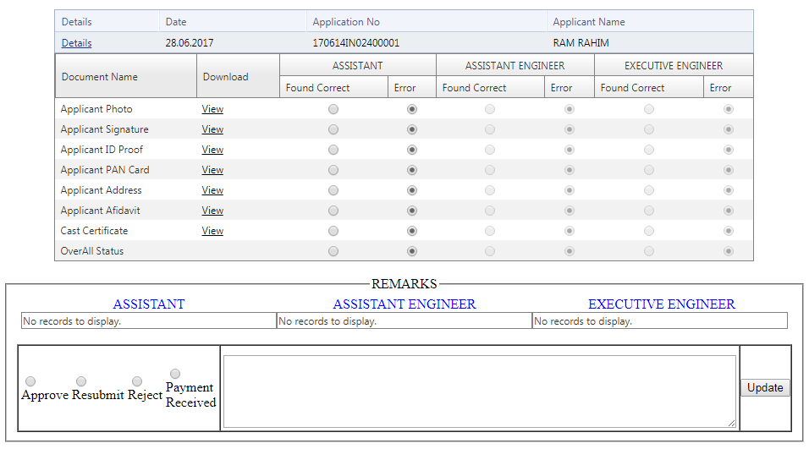
fig. 12
- After verification the details, Section Officer will put his 'Remarks' and 'Update'
- After Update, if the application will found in Order with Requisite Data, it will be forwarded to Assistant Engineer for further action and screen will appear as shown in fig. 13
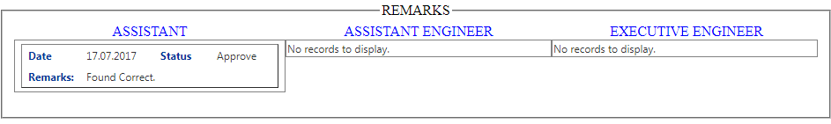
fig. 13
After Verification of Applicant details the Applicant's Application will show pending on Assistant Engineer account.
- For Assistant Engineer
- Go to the URL ‘http://serorg.cloudapp.net/ContractorClass4/HomePage.aspx' and Click on Official Login. the opening screen will appear as shown in fig. 14

fig. 14
- Enter the 'User Name' & 'Password' and 'Sign In' the screen will show as in fig. 11
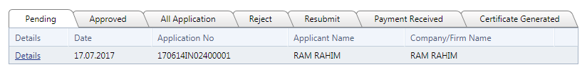
fig.15
- This page contains Pending, All, Approved, Rejected and Resubmitted applications.
- Now Assistant Engineer has to click on any particular pending application,click on 'Details' download the information provided by the Applicant.
- On successfully verification of the applicant's details and forms, Assistant Engineer will verify by checking the concern boxes, 'Found Correct' as shown in fig. 16
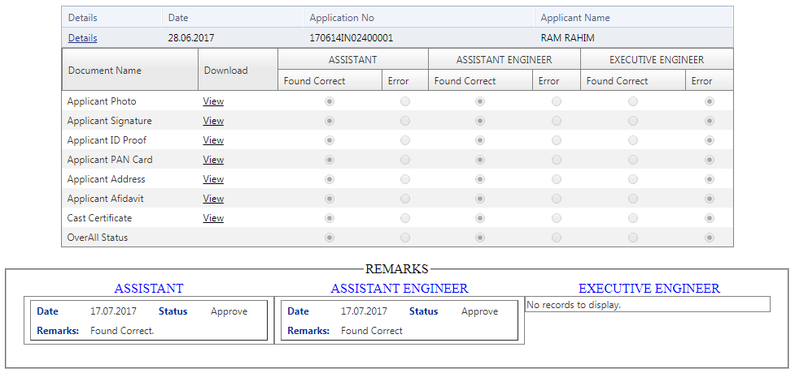
fig. 16
- After verification the details, Assistant Engineer will put his 'Remarks' and 'Update'
- After Verification by Assistant Engineer, Applicant's Application will show pending on Secretary Technical account with Remarks of Assistant Engineer.
- For Executive Engineer
- Go to the URL ‘http://serorg.cloudapp.net/ContractorClass4/HomePage.aspx' and Click on Official Login. the opening screen will appear as shown in fig. 20

fig. 20
- Enter the 'User Name' & 'Password' and 'Sign In' the screen will show as in fig. 21
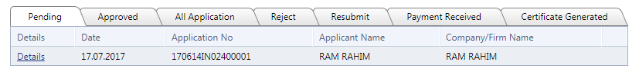
fig.21
- This page contains Pending, All, Approved, Rejected and Resubmitted applications.
- Now Executive Engineer has to click on any particular pending application,click on 'Details' download the information provided by the Applicant.
- On successfully verification of the applicant's details and forms, Executive Engineer will 'verify' by checking the concern boxes as shown in fig. 22
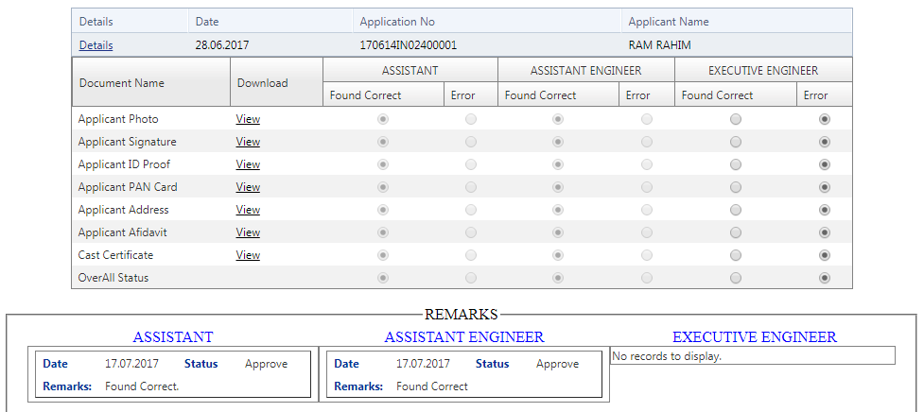
fig. 22
- After Verified by Engineer-in- Chief, EIC may 'Approve', 'Resubmit' or Reject the Application.

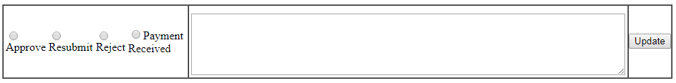

- After Approval from Executive Engineer, the Applicant will directed to proceed to payment by clicking 'Pay Now' on 'Your Application Status' as shown in fig. 23

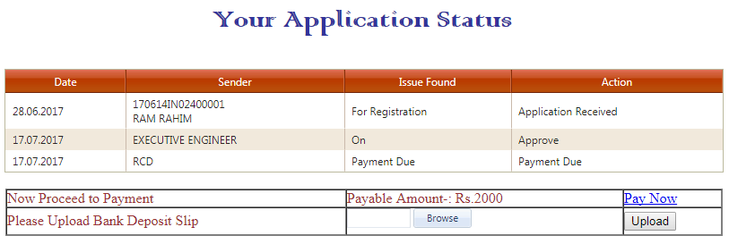
fig. 23

- On clicking on 'Pay Now' the opening page will directed to 'State Bank Collect' Payment portal as shown in fig. 24
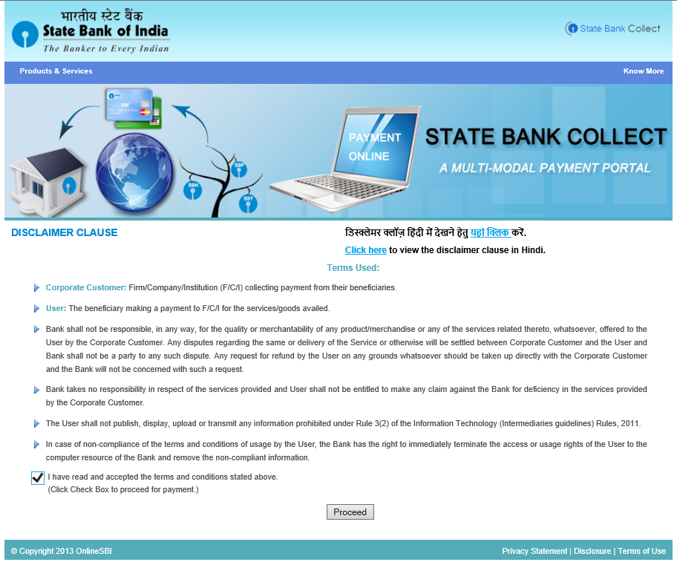
fig. 24
- Check the Terms & Conditions box and 'Proceed' with Payment.
- Opening page contains 'State of Corporation / Institute' and 'Type of Corporate/Institute' Select Bihar and Govt. Department respectively. (ref. fig. 25)
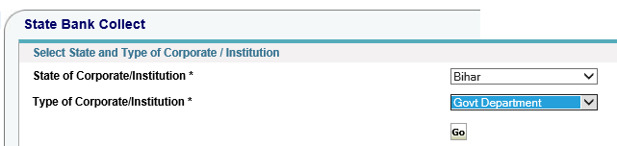
fig. 25
- On clicking 'Go', the opening page will contain 'Govt Department Name', select 'UNDER SECRETARY (ACCOUNTS) RCD BIHAR' (ref. fig. 26)
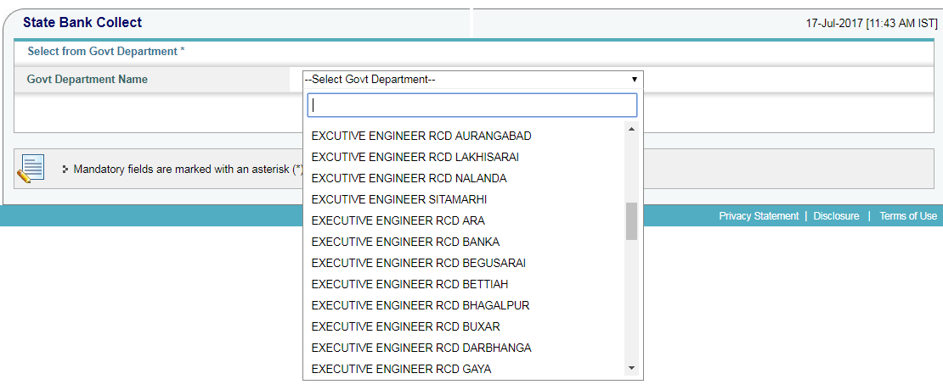
fig. 26
- Click on 'Submit', the opening page will contain 'Select Payment Category', Select 'RCD REGISTRATION FEE' and Enter 'Application ID' and 'Submit' (ref. fig. 27)
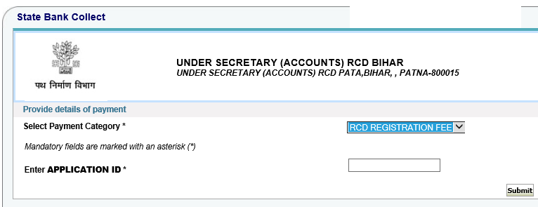
fig. 27
- On submission the opening page will be directed to 'Verification page', this page contains the Auto filled details uploaded by the Road Construction Department (ref fig. 28)
fig. 28
- On verification of details the opening page will be directed to 'Payment Mode' which contains (ref. fig. 29)
- Net Banking of any Bank
- Debit Card of SBI
- SBI Branch for Cash/Cheque/Draft payment

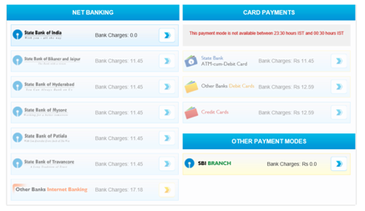
fig. 29
- On payment by Net banking and SBI debit card opening page will be directed to transaction and 'e-receipt' will be generated.
- On payment by SBI Branch for Cash/Cheque/Draft payment a 'Pre-Acknowledgment Form' will issue and which will be deposited in any SBI branch (ref. fig. 30)

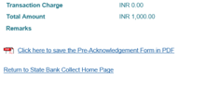
fig. 30
- After deposit the requisite amount in Bank, again applicant has to visit 'SBI Collect portal' for generation of e- receipt
- After confirmation of payment the 'Certificate of Registration' will be generated and will be available on home page Application Status.
Before,
The Notary Public
Patna
A F F I D A V I T
______________________, Son of _________________________________,P.O. ________. ,PS_______, District_______, do hereby solemnly affirm and state as follows;
- That I am going to apply for registration as a Contractor in Class-IV in Road construction Department for the District of Patna.
- That I am declaring that am not registered an applied for registration in any Government Department as a contractor Class-I,II & III earlier.
- That the above mentioned facts are true to my knowledge and belief.

Deponent

शपथ पत्र
मै ......................................................................पिता / पति ......................................................................
उम्र ........ग्राम .....................................................................................पो० .................................................
थाना ......................................... जिला .............................. निष्ठा पूर्वक निम्लिखित ब्यान करता हूँ कि :-
- मै पी० डब्लू० डी० या किसी अन्य विभाग में संवेदक के रूप में श्रेणी 1 2 एवं 3 में निबंधित नहीं हूँ और पूर्व में भी कभी निबंधित नहीं था |
- मै किसी राज्य सरकार भारत सरकार किसी विभाग या रेलवे इत्यादि के द्वारा काली सूची में नामित नहीं हूँ |
- मै सत्य एवं निष्ठा के साथ शपथ-पत्र देता / देती हूँ कि में तथा मेरे परिवार के सभी सदस्य अपने घर में तथा बाहर हमेसा शौचालय का ही उपयोग करते हैं |
- शपथ पूर्वक ब्यान देता/ देती हूँ कि मै ............. जिला का निवासी हूँ एवं उपरोक्त बात मेरी जानकरी में सही एवं दुरुस्त हैं |

शपथ कर्ता का हस्ताक्षर
अधिवक्ता का पहचान
जो श्री .............................
अधिवक्ता द्वारा पहचान होकर शपथ पूर्वक
ब्यान करते हैं कि ब्यानात इनके जानकारी
से सही एवं दुरुस्त हैं |

लेखा प्रमाणक ............. जिला |

