185) In Microsoft Edge browser view profile has issues

The values should always be blue in color. And the expand down arrow is not functioning well. Values highlighted in blue should not be clickable and when blue value is clciked the page shouldn’t remain as is.

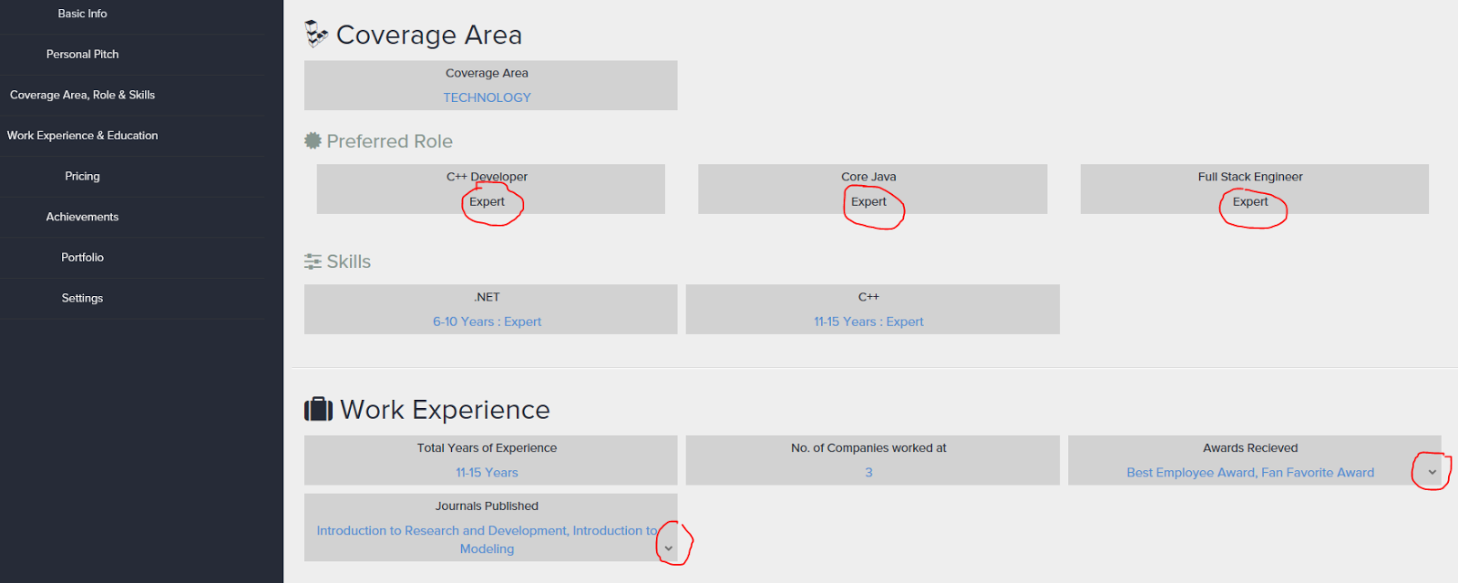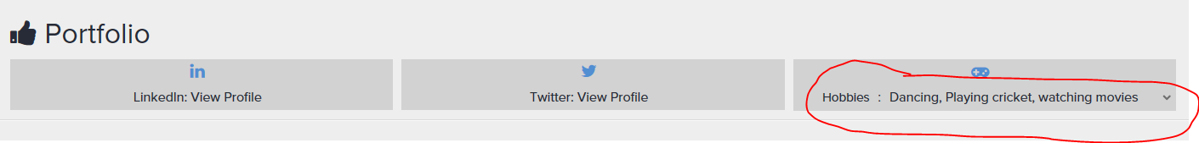

Clicking on this takes to the top of the page:
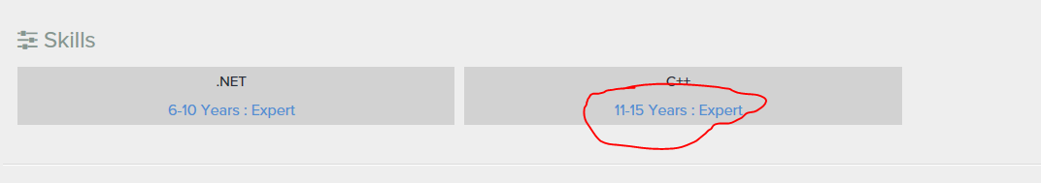

When expert enters multiple roles then view profile doesn’t display the values correctly.
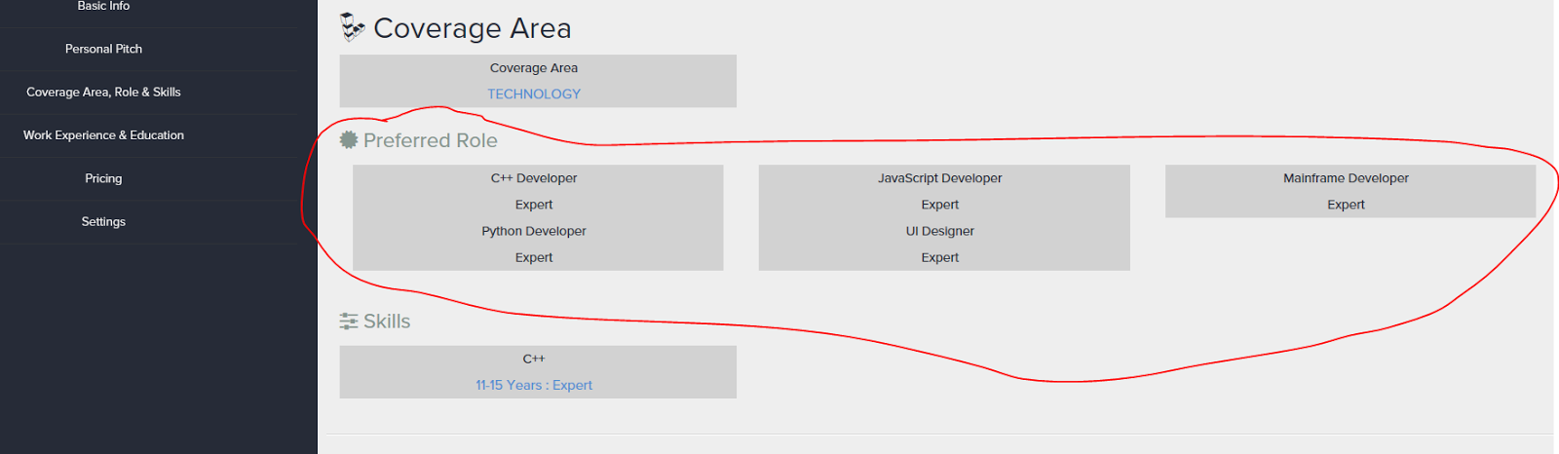

When employer upload logo and clicks on view profile of the employer from the dashboard the log o is way too big. Can you reduce the size of the logo. Look at how LinkedIn controls this?

