* E commerce site based on Women clothes
* Template for website to be like [www.wish.com](http://www.wish.com) and [www.wanelo.com](http://www.wanelo.com)
  + a thin bar on top with business title and links for “who we are” ,” contact”, “the editor page” , and the account user id
  + template will have no more than 4 pictures per row. On the wanelo.com website there are 8
  + We will have tons of pictures, website needs to be responsive and load the additional pictures once user scroll down with mouse
  + Each picture will be a product, so user will click and direct to the page to purchase the product. Each product page will need to have description of product, price like a typical e commerce website. The product page should have zoom capability to see in details the product
  + Would like a java script plugin to show the price of the product as overlay once user move mouse on top of product picture
  + Ability to like and comment the pictures on the main page
  + Each picture should have wanelo plugin to post product on wanelo
  + Each picture should have pin it plugin to post product on pinterest

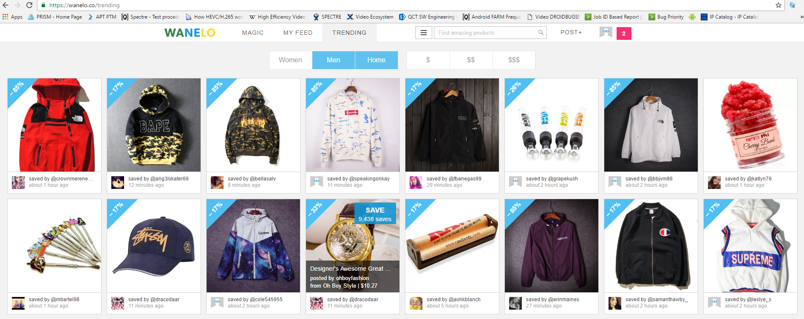

* We need the ability add pictures from admin page
* We need ability to change all word contents in the website from admin page
* Will need a Logo for the website
* Front page will need a filter, like woman , man, kids like in wanelo.com but it will be based on cost. 3 filters “less than 100$” , “less than 200$ , “less than 500$”
* I would like to choose the color palette of the website
* Customer log in page has few requirements
  + As in bombfell.com website customer will need to prompt for their size during registration and provide entries for shirt size, pant size , shoe size.
* Integration with amazon payments for e commerce. Customer will pay with their amazon accounts
* Integration with additional merchant account for ecommerce for payments with credit card