**1)**

1- Here on Mesh Banners , as you can see it is not as it supposed to be and the text is clearly misplaced..

2- Please also check the the menu, the arrows, were not like that, this is how it was looking before

And this is how is looking now..

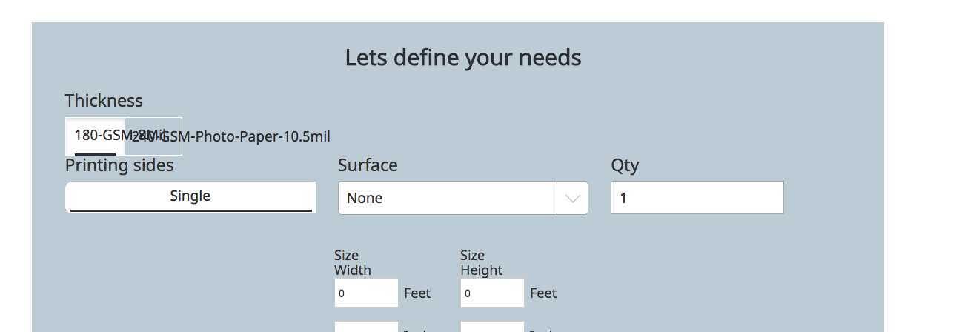



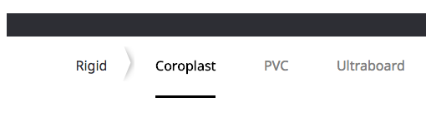

Note: Client want to separate main menu category from slider with next arrow. First issue belongs to front end because it seems alright until zoom in the screen.

**2) Issues PDF link**

http://128.10.1.8:2525/projects/PrintiansWebsite-Tweaking7457/Development/Comments/02FORMSprintians.pdf