# Changes to be done:

## Quote Step 1

* **There should be a common thread on the whole website. The same “spirit” should reign on the whole website  
  Following this comment, the following corrections have to be done:**



Text in blue

This box in light blue

These two boxes in white/transparent, with a blue frame (as login button)

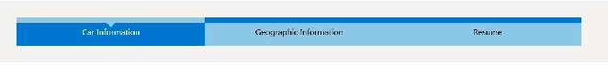

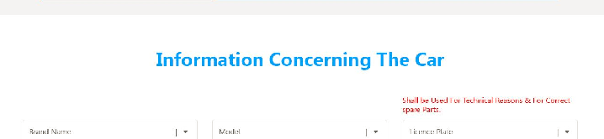

The text here should also be in black

* 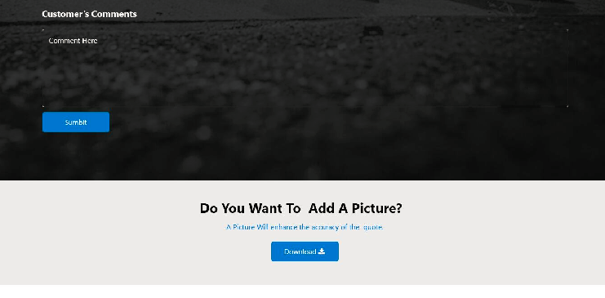

This button should be white with a blue frame. It should become blue, once we go with the cursor on it (same as for the “login” button)

This button is not necessary since it is the same as clicking “next” 🡪 To errase

* 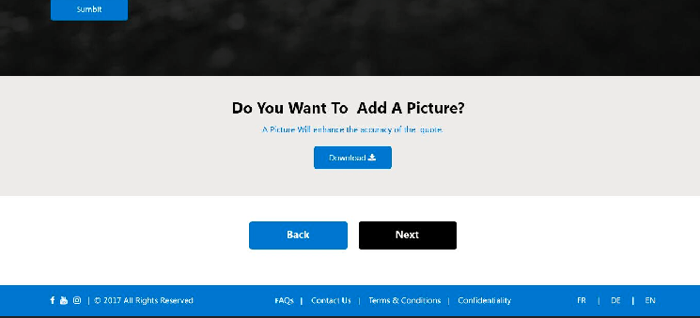

Same as for the homepage, this part should be in grey and not in blue.

These two buttons should be white with a blue frame. They should become blue, once we go with the cursor on them (same as for the “login” button)

‘

* **Registration, send information and get your job button are not as we want them. They’re to big. They have to be smaller. Logo of those 3 columns has to be small, simple, and in accordance with our logo and with our website!**

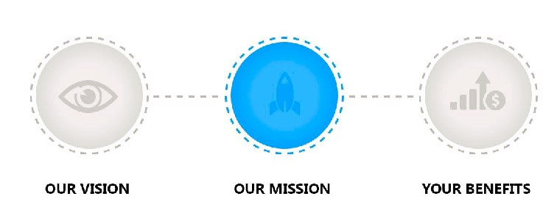

These icons /logos should be different. As we skyped (Frédéric-Sal), Sal told Frédéric logos would be presented (ex. Skyskanner, Uber,…)

**Example of a type of logo that could be used which would create an accordance within our website :** [**https://www.behance.net/gallery/53319855/Freebie-Icon-Sets**](https://www.behance.net/gallery/53319855/Freebie-Icon-Sets)

**Or something like the one you used here:**

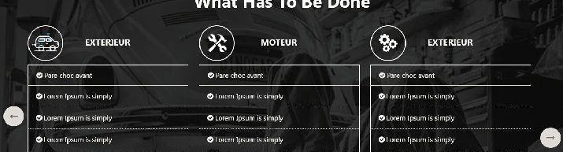

**The most important is to keep the “common thread”! On every site, there should be the same kind of icons/symbols.**

Our proposal:







## Quote Step 2

These two boxes in white/transparent, with a blue frame (as “login” button)

This box in light blue

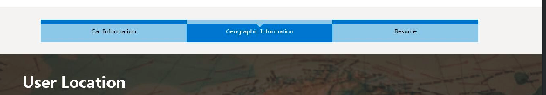

* What is this for?

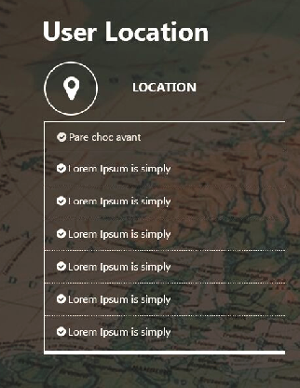

We don’t need so many choices. There is only one location to insert, but automatically, the website should localize the customer.

* The “View distance from garage” option shouldn’t exist. The garages won’t appear on the map.
* The “back” and “next” button shoud be the same as in Quote Step 1

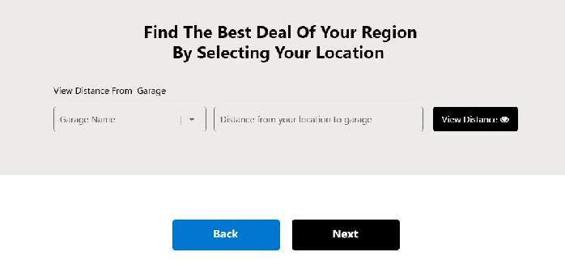

Part to be errased

These two buttons should be white with a blue frame. They should become blue, once we go with the cursor on them (same as for the “login” button)

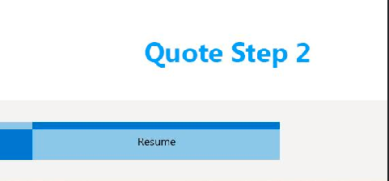

Text in black

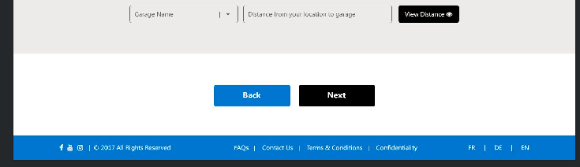

Same as Homepage and quote step 1

## Quote Step 3

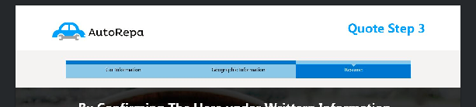

Same as quote step 1 and 2

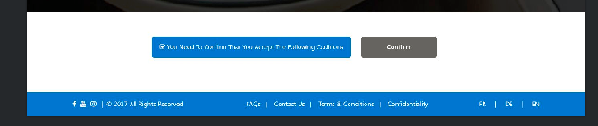

Same as Homepage and quote step 1 and 2

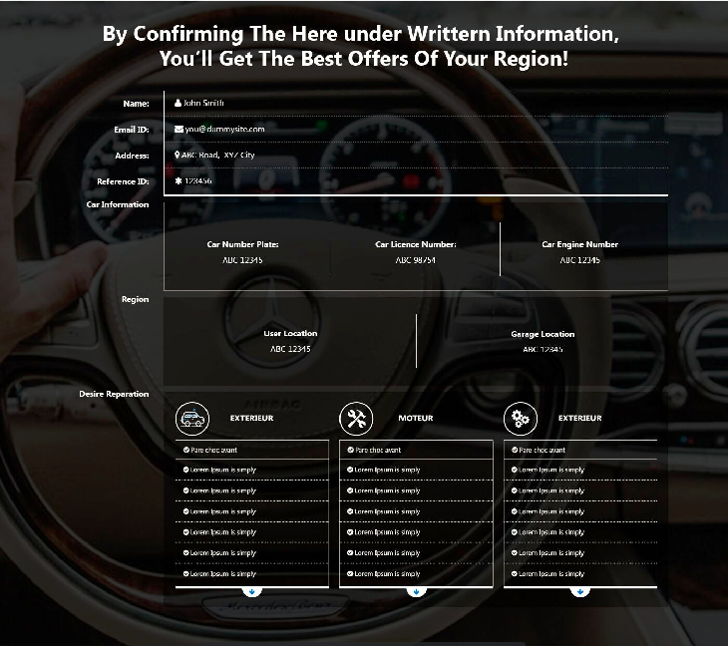

In this part we will only have the reparation selected by the customer

The part with the garage location has to be erased (there won’t be any information on the garages at this stage.

Here will should be:

* Brand name
* Model
* License plate

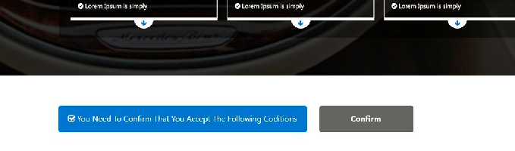

Here we should have the “confirm” button in blue (not grey) and the “you need to confirm…” button shouldn’t be a button. It should only be a text (written “ I confirm that I have read the user conditions”) with a box that **needs** to be checked.

We should be able to access the user conditions by clicking on the text.

## Other comments:

* **For the language, we want that the website detects directly the language of the navigator.**
* **If we want to keep some of the pictures that you proposed (i.e. the homepage picture) is it possible?**