Notes Page :

Backend Issues with Yellow Color

Front End transparent

1)On Uploading New Notes : Message Pop Up . file name is exceeding from the form

2)Set the Design of the Buttons : placed the buttons on the Right Side

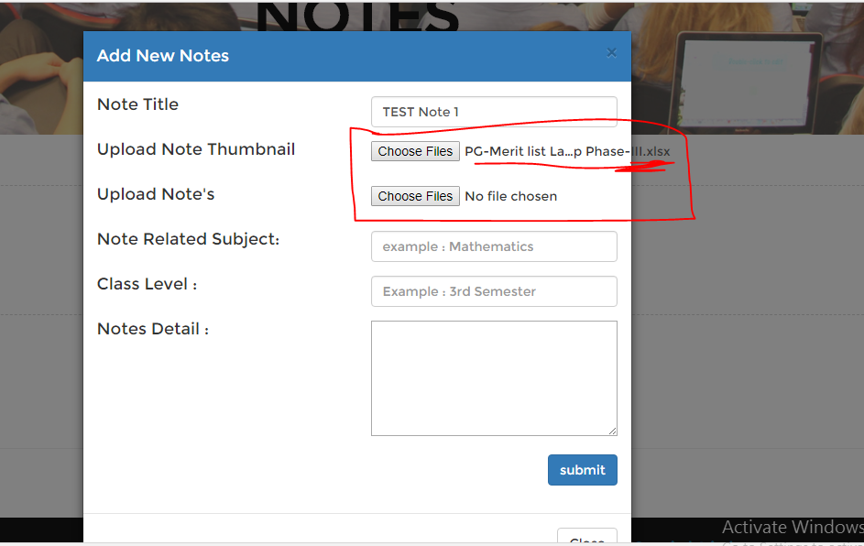

3)Make This button prominent and bold



4) Notes Detail page Edit hover border need to be set

5)These @ buttons only to be appear on my uploaded notes, I can not edit or delete any other tutor notes

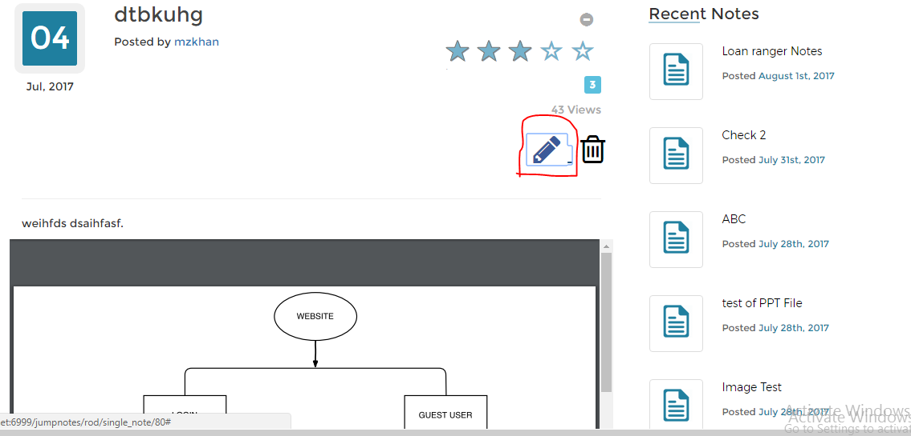

6)Notes Uploading Message

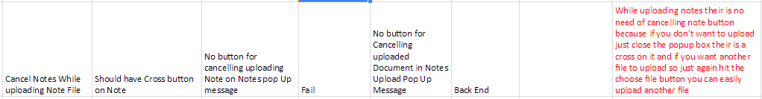

As mentioned , it’s not a proper way . if I want to cancel uploaded note , should have a cross icon button

7) Only single Note with 5 pages ????? 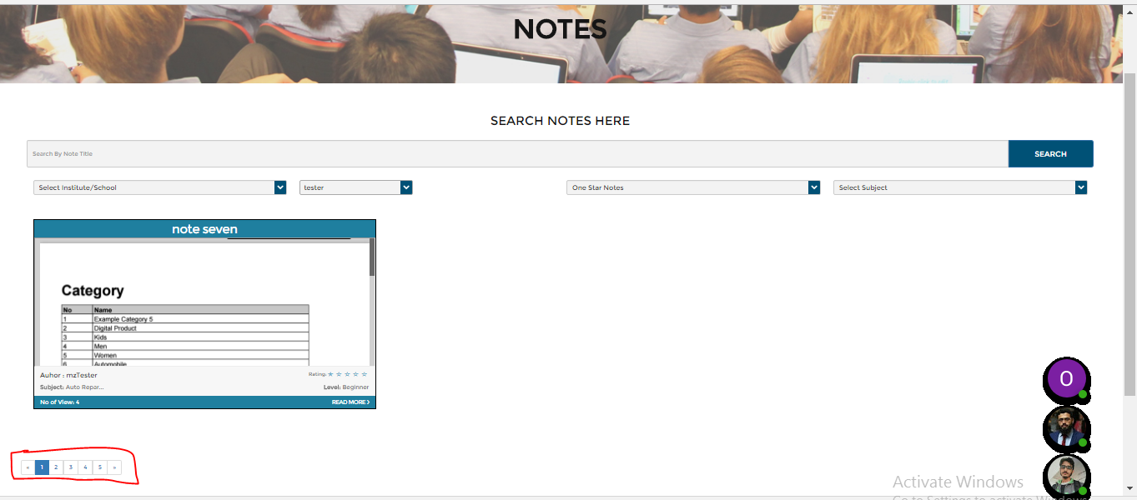

8)Search filed 1st Drop Down

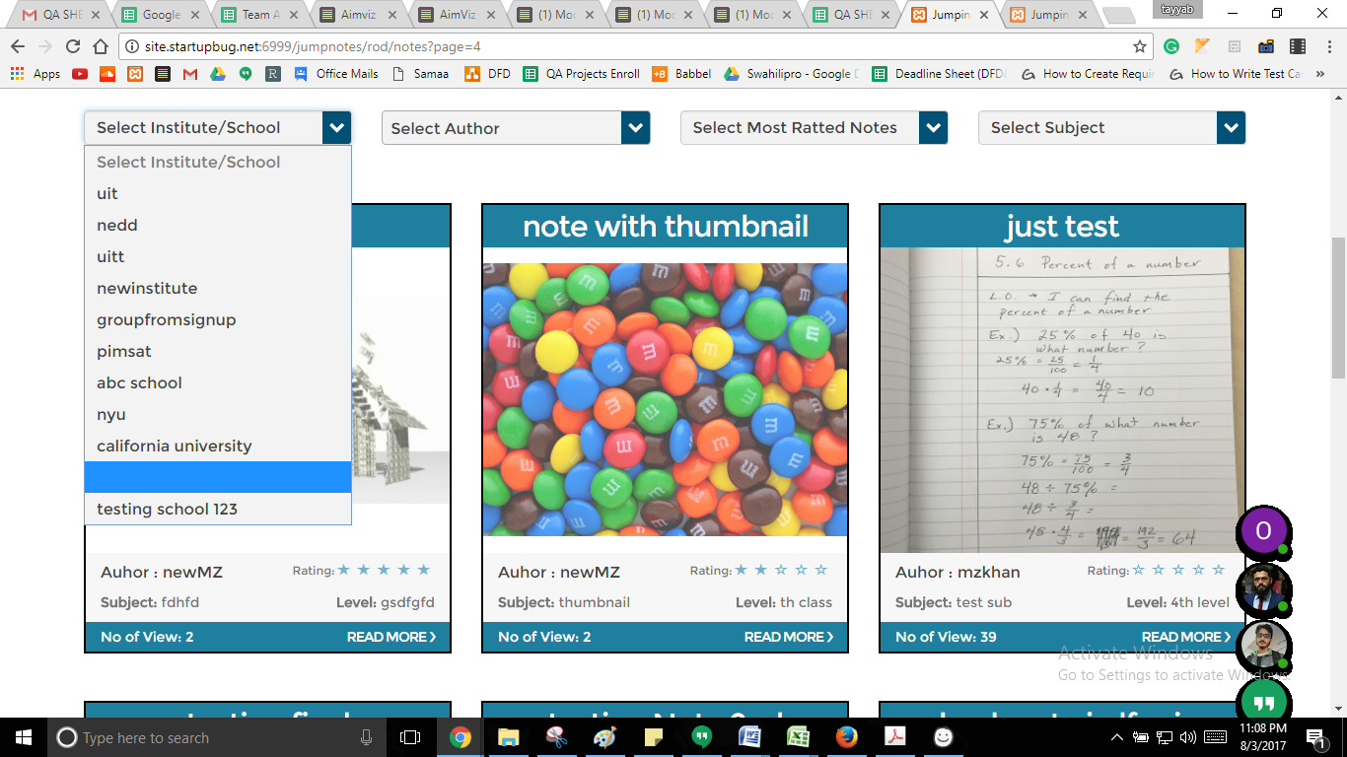

On Clicking View Button in Dashboard , the message opens need to scroll down to view whole screen pls fit the size on the screen so that no need to scroll down the page

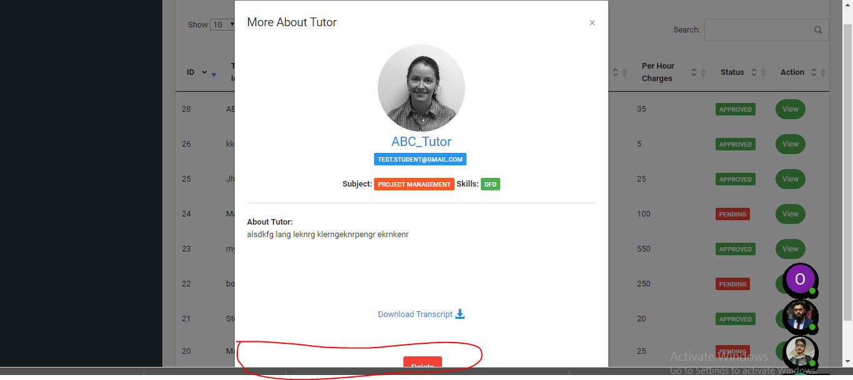

Transaction Tab in Dashboard need to align the table fields

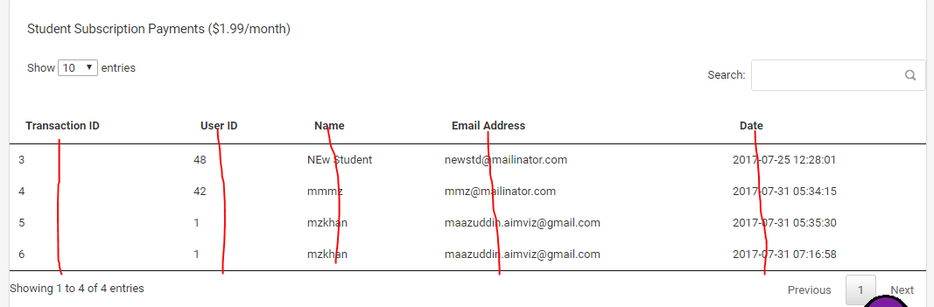

Tutors page with Send payment Message

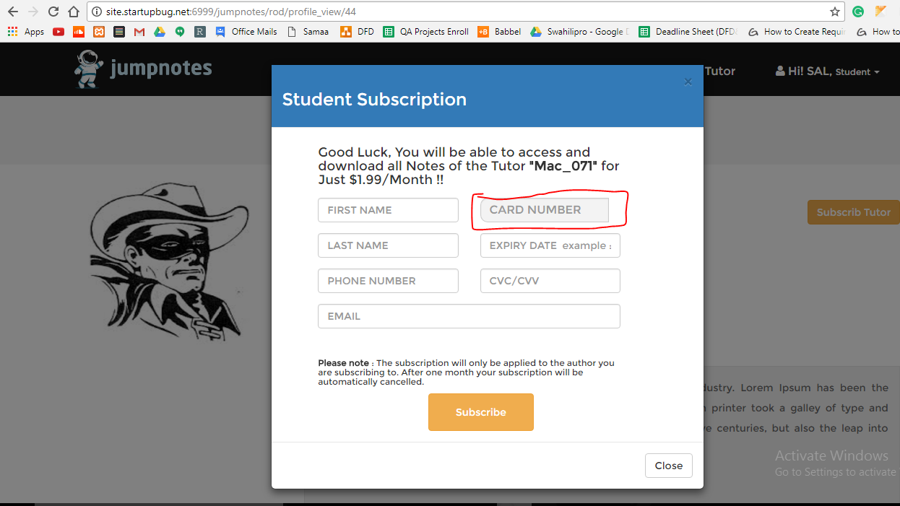

Dashboard Contact List

Recenmt masg appearing in the Last

Chat Page: file name start from next line

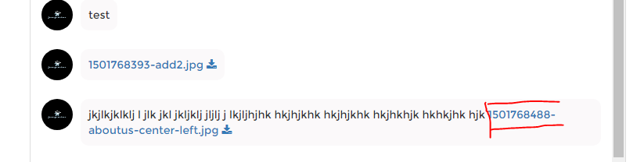

Attaching file to Chat issue : file attached should be in next line

