Vinicius Granja

Dr. Afriyie

International Trade and Investments

5 May, 2014

**Tesla**

**Introduction of the paper: company or organization, industry and basic products or services.**

Tesla Motors is an electric luxury car company created in 2003 by a group of engineers led by Martin Eberhard and Marc Tarpenning. It is the first and remains the only company to develop and sale a fully electric sedan car. The company’s goals is to accelerate the advent of sustainable transport by bringing compelling mass market electric cars to market as soon as possible. It has already started but further success will depend on market strategy, especially internationally. Success to a carmaker startup company in the automobile industry had only happened 79 years ago when Henry J.Kaiser build the Kaiser-Frazer carmaker company which “built 770,000 cars” (Green Car Reports) before stopping production in the U.S. in 1955. Henry J. Kaiser had so many struggles to win over the automobile competition in America that it had to move production abroad to Argentina and Brazil in 1952 (Ate Up With Motor). Henry J. Kaiser automobile industry in Brazil and Argentina gave birth to Jeep which then was sold to the American Motors Corporation in 1970(Ate Up With Motor). After eleven years Tesla has not even reached the number of 50,000 cars manufactured since 2003 while Kaiser-Frazer had produced 770,000 from 1946 to 1955. Tesla has a huge starting advantage that Kaiser-Frazer did not have; its luxury electric car line has had no competition at all since it started in 2003. Tesla has an astounding comparative advantage in the luxury sedan electric car manufacturing line that even internal combustion engine sedan cars in today’s market had lost their comparative advantage over Tesla Model S. Kaisar-Frazer was competing under the same field as the mighty Ford and General Motors in the United States while Tesla is already in a better field than the most successful American, British, German, Japanese, Korean, and Italian automaker companies today. It is certainly a fierce market but the objective of this paper is to show the strategy to be adopted by Tesla in order to make its goal “bringing compelling mass market electric cars to market as soon as possible” a reality. The first part of the paper will be about the company, industry, products, and its comparative advantage. The second part will be the business strategy and lastly the entry strategy.

Awards won: Consumer Reports’ best car ever tested. It received a rating 99 out of 100 / Automobile Magazine 2013: Automobile of the Year / Model S has new record for the lowest likelihood of injury to occupants in the U.S.A. After the three fires caused by damages on the battery, Tesla received the best safety rating from the National Highway Traffic Safety Administration (NHTSA). Despite the record breaking safety ratings, Ellon Musk,CEO of Tesla, has announced that Tesla had reinforced its battery protection with titanium underbody shield and aluminum deflector plates. Tesla puts consumers’ safety as first priority. Moreover, the new protection for cars’ battery is done for free to any car sold before 2014. Tesla has also received many awards internationally, such as

Tesla Model S has set two Guinness World Records. Based on the Tesla blog and soon to be seen in the Guinness World Record, “two Tesla Model S sedans rolled quietly to a stop outside New York's City Hall to set a record speed time for an electric vehicle crossing the United States. The team had just driven the two cars across the U.S. while relying only on Superchargers for energy. Not only did the Cross Country Rally team manage the trip from Los Angeles to New York City in just 76 and a half hours, it also recorded the lowest charge time for an electric vehicle traveling across the country – a feat that is now being assessed for recognition as a GUINNESS WORLD RECORDS achievement.” Yes, American consumers can cross from one coast to another. And, if you remember, the Supercharger stations throughout the U.S. are for free which means you can cross the country using the rote set by Supercharger stations without paying a penny, considering no external problems occur. Information regarding Supercharging locations is provided and located on Tesla’s website.

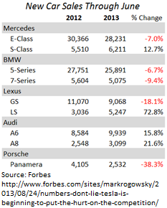Tesla has a comparative advantage in sales over sedan gas cars in the United States. Tesla Model S has outsold all its closest sedan cars competitors in the first quarter of 2013 in the United States, based on insedeEVs. Insede EVs also provided the U.S. sales of top sedan cars in the first quarter of 2013, “ Tesla Model S: 4,900 units, Mercedes-Benz S-Class:  3,077 units, Lexus LS:  2,860 units, BMW 7-Series: 2,338 units, Audi A8:  1,462 units,”. Tesla success on sales of the Model S can also been seen with base on the falling number of car sales from competitors show on the table on your left.

Foreign sales have been very successful. Tesla started selling its Model S cars in Europe in January of 2013. Before even delivering its cars Tesla has already committed to provide right hand drive cars to European customers at the end of Spring 2013. There are foreign markets where Tesla adoption has been much more successful and more promissory than in the United States. “Nearly 1,500 of the high-end plug-in rides were registered by Norwegians in March of 2014, more than double the registrations of the runner-up Volkswagen Golf and making up more than 10 percent of all vehicle registrations in the country” based on New York Daily News. Successful sales in Norway did not only come due to people willingness to adopt a zero emission luxury car but also the tax incentives to electric cars given by Norway’s government. Tesla has showrooms in Norway, Netherlands, and Switzerland. It plans to expand to Unite Kingdom, Germany, Denmark, Belgium, Austria, France, and Italy.

Here are some important features and specs of the Model S electric sedan car taken from Tesla’s website: [www.teslamotors.com](http://www.teslamotors.com). Tesla 85KWh Performance Model S is the fastest electric sedan commercial car in the world. It goes from 0 to 60 mph in only 4.2 seconds. It has much fewer moving parts in its drivetrain than internal combustion cars (ICE). It offers easy maintenance if not the easiest maintenance in the market. Only six parts on Tesla’s Model S car needs regular replacement (csmonitor.com). Those are the four wheels and the two wiper blades. However, it does need year inspection. Technicians need to check the level of battery and the motor and battery coolant. The Model S with 60 kWh battery starts at $63,570 and $87,070 after federal and state incentives. However, with all accessories price can go up to $122,020 after federal and state incentives. No more runs to the gas station. You might make emergency stops in supercharger stations to charge but if you time well your charging schedule that stop will never be needed. There are three possibilities recharge a Tesla car. Mobile Connector: connect in 240(recommended) and 110 volt outlet. It charges 29 miles of range per hour. High Power Charging: A wall connector installed at your house for free by Tesla technicians during the delivery of your car. Charges 58 miles of range per hour which means it would take five hours to fully charge a Tesla battery. Charges done at home are recommended from 11:30PM to 6:30AM because many utility companies charge prices based on demand, so during this time demand is lowest dropping the cost of recharging your Tesla car. Supercharger stations can recharge half of the battery in 30 min. They are for free in the whole United States and in Europe. Yes, you do not pay a penny to charge in Tesla’s Supercharger stations. Tesla’s engineers have been working in a technology, called battery-swapping, that would replace a depleted battery by a recharged one in 90 seconds. In the short term this possibility is not viable, yet, because the small number of electric cars on the roads and limited production of batteries, Tesla is also aware that people would not like to exchange their purchased batteries by used ones, so this technology would mostly envisioned to be used in long trips rather than day-to-day life rides. The owner of the car would be able to temporarily switch his own battery by a used one and travel to his destination by swapping other used ones until reaching his destination and returning back. When the customer returned, his own battery would be swapped back. No, you would not save mileage in your car by doing that, but you would be able to save your battery life span and reduce your recharging time period from 40 minutes to 90 seconds. Most Supercharger stations are powered by Solar Panels. Another goal of Tesla is to develop efficient battery reservoirs so all stations are powered by solar panels. Cars can be charged in Supercharger stations during any harsh weather conditions; however, these conditions might increase the regular charging time period, which is 40 minutes, to more than that. It has a great consumer satisfaction with its All Glass Panoramic Roof which opens wider than any other sedan car in the market. All digitalized with a 17" capacitive touchscreen capable of media, communication, cabin, and vehicle controls. It comes with all the features of top of the line sedan cars today. It offers Bluetooth wireless technology for hands-free calling and streaming music. Three spoke, multi-function steering wheel with tactile controls and tire pressure monitoring system. For safety the car offers driver seat detection sensor for start or stop functionality. It has eight airbags for safety. It includes side curtain airbags, head, knees and pelvis to all passengers. There is no need to heat up the engine by turning on your car earlier through the remote control since Tesla cars have no moving-parts engine. The Model S seats five adults and two children. It has no tailpipe, so it is noise free. It has 63.4 cubic feet of storage in the trunk and many other features which can be found on Tesla’s website.

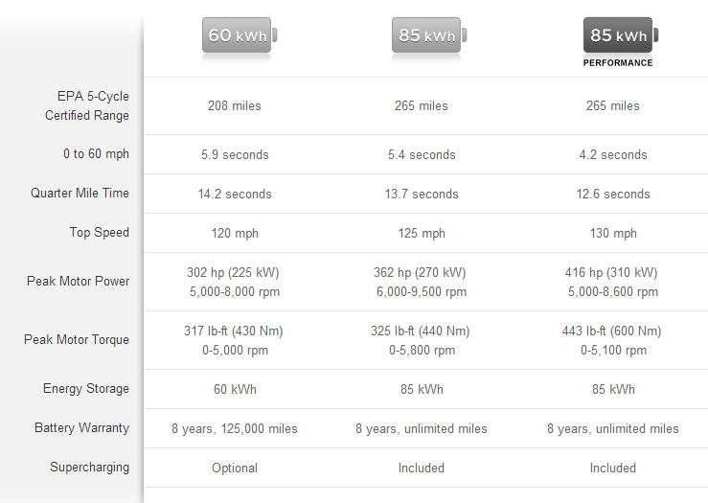

<http://www.teslamotors.com/models/features#/battery>

**International Business Strategy that creates a competitive advantage for your chosen firm or company or organization**

Tesla Model S’ features has already amassed enormous competitive advantage in the luxury sedan automobile market. Today, the biggest problem for Tesla is production. Tesla has no economies of scale in its production. The demand far exceeds the supply and Tesla cars have a fixed price rather than a floating priced driven by demand and supply. It means in order for Tesla to conquer the automobile market it has to increase production and reduce prices on its cars. Tesla has wisely developed the Model X car which is forecasted to start being delivered in the beginning of 2015. It is a midsized SUV car with a minimum cost of $40,000 dollars after federal and state taxes. It is a wise move because the midsized SUV is “the fastest growing sector in Europe” (Sunmotors) and one of the fastest in the U.S.A. The demand for the Model X is expected to exceed the demand for the Model S since it is $20,000 dollars cheaper and also no sign of fierce competition, yet. Tesla is capable to easily develop an electric popular car which would target the biggest automobile sector in the world. However, Tesla has no economies of scale to enter the popular market and fulfill the massive demand. Not achieving demand would only infuriate consumers and consequently give away advantages to competitors in entering the electric car market. Economy of scale is certainly the biggest element to the success of a startup automobile market like Tesla. The biggest limit of Tesla’s manufacturing of cars is the manufacturing of car batteries. Panasonic is the producer of Tesla batteries but that production is limited. The most expensive battery, the 85 kWh Performance, costs approximately $15,000. It is roughly one-sixth of the total car value. If the battery it not so expensive what stops Tesla or Panasonic from producing more? Tesla car technology is a first-mover in the market. The only fierce competition it had faced had come from internal combustion automobiles and not from the hybrid cars, cars that are both electric and instant combustion, which have been in the market much longer than Tesla. The batteries are a brand new technology and there is no other industry with the capability of manufacturing them. There are almost no options of partnership or merger and acquisitions to produce them. The batteries production is most likely to come from a Greenfield strategy. The strategy will be explained right after the market target for production and sales. In order for Tesla to break through the fierce automobile market and strive as the leading electric car company in the World it will have to expand its production internationally to increase production and reduce costs. China is the market where the possibilities of success is in in Tesla’s favor.

The price of the best Model S car battery is $15,000 and made in Japan and the car itself is produced in the United States. This means the cost of production can be reduced by less if the manufacturing of batteries and manufacturing of cars are built together in China. Why increasing production of battery and car in China? The goal of Tesla should be focused in obtaining advantage of continuous flow of production like Henry Ford once did and revolutionized the automobile industy.by introducing the assembly line where the entire car was assembled in one factory. Why a manufacturing development created in 1913 would bring success to Tesla? First Tesla would avoid prices fluctuations in the foreign exchange market. No car manufacturing wants to fall into the billion loss made by Volkswagen after its hedging strategy in 2004 failed to forecast the sharp appreciation in value of the euro against the dollar. Tesla would be bankrupt today. Even though Tesla has been exporting cars, approximately 24,000, it does not want to face the same fate of Volkswagen once competition catches up with Tesla in the electric car market. Like a Roman doctors would famously say, “It is better prevention than cure”, Tesla do not want to become a sick car manufacturing company like Kaiser-Frazer motors because the cure seems to not exist in the automobile market. It is either win or lose.

The most important product on the production and efficiency of lithium-ion battery is Ghraphite. China produced 70% of the world’s graphite in 2013(Techventurenews). However the risk for Tesla is the legal system in China and the awareness that Japan and Korea are the leading producer of batteries for cars. “The Japanese Institute for Information Technology (JIST) notes that the leaders in sales of Li-ion batteries for vehicles are in Japan , which has the lowest material cost for the advanced materials, and Korea, which has the fastest production lines, rather than China” (Specchemonline). Why a strategy to go to China if it does not have the comparative advantage in production of electric car batteries as Japan and Korea have? What have led the international strategy to focus in China, even though it only has comparative advantage in graphite production, are because a few factors. **First** labor is cheaper in China than Japan and Korea. **Second,** Tesla do not want to face problems with foreign currency fluctuations in which even the mighty automobile companies such as Volkswagen have been facing. **Third,** Japan’s economy just came out of a recovery from decades of recession but it is still unclear if its recovery is sustainable. Japan annual GDP growth was 1.3%, South Korea 2.7% and China grew 7.5%. Despite China’s annual growth GDP had fallen from 8.9% to 7.5% in 2013, the Chinese government has stepped up to maintain a target growth of 7.5% this year. In terms of economic size, China is the fastest growing economy and is predicted to surpass United State economy in 2018. This goal has been strictly embedded in China’s government. It is so embedded that the Chinese government have recently started to devaluate the Chinese Yuan Renminbi against the U.S. dollar in order to increase exports and achieve the 7.5% annual-GDP-target-growth rate. **Fourth,** China protectionism over its currency to devaluate it in order to spur exports can help reduce the costs of foreign direct investment in a Greenfield strategy. **Fifth,** everybody is aware that China has a poor legal system. It is not famous for enforcing laws protecting the know-how, copyrights, patents, and trademarks of foreign companies. However, the fear of theft of know-how has only slowed down company’s strategies for expansion. Apple is the best example. The most talked and most revolutionary technology has fallen into the patent war against Samsung and other companies. Despite being very protective it does not take too long for individuals or competitors to dismantle a new revolutionary product and create a better or cheaper one. In a globalized world the market is much bigger and fierce than a company’s own yard. Also, Tesla’s battery patent will expire in 2023. No matter how protective Tesla is over its patents, other industries, where legal system is less enforced, will copy its technology. The best way for Tesla to win patent infringements in this global market is by constantly innovating its own technology. This way the cost of copying, reproducing, and legal rights’ battles undergone by competitors shall exceed the cost of innovation. Manufacturing of Tesla’s car and batteries are not cheap gadgets or low-level-technology which China is famous of copying. It is a technology which only big car manufacturing companies, which China has none, are able to reproduce without infringing patent laws like Samsung over Apple. **Sixth,** China has currently the world’s largest auto market. “It's expected to remain one of the fastest growing for years to come. Consider that as vehicle sales rebounded last year the U.S. market reached 15.6 million units sold, which significantly trailed China's figure of more than 20 million. By 2020 some analysts expect China to top 30 million in sales, compared to estimates for America to reach just over 17 million” (Miller, The Motley Fool). **Seventh,** legal problems has been constantly haunting Tesla in the United States. In the legal system Tesla has found two more contenders fighting against its success, the dealerships and their representatives in the government. Arizona, Maryland, Texas, Virginia, and currently New Jersey have banned the sale of Tesla cars in their states. The legal problem has been cause by Tesla’s sales strategy. Tesla sale its cars directly from manufacturer to consumers while all other car manufacturers sale their cars to dealerships which than is sold to the consumers. Since Tesla cars have much less moving parts in its drivetrain there is almost no need of maintenance, consequently no need of dealerships, which has most of its revenue from car maintenances. Dealerships would only increase the price of Tesla’s cars instead. **Eighth**, In China Tesla is least likely to face legal problems and dealership’s anger. Tesla’s successful sales internationally were into countries favorable legal policies and incentives from the government to increase the adoption of zero emission cars such as the table below. The Chinese government has been the biggest advocates in reducing pollution after being considered the biggest polluter of the world.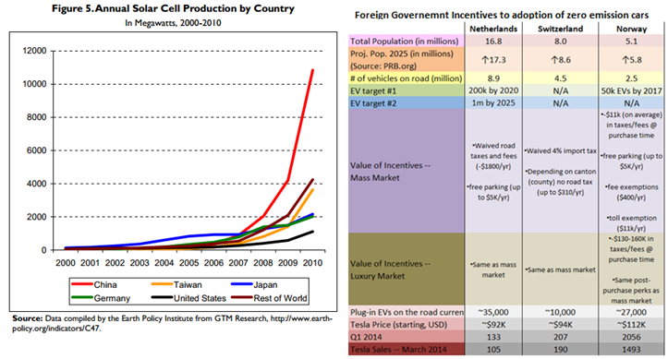

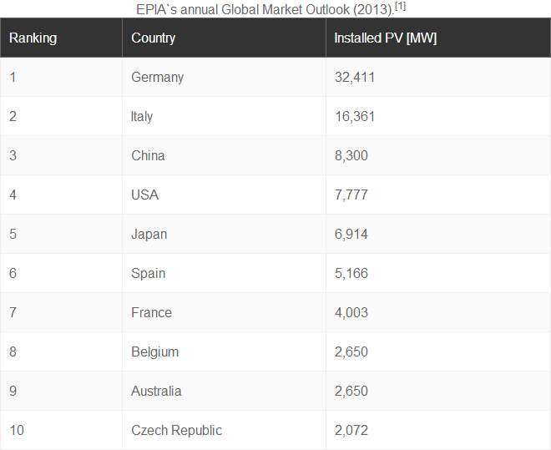It has become the biggest producer of solar cells and has promised the world an increase of 8GW to 35GW installations of solar panel from 2013 to 2015. That is 3GW more than the leading installer of solar panels, Germany. Other alternatives for clean energy have being adopted by China such as wind power. “Between 2006 and 2009, China’s wind power growth rates were more than 100% on average. At the end of 2010, installed wind power capacity in China was more than 40 GW and the grid connected operation capacity was more than 30 GW (ERI, page 8)”. **Ninth,** a production of Tesla cars in China would reduce the cost of the car in Europe and exposition to foreign exchange rate fluctuations since China adopted back its fixed floating exchange rate system. Based on these nine factors an entry strategy to production and sale to China can be created with a lesser risk of failure.

**Entry Strategy: e.g. Joint venture, greenfield, acquisition, among others.**

Tesla has recently laid out a possible strategy of creating the world’s biggest lithium-ion factory, “The Gigafactory”, in the United States. The expectations were that the construction of the factory would begin by the end of 2015 and be completed it in 2017. However, the factory costs were estimated in $5 billion dollars. That is one fourth of Tesla’s market cap share. This first quarter Tesla posted higher revenue but not profit. This poor result in profits had been mostly due to increasing investments in R&D for the new model design, the model X, recharging stations expansion, and the Gigafactory. It is recommended that Tesla look for financial aid from the U.S. government.

The Obama government had recently renewed its aid to environmentally free technology by $16 billion dollars. Despite being just plans but nothing concrete, this announcement came in the best time for Tesla to move the Gigafactory plan from papers to real life. By using this breaking news of how and where to build the factory, Tesla has been driving lots of attention from the U.S. government and the Chinese government. Sluggishly, the USA government has focusing some small investment to green technology while China has heavily investing in sustainable energy to reduce its harmful pollution levels. Panasonic has cogitated that it would possibly partnership with Tesla to the build the factory by providing a funding of $1 billion dollars but nothing is concrete yet. Tesla has to push now financial support from both governments rather than focus on the legal battle with states prohibiting its sale. If Tesla creates the factory in the U.S. and keep fighting legally against states’ governments not in favor of direct sales can be detrimental to Tesla.

The international market is showing to be more supportive to Tesla’s product than the United States has shown. If the Gigafactory is moved to China Tesla has much more to win and less hurdle with competitors and the government in the United States. Furthermore, presidential elections are coming in 2016. A Republican Party victory in the presidential elections of 2016 would most likely increase Tesla’s difficulties with Republican states in the United States. For example, all the states that have prohibited Tesla’s direct sales, such as Texas, New Jersey, and Mississippi are Republican majority. And, Republicans has shown increasingly resistance against policies to fight Global warming. Some of them do not even recognize that there is global warming, despite the overwhelming empirical data from many scientists and meteorologists. For example, Mitch McConnell who said “For everybody who thinks it’s warming, I can find somebody who thinks it isn’t”. Tesla must expand its car manufacturing to China or at least part of it.

Moving production to China, Tesla would not have to worry with channel length which means intermediary businesses through which the good or service passes until reaching the consumer such as the car dealerships in the United States. U.S. government has posing risks to Tesla’s success and expansion. Tesla does not need dealerships and have proven that through its design and consumers’ satisfaction. Without worrying with channel length like ICE automobile factories have, Tesla can focus more on marketing strategy in order to create a comparative advantage on media advertising and consumer service.Tesla must focus on push-pull mix strategy for the success of the company’s marketing. Tesla’s car showrooms are important for the consumer experience and the push strategies are important to sell its product in mass media and drive consumers to car showrooms.Its car prices are almost entirely dependable of battery production. Increasing production of batteries would lower their prices positively reducing its Model S price. An increase in battery production would increase car production. In their strategy of creating the Gigafactory, Ellon Musk and its engineers have predicted that price of batteries would fall by more than 30%. China is the gate to attain the economies of scale which Tesla needs most to survive and strive in the automobile market.

China has all the positive factors for Tesla to expand internationally and strive as the newest automobile startup to succeed after Kaiser-Frazer Motors. Tesla has a comparative advantage on its car design, safety, and performance which means the impact of a copied version of the battery is least likely to impact on sales. It would actually reduce the cost of the battery if copies with patent infringement are attained and used by competitors because as global production increases prices would fall. As a first-mover in the fully electric car manufacturing, Tesla has a successful rate of expanding abroad despite know-how sharing fears. If Tesla expands manufacturing to China, it would be able to achieve its economies of scale production, battery cost reduction, and maintain its comparative advantage in the electric car business.

**Work Cited**

## Tesla Motors: <http://www.teslamotors.com>

## Model S Specs: <http://www.teslamotors.com/models/specs>

## Model S Features: <http://www.teslamotors.com/models/features>

## Musk, Ellon; “[Tesla Adds Titanium Underbody Shield and Aluminum Deflector Plates to Model S](http://www.teslamotors.com/blog/tesla-adds-titanium-underbody-shield-and-aluminum-deflector-plates-model-s)”; Tesla Motors blog, March 28, 2014.

* <http://www.teslamotors.com/blog/tesla-adds-titanium-underbody-shield-and-aluminum-deflector-plates-model-s>

Voelcker, John; “Five Facts About Tesla & Electric Cars That May Surprise You”; Green Car Reports; September 19, 2013.

* <http://www.greencarreports.com/news/1087048_five-facts-about-tesla-electric-cars-that-may-surprise-you>

Bowling, Clarke; “Tesla Model S is Norway’s best-selling vehicle, outsells Ford’s entire range”; New York Daily News, Wednesday, April 2, 2014.

* <http://www.nydailynews.com/autos/tesla-model-s-norway-best-selling-vehicle-outsells-ford-entire-range-article-1.1743470>

Rogowsky, Mark; “Numbers Don’t Lie: Tesla Is Beginning To Put The Hurt On The Competition”; Forbes; October 24, 2013.

* <http://www.forbes.com/sites/markrogowsky/2013/08/24/numbers-dont-lie-tesla-is-beginning-to-put-the-hurt-on-the-competition/>

Severson, Aaron; “Kaisers Never Retrenched: The History of Kaiser-Frazer”; Ate Up With Motor; February 6, 2010.

* <http://ateupwithmotor.com/model-histories/kaiser-frazer-part-2/4/>

Mick, Jason; “As Sales Level in the U.S., Tesla Model S Charges Ahead in Europe, China”; Dailytech, April 24, 2014.

* <http://www.dailytech.com/As+Sales+Level+in+the+US+Tesla+Model+S+Charges+Ahead+in+Europe+China/article34773.htm>

Lanning, Phil; “SUV hat-trick to give Ford the Edge”; Sunmotors; May 12, 2014.

* <http://www.sunmotors.co.uk/news/suv-hat-trick-to-give-ford-the-edge/>

Tech Venture News, “Tesla’s Lithium-Ion Plant a Paradigm Shift for Graphite Demand” techventurenews.com; March 6, 2014.

* <http://www.techventurenews.com/teslas-lithium-ion-plant-paradigm-shift-graphite-demand>

Harrop, Peter; “Where are lithium-ion batteries headed?”, specchemonline.com; February 2013.

* <http://www.specchemonline.com/articles/view/where-are-lithium-ion-batteries-headed#.U3o6tfldX_E>

Maehlum, Mathias; “Where is Solar Power Used the Most”; Energy Informative; May 12, 2014.

* <http://energyinformative.org/where-is-solar-power-used-the-most/>

Energy Research Institute, “Technology Road Map: China Wind Energy Development Roadmap 2050”; published by International Energy Agency (IEA), October 2011.

* <http://www.iea.org/publications/freepublications/publication/china_wind.pdf>
* This document was originally released in Chinese in October 2011. The IEA and ERI have tried to ensure the consistency of this English translation with the original Chinese text, however it is possible that minor differences exist.

Miller, Daniel; “Ford Motor Company’s Sales Soar in the World’s Largest Automotive Market”; The Motley Fool, March 6, 2014.

* <http://www.fool.com/investing/general/2014/03/06/ford-motor-companys-sales-soar-in-the-worlds-large.aspx>