**Roderick Enoch**

**Macroeconomic**

The topic of discussion will be Quantitative easing, more specifically, the impact of tapering such a program. With this topic in mind, I will touch on the economic factors, economic policies, political factors and market psychology, to illustrate how my topic was impacted by these factors and vice versa. I will use the sticky price model to further clarify shifts in unexpected and anticipated changes in monetary policy affected prices.

It is always good to start with the fundamentals, whenever we are learning something new. Emphatically, the economic fundamentals. What changed from the beginning of my topic up until now is the depth and detail around my topic. Initially, the term tapering hadn’t seem to settle in, however as the weeks went by, I noticed that the term (tapering) was in almost every article that involved QE. I began to wonder. Why the change? What are some of the economic factors causing the increased volume in the term tapering? While reading the article Untying QE And Fed Rate Policy, written by Jeroen Blokland, we find that “after strong economic data and the somewhat surprising announcement that U.S. budget negotiators have reached a provisional two-year deal to avert another government shutdown, tapering is back on the table”. In other words, strong economic data maybe the reason why tapering QE is being talked about more often, because the economy can stand on its own two now. What kind of economic data you ask? Well GDP in the U.S. has increased as you can see below.

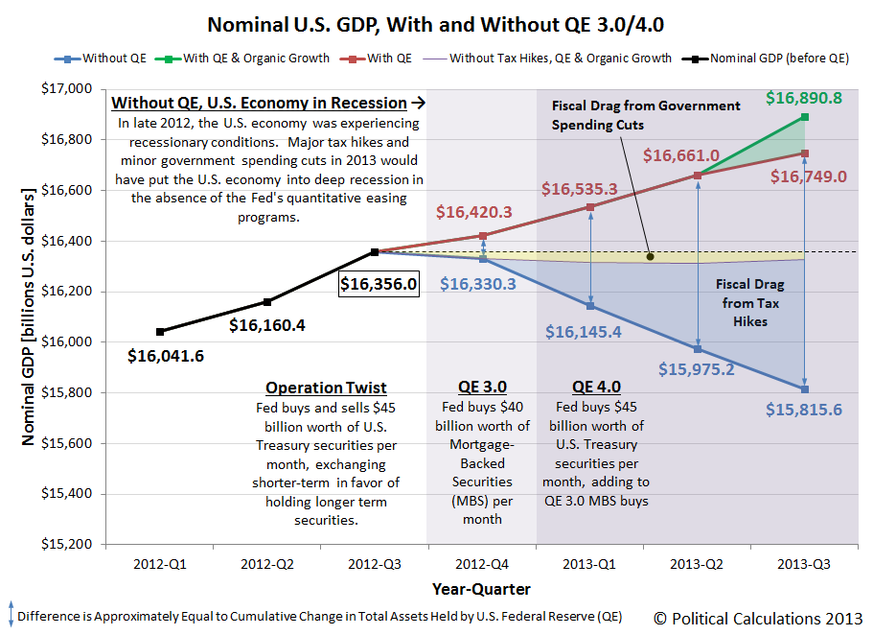

The graph above illustrates how “gross domestic product grew at a 3.6 percent annual rate instead of the 2.8 percent pace reported a month ago, the Commerce Department said on Thursday. It was the biggest gain since the first quarter of 2012, but inventories accounted for almost half of the increase in growth.”

Looking at the sticky price model and monetary policy, Y = Y(bar) + a(p-ep). We can argue that the continuation of QE at the same rate was unanticipated while tapering had been anticipated, thus causing the unexpected growth in GDP. This idea stems from economic data found in the article Quantitative Easing Has Failed To Attract Consumer Demand, But That's OK, written by Jeffery Rosen. Rosen talked about how monetary policy has failed to influence consumer demand, using interest rates as a tool. In other words, “the lack of interest rate sensitivity means a tapering decision, which we consider to be on par with minor monetary tightening”. However, taperng has not been the case as of yet, could this be the reason for strong GDP growth in the U.S? Well, according the the Sticky price model, it could be. If monetary policy hasn’t impacted consumer demand as anticipated that would mean that EP is not equal to P. When EP isn’t in line with P we find that Y is not equal to Y(bar). See below for the consumer demand graph.

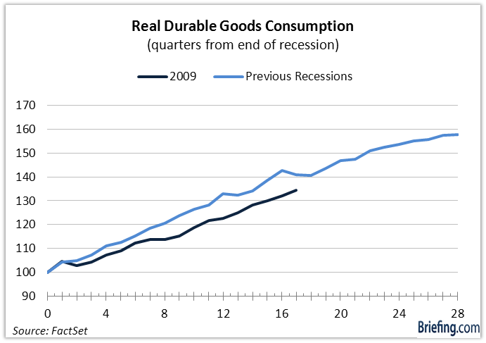

The chart above illustrates a weak response in demand to changes in interest rates, when “Kansas City Fed economists Zandweghe and Braxton (2013) posited that the weakness in consumption growth may be attributed to a shift in interest rate elasticities. Consumers, who had been very cognizant of fluctuations in interest rates in previous recessions, are not nearly as tempted to buy things when interest rates decline today.” The author goes on to talk about how he believes tapering wouldn’t cause any changes in the graph above, mostly because tapering will not shock the consumption demand. In the sticky price model the only way to shock aggregate demand and increase it is to unexpectedly increase monetary expansion. Since the expectation is that tapering will be the end result as some point, I think the market is preparing for that. When I see GDP growth this year, I see a short term growth. See below for graphs of the stick price model.

*Google images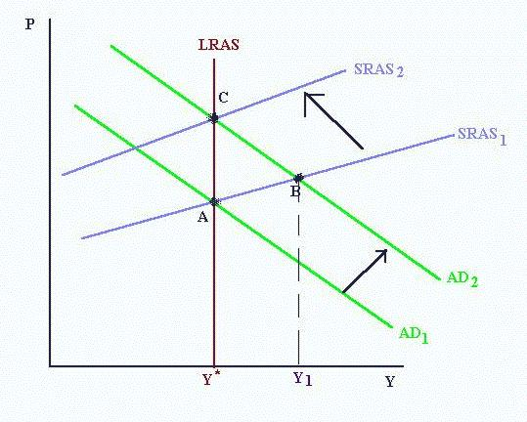

In regards to the topic that I mentioned in the beginning, dealing with QE and the effects of tapering. I think we are at point B where there is an increase in GDP, where EP is less than P, giving us a positive number in the equation Y=Y(bar)+a(P-EP). I think that tapering will put us back where we belong at point C, because tapering is anticipated and this will make EP = P. There is one major flaw in this problem and it is that AD is not shifting upward, however there is still an expansion in GDP. Maybe that’s because AD had already shifted when QE was initially introduced.

When we look at political factors, we look at Bernake and Yellen. When Bernake announced that he would be leaving office next year. Many were concerned with whether or not the new Fed chairman would keep things the same. This was a time of uncertainty as many had already knew that tapering would eventually come, it was just a matter of time. With a new Fed person no one knew what to expect. However, when Janet Yellen was elected to be the new official chair and when she also announced to keep things similar to Bernake when she stated “We’re going to keep doing the same thing, but we’re going to stop, too…. probably.”(1) and hold off on tapering. The market rose similar to the way it did September 18th,2014 when Bernake first shared that he would not be scaling back on the QE just yet.(2)

In the end, I had the opportunity to watch my topic grow and evolve. I saw the concerns shift from, what is tapering, where did it come from and how will it impact the economy. To its time for tapering and authors using actual data analysis to support why it is time for tapering. There were a number of reasons why it is time for tapering, in fact I was convince that it is time for tapering through this project. I had the opportunity to learn more about the sticky price model and how it applies to the real world. I had the opportunity to analize my topic from a plethora of anagles, such as economic factors, political factors and how those things effect market phycology. I learned how unanticipated changes in monetart policy can cause an increase in the market, which sent the S&P and Dow to record highs according to the article, No Taper! Dow, S&P 500 Soar to Record Closing Highs. I will continue to look for these relationships in the future.

Works Cited

1."The Coronation of Janet Yellen." *» CounterPunch: Tells the Facts, Names the Names*. MIKE WHITNEY, 18 Nov. 2013. Web. 16 Dec. 2013.

"An Economic Detective Story: Solving The Mystery Of Unexpectedly Strong U.S. GDP Growth." *- Seeking Alpha*. Ironman at Political Calculations, 12 Dec. 2013. Web. 16 Dec. 2013.

"The Economy Continues To Grow, So Bring On The Taper." *- Seeking Alpha*. Califia Beach Pundit, 4 Dec. 2013. Web. 16 Dec. 2013.

2."No Taper! Dow, S&P 500 Soar to Record Closing Highs." *Yahoo Finance*. Jennifer Carinci, 18 Sept. 2013. Web. 16 Dec. 2013.

"QE: How Will It All End?" *[SPDR Gold Trust (ETF), Annaly Capital Management, Inc., JPMorgan Chase & Co., Wells Fargo & Co, Goldman Sachs Group Inc, Financial Select Sector SPDR (ETF)]*. Nasser Kharishi, 19 Nov. 2013. Web. 16 Dec. 2013.

"Quantitative Easing Has Failed To Attract Consumer Demand, But That's OK." *- Seeking Alpha*. Jeffery Rosen, 12 Dec. 2013. Web. 16 Dec. 2013.

"The Taper Caper." *- Seeking Alpha*. Ben Kramer-Miller, 25 Nov. 2013. Web. 16 Dec. 2013.

"Too Much QE? Yes, Without A Shadow Of A Doubt." *[SPDR S&P 500 ETF Trust, ProShares Short S&P500 (ETF), ProShares Ultra S&P500 (ETF), ProShares Short QQQ (ETF), IShares S&P 500 Index (ETF), Vanguard 500 Index Fund, ProShares UltraShort QQQ (ETF)]*. Jeffery Rosen, 13 Nov. 2013. Web. 16 Dec. 2013.

"Untying QE And Fed Rate Policy." *- Seeking Alpha*. Jeroen Blokland, 13 Dec. 2013. Web. 16 Dec. 2013.

"With A Continuing Weak Economy, Will QE Ever End?" *- Seeking Alpha*. Steven Hanson, 26 Oct. 2013. Web. 16 Dec. 2013.